Functional Specification Document

# Project Members

Altin Kelmendi, Benjamin Jukic, Julian Hoffmann | **Group 6, B1/B2**

# Project Title

Transaction Service for Aggregation and Management of Account Data

# Objective

A transaction service that receives external transactions, stores them, and aggregates or queries the account balance at a specific timestamp.

# System Overview

The system consists of two interfaces (SOAP and REST), a database (PostgreSQL), and external services that interact with the system.

# Component Diagram

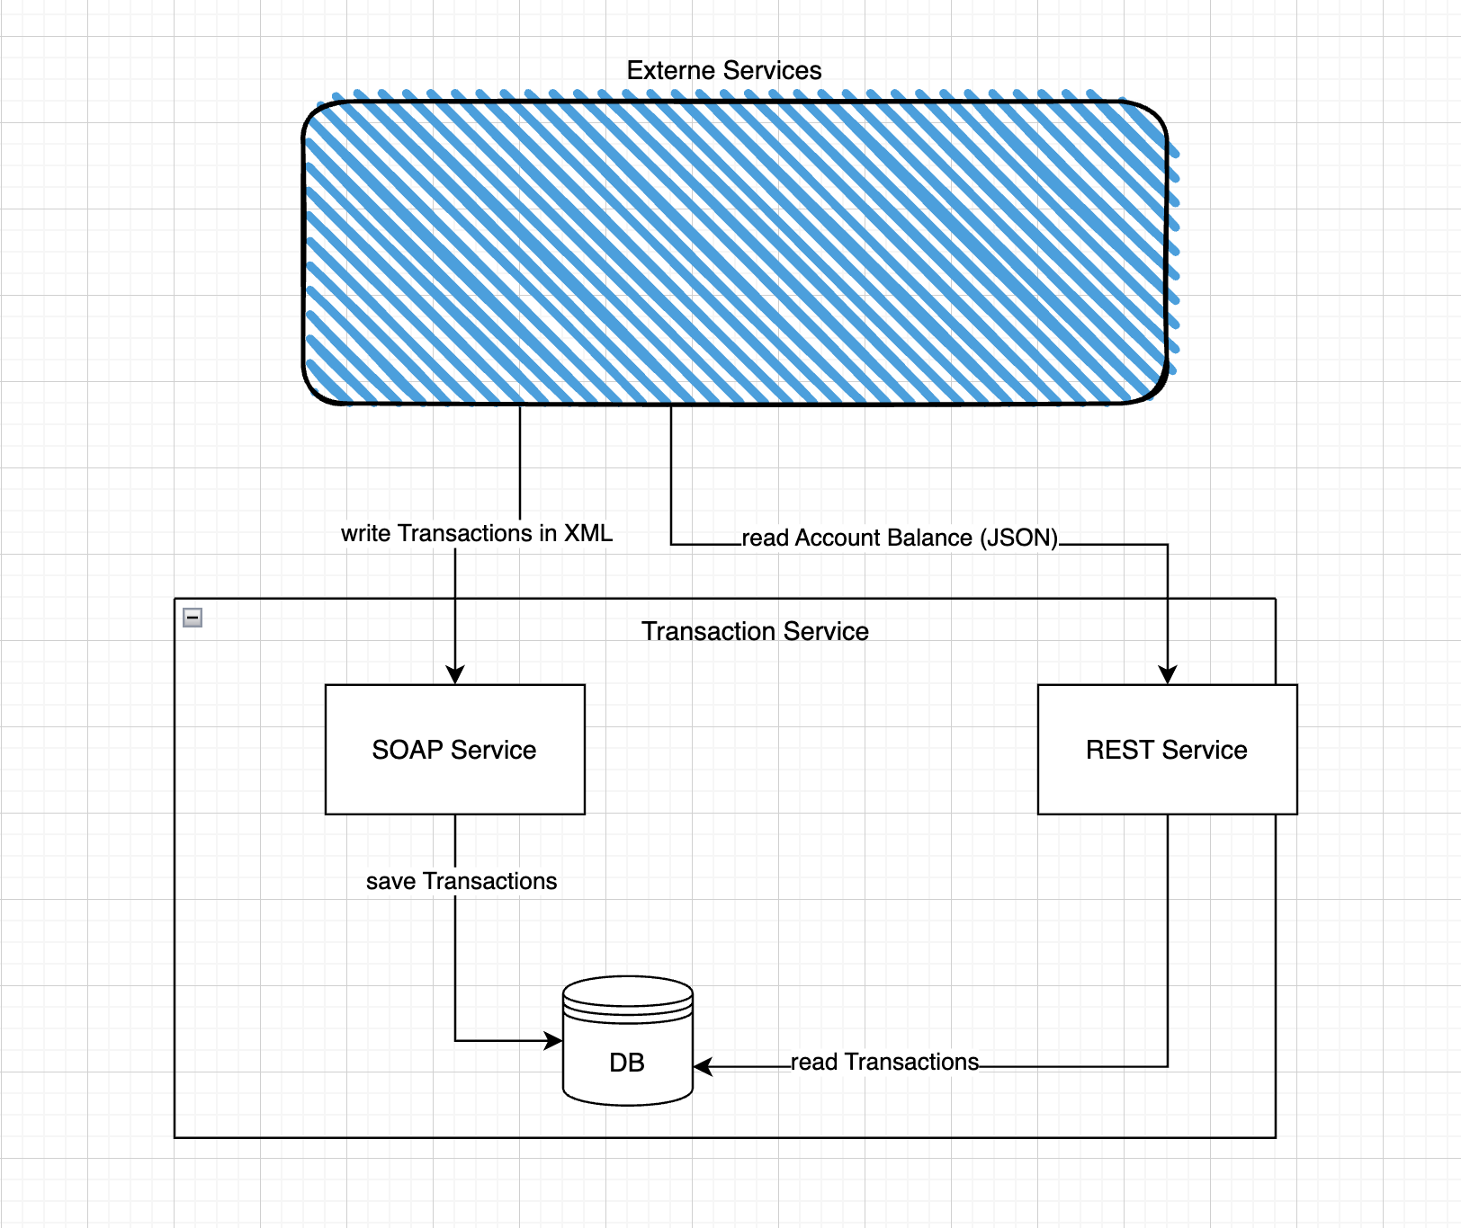

# Component Description

## 1. SOAP Service

Function: Receiving and storing transactions.

Data format: XML (XSD-based)

Received data (attributes):  
- ID (Integer)  
- Name (String)  
- Timestamp (ISO8601 format)  
- Amount (Decimal, positive or negative)

Behavior:  
- Transactions are stored in the database without filtering.  
- No business logic validation or balance calculation in the SOAP service.

## 2. REST Service

Function: Querying the account balance (aggregated) at a specific timestamp.

Data format: JSON (schema-based)

Input parameters:  
- ID (Integer)  
- Timestamp (ISO8601 format)

Response:  
- Current account balance at the given timestamp (aggregated from transactions)  
- User (ID, Name)

Behavior:  
- Aggregation: All transactions with timestamp <= given timestamp are summed.  
- Result: Total account balance

## 3. Database (PostgreSQL)

Function: Persistence layer for transaction data.

Table structure (Transactions):  
- ID (Primary Key)  
- Name  
- Timestamp  
- Amount

Usage:  
- SOAP writes data  
- REST reads and aggregates data

## 4. External Services

Write transactions via SOAP (XML)  
Read account balance via REST (JSON)

# Use of Standards

- SOAP Service: XSD for validating the transaction structure  
- REST Service: JSON Schema for validating requests

# Use Cases

## +++ UC1: Store Transaction

An external service sends a list of transactions via SOAP.  
Each transaction contains ID, Name, Timestamp, and Amount.  
The transactions are persisted.

Example XML:

<transaction>  
 <id>123</id>  
 <name>Max Mustermann</name>  
 <timestamp>2025-05-10T12:00:00Z</timestamp>  
 <amount>+100.00</amount>  
</transaction>

## --- UC2: Query Account Balance

A client sends a GET/POST request to the REST API with ID and Timestamp.  
The account balance at the given time is calculated.

Example JSON request:

{  
 "id": "123",  
 "timestamp": "2025-05-10T13:00:00Z"  
}

Response:

{  
 "id": "123",  
 "balance": 250.00  
}

# Summary:

This service acts as a central integration component for transactions, offering both a write interface (SOAP/XML) and a read interface (REST/JSON). The data is stored in a PostgreSQL database, which serves as the source for aggregated balance information.

# Technology Stack:

- SOAP + XML + XSD  
- REST + JSON + Schema  
- PostgreSQL