Команды настройки сети
Вариант №1: GRE, OSPF, DHCP, VLAN, STP, EtherChannel, SSH, Port Security
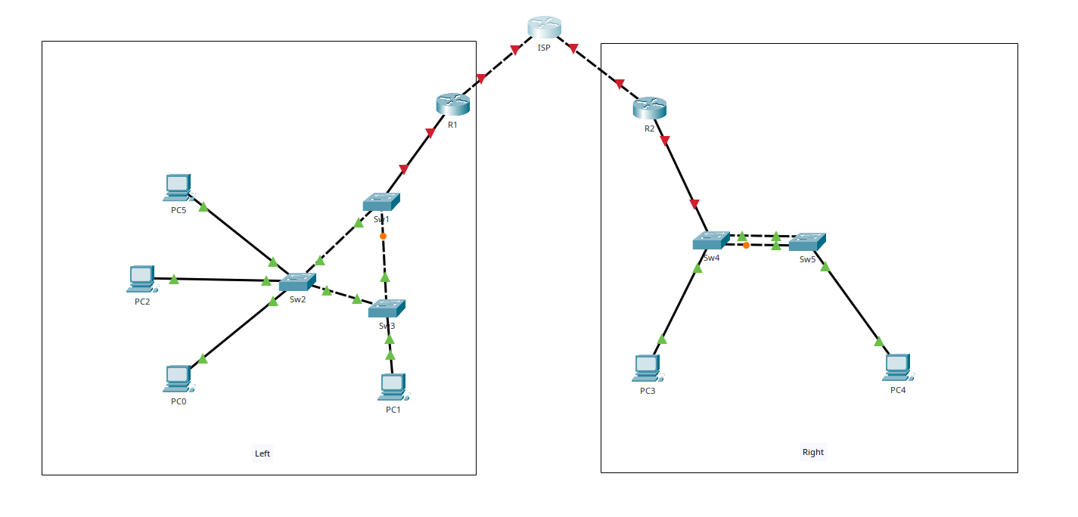
Схема сети из задания
Примечание: номера интерфейсов приняты по типовой схеме Packet Tracer. Если в твоей схеме используются другие порты, замени только имена интерфейсов, не меняя логику команд.

1. Принятые подключения
Линк | Интерфейсы
ISP — R1 | ISP G0/0 ↔ R1 G0/0
ISP — R2 | ISP G0/1 ↔ R2 G0/0
R1 — SW1 | R1 G0/1 ↔ SW1 G0/1
SW1 — SW2 | SW1 F0/1 ↔ SW2 F0/1
SW1 — SW3 | SW1 F0/2 ↔ SW3 F0/1
SW2 — SW3 | SW2 F0/2 ↔ SW3 F0/2
R2 — SW4 | R2 G0/1 ↔ SW4 G0/1
SW4 — SW5 EtherChannel | SW4 F0/23-24 ↔ SW5 F0/23-24

2. IP-адресация
Устройство | Интерфейс | IP
ISP | G0/0 | 10.0.0.1/30
ISP | G0/1 | 10.0.0.5/30
R1 | G0/0 | 10.0.0.2/30
R1 | G0/1.10 | 192.168.10.1/26
R1 | G0/1.20 | 192.168.10.65/27
R1 | G0/1.30 | 192.168.10.97/27
R1 | Tunnel0 | 192.168.255.1/30
R2 | G0/0 | 10.0.0.6/30
R2 | G0/1 | 172.16.20.1/24
R2 | Tunnel0 | 192.168.255.2/30
SW1 | VLAN 10 | 192.168.10.2/26
SW2 | VLAN 10 | 192.168.10.3/26
SW3 | VLAN 10 | 192.168.10.4/26
SW4 | VLAN 1 | 172.16.20.2/24
SW5 | VLAN 1 | 172.16.20.3/24

3. VLAN Left
VLAN | Подсеть | Gateway
VLAN 10 | 192.168.10.0/26 | 192.168.10.1
VLAN 20 | 192.168.10.64/27 | 192.168.10.65
VLAN 30 | 192.168.10.96/27 | 192.168.10.97

4. Команды настройки устройств

ISP
enable
conf t
hostname ISP

enable secret securepass1
service password-encryption

line console 0
password console123
login
logging synchronous
exit

ip domain-name example.com
username admin secret sshpassword1
crypto key generate rsa modulus 1024
ip ssh version 2

line vty 0 4
login local
transport input ssh
exit

interface g0/0
description TO-R1
ip address 10.0.0.1 255.255.255.252
no shutdown
exit

interface g0/1
description TO-R2
ip address 10.0.0.5 255.255.255.252
no shutdown
exit

end
wr

R1
enable
conf t
hostname R1

enable secret securepass1
service password-encryption

line console 0
password console123
login
logging synchronous
exit

ip domain-name example.com
username admin secret sshpassword1
crypto key generate rsa modulus 1024
ip ssh version 2

line vty 0 4
login local
transport input ssh
exit

interface g0/0
description TO-ISP
ip address 10.0.0.2 255.255.255.252
no shutdown
exit

interface g0/1
description TO-SW1-TRUNK
no ip address
no shutdown
exit

interface g0/1.10
description VLAN10
encapsulation dot1Q 10
ip address 192.168.10.1 255.255.255.192
exit

interface g0/1.20
description VLAN20
encapsulation dot1Q 20
ip address 192.168.10.65 255.255.255.224
exit

interface g0/1.30
description VLAN30
encapsulation dot1Q 30
ip address 192.168.10.97 255.255.255.224
exit

ip route 10.0.0.4 255.255.255.252 10.0.0.1

interface Tunnel0
description GRE-TO-R2
ip address 192.168.255.1 255.255.255.252
tunnel source g0/0
tunnel destination 10.0.0.6
no shutdown
exit

ip dhcp excluded-address 192.168.10.1 192.168.10.10
ip dhcp excluded-address 192.168.10.65 192.168.10.70
ip dhcp excluded-address 192.168.10.97 192.168.10.100

ip dhcp pool VLAN10
network 192.168.10.0 255.255.255.192
default-router 192.168.10.1
dns-server 8.8.8.8
exit

ip dhcp pool VLAN20
network 192.168.10.64 255.255.255.224
default-router 192.168.10.65
dns-server 8.8.8.8
exit

ip dhcp pool VLAN30
network 192.168.10.96 255.255.255.224
default-router 192.168.10.97
dns-server 8.8.8.8
exit

router ospf 1
router-id 1.1.1.1
passive-interface default
no passive-interface Tunnel0
network 192.168.255.0 0.0.0.3 area 0
network 192.168.10.0 0.0.0.63 area 0
network 192.168.10.64 0.0.0.31 area 0
network 192.168.10.96 0.0.0.31 area 0
exit

end
wr

R2
enable
conf t
hostname R2

enable secret securepass1
service password-encryption

line console 0
password console123
login
logging synchronous
exit

ip domain-name example.com
username admin secret sshpassword1
crypto key generate rsa modulus 1024
ip ssh version 2

line vty 0 4
login local
transport input ssh
exit

interface g0/0
description TO-ISP
ip address 10.0.0.6 255.255.255.252
no shutdown
exit

interface g0/1
description TO-SW4
ip address 172.16.20.1 255.255.255.0
no shutdown
exit

ip route 10.0.0.0 255.255.255.252 10.0.0.5

interface Tunnel0
description GRE-TO-R1
ip address 192.168.255.2 255.255.255.252
tunnel source g0/0
tunnel destination 10.0.0.2
no shutdown
exit

ip dhcp excluded-address 172.16.20.1 172.16.20.20

ip dhcp pool RIGHT
network 172.16.20.0 255.255.255.0
default-router 172.16.20.1
dns-server 8.8.8.8
exit

router ospf 1
router-id 2.2.2.2
passive-interface default
no passive-interface Tunnel0
network 192.168.255.0 0.0.0.3 area 0
network 172.16.20.0 0.0.0.255 area 0
exit

end
wr

SW1
enable
conf t
hostname SW1

enable secret securepass1
service password-encryption

line console 0
password console123
login
logging synchronous
exit

ip domain-name example.com
username admin secret sshpassword1
crypto key generate rsa modulus 1024
ip ssh version 2

line vty 0 4
login local
transport input ssh
exit

vlan 10
name VLAN10
exit
vlan 20
name VLAN20
exit
vlan 30
name VLAN30
exit

interface vlan 10
ip address 192.168.10.2 255.255.255.192
no shutdown
exit

ip default-gateway 192.168.10.1

interface g0/1
description TO-R1
switchport mode trunk
switchport trunk allowed vlan 10,20,30
no shutdown
exit

interface f0/1
description TO-SW2
switchport mode trunk
switchport trunk allowed vlan 10,20,30
no shutdown
exit

interface f0/2
description TO-SW3
switchport mode trunk
switchport trunk allowed vlan 10,20,30
no shutdown
exit

spanning-tree mode pvst
spanning-tree vlan 10,20,30 priority 4096

end
wr

SW2
enable
conf t
hostname SW2

enable secret securepass1
service password-encryption

line console 0
password console123
login
logging synchronous
exit

ip domain-name example.com
username admin secret sshpassword1
crypto key generate rsa modulus 1024
ip ssh version 2

line vty 0 4
login local
transport input ssh
exit

vlan 10
name VLAN10
exit
vlan 20
name VLAN20
exit
vlan 30
name VLAN30
exit

interface vlan 10
ip address 192.168.10.3 255.255.255.192
no shutdown
exit

ip default-gateway 192.168.10.1

interface f0/1
description TO-SW1
switchport mode trunk
switchport trunk allowed vlan 10,20,30
no shutdown
exit

interface f0/2
description TO-SW3
switchport mode trunk
switchport trunk allowed vlan 10,20,30
no shutdown
exit

interface range f0/10-19
description VLAN10-ACCESS
switchport mode access
switchport access vlan 10
switchport port-security
switchport port-security mac-address sticky
switchport port-security violation restrict
spanning-tree portfast
spanning-tree bpduguard enable
no shutdown
exit

interface range f0/20-29
description VLAN20-ACCESS
switchport mode access
switchport access vlan 20
switchport port-security
switchport port-security mac-address sticky
switchport port-security violation restrict
spanning-tree portfast
spanning-tree bpduguard enable
no shutdown
exit

spanning-tree mode pvst
spanning-tree vlan 10,20,30 priority 8192

end
wr

SW3
enable
conf t
hostname SW3

enable secret securepass1
service password-encryption

line console 0
password console123
login
logging synchronous
exit

ip domain-name example.com
username admin secret sshpassword1
crypto key generate rsa modulus 1024
ip ssh version 2

line vty 0 4
login local
transport input ssh
exit

vlan 10
name VLAN10
exit
vlan 20
name VLAN20
exit
vlan 30
name VLAN30
exit

interface vlan 10
ip address 192.168.10.4 255.255.255.192
no shutdown
exit

ip default-gateway 192.168.10.1

interface f0/1
description TO-SW1
switchport mode trunk
switchport trunk allowed vlan 10,20,30
no shutdown
exit

interface f0/2
description TO-SW2
switchport mode trunk
switchport trunk allowed vlan 10,20,30
no shutdown
exit

interface range f0/10-19
description VLAN30-ACCESS
switchport mode access
switchport access vlan 30
switchport port-security
switchport port-security mac-address sticky
switchport port-security violation restrict
spanning-tree portfast
spanning-tree bpduguard enable
no shutdown
exit

spanning-tree mode pvst
spanning-tree vlan 10,20,30 priority 12288

end
wr

SW4
enable
conf t
hostname SW4

enable secret securepass1
service password-encryption

line console 0
password console123
login
logging synchronous
exit

ip domain-name example.com
username admin secret sshpassword1
crypto key generate rsa modulus 1024
ip ssh version 2

line vty 0 4
login local
transport input ssh
exit

interface vlan 1
ip address 172.16.20.2 255.255.255.0
no shutdown
exit

ip default-gateway 172.16.20.1

interface g0/1
description TO-R2
switchport mode access
switchport access vlan 1
no shutdown
exit

interface range f0/23-24
description LACP-TO-SW5
switchport mode trunk
channel-protocol lacp
channel-group 1 mode active
no shutdown
exit

interface port-channel 1
description LACP-TO-SW5
switchport mode trunk
no shutdown
exit

interface f0/10
description TO-PC3
switchport mode access
switchport access vlan 1
switchport port-security
switchport port-security mac-address sticky
switchport port-security violation restrict
spanning-tree portfast
spanning-tree bpduguard enable
no shutdown
exit

end
wr

SW5
enable
conf t
hostname SW5

enable secret securepass1
service password-encryption

line console 0
password console123
login
logging synchronous
exit

ip domain-name example.com
username admin secret sshpassword1
crypto key generate rsa modulus 1024
ip ssh version 2

line vty 0 4
login local
transport input ssh
exit

interface vlan 1
ip address 172.16.20.3 255.255.255.0
no shutdown
exit

ip default-gateway 172.16.20.1

interface range f0/23-24
description LACP-TO-SW4
switchport mode trunk
channel-protocol lacp
channel-group 1 mode active
no shutdown
exit

interface port-channel 1
description LACP-TO-SW4
switchport mode trunk
no shutdown
exit

interface f0/10
description TO-PC4
switchport mode access
switchport access vlan 1
switchport port-security
switchport port-security mac-address sticky
switchport port-security violation restrict
spanning-tree portfast
spanning-tree bpduguard enable
no shutdown
exit

end
wr

5. Настройка ПК
На всех ПК включить DHCP.
ПК | Коммутатор/порт | VLAN | DHCP-сеть
PC0 | SW2 F0/10 | 10 | 192.168.10.0/26
PC5 | SW2 F0/11 | 10 | 192.168.10.0/26
PC2 | SW2 F0/20 | 20 | 192.168.10.64/27
PC1 | SW3 F0/10 | 30 | 192.168.10.96/27
PC3 | SW4 F0/10 | 1 | 172.16.20.0/24
PC4 | SW5 F0/10 | 1 | 172.16.20.0/24

6. Проверка
show ip interface brief
show interfaces tunnel 0
show ip ospf neighbor
show ip route ospf
show spanning-tree vlan 10
show spanning-tree vlan 20
show spanning-tree vlan 30
show etherchannel summary
show port-security
show port-security interface f0/10
show ip dhcp binding

7. Проверка связности
ping 192.168.255.2
ping 172.16.20.1
ping 192.168.10.1
ping 192.168.10.65
ping 192.168.10.97

8. Если WAN-интерфейсы Serial
Если в Packet Tracer у роутеров WAN-интерфейсы Serial, вместо G0/0/G0/1 используй свои S0/0/0 и S0/0/1. На DCE-стороне добавь:
clock rate 64000

