# Image Classification Recipe

# SaaS platforms setup

Creating an IBM Watson Studio account and a Visual Recognition project 1

Creating a Cloud AutoML account and a AutoML Vision project 6

## Creating an IBM Watson Studio account and a Visual Recognition project

1. Go to <https://www.ibm.com/cloud/watson-visual-recognition>

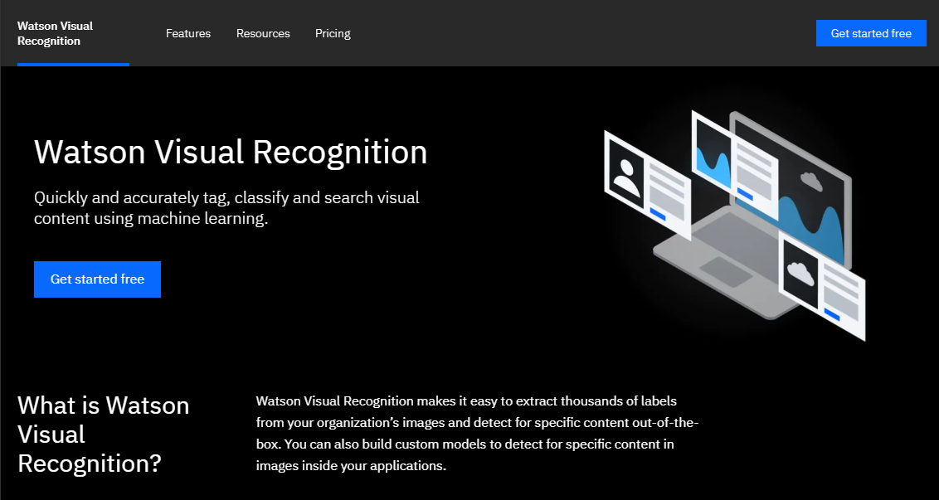

1. Select “Get started free” and then create an IBM Cloud account (if needed)

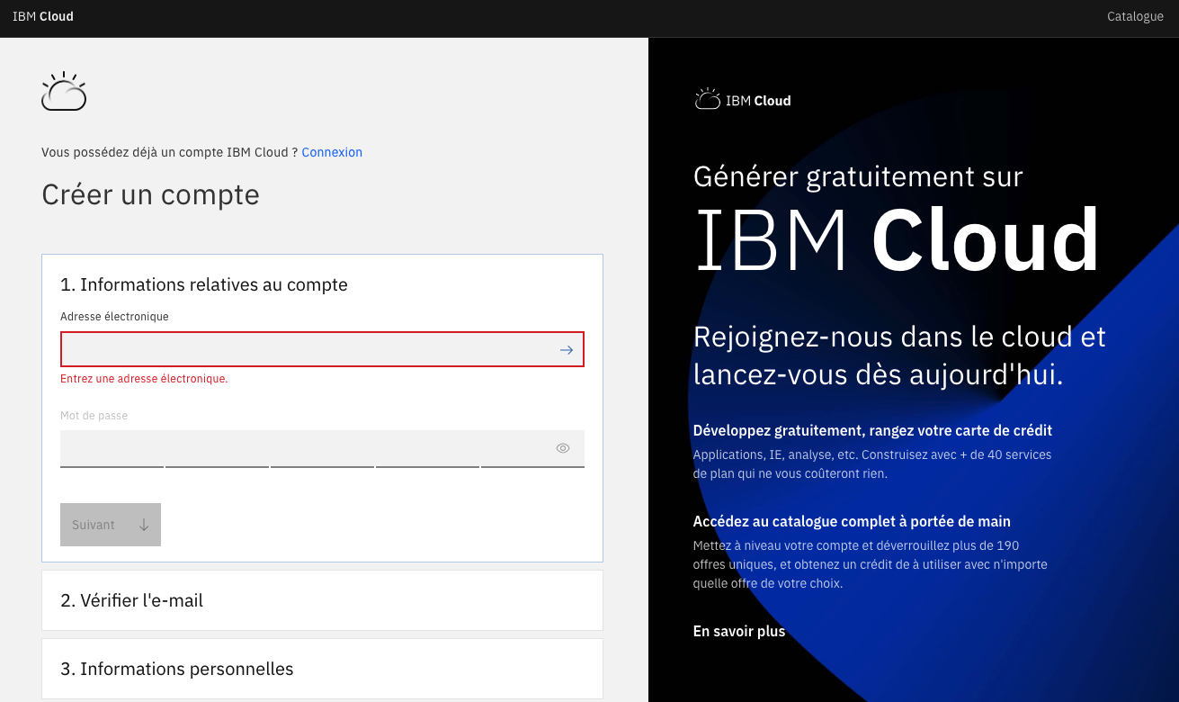

1. Validate the email received from IBM

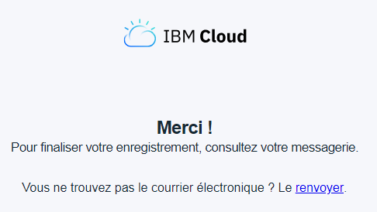

1. In the IBM Cloud applications catalog, choose "Watson"

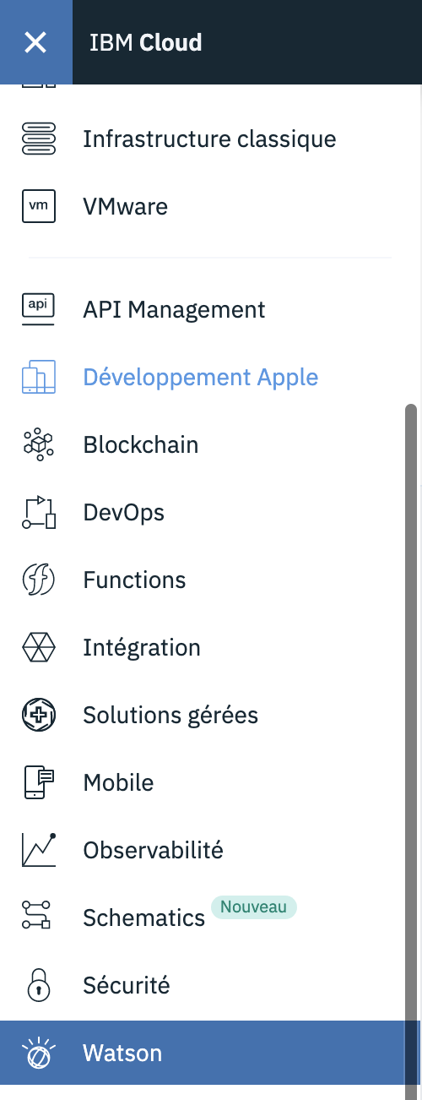

1. Then choose “Watson Services” and then “Watson Studio”

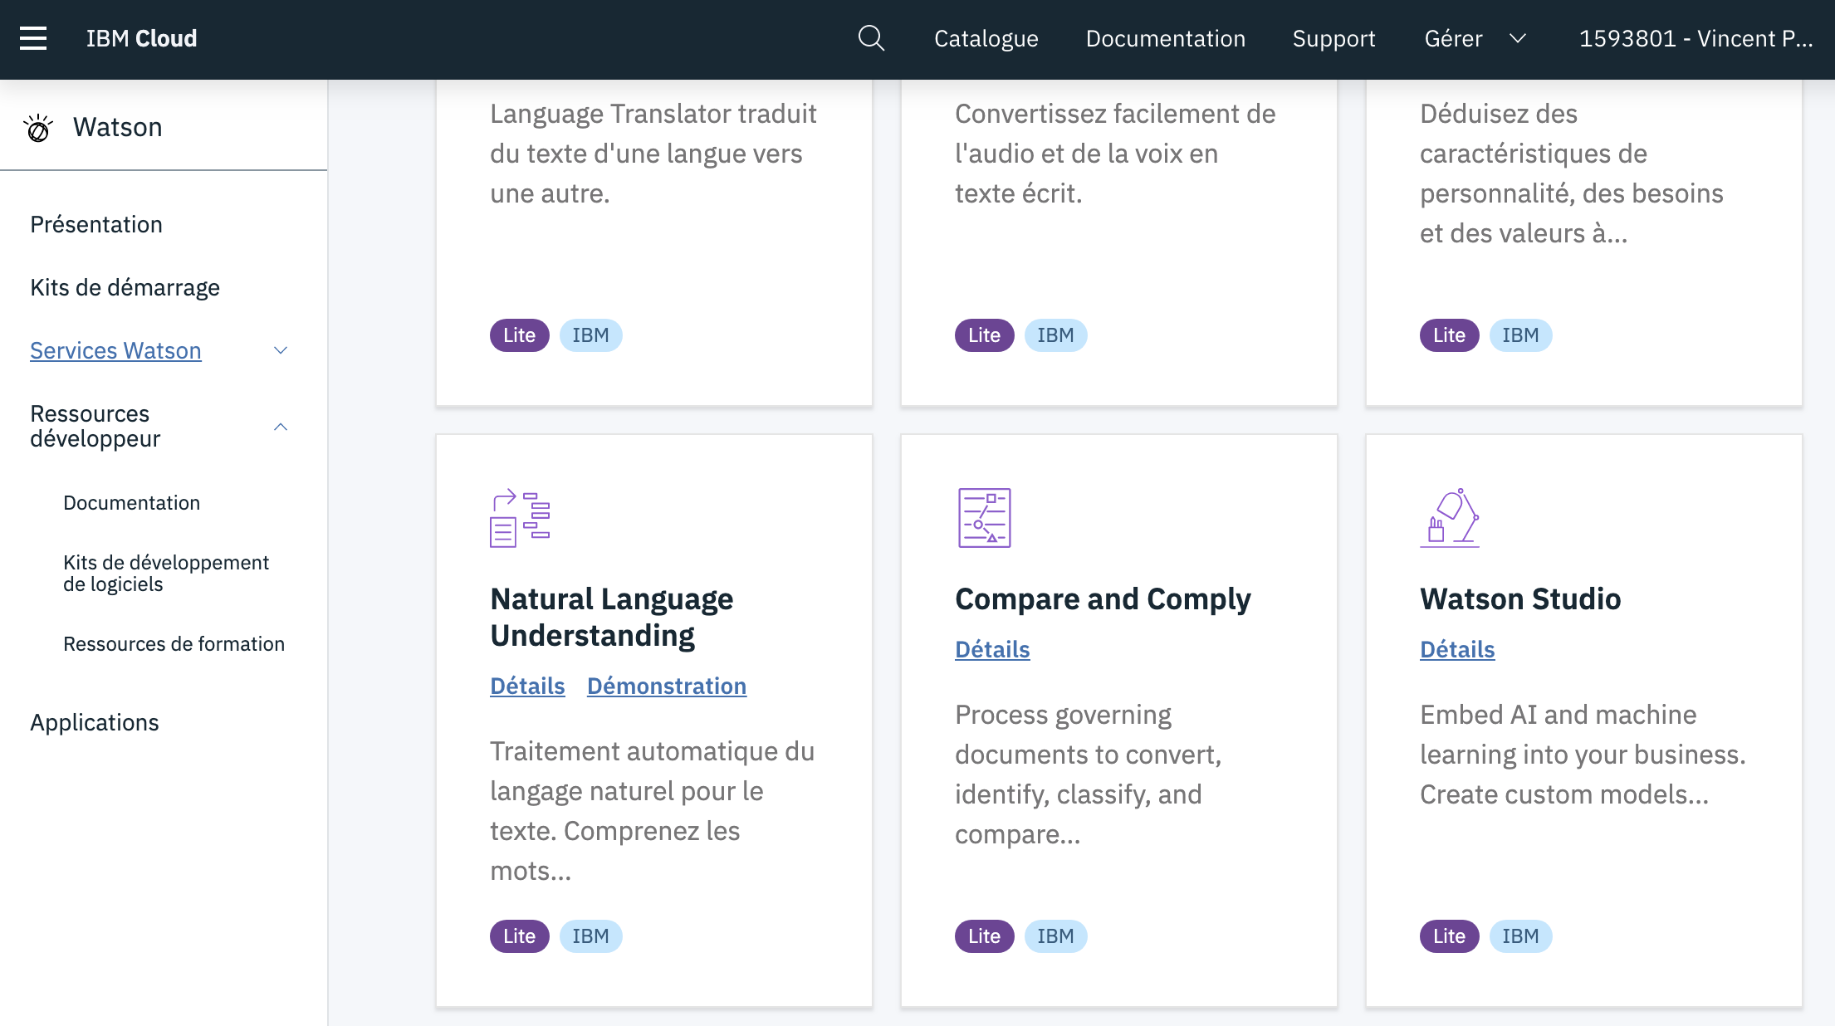

1. Launch the Watson Studio web app

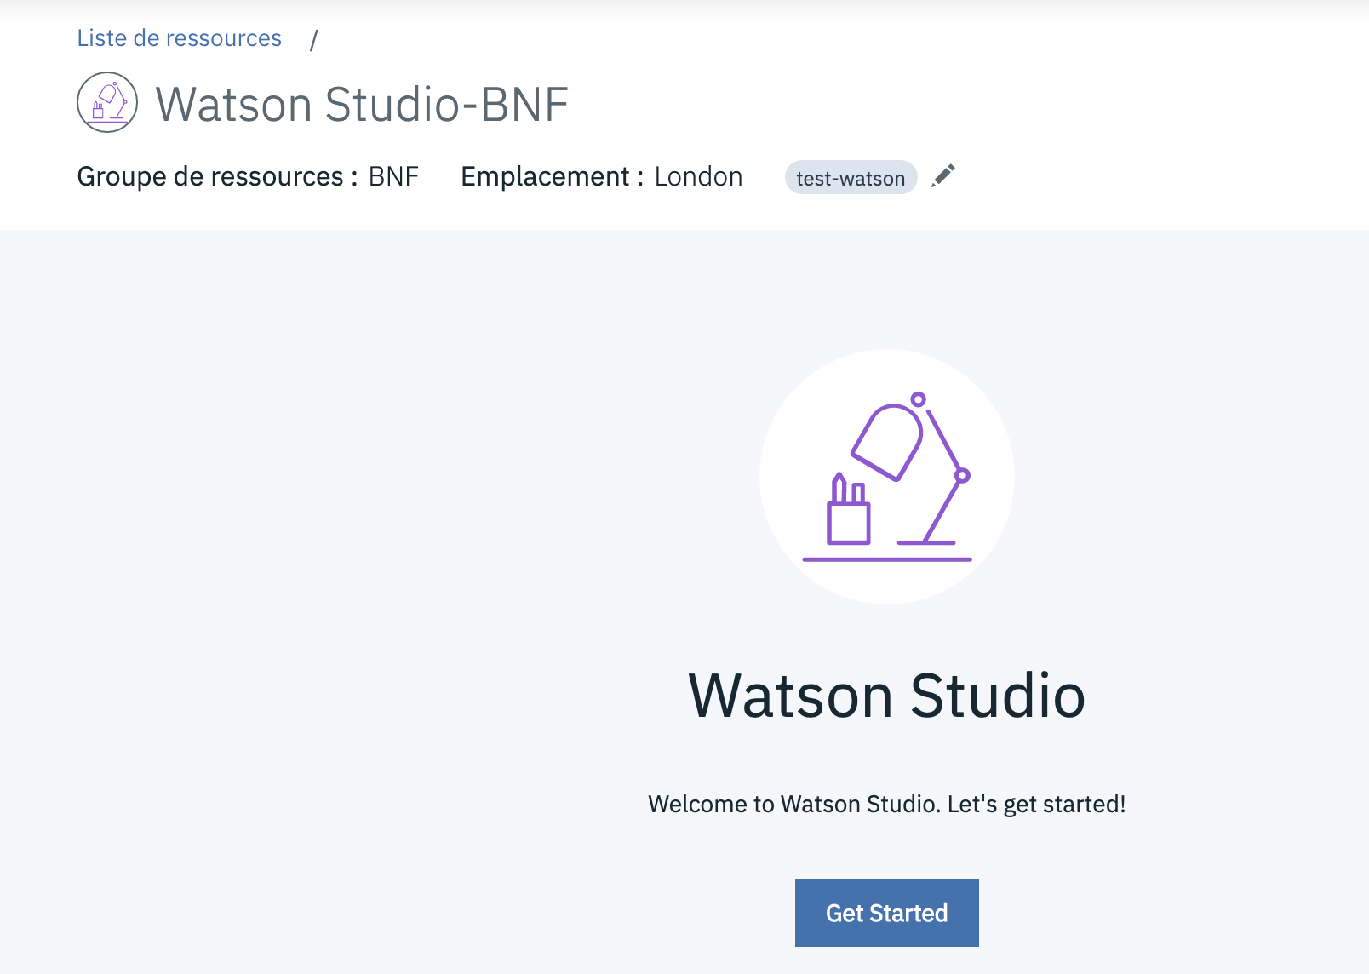

1. Choose the « Lite » cost plan

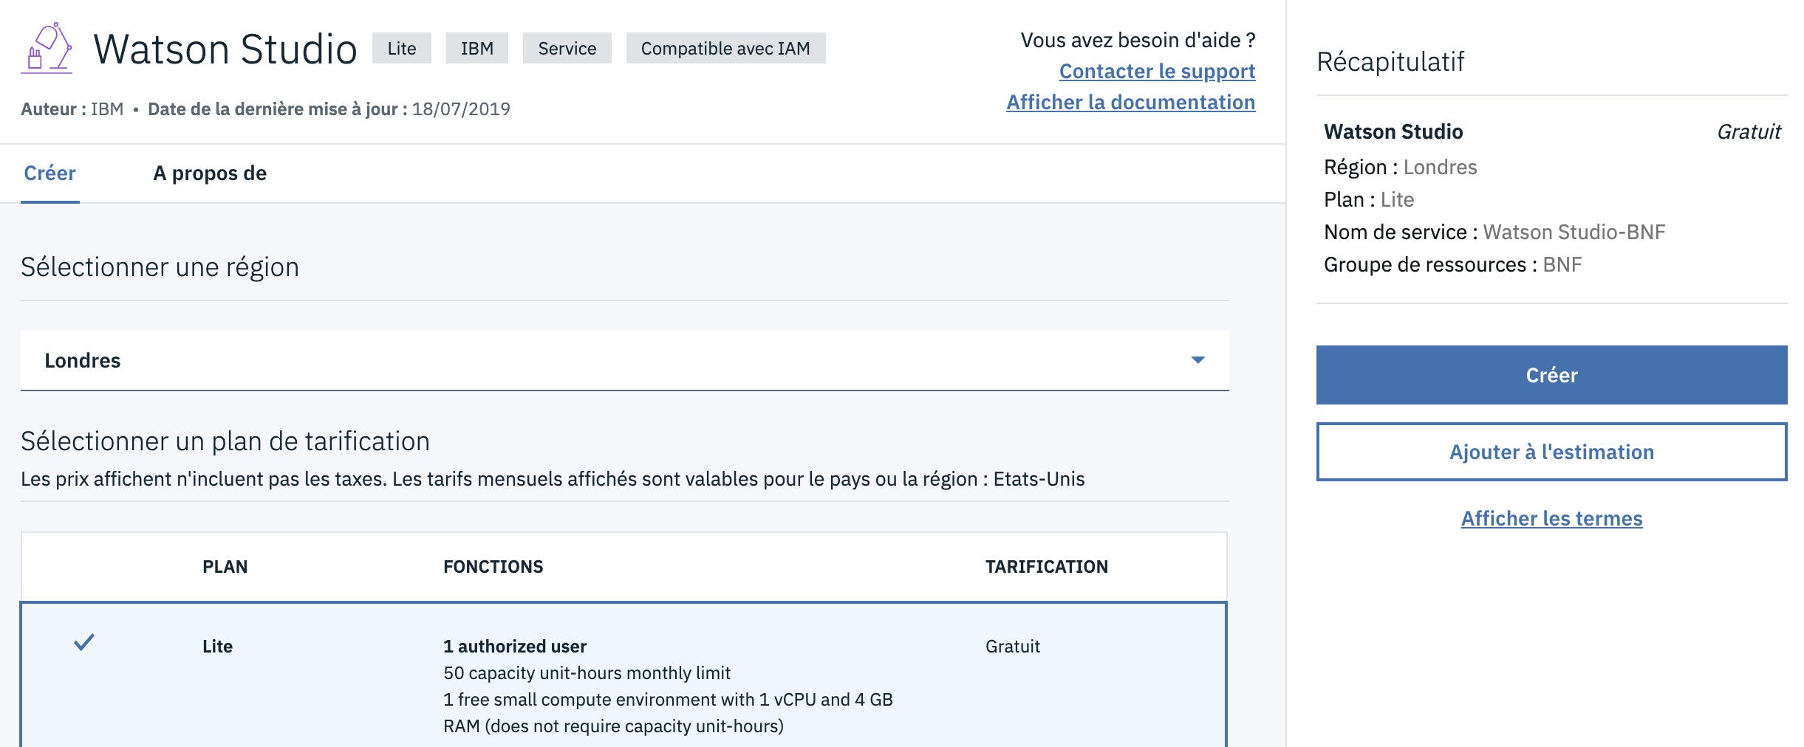

1. Name your new service

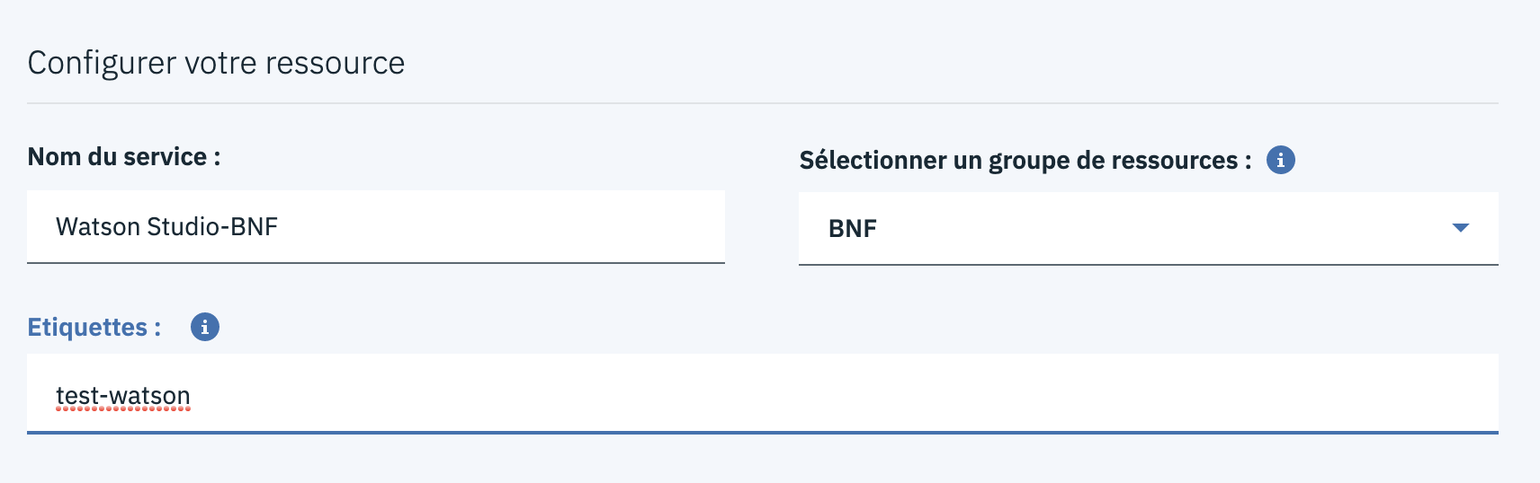

1. Create a new project and say a few words about it

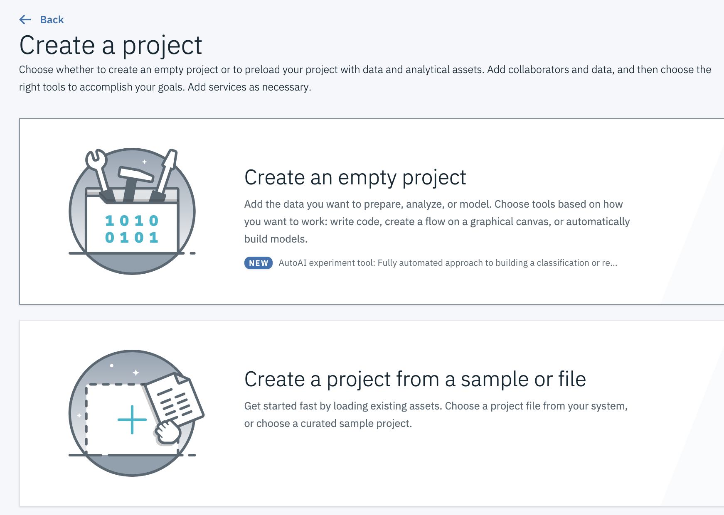 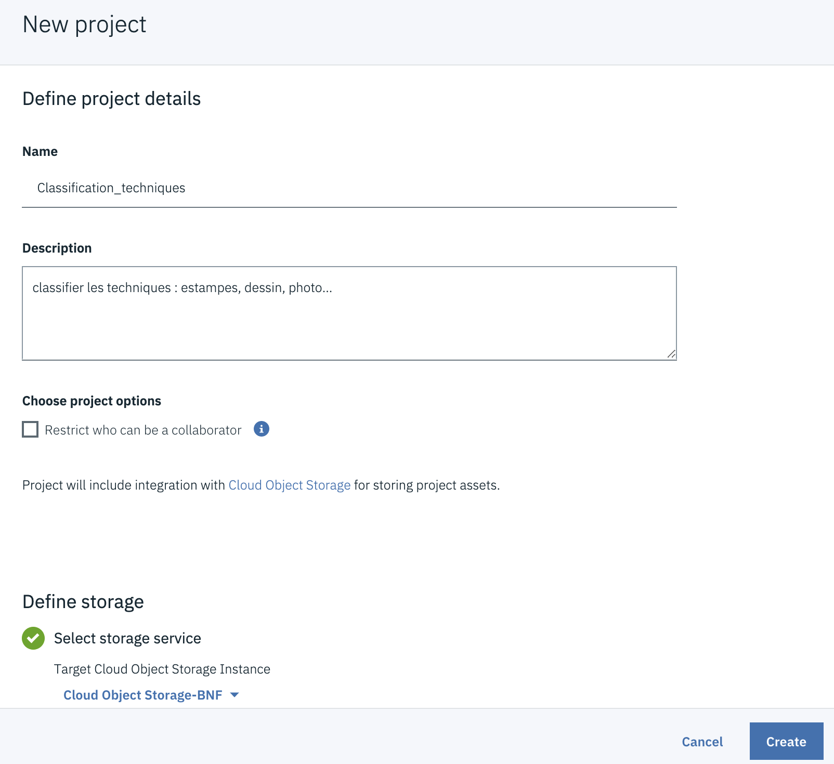

1. Choose a “Visual Recognition” asset

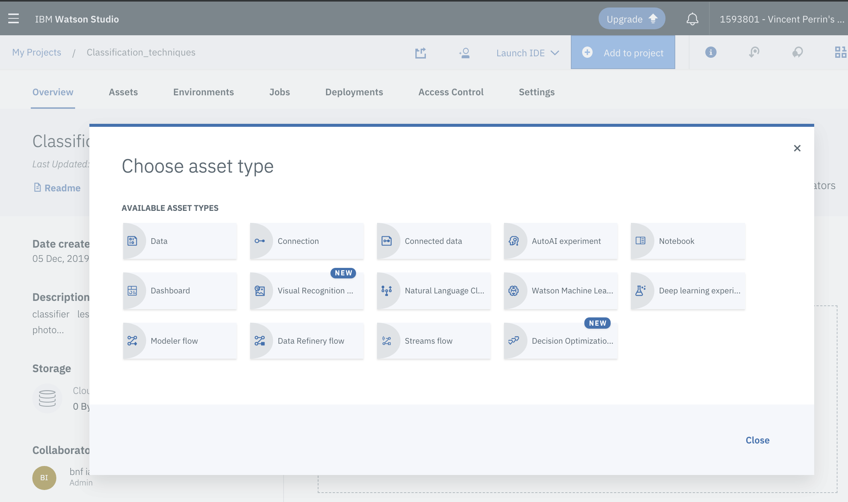

1. Lite cost plan again

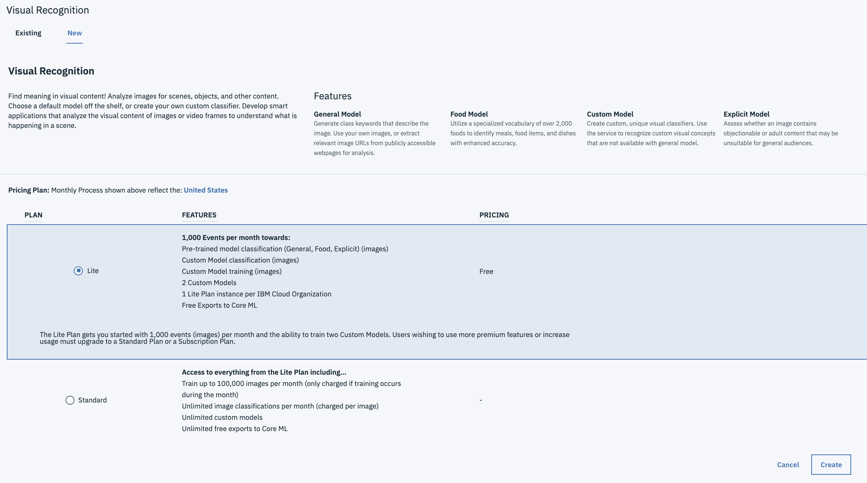

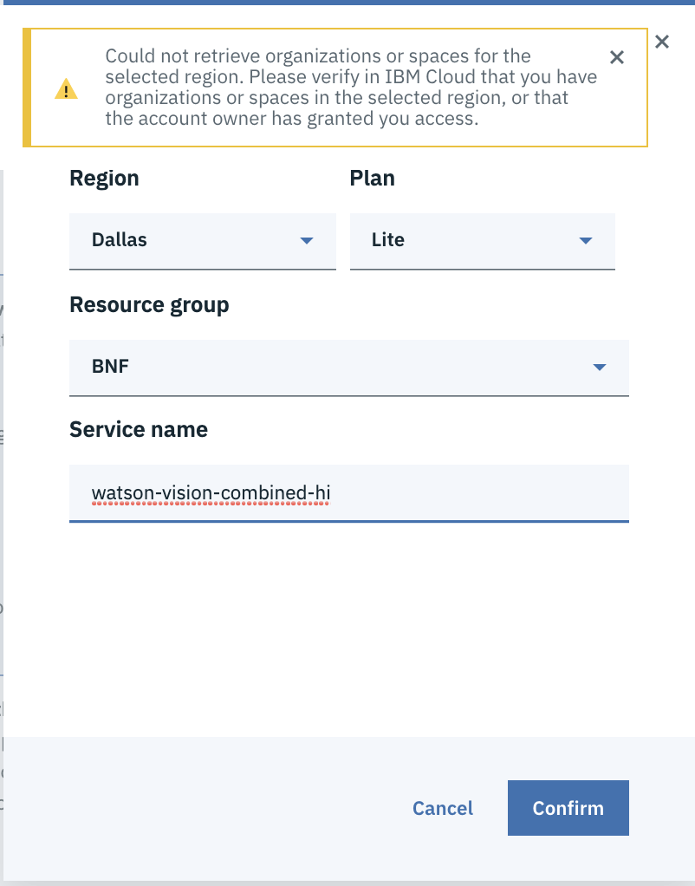

1. Choose the "Classify Images" model

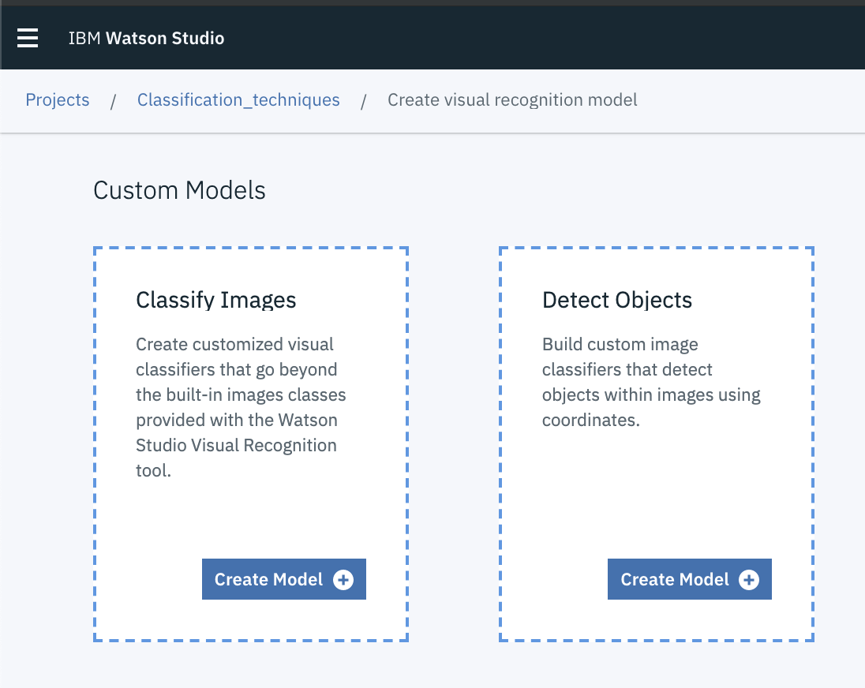

## Creating a Cloud AutoML account and an AutoML Vision project

1. Go to <https://cloud.google.com/automl/>

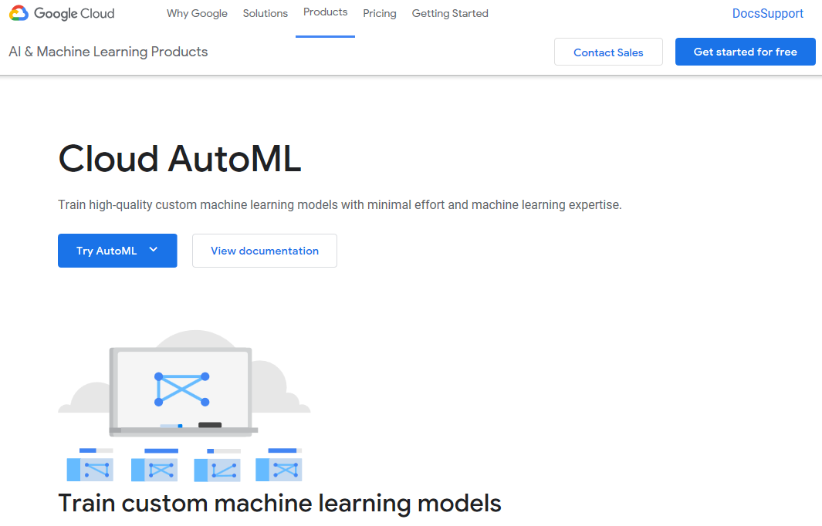

1. Select “Try AutoML” and then choose “AutoML Vision”

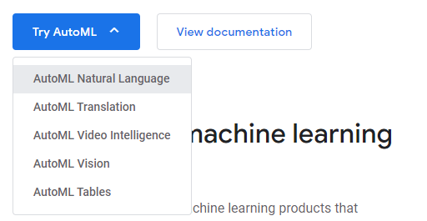

1. Depending of your Google account, select Vision in the menu

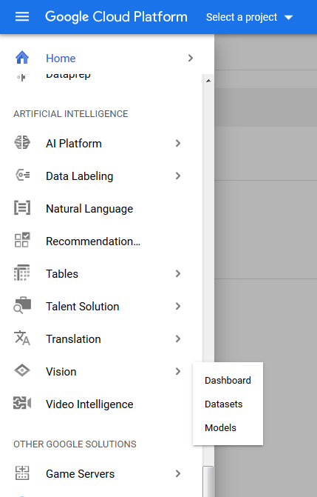

Or use this link in the page that may be displayed:

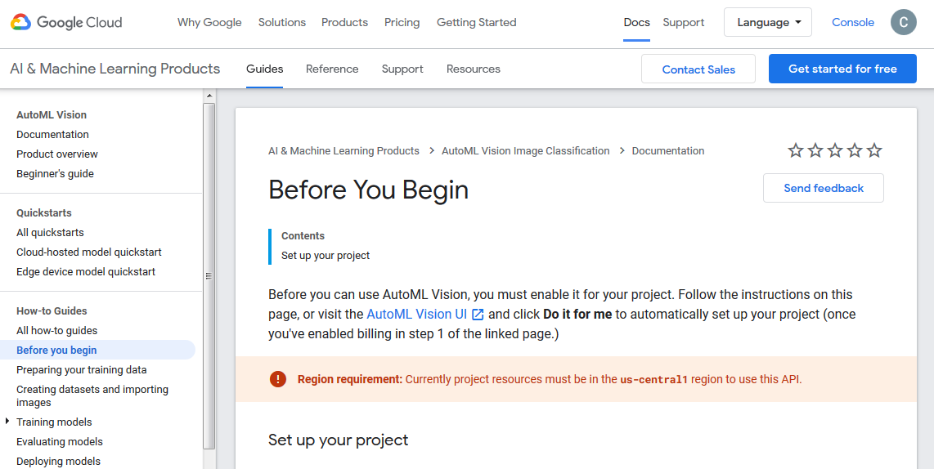

You may have to activate billing at some point of the process.

1. On the Dashboard page, select “Create a new project”

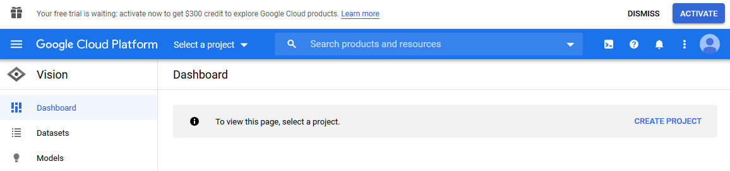

And then create your project:

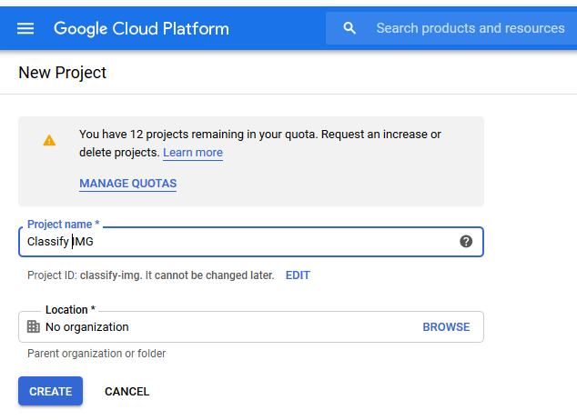

1. Now select the “Image Classification” model (Get started link)

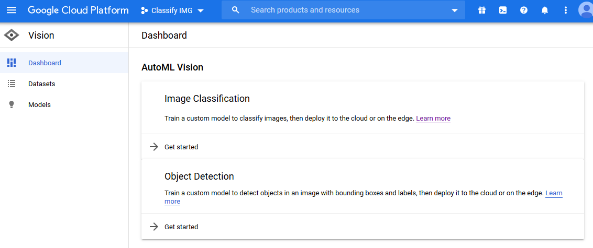

1. You may have to activate the AutoML API

