Impact of dried blood spot sample collection on SARS-CoV-2 antibody test results in a serological study of older Canadians

Jiacheng Chen1, W. Alton Russell1,

1School of Population and Global Health, McGill University, Montreal, Canada

# Letter (384 / 500 Words)

Participant-collected dried blood spots (DBS) are a convenient, minimally invasive alternative to phlebotomist-collected venous samples for population serological surveillance. Several SARS-CoV-2 serosurveillance studies collected DBS samples in the mail to reach wider geographic areas and minimize face-to-face contact during the pandemic [1–3]. Prior studies characterized assay accuracy with DBS as ‘reliable’, based on their high sensitivity and specificity, which were derived from paired comparisons with venous samples [2,4,5]. A recent study comparing SARS-CoV-2 IgG results from paired venous and DBS samples concluded performance was “comparable” [6]. In a national SARS-CoV-2 serological study of older Canadians conducted by the Canadian Longitudinal Study on Aging [7], participants choose whether to mail a DBS sample or provide a venous sample at a testing center. We analyze these data to assess for systematic differences in assay findings between DBS and venous samples.

We developed a propensity model to examine the association of demographics, geography, and health-related factors with the choice of DBS or venous sample, and we compared SARS-CoV-2 Anti-N and Anti-S (7,230 assays each) results between participants who provided DBS (n = 3,773) or venous samples (n = 3,450; **Fig. S1**), using inverse probability of treatment weighting to adjust from potential confounding variables (details in **Supplemental Methods**).

Participants who provided in-person venous samples were more likely to be male, white, unvaccinated, and living in an urban area (**Fig. 1**). Propensity weights achieved good balance. After weighting, venous samples were 223% more likely to be Anti-N positive (Odds ratio [OR]: 3.33, 95% confidence interval [CI]: 2.78–4.01) and 27% more likely to be Anti-S positive (OR: 1.27, 95% CI: 1.08–1.49). Among Anti-S antibody positive samples, the distribution of quantitative anti-S levels differed between DBS and venous samples (p < 0.0001, Kolmogoriv-Smirnov test), with substantially higher in venous samples (**Fig. 2**). Province-level sub-analyses yielded consistent findings (**Fig. S3**). Compared to using venous samples, we estimate that DBS for all participants would have underestimated anti-N seropositivity by 69.3% (2.49% positive vs. 8.12%) and would have underestimated anti-S positivity by 13.7% (43.74% positive vs. 50.68%).

In contrast to earlier reports [1–3,5], we found substantial differences between SARS-CoV-2 serological findings in DBS and venous samples. While assay-specific in-house calibration may mitigate these differences [1], more work is needed to understand how use of DBS samples impacts population serosurveillance estimates.

# Declarations

**Funding:** None.

**Conflicts:** No conflicts of interests.

**Ethics/Consent:** REB submitted and approved (REB 23-09-061).

**Data and materials:** Data are all de-identified prior to transfer to our research team by our data-sharing partners (Canadian Blood Services, Alberta Precision Labs, and the Canadian Longitudinal Study on Aging).

**Code availability:** https://github.com/altonrus/dbs-vs-venous-antibodies

**Authors’ contributions:** Finish this part once we got input from all co-authors.

# References

1. Zava TT, Zava DT. Validation of dried blood spot sample modifications to two commercially available COVID-19 IgG antibody immunoassays. *Bioanalysis*. 2021;13(1):13-28. doi:[10.4155/bio-2020-0289](https://doi.org/10.4155/bio-2020-0289)

2. Meyers E, Heytens S, Formukong A, et al. Comparison of Dried Blood Spots and Venous Blood for the Detection of SARS-CoV-2 Antibodies in a Population of Nursing Home Residents. *Microbiology Spectrum*. 2021;9(2):e00178-21. doi:[10.1128/Spectrum.00178-21](https://doi.org/10.1128/Spectrum.00178-21)

3. Mackett K, Oz UE, Naik C, et al. Do instructions for at-home dried blood spot (DBS) collection affect the quality of collection? Data from the Canadian Longitudinal Study on Aging (CLSA) COVID-19 seroprevalence study. *Clinical Biochemistry*. 2022:115-115.

4. Simmonds MJ, Baskurt OK, Meiselman HJ, Marshall-Gradisnik SM. A comparison of capillary and venous blood sampling methods for the use in haemorheology studies. *Clinical Hemorheology and Microcirculation*. 2011;47(2):111-119. doi:[10.3233/CH-2010-1372](https://doi.org/10.3233/CH-2010-1372)

5. Morley GL, Taylor S, Jossi S, et al. Sensitive Detection of SARS-CoV-2-Specific Antibodies in Dried Blood Spot Samples. *Emerging Infectious Diseases*. 2020;26(12):2970-2973. doi:[10.3201/eid2612.203309](https://doi.org/10.3201/eid2612.203309)

6. Nikiforuk AM, McMillan B, Bartlett SR, et al. Performance of Immunoglobulin G Serology on Finger Prick Capillary Dried Blood Spot Samples to Detect a SARS-CoV-2 Antibody Response. *Microbiology Spectrum*. 2022;10(2):e01405-21. doi:[10.1128/spectrum.01405-21](https://doi.org/10.1128/spectrum.01405-21)

7. Raina P, Wolfson C, Kirkland S, et al. Cohort Profile: The Canadian Longitudinal Study on Aging (CLSA). *International Journal of Epidemiology*. 2019;48(6):1752-1753j. doi:[10.1093/ije/dyz173](https://doi.org/10.1093/ije/dyz173)

8. *COVID-19 Antibody Study Findings*. Canadian Longitudinal Study on Aging; 2022. <https://www.clsa-elcv.ca/doc/5054>. Accessed November 17, 2023.

9. Adeyinka DA, Neudorf C, Camillo CA, Marks WN, Muhajarine N. COVID-19 Vaccination and Public Health Countermeasures on Variants of Concern in Canada: Evidence From a Spatial Hierarchical Cluster Analysis. *JMIR Public Health and Surveillance*. 2022;8(5):e31968. doi:[10.2196/31968](https://doi.org/10.2196/31968)

10. Hale T, Angrist N, Goldszmidt R, et al. A global panel database of pandemic policies (Oxford COVID-19 Government Response Tracker). *Nature Human Behaviour*. 2021;5(4):529-538. doi:[10.1038/s41562-021-01079-8](https://doi.org/10.1038/s41562-021-01079-8)

# Figure

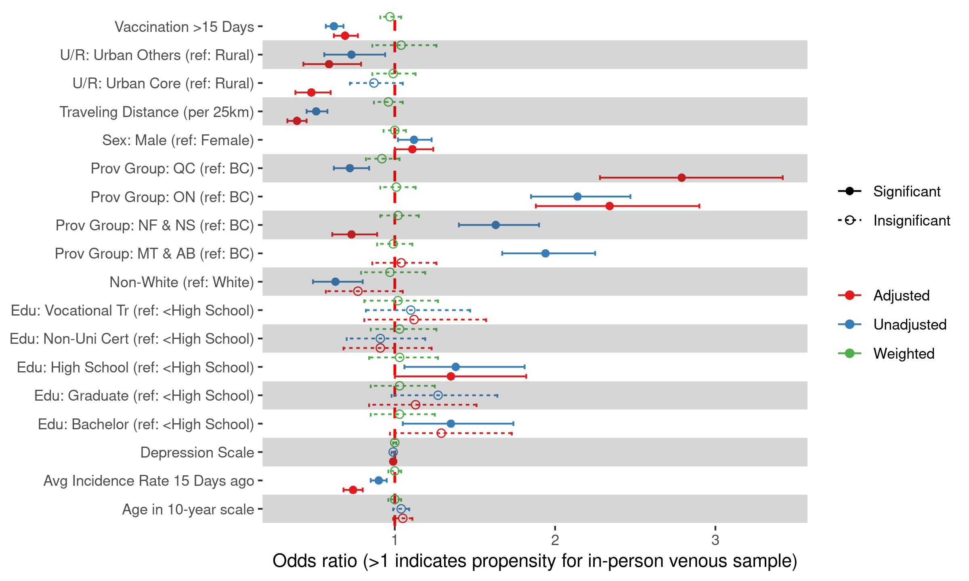

**Figure 1**: Odds ratios for providing an in-person venous sample instead of DBS using a multivariate logistic regression model (‘adjusted’) and univariate model (‘unadjusted’). After applying inverse probability of treatment weighting (‘weighted’), all odds ratios were insignificant.

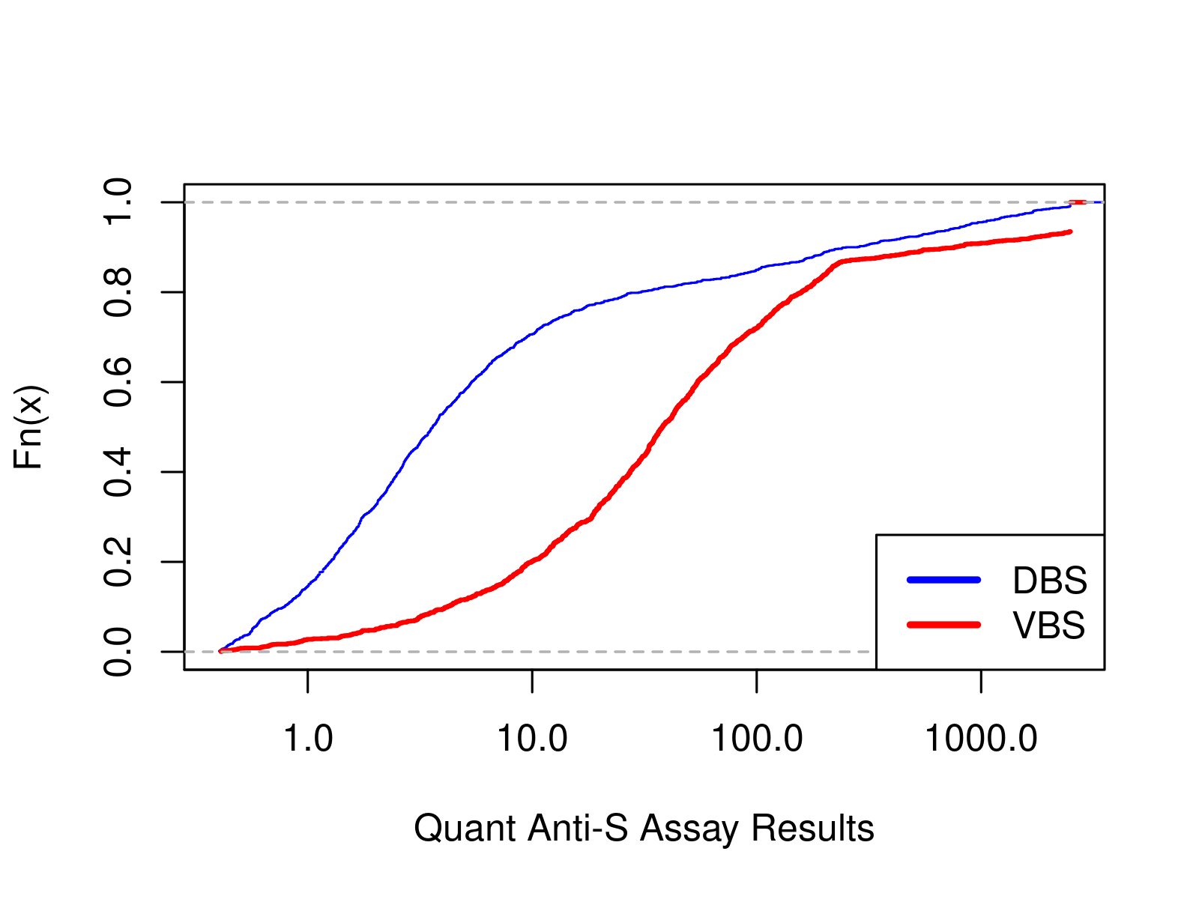

**Figure 2**: Empirical cumulative distribution function for the quantitative Anti-S level among participants who tested positive on the Anti-S assay. Venous samples tended to have higher Anti-S levels (mean: 300.54 AU/ml, median: 38.63 AU/ml) compared to DBS (mean: 105.75 AU/ml, median: 3.43 AU/ml). 8.43% of venous samples were above the assay’s upper limit of detection, compared to 0% of DBS.

# Supplemental materials

# Supplemental methods

## Dataset

The Canadian Longitudinal Study on Aging (CLSA) is a comprehensive national long-term study designed to track approximately 50,000 individuals aged 45 to 85 years at recruitment for a minimum of 20 years [7]. The CLSA COVID-19 Antibody Study has two complementary cohorts. The first one is called “comprehensive cohort”, in which 30,097 participants were randomly selected from locations within 25-50 km of the data collection sites (DCS) and underwent in-person interviews, providing detailed information on demographics, physical and mental health status, as well as vaccination and hospitalization history. The second cohort, known as the “tracking cohort,” was interviewed by telephone. The detailed sampling process of CLSA is presented in the flowchart (**Fig. S1**).

During the COVID-19 pandemic, the CLSA COVID-19 Antibody Study was conducted to evaluate the pandemic’s population-level health impact on older Canadians. The CLSA COVID-19 Antibody Study included over 18,000 CLSA participants across ten provinces from November 2020 to July 2021 [8]. Among those participants, 10,259 from the comprehensive cohort provided samples that were suitable for testing, within which N=4,258 contributed venous blood samples, and N=5,495 provided dried blood samples. In addition to demographic and health status variables, the data we acquired included immunoassay tests results.

In our analysis, we utilized data exclusively from the comprehensive cohort of the CLSA COVID-19 Antibody Study, as it provides more comprehensive demographic and health condition data. Additionally, we excluded participants residing in regions located more than 50 km from the data collection center, as their extended travel distance is caused by recent relocations subsequent to enrollment in the study. The final sample size included in our analysis was 7,230.

## Statistical analysis

**Analyzing predictors of in-person venous samples vs. DBS:** Before conducting propensity score weighting, we performed an initial unadjusted bivariate analysis to compare the DBS and VBS groups. Additionally, we developed multivariate logistic regression models that regressed VBS/DBS against demographic factors, physical and mental health conditions, travel distance, vaccination status, and time since the last COVID outbreak. The comprehensive results generated by those simple logistic regression models and the full model are displayed in the odds ratio (OR) plot (**Fig. 1**).

**Propensity score weighting:** Upon completion of the full model, we constructed a best-fit model utilizing a backward stepwise model selection strategy. The model with lowest Akaike Information Criterion (AIC) value was selected as the best-fit model. Subsequently, we applied this best-fit model to calculate propensity scores for the selection of VBS over DBS. Participants from both groups were weighteded based on their propensity scores using inverse probability of treatment weighting (IPTW). IPTW achieved good balance between the DBS and VBS groups, illustrated by the fact that the odds ratios in the model are all not significant after applying the weights.

**Analysis with Weighted Data：** Utilizing weighted data, we further analyzed the differences in assay positivity between the DBS and VBS cohorts. The outcomes of the stratified analysis (**Fig. S3**) aligned with those from the unstratified national dataset. To analyze the variation in quantitative Anti-S immunoassay results, we employed the weighted empirical cumulative distribution function (eCDF) to visualize the distribution in the DBS and VBS cohorts (**Fig. 2**). We used Kolmogorov-Smirnov (KS) Test to assess whether the distributions are statistically-significantly different.

**Sub-analyses:** Based on the national data, we conducted a stratified analysis by province. Our study sample included participants from seven provinces, which were recategorized into five groups according to their locations and geographic proximities: British Columbia (BC), Manitoba (MB) & Alberta (AB), Ontario (ON), Quebec (QC), and Newfoundland (NL) & Nova Scotia (NS). The pandemic’s impact varied across these regions, with residents adapting differently to the diverse policies implemented by their respective health departments [9,10]. **Figure S2** illustrates the variation in odds ratios for the preference of venous blood sampling across provinces.

# Supplemental figures

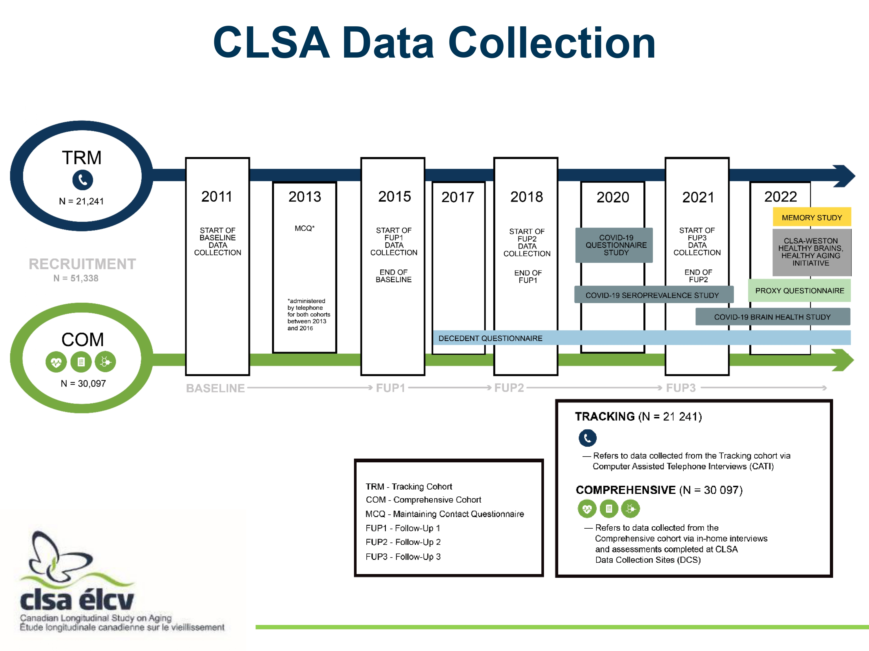

**Figure S1: CLSA COVID-19 Study Sampling Process.** Reproduced from <https://www.clsa-elcv.ca/doc/2429>

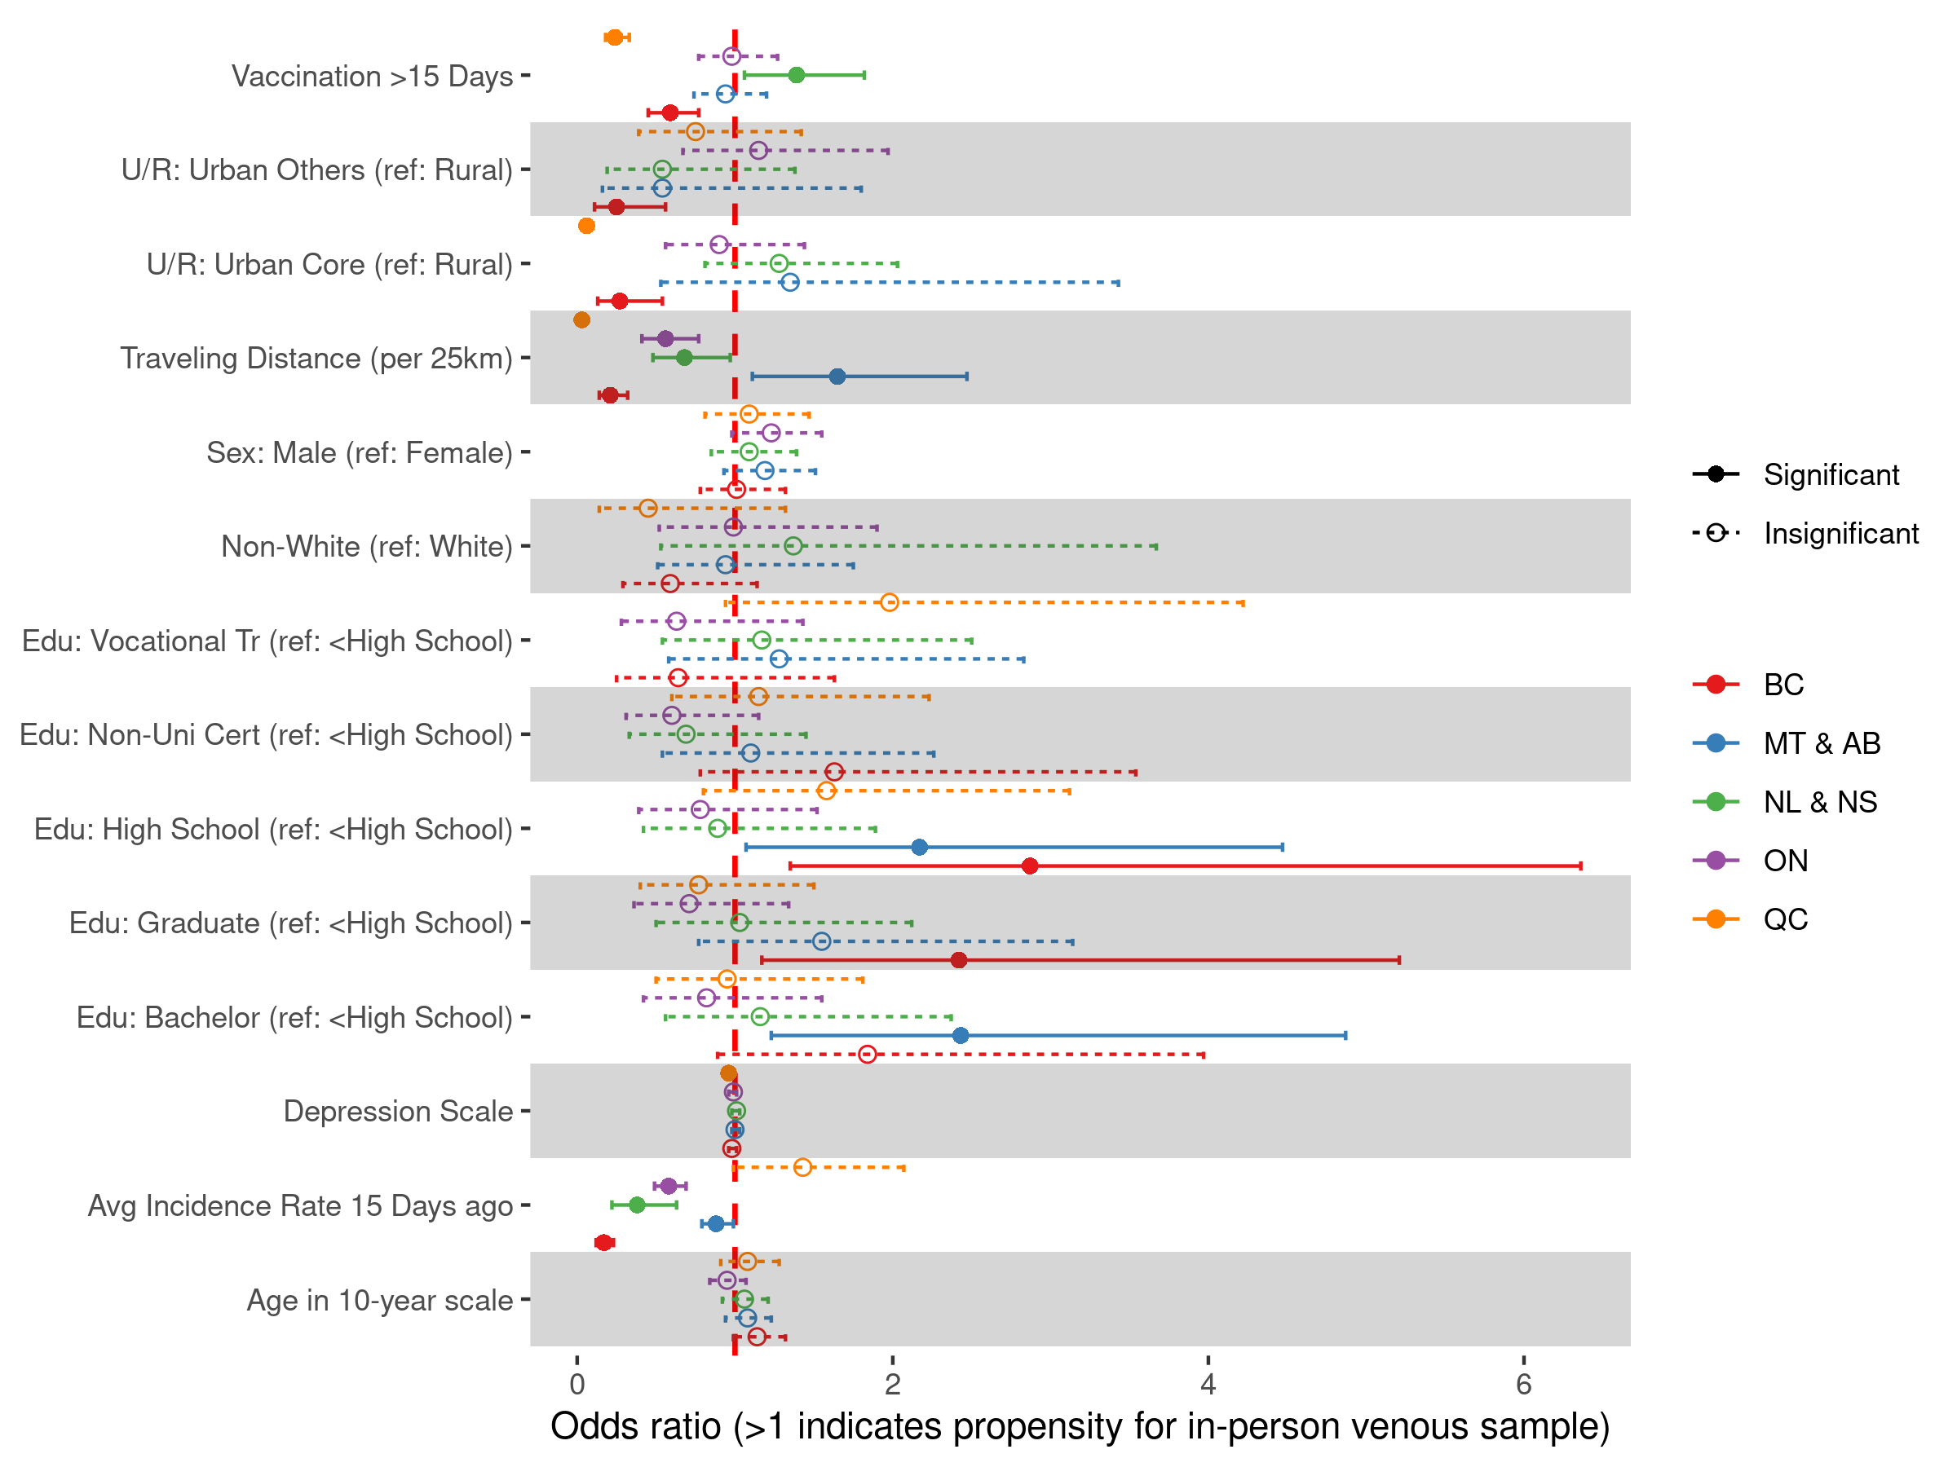

**Figure S2. Odds Ratio of Venous Blood Sampling, Stratified by Province or Region.** The odds ratios for venous blood sampling vary among the five provincial groups. We observed significant differences in sampling method preferences across provinces. Compared to British Columbia (BC), participants in Ontario (ON) and Quebec (QC) preferred in-person venous sampling. In the Atlantic provinces, however, there was a preference for at-home DBS sampling over the venous sampling approach.

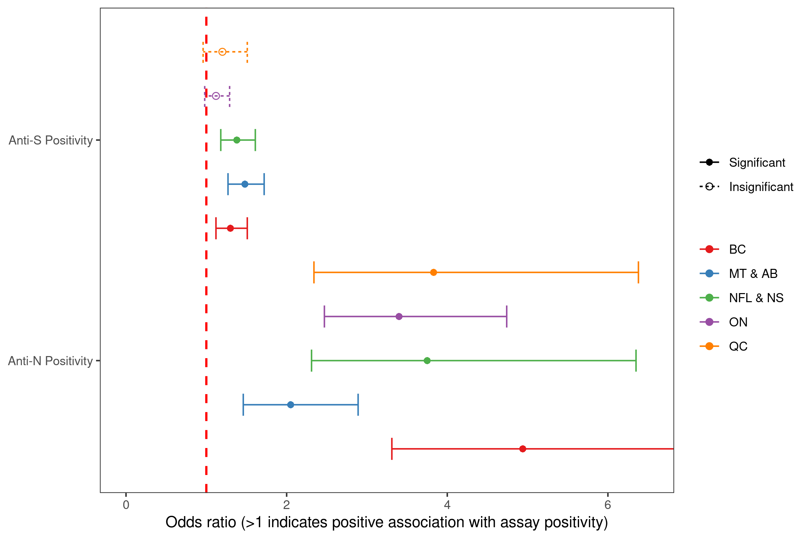

**Figure S3. Odds Ratio of Assay Positivity, Stratified by Province or Region.** We observed an increased odds of assay positivity in venous blood samples for both anti-N and anti-S assays, which is consistent with the analysis using unstratified national data.