Differences in time to return after temporary deferral for donors at mobile vs. fixed collect sites

Huzhah Jagirdar1, W. Alton Russell1

1School of Population and Global Health, McGill University, Montreal, Canada

**Corresponding author:**

**Key words:**

**Running title:**

# Abstract

**Background:** A

**Methods:** A

**Results:** A

**Conclusions:** A

# Introduction

The problem. What is none

More lit review

In this study, we ….

# Methods

## Data and preprocessing

## Time to return (kaplan meyer)

## Penalized Cox model

See [1,2] and .

## Subsection

See . See .

# Results

A

# Discussion

A

# Declarations

**Funding:** A

**Conflicts:** A

**Ethics/Consent:** A

**Data and materials:** A

**Code availability:** A

**Authors’ contributions:**

# References

1. Langham S, Wright A, Kenworthy J, Grieve R, Dunlop WCN. Cost-effectiveness of take-home naloxone for the prevention of overdose fatalities among heroin users in the United Kingdom. *Value in Health*. 2018;21(4):407-415. doi:[10.1016/j.jval.2017.07.014](https://doi.org/10.1016/j.jval.2017.07.014)

2. Keane C, Egan JE, Hawk M. Effects of naloxone distribution to likely bystanders: Results of an agent-based model. *International Journal of Drug Policy*. 2018;55:61-69. doi:[10.1016/j.drugpo.2018.02.008](https://doi.org/10.1016/j.drugpo.2018.02.008)

# Tables

**Table** : This is a sample table.

| **col1** | **col2** | **Source** |
| --- | --- | --- |
|  | | |
| 1 | Yes1 | Langham et al. 20182 |
| 2 | Yes | Keane et al. 2018 |
|  | | |
| 1 | No |  |
| 2 | No |  |
| 1Footnote 2 | | |
| 2Footnote 1 | | |

# Figures

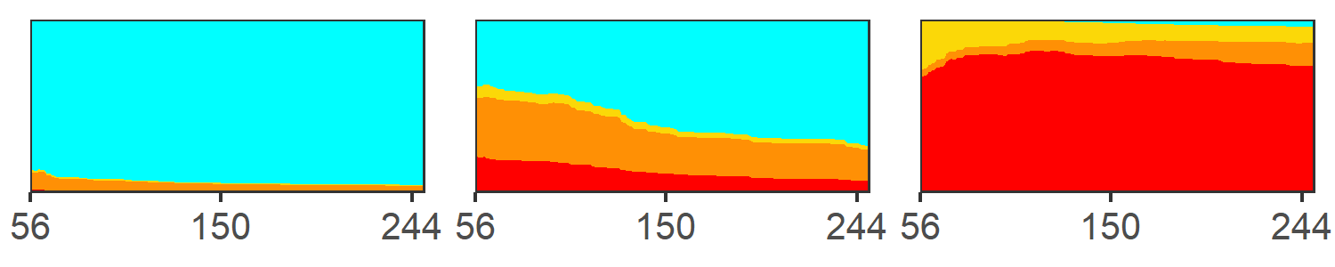

**Figure** : This is a figure caption.

# Supplemental materials

# A. Supplement section

# Supplemental tables

**Table** : This is a sample table.

| **col1** | **col2** | **Source** |
| --- | --- | --- |
|  | | |
| 1 | Yes1 | [1]2 |
| 2 | Yes | [2] |
|  | | |
| 1 | No |  |
| 2 | No |  |
| 1Footnote 2 | | |
| 2Footnote 1 | | |

# Supplemental figures



**Figure S**: A figure caption.