Cost-effectiveness and budget impact of whole blood pathogen reduction in Ghana

**Running title:** Pathogen reduction in Ghana

W. Alton Russell1,2,3, Shirley Owusu-Ofori4, Alex Owusu-Ofori5,6, Eileen Micah7, Betty Norman7, Brian Custer2,8

1Department of Management Science and Engineering, Stanford University, Stanford, USA

2Vitalant Research Institute, San Francisco, USA

3MGH Institute for Technology Assessment, Harvard Medical School, Boston, USA

4Transfusion Medicine Unit, Komfo-Anokye Teaching Hospital, Kumasi, Ghana

5Laboratory Services Directorate, Komfo-Anokye Teaching Hospital, Kumasi, Ghana

6Department of Clinical Microbiology, Nkrumah University of Science and Technology, Kumasi, Ghana

7Department of Medicine, Komfo-Anokye Teaching Hospital, Kumasi, Ghana

8Department of Laboratory Medicine, University of California, San Francisco, CA

**Corresponding author:** W. Alton Russell, Harvard Medical School, 101 Merrimac St, Room 1032, Boston, MA, 02114, United States. email: [warussell@mgh.harvard.edu](mailto:warussell@mgh.harvard.edu).

**Funding:** This work was supported by Terumo BCT, Inc. (Lakewood, Colorado, USA). Terumo BCT provided no editorial control over the research or the manuscript.

**Precis:** We estimate that whole blood pathogen inactivation would avert many transfusion related adverse events in Ghana and may be cost-saving.

**Acknowledgments:** The authors thank Dr. Marcia Cardoso of Terumo BCT for providing technical expertise and contributing to the development of the analysis and manuscript. We also thank Ms. Marion Vermeulen of the South African National Blood Supply for providing unpublished hemovigilance data for syphilis; Dr. Lucy Asamoah-Akuoko of the National Blood Service, Ghana, for providing unpublished data on the percent of whole blood units not transfused; and Nigel Talboys and Eric Mwenda of Terumo BCT, Inc. for providing estimated costs for whole blood pathogen reduction.

**Key words:** Pathogen reduction, blood safety, cost-utility, sub-Saharan Africa

3352 words | 27 pages | 2 tables | 4 figures

**Abbreviations:** **AVT** antiviral therapy, **FNHTR** febrile non-hemolytic transfusion reaction, **HBV** hepatitis B, **HCV** hepatitis C, **HIV** human immunodeficiency virus, **WBPR** whole blood pathogen reduction.

##### 

# Abstract

**Background:** Despite the promise of pathogen reduction for reducing transfusion-associated adverse events in sub-Saharan Africa, no health-economic assessment is publicly available.

**Study Design and Methods:** We developed a mathematical risk reduction model to estimate the impact of nationwide whole blood pathogen reduction in Ghana on the incidence of six infectious and one non-infectious transfusion-associated adverse events. We estimated the lifetime direct healthcare costs and disability-adjusted life years lost for each adverse event. For HIV, HCV, and HBV, we simulated disease progression using Markov models, accounting for the likelihood and timing of clinical detection and treatment. We performed probabilistic and univariate sensitivity analysis.

**Results:** Adding whole blood pathogen reduction to Ghana’s blood safety portfolio would avert an estimated 19,898 (11,948 – 27,353) adverse events and 38,491 (16,444 – 67,118) disability-adjusted life years annually, primarily by averting sepsis (49%) and malaria (31%) infections. One year of pathogen reduction would cost an estimated $8,037,191 ($6,381,946 – $9,880,760) and eliminate $8,656,389 ($4,462,614 – $13,469,448) in direct healthcare spending on transfusion-associated adverse events. We estimate a 58% probability that the addition of pathogen reduction would reduce overall healthcare spending. Findings were most sensitive to uncertainty in the probability that a bacterially contaminated blood donation causes sepsis.

**Conclusion:** Whole blood pathogen reduction would substantially reduce the burden of known transfusion-associated adverse events in Ghana and may reduce overall healthcare spending. Additional benefits not captured by this analysis may include averting secondary transmission of infectious diseases, reducing non-medical costs, and averting new or re-emerging transfusion-transmitted infections.

##### 

# Introduction

Pathogen reduction of blood components for transfusion is a promising intervention for reducing transfusion-transmitted infections and non-infectious transfusion-associated adverse events in Sub-Saharan Africa [1]. Different types of pathogen reduction use ultraviolet light and/or intercalating compounds to inactivate pathogens in blood components or whole blood [2]. The health-economic consequences of pathogen reduction of plasma and platelet components have been estimated for health systems in Europe and North America [3–7]. Compared to these settings, health systems in sub-Saharan Africa often experience greater resource constraints, higher baseline rates of certain transfusion-associated adverse events, and more frequent blood shortages [8,9]. Furthermore, use of whole blood rather than components limits the applicability of platelet and plasma pathogen reduction in this context (in Ghana, more than 80% of blood donations are transfused as a whole blood units) [10,11]. For these reasons, whole blood pathogen reduction (WBPR) may be a more appropriate technology for many countries in sub-Saharan Africa. A clinical trial in Ghana found that WBPR substantially reduced risk for transfusion-transmitted malaria in Ghana [12]. However, no health-economic assessment has been published for WBPR in any context, nor for any pathogen reduction modality in sub-Saharan Africa.

Based on Ghana’s unique experience with WBPR, we developed a decision-analytic model to estimate how universal adoption of WBPR in addition to the existing blood safety program would impact the number of transfusion-associated adverse events in Ghana. Leveraging clinical data and the first-hand experience of clinicians in Ghana, we also developed a detailed model of clinical outcomes from transfusion-associated adverse events and their treatment, which we used to estimate the direct healthcare costs, disability-adjusted life years (DALYs) lost, and calculate the cost-effectiveness of universal WBPR in Ghana.

# Methods

We estimated the health-economic consequences of WBPR in Ghana from a healthcare payer perspective. We considered seven transfusion-associated adverse events, including chronic viral infections (HIV, HCV, HBV), bacterial infections (syphilis, transfusion-transmitted bacterial infection leading to sepsis [TTBI-sepsis]), malaria, and febrile non-hemolytic transfusion reactions (FNHTRs), a non-infectious adverse event. Our risk reduction model estimated the number of adverse event cases in all transfusion recipients with and without WBPR. We then estimated the DALYs and healthcare costs incurred per case, the budget impact of WBPR, and the cost-effectiveness of WBPR in 2019 US dollars spent per DALY averted. We assessed uncertainty through deterministic and probabilistic sensitivity analysis. The model was programmed in R, and all data and code are available in a public repository [13]. We provide the Consolidated Health Economic Evaluation Reporting Standards (CHEERS) checklist [14] and the impact inventory [15] in Supplemental Tables S6 and S7.

## Risk reduction model structure

Our two-armed decision tree estimated the number of adverse event cases for status quo blood safety interventions and for the status quo plus WBPR. The status quo was to test all donations for HIV-Ab, HBsAg, Anti-HCV Ab, and Anti-treponemal Ab [11]. All parameter values for the risk reduction model are shown in Table 1 [3,4,11,12,16–34], and mathematical calculations are provided in Supplemental Methods Section A.

We assumed that each whole blood unit would be transfused to a single recipient (i.e., would not be processed into components), and we assumed that if one recipient experienced multiple adverse events from a single transfusion event then the associated costs and disutility would be additive. For each of the six transfusion-transmitted infections, the baseline (without WBPR) number of clinically meaningful adverse events was calculated from the annual number of whole blood donations collected nationally, the percent of collected donations not transfused (wastage), the estimated residual risk among donors after disease marker screening, and the risk of clinical outcome (i.e., likelihood that transfusion of an infectious unit results in clinically relevant disease). For FNHTR, the baseline rate of clinically relevant adverse events per recipient was extrapolated from local data and prior studies, and the per-donation risk of FNHTR was derived by multiplying the per-recipient rate by the estimated average number of whole blood units transfused per recipient (1.66 units) [23]. We assumed some recipients were not at risk of clinical outcomes due to factors such as prior malaria infection, HBV vaccination, and existing HIV infection (Table 1). For each adverse event, we divided the number of adverse events without WBPR by an *x*-fold risk-reduction factor to estimate the number of adverse events when using WBPR. Risk-reduction factors were based on clinical data when available (malaria, FNHTR) and were otherwise sourced from prior modeling studies [3,4].

## Estimating costs and DALYs from adverse events

We estimated costs and DALYs due to adverse events over a lifetime horizon using a 3% annual discount rate. We separately modeled a pediatric and adult cohort of transfusion recipients, with an average age of 5 and 40 at the time of transfusion, respectively. Both cohorts had a 5.7% – 8.6% chance of inpatient mortality [35], after which we calculated expected survival based on the age-specific death rate indicator in the World Health Organization Global Health Observatory data repository [36]. Parameters used to calculate the average DALYs of each adverse event are shown in Supplemental Table S1 [3,37–41]. We used estimates of the duration of illness and the associated disability weight to estimate the average years lived with disability (YLD) for each adverse event. We calculated the average years of life lost (YLL) based on the estimated increased risk of inpatient mortality for malaria in the pediatric cohort and TTBI-sepsis in both cohorts. For each chronic viral infection, we developed Markov models for both the pediatric and adult cohorts to estimate medical costs and DALYs lost related to the infection over the remaining lifetime of transfusion recipients.

We used a micro-costing approach to estimate the average health care spending associated with each transfusion-associated adverse event. Most parameters related to clinical resources and costs for treating transfusion-associated adverse event were estimated based on the real-world experience of authors who practice clinically at Komfo Anokye Teaching Hospital in Kumasi, Ghana and routinely treat patients with these conditions (SOO, AOO, EM, BN). For HIV, we assumed infections that had not yet progressed to AIDS would be detected in an outpatient clinic and used empirical costing estimates from a recent study of healthcare costs for patients initiating antiviral therapy (AVT) [42]. We treated FNHTR, malaria, syphilis, and TTBI-sepsis as acute infections and assumed associated costs and morbidity occurred within a year of transfusion. For HIV, HBV, and HCV. we estimated the annual resource utilization and associated costs for each disease state in the Markov models. Supplemental Table S2 [35,42] contains estimates and uncertainty ranges for all micro-costing parameters, and Supplemental Table S3 contains the calculations used for the four acute adverse events and for each disease state of the chronic viral infections.

The Markov models for HCV, HBV, and HIV captured the disease natural history, timing of detection and treatment initiation, and treatment effectiveness (Figure 1). We used a one-year cycle length, discounted future costs at 3% annually, and used the cycle tree method to correct for discretization error [43]. All transition probabilities and their sources are listed in Supplemental Table S4 [39,40,44,45]. The supplement also contains schematics for the transition matrix for each chronic adverse event (Supplemental Figures S1 – S3) and Markov trace plots of the proportion of transfusion recipients in each disease state over time (Supplemental Figures S4 – S6).

For HCV, our natural history model and treatment efficacy estimates were based on a health economic model developed for The Gambia [40], and transitions into treatment were estimated based on authors’ clinical experience. Within the model, a small percentage of infections are detected during the acute phase in the first year and receive AVT; otherwise, recipients have subclinical acute infections. Some initially subclinical infections progress through chronic HCV disease states. A percentage of patients in the subclinical chronic HCV, compensated cirrhosis, or decompensated cirrhosis disease states are detected and receive AVT each year. AVT clears most HCV infections, but some patients experience treatment failure. For those patients, their disease will continue to progress while they receive monitoring and care.

For HBV, our natural history model and treatment efficacy estimates were based on a health economic model developed for South Africa [39]. In the model, acute infections have a small probability of being detected and receive monitoring and care during the first year, but most infections are subclinical during the acute phase. Subclinical infections that progress to the immune reactive, compensated cirrhosis, or decompensated cirrhosis states have an annual probability of clinical detection, at which point AVT is initiated. Subclinical patients in the chronic HBeAg- phase also have an annual probability of detection. Those patients transition to receiving monitoring and care without AVT, but some initiate AVT each year due to clinical indications such as a spike in viral load. We assumed patients on AVT do not progress to later disease states and would continue with AVT and monitoring for their lifetimes. However, a small annual risk of developing hepatocellular carcinoma remains for those who developed cirrhosis before AVT initiation.

For HIV, we constructed a natural history model and calibrated the annual probability of progression to AIDS, death from HIV, and death from AIDS in the absence of treatment to a longitudinal study of HIV progression from Uganda (Figure S7) [45]. We estimated the annual probability of initiating AVT from different subclinical disease states based on the authors’ clinical experience. We assumed patients who initiated AVT before progressing to AIDS continue with treatment for the remainder of their lives and have a normal life expectancy. Annual costs for those who initiated AVT before progressing to AIDS are based on an empirical study conducted in HIV clinics in Ghana that found that on average, medical expenses were highest in the year of AVT initiation and tapered off over three years [42]. For patients who initiate AVT after progressing to AIDS, we assumed they would receive a diagnosis and initiate AVT during a hospitalization for AIDS complications and therefore incur substantially higher costs, and risk of dying, in the first two years as compared to those initiating AVT with HIV. After two years on AVT, we assumed most surviving AIDS patients would have recovered their CD4 counts and have the same annual costs and risk of death as any other AVT patient. Some surviving AIDS patients, however, would have residual disability due to AIDS-associated illnesses such as stroke or kidney failure. For these patients, we assumed a higher annual cost and mortality risk over their remaining lifetime.

## Uncertainty analysis

For each input parameter, we estimated a range of reasonable values it may take for deterministic sensitivity analysis and assigned a distribution for probabilistic sensitivity analysis. We used beta distributions when estimates were based on counts for a binary outcome or when the parameter source used a beta distribution; otherwise, we sampled each parameter from a PERT distribution. For all outcomes, we reported the expected value from the base case scenario and a 95% uncertainty interval based on the 2.5th and 97.5th quantiles of the outcome across 10,000 iterations of probabilistic sensitivity analysis. We conducted two scenario analyses. In one, we approximated secondary infections by assuming each surviving recipient infected with HIV, HBV, or HCV infects one other person during the first year following transfusion. We also conducted a scenario that excluded benefits related to TTBI-sepsis. This scenario is a lower bound on the additional benefit WBPR could confer if the relatively high rate of TTBI-sepsis in Ghana were reduced and may also be informative for settings that have lower rates of bacterial contamination in blood units but are similar to Ghana in other respects.

# Results

The number of modeled adverse events in Ghana per year without WBPR was 25,122 (17,050 – 33,952), which corresponds to 15.6 (11 – 20.4) adverse events per 100 whole blood units transfused. This number includes 19,310 (11,852 – 27,412) transfusion-transmitted infections and 5,812 (3,726 – 8,374) cases of FNHTR cases, a non-infectious adverse event. WBPR reduced the number of adverse events by 19,898 (11,948 – 27,353) to 5,224 (3,409 – 9,850) per year, or 3.6 (2.2 – 6.1) adverse events per 100 units transfused. 49% (28% – 68%) of averted adverse event cases were TTBI-sepsis; 31% (13% – 48%) were malaria; 12% (5% – 23%) were FNHTR; 4% (2% – 8%) were HCV; 3% (1% – 7%) were HBV; 0.8% (0.3% – 1.7%) were HIV; and 0.28% (0.1% – 1.7%) were syphilis (Table 2). The estimated DALYs lost without WBPR was 40,368 (17,524 – 70,285), of which 92% (80% – 96%) was due to TTBI-sepsis. One year of WBPR would avert an estimated 38,491 (16,444 – 67,118) net present DALYs.

The estimated net present cost per adverse event ranged from $2.59 ($1.31 – $4.53) for syphilis to $1,500.99 ($999.73 – $2,072.06) for HCV. Because most chronic viral infections were not immediately detected, less than 10% of healthcare costs associated with HIV, HBV, and HCV occurred in the first post-transfusion year (Supplemental Table S4). The total net present healthcare costs due to adverse events was $9,440,837 ($5,095,056 – $14,596,392) without WBPR and $784,449 ($521,489 – $1,259,195) with WBPR. Of the adverse events evaluated, TTBI-sepsis had only the fourth highest per-case cost at $667.29 ($522.38 – $848.19) but represented 71% (48% – 84%) of healthcare spending due to adverse events without WBPR and 75% (53% – 87%) of net present healthcare savings due to PI.

One year of WBPR in Ghana would cost an estimated $8,037,191 ($6,381,946 – $9,880,760) and reduce net present healthcare spending by $8,656,389 ($4,462,614 – $13,469,448) due to averted adverse events, resulting in an annual net savings of $619,198 (-$3,720,662 – $5,372,198) (Figure 2). WBPR led to an overall reduction in net present healthcare spending in 58% of probabilistic sensitivity analysis iterations (Figure 3). Across the 42% iterations where WBPR had a positive net cost, WBPR never cost more than $687 per DALY averted.

In univariate sensitivity analysis, our conclusion that WBPR would be cost saving was sensitive to nine input parameters (Figure 4). At the low end of our uncertainty range for the probability of clinical TTBI-sepsis from a bacterially contaminated unit, WBPR had a net present cost of $5,169,958 annually. At the high end of our uncertainty range for the per-donation cost of WBPR, WBPR had a net present cost of $1,081,587 annually. For seven other parameters, WBPR had a positive net present cost of less than $1 million annually at one of the extreme values of the uncertainty range. The highest cost-effectiveness ratio observed for WBPR in univariate sensitivity analysis was $721 per DALY averted, achieved at the low end of our uncertainty range for the probability of clinical TTBI-sepsis from a bacterially contaminated unit.

In the scenario analysis where we accounted for one secondary infection for all HBV, HCV, and HIV-infected recipients, the net present healthcare costs due to adverse events averted by WBPR increased from $8,656,389 to $10,476,072 ($5,848,861 – $15,687,403) annually, and WBPR reduced overall healthcare costs in 82% of iterations. In the scenario analysis where we excluded benefits related to averting TTBI-sepsis cases, WBPR was no longer cost saving: WBPR led to an overall increase in annual healthcare spending of $5,852,607 ($4,096,752 – $7,843,358) and had an incremental cost-effectiveness ratio of $2,011.84 ($1,132.09 – $3,934.69) per DALY averted in the scenario, similar to Ghana’s per-capita gross national income ($2220 in 2019 [46]). The World Health Organization’s (WHO’s) Choosing Interventions that are Cost-Effective (CHOICE) program suggests considering interventions ‘cost-effective’ or ‘very cost-effective’ if they cost below one times or three times the per-capita gross national income per DALY averted respectively [47]. Using these thresholds, WBPR was cost-effective in 99.97% of iterations and very cost effective in 56% of iterations when excluding TTBI-sepsis from the analysis (Supplemental Figure S8).

# Discussion

Our study suggests that adding WBPR to the existing blood safety portfolio would substantially reduce the burden of transfusion-associated adverse events in Ghana. In this context, WBPR is a cost-effective intervention and may be cost-saving: we estimated a 58% probability that WBPR would lead to a net reduction in healthcare costs. We took a healthcare payer perspective and did not consider costs such as family caregiver time, productivity loss, or transportation costs. We also did not evaluate all types of adverse events for which WBPR may reduce risk, which could include emerging infectious diseases not yet identified as blood safety threats. Because these potential benefits were not included, the total societal benefit of WBPR likely exceeds the direct healthcare-related impact as estimated in this analysis. For example, the probability that WBPR would be cost-saving increased to 82% when factoring in healthcare costs for one secondary transmission for each HIV, HBV, and HCV infection.

Our analysis is the most comprehensive estimation of the burden of transfusion-associated adverse events to date for a sub-Saharan African setting. Because published data are lacking on clinical outcomes following a transfusion-associated adverse event in Ghana, we developed a detailed model directly based on current clinical practices in Ghana that accounted for the timing and likelihood of clinical detection, associated disability and mortality, the clinical resources used for treatment, and the associated costs. Our model is specific to Ghana, which may differ from other settings. Our approach, combined with therapeutic developments such as price reductions for HIV antiviral therapy drugs [48] and greater immunity to HBV through vaccination [49], led to lower estimates of the per-exposure costs for transfusion-transmitted HBV, HCV, and HIV events as compared to past analyses of blood safety interventions in sub-Saharan Africa [35,44,50].

To our knowledge, this is the first study to estimate healthcare costs and DALYs lost due to TTBI-sepsis in a sub-Saharan African setting. While our estimates are not precise due to parameter uncertainty, we estimated that TTBI-sepsis accounts for a majority of the healthcare costs (48% – 84%) and DALYs lost (80% – 96%) due transfusion-associated adverse events in Ghana. The rate of bacterial contamination of blood products varies across African settings, ranging from 0% to 17.9% in a recent systematic review [51]. Contamination rates for studies in Ghana were higher than those in many other countries, suggesting a need to improve practices around the collection and preparation of blood for transfusion. While reducing bacterial contamination by other means would reduce the value-add of WBPR, WBPR remained cost-effective under the WHO CHOICE guidelines in our scenario analysis that excluded TTBI-sepsis [47]. Unfortunately, data on clinical outcomes following transfusion of a bacterially contaminated whole blood unit are extremely sparse. Lack of precision in the estimated risk of clinical TTBI-sepsis following transfusion of a bacterially contaminated whole blood unit was the largest source of uncertainty in our findings.

Our study has several limitations, most importantly the dearth of recent published data for many model parameters. We accounted for this by defining wide uncertainty ranges around less certain parameters and, for parameters specific to the Ghanaian health system, by estimating parameters directly from first-hand clinical experience. While our detailed micro-costing reflects current clinical practice in Ghana, a rigorous empirical study would enhance precision and may uncover in-country variability. Data on the rate of transfusion-associated adverse events in Ghana, and in sub-Saharan Africa generally, are limited. The benefit of WBPR depends on the baseline residual risk of each adverse event, and updated risk estimates using hemovigilance data, if made available, could improve estimation. Due to lack of data, we did not account for variability in the number of whole blood units transfused per recipient, nor the association between mortality and the number of units transfused. This could lead to an overestimation of the benefits of WBPR if patients receiving several units, who are at an elevated risk of transfusion-associated adverse events, have lower baseline expected survival, as has been estimated in other settings [52]. Lastly, we only considered adding WBPR to the existing blood safety portfolio in Ghana and did not consider other available interventions. For example, other African countries employ interventions to prevent TTBI-sepsis such as skin disinfection, diversion pouches, bacterial culturing, and point of release testing [51]. To identify the optimal portfolio of blood safety interventions, all feasible combinations of all available interventions should be considered [53].

Despite these limitations, our analysis found robust evidence that adding nationwide WBPR to the blood safety portfolio would be cost-effective in Ghana. Future research could further elucidate the societal impact of WBPR and other blood safety interventions by improving estimation of the burden of illness from transfusion-associated adverse events, estimating other societal costs of adverse events, and by considering other settings in sub-Saharan Africa.

##### 

# References

1. Ware AD, Jacquot C, Tobian AAR, Gehrie EA, Ness PM, Bloch EM. Pathogen reduction and blood transfusion safety in Africa: strengths, limitations and challenges of implementation in low-resource settings. *Vox Sanguinis*. 2018;113(1):3-12. doi:[10.1111/vox.12620](https://doi.org/10.1111/vox.12620)

2. Prowse CV. Component pathogen inactivation: A critical review. *Vox Sanguinis*. 2013;104(3):183-199. doi:[10.1111/j.1423-0410.2012.01662.x](https://doi.org/10.1111/j.1423-0410.2012.01662.x)

3. Custer B, Agapova M, Martinez RH. The cost-effectiveness of pathogen reduction technology as assessed using a multiple risk reduction model. *Transfusion*. 2010;50(11):2461-2473. doi:[10.1111/j.1537-2995.2010.02704.x](https://doi.org/10.1111/j.1537-2995.2010.02704.x)

4. Agapova M, Lachert E, Brojer E, Letowska M, Grabarczyk P, Custer B. Introducing pathogen reduction technology in Poland: A cost-utility analysis. *Transfus Med Hemother*. 2015;42:158-165. doi:[10.1159/000371664](https://doi.org/10.1159/000371664)

5. Bell CE, Botteman MF, Gao X, et al. Cost-effectiveness of transfusion of platelet components prepared with pathogen inactivation treatment in the United States. *Clinical Therapeutics*. 2003;25(9):2464-2486. doi:[10.1016/S0149-2918(03)80288-6](https://doi.org/10.1016/S0149-2918(03)80288-6)

6. Babigumira JB, Lubinga SJ, Castro E, Custer B. Cost-utility and budget impact of methylene blue-treated plasma compared to quarantine plasma. *Blood Transfusion*. 2018;16(2):154-162. doi:[10.2450/2016.0130-16](https://doi.org/10.2450/2016.0130-16)

7. Canadian Agency for Drugs and Technologies in Health (CADTH). Octaplas compared with fresh frozen plasma to reduce the risk of transmitting lipid-enveloped viruses: an economic analysis and budget impact analysis. *CADTH technology overviews*. 2010;1(1):e0106. [http://www.ncbi.nlm.nih.gov/pubmed/22977394 http://www.pubmedcentral.nih.gov/articlerender.fcgi?artid=PMC3411137](http://www.ncbi.nlm.nih.gov/pubmed/22977394%20http://www.pubmedcentral.nih.gov/articlerender.fcgi?artid=PMC3411137).

8. Bloch EM, Vermeulen M, Murphy E. Blood transfusion safety in Africa: A literature review of infectious disease and organizational challenges. *Transfusion Medicine Reviews*. 2012;26(2):164-180. doi:[10.1016/j.tmrv.2011.07.006](https://doi.org/10.1016/j.tmrv.2011.07.006)

9. Barro L, Drew VJ, Poda GG, et al. Blood transfusion in sub-Saharan Africa: understanding the missing gap and responding to present and future challenges. *Vox Sanguinis*. 2018;113(8):726-736. doi:[10.1111/vox.12705](https://doi.org/10.1111/vox.12705)

10. Allain JP, Goodrich R. Pathogen reduction of whole blood: utility and feasibility. 2017;27:320-326. doi:[10.1111/tme.12456](https://doi.org/10.1111/tme.12456)

11. World Health Organisation. *Global status report on blood safety and availability*.; 2017:1-73. <http://apps.who.int/iris/bitstream/handle/10665/254987/9789241565431-eng.pdf?sequence=1>.

12. Allain JP, Owusu-Ofori AK, Assennato SM, Marschner S, Goodrich RP, Owusu-Ofori S. Effect of Plasmodium inactivation in whole blood on the incidence of blood transfusion-transmitted malaria in endemic regions: The African Investigation of the Mirasol System (AIMS) randomised controlled trial. *The Lancet*. 2016;387(10029):1753-1761. doi:[10.1016/S0140-6736(16)00581-X](https://doi.org/10.1016/S0140-6736(16)00581-X)

13. Russell WA. Code and data repository for cost-effectiveness of whole blood pathogen inactivation in Ghana. *Zenodo*. March 2021. doi:[10.5281/zenodo.4646426](https://doi.org/10.5281/zenodo.4646426)

14. Husereau D, Drummond M, Petrou S, et al. Consolidated Health Economic Evaluation Reporting Standards (CHEERS) statement. *BMJ (Clinical research ed)*. 2013;346. doi:[10.1136/bmj.f1049](https://doi.org/10.1136/bmj.f1049)

15. Neumann PJ, Sanders GD, Russell LB, Siegel JE, Ganiats TG. *Cost Effectiveness in Health and Medicine*. 2nd ed. Oxford University Press; 2016.

16. Mafirakureva N, Khoza S, Hassall O, et al. Profiles of blood and blood component transfusion recipients in Zimbabwe. *Blood Transfusion*. 2015;13(4):600-609. doi:[10.2450/2015.0019-15](https://doi.org/10.2450/2015.0019-15)

17. Jayaraman S, Chalabi Z, Perel P, Guerriero C, Roberts I. The risk of transfusion-transmitted infections in sub-Saharan Africa. *Transfusion*. 2010;50(2):433-442. doi:[10.1111/j.1537-2995.2009.002402.x](https://doi.org/10.1111/j.1537-2995.2009.002402.x)

18. Owusu-ofori AK. *Transfusion transmitted malaria and bacterial infections in a malaria endemic region [Doctoral Dissertation]*. Liverpool: University of Liverpool; 2012. <http://livrepository.liverpool.ac.uk/6173>.

19. Opoku-Okrah C, Feglo P, Amidu N, Dakorah MP. Bacterial contamination of donor blood at the Tamale Teaching Hospital, Ghana. *African Health Sciences*. 2009;9(1):13-18. doi:[10.4314/AHS.V9I1.7097](https://doi.org/10.4314/AHS.V9I1.7097)

20. Boye A, Daniel D, Samuel A, James A, Mate-Siakwa P. Bacterial contamination of at-point-of transfusion blood in a tertiary hospital in Ghana. *EC Bacteriology and Virology*. 2016;4(May):121-128. <https://www.researchgate.net/publication/302874421>.

21. Adjei AA, Kuma GK, Tettey Y, et al. Bacterial contamination of blood and blood components in three major blood transfusion centers, Accra, Ghana. *Japanese Journal of Infectious Diseases*. 2009;62(4):265-269.

22. Allotey A. Bacterial contamination of blood and blood components at the Accra area blood centre of the National Blood Service, Ghana. *Africa Sanguine*. 2019;21(1):31.

23. Osei EN, Odoi AT, Owusu-Ofori S, Allain JP. Appropriateness of blood product transfusion in the Obstetrics and Gynaecology (O&G) department of a tertiary hospital in West Africa. *Transfusion Medicine*. 2013;23(3):160-166. doi:[10.1111/tme.12028](https://doi.org/10.1111/tme.12028)

24. Owusu-Ofori AK, Owusu-Ofori SP, Bates I. Detection of adverse events of transfusion in a teaching hospital in Ghana. *Transfusion Medicine*. 2017;27(3):175-180. doi:[10.1111/tme.12392](https://doi.org/10.1111/tme.12392)

25. World Health Organization. *HIV Country Profiles*.; 2019:1-6. <https://cfs.hivci.org/country-factsheet.html>.

26. United Nations Population Division. *World Population Prospects*. New York; 2019. <https://population.un.org/wpp/Download/Standard/Population/>.

27. World Health Organization. *WHO and UNIFEF estimates of national immunization coverage in Ghana*. Geneva; 2020:1-22. <https://www.who.int/immunization/monitoring_surveillance/data/gha.pdf>.

28. Sluis JJ van der, Kate FJW ten, Vuzevski VD, Kothe FC, Aelbers GMN, Eijk RVW van. Transfusion syphilis, survival of Treponema pallidum in stored donor blood. *Vox Sanguinis*. 1985;49(6):390-399. doi:[10.1111/j.1423-0410.1985.tb01131.x](https://doi.org/10.1111/j.1423-0410.1985.tb01131.x)

29. Adegoke AO, Akanni OE. Survival of treponema pallidum in banked blood for prevention of syphilis transmission. *North American Journal of Medical Sciences*. 2011;3(7):329-332. doi:[10.4297/najms.2011.3329](https://doi.org/10.4297/najms.2011.3329)

30. Owusu-Ofori AK, Parry CM, Bates I. Transfusion-transmitted syphilis in teaching hospital, Ghana. *Emerging Infectious Diseases*. 2011;17(11):2080-2082. doi:[10.3201/eid1711.110282](https://doi.org/10.3201/eid1711.110282)

31. Goodrich RP, Gilmour D, Hovenga N, Keil SD. A laboratory comparison of pathogen reduction technology treatment and culture of platelet products for addressing bacterial contamination concerns. *Transfusion*. 2009;49(6):1205-1216. doi:[10.1111/j.1537-2995.2009.02126.x](https://doi.org/10.1111/j.1537-2995.2009.02126.x)

32. Yonemura S, Doane S, Keil S, Goodrich R, Pidcoke H, Cardoso M. Improving the safety of whole blood-derived transfusion products with a riboflavinbased pathogen reduction technology. 2017;15:357-364. doi:[10.2450/2017.0320-16](https://doi.org/10.2450/2017.0320-16)

33. Jimenez-Marco T, Garcia-Recio M, Girona-Llobera E. Our experience in riboflavin and ultraviolet light pathogen reduction technology for platelets: from platelet production to patient care. *Transfusion*. 2018;(July):1-9. doi:[10.1111/trf.14797](https://doi.org/10.1111/trf.14797)

34. Owusu-Ofori A, Asamoah-Akuoko L, Acquah M, et al. Hemovigilance on Mirasol pathogen-reduced whole blood in Ghana. In: *Abstract of 29th Regional Congress of the ISBT, Vox Sanguinis*.; 2019:67. doi:[10.1111/vox.12792](https://doi.org/10.1111/vox.12792)

35. Hulst M van, Sagoe KWCC, Vermande JE, et al. Cost-effectiveness of HIV screening of blood donations in Accra (Ghana). *Value in Health*. 2008;11(5):809-819. doi:[10.1111/j.1524-4733.2008.00337.x](https://doi.org/10.1111/j.1524-4733.2008.00337.x)

36. World Health Organization. Global Health Observatory data repository. <https://apps.who.int/gho/data/node.main>. Accessed July 2, 2020.

37. Lewis JM, Feasey NA, Rylance J. Aetiology and outcomes of sepsis in adults in sub-Saharan Africa: A systematic review and meta-analysis. *Critical Care*. 2019;23(1):212. doi:[10.1186/s13054-019-2501-y](https://doi.org/10.1186/s13054-019-2501-y)

38. Salomon JA, Haagsma JA, Davis A, et al. Disability weights for the Global Burden of Disease 2013 study. *The Lancet Global Health*. 2015;3(11):e712-e723. doi:[10.1016/S2214-109X(15)00069-8](https://doi.org/10.1016/S2214-109X(15)00069-8)

39. Fraser I, Burger J, Lubbe M, Dranitsaris G, Sonderup M, Stander T. Cost-effectiveness modelling of Sofosbuvir-containing regimens for chronic genotype 5 hepatitis C virus infection in South Africa. *PharmacoEconomics*. 2016;34(4):403-417. doi:[10.1007/s40273-015-0356-x](https://doi.org/10.1007/s40273-015-0356-x)

40. Nayagam S, Conteh L, Sicuri E, et al. Cost-effectiveness of community-based screening and treatment for chronic hepatitis B in The Gambia: an economic modelling analysis. *The Lancet Global Health*. 2016;4(8):e568-e578. doi:[10.1016/S2214-109X(16)30101-2](https://doi.org/10.1016/S2214-109X(16)30101-2)

41. Stanaway JD, Flaxman AD, Naghavi M, et al. The global burden of viral hepatitis from 1990 to 2013: findings from the Global Burden of Disease Study 2013. *The Lancet*. 2016;388(10049):1081-1088. doi:[10.1016/S0140-6736(16)30579-7](https://doi.org/10.1016/S0140-6736(16)30579-7)

42. Mikkelsen E, Hontelez JAC, Nonvignond J, et al. The costs of HIV treatment and care in Ghana. *AIDS*. 2017;31(16):2279-2286. <https://www.ncbi.nlm.nih.gov/pmc/articles/PMC5642329/pdf/aids-31-2279.pdf>.

43. Naimark DMJ, Kabboul NN, Krahn MD. The half-cycle correction revisited: Redemption of a kludge. *Medical Decision Making*. 2013;33(7):961-970. doi:[10.1177/0272989X13501558](https://doi.org/10.1177/0272989X13501558)

44. Mafirakureva N, Mapako T, Khoza S, et al. Cost effectiveness of adding nucleic acid testing to hepatitis B, hepatitis C, and human immunodeficiency virus screening of blood donations in Zimbabwe. *Transfusion*. 2016;56(12):3101-3111. doi:[10.1111/trf.13858](https://doi.org/10.1111/trf.13858)

45. Morgan D, Mahe C, Mayanja B, Okongo JM, Lubega R, Whitworth JAG. HIV-1 infection in rural Africa: Is there a difference in median time to AIDS and survival compared with that in industrialized countries? *AIDS*. 2002;16(4):597-603. doi:[10.1097/00002030-200203080-00011](https://doi.org/10.1097/00002030-200203080-00011)

46. The World Bank. World Bank Open Data. 2021. <https://data.worldbank.org/>. Accessed March 6, 2021.

47. Robinson LA, Hammitt JK, Chang AY, Resch S. Understanding and improving the one and three times GDP per capita cost-effectiveness thresholds. *Health Policy and Planning*. 2017;32(1):141-145. doi:[10.1093/heapol/czw096](https://doi.org/10.1093/heapol/czw096)

48. Lee JSF, Sagaon Teyssier L, Dongmo Nguimfack B, et al. An analysis of volumes, prices and pricing trends of the pediatric antiretroviral market in developing countries from 2004 to 2012. *BMC Pediatrics*. 2016;16(1):1-8. doi:[10.1186/s12887-016-0578-x](https://doi.org/10.1186/s12887-016-0578-x)

49. Sarkodie F, Ullum H, Owusu-Dabo E, Owusu-Ofori S, Owusu-Ofori A, Hassall O. A novel strategy for screening blood donors for syphilis at Komfo Anokye Teaching Hospital, Ghana. *Transfusion Medicine*. 2016;26(1):63-66. doi:[10.1111/tme.12279](https://doi.org/10.1111/tme.12279)

50. Custer B, Janssen MP, Hubben G, Vermeulen M, Hulst M van. Development of a web-based application and multicountry analysis framework for assessing interdicted infections and cost-utility of screening donated blood for HIV, HCV and HBV. *Vox Sanguinis*. 2017;112(6):526-534. doi:[10.1111/vox.12538](https://doi.org/10.1111/vox.12538)

51. Ahmad Y, Heroes AS, Hume HA, et al. Bacterial contamination of blood products in Africa. *Transfusion*. January 2021:1-14. doi:[10.1111/trf.16262](https://doi.org/10.1111/trf.16262)

52. Russell WA, Stramer SL, Busch MP, Custer B. Screening the blood supply for Zika virus in the 50 U.S. States and Puerto Rico: A cost-effectiveness analysis. *Annals of Internal Medicine*. 2019;170(3):164-174. doi:[10.7326/M18-2238](https://doi.org/10.7326/M18-2238)

53. Russell WA, Custer B, Brandeau ML. Optimal portfolios of blood safety interventions: test, defer or modify? *Health Care Management Science*. March 2021:1-18. doi:[10.1007/s10729-021-09557-1](https://doi.org/10.1007/s10729-021-09557-1)

##### 

**Table 1** Parameters for modeling the risk of adverse events with and without whole blood pathogen reduction.

| **Risk model parameters** | **Value (range); distribution1** | **References** |
| --- | --- | --- |
| **System parameters** | | |
| Percent recipients who are pediatric | 19% (15%–25%); PERT | 16 |
| Number of components transfused | 160000 (128000–192000); PERT | 11 |
| Percent of donations not transfused2 | 9% (1%–17%); PERT | Unpublished data |
| Cost of WBPR per treatment (in $)2 | $46 ($37–$55); PERT | Unpublished data |
| **Baseline risk** | | |
| HIV | 0.112% (0.036%–0.324%); PERT | 17 |
| TTBI-sepsis (bacterial contamination)2 | 15.1% (11.8%–18.8%); Beta(86, 483) | 18 - 22 |
| HCV | 0.54% (0.135%–1.22%); PERT | 17 |
| HBV | 0.94% (0.235%–2.12%); PERT | 17 |
| Syphilis2 | 0.064% (0.034%–0.092%); PERT | Unpublished data |
| Malaria | 25% (19.8%–30.2%); Beta(91, 276) | 12 |
| FNHTR2 | 3.63% (2.2%–5.43%); Beta(26, 691.12) | 23, 24 |
| **Symptomatic outcome risk** | | |
| HIV | 98.3% (50%–100%); PERT | 22 |
| TTBI-sepsis2 | 41.7% (5%–70%); PERT | 18 |
| HCV | 100% (50%–100%) | 4 |
| HBV2 | 46% (40%–70%); PERT | 26, 27 |
| Syphilis2 | 57% (0%–100%); PERT | 28 - 30 |
| Malaria2 | 18.5% (8.4%–33.7%); PERT | 12 |
| FNHTR | 100% (NA%–NA%) | Assumed |
| **Fold reduction of WBPR** | | |
| HIV | 10 (5–20); PERT | 4 |
| TTBI-sepsis2 | 25 (10–40); PERT | 3, 4, 31, 32 |
| HCV | 10 (5–20); PERT | 4 |
| HBV | 10 (5–20); PERT | 4 |
| Syphilis | 20 (10–40); PERT | 4 |
| Malaria | 6.05 (1–20); PERT | 12 |
| FNHTR2 | 1.7 (1.1–3); PERT | 33, 34 |
| 1‘Min’ and ‘Max’ values were used for deterministic sensitivity analysis; ‘Distribution’ was used for probabilistic sensitivity analysis. Beta distribution was used when proportion count data were available; PERT distribution using the point estimate as mean was used otherwise. | | |
| 2See Supplemental Methods Section B for additional details on the estimation of these parameters. | | |

**Table 2** Estimated cases and healthcare spending incurred for each adverse event with and without whole blood pathogen reduction for one year. Abbreviations: DALY, disability-adjusted life year; TTBI-sepsis, transfusion-transmitted bacterial infection leading to sepsis; WBPR, whole blood pathogen reduction; YLD, years lived with disability; YLL, years of life lost.

| **Outcome** | **TTBI-sepsis** | **Malaria** | **FNHTR** | **Syphilis** | **HBV** | **HCV** | **HIV** |
| --- | --- | --- | --- | --- | --- | --- | --- |
| Cases without WBPR | 10,103 (4,087 – 16,482) | 7,414 (3,974 – 11,846) | 5,812 (3,726 – 8,374) | 58 (19 – 106) | 693 (258 – 1,280) | 866 (334 – 1,548) | 176 (62 – 333) |
| Cases with WBPR | 404 (153 – 857) | 1,225 (432 – 5,218) | 3,419 (1,930 – 5,801) | 3 (1 – 7) | 69 (24 – 166) | 87 (31 – 194) | 18 (6 – 41) |
| Cases reduced by WBPR | 9,699 (3,917 – 15,776) | 6,189 (2,152 – 9,777) | 2,393 (829 – 4,030) | 56 (18 – 100) | 624 (232 – 1,149) | 779 (298 – 1,389) | 159 (55 – 301) |
| Net present cost per case | $667.29 ($522.38 – $848.19) | $27.37 ($20.24 – $34.91) | $81.63 ($57.55 – $111.34) | $2.59 ($1.31 – $4.53) | $786.26 ($584.33 – $1,004.43) | $1,500.99 ($999.73 – $2,072.06) | $1,006.63 ($928.26 – $1,250.60) |
| YLD per case | 0.01 (0.0081 – 0.013) | 0.0012 (0.00074 – 0.0019) | 0.0018 (0.00092 – 0.0032) | 0.027 (0.018 – 0.043) | 0.43 (0.31 – 0.5) | 1.1 (0.71 – 1.5) | 1.3 (0.98 – 1.5) |
| YLL per case | 3.7 (2.6 – 4.9) | 0.12 (0.033 – 0.21) | 0 (0 – 0) | 0 (0 – 0) | 0.84 (0.75 – 0.94) | 0.082 (0.048 – 0.14) | 1.7 (1.1 – 2.9) |
| Total net present cost reduced by WBPR | $6,471,805 ($2,532,899 – $11,181,601) | $169,403 ($56,207.56 – $284,797) | $195,354 ($63,348.05 – $355,528) | $144.05 ($38.24 – $318.92) | $490,474 ($169,202 – $938,293) | $1,169,325 ($407,535 – $2,278,017) | $159,884 ($57,832.48 – $322,889) |
| DALYs averted by WBPR | 35,581.80 (13,705.84 – 64,246.33) | 759.00 (136.47 – 1,588.74) | 4.34 (1.22 – 9.07) | 1.53 (0.44 – 3.15) | 792.25 (294.17 – 1,468.93) | 883.51 (318.18 – 1,786.87) | 468.46 (161.06 – 954.51) |

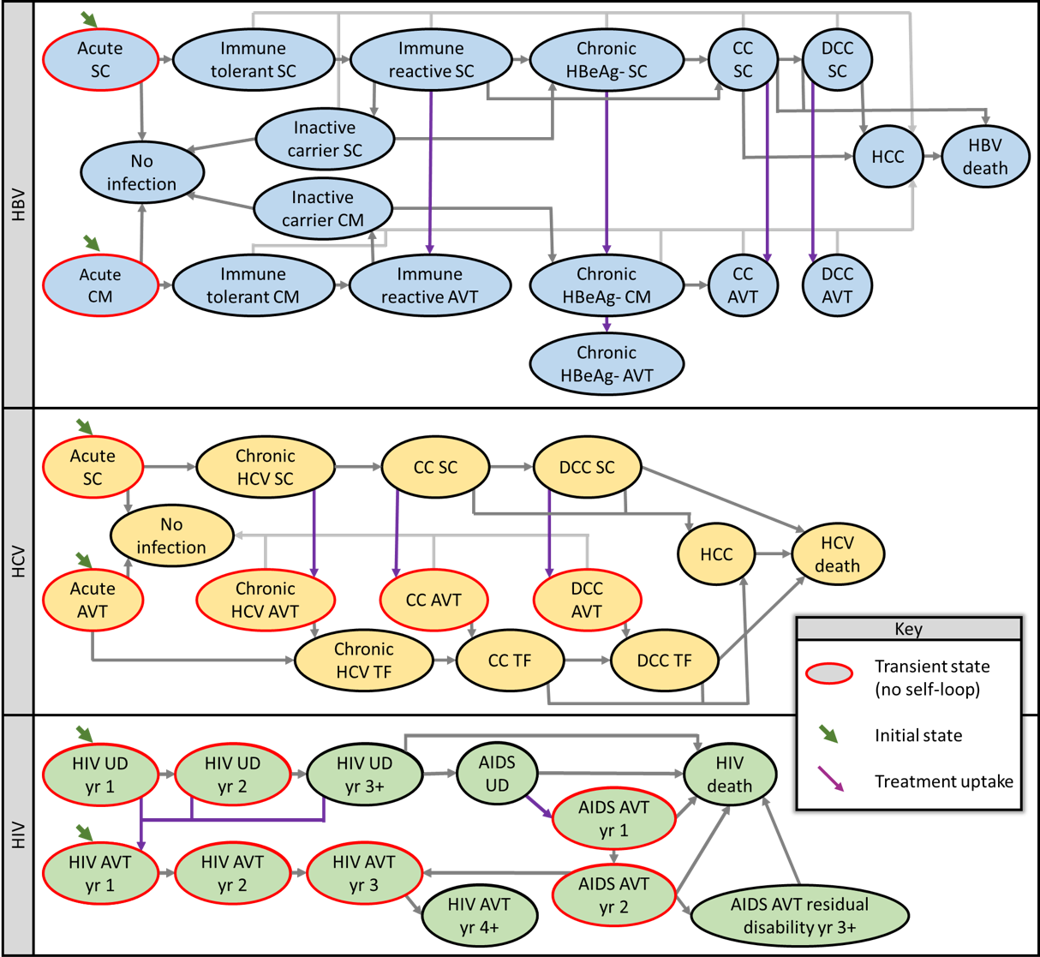

**Fig. 1.** Schematics for Markov models used to estimate net-present lifetime costs for chronic viral infections. Death from other causes possible from any disease state (not shown). Abbreviations AVT, antiviral therapy, CC, compensated cirrhosis, CM, clinical monitored, DCC, decompensated cirrhosis, HCC, hepatocellular carcinoma, HBV, hepatitis B, HCV, hepatitis C, HIV, human immunodeficiency virus, TF, treatment failure, UD, undetected, SC, subclinical

##### 

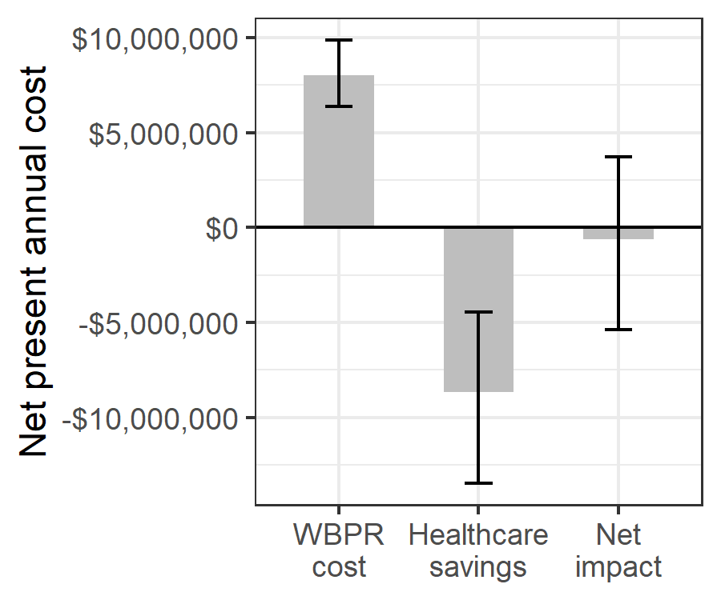

Fig. 2. Estimated net impact on healthcare spending of whole blood pathogen reduction. Net impact is the cost of pathogen reduction minus the net present healthcare savings from averted transfusion-associated adverse events.

##### 

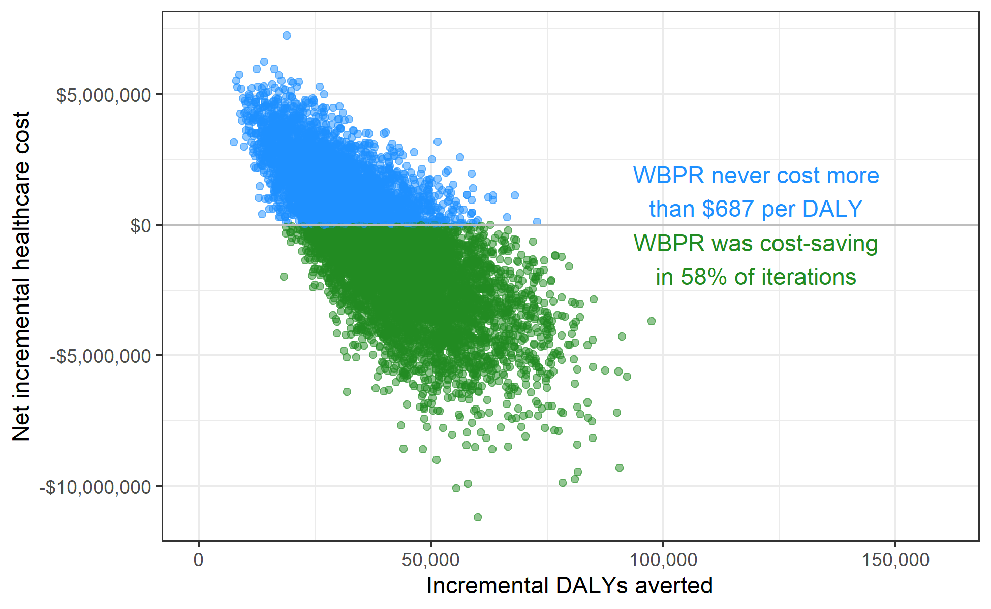

**Fig. 3.** Scatterplot showing the incremental healthcare costs and DALYs averted for WBPR across 10,000 probabilistic sensitivity analysis iterations. WBPR was cost-saving in 57.9% and cost less than $100 per DALY in 90.0% of iterations.

##### 

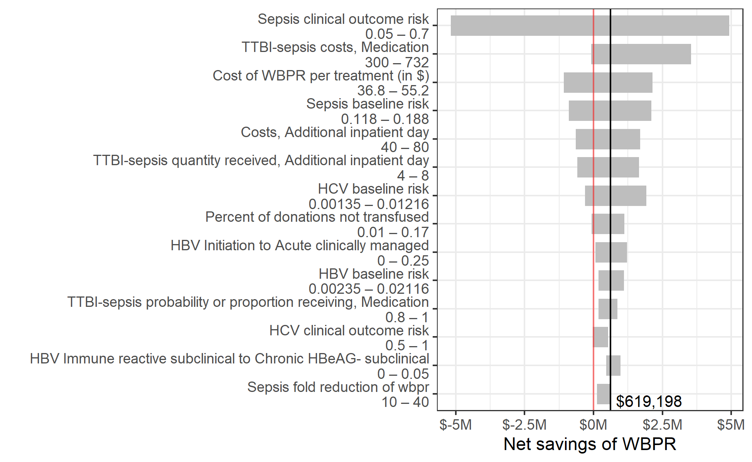

**Fig. 4.** Sensitivity of the net savings of pathogen reduction to changes in the value of individual input parameters within prespecified uncertainty ranges. Y-axis shows all model parameters for which varying the value along the indicated range while keeping other parameters at their base case value led to a variation of more than $500,000 in the estimated net savings of whole blood pathogen reduction.

##### 

# Supplemental materials

**Cost-effectiveness and budget impact of whole blood pathogen reduction in Ghana**

W. Alton Russell, Shirley Owusu-Ofori, Alex Owusu-Ofori, Eileen Micah, Betty Norman, Brian Custer

# Supplemental methods

## A. Risk model calculations

The following equation was used to calculate the number of cases of each adverse event [AE], with and without WBPR:

The annual cost of WBPR was calculated as:

## B. Additional details for risk model parameter estimation

**Percent of donations not transfused:** Based on unpublished data for Komfo Anokye Teaching Hospital collected by the authors and data for the Southern Area Blood Center provided by Dr. Lucy Asamoah-Akuoko of the National Blood Service, Ghana, personal communication.

**Per-donation cost of WBPR:** Provided by Nigel Talboys and Eric Mwenda, Terumo BCT, personal communication.

**Baseline (without WBPR) risk of bacterial infection:** The baseline rate of bacterial infection refers to bacterial infection in the blood donor or contamination during collection and processing, which may be due to incomplete arm disinfection, failure of the closed system for blood collection, or donor bacteremia. Hospital acquired bacterial infections from other sources such as patient lines, ports, or contamination of the patient’s skin are not included. This parameter was estimated by pooling five different studies in Ghanaian hospitals in which donations were tested for bacterial isolates. The findings of those studies were:

* Allotey et. al. 2019: 9 of 100 (9%) positive donations [22]
* Adjei et. al. 2009: 24 of 192 (13%) positive donations [21]
* Boye et. al. 2016: 16 of 97 (16%) positive donations [20]
* Opoku-Okrah et. al. 2009: 14 of 80 (18%) positive donations [19]
* Owusu-Ofori 2012: 23 of 100 (23%) positive donations [18]

Pooling these studies, we estimate that 15% (86 of 569) of donations are bacterially contaminated.

**Baseline (without WBPR) risk of syphilis:** Estimated based on rate of repeat reactive Treponema pallidum hemagglutination assay (TPHA) positivity in Durban and Johannesburg provided by Marion Vermeulen of the South African National Blood Service, personal communication.

**Baseline (without WBPR) risk of FNHTR:** 26 reactions observed in 432 transfusion recipients in Owusu-Ofori et. al. 2017 [24]. Divided the rate per recipient by the average number of units transfused to each recipient (1.66, as reported in Osei et. al. 2013 [23]) to derive the rate per unit transfused.

**Risk of symptomatic TTBI-sepsis outcomes from a bacterial-contaminated unit:** Identifying transfusion-transmitted bacterial infections is difficult. Patients’ underlying conditions can mask symptoms, and even when a bacterial infection is proven, clinicians cannot always definitively attribute the infection to the transfusion. Our source for this parameter estimate was a single 2012 study of 200 recipients that cultured blood from the donor and the recipient and monitored for signs of infection after transfusion [18]. Of 23 culture-positive donations, 6 resulted in a ‘probable’ TT-bacterial infection and 5 resulted in a ‘possible’ TT-bacterial infection, and 12 were classified as ‘unlikely’ to have resulted in a TT-bacterial infection. For these designations, we assigned a probability that the recipient experienced TTBI-sepsis: 90% for ‘probable,’ 60% for ‘possible,’ and 10% for ‘unlikely,’ then calculated the probability of clinical TTBI-sepsis from WBPR as (6×90%+5×60%+12×10%)/23 = 41.7%. We assigned a wide uncertainty range (5% - 70%) due to the challenges in ascertaining these outcomes and the lack of additional datapoints.

**Risk of HBV infection from a whole blood unit contaminated with HBV:** Assumed HBV vaccinated individuals have no risk of clinical outcomes. Estimated that 95% of recipients under 25 would be vaccinated based on WHO/UNICEF 2020 report [27] and that 56% of population is under 20 based on data from the United Nations [26].

**Risk of syphilis infection from a whole blood unit contaminated with syphilis:** Assumed transmission occurred in donations stored less than 4 days only based on van der Sluis et. al. 1985 and Adegoke et. al. 2011 [28,29]. Estimated that 57% of donations are stored less than 4 days from Owusu-Ofori 2011 [30].

**Risk of clinical malaria infection from a whole blood unit contaminated with malaria:** Calculated from Allain et. al. 2016 [12]; see Supplemental Methods section C.

**X-fold reduction of TTBI-sepsis:** Our estimate for this parameter was a 25-fold reduction with an uncertainty range from 10 to 40-fold. This was informed by multiple sources:

* A clinical trial of WBPR in Ghana found the same postcollection bacterial contamination rate between the WBPR and control arms. Of the 6/111 donations that were contaminated post-collection, all were negative following WBPR [12].
* Two prior model-based analyses of platelet and plasma pathogen reduction with the Mirasol system use a risk-reduction factor of 50 (10-90) [3,4]. These papers based the parameter estimate on a laboratory study of platelet pathogen reduction [31] that concluded: “The results from this work suggest that the riboflavin and UV light process may provide up to 98% protection against transfusion of bacterially contaminated units at the most clinically relevant contamination levels (<20 CFUs per product).”
* A 2017 article reports log reductions of various bacteria in whole blood, finding log reductions for 8 different bacteria that ranged from 3.2 to 5.3, which represents a reduction of over 99% reduction [32]. Based on the sum of the evidence, we estimated a 25-fold risk reduction factor, which we varied from 10 to 40 in sensitivity analysis.

**X-fold reduction of FNHTR:** In prospectively collected pre- and post-implementation from two hospitals in Ghana, 32/1162 (2.75%) conventional donations and 17/1019 (1.67%) WBPR treated donations resulted in FNHTR, a 1.7-fold reduction [34]. Jimenez-Marco et. al. 2018 estimated a 2.08-fold reduction in pathogen reduced platelets in the Balearic Islands using a similar pre- vs. post-implementation design [33]. We chose 1.7-fold as the base case estimate with an uncertainty range of 1.1 - 3-fold.

## C. Estimation of malaria clinical outcome risk

The risk of clinical malaria infection from the transfusion of a parasitaemic donation was calculated from data in Allain 2016 [12]. In that study, the prevalence of parasitemia was 23% (50/217) in recipients and 25% (91/367) in donors. Parasitemia by malaria species was also reported:

* In donors: 56 had *P falciparum* only; 4 had *P malariae* only; 1 had *P ovale* only; 26 had both *P falciparum* and *P malariae*; and 4 had all 3 species.
* In recipients: 48 had *P falciparum* only; 1 had *P malariae* only; 0 had *P ovale* only; 2 had both *P falciparum* and *P malariae*; and 0 had all 3 species.

From these numbers, we calculated the following probabilities:

* Probability donation has non-falciparum species given that it has malaria: 38.46%
* Probability donation has non-malariae species given that it has malaria: 62.64%
* Probability donation has non-ovale species given that it has malaria: 94.51%
* Probability donation has neither *P falciparum* nor *P malariae* given that it has malaria: 1.10%

From these, the probability that a parasitaemic recipient who is transfused with a parasitaemic donation would receive a species they are not already parasaetimic for was calculated by taking a sum of the probability donations do not have each set of malaria species weighted by the probability that recipients do have each set of malaria species. The result was 37.47%.

The probability of clinical outcomes when a malaria-positive donation is transfused to a non-parasitaemic recipient was reported as 21.6% (8 of 37 transfusions) with a 95% confidence interval of 9.8–38.2%. We assumed that when a parasitaemic donation is transfused to a parasitaemic recipient, the risk of transmission is the same as with a non-parasitaemic recipient when the donation contained a malaria species for which the recipient was not parasitaemic, and the risk of clinical outcomes was 0 when the recipient was already parasitaemic with all malaria species in the donation. Therefore, the estimated clinical outcome risk for a parasitaemic recipient was . We then calculated the overall expected probability of transmission of a malaria parasitaemic donation by weighting the probability in parasitaemic recipients (8.09%) and the probability in non-parasitaemic recipients (21.60%) by the proportion of recipients who were parasitaemic (23%) for an overall risk of clinical outcomes of 18.5%. For the uncertainty range, we assumed the value could range from 45% to 176% of the base case value based on the range in the confidence interval around the risk of transmission from Allain 2016.

##### 

# Supplemental tables

**Table S1** Additional parameters used to calculate disability-adjusted life years (DALYs). These parameters were sampled from a PERT distribution in probabilistic sensitivity analysis.

| **Description** | **Value (range)** | **Source** |
| --- | --- | --- |
| **TTBI-sepsis DALY calculation parameters1** | | |
| Inpatient disability weight | 0.5 (0.4–0.6) | Custer 2010 [3] |
| Probability of mortality due to TTBI-sepsis | 19% (12%–29%) | Lewis 2019 [37] |
| Probability of post-hospitalization sequelae | 15% (10%–20%) | Custer 2010 [3] |
| Duration post-hospitalization sequelae (days) | 20 (14–30) | Estimated |
| Disability weight for post-hospitalization sequelae | 0.69 (0.59–0.79) | Custer 2010 [3] |
| **FNHTR DALY calculation parameters** | | |
| Disability weight | 0.051 (0.032–0.074) | Estimated |
| Disability duration (days) | 14 (7–30) | Estimated |
| **Syphilis DALY calculation parameters** | | |
| Disability weight | 0.12 (0.09–0.15) | Custer 2010 [3] |
| Disability duration (days) | 90 (60–180) | Estimated |
| **Malaria DALY calculation parameters** | | |
| Disability weight | 0.051 (0.032–0.074) | GBD 2013 [38] |
| Disability duration (days) | 9 (7–20) | Estimated |
| Probability of mortality in pediatric cohort | 2.5% (0%–5%) | Estimated |
| **HCV disability weights2** | | |
| Acute subclinical | 0 (0–0) | Assumed |
| No infection | 0 (0–0) | Assumed |
| Acute on AVT | 0.094 (0–0.15) | Stanaway 2016 [41], Fraser 2016 [39] |
| Chronic HCV subclinical | 0.21 (0.18–0.26) | Fraser 2016 [39] |
| Chronic HCV on AVT | 0.25 (0.09–0.41) | Fraser 2016 [39] |
| Chronic HCV treatment failure | 0.21 (0.18–0.26) | Fraser 2016 [39] |
| Compensated cirrhosis subclinical | 0.252 (0.23–0.26) | Fraser 2016 [39] |
| Compensated cirrhosis on AVT | 0.299 (0.15–0.45) | Fraser 2016 [39] |
| Compensated cirrhosis treatment failure | 0.252 (0.23–0.26) | Fraser 2016 [39] |
| Decompensated cirrhosis subclinical | 0.328 (0.31–0.4) | Fraser 2016 [39] |
| Decompensated cirrhosis on AVT | 0.389 (0.368–0.475) | Fraser 2016 [39] |
| Decompensated cirrhosis treatment failure | 0.328 (0.31–0.4) | Fraser 2016 [39] |
| Hepatocellular carcinoma | 0.39 (0.33–0.8) | Fraser 2016 [39] |
| **HBV disability weights3** | | |
| Chronic HBeAG- subclinical | 0.0265 (0–0.035) | Estimated |
| Chronic HBeAG- clinically managed | 0.0265 (0–0.035) | Estimated |
| Compensated cirrhosis subclinical | 0.252 (0.23–0.26) | Fraser 2016 [39] |
| Decompensated cirrhosis subclinical | 0.328 (0.31–0.4) | Fraser 2016 [39] |
| Hepatocellular carcinoma | 0.39 (0.33–0.8) | Fraser 2016 [39] |
| Immune reactive on AVT | 0.053 (0.0424–0.0636) | Nayagam 2016 [40] |
| Chronic HBeAG- on AVT | 0.053 (0.0424–0.0636) | Nayagam 2016 [40] |
| Compensated cirrhosis on AVT | 0.053 (0.0424–0.0636) | Nayagam 2016 [40] |
| Decompensated cirrhosis on AVT | 0.127 (0.102–0.152) | Nayagam 2016 [40] |
| Acute subclinical | 0 (0–0) | Assumed |
| Acute clinically managed | 0.053 (0.0424–0.0636) | Stanaway 2016 [41] |
| No infection | 0 (0–0) | Assumed |
| Immune tolerant subclinical | 0 (0–0) | Assumed |
| Immune tolerant clinically managed | 0 (0–0) | Assumed |
| Carrier subclinical | 0 (0–0) | Assumed |
| Carrier clinically managed | 0 (0–0) | Assumed |
| Immune reactive subclinical | 0.053 (0–0.0636) | Nayagam 2016 [40] |
| **HIV disability weights4** | | |
| HIV undetected year 1 | 0 (0–0) | Assumed |
| HIV undetected year 2 | 0 (0–0) | Assumed |
| HIV undetected year 3+ | 0 (0–0) | Assumed |
| AIDS undetected | 0.137 (0.092–0.188) | Estimated |
| AVT year 1 | 0.127 (0.085–0.178) | GBD 2013 [38] |
| AVT year 2 | 0.078 (0.052–0.111) | GBD 2013 [38] |
| AVT year 3 | 0.078 (0.052–0.111) | GBD 2013 [38] |
| AVT year 4+ | 0.078 (0.052–0.111) | GBD 2013 [38] |
| AIDS on AVT year 1 | 0.33 (0.229–0.427) | GBD 2013 [38] |
| AIDS on AVT year 2 | 0.204 (0.14–0.269) | GBD 2013 [38] |
| Residual disability from AIDS on AVT | 0.204 (0.14–0.269) | GBD 2013 [38] |
| 1TTBI-sepsis: Inpatient mortality weight applied to the increased duration of hospitalization (parameter in Table S2). Probability of post-hospitalization sequelae applied to patients surviving hospitalization. | | |
| 2HCV: Assumed no disability from subclinical acute HCV. Assumed some disability from acute HCV on AVT due to both symptoms (estimated from Stanaway 2016) and treatment side effects, calculated from the difference between the disability weights used for treatment at other disease stages in Fraser 2016. | | |
| 3HBV: Assumed no disability for subclinical acute, immune tolerant, and inactive carrier disease states. We assumed the disability in the chronic HBeAg- HBV would be half that of immune reactive when not on AVT and would be equal to that of immune reactive when on AVT. | | |
| 4HIV: We assumed no disability for undetected (subclinical) HIV. For undetected AIDS, we assumed patients experience symptoms that are less severe than average (otherwise they would be diagnosed), and we calculated their disability weight as 50% the typical disability weight for symptomatic pre-HIV AIDS. For patients initiating AVT with pre-AIDS HIV, we assume 50% had no symptoms and 50% have symptomatic HIV that typically becomes asymptomatic about 6 months after AVT initiation. We therefore calculated the average disability weight for the first year of HIV treatment as 75% of the 'receiving treatment' weight and 25% of the 'symptomatic HIV' weight. For patients initiating AVT with AIDS, we calculated their first-year disutility as 50% that of untreated AIDS and 50% that of a typical patient on treatment. We calculated their second-year disutility as 25% that of untreated AIDS and 75% that of a typical patient on treatment. For those with residual disability from their AIDS-associated illness, we assumed their disutility remained the same for subsequent years on treatment. | | |

##### 

**Table S2** Parameters for the micro-costing calculations

| **Micro-costing parameters** | **Value (range); distribution** | **Source** |
| --- | --- | --- |
| **Probability or proportion receiving** | | |
| Inpatient mortality (no adverse event) | 0.072 (0.0576–0.0864); PERT | van Hulst 2008 [35] |
| Acute adverse event costs incurred if inpatient mortality | 0.45 (0.1–0.8); PERT | Estimated |
| Additional inpatient day, FNHTR | 0.5 (0.4–0.6); PERT | Estimated |
| Additional inpatient day, Malaria | 0.05 (0.01–0.09); PERT | Estimated |
| Outpatient clinic visit, Malaria | 0.5 (0.4–0.6); PERT | Estimated |
| Medication, TTBI-sepsis | 0.9 (0.8–1); PERT | Estimated |
| Diagnosis & treatment, Syphilis | 0.1 (0.05–0.2); PERT | Estimated |
| **Costs** | | |
| Additional inpatient day | 60 (40–80); PERT | Estimated |
| Liver function test | 13 (11–15); PERT | Estimated |
| International normalized ratio test | 7.7 (6.3–9); PERT | Estimated |
| Full blood count | 6.4 (5.5–7.3); PERT | Estimated |
| Blood urea nitrogen, creatinine, & electrolytes | 11.5 (10–13); PERT | Estimated |
| Alpha fetoprotein | 11.5 (11–12); PERT | Estimated |
| Brief outpatient visit | 6 (4–8); PERT | Estimated |
| Extensive outpatient visit | 12 (8–16); PERT | Estimated |
| Abdominal ultrasonography | 10 (8–12); PERT | Estimated |
| Endoscopy with band ligation | 272 (245–350); PERT | Estimated |
| Spironolactone | 350 (182–782); PERT | Estimated |
| Furosemide | 60.8 (55–66); PERT | Estimated |
| Transarterial chemoembolization | 1810 (1400–2200); PERT | Estimated |
| Triphasic CT scan | 173 (150–196); PERT | Estimated |
| Sorafenib (9-12 tablets) | 1920 (1640–2190); PERT | Estimated |
| Consultation and medication, FNHTR | 25 (20–30); PERT | Estimated |
| HBsAg test, HBV | 3.78 (2.16–5.4); PERT | Estimated |
| HBV profile test, HBV | 35.1 (21.6–48.6); PERT | Estimated |
| HBV DNA test, HBV | 73.8 (72–75.6); PERT | Estimated |
| AVT for non-cirrhotic patients, HBV | 326 (261–391); PERT | Estimated |
| AVT with cirrhosis, HBV | 869 (326–3590); PERT | Estimated |
| Ab screen and confirmation, HCV | 9 (7–13); PERT | Estimated |
| RNA test, HCV | 145 (120–170); PERT | Estimated |
| Genotyping, HCV | 163 (140–186); PERT | Estimated |
| Antiviral medication, HCV | 650 (548–1090); PERT | Estimated |
| AVT for decompensated cirrhosis, HCV | 1630 (1100–2170); PERT | Estimated |
| AIDS care first year on AVT, HIV | 585 (436–733); PERT | Estimated |
| AIDS care second year on AVT, HIV | 330 (266–393); PERT | Estimated |
| Residual disability from AIDS on AVT, HIV | 1150 (1000–1500); PERT | Estimated1 |
| Outpatient clinic visit, Malaria | 15 (10–20); PERT | Estimated |
| RDT + Microscopy, Malaria | 3 (1–5); PERT | Estimated |
| Medication, Malaria | 12 (4–20); PERT | Estimated |
| Medication, TTBI-sepsis | 372 (300–732); PERT | Estimated |
| Diagnosis, Syphilis | 15 (10–40); PERT | Estimated |
| Treatment, Syphilis | 12 (5–20); PERT | Estimated |
| AIDS care undetected, HIV | 150 (600–50); PERT | Mikkelsen 2017 [42] |
| HIV care first year on AVT, HIV | 187 (149–224); PERT | Mikkelsen 2017 [42] |
| HIV care second year on AVT, HIV | 64.5 (51.6–77.4); PERT | Mikkelsen 2017 [42] |
| HIV care third year on AVT, HIV | 57 (45.6–68.4); PERT | Mikkelsen 2017 [42] |
| HIV care annual cost after third year on AVT, HIV | 46.4 (37.1–55.6); PERT | Mikkelsen 2017 [42] |
| **Quantity received** | | |
| Additional inpatient day, FNHTR | 2 (1–3); PERT | Estimated |
| Annual brief outpatient visits for chronic HBeAg-negative infection no AVT, HBV | 3 (2–4); PERT | Estimated |
| Annual brief outpatient visits for chronic HBeAg-negative infection with AVT, HBV | 1 (0–2); PERT | Estimated |
| Annual brief outpatient visits for compensated cirrhosis no AVT, HBV | 3 (2–4); PERT | Estimated |
| Annual brief outpatient visits for compensated cirrhosis with AVT, HBV | 3 (2–4); PERT | Estimated |
| Annual brief outpatient visits for decompensated cirrhosis no AVT, HBV | 4 (2–6); PERT | Estimated |
| Annual brief outpatient visits for decompensated cirrhosis with AVT, HBV | 4 (2–6); PERT | Estimated |
| Annual brief outpatient visits for acute infection with AVT, HCV | 3 (2–4); PERT | Estimated |
| Annual brief outpatient visits for chronic HCV without cirrhosis no AVT, HCV | 3 (2–4); PERT | Estimated |
| Annual brief outpatient visits for compensated cirrhosis no AVT, HCV | 4 (2–6); PERT | Estimated |
| Annual brief outpatient visits with decompensated cirrhosis no AVT, HCV | 4 (2–6); PERT | Estimated |
| Additional inpatient day, Malaria | 1.5 (1–2); PERT | Estimated |
| Outpatient clinic visit, Malaria | 1.2 (1–2); PERT | Estimated |
| Additional inpatient day, TTBI-sepsis | 6 (4–8); PERT | Estimated |
| 1We assumed patients who initiated AVT after AIDS progression were diagnosed based on symptoms and therefore incurred additional costs for due to AIDS-associated illnesses. Costs in the first year were comprised of $57.80 for baseline laboratory investigations, $40.46 in follow-up visits, $255 - $510 for investigation and treatment for AIDS-associated illnesses, and $83.04 -- $124.56 for AVT. Costs in the second year were the same, except we assumed only one third as much spending on investigation and treatment for AIDS-associated illnesses. | | |

.

##### 

**Table S3** Annual transition probabilities used in the Markov models of chronic HIV, HBV, and HCV infections. Transitions indicated by `#` are calculated as one minus the probability of transitioning to any other state.

| **Annual transition probability** | | **Value (range); distribution** | **Source** |
| --- | --- | --- | --- |
| **From** | **To** |
| **HBV natural history** | | | |
| Acute subclinical | Immune tolerant subclinical | 95% (90%–99%); PERT | Mafirakureva 2016 [44] |
| No infection | # |  |
| Acute clinically managed | Immune tolerant clinically managed | 95% (90%–99%); PERT | Mafirakureva 2016 [44] |
| No infection | # |  |
| No infection | No infection | 100% |  |
| Immune tolerant subclinical | Immune reactive subclinical | 10% (3%–20%); β(5.063, 45.57) | Nayagam 2016 [40] |
| Hepatocellular carcinoma | 0.3% (0%–0.6%); β(3.985, 1324.35) | Nayagam 2016 [40] |
| Immune tolerant subclinical | # |  |
| Immune tolerant clinically managed | Immune reactive on AVT | 10% (3%–20%); β(5.063, 45.57) | Nayagam 2016 [40] |
| Immune tolerant clinically managed | # |  |
| Carrier subclinical | Chronic HBeAG- subclinical | 2.68% (1.55%–4.71%); β(11.173, 405.74) | Nayagam 2016 [40] |
| Hepatocellular carcinoma | 0.065% (0%–0.1%); β(0.057, 94.89) | Nayagam 2016 [40] |
| No infection | 1% (0.97%–2.26%); β(17.146, 1257.65) | Nayagam 2016 [40] |
| Carrier subclinical | # |  |
| Carrier clinically managed | Chronic HBeAG- clinically managed | 2.68% (1.55%–4.71%); β(11.173, 405.74) | Nayagam 2016 [40] |
| No infection | 1% (0.97%–2.26%); β(17.146, 1257.65) | Nayagam 2016 [40] |
| Carrier clinically managed | # |  |
| Immune reactive subclinical | Chronic HBeAG- subclinical | 0.5% (0%–5%); β(0.154, 30.69) | Nayagam 2016 [40] |
| Carrier subclinical | 5.74% (4.58%–6.88%); β(11.971, 196.76) | Nayagam 2016 [40] |
| Hepatocellular carcinoma | 0.65% (0.27%–1%); β(12.596, 1925.3) | Nayagam 2016 [40] |
| Immune reactive subclinical | # |  |
| Chronic HBeAG- subclinical | Compensated cirrhosis subclinical | 4% (1%–5.2%); β(11.173, 300.92) | Nayagam 2016 [40] |
| Hepatocellular carcinoma | 0.616% (0.27%–1%); β(11.3, 1824.5) | Nayagam 2016 [40] |
| Chronic HBeAG- subclinical | # |  |
| Chronic HBeAG- clinically managed | Compensated cirrhosis on AVT | 4% (1%–5.2%); β(11.173, 300.92) | Nayagam 2016 [40] |
| Hepatocellular carcinoma | 0.616% (0.27%–1%); β(11.3, 1824.5) | Nayagam 2016 [40] |
| Chronic HBeAG- clinically managed | # |  |
| Compensated cirrhosis subclinical | Decompensated cirrhosis subclinical | 3.9% (3.2%–4.6%); β(2.848, 70.18) | Nayagam 2016 [40] |
| Hepatocellular carcinoma | 3.66% (0.8%–8%); β(3.947, 103.88) | Nayagam 2016 [40] |
| HBV-related death | 3.9% (3.9%–50.7%); β(0.27, 6.66) | Nayagam 2016 [40] |
| Compensated cirrhosis subclinical | # |  |
| Decompensated cirrhosis subclinical | Hepatocellular carcinoma | 3.76% (2.3%–7.1%); β(9.411, 240.88) | Nayagam 2016 [40] |
| HBV-related death | 31.4% (4.3%–57%); β(3.583, 7.83) | Nayagam 2016 [40] |
| Decompensated cirrhosis subclinical | # |  |
| Hepatocellular carcinoma | HBV-related death | 50% (40%–100%); β(5.056, 5.06) | Nayagam 2016 [40] |
| Hepatocellular carcinoma | # |  |
| HBV-related death | HBV-related death | 100% | Nayagam 2016 [40] |
| **HBV treatment effectiveness** | | | |
| Immune reactive on AVT | Immune reactive on AVT | 100% | Nayagam 2016 [40] |
| Chronic HBeAG- on AVT | Chronic HBeAG- on AVT | 100% | Nayagam 2016 [40] |
| Compensated cirrhosis on AVT | Hepatocellular carcinoma | 0.5% (0%–1%); β(0.747, 149) | Nayagam 2016 [40] |
| Compensated cirrhosis on AVT | # |  |
| Decompensated cirrhosis on AVT | Hepatocellular carcinoma | 1% (0%–4.4%); β(0.808, 80) | Nayagam 2016 [40] |
| Decompensated cirrhosis on AVT | # |  |
| **HBV treatment uptake** | | | |
| Initiation | Acute clinically managed | 10% (0%–25%); PERT | Estimated |
| Acute subclinical | # |  |
| Chronic HBeAG- subclinical | Chronic HBeAG- clinically managed | 5% (1%–20%); PERT | Estimated |
| Chronic HBeAG- clinically managed | Chronic HBeAG- on AVT | 9% (4%–18%); PERT | Estimated |
| Compensated cirrhosis subclinical | Compensated cirrhosis on AVT | 30% (10%–40%); PERT | Estimated |
| Decompensated cirrhosis subclinical | Decompensated cirrhosis on AVT | 70% (50%–90%); PERT | Estimated |
| **HCV natural history** | | | |
| Acute subclinical | No infection | 31% (15%–40%); PERT | Mafirakureva 2016 [44] |
| Chronic HCV subclinical | # |  |
| No infection | No infection | 100% |  |
| Chronic HCV subclinical | Compensated cirrhosis subclinical | 1.1% (0.5%–1.8%); PERT | Fraser 2016 [39] |
| Chronic HCV subclinical | # |  |
| Chronic HCV treatment failure | Compensated cirrhosis treatment failure | 1.1% (0.5%–1.8%); PERT | Fraser 2016 [39] |
| Chronic HCV treatment failure | # |  |
| Compensated cirrhosis subclinical | Decompensated cirrhosis subclinical | 6.4% (3%–7%); PERT | Fraser 2016 [39] |
| Hepatocellular carcinoma | 3.6% (1.5%–4%); PERT | Fraser 2016 [39] |
| Compensated cirrhosis subclinical | # |  |
| Compensated cirrhosis treatment failure | Decompensated cirrhosis treatment failure | 6.4% (3%–7%); PERT | Fraser 2016 [39] |
| Hepatocellular carcinoma | 3.6% (1.5%–4%); PERT | Fraser 2016 [39] |
| Compensated cirrhosis treatment failure | # |  |
| Decompensated cirrhosis subclinical | Hepatocellular carcinoma | 6.8% (4.1%–9.9%); PERT | Fraser 2016 [39] |
| HCV-related death | 16.8% (12%–40%); PERT | Fraser 2016 [39] |
| Decompensated cirrhosis subclinical | # |  |
| Decompensated cirrhosis treatment failure | Hepatocellular carcinoma | 6.8% (4.1%–9.9%); PERT | Fraser 2016 [39] |
| HCV-related death | 16.8% (12%–40%); PERT | Fraser 2016 [39] |
| Decompensated cirrhosis treatment failure | # |  |
| Hepatocellular carcinoma | HCV-related death | 60.5% (30%–80%); PERT | Fraser 2016 [39] |
| Hepatocellular carcinoma | # |  |
| HCV-related death | HCV-related death | 100% | Fraser 2016 [39] |
| **HCV treatment effectiveness** | | | |
| Acute on AVT | No infection* | 95% (90%–99%); PERT | Fraser 2016 [39] |
| Chronic HCV treatment failure | # |  |
| Chronic HCV on AVT | No infection | 95% (90%–99%); PERT | Fraser 2016 [39] |
| Chronic HCV treatment failure | # |  |
| Compensated cirrhosis on AVT | No infection | 95% (90%–99%); PERT | Fraser 2016 [39] |
| Compensated cirrhosis treatment failure | # |  |
| Decompensated cirrhosis on AVT | No infection | 95% (90%–99%); PERT | Fraser 2016 [39] |
| Decompensated cirrhosis treatment failure | # |  |
| **HCV treatment uptake** | | | |
| Initiation | Acute on AVT | 10% (0%–25%); PERT | Estimated |
| Acute subclinical | # |  |
| Chronic HCV subclinical | Chronic HCV on AVT | 10% (5%–30%); PERT | Estimated |
| Compensated cirrhosis subclinical | Compensated cirrhosis on AVT | 30% (10%–40%); PERT | Estimated |
| Decompensated cirrhosis subclinical | Decompensated cirrhosis on AVT | 70% (50%–90%); PERT | Estimated |
| **HIV natural history** | | | |
| HIV subclinical 1st year | HIV subclinical 2nd year | 100% |  |
| HIV subclinical 2nd year | HIV subclinical 3+ years | 100% |  |
| HIV subclinical 3+ years | AIDS (pediatric) | 4.21% (3.07%–5.62%); PERT | Morgan 2002 [45] |
| AIDS (adult) | 15% (10.1%–22.6%); PERT | Morgan 2002 [45] |
| HIV-related death (pediatric) | 1.5% (0%–6.9%); PERT | Morgan 2002 [45] |
| HIV-related death (adult) | 0% (0%–5.5%); PERT | Morgan 2002 [45] |
| HIV subclinical 3+ years | # |  |
| AIDS subclinical | HIV-related death (pediatric) | 60.2% (32.4%–70%); PERT | Morgan 2002 [45] |
| HIV-related death (adult) | 61.5% (28.6%–70%); PERT | Morgan 2002 [45] |
| AIDS subclinical | # |  |
| HIV-related death | HIV-related death | 100% | Morgan 2002 [45] |
| **HIV treatment uptake** | | | |
| Initiation | AVT year 1 | 7.5% (0%–15%); PERT | Estimated |
| HIV subclinical year 1 | # |  |
| HIV subclinical year 1 | AVT year 1 | 7.1% (0%–13%); PERT | Estimated |
| HIV subclinical year 2 | AVT year 1 | 18.6% (7%–31%); PERT | Estimated |
| HIV subclinical year 3+ | AVT year 1 | 30% (14%–47%); PERT | Estimated |
| AIDS subclinical | AIDS on AVT year 1 | 50% (30%–70%); PERT | Estimated |
| **HIV treatment effectiveness** | | | |
| AVT year 1 | AVT year 2 | 100% | Assumed |
| AVT year 2 | AVT year 3 | 100% | Assumed |
| AVT year 3 | AVT year 4+ | 100% | Assumed |
| AVT year 4+ | AVT year 4+ | 100% | Assumed |
| AIDS on AVT year 1 | HIV-related death | 30% (15%–40%); PERT | Estimated |
| AIDS on AVT year 2 | # |  |
| AIDS on AVT year 2 | HIV-related death | 15% (0%–30%); PERT | Estimated |
| Residual disability on AVT | 35% (15%–55%); PERT | Estimated |
| AVT year 3 | # |  |
| Residual disability from AIDS on AVT | HIV-related death | 15% (0%–30%); PERT | Estimated |
| Residual disability from AIDS on AVT | # |  |

##### 

**Table S4** Calculations used for each disease state (acute illness for TTBI-sepsis, malaria, febrile non-hemolytic transfusion reactions, and syphilis; annual costs for each disease state in the HBV and HIV Markov models)

| **Disease state** | **Microcosting calculation** |
| --- | --- |
| TTBI-sepsis | (cost × quantity) additional inpatient days +  (proportion × cost) medication |
| Malaria | (cost × quantity × proportion) additional inpatient days +  (cost × quantity × proportion) outpatient clinic visits +  (cost) diagnosis +  (cost) medication |
| FNHTR | (cost) medication and consult +  (cost × quantity × proportion) additional inpatient days |
| Syphilis | (cost × proportion) diagnosis +  (cost × proportion) medications |
| HBV acute clinically managed | (2 × cost) HBsAg test +  (cost) HBV profile +  (cost) HBV DNA test +  (cost) extensive outpatient clinic visit +  (cost) brief outpatient clinic visit |
| HBV acute subclinical | 0 |
| HBV no infection | 0 |
| HBV immune tolerant clinically managed | (cost) extensive outpatient clinic visit +  (cost) HBsAg test +  (cost) HBV profile +  (cost) HBV DNA test +  (cost) liver function test |
| HBV immune tolerant subclinical | 0 |
| HBV carrier subclinical | 0 |
| HBV carrier clinically managed | 0 |
| HBV immune reactive on AVT | cost) extensive outpatient clinic visit +  (cost) HBsAg test +  (cost) HBV profile +  (cost) HBV DNA test +  (cost) liver function test +  (cost) HBV antivirals for non-cirrhotic patients |
| HBV immune reactive subclinical | 0 |
| HBV chronic HBeAg- on AVT | (cost) liver function test +  (cost) HBV profile +  (cost) HBV DNA test +  (cost) blood urea nitrogen, creatinine, & electrolytes +  (cost) full blood count +  (cost) alpha fetoprotein test +  (cost) abdominal ultrasonography +  (cost × quantity) brief outpatient visit +  (cost) HBV antivirals for non-cirrhotic patients |
| HBV chronic HBeAg- clinically managed | (cost) liver function test +  (cost) HBV profile +  (cost) HBV DNA test +  (cost) blood urea nitrogen, creatinine, & electrolytes +  (cost) full blood count +  (cost) alpha fetoprotein test +  (cost) abdominal ultrasonography +  (cost × quantity) brief outpatient visit |
| HBV chronic HBeAg- subclinical | 0 |
| HBV compensated cirrhosis on AVT | (cost) liver function test +  (cost) international normalized ratio test +  (2 × cost) HBV DNA test +  (cost) blood urea nitrogen, creatinine, & electrolytes +  (cost) full blood count +  (2 × cost) alpha fetoprotein test +  (2 × cost) abdominal ultrasonography +  (cost × quantity) brief outpatient visit |
| HBV compensated cirrhosis subclinical | 0 |
| HBV decompensated cirrhosis on AVT | (cost) liver function test +  (cost) international normalized ratio test +  (2 × cost) HBV DNA test +  (cost) blood urea nitrogen, creatinine, & electrolytes +  (cost) full blood count +  (2 × cost) alpha fetoprotein test +  (2 × cost) abdominal ultrasonography +  (cost × quantity) brief outpatient visit +  (cost) HBV antivirals for patients with cirrhosis |
| HBV decompensated cirrhosis subclinical | 0 |
| HBV hepatocellular carcinoma | (cost) liver function test +  (cost) international normalized ratio test +  (cost) Full blood count +  (cost) alpha fetoprotein test +  (cost) triphasic CT scan +  (cost) endoscopy with band ligation +  (cost) sorafenib +  (cost) transarterial chemoembolization |
| HBV related death or other-cause death | 0 |
| HCV acute subclinical | 0 |
| HCV acute with AVT | (cost) Ab screen and confirmation +  (2 × cost) HCV RNA test +  (cost) HCV genotyping +  (cost) liver function test +  (cost) Blood urea nitrogen, creatinine, & electrolytes +  (cost × quantity) brief outpatient visit +  (cost) HCV antivirals |
| HCV no infection | 0 |
| HCV chronic subclinical | 0 |
| HCV chronic with AVT | (cost) liver function test +  (cost) Blood urea nitrogen, creatinine, & electrolytes +  (cost) Full blood count +  (cost) alpha fetoprotein test +  (cost) abdominal ultrasonography +  (cost) HCV genotyping +  (2 × cost) HCV RNA test +  (cost × quantity) brief outpatient visit  (cost) HCV antivirals |
| HCV chronic treatment failure | (cost) liver function test +  (cost) Blood urea nitrogen, creatinine, & electrolytes +  (cost) Full blood count +  (cost) alpha fetoprotein test +  (cost) abdominal ultrasonography +  (cost) HCV genotyping +  (2 × cost) HCV RNA test +  (cost × quantity) brief outpatient visit |
| HCV compensated cirrhosis subclinical | 0 |
| HCV compensated cirrhosis with AVT | (cost) liver function test +  (cost) international normalized ratio test +  (cost) Blood urea nitrogen, creatinine, & electrolytes +  (cost) Full blood count +  (2 × cost) alpha fetoprotein test +  (2 × cost) abdominal ultrasonography +  (cost) HCV genotyping +  (2 × cost) HCV RNA test +  (cost × quantity) brief outpatient visit  (cost) HCV antivirals |
| HCV compensated cirrhosis treatment failure | (cost) liver function test +  (cost) international normalized ratio test +  (cost) Blood urea nitrogen, creatinine, & electrolytes +  (cost) Full blood count +  (2 × cost) alpha fetoprotein test +  (2 × cost) abdominal ultrasonography +  (cost) HCV genotyping +  (2 × cost) HCV RNA test +  (cost × quantity) brief outpatient visit |
| HCV decompensated cirrhosis subclinical | 0 |
| HCV decompensated cirrhosis with AVT | (cost) liver function test +  (cost) international normalized ratio test +  (cost) Blood urea nitrogen, creatinine, & electrolytes +  (cost) Full blood count +  (2 × cost) alpha fetoprotein test +  (2 × cost) abdominal ultrasonography +  (cost) HCV genotyping +  (3 × cost) HCV RNA test +  (2 × cost) endoscopy with band ligation +  (cost) spironolactone +  (cost) furosemide +  (cost × quantity) brief outpatient visit  (cost) HCV antivirals |
| HCV decompensated cirrhosis treatment failure | (cost) liver function test +  (cost) international normalized ratio test +  (cost) Blood urea nitrogen, creatinine, & electrolytes +  (cost) Full blood count +  (2 × cost) alpha fetoprotein test +  (2 × cost) abdominal ultrasonography +  (cost) HCV genotyping +  (3 × cost) HCV RNA test +  (2 × cost) endoscopy with band ligation +  (cost) spironolactone +  (cost) furosemide +  (cost × quantity) brief outpatient visit |
| HCV hepatocellular carcinoma | (cost) liver function test +  (cost) international normalized ratio test +  (cost) Full blood count +  (cost) alpha fetoprotein test +  (cost) triphasic CT scan +  (cost) endoscopy with band ligation +  (cost) sorafenib +  (cost) transarterial chemoembolization |
| HCV related death or other-cause death | 0 |
| AVT initiation with AIDS | (cost) AVT costs (year 1) +  (cost) treatment of AIDS-related illness |
| Second year on AVT with AIDS | (cost) AVT costs (year 2) +  (cost) treatment of AIDS-related illness |
| Residual disability from AIDS on AVT | (cost) AVT costs (year 4+) +  (cost) treatment of residual disability |

##### 

**Table S5** Calculated annual costs for each disease state in the HIV, HBV, and HCV disease progression Markov models

| **Disease state** | **Annual cost** | **Undiscounted Lifetime cost, Adult** | **Undiscounted Lifetime cost, Pediatric** | **Net present lifetime cost, Adult** | **Net present lifetime cost, Pediatric** |
| --- | --- | --- | --- | --- | --- |
| HBV | | | | | |
| Acute clinically managed | $134.46 | $6.72 | $6.72 | $6.72 | $6.72 |
| Acute subclinical | $0.00 | $0.00 | $0.00 | $0.00 | $0.00 |
| Carrier clinically managed | $0.00 | $0.00 | $0.00 | $0.00 | $0.00 |
| Carrier subclinical | $0.00 | $0.00 | $0.00 | $0.00 | $0.00 |
| Chronic HBeAG- clinically managed | $179.30 | $52.75 | $202.36 | $23.71 | $60.92 |
| Chronic HBeAG- on AVT | $493.23 | $122.62 | $1,148.44 | $48.69 | $257.31 |
| Chronic HBeAG- subclinical | $0.00 | $0.00 | $0.00 | $0.00 | $0.00 |
| Compensated cirrhosis on AVT | $1,116.34 | $445.53 | $3,504.13 | $181.25 | $822.75 |
| Compensated cirrhosis subclinical | $0.00 | $0.00 | $0.00 | $0.00 | $0.00 |
| Decompensated cirrhosis on AVT | $2,076.14 | $42.51 | $328.39 | $17.19 | $77.65 |
| Decompensated cirrhosis subclinical | $0.00 | $0.00 | $0.00 | $0.00 | $0.00 |
| HBV-related death | $0.00 | $0.00 | $0.00 | $0.00 | $0.00 |
| Hepatocellular carcinoma | $4,210.60 | $726.90 | $1,287.79 | $454.78 | $621.00 |
| Immune reactive on AVT | $463.61 | $913.57 | $2,228.22 | $511.88 | $857.42 |
| Immune reactive subclinical | $0.00 | $0.00 | $0.00 | $0.00 | $0.00 |
| Immune tolerant clinically managed | $137.68 | $117.46 | $127.98 | $94.82 | $100.56 |
| Immune tolerant subclinical | $0.00 | $0.00 | $0.00 | $0.00 | $0.00 |
| No infection | $0.00 | $0.00 | $0.00 | $0.00 | $0.00 |
| Other-cause death | $0.00 | $0.00 | $0.00 | $0.00 | $0.00 |
| HCV | | | | | |
| Acute on AVT | $1,154.50 | $57.72 | $57.72 | $57.72 | $57.72 |
| Acute subclinical | $0.00 | $0.00 | $0.00 | $0.00 | $0.00 |
| Chronic HCV on AVT | $1,173.40 | $597.84 | $649.35 | $475.74 | $505.23 |
| Chronic HCV subclinical | $0.00 | $0.00 | $0.00 | $0.00 | $0.00 |
| Chronic HCV treatment failure | $523.40 | $307.64 | $635.48 | $178.68 | $271.34 |
| Compensated cirrhosis on AVT | $1,208.60 | $47.73 | $53.37 | $35.35 | $38.45 |
| Compensated cirrhosis subclinical | $0.00 | $0.00 | $0.00 | $0.00 | $0.00 |
| Compensated cirrhosis treatment failure | $558.60 | $32.76 | $74.90 | $17.77 | $29.44 |
| Decompensated cirrhosis on AVT | $3,291.40 | $17.31 | $19.65 | $12.37 | $13.63 |
| Decompensated cirrhosis subclinical | $0.00 | $0.00 | $0.00 | $0.00 | $0.00 |
| Decompensated cirrhosis treatment failure | $1,657.40 | $23.38 | $58.12 | $12.11 | $21.55 |
| HCV-related death | $0.00 | $0.00 | $0.00 | $0.00 | $0.00 |
| Hepatocellular carcinoma | $4,210.60 | $43.72 | $75.79 | $27.66 | $37.23 |
| No infection | $0.00 | $0.00 | $0.00 | $0.00 | $0.00 |
| Other-cause death | $0.00 | $0.00 | $0.00 | $0.00 | $0.00 |
| HIV | | | | | |
| AIDS on ART year 1 | $771.26 | $83.21 | $28.89 | $71.53 | $24.48 |
| AIDS on ART year 2 | $394.08 | $29.52 | $10.32 | $24.64 | $8.49 |
| ART year 1 | $186.70 | $142.47 | $163.19 | $130.83 | $147.95 |
| ART year 2 | $64.52 | $51.29 | $58.72 | $45.99 | $51.97 |
| ART year 3 | $57.02 | $47.09 | $52.56 | $40.87 | $45.12 |
| ART year 4+ | $46.35 | $972.20 | $2,357.82 | $558.79 | $947.85 |
| HIV-related death | $0.00 | $0.00 | $0.00 | $0.00 | $0.00 |
| Other-cause death | $0.00 | $0.00 | $0.00 | $0.00 | $0.00 |
| Residual disability from AIDS on AVT | $1,196.35 | $192.38 | $72.04 | $136.17 | $49.56 |
| Subclinical AIDS | $150.00 | $32.61 | $11.25 | $28.88 | $9.82 |
| Subclinical HIV year 1 | $0.00 | $0.00 | $0.00 | $0.00 | $0.00 |
| Subclinical HIV year 2 | $0.00 | $0.00 | $0.00 | $0.00 | $0.00 |
| Subclinical HIV year 3+ | $0.00 | $0.00 | $0.00 | $0.00 | $0.00 |

##### 

**Table S6** Consolidated Health Economic Evaluation Reporting Standards (CHEERS) checklist.

| **Topic** | **#** | **Recommendation** | **Reported in paragraph number within section** |
| --- | --- | --- | --- |
| **Title/abstract** | | | |
| Title | 1 | Identify the study as an economic evaluation or use more specific terms such as “cost-effectiveness analysis”, and describe the interventions compared. | Title |
| Abstract | 2 | Provide a structured summary of objectives, perspective, setting, methods (including study design and inputs), results (including base case and uncertainty analyses), and conclusions. | Abstract |
| **Introduction** | | | |
| Background and objectives | 3 | Provide an explicit statement of the broader context for the study. | 1 |
| Present the study question and its relevance for health policy or practice decisions. | 2 |
| **Methods** | | | |
| Target population and subgroups | 4 | Describe characteristics of the base case population and subgroups analysed, including why they were chosen. | 1 |
| Setting and location | 5 | State relevant aspects of the system(s) in which the decision(s) need(s) to be made. | 1,2 |
| Study perspective | 6 | Describe the perspective of the study and relate this to the costs being evaluated. | 1, 5 |
| Comparators | 7 | Describe the interventions or strategies being compared and state why they were chosen. | 2 |
| Time horizon | 8 | State the time horizon(s) over which costs and consequences are being evaluated and say why appropriate. | 4 |
| Discount rate | 9 | Report the choice of discount rate(s) used for costs and outcomes and say why appropriate. | 4 |
| Choice of health outcomes | 10 | Describe what outcomes were used as the measure(s) of benefit in the evaluation and their relevance for the type of analysis performed. | 1, 2, 4 |
| Measurement of effectiveness | 11a | Single study-based estimates: Describe fully the design features of the single effectiveness study and why the single study was a sufficient source of clinical effectiveness data | NA |
| 11b | Synthesis-based estimates: Describe fully the methods used for identification of included studies and synthesis of clinical effectiveness data. | 2, 3, Table 1 |
| Measurement and valuation of preference based outcomes | 12 | If applicable, describe the population and methods used to elicit preferences for outcomes | Table S1 |
| Estimating resources and costs | 13a | Single study-based economic evaluation: Describe approaches used to estimate resource use associated with the alternative interventions. Describe primary or secondary research methods for valuing each resource item in terms of its unit cost. Describe any adjustments made to approximate to opportunity costs. | NA |
| 13b | Model-based economic evaluation: Describe approaches and data sources used to estimate resource use associated with model health states. Describe primary or secondary research methods for valuing each resource item in terms of its unit cost. Describe any adjustments made to approximate to opportunity costs. | 4-9, Table 1, Table S2, Table S4 |
| Currency, price date, and conversion | 14 | Report the dates of the estimated resource quantities and unit costs. Describe methods for adjusting estimated unit costs to the year of reported costs if necessary. Describe methods for converting costs into a common currency base and the exchange rate. | 1 |
| Choice of model | 15 | Describe and give reasons for the specific type of decision-analytical model used. Providing a figure to show model structure is strongly recommended. | 2, 4-9, Fig 1, supplement A |
| Assumptions | 16 | Describe all structural or other assumptions underpinning the decision-analytical model. | 3-9, Table 1, Supplement A and B |
| Analytical models | 17 | Describe all analytical methods supporting the evaluation. This could include methods for dealing with skewed, missing, or censored data; extrapolation methods; methods for pooling data; approaches to validate or make adjustments (such as half cycle corrections) to a model; and methods for handling population heterogeneity and uncertainty. | 3-6, Supplement B, Table 1, S1-S4 and footnotes |
| Study parameters | 18 | Report the values, ranges, references, and, if used, probability distributions for all parameters/ Report reasons or sources for distributions used to represent uncertainty where appropriate. Providing a table to show the input values is strongly recommended. | Tables 1, S1-S3 |
| **Results** | | | |
| Incremental costs and outcomes | 19 | For each intervention, report mean values for the main categories of estimated costs and outcomes of interest, as well as mean differences between the comparator groups. If applicable, report incremental cost-effectiveness ratios. | 1-3, Table 2 |
| Characterising uncertainty | 20a | Single study-based economic evaluation: Describe the effects of sampling uncertainty for the estimated incremental cost and incremental effectiveness parameters, together with the impact of methodological assumptions (such as discount rate, study perspective). | NA |
| 20b | Model-based economic evaluation: Describe the effects on the results of uncertainty for all input parameters, and uncertainty related to the structure of the model and assumptions. | 4-5, Table 2, Figures 3-4 |
| Characterising heterogeneity | 21 | If applicable, report differences in costs, outcomes, or cost-effectiveness that can be explained by variations between subgroups of patients with different baseline characteristics or other observed variability in effects that are not reducible by more information. | NA |
| **Discussion** | | | |
| Study findings, limiations, generalisability, and current knowledge | 22 | Summarise key study findings and describe how they support the conclusions reached. Discuss limitations and the generalisability of the findings and how the findings fit with current knowledge. | 1-4 |
| **Other** | | | |
| Source of funding | 23 | Describe how the study was funded and the role of the funder in the identification, design, conduct, and reporting of the analysis. Describe other non-monetary sources of support. | Funding declaration |
| Conflicts of interest | 24 | Describe any potential for conflict of interest of study contributors in accordance with journal policy. Int eh absence of a journal policy, we recommend authors comply with International Committee of Medical Journal Editors recommendations. | COI declaration |

##### 

**Table S7** Impact inventory for cost-effectiveness analyses

| **Category** | **Item** | **Included?** |
| --- | --- | --- |
| **Former Health Care Sector** | | |
| Health effects | Longevity effects: Loss of life year simulated | Yes |
| Health-related quality-of-life effects: Disability-adjusted life years | Yes |
| Other health effects (e.g., adverse events and secondary transmission of infections): | No |
| Medical costs | Paid for by third-party payers | Yes |
| Paid for by patients out-of-pocket | Yes |
| Future related medical costs (payers and patients) | Yes |
| Future unrelated medical costs (payers and patients) | No |
| **Informal Health Care Sector** | | |
| Additional costs | Patient-time costs | No |
| Unpaid caregiver-time costs | No |
| Transportation costs | No |
| **Non-Health Care Sector** | | |
| Productivity | Labor market earnings lost | No |
| Cost of unpaid lost productivity due to illness | No |
| Cost of uncompensated household production | No |
| Future consumption unrelated to health | No |
| Consumption | Cost of social services as part of intervention | No |
| Social Services | Number of crimes related to intervention | No |
| Legal or Criminal Justice | Cost of crimes related to intervention | No |
| Education | Impact of intervention on education achievement of population | No |
| Housing | Cost of intervention on home improvements (e.g., removing lead paint) | No |
| Enivonment | Production of toxic waste pollution by intervention | No |
| Other (specify) | Other impacts | No |

# Supplemental figures

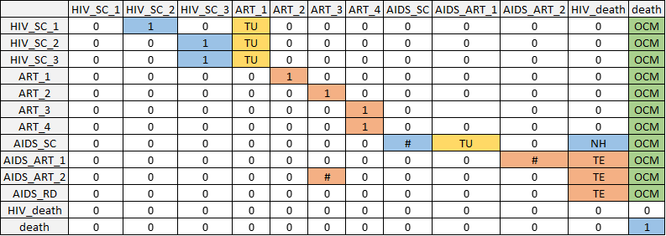

**Fig. S1.** Transition matrix schematic for HIV. Non-zero transition probabilities are indicated in blue for natural history transitions, yellow for treatment uptake transitions, orange for treatment effectiveness transitions, and green for other-cause mortality. Markov model constructed by first creating a transition matrix without treatment uptake or other-cause death; then adding in treatment uptake transitions while scaling other transitions such that each row still sums to 1; then adding in transitions to other-cause mortality with the same approach. Disease state names: AIDS_SC, Subclinical AIDS; ART_1, ART year 1; ART_2, ART year 2; ART_3, ART year 3; ART_4, ART year 4+; HIV_death, HIV-related death; HIV_SC_1, Subclinical HIV year 1; HIV_SC_2, Subclinical HIV year 2; HIV_SC_3, Subclinical HIV year 3+; AIDS_ART_1, AIDS on ART year 1; AIDS_ART_2, AIDS on ART year 2; AIDS_RD, Residual disability from AIDS on AVT; death, Other-cause death. Abbreviations: NH, natural history (blue); TU, treatment uptake (marigold); TE, treatment effectiveness (orange); OCM, other cause mortality (green)

##### 

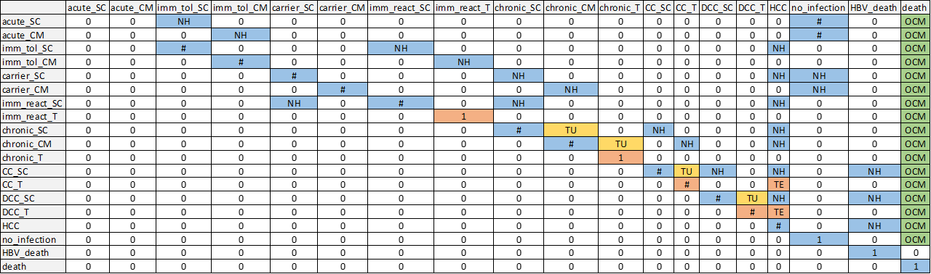

**Fig. S2.** Transition matrix schematic for HBV. Non-zero transition probabilities are indicated in blue for natural history transitions, yellow for treatment uptake transitions, orange for treatment effectiveness transitions, and green for other-cause mortality. Markov model constructed by first creating a transition matrix without treatment uptake or other-cause death; then adding in treatment uptake transitions while scaling other transitions such that each row still sums to 1; then adding in transitions to other-cause mortality with the same approach. Disease state names: acute_CM, Acute clinically managed; acute_SC, Acute subclinical; carrier_CM, Carrier clinically managed; carrier_SC, Carrier subclinical; CC_SC, Compensated cirrhosis subclinical; CC_T, Compensated cirrhosis on AVT; chronic_CM, Chronic HBeAG- clinically managed; chronic_SC, Chronic HBeAG- subclinical; chronic_T, Chronic HBeAG- on AVT; DCC_SC, Decompensated cirrhosis subclinical; DCC_T, Decompensated cirrhosis on AVT; HBV_death, HBV-related death; HCC, Hepatocellular carcinoma; imm_react_SC, Immune reactive subclinical; imm_react_T, Immune reactive on AVT; imm_tol_CM, Immune tolerant clinically managed; imm_tol_SC, Immune tolerant subclinical; init, Initiation; no_infection, No infection; death, Other-cause death. Abbreviations: NH, natural history (blue); TU, treatment uptake (marigold); TE, treatment effectiveness (orange); OCM, other cause mortality (green)

##### 

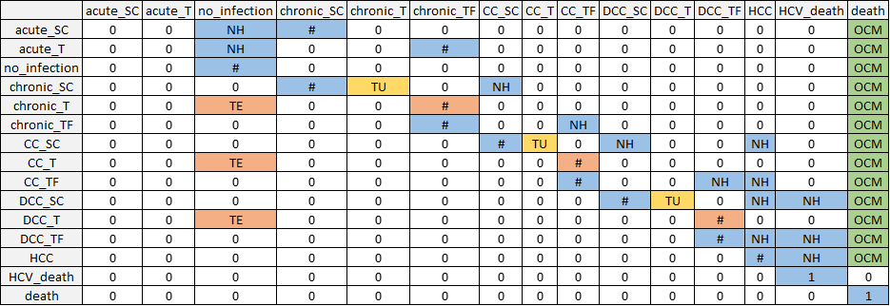

**Fig. S3.** Transition matrix schematic for HCV. Non-zero transition probabilities are indicated in blue for natural history transitions, yellow for treatment uptake transitions, orange for treatment effectiveness transitions, and green for other-cause mortality. Markov model constructed by first creating a transition matrix without treatment uptake or other-cause death; then adding in treatment uptake transitions while scaling other transitions such that each row still sums to 1; then adding in transitions to other-cause mortality with the same approach. Disease state names: acute_SC, Acute subclinical; acute_T, Acute on AVT; CC_SC, Compensated cirrhosis subclinical; CC_T, Compensated cirrhosis on AVT; CC_TF, Compensated cirrhosis treatment failure; chronic_SC, Chronic HCV subclinical; chronic_T, Chronic HCV on AVT; chronic_TF, Chronic HCV treatment failure; DCC_SC, Decompensated cirrhosis subclinical; DCC_T, Decompensated cirrhosis on AVT; DCC_TF, Decompensated cirrhosis treatment failure; HCC, Hepatocellular carcinoma; HCV_death, HCV-related death; init, Initiation; no_infection, No infection; death, Other-cause death. Abbreviations: NH, natural history (blue); TU, treatment uptake (marigold); TE, treatment effectiveness (orange); OCM, other cause mortality (green)

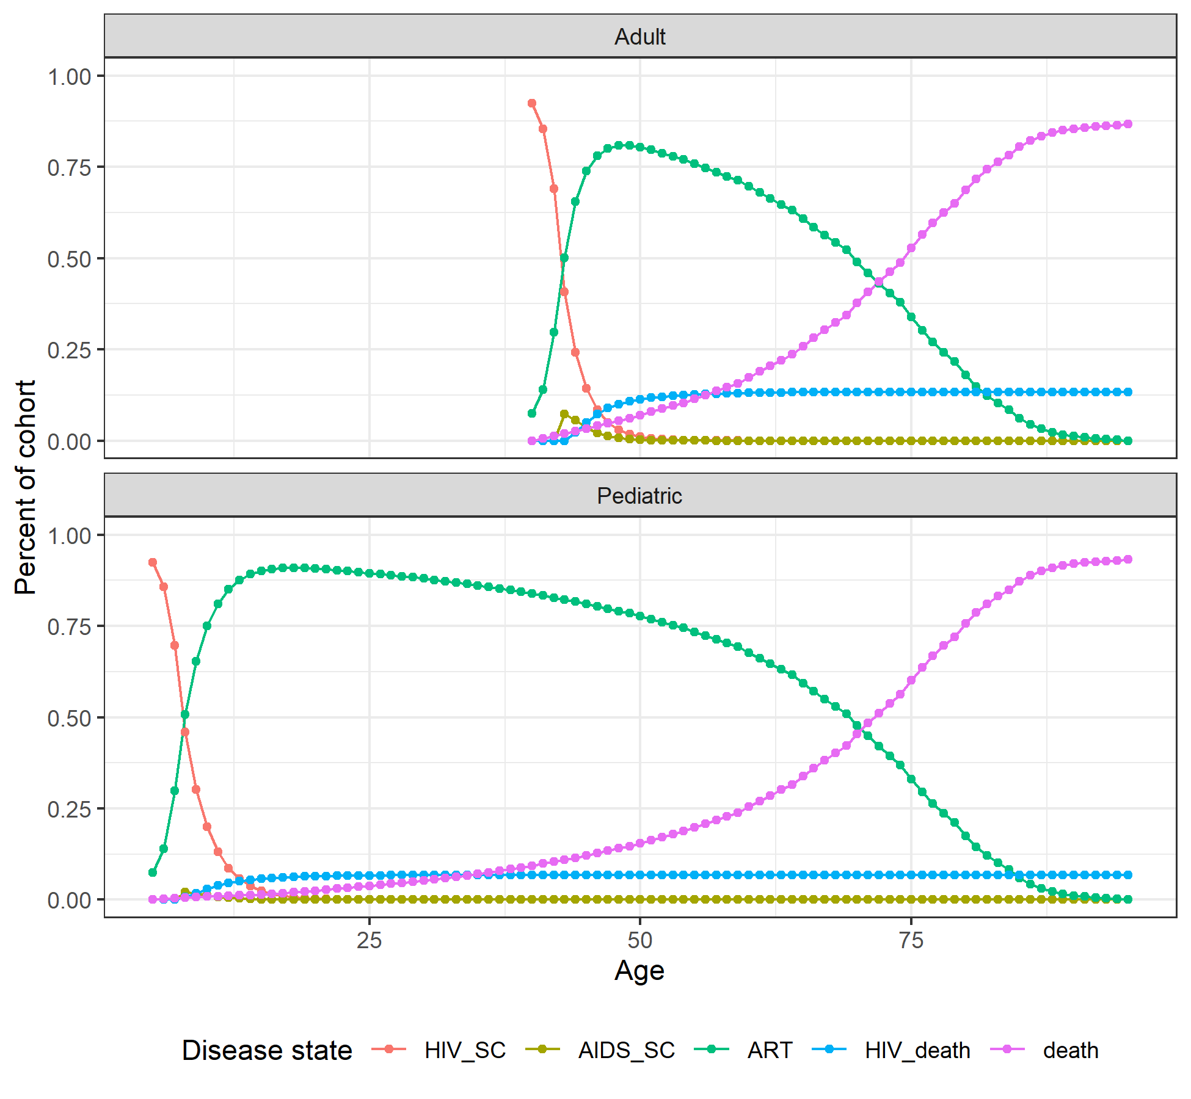

**Fig. S4.** Markov trace plot for HIV pediatric and adult cohorts. HIV_SC and AIDS_SC are sub-clinical HIV and AIDS, respectively. ART corresponds to patients on antiretroviral therapy (called antiviral therapy in the maintext for consistancy with hepatitis therapies), and includes all patients on antivirals. This corresponds to the modeled disease states ART_1, ART_2, ART_3 and ART_4 (non-AIDS HIV patients on ART in years 1, 2, 3, or 4+); AIDS_ART_1, AIDS_ART_2, and AIDS_RD (AIDS patients on ART in years 1, 2, and with residual disability).

##### 

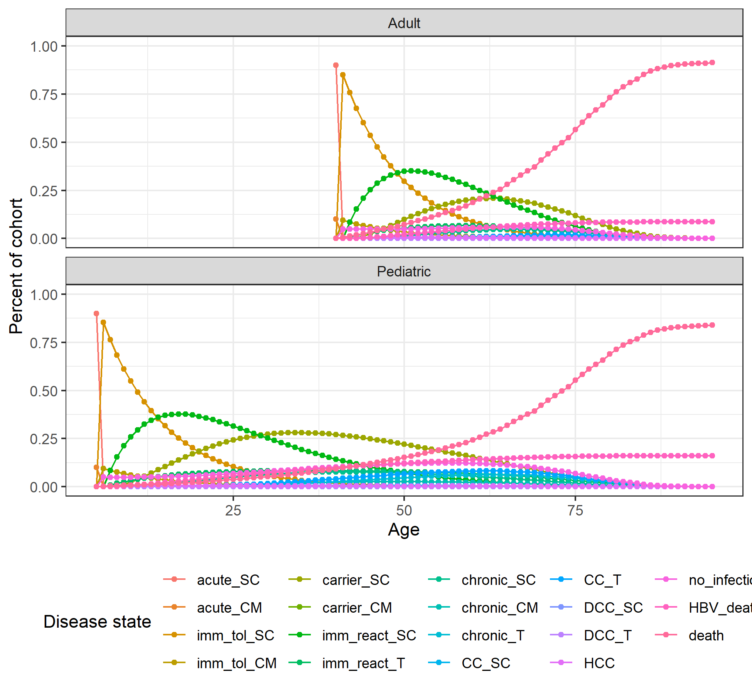

**Fig. S5.** Markov trace plot for HBV pediatric and adult cohorts. Disease state names: acute_CM, Acute clinically managed; acute_SC, Acute subclinical; carrier_CM, Carrier clinically managed; carrier_SC, Carrier subclinical; CC_SC, Compensated cirrhosis subclinical; CC_T, Compensated cirrhosis on AVT; chronic_CM, Chronic HBeAG- clinically managed; chronic_SC, Chronic HBeAG- subclinical; chronic_T, Chronic HBeAG- on AVT; DCC_SC, Decompensated cirrhosis subclinical; DCC_T, Decompensated cirrhosis on AVT; HBV_death, HBV-related death; HCC, Hepatocellular carcinoma; imm_react_SC, Immune reactive subclinical; imm_react_T, Immune reactive on AVT; imm_tol_CM, Immune tolerant clinically managed; imm_tol_SC, Immune tolerant subclinical; init, Initiation; no_infection, No infection; death, Other-cause death.

##### 

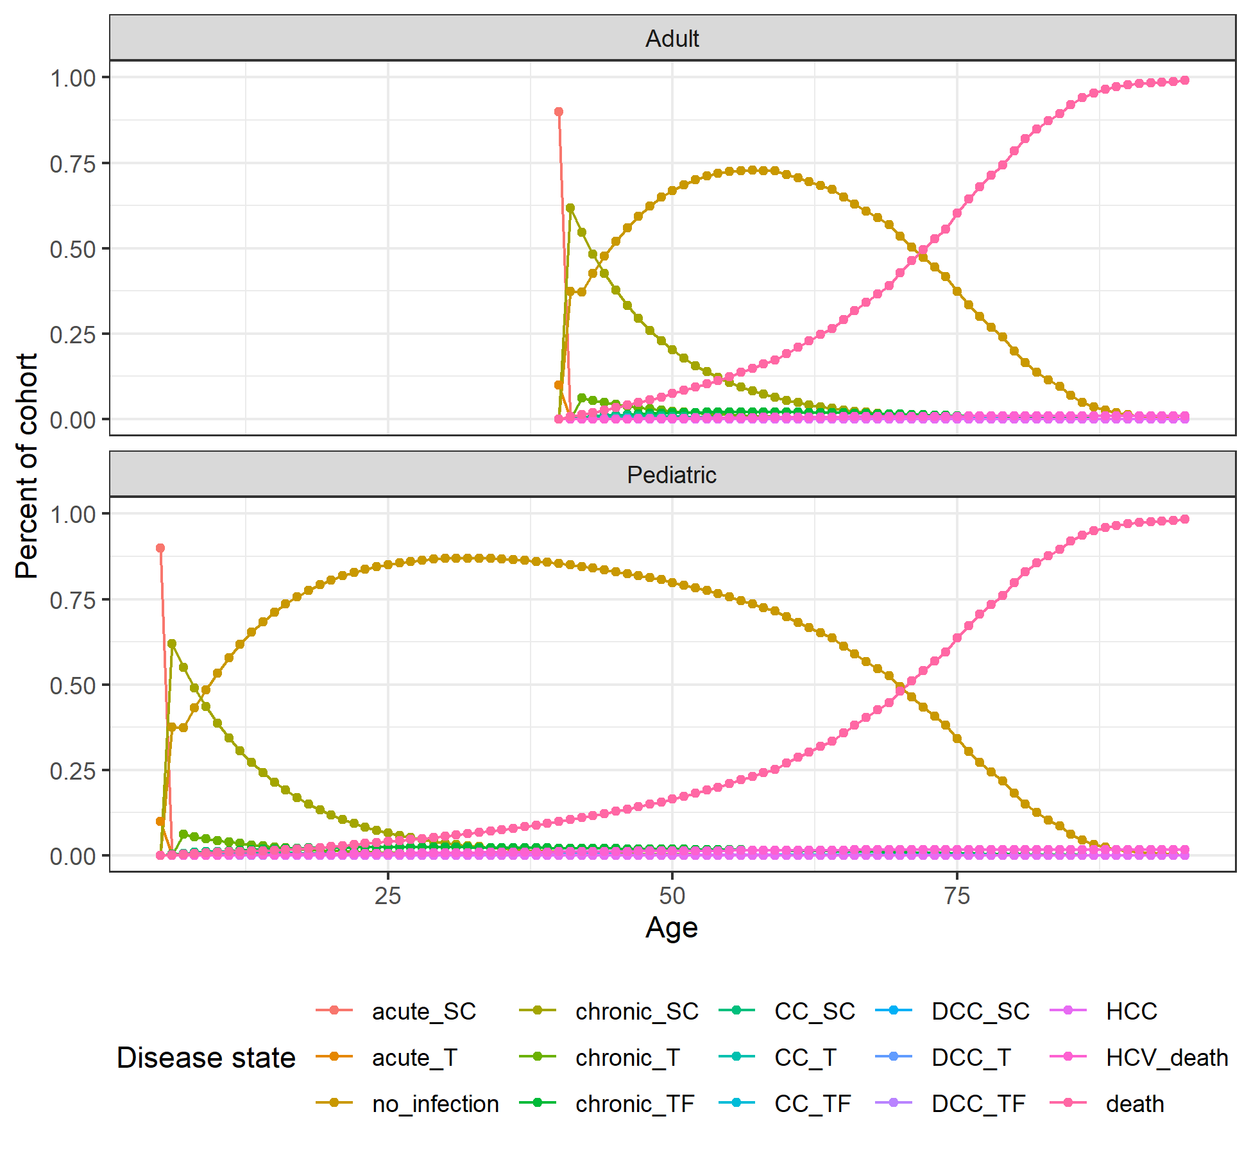

**Fig. S6.** Markov trace plot for HCV pediatric and adult cohorts. Disease state names: acute_SC, Acute subclinical; acute_T, Acute on AVT; CC_SC, Compensated cirrhosis subclinical; CC_T, Compensated cirrhosis on AVT; CC_TF, Compensated cirrhosis treatment failure; chronic_SC, Chronic HCV subclinical; chronic_T, Chronic HCV on AVT; chronic_TF, Chronic HCV treatment failure; DCC_SC, Decompensated cirrhosis subclinical; DCC_T, Decompensated cirrhosis on AVT; DCC_TF, Decompensated cirrhosis treatment failure; HCC, Hepatocellular carcinoma; HCV_death, HCV-related death; init, Initiation; no_infection, No infection; death, Other-cause death.

##### 

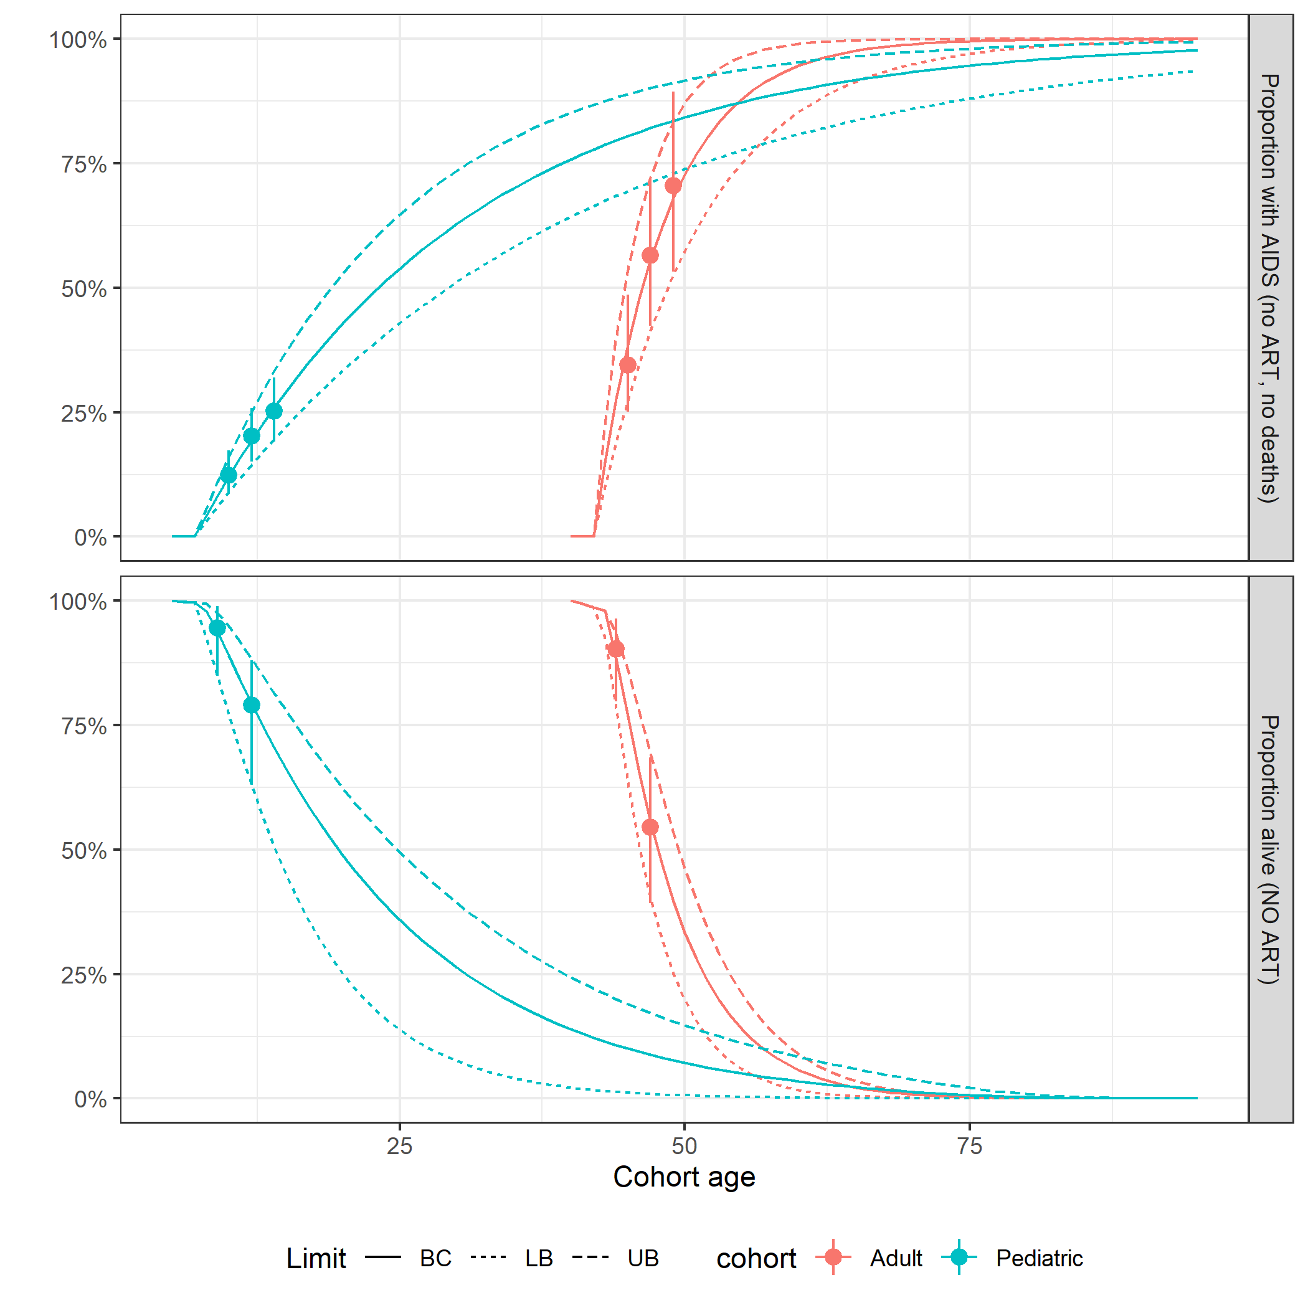

**Fig. S7.** Calibration plots for HIV natural history transition probabilities in the absence of antiviral therapy. As shown in Figure S4, the majority of patients infected with HIV will begin antiviral therapy in the first 5 years of treatment and do not progress to AIDS.

##### 

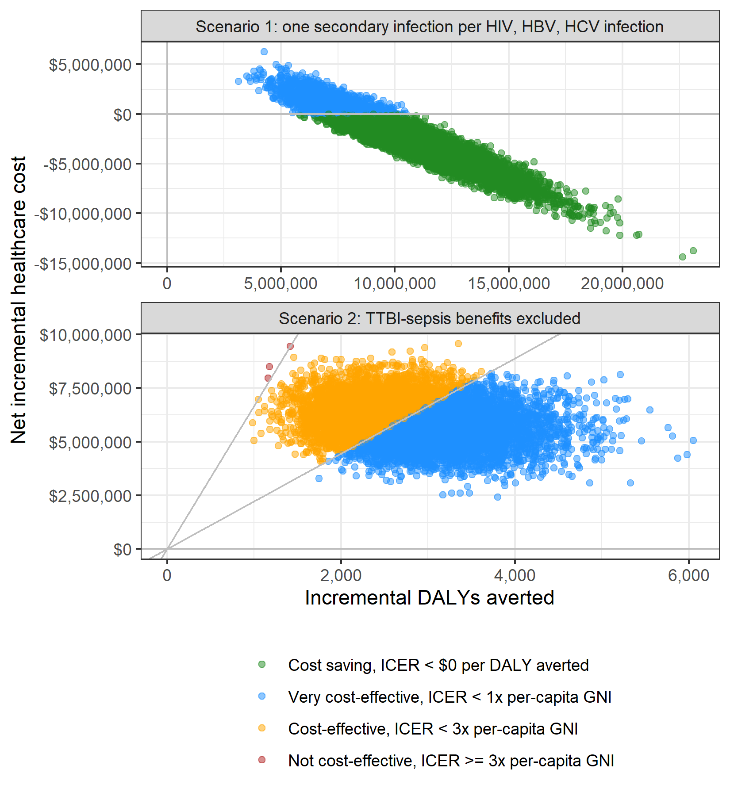

**Fig. S8.** Scatterplots showing the incremental healthcare costs and DALYs averted for WBPR across 10,000 probabilistic sensitivity analysis iterations for the two scenario analysis: with one secondary transmission per HIV, HCV, and HBV (top) and without factoring in WBPR benefits related to TTBI-sepsis (bottom).