Evaluating the use of blood donor data for SARS-CoV-2 serological surveillance

Yuan Yu1, Matthew Knight1, Sheila O’Brien2, David L. Buckeridge1, W. Alton Russell1

1School of Population and Global Health, McGill University, Montreal, Canada

2 Canadian Blood Services, Ottawa, Canada

**Corresponding author:**

**Key words:**

**Running title:**

# Abstract

**Background:** A

**Methods:** A

**Results:** A

**Conclusions:** A

# Introduction

Citation [1]

# Methods

See [1,2] and .

## Subsection

See . See .

# Results

The number of patients was 2000

A

# Discussion

A

# Declarations

**Funding:** A

**Conflicts:** A

**Ethics/Consent:** A

**Data and materials:** A

**Code availability:** A

**Authors’ contributions:**

# References

1. Langham S, Wright A, Kenworthy J, Grieve R, Dunlop WCN. Cost-effectiveness of take-home naloxone for the prevention of overdose fatalities among heroin users in the United Kingdom. *Value in Health*. 2018;21(4):407-415. doi:[10.1016/j.jval.2017.07.014](https://doi.org/10.1016/j.jval.2017.07.014)

2. Keane C, Egan JE, Hawk M. Effects of naloxone distribution to likely bystanders: Results of an agent-based model. *International Journal of Drug Policy*. 2018;55:61-69. doi:[10.1016/j.drugpo.2018.02.008](https://doi.org/10.1016/j.drugpo.2018.02.008)

# Tables

**Table** : This is a sample table.

| **col1** | **col2** | **Source** |
| --- | --- | --- |
|  | | |
| 1 | Yes1 | Langham et al. 20182 |
| 2 | Yes | Keane et al. 2018 |
|  | | |
| 1 | No |  |
| 2 | No |  |
| 1Footnote 2 | | |
| 2Footnote 1 | | |

# Figures

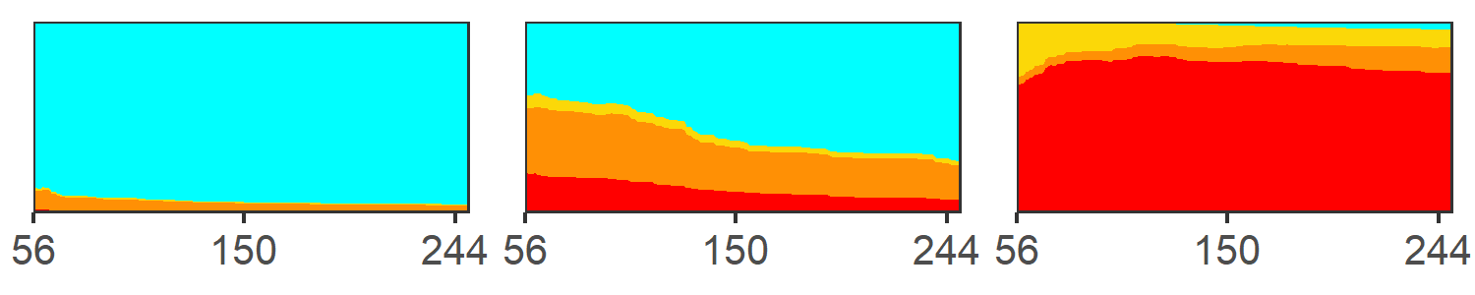

**Figure** : This is a figure caption.

# Supplemental materials

# A. Supplement section

# Supplemental tables

**Table** : This is a sample table.

| **col1** | **col2** | **Source** |
| --- | --- | --- |
|  | | |
| 1 | Yes1 | [1]2 |
| 2 | Yes | [2] |
|  | | |
| 1 | No |  |
| 2 | No |  |
| 1Footnote 2 | | |
| 2Footnote 1 | | |

# Supplemental figures



**Figure S**: A figure caption.