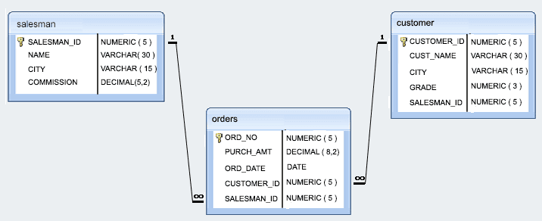

salesman_id name city commission
----------- ---------- ---------- ----------
5001 James Hoog New York 0.15
5002 Nail Knite Paris 0.13
5005 Pit Alex London 0.11
5006 Mc Lyon Paris 0.14
5003 Lauson Hen San Jose 0.12
5007 Paul Adam Rome 0.13

customer_id cust_name city grade salesman_id
----------- ------------ ---------- ---------- -----------
3002 Nick Rimando New York 100 5001
3005 Graham Zusi California 200 5002
3001 Brad Guzan London 100 5005
3004 Fabian Johns Paris 300 5006
3007 Brad Davis New York 200 5001
3009 Geoff Camero Berlin 100 5003
3008 Julian Green London 300 5002
3003 Jozy Altidor Moncow 200 5007

ord_no purch_amt ord_date customer_id salesman_id
---------- ---------- ---------- ----------- -----------
70001 150.5 2012-10-05 3005 5002
70009 270.65 2012-09-10 3001 5005
70002 65.26 2012-10-05 3002 5001
70004 110.5 2012-08-17 3009 5003
70007 948.5 2012-09-10 3005 5002
70005 2400.6 2012-07-27 3007 5001
70008 5760 2012-09-10 3002 5001
70010 1983.43 2012-10-10 3004 5006
70003 2480.4 2012-10-10 3009 5003
70012 250.45 2012-06-27 3008 5002
70011 75.29 2012-08-17 3003 5007
70013 3045.6 2012-04-25 3002 5001

QUERIES

1.- Write a SQL statement to prepare a list with salesman name, customer name and their cities for the salesmen and customer who belongs to same city.

2.- Write a SQL statement to make a list with order no, purchase amount, customer name and their cities for those orders which order amount between 500 and 2000.

3.- Write a SQL statement to know which salesman are working for which customer.

4.- Write a SQL statement to find the list of customers who appointed a salesman for their jobs who gets a commission from the company is more than 12%.

5.- Write a SQL statement to find the list of customers who appointed a salesman for their jobs who does not live in same city where there customer lives, and gets a commission is above 12% .

6.- Write a SQL statement to find the details of a order i.e. order number, order date, amount of order, which customer gives the order and which salesman works for that customer and how much commission he gets for an order.

7.- Write a SQL statement to make a join within the tables salesman, customer and orders in such a form that the same column of each table will appear once and only the relational rows will come.

8.- Write a SQL statement to make a list in ascending order for the customer who works either through a salesman or by own.

9.- Write a SQL statement to make a list in ascending order for the customer who holds a grade less than 300 and works either through a salesman or by own.

10.- Write a SQL statement to make a report with customer name, city, order number, order date and order amount in ascending order according to the order date to find that either any of the existing customer have placed no order or placed one or more orders.

11.- Write a SQL statement to make a report with customer name, city, order number, order date, order amount salesman name and commission to find that either any of the existing customer have placed no order or placed one or more orders by their salesman or by own.

12.- Write a SQL statement to make a list in ascending order for the salesmen who works either for one or more customer or not yet join under any of the customer.

13.- Write a SQL statement to make a list for the salesmen who works either for one or more customer or not yet join under any of the customer who placed either one or more orders or no order to their supplier.

14.- Write a SQL statement to make a list for the salesmen who either work for one or more customer or yet to join any of the customer. The customer, may have placed, either one or more orders on or above order amount 2000 and must have a grade, or he may not have placed any order to the associated supplier.

15.- Write a SQL statement to make a report with customer name, city, order no. order date, purchase amount for those customers from the existing list who placed one or more orders or which order(s) have been placed by the customer who are not in the list.

16.- Write a SQL statement to make a report with customer name, city, order no. order date, purchase amount for only those customers in the list who must have a grade and placed one or more orders or which order(s) have been placed by the customer who are neither in the list not have a grade.

17.- Write a SQL statement to make a cartesian product between salesman and customer i.e. each salesman will appear for all customer and vice versa.

18.- Write a SQL statement to make a cartesian product between salesman and customer i.e. each salesman will appear for all customer and vice versa for those customer who belongs to a city.

19.- Write a SQL statement to make a cartesian product between salesman and customer i.e. each salesman will appear for all customer and vice versa for those salesmen who belongs to a city and the customers who must have a grade.

20.- Write a SQL statement to make a cartesian product between salesman and customer i.e. each salesman will appear for all customer and vice versa for those salesmen who must belongs a city which is not the same as his customer and the customers should have a own grade.

