AI Model and Application Results Report
Intelligent Solar-Assisted Fish Kiln Monitoring System
Generated: 2026-06-27

Executive Summary
This report summarizes the current machine-learning model and application validation results for the fish kiln monitoring prototype. The model estimates remaining drying time from fish type, weight readings, temperature, humidity, elapsed time, and derived drying measurements.
Important limitation: the current training dataset is synthetic demonstration data generated by the project pipeline. It should be presented as a prototype dataset until real experimental drying trials are collected and used for retraining.

Dataset and Training Setup
Item | Value
Dataset file | backend/synthetic_drying_data.csv
Total rows | 2100
Fish species | catfish, mackerel, tilapia
Feature count | 11
Target variable | remaining_drying_time
Model type | Random Forest Regression
Train/test split | 80% training, 20% testing, random_state=42

Model Evaluation Metrics
Metric | Value | Meaning
MAE | 14.222 | Average absolute error in minutes
RMSE | 19.622 | Penalizes larger prediction errors
R2 | 0.979 | Explained variance on the held-out test set
A standard classification confusion matrix is not directly applicable because the model is a regression model with a continuous target. To provide a confusion-matrix-like result, the continuous remaining-time output was grouped into operational classes: Ready/complete, Short wait, and Needs drying.

Correlation Heatmap
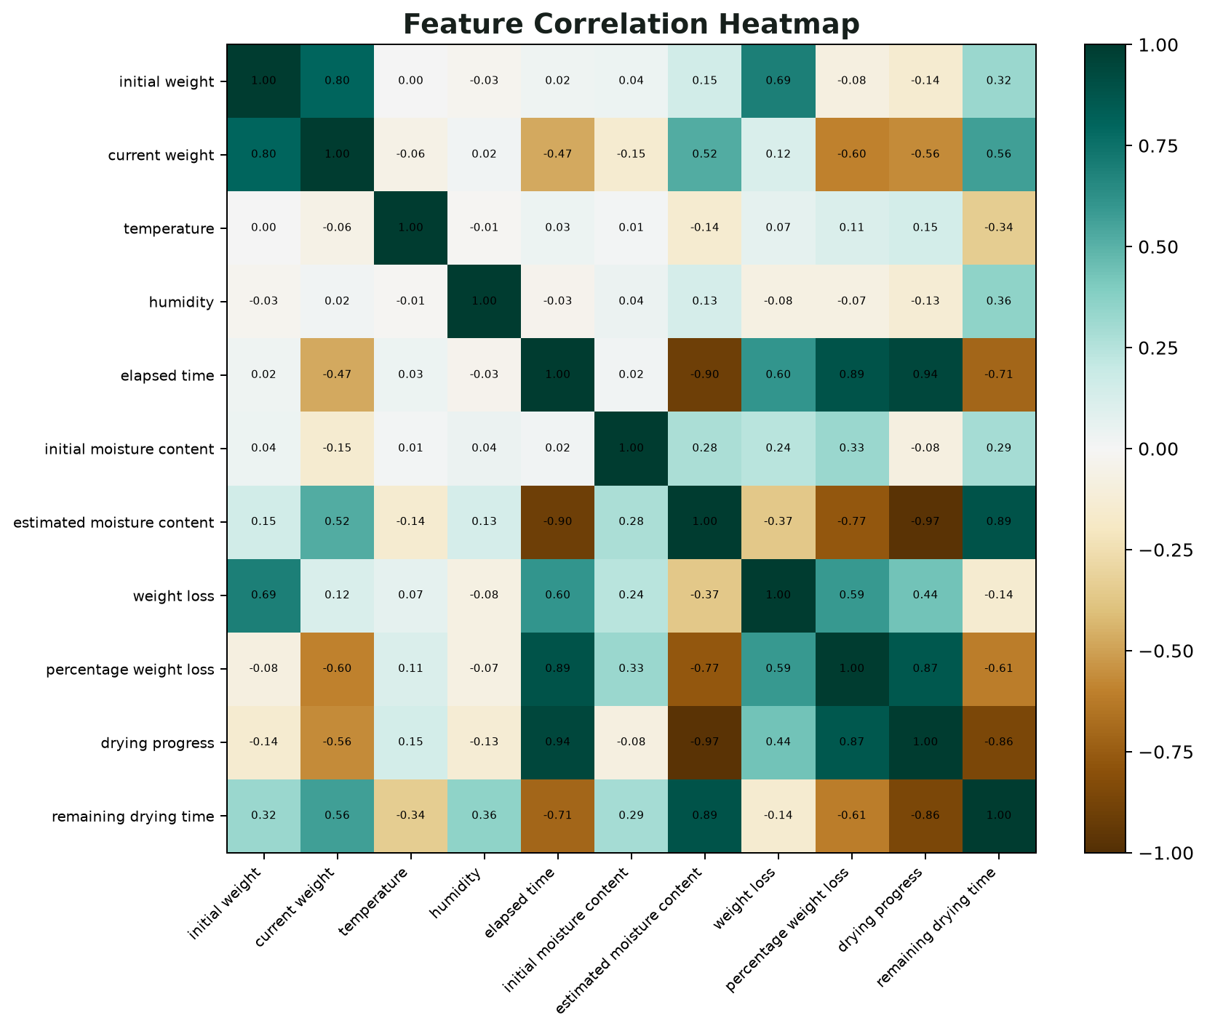
Shows relationships between numeric input and derived drying variables. This helps explain which measurements move together during drying.

Actual vs Predicted Plot
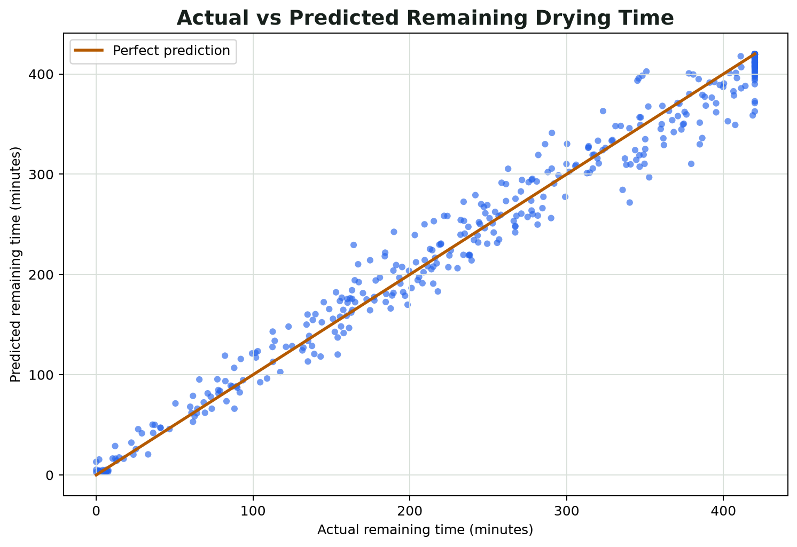
Points close to the diagonal line indicate predictions close to the held-out test target.

Residual Distribution
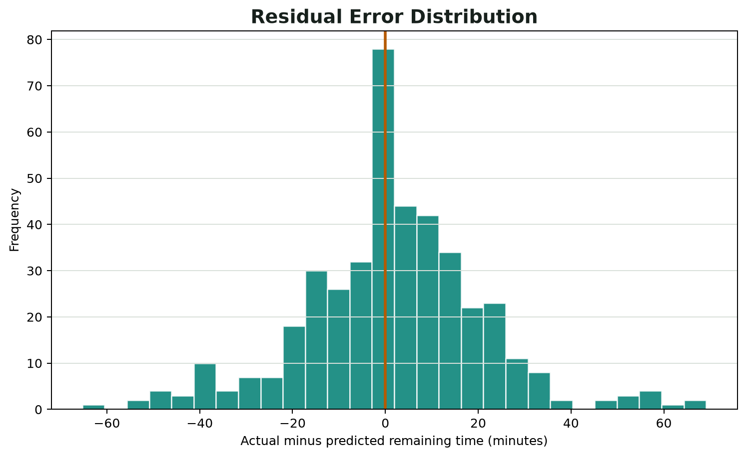
Residuals centered near zero indicate that the model is not strongly biased toward overprediction or underprediction.

Feature Importance
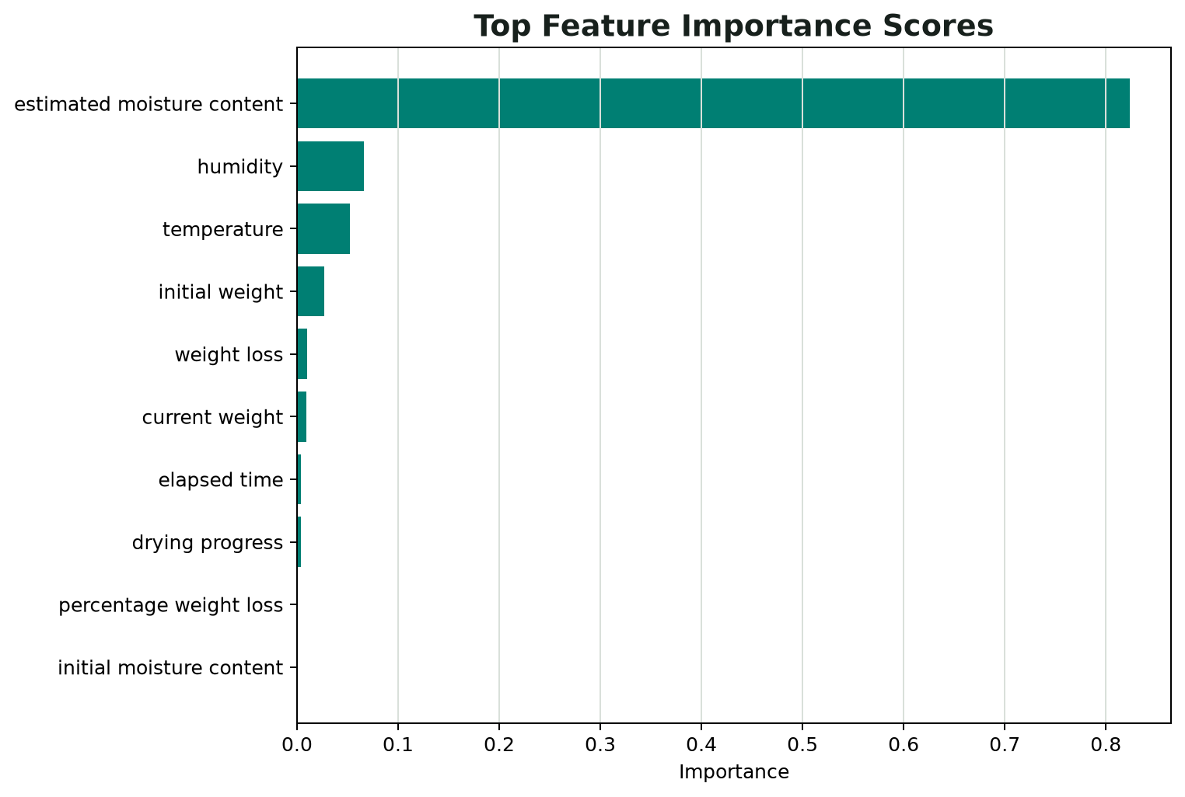
Shows the strongest contributors used by the Random Forest model for remaining-time estimation.

Operational Decision Matrix
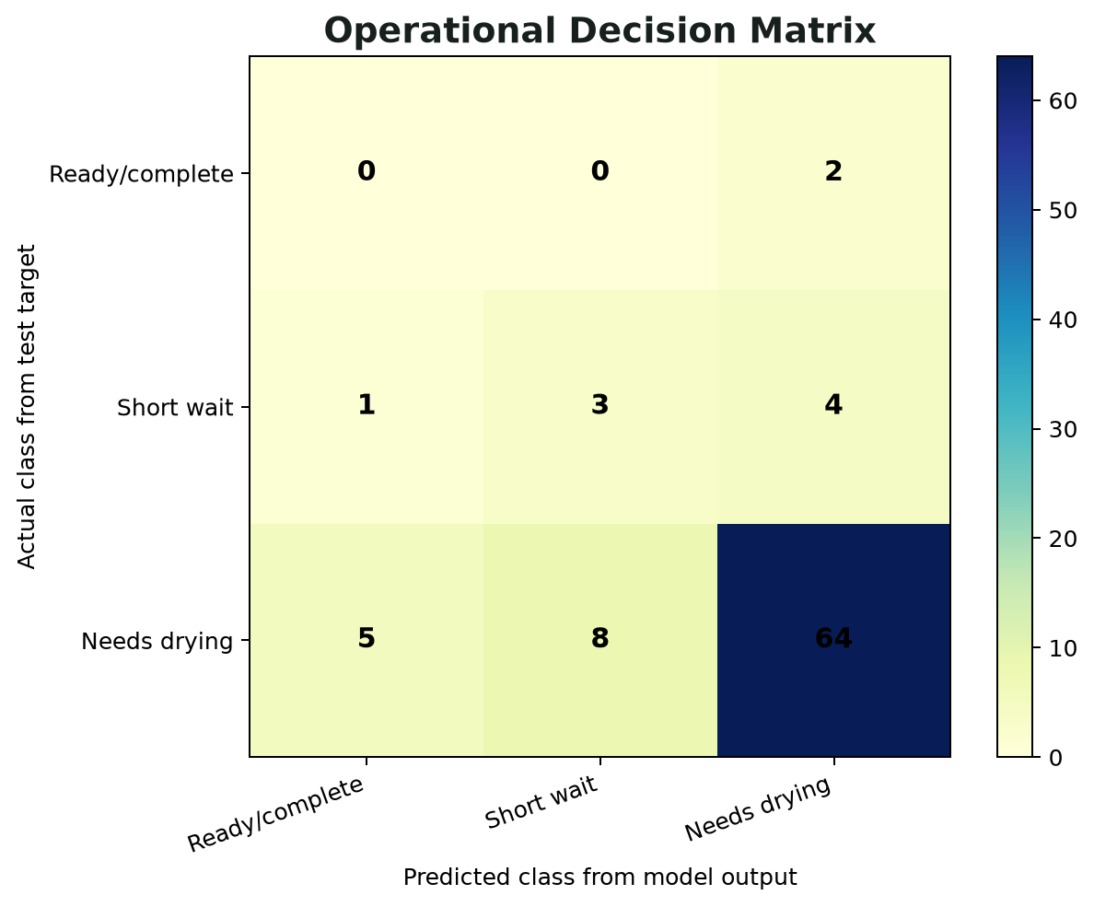
A binned regression output matrix used as the practical equivalent of a confusion matrix for the app decision categories.

Decision Matrix Values
Actual / Predicted | Ready/complete | Short wait | Needs drying
Ready/complete | 0 | 0 | 2
Short wait | 1 | 3 | 4
Needs drying | 5 | 8 | 64

Application Validation Matrix
Area | Check | Status | Evidence
Frontend | Production build | Pass | Vite build completed
Frontend | Compiled asset size | Recorded | 170.8 KB in dist/assets
Backend API | Health endpoint | Pass | HTTP 200
Backend API | Model metadata endpoint | Pass | HTTP 200
Backend API | Prediction endpoint | Pass | HTTP 200; status=Drying in progress; remaining=218.67 min
Validation | Reject humidity above 100% | Pass | HTTP 400
Validation | Reject unsupported fish type | Pass | HTTP 400

Demo Prediction Result
Output | Value
Fish type | catfish
Estimated moisture content | 50.0%
Drying progress | 30.0%
Estimated remaining time | 218.67 minutes
Drying status | Drying in progress
Alerts | None

Supervisor Explanation Notes
The system combines physical drying calculations with an ML model that predicts remaining drying time.
Weight loss is used to estimate current moisture content and drying progress toward the 15% target moisture level.
The current model is trained on synthetic data, so it proves the workflow and app logic but should be retrained with real kiln experiment data.
Regression results are reported with MAE, RMSE, R2, residual plots, feature importance, and actual-vs-predicted plots.
The app was validated through production build checks, API health checks, prediction checks, and bad-input validation checks.

