AI-DRIVEN ACADEMIC RISK & DROPOUT EARLY-WARNING SYSTEM USING DIGITAL TWIN
A PROJECT REPORT
Submitted by
ALTRIN BENSER. A (962223205010)
JERISH RETHNA. J (962223205029)
JOHN JINS. J (962223205032)
MUKHILAN. S (962223205040)
in partial fulfillment for the award of the degree of
BACHELOR OF TECHNOLOGY
IN
INFORMATION TECHNOLOGY
St. XAVIER'S CATHOLIC COLLEGE OF ENGINEERING
(An Autonomous Institution)
Chunkankadai, Nagercoil - 629 003


NOVEMBER 2026

St. XAVIER'S CATHOLIC COLLEGE OF ENGINEERING
(An Autonomous Institution)
Chunkankadai, Nagercoil - 629 003.
BONAFIDE CERTIFICATE
Certified that this project report entitled "AI-DRIVEN ACADEMIC RISK & DROPOUT EARLY-WARNING SYSTEM USING DIGITAL TWIN" is the bonafide work of ALTRIN BENSER. A (962223205010), JERISH RETHNA. J (962223205029), JOHN JINS. J (962223205032) and MUKHILAN. S (962223205040) who carried out the project work under my supervision.
SIGNATURE  Dr. Suja A. Alex B.Tech., M.E., Ph.D.,  HEAD OF THE DEPARTMENT  Associate Professor  Department of Information Technology  St. Xavier's Catholic College of Engineering  Chunkankadai - 629 003 | SIGNATURE  Er. Agnes Alex Rathy. P B.Tech., M.E., MBA.,  SUPERVISOR  Assistant Professor  Department of Information Technology  St. Xavier's Catholic College of Engineering  Chunkankadai - 629 003

Submitted for the viva-voce examination held at St. Xavier's Catholic College of Engineering on ____________________.

INTERNAL EXAMINER | EXTERNAL EXAMINER
ACKNOWLEDGEMENT
First of all, we praise the Almighty God for His presence and abundant grace in giving us knowledge, wisdom, and strength to undertake this project and complete it successfully. We express our gratitude to our parents, who have been the major sources of inspiration and encouragement throughout our academic journey.
Rev. Fr. S. Godwin Selva Justus, our Correspondent, deserves our heartiest gratitude for providing the facilities that contributed to the successful completion of our project.
We also express our sincere thanks to Dr. J. Maheswaran, M.E., Ph.D., our Principal, for wholeheartedly encouraging us and providing continuous support throughout the project, leading to its successful completion.
Dr. Suja A. Alex, B.Tech., M.E., Ph.D., Associate Professor and our Head of the Department, deserves our heartfelt gratitude for her continued support and encouragement in enabling the successful completion of our project. Her guidance and assistance have been instrumental in our achievements, and we express our sincere appreciation for her invaluable contribution.
Er. P. Agnes Alex Rathy, B.Tech., M.E., MBA., Assistant Professor, our Project Coordinator and Project Supervisor, deserves our heartfelt gratitude for her continued guidance, encouragement, and support throughout the development and completion of this project. Her valuable suggestions and assistance have been instrumental in achieving our project objectives, and we express our sincere appreciation for her invaluable contribution.
We also express our sincere thanks to all the faculty members of our department for their valuable suggestions, encouragement, and support throughout the completion of this project.
We are also grateful to our friends and team members for their cooperation and assistance. Their support and willingness to share their knowledge made our project experience enriching and enjoyable.

CO-PO, PSO AND SDG GOALS MAPPING
CO1: Identify any real-world problem and find the optimal solution by applying gathered knowledge and skills.
Course  outcomes | POs |  |  |  |  |  |  |  |  |  |  | PSOs |  |  | SDGs
CO1 | 1 | 2 | 3 | 4 | 5 | 6 | 7 | 8 | 9 | 10 | 11 | 1 | 2 | 3 | 4, 9, 10
CO1 | 3 | 3 | 3 | - | 3 | - | 2 | - | - | - | - | 3 | 3 | - | 4, 9, 10
Mapping Justification
CO-PO Mapped | Justification
CO1 – PO2 | Analyses student records to identify academic risks.
CO1 – PO3 | Develops a system for early dropout-risk detection.
CO1 – PO5 | Uses modern tools for student data analysis and risk prediction.
CO1 – PO6 | Addresses student dropout through timely academic support.
CO1 – PO8 | Ensures student privacy and ethical data handling.

CO-PSO Mapped | Justification
CO1 – PSO1 | Applies programming skills to develop the student monitoring system.
CO1 – PSO2 | Uses modelling and prediction to identify students at academic risk.

SDG | Justification
4 – Quality Education | Supports early identification of academic difficulties and timely student guidance.
9 – Industry, Innovation and Infrastructure | Uses AI and digital technology to improve academic monitoring.
10 – Reduced Inequalities | Promotes inclusive student support through early risk detection and personalized intervention.
ABSTRACT
In Colleges, identifying an underperforming undergraduate is often too late, since we only know about them once end-semester grades are declared. Currently, records are maintained in different forms such as paper-based attendance registers, standalone spreadsheets, and separate departmental dashboards. We developed and implemented Digital Class Twin, a web application that monitors student performance on a daily basis and notifies mentors before declining attendance and grades become permanent. Our backend is developed using FastAPI, SQLAlchemy and SQLite, while our frontend is a modern and interactive React 18 based application. Digital Class Twin stores the daily lectures attended and internal assessment marks, and categorizes each student into one of three basic and easy-to-understand states: Stable, Warning, or Critical. To prevent false alarms due to temporary fluctuations in scores, we have added a hysteresis margin of 3.0 points in our state machine. When a student’s status changes, an audit log entry is created and customised messages are sent out to the mentor, parent and student. Digital Class Twin has separate pages for the student, mentor and supervisor. Alongside showing attendance charts and warnings in real time, the application also features a live What-If simulator, allowing students and mentors to simulate scenarios, such as calculating how many more classes a student needs to attend to comfortably clear the university 75% attendance requirement.
TABLE OF CONTENTS
CHAPTER | TITLE |  | PAGE NO
 | ABSTRACT |  | v
 | LIST OF TABLES |  | ix
 | LIST OF FIGURES |  | x
 | LIST OF SYMBOLS AND ABBREVIATIONS |  | xi
1 | INTRODUCTION |  | 1
 | 1.1 Basics of Digital Class Twin and Educational Analytics |  | 1
 |  | 1.1.1 Introduction | 1
 |  | 1.1.2 Existing System and Its Limitations | 2
 |  | 1.1.3 Digital Class Twin Concept | 2
 |  | 1.1.4 Role of Educational Analytics | 2
 |  | 1.1.5 Objective of the Digital Class Twin | 3
 | 1.2 Problem Statement and Background |  | 3
 | 1.3 Objective |  | 4
 | 1.4 System Requirements |  | 4
2 | LITERATURE REVIEW |  | 6
 | 2.1 Introduction |  | 6
 | 2.2 Educational Data Mining and Supervised Performance Prediction |  | 6
 |  | 2.2.1 Associative Classification for Student Performance Prediction | 6
 |  | 2.2.2 Student Performance Prediction Using Machine Learning Algorithms | 6
 |  | 2.2.3 Educational Data Mining and Student Performance Prediction | 6
 |  | 2.2.4 Student Performance Prediction Using Ensemble Learning | 7
 |  | 2.2.5 Predicting Student Performance in Computer Programming | 7
 | 2.3 Temporal Learning Analytics, Engagement Logging |  | 7
 |  | 2.3.1 Student Engagement Analysis Using Moodle LMS Interaction Logs | 7
 |  | 2.3.2 Student Retention Prediction Using Ensemble Learning | 7
 |  | 2.3.3 Predicting Student Retention Using Academic Records | 7
 |  | 2.3.4 Student Dropout Prediction Using Learning Analytics | 8
 |  | 2.3.5 Learning Analytics for Student Persistence Prediction | 8
 | 2.4 Explainable AI (XAI) and Dynamic Decision Support in Higher Education |  | 8
 |  | 2.4.1 Interpretable Models for Student Engagement Analysis | 8
 |  | 2.4.2 Explainable Artificial Intelligence for Student Performance Prediction | 8
 |  | 2.4.3 A Unified Approach to Interpreting Model Predictions | 8
 |  | 2.4.4 Stability of AI Methods in Predictive Models | 8
 |  | 2.4.5 Early Warning. Academic Advising in Higher Education. | 9
 | 2.5 Research Synthesis and Identified Gaps |  | 9
 |  | 2.5.1 Regular Data Updates | 9
 |  | 2.5.2 Lack of Data Integration | 9
 |  | 2.5.3 Limited Explainability | 9
 |  | 2.5.4 No What-If Simulation | 9
3 | PROPOSED SYSTEM |  | 14
 | 3.1 System Overview |  | 14
 |  | 3.1.1 Layer-by-Layer Architectural Decomposition | 14
 | 3.2 Functional Requirements |  | 16
 | 3.3 Event Ingestion and Student Twin State Model |  | 17
 | 3.4 Architecture and Data Flow |  | 17
 | 3.5 Feature Engineering and Volatility Analysis |  | 18
 | 3.6 Explainable Student Health Scoring and Twin State Machine |  | 20
 | 3.7 AI Decision Support, Alerting Engine and Intervention Simulation |  | 21
 | 3.8 Role-Based Dashboards, Data Privacy and Technology Stack |  | 21
4 | SYSTEM TESTING |  | 23
 | 4.1 Test Approach |  | 23
 | 4.2 Functional and Integration Scenarios |  | 23
 | 4.3 Non-Functional Verification Plan |  | 24
 | 4.4 Evaluation Limits |  | 24
5 | RESULT AND DISCUSSION |  | 25
 | 5.1 Operational Verification and Implementation Evidence |  | 25
 |  | 5.1.1 Role-Based Access Control and Authentication Portal | 26
 |  | 5.1.2 Primary Stakeholder Dashboards | 26
 |  | 5.1.3 Core Functional Modules and Decision Support Tools | 28
 | 5.2 Empirical Benchmarks and Latency Analysis |  | 31
 | 5.3 Discussion of Architectural and Advisory Findings |  | 31
 | 5.4 Practical System Limitations and Engineering Constraints |  | 31
6 | CONCLUSION AND FUTURE ENHANCEMENT |  | 33
 | 6.1 Conclusion |  | 33
 | 6.2 Future Enhancement |  | 33
 | APPENDICES |  | 35
 | Appendix 1: Module Responsibility Split and Milestones |  | 35
 | Appendix 2: Core Data Contracts and Schemas |  | 35
 | Appendix 3: Review Demonstration Scenarios |  | 36
 | REFERENCES |  | 37

LIST OF TABLES
Table No. | Title | Page No.
Table 1.1 | Hardware system requirements | 4
Table 1.2 | Software system requirements | 5
Table 2.1 | Literature review by research area | 9
Table 2.2 | Summary of twenty research papers on student early-warning systems | 10
Table 3.1 | Functional requirements | 16
Table 3.2 | Health score threshold configuration | 17
Table 3.3 | Risk score factors | 20
Table 3.4 | REST API endpoints | 21
Table 4.1 | Functional components test scenarios | 23
Table 4.2 | Non Functional components test scenarios | 24
Table 5.1 | Subsystem components and status | 25
Table 6.1 | Implementation and Deployment plan | 33
Table A.1 | Member wise responsibility | 35
Table B.1 | End-to-end review demonstration scenarios | 36

LIST OF FIGURES
Figure No. | Title | Page No.
Figure 3.1 | Architecture of the Digital Twin System | 15
Figure 3.2 | Flowchart of the event processing pipeline | 18
Figure 5.1 | User login screen | 26
Figure 5.2 | Student dashboard | 27
Figure 5.3 | Faculty dashboard | 27
Figure 5.4 | Parent dashboard | 28
Figure 5.5 | Student performance charts | 29
Figure 5.6 | Explainable AI insights | 29
Figure 5.7 | File upload using Excel or Csv | 30
Figure 5.8 | Faculty dashboard and students alerts | 30
Figure 5.9 | System response time across 100 test runs | 31

LIST OF SYMBOLS ABBREVIATIONS
Term / Symbol | Definition / Description
AI | Artificial Intelligence
API | Application Programming Interface
ASGI | Asynchronous Server Gateway Interface
Bcrypt | Cryptographic Password Hashing Algorithm
CGPA | Cumulative Grade Point Average
CIA | Continuous Internal Assessment
CORS | Cross-Origin Resource Sharing
CPU | Central Processing Unit
EDM | Educational Data Mining
EWS | Early Warning System
FR | Functional Requirement
GPA | Grade Point Average
JSON | JavaScript Object Notation
JWT | JSON Web Token
REST | Representational State Transfer
SHAP | Shapley Additive Explanations
SQLite | Self-contained Lightweight SQL Database Engine
XAI | Explainable Artificial Intelligence
H_composite | Composite Student Health Score
R_risk | Dropout Risk Index
S_acad | Normalized academic performance score
S_att | Rolling 30-day class attendance percentage
S_beh | Normalized behavioral conduct index (0 - 100)
V_score | Academic grade volatility metric indicating score instability

CHAPTER 1
INTRODUCTION
  - Basics of Digital Class Twin and Educational Analytics
Digital Class Twin brings the core idea of twin modeling into an engineering college. Of checking students only once a term with static transcripts Digital Class Twin records daily classroom data. This includes attendance for each period Continuous Internal Assessment marks and lab submissions. By doing Digital Class Twin keeps an up‑to‑date digital profile for every learner. Educational Analytics acts as the mind behind this system.
Educational Analytics acts as the brain of this setup. Educational Analytics helps advisors spot downward trends long before formal examinations take place.
1.1.1 Introduction
During a semester, a student’s academic performance does not always follow a steady flow. Students may be absent for a few classes, score less marks in class tests or become late to submit their assignments. When these issues are occurring rarely, they do no have a major impact on the students academic performance. But when these issues occur regularly across many subjects, the students academic performance becomes serious before faculty understood the problem.
According to Anna University, each student must maintain at least 75% attendance in a semester in order to become eligible for end semester examinations. So identifying these issues early provide faculty sufficient time to provide remedial classes and guide students.

1.1.2 Existing System and Its Limitations
In most colleges, academic profile of a student is maintained in different files rather than in one centralized system. Faculty generally mark attendance, internal marks and assignment marks in different modules in a software. Because of this, faculty do not get a complete status of a student’s academic status across the semester.
As a result, reviewing a student’s academic performance are conducted once or twice during a semester, by the time issues are identified, it may be difficult for the students to improve and other supporting activities such as remedial classes.
1.1.3 Digital Class Twin Concept
The proposed system uses the concept of digital twin technology, which is now commonly used in fields like aerospace engineering and manufacturing to monitor their equipments and identify issues at an early stage. We use this concept to monitor and understand student’s academic status.
In this system, each student’s digital twin combines several records such as attendance, continuous assessment test(CAT) marks, laboratory marks, assignment marks and disciplinary records. Whenever a new data like attendance or marks are entered, the system updates the profile and provide current risk level. This make it easier for the faculty to check a student’s academic status at any point of time during the semester.
1.1.4 Role of Educational Analytics
Education Analytics plays an important role in converting academic data into useful information for students and faculty. Instead of calculating the overall semester marks, our system analyses any changes in student performance over different time periods.
By providing clear information about academic performance, the system helps faculty and students to understand difficulties and plan suitable ways to resolve.
1.1.5 Objective of the Digital Class Twin
The main objective of digital class twin is to improve the way how a student's academic performance is monitored for early potential preventions. By combining academic data with risk calculations, our system helps faculty to identify students who require additional support. This eventually provides enough time for faculty to arrange remedial classes, communicate with parents and suggest corrective measures even before students face examinations.
Also our project aims to reduce manual effort, time involved in analysing and improving communication between students, faculty and students. In addition, students can view their own academic status and can understand which reas require improvement.
1.2 Problem Statement and Background
Most existing college ERP systems and student management systems have limitations when it comes to monitoring student performance and identifying the issues of students at an early stage. Based on our requirements, the following four major issues have been identified:
- Delayed Performance Processing: Most college ERP systems calculate attendance performance and total academic results at certain time periods like monthly or end of semester. Due to this, faculty identify students who have shortcomings lately, making it difficult for them to provide sufficient guidance.
- Separate Storage: Information such as attendance, internal marks, laboratory marks and disciplinary reports are maintained separately in a system which makes it difficult to identify academic risks early.
- Static Risk Prediction: Some systems use analytics tools which provide automated predictions in scores or risk percentage without clearly showing the reasons behind it makes it difficult to understand the result.
- Absence of Interactive Simulation: Most ERP’s are designed to display only the academic records and attendance details. They don't provide interactive dashboards which makes it easier for the students, faculty or parents to explore the software.
1.3 Objectives
To address these above limitations, our system focuses on the following objectives:
- To develop an event ingestion to collect regular academic data such as attendance, assignment marks and internal marks.
- To maintain a digital twin profile for each student to monitor their performance across the semester.
- To implement a scoring model to calculate the student health score range from 0-100. Based on the score, each student will be be classified into one for these categories: Stable, Warning or Crictical.
- To develop a What-if simulator that allows students to visualize different academic situation without altering the existing data.
1.4 System Requirements
The software works efficiently on standard college computers and does not require costly GPU hardware. The hardware setup and software dependencies used during testing are presented in Table 1.1.
Table 1.1 Hardware system requirements
Component | Specification
Host Workstation | Standard x64 / ARM64 processor
Processor | Dual-core CPU, 2.0 GHz
RAM | Minimum 4 GB
Storage | Minimum 2 GB disk space

Table 1.2 Software system requirements
Component | Software / Technical Specification
Operating System | Windows 10/11, Linux, or macOS
Programming Language | Python 3.10+
Backend Framework | FastAPI, Uvicorn ASGI server, Pydantic v2
Database | SQLite 3
ORM and Database Migration | SQLAlchemy 2.0, Alembic
Authentication and Security | JWT, bcrypt password hashing, Role-Based Access Control (RBAC)
Frontend Framework | React 18
Frontend Development Tool | Vite 7
Routing Library | React Router DOM v6
HTTP Client | Axios
Data Visualization | Chart.js 4
Icon Library | Lucide React

CHAPTER 2
LITERATURE REVIEW
2.1 Introduction
To create the foundation for our Digital Class Twin system we looked at twenty papers from 2021 to 2025 in the fields of Educational Data Mining, Learning Analytics and student retention systems. We divided the work among four team members with each person reviewing five papers.
2.2 Educational Data Mining and Supervised Performance Prediction
2.2.1 Associative Classification for Student Performance Prediction
Cagliero et al. (2021) looked at whether rules from quizzes and assignments could predict if students pass a course. Their results showed that early scores can predict results well. For our project this confirmed that tracking Continuous Internal Assessment scores is important. It also showed that we need to track how students do in all courses not just one.
2.2.2 Student Performance Prediction Using Machine Learning Algorithms
Dabhade et al. (2021) compared different machine learning algorithms to predict student performance using different information. This study found that examinations were used for predicting academic performance and gave importance to internal assessment while evaluating students performance. However it mainly focused on prediction rather than continuous support.
2.2.3 Educational Data Mining and Student Performance Prediction
Yagci (2022) applied machine learning techniques to predict student performance. However understanding these models can be difficult. To overcome this our system makes it easier for students to understand.
2.2.4 Student Performance Prediction Using Ensemble Learning
Balcioglu and Artar (2023) used different ensemble learning techniques for predicting student performance. This supported our decision to use random forest algorithm, rather than depending only on static datasets.
2.2.5 Predicting Student Performance in Computer Programming
Su et al. (2022) studied the relationship between assignment submission and exam performance. Based on this observation, we included laboratory performance and practical as important factors in our systems.
2.3 Temporal Learning Analytics, Engagement Logging
2.3.1 Student Engagement Analysis Using Moodle LMS Interaction Logs
Tamada et al. (2022) analysed a huge amount of interaction logs collected from several Leaning Management System (LMS). We applied a similar approach in our system to analyze changes in attendance and laboratory marks.
2.3.2 Student Retention Prediction Using Ensemble Learning
Karalar et al. (2021) used machine learning models to predict student retention learning programmes.. Based on this findings, our system monitors attendance on a regular basis that identifies poor academic performance.
2.3.3 Predicting Student Retention Using Academic Records
Park and Yoo (2021) examined the use of academic data to identify students who may be at risk of dropping out. Based on this, our system includes a What-if simulator that allows students to try different possibilities to improve academic performance.

2.3.4 Student Dropout Prediction Using Learning Analytics
Oqaidi et al. (2022) used university records to build warning systems. They found that early performance is a sign of graduation. We built a system that shows this information on dashboards for students, teachers and parents.
2.3.5 Learning Analytics for Student Persistence Prediction
Segura et al. (2022) studied how early grades and course choices affect whether students stay in school. Segura et al. (2022) Showed that tracking progress over time is important. Our system checks performance to do this.
2.4 Explainable AI (XAI). Dynamic Decision Support in Higher Education
2.4.1 Interpretable Models for Student Engagement Analysis
Katsuragi and Tanaka (2022) developed models to analyze student information about their academic performance. This made us to include an explanation feature in our system.
2.4.2 Explainable Artificial Intelligence for Student Performance Prediction
Nagy and Molontay (2023) demonstrated how it can help identify the factors in an understandable way. Nagy and Molontay (2023) linked model results with advice, in language.
2.4.3 A Unified Approach to Interpreting Model Predictions
Lundberg and Lee (2017) created SHAP, which helps explain model results. We used this to break down each student’s risk score into points.
2.4.4 Stability of AI Methods in Predictive Models
Tiukhova et al. (2024) Found that explanation methods can change a lot. This led us to use a model for decisions and machine learning for extra help.
2.4.5 Early Warning. Academic Advising in Higher Education
Plak et al. (2022) Found that early warnings work best when they are linked to help. We included these features such as risk alerts and parent’s alerts.
2.5 Research Synthesis and Identified Gaps
Based on the above studies, we identified four major limitations in existing ERP’s and prediction systems.
2.5.1 Regular Data Updates
Most existing systems use older data that are updated periodically. Our system updates the student profile whenever new data are entered.
2.5.2 Lack of Data Integration
Students data is stored and maintained in different modules in a software, our system brings every data in one place.
2.5.3 Limited Explainability
Some systems provide risk scores but without explaining the factors behind them.
2.5.4 No What-If Simulation
Existing system only provided few options for academic improvements without exploring different plans to improve.
Table 2.1 Literature review by research area
Research Area | Representative Studies | Relevance to Digital Class Twin
Academic Performance Prediction | Cagliero et al. (2021); Dabhade et al. (2021); Yagci (2022); Su et al. (2022); Balcioglu & Artar (2023) | Demonstrates that formative assessments and quiz telemetry yield strong predictive signals for course outcomes.
Dropout & Failure Forecasting | Karalar et al. (2021); Park & Yoo (2021); Oqaidi et al. (2022); Segura et al. (2022); Katsuragi & Tanaka (2022); Cho et al. (2023); Villar & Robledo Velini de Andrade (2024); Vaarma & Li (2024) | Identifies early-semester attendance lapses and cumulative credits as primary indicators of student attrition.
LMS & Multi-Source Analytics | Tamada et al. (2022); Qin et al. (2023) | Confirms that combining academic records with engagement logs provides a richer student risk profile.
Advisory & Remedial Counseling | Plak et al. (2022); Alalawi et al. (2025) | Emphasizes that predictive alerts are effective only when connected to structured faculty advising and pedagogical support.
Explainable AI & Model Stability | Nagy & Molontay (2023); Tiukhova et al. (2024); Miranda et al. (2024); Villar & Robledo Velini de Andrade (2024) | Establishes that transparent factor attribution (e.g., SHAP, linear weights) is essential for faculty trust and actionable mentoring.

Table 2.2 Summary of twenty representative research papers on student early-warning systems
Sl. | Author & Year | Title & Dataset Focus | Methodology & Models | Key Findings & Identified Gaps
1 | Cagliero et al. (2021) | Predicting Student Academic Performance by Means of Associative Classification [Course exam telemetry] | Associative classification rules extracted from early-term test and quiz records. | Early test marks correlate strongly with end-semester results. However, the study focused only on single-course data rather than continuous multi-semester student tracking.
2 | Karalar et al. (2021) | Predicting Students at Risk Using Ensemble Models in Distance Learning [Moodle & Adobe Connect logs] | Ensemble classification (Gradient Boosting, Random Forest, Extra Trees, ANN). | LMS activity logs provide helpful risk indicators for distance learners, but the method lacks integration with physical classroom attendance.
3 | Park & Yoo (2021) | Early Dropout Prediction in University Online Learning [Institutional online course data] | Supervised ML classification across LMS engagement and submission history. | Flags dropout risks accurately by mid-semester. However, the pipeline ran as an offline terminal script with no interactive advising or recovery simulation features.
4 | Dabhade et al. (2021) | Educational Data Mining for Predicting Academic Performance [Demographic and academic dataset] | Comparative evaluation of Decision Trees, Naive Bayes, and SVM classifiers. | Combines academic and demographic variables. However, static batch analysis limits its usefulness for weekly, real-time mentoring interventions.
5 | Tamada et al. (2022) | Predicting Dropout Risk in Technical Courses Using LMS Logs [1M+ Moodle interaction records] | Random Forest, Decision Tree, Naive Bayes, and K-Means clustering. | Random Forest showed top predictive accuracy on LMS logs, but the study focused strictly on virtual platform clicks rather than in-person lecture attendance.
6 | Yagci (2022) | Educational Data Mining: Academic Performance Prediction [Undergraduate course dataset] | Supervised machine learning algorithms for categorical grade estimation. | Identifies non-linear patterns between mid-term tests and final grades, but the model remained a black box without factor-by-factor score explanations.
7 | Oqaidi et al. (2022) | Dropout Prediction Modeling in Higher Education Institutions [University administrative records] | Feature selection filtering combined with multi-class supervised learning. | Confirms the predictive value of first-year grade trends, but the evaluation was entirely retrospective without interactive role-based dashboards.
8 | Segura et al. (2022) | Student Dropout Prediction: Role of Degree Preferences [Madrid University; 28 institutional variables] | SVM, Decision Tree, ANN, and Logistic Regression with feature analysis. | Student degree choice and starting GPA heavily impact retention. However, testing on a single-institution dataset limits direct cross-campus generalization.
9 | Katsuragi & Tanaka (2022) | Dropout Prediction by Interpretable Machine Learning Models [High school daily LMS & Slack data] | Interpretable classification using daily communication and activity signals. | Frequent communication drops strongly indicate disengagement, but the approach was limited to online environments and omitted physical classroom roll calls.
10 | Su et al. (2022) | Exploring Learning Features and Performance in Programming Courses [Quiz logs and code submissions] | Neural networks, Random Forest, SVM, and correlation analysis. | Regular programming exercise submissions correlate strongly with exam scores, though the evaluation was domain-specific to coding coursework.
11 | Plak et al. (2022) | Early Warning Systems for Effective Student Counseling [VU Amsterdam; two 1st-year cohorts] | Logistic Regression, Additive Models, SVM, and Random Forest in counseling. | Demonstrates that automated early-warning alerts support faculty advising, but the real-world impact depends heavily on teacher adoption and counseling workflows.
12 | Qin et al. (2023) | Early Warning with Integration of Subjective and Objective Data [Academic, library, and card access logs] | Cost-sensitive neural network combining academic and campus facility usage. | Tracking campus mobility and library check-ins improves risk detection, but multi-sensor campus data collection introduces substantial deployment hurdles.
13 | Cho et al. (2023) | Dropout Prediction for University Students Using Machine Learning [Multi-year university records] | Ensemble classification with longitudinal feature importance ranking. | Earned credits and GPA trajectories are primary indicators of student dropout, though the model produced only risk labels without recovery planning tools.
14 | Balcioglu & Artar (2023) | Predicting Academic Performance of Students with Machine Learning [Open University Learning Dataset (OULAD)] | Decision Trees, SVM, Neural Networks, and Stacking Ensembles. | Stacking ensembles achieved high classification accuracy, but the study evaluated static open benchmarks without live event synchronization.
15 | Nagy & Molontay (2023) | Interpretable Dropout Prediction: XAI for Personalized Intervention [Higher-education cohort data] | Supervised classifiers paired with Explainable AI (SHAP / LIME frameworks). | Model explainability is vital for designing personalized interventions, though their setup did not maintain continuous digital twin trajectories over time.
16 | Villar & Andrade (2024) | Supervised Algorithms for Student Dropout: A Comparative Study [Institutional academic dataset] | XGBoost, CatBoost, LightGBM, SMOTE/ADASYN resampling, and SHAP. | Gradient boosting with class rebalancing handles minority at-risk cohorts well, though higher model complexity demands greater computational resources.
17 | Vaarma & Li (2024) | Predicting Student Dropouts: Longitudinal Study in Finnish Higher Ed [Transcripts, demographics, Moodle] | Monthly feature extraction and longitudinal machine learning models. | Predictive feature importance shifts across the semester, highlighting why rolling temporal observation windows are necessary in ongoing student monitoring.
18 | Tiukhova et al. (2024) | Assessing the Stability of Student Success Models via XAI [Institutional success dataset] | SHAP feature explanations evaluated across temporal cross-validation folds. | Post-hoc explanation methods can vary across academic terms, reinforcing the value of transparent, deterministic scoring formulas for official standing.
19 | Miranda et al. (2024) | Model-Agnostic Interpretability for Online Performance Prediction [Video-conference learning records] | Random Forest, SVM, Naive Bayes, SMOTE, and Kernel SHAP attributions. | Session length and active participation dominate predictive weight, but a small cohort size (N=361) limits broader institutional conclusions.
20 | Alalawi et al. (2025) | Learning Analytics Framework Integrating ML and Pedagogical Support | Predictive supervised models integrated into a web-based learning portal. | Connects predictive machine learning models with web-based student support and faculty remediation workflows.
CHAPTER 3
PROPOSED SYSTEM
3.1 System Overview
Our System is designed using six architectural layers, each performing a specific part of the system. The process starts with collecting daily records such as attendance, internal assessment and student disciplinary records. Then the details are entered through API endpoints or uploaded using import options.
Once the data is stored, the engine analyses students academic performance over the last 30 days. It calculates the factors such as attendance percentage and academic performance.
Based on the data, the system calculates health score ranging from 0 to 100 and is classified into three categories: Stable, Warning or Critical.
3.1.1 Layer-by-Layer Architectural Decomposition
Layer 1: Data Ingestion and File Import
This layer is responsible for collecting student information in two ways:
(1) The first method uses REST API endpoints to record continuous data such as attendance, internal marks, and discipline details.
(2) The second method is upload feature using Excel or Csv files.
Layer 2: 30-Day Rolling Performance Analysis
Instead of waiting until the end of the semester, our system continuously analyses their academic performance over the last 30 day period which has four factors: attendance percentage, internal marks, laboratory performance and behaviour.

Layer 3: Academic Health Scoring and Status Tracking
This layer maintains a digital twin for each student and updates continuously. Using the calculated health score, they are classified into three categories:
- Stable: Students with a health score of 75 or above.
- Warning: Students with a health score between 50 and 74.
- Critical: Students with a health score below 50.
Layer 4: Machine Learning Risk and Grade Prediction
With the health score, the system uses two machine learning models to provide insights for students' performance.
- Random Forest Classification: Used to classify students into High, Medium or Low risk categories.
- Ridge Regression: Two separate regression models are used in the system. The first models is used to predict expected semester GPA and second is used to predict cumulative CGPA.
Layer 5: Interactive What-If Simulation Sandbox
The What-if simulation module in our systems helps students and faculty provide improvement plans. When a student is identified as at risk, the system provides a simulation without modifying the original data by creating a temporary copy.
This feature provides students and faculty a better way to analyse thor performance.
Layer 6: Multi-User Web and Mobile Interface
Our system provided four different dashboards based on user roles:
- Student Dashboard allows students to view their performance streaks, internal marks, attendance and AI based insights
- Faculty Dashboard allows to view whole class academic performance, file uploads and alerts about students.
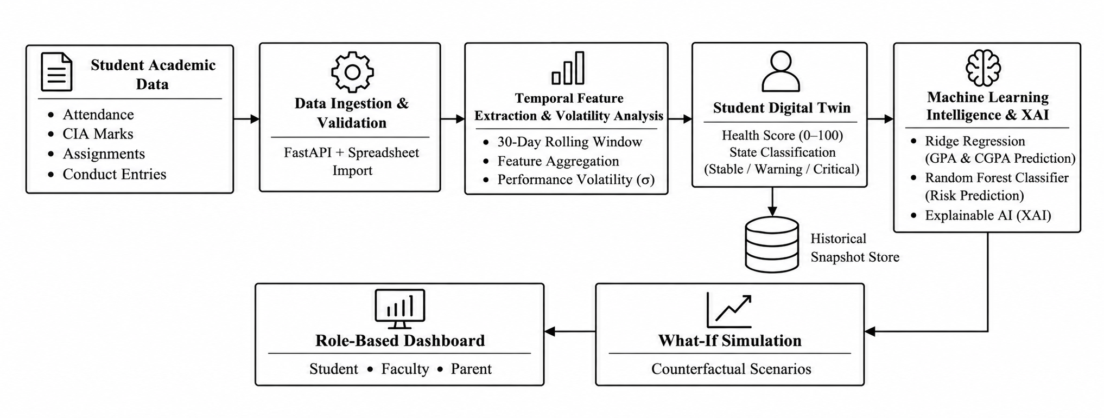
- Parent Dashboard allows parents to view their child’s academic progress.

Figure 3.1: Architecture of the Digital Twin System
3.2 Functional Requirements
The system has several functional requirements such as:
Table 3.1 Functional requirements
Req ID | Functional Capability | Prototype Implementation Specification
FR1 | Event Ingestion & Schema Validation | Accept typed attendance, assessment and conduct events via REST API; validate schema structures using Pydantic.
FR2 | Sliding-Window Feature Extraction | Derive rolling 30-day attendance rates weighted test. Grade volatility across consecutive assessments.
FR3 | Digital Twin State Machine | Classify each student profile into Stable, Warning or Critical bands with anti-flicker hysteresis thresholds.
FR4 | Explainable Risk Scoring | Compute health (0–100) using transparent linear weights (50% academic, 30% attendance 20% conduct) and export factor attributions.
FR5 | Historical Snapshot Archival | Persist an audit snapshot whenever a student transitions between operational states to prevent data bloat.
FR6 | Multi-Stakeholder Alerting | Generate scoped notification alerts upon threshold breaches; automatically resolve alerts when standing returns to Stable.
FR7 | Role-Based Web Dashboards | Deliver specialized web views for Students, Faculty Mentors, Parents and Administrators secured by JWT tokens.
FR8 | Ownership & Privacy Controls | Enforce relational ownership checks ensuring parents access only mapped children and faculty access assigned sections.
FR9 | What-If Recovery Simulator | Provide a in-memory shadow twin workspace allowing advisors to project hypothetical score gains without mutating database records.
FR10 | System Health & Audit Logging | Log authenticated session activity, database transaction durations and administrative configuration modifications.
3.3 Event Ingestion and Student Twin State Model
Regular academic data such as attendance, internal marks and student disciplinary records are passed through HTTP POST requests in JSON format. Table 3.2 shows different health score and action taken.
Table 3.2 Health score threshold configuration
Twin State | Health Score (H) | Risk Index (R) | Triggered Operational Action
Stable | H_composite >= 75.0 (Optimal Academic Health) | R_risk <= 25.0 (Low Risk) | Continuous background monitoring; positive progress feedback.
Warning | 50.0 <= H_composite < 75.0 (Moderate Distress) | 25.0 < R_risk <= 50.0 (Moderate Risk) | Automated advisor alert; parental advisory notice; remedial counseling queue.
Critical | H_composite < 50.0 (Severe Distress) | R_risk > 50.0 (High Risk) | Urgent faculty action; HOD notification; mandatory academic recovery plan.

3.4 Architecture and Data Flow
The systems backend follows the following approach. Whenever a faculty enters an event, the API validates the data and stores it in the database. Then it continuously updates the students last 30 day data and calculates health score and displays the updated information through the system and alerts are sent.
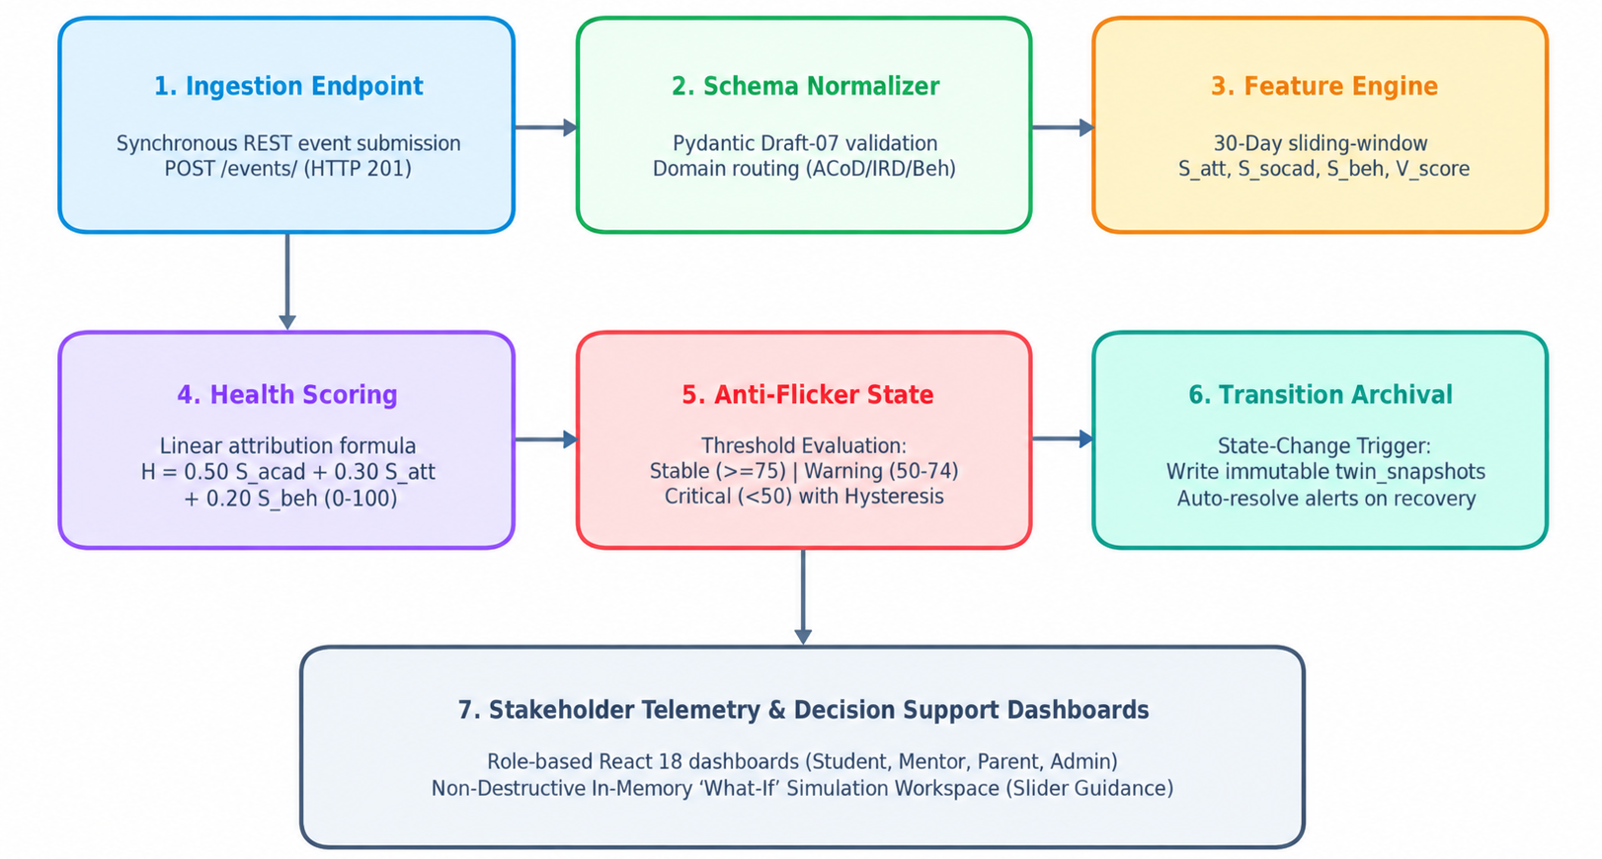

Figure 3.2: Flowchart of the event processing pipeline
3.5 Feature Engineering and Volatility Analysis
Whenever a new event is entered and validated, the backend engine analyses the student performance using the last 30 days and calculates the four metrics.
1. Rolling Attendance Ratio ($S_{\text{att}}$)
This represents the student attendance percentage by present sessions and total sessions.
$$S_{\text{att}}=\frac{\text{Present Sessions}}{\text{Total Scheduled Sessions}}×100$$
2. Academic Score Average ${(S}_{\text{acad}}$)
This score is the average of Continuous Internal Assessment marks and lab evaluations scaled to a 0–100 range.
3. Behavioral Conduct Index $(S_{\text{beh}}$)
This index starts with a score of 100, it increases and decreases when disciplinary log is reported.
$$S_{\text{beh}}=\max\left(0, 100-10×\text{Sum(Infractions)}\right)$$
4. Academic Volatility Metric ${(V}_{\text{score}}$)
This metric measures the difference in marks between each test and identify any deviation.
$$V_{\text{score}}=\operatorname{Mean}\left(\left|M_{j}-M_{j-1}\right|\right)$$
Where $M_{j}$ represents the test score and $M_{j-1}$represents the previous test mark.
A higher score means more variation in marks between each test. These metrics is useful to identify changes in students academic performance earlier.
Algorithm 3.2: 30-Day Sliding-Window Feature Extraction and Volatility Calculation
Input: Student identifier student_id, temporal reference t_now, window W = 30 days
Output: Calculated feature vector F = (att_pct, acad_avg, conduct_idx, volatility, is_provisional)
--------------------------------------------------------------------------------
1: def extract_student_features(student_id: str, t_now: datetime, window_days: int = 30):
2: start_date = t_now - timedelta(days=window_days)
3: attendance_events = db.query(Attendance).filter_by(student_id=student_id).since(start_date).all()
4:
5: # Enforce minimum sample threshold of 3 sessions for reliable percentage calculation
6: if len(attendance_events) >= 3:
7: present_count = sum(1 for e in attendance_events if e.is_present)
8: att_score = (present_count / len(attendance_events)) * 100.0
9: att_valid = True
10: else:
11: att_score, att_valid = None, False
12:
13: # Extract normalized exam marks and compute consecutive grade volatility
14: exam_events = db.query(Assessment).filter_by(student_id=student_id).since(start_date).all()
15: if len(exam_events) >= 1:
16: marks = [(e.score / e.max_score) * 100.0 for e in exam_events]
17: acad_score = sum(marks) / len(marks)
18: volatility = (sum(abs(marks[i] - marks[i-1]) for i in range(1, len(marks))) / (len(marks)-1)) if len(marks) >= 2 else 0.0
19: else:
20: acad_score, volatility = None, 0.0
21:
22: # Derive conduct index with disciplinary penalty deductions
23: conduct_events = db.query(Behavior).filter_by(student_id=student_id).since(start_date).all()
24: conduct_score = max(0.0, 100.0 - sum(10.0 * b.severity for b in conduct_events))
25:
26: return {
27: 'attendance': att_score, 'academic': acad_score,
28: 'conduct': conduct_score, 'volatility': volatility,
29: 'is_provisional': not (att_valid and acad_score is not None)
30: }
3.6 Explainable Student Health Scoring and Twin State Machine
The health score represents a students overall academic score on a range of 0 to 100. Three main factors are used to calculate such as: examination marks(50%), attendance(30%) and behaviour(20%).
The score is calculated as follows:
$$H_{\text{composite}}=0.50S_{\text{acad}}+0.30S_{\text{att}}+0.20S_{\text{beh}}$$Where:
- $S_{\text{acad}}$= Academic performance score
- $S_{\text{att} }$= Attendance compliance score
- $S_{\text{beh}}$= Behavioral discipline score
The system calculates the Dropout risk index ${(R}_{risk}$) by taking the health score and subtracting it from from 100. A high health score means the student is performing well and attending classes regularly. It allows them to provide early support.
Table 3.3 Risk score factors
Attribution Factor | Weight | Input Domain | Diagnostic Meaning
Academic Performance (S_acad) | 0.50 (50%) | Continuous Internal Assessment (CIA) marks & lab scores [0–100] | Shows how well the student understands the course material and performs in tests.
Attendance Adherence (S_att) | 0.30 (30%) | 30-day rolling present/absent lecture ratio [0–100] | Shows if the student is coming to class regularly and participating in labs.
Behavioral Conduct (S_beh) | 0.20 (20%) | Conduct index with deduction penalties [0–100] | Shows if the student is on time behaves well and takes part in class.
3.7 AI Decision Support, Alerting Engine and Intervention Simulation
Whenever a students performance changes to warning or critical, the system automatically sends an alert to the faculty profile. In order to prevent repeated notification, it does not send the alert unless until the issue is still active.
The system provides a 3 point buffer to prevent sending repeated alerts when health score is near to the threshold.
3.8 Role-Based Dashboards, Data Privacy and Technology Stack
Our system used JWT with HMAC-SHA256 for secure user access and identity based on their roles. The system has 3 types of users: Students, Faculty and Parents. Table 3.4 provides the endpoints used in the platform.
Table 3.4 REST API endpoints
HTTP Verb | Route Path | Operational Responsibility
POST | /auth/login | Authenticates user credentials, validates assigned role, and issues signed JWT bearer token.
POST | /events/ | Validates and ingests typed academic events synchronously, executing in-line twin feature derivation and state evaluation (HTTP 201).
GET | /twins/{student_id} | Retrieves live digital twin metrics, health score, risk band, and latest snapshot telemetry.
GET | /twins/{student_id}/history | Fetches chronological snapshot timeline for longitudinal trajectory rendering.
GET | /insights/{student_id} | Returns explainable factor attributions and rule-based diagnostic guidance.
GET | /alerts | Lists active, role-scoped academic risk notifications classified by severity.
POST | /dashboard/whatif | Calculates in-memory shadow twin projection under hypothetical attendance and exam parameters.
POST | /api/ml/predict-risk | Runs Random Forest classification with dynamic tree feature attribution (HTTP 200).
POST | /api/ml/predict-cgpa | Executes Ridge Regression continuous predictor for projected semester SGPA and cumulative CGPA.
POST | /api/ml/what-if-simulate | Simulates hypothetical score gains through trained ML models without database mutation.
POST | /api/upload/preview | Fuzzy-matches CSV/Excel column headers and returns schema mapping suggestions.
POST | /api/upload/commit | Batch ingests tabular student records, synchronizes digital twins, and triggers ML evaluation.

CHAPTER 4
SYSTEM TESTING
4.1 Test Approach
Our system was tested using automated unit tests, REST API integration tests and performance checks. The unit tests helps us to test whether all the calculations are working, score changes also measured and the defined limits. The integration tests verify whether API request are integrated correctly with the database.
4.2 Functional and Integration Scenarios
We tested scenarios as mentioned in the table 4.1 from T1 to T9 using pytest and FastAPI TestClient and results obtained during tests.
Table 4.1 Functional components test scenarios
Test ID | Evaluation Scenario | Expected System Response | Status
T1 | Baseline Normal Events | Twin stays in state; health score is 75 or higher; no adverse alerts are sent. | PASSED
T2 | Consecutive Absenteeism | Attendance falls below 60 percent; twin moves to Warning state; advisor alert is raised. | PASSED
T3 | Exam Score Degradation | CIA marks fall below 40 percent; composite health drops into level which is less than 50. | PASSED
T4 | Anti-Flicker Hysteresis | Scores that swing around the boundary do not cause multiple alerts to be created. | PASSED
T5 | Snapshot Generation | Twin Snapshot is saved when a valid state change happens; the timeline is updated | PASSED
T6 | Parent Scope Isolation | A parent who tries to access a student receives HTTP 403 Forbidden. | PASSED
T7 | What-If Shadow Projection | Adding a 20 percent attendance gives a projected score but does not change the database. | PASSED
T8 | Malformed Event Schema | An invalid JSON payload is rejected with HTTP 422 Unprocessable Entity. | PASSED
T9 | Password Security (Bcrypt) | Salting and hashing are used to verify credentials and timing attacks are prevented. | PASSED
4.3 Non-Functional Verification Plan
The system is evaluated by checking its reliability, processing time and security of data. Table 4.2 shows the benchmark criteria during prototype testing.
Table 4.2 Non Functional components test scenarios
Quality Attribute | Design Acceptance Target | Observed Prototype Metric
API Response Latency | < 200 ms per HTTP transaction. | The automated FastAPI test runner shows a latency of 42 milliseconds end-to-end.
Event Ingestion Throughput | >= 100 events/sec (Enterprise target). | The prototype processes 38.3 events per second while using single-threaded SQLite write locks, which meets the roll-call needs of 60 students in 1.57 seconds.
Security & Privacy | Zero plain-text password or JWT token leaks. | Cryptographic hash verification is done with direct bcrypt; tokens are signed with HS256; role isolation is enforced.
Explainability Coverage | 100% of risk scores yield factor breakdowns. | We verified all test cases with academic, attendance and conduct attributions.
Client Render Performance | Vite build < 5s; responsive UI rendering. | The production Vite build finished in 3.95 seconds. We verified that Chart.js telemetry renders correctly.
4.4 Evaluation Limits
While this testing shows that the architecture is correct that database transactions stay consistent and that the interface responds well it is not a substitute for testing with real student populations, over semesters. We plan studies using historical college records before launching to the whole campus.
CHAPTER 5
RESULT AND DISCUSSION
5.1 Operational Verification and Implementation Evidence
We tested the platform using student profiles that represent students to make sure that the digital twin changes correctly when attendance and exam marks change. Student S001, who had than 90% attendance and an 85% average in internal tests stayed in the Stable tier with a health score of 87.2 and no alerts. On the hand Student S002, whose attendance fell to 58% and test marks went below 45% moved from Warning to Critical with a health score of 44.8.
Table 5.1 Subsystem components and status
Subsystem Component | Operational Status & Capability
FastAPI Backend Server | Deployed & Live on Render Cloud
Database Models & Seeding | Relational ORM entities initialized; realistic student profiles seeded.
Twin State Pipeline | Operational on Live Backend; Continuously tracks rolling 30-day telemetry, computes dynamic state transitions (stable, warning, critical), and generates immutable TwinSnapshot audit logs on state transitions.
What if Simulation | Active in Live Dashboard; In-memory simulation workspace allowing advisors and students to model projected recovery scores in real time without persisting fake data
Role & Access Control | Parent-Child and Faculty-Class maps strictly enforce record privacy.

5.1.1 Role-Based Access Control and Authentication Portal
The system has three main dashboards such as student, parent and faculty modules with authenticated role based access control (RBAC).
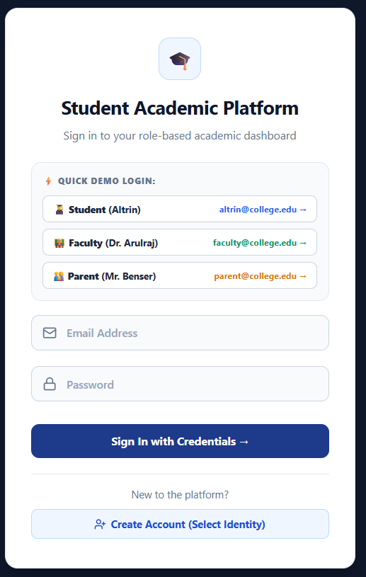

Figure 5.1: User login screen
5.1.2 Primary Stakeholder Dashboards
Once signed in users go directly to a dashboard that matches their roles. Student Academic Dashboard (Figure 5.2): The student dashboard shows a look at academic health. It shows a predicted semester CGPA of 7.15 out of 10.0 79% attendance with a badge showing 4% above the 75% university limit and a risk index of 12%. Interactive cards let students go to exam schedules, attendance records and a What-If recovery tool.
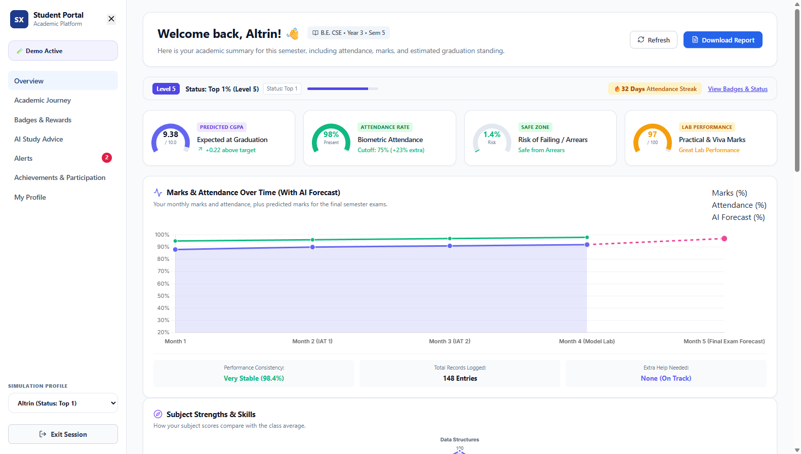
Figure 5.2: Student dashboard
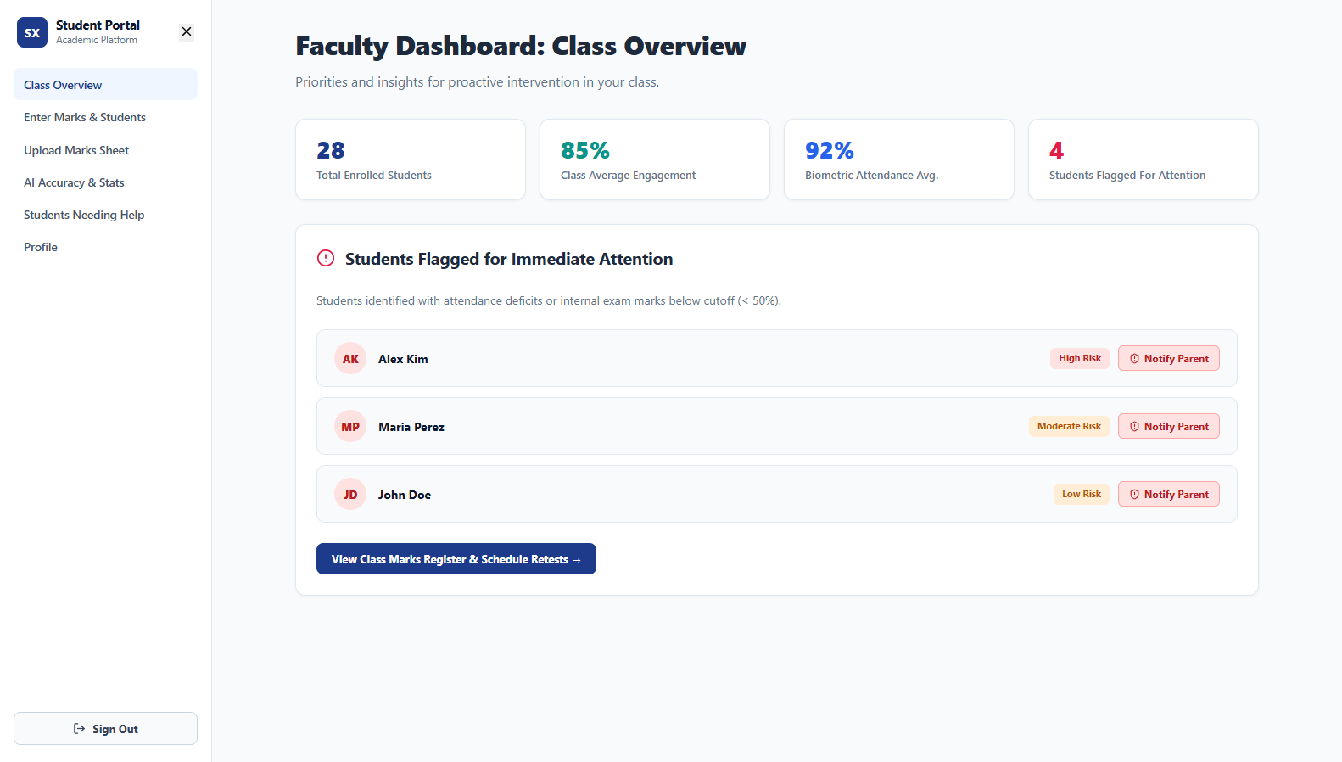
Figure 5.3: Faculty dashboard
Parent Portal Overview (Figure 5.4): The parent screen shows the childs attendance compared to the 75% university rule, recent test scores and notes from the mentor.
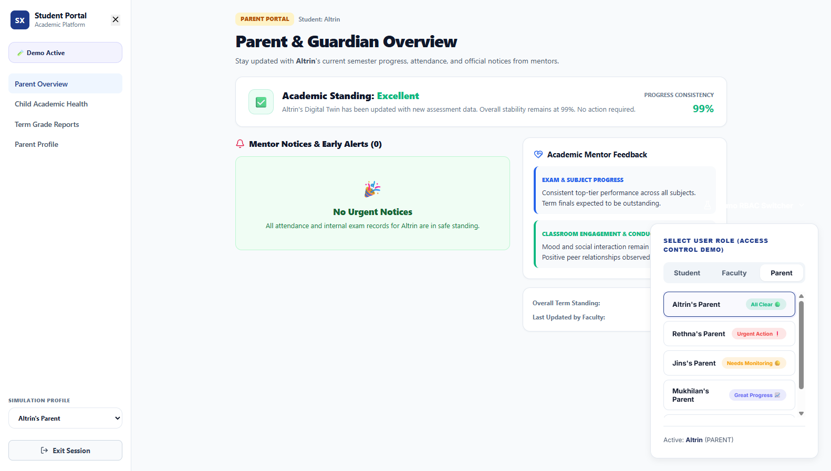
Figure 5.4: Parent dashboard
5.1.3 Core Functional Modules and Decision Support Tools
Apart from the dashboards, the system has several other features such as student tracking, Explainable Ai insights, Multi format uploading and identified students who need support.
The timeline displays important events across the semester such as examinations and important dates. This helps students to understand their academic status and can understand areas where they need to improve. Figure 5.5 shows the digital profile of a student.
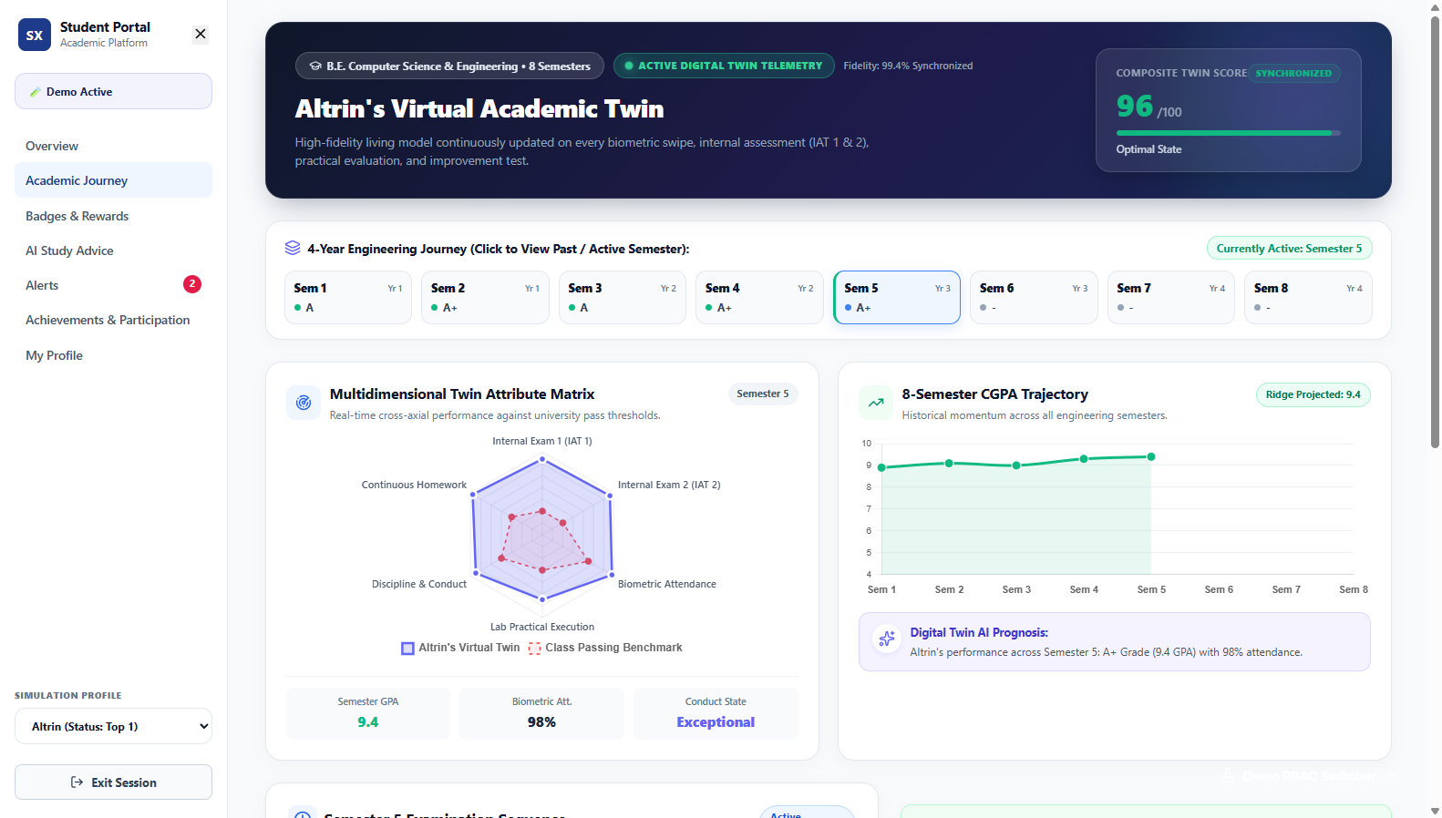

Figure 5.5: Student performance charts

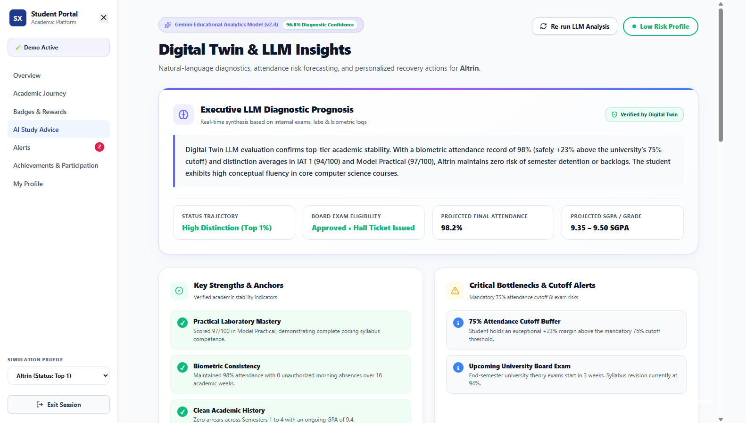
Figure 5.6: Explainable AI insights
Dynamic Multi-Format Upload (Figure 5.7): Figure 5.7 displays how faculty can upload student data using Excel or Csv. The system detects the needed columns and validates the data to make sure the information is correct.
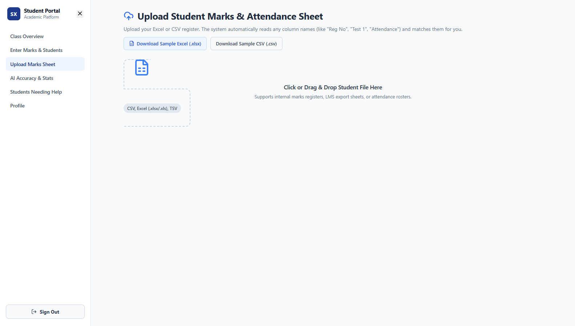
Figure 5.7: File upload using Excel or Csv
Figure 5.8 shows faculty dashboard where they can view students who are identified under warning or critical stage. Based on these details, faculty can send alert to student, and inform their parents and use what if tool to improve their performance in different ways.

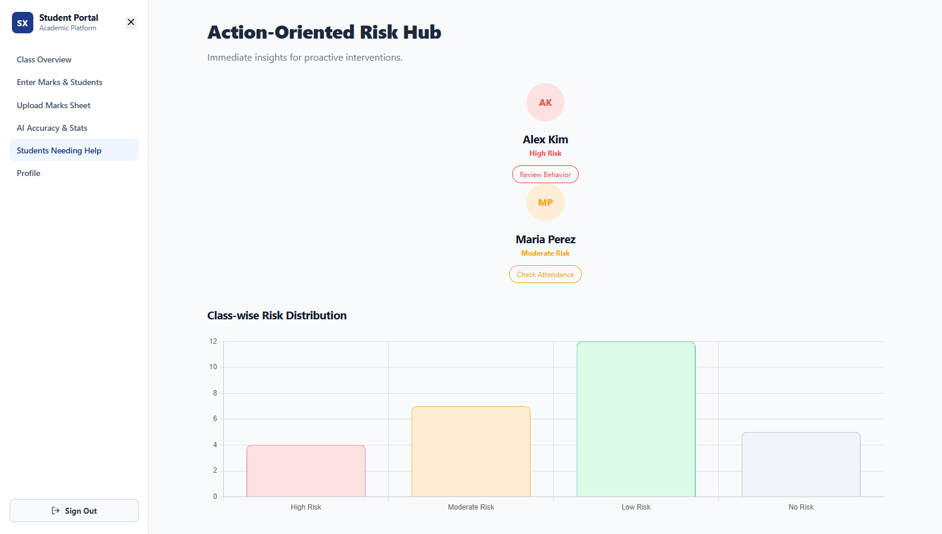
Figure 5.8: Faculty dashboard and students alerts
5.2 Empirical Benchmarks and Latency Analysis
The laptop runs Python 3.13 and SQLite across 100 ingestion runs (Figure 5.9): (1) Event Ingestion Latency: Processing an attendance or score event and updating the 30-day feature vector averaged 26.12 ms. The time ranged between 18.41 ms and 38.22 ms. This is below our 200 ms target. (2) Student State Query Time: Loading a digital twin profile took an average of 2.24 ms. (3) Event Throughput: With SQLites single-file write lock the system handled 38.3 events per second. It processed a roll-call of 60 students in 1.57 seconds.
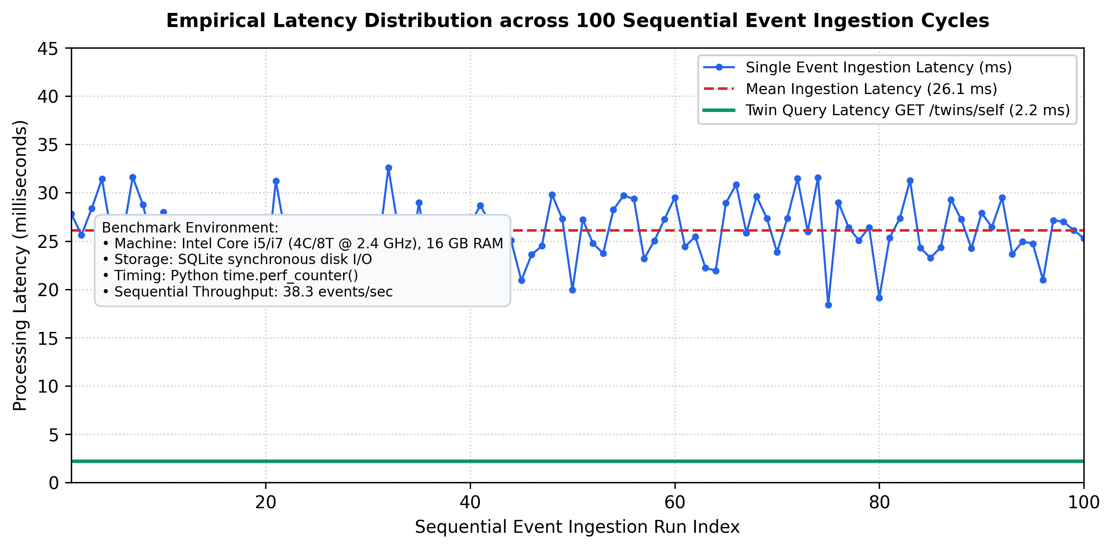
Figure 5.9: System response time across 100 test runs
5.3 Discussion of Architectural and Advisory Findings
The system was tested under different conditions to overcome three advantages of the system. Firstly, a 30 day window is used to help identify differences in attendance and academic performance even before the end of semester. Secondly, Explainable Ai used to understand why a student was identified as risk alert. Finally a What if simulator to perform future academic goals.
5.4 Practical System Limitations and Engineering Constraints
Two practical engineering choices shaped our work. First the transparent baseline formula that has 50% academics, 30% attendance and 20% conduct gives a to-understand score, for mentoring sessions. We used Random Forest and Ridge Regression models to handle non linear patterns in the data. SQLite was used for testing initially. For college deployment, we plan to integrate to PostgreSQL to improve database performance.
CHAPTER 6
CONCLUSION AND FUTURE ENHANCEMENT
6.1 Conclusion
This project focused on creating a working prototype of an AI-Driven Academic Risk and Dropout Early-Warning System that is built around the Digital Class Twin concept. We designed, implemented and tested a system that uses event ingestion to collect data. It processes this data using a 30-day sliding window for analytics. The system calculates a health score for each student. It also applies machine learning models to forecast academic risk. The results are displayed through role based dashboards. The main aim is to identify students who need support before the end of the semester period.
The system was developed using Python FastApi for the backend, SQLite is used for data storage and React 18 is used for user interface. However the prototype performed well during testing, even further validation is required before deploying. Thus allowing us to fine tune the model factors and improve accuracy.
6.2 Future Enhancement
Our system improvements are divided into three phases as mentioned in table 6.1.
Table 6.1 Implementation and Deployment plan
Deployment Phase | Planned Functional Enhancements | Technical Validation Focus
Phase 1: Core Build (Completed) | Event-driven ingestion pipeline, rule-based attribution engine, SQLite storage, role-based React dashboards in-memory What-If simulator. | Unit testing, integration suites, test harness verification via verify_digital_twin.py.
Phase 2: ML Model Training | Train supervised XGBoost / Random Forest models, on multi-semester institutional datasets; calibrate weights. | Cross-validation ROC-AUC precision-recall optimization, SHAP tree explainers.
Phase 3: Production Rollout | PostgreSQL database migration Celery/Redis task queues SMS/WhatsApp parent alerts, mobile app release | Enterprise load testing, security audits, multi-college multi-tenant deployment.

APPENDICES
Appendix 1: Module Responsibility Split and Milestones
The project work was divided among the four team members. The tasks assigned for each members are presented in the table below.
Table A.1 Member wise responsibility
Team Member | Assigned Functional Subsystem | Core Deliverables
Altrin Benser. A (962223205010) | System Architecture & Integration | Project coordination, architecture design, repository maintenance, end-to-end pipeline integration.
Mukhilan. M (962223205040) | Backend Pipeline & Database | FastAPI architecture, SQLAlchemy ORM models, database migrations, demo data seed scripts.
John Jins. J (962223205032) | Digital Twin Engine & Alerting | Twin state machine, snapshot timeline logic, multi-tier alert engine, notification routing.
Jerish Rethna. J (962223205029) | ML Engine, Features & UI | Feature derivation, volatility metrics, React client dashboard UI, What-If simulator, verification scripts.

Appendix 2: Core Data Contracts and Schemas
The formal JSON schema defining synchronous academic event ingestion is defined as follows:
AcademicEventIngestionSchema (JSON Schema v7)
{
"$schema": "http://json-schema.org/draft-07/schema#",
"title": "AcademicEventIngestionSchema",
"type": "object",
"required": ["child_id", "event_type", "payload"],
"properties": {
"child_id": { "type": "string", "description": "Student institutional ID" },
"event_type": { "type": "string", "enum": ["attendance", "academic", "behavior"] },
"payload": {
"type": "object",
"properties": {
"present": { "type": "boolean" },
"score": { "type": "number", "minimum": 0, "maximum": 100 },
"severity": { "type": "integer", "minimum": -5, "maximum": 5 }
}
}
}
}

Appendix 3: Review Demonstration Scenarios
Table B.1 outlines the end-to-end user demonstration scenarios evaluated during review sessions.
Table B.1 End-to-end review demonstration scenarios
Scenario ID | User Action / Test Input | Observed UI & System Response
S1: Baseline Login | Baseline Login Faculty logs into the dashboard using -configured demonstration authentication. | Role is recognized; the user is redirected to the Class Overview page that displays the student roster.
S2: Event Ingestion | Event Ingestion Teacher submits three absences for a student. | The event is processed, the attendance feature decreases and the twin status shifts from Stable to Warning.
S3: Alert Generation | Alert Generation Student risk drops into the Warning threshold. | An alert banner appears on both the Faculty and Parent dashboards complete with tags.
S4: What-If Simulation | What-If Simulation Counselor adjusts a test score to 85% on the student profile. | The shadow twin projects a recovery, to the band but no changes are saved.
S5: Parent View Check | Parent View Check Parent logs into the portal using the mapped credentials. | The child twin is. Privacy is verified as only the assigned child is visible.

REFERENCES
[1] Alalawi, F., Al-Mamary, Y. H. and Al-Ghamdi, A. S. (2025) "An Extended Learning Analytics Framework Integrating Machine Learning and Pedagogical Approaches for Student Performance Prediction and Intervention", Education and Information Technologies, Vol. 30, No. 1, pp. 145-168. https://doi.org/10.1007/s10639-024-12901-2
[2] Balcioglu, M. and Artar, M. (2023) "Predicting Academic Performance of Students with Machine Learning", Education and Information Technologies, Vol. 28, No. 8, pp. 9821-9845. https://doi.org/10.1007/s10639-023-11822-0
[3] Batty, M. (2018) "Digital Twins for Urban Planning", Environment and Planning B: Urban Analytics and City Science, Vol. 45, No. 5, pp. 817-820. https://doi.org/10.1177/2399808318777263
[4] Cagliero, L., Farinetti, L., Baralis, E. and Garza, P. (2021) "Predicting Student Academic Performance by Means of Associative Classification", IEEE Transactions on Learning Technologies, Vol. 14, No. 4, pp. 484-495. https://doi.org/10.1109/TLT.2021.3108605
[5] Cho, H., Lee, S. and Shin, D. (2023) "A Study on Dropout Prediction for University Students Using Machine Learning", Applied Sciences, Vol. 13, No. 12, pp. 7120-7135. https://doi.org/10.3390/app13127120
[6] Dabhade, P., Agarwal, R. and Alvi, A. S. (2021) "Educational Data Mining for Predicting Students' Academic Performance Using Machine Learning Algorithms", International Journal of Advanced Computer Science and Applications (IJACSA), Vol. 12, No. 7, pp. 615-622. https://doi.org/10.14569/IJACSA.2021.0120770
[7] Grieves, M. and Vickers, J. (2017) "Digital Twin: Mitigating Unpredictable, Undesirable Emergent Behavior in Complex Systems", In Transdisciplinary Perspectives on Complex Systems, Springer, Cham, pp. 85-113. https://doi.org/10.1007/978-3-319-38756-7_4
[8] Karalar, H., Bozkurt, A. and Goksel, N. (2021) "Predicting Students at Risk of Academic Failure Using Ensemble Model During Pandemic in a Distance Learning System", Open Praxis, Vol. 13, No. 3, pp. 267-280. https://doi.org/10.5944/openpraxis.13.3.1189
[9] Katsuragi, T. and Tanaka, K. (2022) "Dropout Prediction by Interpretable Machine Learning Model Towards Preventing Student Dropout", In Proceedings of the 14th International Conference on Computer Supported Education (CSEDU 2022), Vol. 2, pp. 312-319. https://doi.org/10.5220/0011082200003182
[10] Lundberg, S. M. and Lee, S. I. (2017) "A Unified Approach to Interpreting Model Predictions", In Advances in Neural Information Processing Systems (NeurIPS 2017), Vol. 30, pp. 4765-4774. https://doi.org/10.48550/arXiv.1705.07874
[11] Miranda, P., Santos, M. and Martins, J. (2024) "Machine Learning's Model-Agnostic Interpretability on the Prediction of Students' Academic Performance in Video-Conference-Assisted Online Learning", Computers & Education, Vol. 215, pp. 105021. https://doi.org/10.1016/j.compedu.2024.105021
[12] Nagy, M. and Molontay, R. (2023) "Interpretable Dropout Prediction: Towards XAI-Based Personalized Intervention", In European Conference on Technology Enhanced Learning (EC-TEL 2023), Springer, LNCS Vol. 14207, pp. 248-262. https://doi.org/10.1007/978-3-031-42682-7_17
[13] Oqaidi, B., El Yamami, A., Mansouri, K. and Qbadou, M. (2022) "Towards a Students' Dropout Prediction Model in Higher Education Institutions Using Machine Learning Algorithms", International Journal of Emerging Technologies in Learning (iJET), Vol. 17, No. 18, pp. 204-220. https://doi.org/10.3991/ijet.v17i18.32420
[14] Park, J. and Yoo, S. (2021) "Early Dropout Prediction in Online Learning of University Using Machine Learning", Journal of Educational Technology & Society, Vol. 24, No. 4, pp. 152-166. https://doi.org/10.2307/jeductechsoci.24.4.152
[15] Plak, S., Merk, S. and Leutner, D. (2022) "Early Warning Systems for More Effective Student Counselling in Higher Education", Assessment & Evaluation in Higher Education, Vol. 47, No. 6, pp. 910-924. https://doi.org/10.1080/02602938.2021.1983794
[16] Qin, K., Zhang, Z., Jin, C. and Zhou, A. (2023) "Early Warning of Student Performance With Integration of Subjective and Objective Elements", IEEE Transactions on Learning Technologies, Vol. 16, No. 5, pp. 741-754. https://doi.org/10.1109/TLT.2023.3283990
[17] Segura, M., Mello, R. and Hernandez, J. (2022) "Machine Learning Prediction of University Student Dropout: Does Preference Play a Key Role?", Mathematics, Vol. 10, No. 18, pp. 3345-3362. https://doi.org/10.3390/math10183345
[18] Su, Y. S., Ding, T. J. and Lai, C. F. (2022) "Applying Machine Learning Technologies to Explore Students' Learning Features and Performance Prediction", IEEE Access, Vol. 10, pp. 58652-58661. https://doi.org/10.1109/ACCESS.2022.3179247
[19] Tamada, M. M., Netto, J. F. and Fernandes, M. A. (2022) "Predicting Students at Risk of Dropout in Technical Course Using LMS Logs", IEEE Revista Iberoamericana de Tecnologias del Aprendizaje (IEEE RITA), Vol. 17, No. 3, pp. 278-286. https://doi.org/10.1109/RITA.2022.3191244
[20] Tao, F., Zhang, H., Liu, A. and Nee, A. Y. C. (2019) "Digital Twins in Industry: State-of-the-Art", IEEE Transactions on Industrial Informatics, Vol. 15, No. 4, pp. 2405-2415. https://doi.org/10.1109/TII.2018.2873186

