**Summary:** Built a Library Management System Using Python and Django Where One Can Perform CRUD Operations on Users and Books. Following Modules have Been Built into System:

Library Management System

1. Login Page
2. Admin Module  
   1. Admin and User Signup  
   2. Add Books  
   3. Update/Delete Books  
   4. View User Records  
   5. View added Books.
3. API login page
4. **Login Page**

Admin or user must provide username and password to login library.

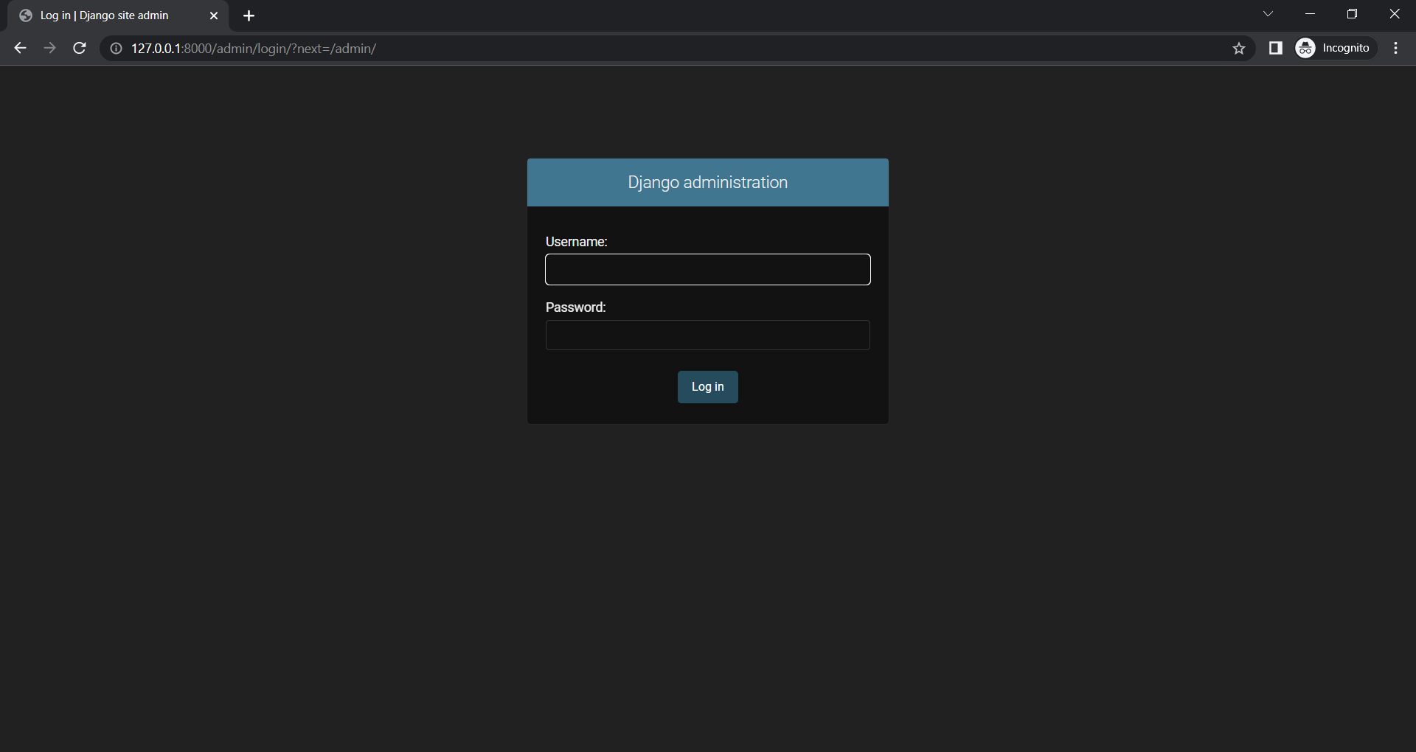

1. **Admin Module**
2. Admin and User Signup

Admin and User can Signup from backend through Superuser.

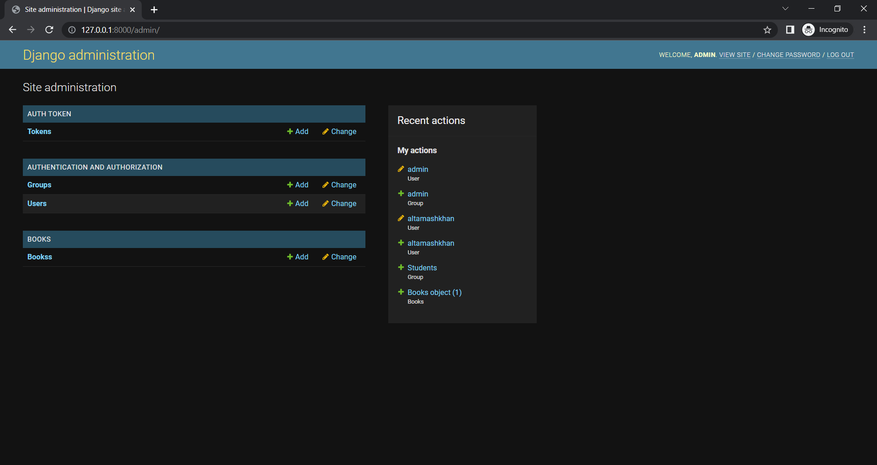

1. **Add Books**

Superuser can add books from backend.

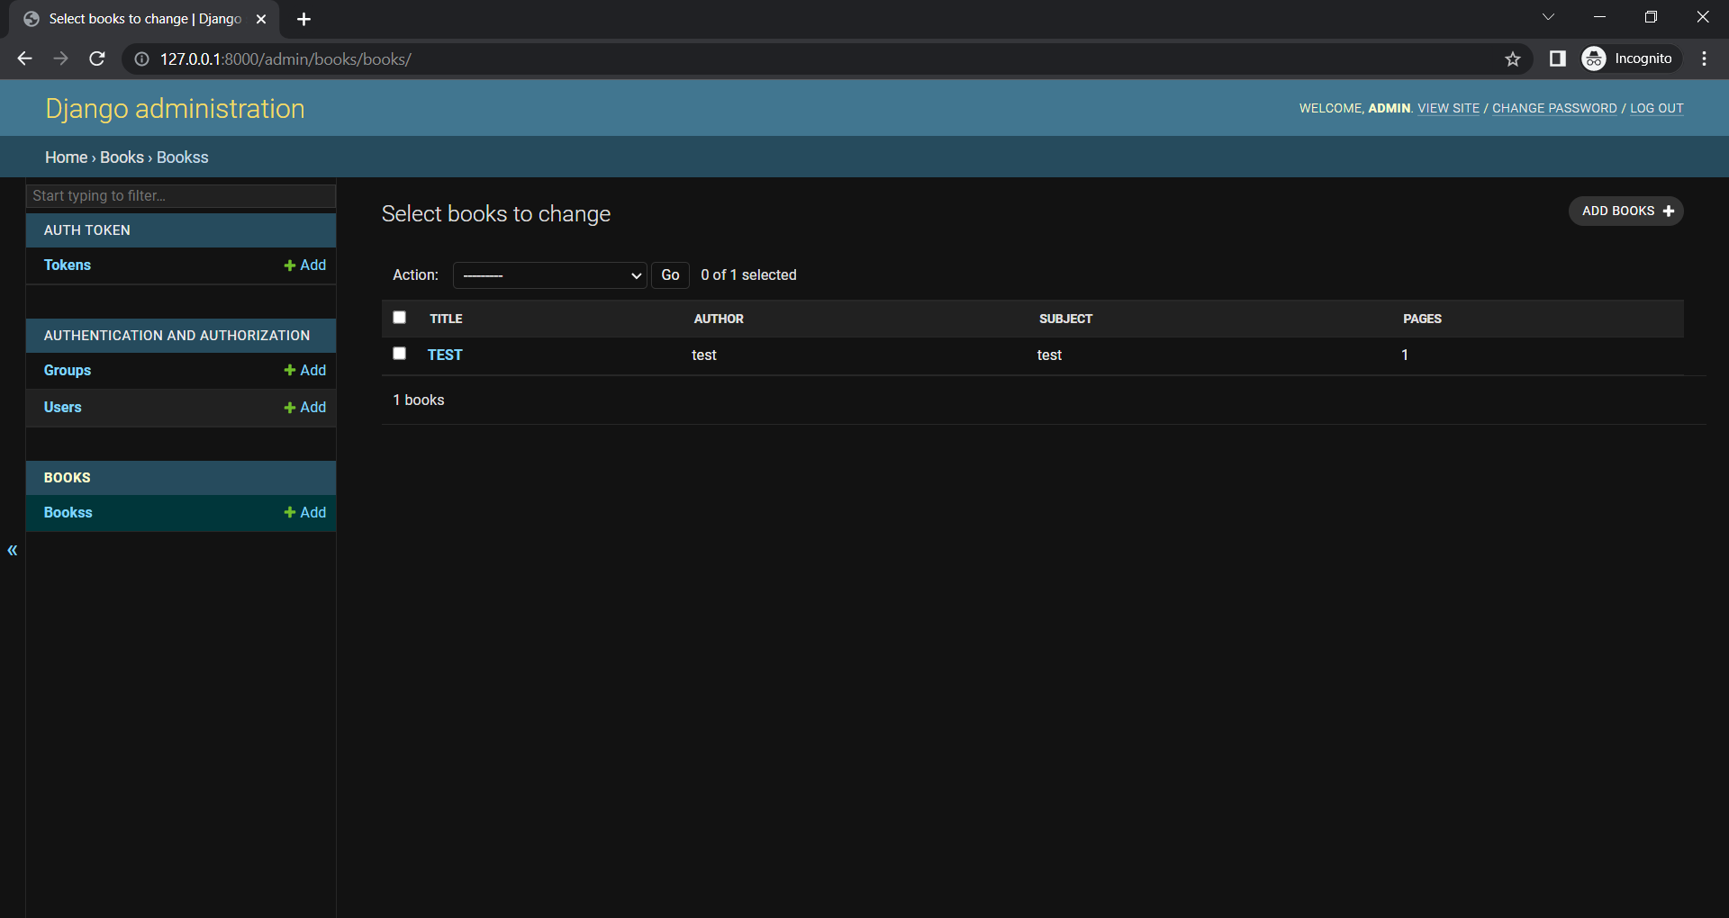

1. **Update/Delete Books**

Superuser can Update or Delete books through backend.

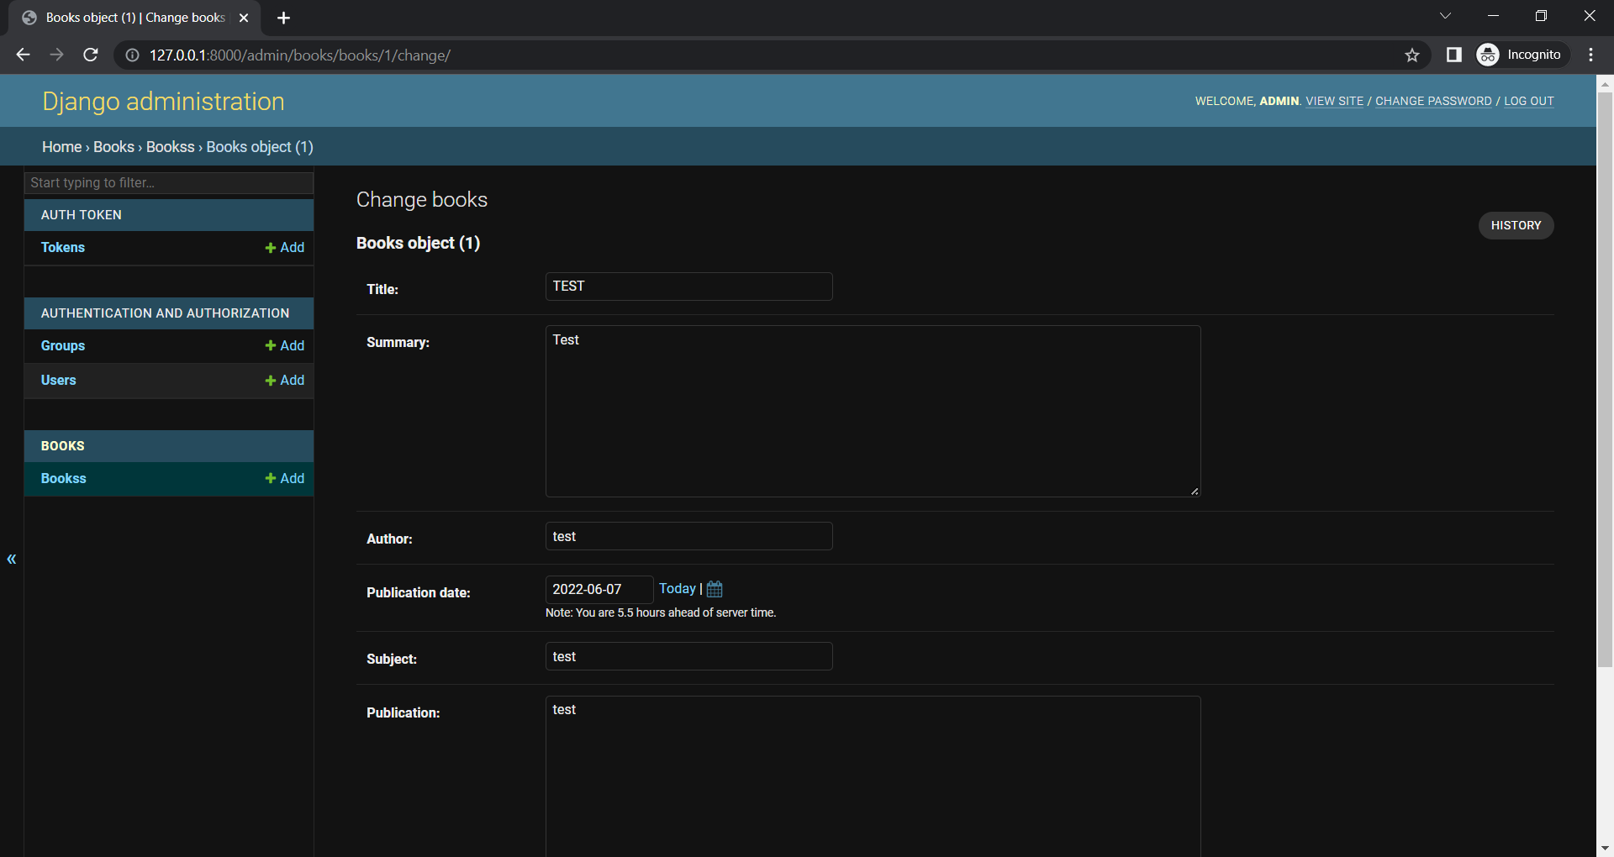

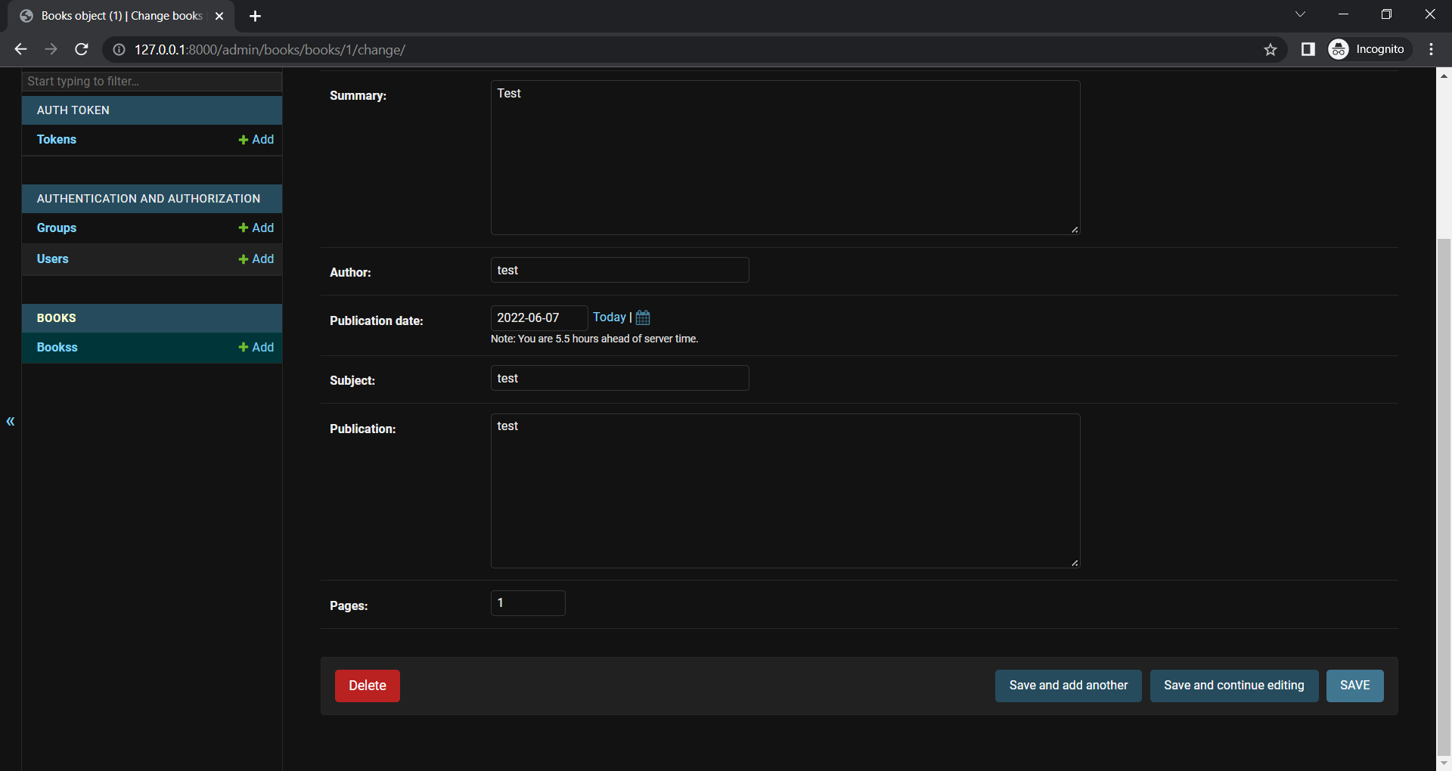

1. View User Records

Superuser can view all the User, Admin or Books records.

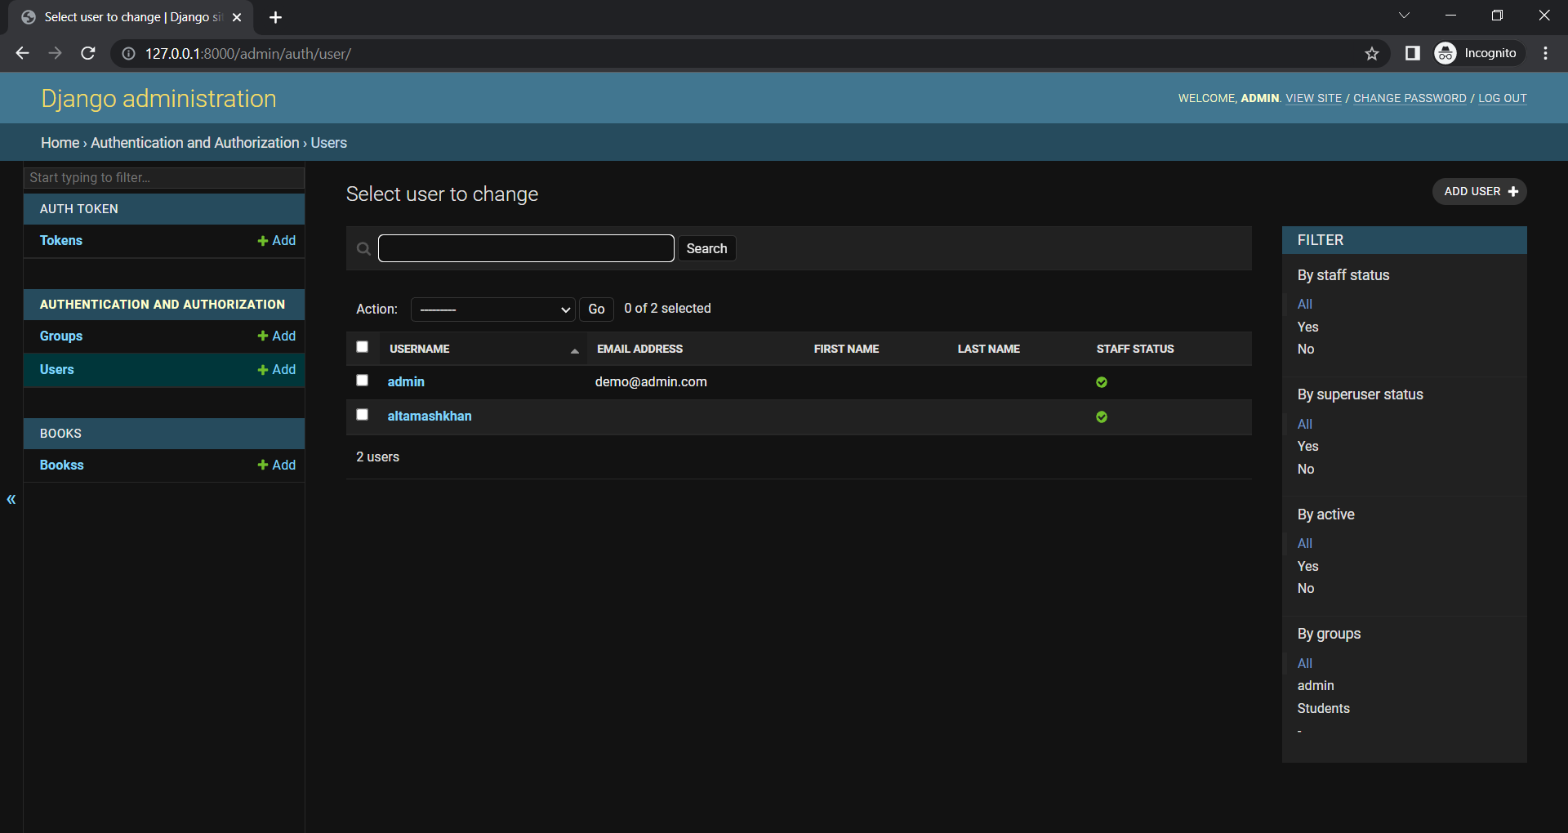

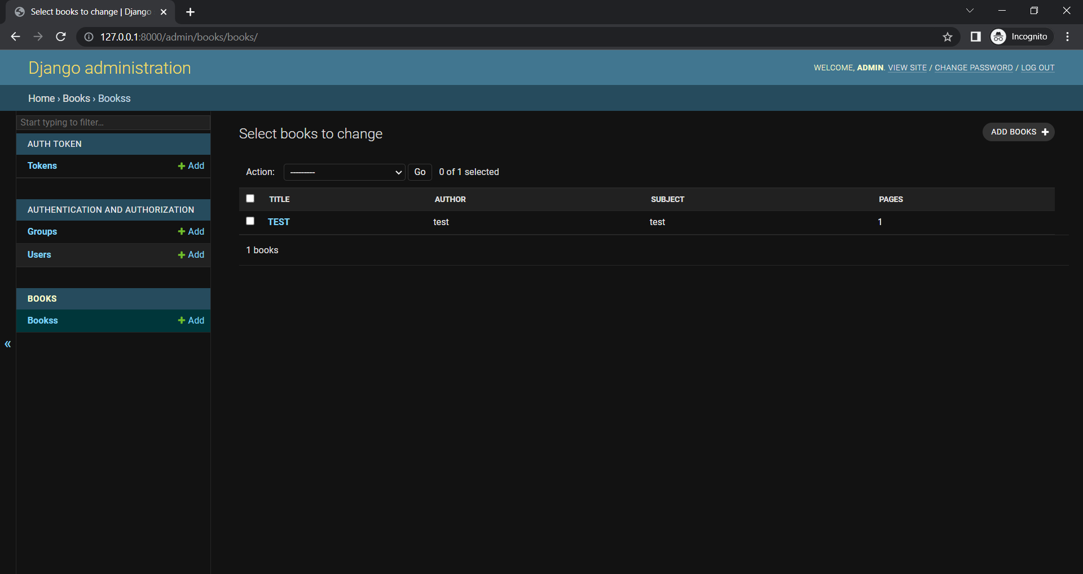

1. **View added Books.**

Admin or User can view all the added books.



1. **API Login Page**

It’s a Restful Api login panel

