An Algebraic Solution for Variation Management in Ontologies
Yusuf Altunel
LC Waikiki | Istanbul Kültür University, Department of Software Engineering
yusuf.altunel@LCWaikiki.com | y.altunel@iku.edu.tr
Abstract—Ontology-based systems increasingly need to compose independently governed components without collapsing into a single brittle graph, a problem the ontology-modularity literature has named but left without a computable answer. This paper builds on an algebraic framework previously developed to formally define software variants, and generalizes it into a domain-independent approach for managing variation in multi-step systems generally: the many ways such a system's parts could be combined are narrowed to a limited, well-defined set of valid options, governed by explicit rules such as dependency, exclusiveness, optionality, and repetition. Applied to ontological structures, this approach yields a single, reproducible number, a Variation Capacity, in place of a qualitative claim that some combination is merely compatible or plausible. We validate the approach with a working proof of concept, PIB (Profile and Integration-Interface Blueprint), built and evaluated as part of this study to manage variation within ontologies so that only the specific features requested by a consuming system are reused. Our experimental results show that representing the framework in ontology form costs efficiency compared to its earlier procedural version, a tradeoff we judge worth paying for the interoperability, machine-checkability, and reasoning support an ontology-based representation provides. Beyond software, this paper's central motivation is to establish the algebra as a domain-independent mechanism for managing variability in any structured, multi-step artifact, ontologies first, but by the same argument applicable to roadmaps, workflows, and governed lineages.
Index Terms—variant algebra, feature-oriented software product lines, ontology engineering, SHACL, OWL, variability management, ecosystem integration
List of Abbreviations
AI EDAM Artificial Intelligence for Engineering Design, Analysis and Manufacturing
AMAST Algebraic Methodology and Software Technology
DL Description Logic
FODA Feature-Oriented Domain Analysis
FOSD Feature-Oriented Software Development
ICSOC International Conference on Service-Oriented Computing
IEEE Institute of Electrical and Electronics Engineers
K-CAP Knowledge Capture Conference
LNCS Lecture Notes in Computer Science
OVM Orthogonal Variability Model
OWL Web Ontology Language
PIB Profile and Integration-Interface Blueprint
RDF Resource Description Framework
SAT Boolean Satisfiability (Problem)
SBF Structure-Behavior-Function (modeling language)
SEI Software Engineering Institute
SHACL Shapes Constraint Language
SPARQL SPARQL Protocol and RDF Query Language
SPL Software Product Line
SPLC Software Product Line Conference
W3C World Wide Web Consortium
WWW World Wide Web (Conference)

I. Introduction
Software product line (SPL) engineering has long relied on feature models (Kang et al., 1990) and their algebraic treatments (Höfner et al., 2006), (Apel et al., 2008) to formalize variability. A 2013 doctoral thesis developed an independent algebraic approach to the same problem, defining a formal structure over software elements and six composition operators (Altunel, 2013). This paper reports a substantial extension of that work, grounded in a considerably wider body of prior literature than the original thesis engaged directly, and a real, external application demonstrating its value beyond the domain it was originally designed for.
Ontologies, roadmaps, workflows, and governed lineages share a common structural property: each is a multi-step, rule-constrained artifact built by combining a bounded set of parts in only some of the ways combination allows. This paper adapts the algebra to manage variability in one such artifact, ontological structures, and argues, by the same reasoning that motivates that adaptation, that the same formal mechanism generalizes to the others. Section VII returns to this point directly, once the ontology case has been established in full.
A brief note on implementation language is warranted before proceeding, since the algebra's own history spans three of them. The originating thesis implements its calculi in Java, on the NetBeans platform. Subsequent development reimplemented these calculi first in Python, then in the ontology-native form examined in this paper, using SPARQL (SPARQL Protocol and RDF Query Language) over an OWL-based representation. What matters, and what Section IV argues for directly, is the reason for the final move: a declarative ontology language offers interoperability across tools built on the same standard, machine-checkable validation independent of any single codebase, and the capacity for a reasoner to derive consequences the original procedural code would have had to compute by hand for every new case.
Section II presents the algebra's formal foundations, its operator family, composition model, and domain-independence extension. Section III presents the profile mechanism realized independently in both systems studied. Sections IV and V present the calculus reimplementation and PIB's own real application to ecosystem integration, respectively. Section VI reports the two honest empirical results. Section VII concludes.

II. VARIANT ALGEBRA FOUNDATIONS
The variant algebra that grounds this work formalizes how software component variants are generated from a bounded set of algebraic elements and operators. This section outlines its historical origin before turning to the three extensions this paper contributes.
The algebra originates in a 2013 doctoral thesis, which defines a formal structure Lambda = <Psi, Phi, Delta, Gamma> (Altunel, 2013). Psi denotes the algebraic elements, including Entity, Component, Feature, Attribute, and Method; Phi their attributes; Delta the admissible operations; and Gamma the combinations of operation and element the algebra sanctions as well-formed. A comparable formal treatment appears independently in the feature-algebra literature, where composition is instead modeled using an idempotent semiring over sets of products (Höfner et al., 2006). That work was later extended by the same research group into a more general algebraic foundation for feature-oriented program synthesis (Apel et al., 2008).
Both lineages address the same underlying problem: specifying which combinations of parts constitute a valid product. This concern traces to a much older one in software engineering, decomposing systems into independently modifiable parts (Parnas, 1972), and to the feature-oriented domain analysis methodology from which the wider field descends (Kang et al., 1990). A third, formally distinct lineage addresses the same problem differently. Feature models can be translated directly into propositional logic, so that questions of consistency, dead features, and common features reduce to satisfiability checks a general-purpose SAT solver can answer (Czarnecki and Wasowski, 2007). A wide subsequent survey situates this approach among several automated analysis techniques for variability models (Benavides et al., 2010). The present algebra shares this third lineage's concern with mechanical checkability, but expresses admissibility through its own six operators rather than a compiled propositional formula.
Three extensions distinguish the present treatment from the original thesis. The first generalizes the algebra's elements beyond software through a domain-neutral superclass, tested by demonstration on an independent, non-software domain rather than simply declared. The second recasts several original detection calculi as declarative SPARQL CONSTRUCT queries, trading a procedural description for a logical specification. The third establishes a working profile mechanism binding the algebra's general apparatus to concrete uses, realized here first for software and then, independently, for validating integration between ecosystem tools. Each extension carries its own evidentiary standard, so a reader encounters the specific proof, benchmark, or reproduced metric that grounds it, not merely a claim of generality.
For a reader assessing whether an algebraic account of variant generation genuinely generalizes beyond its originating domain, the implication is that domain-independence claims warrant evaluation against a real cross-domain demonstration. The mere absence of domain-specific assertions is a substantially weaker standard, one too easily satisfied to be persuasive on its own. This distinction bears directly on how any future extension of the present algebra ought to be evaluated before its generality is accepted.

A. Operator Family
Six operators govern feature composition within the algebra: Mandatory, Optional, Exclusive, Or, Dependency, and Repetition. Each is formally defined together with a distribution rule specifying how it interacts with the others (Altunel, 2013). These six belong to a larger, evolving operator family within the same algebra, tagged in the underlying ontology as governing presence and absence specifically; a second, co-equal family governs set-level transformation over elements (addition, subtraction, intersection, Cartesian product, division, and inverse), and is not exercised by this paper's own scope, which follows PIB's use of the presence-governing operators only. Neither family is a subset of the other in any privileged sense; both are tagged, in the ontology, as belonging to one shared operator category, and this paper's narrower scope reflects what its own application exercises, not a claim about the algebra's complete extent. A related set of relations appears in the feature-diagram literature, which defines Mandatory, Optional, Alternative, and Or in comparable terms, treating Requires and Excludes as supplementary textual constraints rather than diagrammatic operators (Wang et al., 2007). That two independently developed vocabularies converge so closely suggests the six-operator core is not an idiosyncrasy of this particular formalization.
The broader categorization these operators sit within, syntax, semantics, and behavior, is a deliberate departure from classical trichotomies, not an unexamined convention. The classical semiotic division is syntax, semantics, and pragmatics (Morris, 1938). A distinct structure-behavior-function triad exists independently in systems engineering, formalized there as its own knowledge-representation language (Goel et al., 2009). The present categorization's own fitness deserves the same scrutiny typically given to the operators it organizes.
Each operator carries a corresponding SHACL shape in the current implementation. A declared relation can therefore be validated structurally, at the moment it is asserted, rather than trusted by convention until some later stage reveals an inconsistency. This differs from approaches relying primarily on a description-logic reasoner to detect inconsistency in an already-fixed configuration, since reasoner-based checking of that kind typically applies only once a configuration has been assembled (Wang et al., 2007). A wrongly declared relation may persist undetected until a specific configuration happens to exercise it. The two techniques are therefore better understood as complementary than competing, addressing correctness at different stages of the same workflow.
The operators introduced above are not an ad hoc list; all seven, including the Cartesian product operator used by the enumeration engine in Section IV.C, are real subclasses of a single VariabilityOperator class in the underlying ontology, shown in Figure 1.
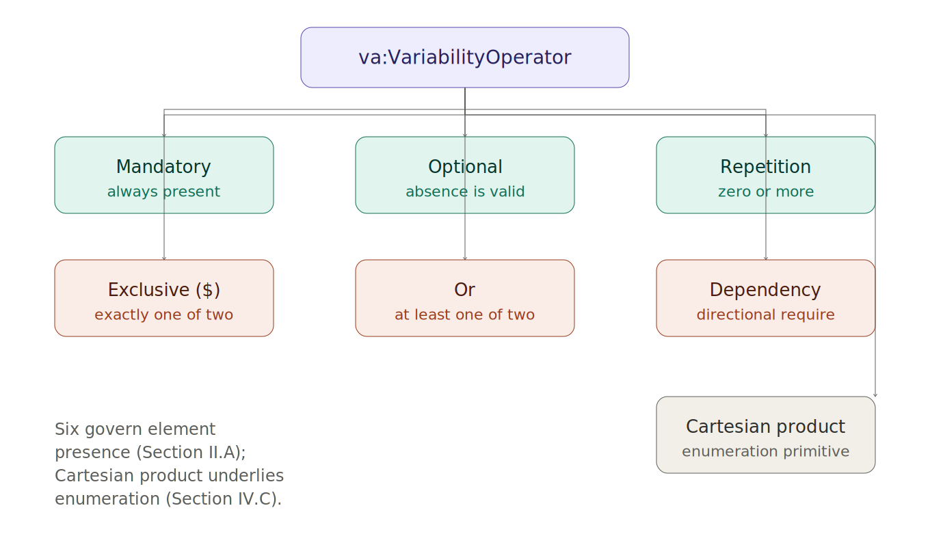
Figure 1. The operator taxonomy. Six operators govern element presence; the Cartesian product operator underlies enumeration.
Figure 2 applies six of these operators to a small, concrete element set, {Email, SMS, Push, LightTheme, DarkTheme, DeliveryConfirmation, RetryPolicy}, and evaluates three candidate variants against the resulting constraints.
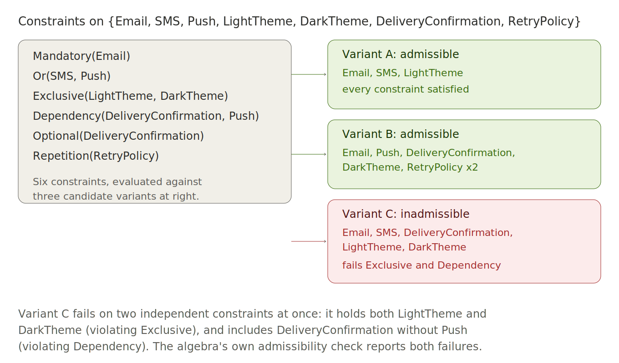
Figure 2. Two admissible variants and one inadmissible variant, evaluated against the same six constraints. Variant C fails two constraints at once.
This is the same check, at the same granularity, that the enumeration engine in Section IV.C performs at scale: given a full element set and its operator constraints, it computes every variant the constraints admit directly, which is what makes Variation Capacity in Section V.C a count rather than an estimate.

B. Composition Model
A composable unit denotes a software unit eligible to serve as an operand of a composition operator. It is typically a feature, method, or component drawn from an artifact under discovery or synthesis. Composability of this kind sits within a broader tradition in feature-oriented product line engineering. That tradition generally treats composition as the central mechanism by which variants are constructed from reusable parts (Apel et al., 2013). A substantial literature has since classified the concrete techniques by which such composition is realized in practice, from inheritance to code generation (Svahnberg et al., 2005).
The term variant itself is worth grounding explicitly here, since the present algebra uses it in a specific, technical sense. In the foundational software product line literature, a variant is a member of a family of systems built from a shared, managed set of core assets, developed in a prescribed way rather than assembled ad hoc (Clements and Northrop, 2001). That definition is qualitative: it says what a variant is, but not how to decide, for a specific combination of assets, whether it counts as one. A formalism is needed precisely because a shared asset base admits many valid combinations, and only some of those combinations should count as an intended, supportable variant. Without a formal admissibility rule, that distinction can only be maintained informally, and informally maintained distinctions tend to erode as a product family grows. Supplying exactly this missing formal mechanism, an algebraic operator set against which any candidate combination can be mechanically checked for admissibility, is the present algebra's own original contribution, first made in the 2013 thesis this paper extends and not, to the present research, already available elsewhere in the literature surveyed here.
Every operator ultimately acts on some real composable unit drawn from an artifact under discovery or synthesis. Operator semantics are therefore only as meaningful as the underlying identification of that unit is sound. This dependency is not unique to the present algebra; feature-model approaches generally presuppose that the features being composed were already correctly identified within the source diagram or ontology (Wang et al., 2007). It is worth stating the dependency explicitly nonetheless, since a defect in unit identification would otherwise propagate silently through an operator application that is, on its own formal terms, entirely correct.

C. Domain Independence
The originating thesis defines its algebra over software elements specifically, without addressing whether the same formal apparatus applies outside software (Altunel, 2013). The present work extends the algebra with a domain-neutral superclass, tested by constructing an independent, non-software domain: a set of recipes, in which ingredients and preparation steps stand in for features and components. The domain's own competency questions were answered correctly under full RDFS deductive closure, a substantially more demanding test than simply confirming the absence of software-specific assertions.
Prior work has already shown that description-logic reasoning can verify variability structures represented as OWL ontologies, though largely within the software domain from which those structures were drawn (Wang et al., 2007). A related line of work goes further. It maps feature-model elements directly to OWL classes and properties, demonstrating that the resulting ontology can drive a generated application rather than remain a static verification artifact (Afriyanti et al., 2017). A domain ontology treating variability itself as a first-class subject has independent precedent too (Asikainen et al., 2007). The present result differs from this prior work in scope, not technique: the reasoning apparatus is comparable, but the domain under test was deliberately chosen to contain no software-specific content, so a positive result speaks to generality.
A real, independent instance of this same generality appeared unexpectedly elsewhere in the ecosystem. A separate governance tool later adapted five of the algebra's six operators to constrain its own internal presentation-widget rules, by declared conceptual analogy rather than import. This is a domain with no relation to software components at all.
Variability management has, in fact, already crossed from software into an entirely different engineering discipline once before. Business process management defines configurable reference process models. Variation points and configuration alternatives govern which workflow variant results, using a vocabulary that parallels the present algebra's own operators closely, despite having been developed independently for a different kind of artifact (Rosemann and van der Aalst, 2007). This precedent, together with the recipe domain and the widget-rule instance, suggests domain-independence claims of this kind have real company in practice, not only a defense in principle.

D. What the Thesis Established and What This Paper Adds
The material presented above in this section, the formal structure Lambda, the six operators, and their treatment of composability, belongs to the 2013 thesis (Altunel, 2013). Nothing about the operators themselves, their number, or their formal definitions changes in this paper. What follows in the rest of this paper is additive: three extensions layered onto that unchanged foundation, none of which required modifying the operator set the thesis already defined.
The first extension is domain-independence, presented in Section II.C: a single new superclass generalizing the algebra's elements beyond software, tested by demonstration rather than declared. The second is the ontology-native reimplementation presented in Section IV, which changes how the calculi execute without changing what they compute. The third, and the one Section III develops in full, is a second profile. The thesis realizes the algebra's general operators as exactly one concrete profile, for software. This paper adds a second, independently defined profile, for ecosystem integration, built on top of the same unchanged six operators and validated by PIB. Where the thesis instantiates the algebra once, this paper instantiates it twice, and argues in Section VII that a third and further instantiations, for roadmaps, workflows, and governed lineages, follow the same pattern.
A profile, in this sense, is not a fourth operator or a modification to the existing six; it is a specific binding of them; a choice of which elements, attributes, and constraints from the general algebra apply to one concrete use. The thesis's software profile and this paper's integration profile therefore share every operator and formal rule the thesis defined; they differ only in which elements those operators are bound to and which artifact the resulting admissibility check runs against.
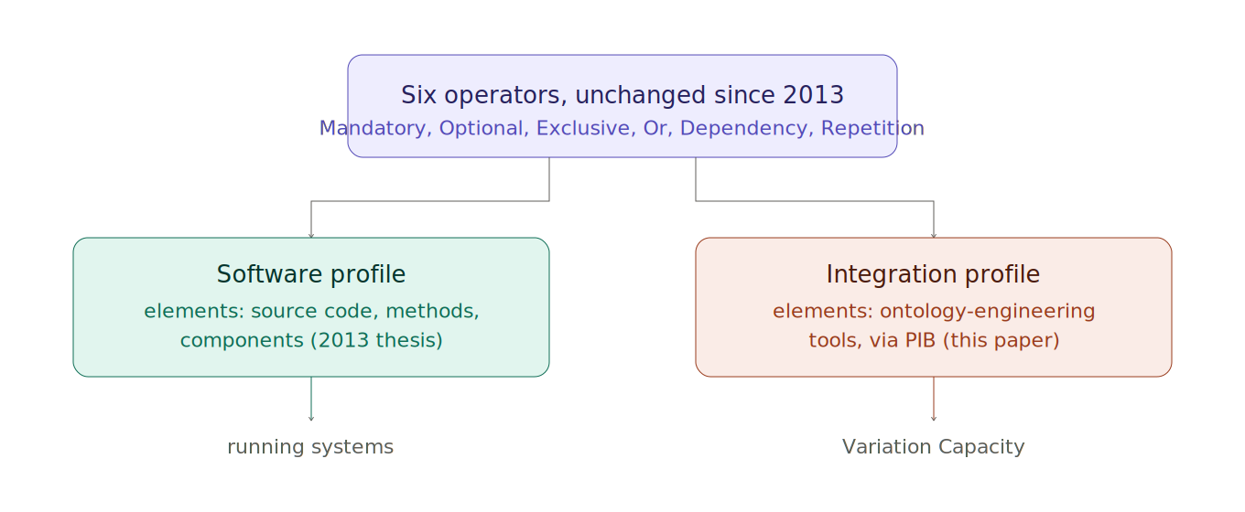
Figure 4. One operator core, two independent profiles. The thesis realizes the left branch; this paper adds the right.

III. PROFILE MECHANISM
A construct recurring across both systems examined here is the profile, a mechanism binding the algebra's general machinery to one specific use. This section introduces the two independently defined profiles this paper studies, and the naming collision that arises between them.
The originating framework realizes a profile once, for software, spanning discovery, conversion, and synthesis over source code and oriented toward identifying relationships between software units so variants may be built from them (Altunel, 2013). A second, independently defined profile appears in the ecosystem-integration application examined later (Sections 7 through 10), where a profile instead binds an artifact category to a validated wiring configuration. Both instantiate a shared general pattern, a configuration that resolves a bounded variation space to a single, reproducible point, without either sharing a formal definition with the other.
This shared name reflects a genuine naming collision rather than substantive overlap. It was treated deliberately in constructing the domain ontology underlying this paper. Each profile is represented by citing its own authoritative definition rather than collapsing both into a shared class, since doing so would misrepresent two structurally distinct mechanisms as one. The same discipline extends to several further terms examined later, where a term native to one system's vocabulary is found, on inspection, to already carry a related but distinct meaning within the other. Product-line tooling implicitly recognizes a comparable risk, since a configuration mechanism in one tool need not denote the same structure a like-named mechanism provides elsewhere (Apel et al., 2013).
The word profile itself carries at least two further, well-established meanings this paper must be read against. The W3C's own OWL 2 specification uses profile for a syntactically restricted sublanguage that trades expressive power for reasoning efficiency, a fragment in the logician's sense rather than a configured use case (Motik et al., 2012). The variability literature, meanwhile, generally uses variant for a concrete option realized at a variation point, treating variant and variation point as its own pair of primary terms, formalized in a widely adopted reference text and later incorporated into an international standard for product-line engineering (Pohl et al., 2005). Neither of these established senses is the one this paper uses for profile or variant; both are noted here so a reader arriving from either tradition is not misled by the overlap.
A shared vocabulary term should not be assumed to denote a shared concept without checking each system's own authoritative definition directly. Constructing this paper's own supporting ontology required exactly this check for ten of fourteen candidate concepts, and the discipline it imposed is offered here as a general caution, not a peculiarity of this pair of systems.

A. Software Profile
Software is realized as the framework's first concrete domain profile, spanning discovery over source code, development documentation, and database metadata (Altunel, 2013). It is oriented toward identifying relationships between software units, typically selecting and constructing variants from them, and synthesizing running systems as the result. This is the profile against which the framework's own working pipeline, comprising discovery, conversion, and synthesis, was built and tested. It is also the profile from which this paper's two empirical results (Sections 12 and 13) are drawn.
This orientation toward recursive, variant-aware component development is not new to the present work. It extends a research trajectory the same author had already begun with a recursive development and variant-generation approach to component-based design (Altunel and Tolun, 2004), followed by a treatment of the project-estimation issues such recursive development raises (Altunel and Tolun, 2008).
The software profile's own scope extends beyond what this paper's results directly exercise, spanning documentation and metadata sources not otherwise discussed here. Neither this paper's empirical results nor its application study of the ecosystem-integration system draws on that broader scope. A complete account of the profile's real capabilities is accordingly broader than what is reported, which restricts itself to the components its own results actually exercise. Documenting only a profile's exercised subset, rather than its full theoretical extent, is in any case the general reporting practice the product-line literature follows when presenting a specific study (Apel et al., 2013).

B. Integration Profile
The ecosystem-integration application studied later in this paper defines its own, genuinely distinct profile. It binds exactly one artifact category, the criteria shared across the systems that consume it, and exactly one validated wiring configuration. Where the software profile answers how a component varies internally, this profile instead answers which integration wiring is typically reproducible for a given kind of artifact, a structurally different question despite the shared term.
This profile's value is best appreciated against a longstanding concern in the ontology-modularity literature. That literature raises brittle coupling between independently maintained ontologies as a real risk (Rector et al., 2012). Rather than merging systems into a single graph through owl:imports, the integration profile resolves a bounded configuration space to one reproducible point per artifact category, leaving each system's own ontology untouched and independently governed.
A comparable concern for bounded, governed variation motivates the product-line literature's general treatment of configuration as an artifact distinct from the feature model it configures (Apel et al., 2013). This suggests a recurring pattern here, not an isolated decision.

C. Toward LLM-Assisted Profile Management
The two profiles examined above share a common shape: each binds the algebra's general operators to one concrete use by selecting a bounded set of elements, criteria, and constraints from a much larger space of possibilities. Selecting that bounded set well is a task that currently requires a person familiar with both the algebra and the target domain. Once the algebra exists in ontology form, as it does here, this task becomes a natural candidate for large-language-model assistance: a model conditioned on the algebra's own formal vocabulary could propose candidate profile definitions, flag elements a draft profile has left unbound, or check a proposed profile's constraints against the same SHACL shapes this paper's own validation architecture already uses. This is a genuinely different role for a language model than authoring prose: the model's output would remain fully checkable against the algebra's own formal semantics, in the same way PIB's own wiring validator checks a proposed integration rather than trusting it. This paper does not implement or evaluate such a system; it is raised here as motivation for future work, made concrete by the fact that the formal substrate such a system would depend on, the ontology-native algebra and its profile mechanism, already exists and has been validated in this paper.

IV. CALCULUS AND CONVERSION
Several of the framework's original detection calculi, rules examining source structure and proposing algebraic relationships, were reimplemented during this work as declarative SPARQL CONSTRUCT queries. This section covers that reimplementation, the quality gate applied to each conversion, and the enumeration mechanism computing which variants a constraint set admits.
The originating thesis implements its calculi as a Java application on the NetBeans platform, not procedurally in Python. The thesis states directly that Java was preferred for its wide use and rich libraries, with the completed system coded on NetBeans IDE 7.1 and 7.2 against a PostgreSQL database (Altunel, 2013). VAF's own later development reimplemented these calculi twice in succession. The first reimplementation used Python, as an intermediate step; the second produced the declarative SPARQL CONSTRUCT queries examined in this paper. This three-stage history is disclosed explicitly, since the paper's own benchmark (Section 12) typically compares SPARQL against the intermediate Python version, not against the thesis's original Java implementation.
The reimplementation reported here differs from a pure consistency check in an important respect. Rather than only detecting an invalid configuration, the converted calculi propose new algebraic relationships from discovered facts. This task more closely parallels ontology-generation work that derives an OWL ontology directly from a feature model and uses it to drive an application (Afriyanti et al., 2017). The distinction matters because a defect in a proposing calculus manifests differently than a defect in a checking calculus. The former can silently produce an incorrect relationship, whereas the latter merely fails to flag an existing one, and it is precisely this first category of defect the quality gate examined in Section 13 was built to catch.
Projects considering similar declarative reimplementation of proposing, rather than merely checking, analysis logic should budget for a dedicated quality-gate mechanism distinct from what a pure consistency check would require. A proposing calculus's characteristic failure mode is not the failure mode a consistency-only literature was designed to catch.

A. Calculus Reimplementation
The attribute-usage detection calculus proposes that a method depends on an attribute it reads. Within VAF's own development, prior to the present work, this calculus existed as a Python rule. That Python version was itself already a reimplementation of the thesis's own original Java version (Altunel, 2013). It was reimplemented a second time during the present work, now as a declarative SPARQL CONSTRUCT query producing the identical relationship over the same discovered facts. This calculus is typically representative of the broader reimplementation performed here, in which rules most recently expressed as Python procedural code became declarative graph queries.
The conversion's correctness was tested directly against VAF's own intermediate Python implementation on shared fixtures, rather than simply assumed from the query's apparent correspondence to the rule it replaces; the thesis's own original Java implementation was not itself re-run for this comparison, since VAF's own Python version is the immediate predecessor the SPARQL query was converted from. This distinction matters. Declarative and procedural expressions of the same intended logic can diverge subtly at edge cases, even when the two appear equivalent on inspection. This empirical testing discipline generally parallels the evaluation approach taken more broadly in feature-model verification work, where a reasoning-based check is typically validated against an independently constructed feature model and configuration set, rather than trusted purely by virtue of how it was built (Wang et al., 2007).

B. Conversion Quality Gate
Every conversion attempt typically receives an accept, reject, or needs-review verdict from a dedicated quality gate. Such a gate is only as trustworthy as the defects it can be shown to catch: a genuine defect surfaced here illustrates the point directly. Two legitimate, independent conversions that happened to share a slot name were wrongly flagged as ambiguous by an already-shipped validator (Altunel, 2013). The error traced to a missing ontology property that would otherwise have distinguished the two cases.
The defect illustrates a general property of proposing, as opposed to checking, calculi, discussed above in Section 4. A wrongly proposed relationship can persist undetected until some case exercises the specific gap in the validator's discriminating logic, in this instance a missing distinguishing property rather than any flaw in the underlying reasoning. Remediation extended to both the SHACL shape and the production entry point, with a regression fixture added so the defect could not silently recur. This correction discipline mirrors, though independently of, the systematic error-cataloguing approach in the OWL-authoring literature, where a fixed set of frequently made modeling errors is compiled into a reusable debugging heuristic (Wang et al., 2007).

C. Variant Enumeration
Given a set of operator constraints, the enumeration engine computes every admissible variant. Every assignment must satisfy every Mandatory, Exclusive, Dependency, and other constraint simultaneously (Altunel, 2013). This mechanism is exercised directly by the ecosystem-integration application examined later (Section 9). It calls the enumeration engine as an external, pinned dependency to compute a Variation Capacity metric for a given integration wiring.
This computation reproduces the pinned engine's own worked example exactly: nine admissible wirings. All four collision-guard checks behave precisely as documented: two measurers, consume-without-produce, no source, and the valid case. Brute-force enumeration of this kind trades computational efficiency for a comparatively simple, directly auditable correctness argument. A description-logic reasoning approach would instead derive admissibility from a consistency check over an OWL representation of the same constraints. This typically comes at the cost of a derivation that is less directly inspectable (Wang et al., 2007). The present work adopts brute-force enumeration deliberately for the auditability this affords, notwithstanding the runtime cost documented in Section 12's benchmark.

V. ECOSYSTEM INTEGRATION
The variant algebra is applied in this work to a problem the originating thesis does not address: validating how independent software systems ought to integrate. This section introduces the real application under study and the architectural principle, declared contracts rather than merged graphs, that governs it.
Three real, separately governed ontology-engineering tools must typically compose without collapsing into a single, brittle graph: one generates artifacts, one measures them, and one grades them. This is not a narrow or recent concern; ontology modularity has been studied for two decades, in a line of work that traces the same modular-design tradition long established in software engineering more broadly. An early treatment argued that modularity is a key requirement for ontology reuse, maintainability, and evolution, and proposed a normalization method for description-logic ontologies to support it (Rector, 2003). A widely cited technical treatment shortly after proposed representing module boundaries using a formal logical connective, so that separate ontologies could be combined while keeping each one's own reasoning tractable, leaving the approach's scalability across arbitrary import patterns an open question (Cuenca Grau et al., 2005). A parallel line of work developed algorithms for extracting relevant, self-contained segments from large medical ontologies for human and machine tractability, evaluated on a real clinical ontology; the resulting segments proved useful in practice but were not always semantically complete as standalone modules in their own right (Seidenberg and Rector, 2006). By the end of the decade the field had matured enough to support a dedicated edited volume surveying the state of the art, one that explicitly situates ontology modularization within this same broader software-engineering tradition, reusing many of software's own criteria for what makes a good module (Stuckenschmidt et al., 2009). A systematic review spanning two full decades of this research confirms it remains an active area without full methodological convergence (Le Clair et al., 2023). This requirement maps onto a gap named more specifically in later work: a call for an adaptation mechanism permitting axioms to be filtered as well as added, since OWL's own import semantics remain global rather than selective (Rector et al., 2012). None of this substantial literature, spanning normalization, logical connectives, segmentation, and comprehensive surveys, supplies a directly computable admissibility metric for validating a specific integration wiring among a bounded, fixed set of already-complete, independently governed ontologies; each instead addresses extracting, combining, or surveying modules for reuse and reasoning tractability. This is the more specific gap the present application closes.
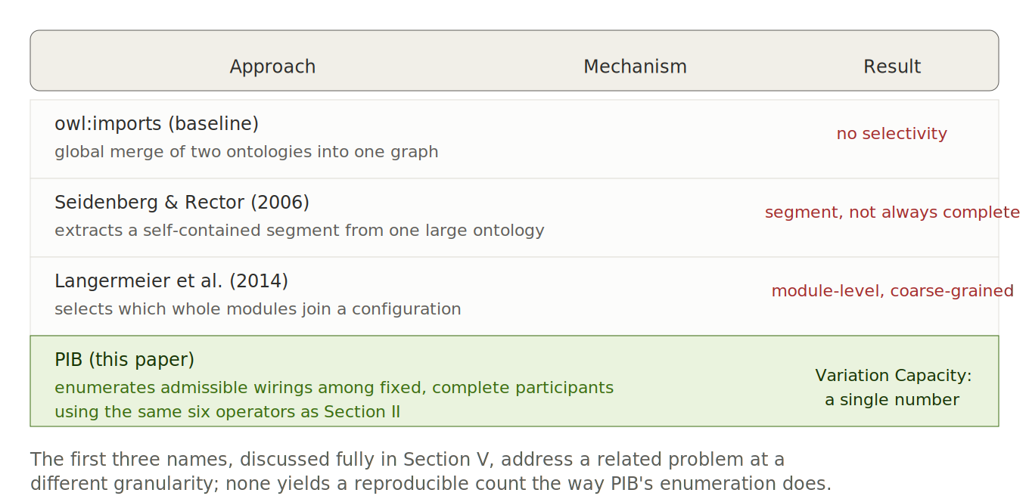
Figure 5. PIB against the three related approaches discussed above, compared by mechanism and by what each produces.
The application under study answers this gap directly. It treats the space of valid integration wirings as a variant-algebra variation space, governed by the same operators the thesis originally defined for software components (Altunel, 2013). This treats an integration contract as a variability-bearing artifact. The product-line variability literature already applies a comparable treatment to a product's own internal configuration space (Bachmann and Clements, 2005); the present work extends that treatment to inter-system variability.
The closest existing precedent for ontology-composition variability works at a coarser granularity, selecting whole modules (Langermeier et al., 2014). The present application instead selects among wiring configurations within a fixed set of participants, and a real, working enumeration engine computes which wirings that space actually admits. Where the modularity literature names adaptation as an unaddressed need, the present application provides a working, tested implementation of it, applied to a domain the originating algebra was never designed for.
For ontology-engineering practice more broadly, a formally defined variant algebra, once extended for domain-independence, offers a genuine alternative to owl:imports for composing independently governed systems. It additionally yields a directly computable admissibility metric, reported in Section 9, rather than only a qualitative claim of compatibility.

A. Integration Contract
Each participating ontology in the ecosystem under study declares what it produces and what it consumes, without recourse to owl:imports. The coupling between systems therefore takes the form of a declared, machine-checked contract rather than a hard and brittle dependency. This design answers directly the adaptation gap named explicitly in the ontology-modularity literature (Rector et al., 2012).
The produces/consumes contract, together with the algebra's own Subtraction operator, gives the adaptation mechanism called for in that literature a working, tested implementation, rather than leaving it a named but unaddressed need (Rector et al., 2012), (Altunel, 2013). This differs from the OWL-individuals-based integration style in the feature-modeling literature, where dynamic, frequently changing relationships are modeled as individual instances rather than class-level structure (Wang et al., 2007). The present contract instead treats produces/consumes declarations as a stable, class-level structural commitment. This appears appropriate given that an integration contract between independently governed systems is generally expected to change far less frequently than any single system's internal configuration.

B. Validation Architecture
The application under study requires two independent gates before adopting any wiring. Self-coverage requires each participating ontology to be valid entirely on its own. Wiring validity requires the produces/consumes contract to close and the operator constraints to hold, the latter verified by the enumeration engine (Altunel, 2013).
Both gates hold up under scrutiny, not only under documentation. The wiring validator reproduces the reported admissibility count exactly. The self-coverage gate correctly refuses three worked-example interfaces for lacking the required attestation, evidence that the gate genuinely refuses an unearned pass. A comparable two-stage verify-then-debug architecture appears in OWL feature-model tooling, where an automated reasoner first detects an inconsistency and a separate heuristic debugger subsequently explains its cause (Wang et al., 2007). The present architecture differs in that both of its own gates function as refusal mechanisms operating before adoption, rather than a detection stage followed by post-hoc explanation.
Both gates, and every validation reported throughout this paper, rest on a disclosed methodological choice: merging a domain's own TBox with a SHACL shape graph before validating an ABox against the result. This technique has a formal semantic grounding in the literature on combining SHACL validation with OWL reasoning (Oudshoorn et al., 2026). It is applied here with hand-authored, not auto-generated, shapes, a distinction one real-world co-development report identifies as consequential for maintainability (Ruckhaus et al., 2025). This places the present validation methodology within an active, current area of the RDF-validation tooling landscape, rather than a settled or niche practice (Jakubowski et al., 2025).

C. One Constraint, Checked Two Independent Ways
Section II.A's Dependency operator, illustrated in Figure 2 as DeliveryConfirmation requiring Push, is expressible directly as a SHACL shape once the element set is represented as an OWL individual graph, giving self-coverage, the gate just described, an independent, ontology-native check rather than relying on the algebra's own enumeration alone.
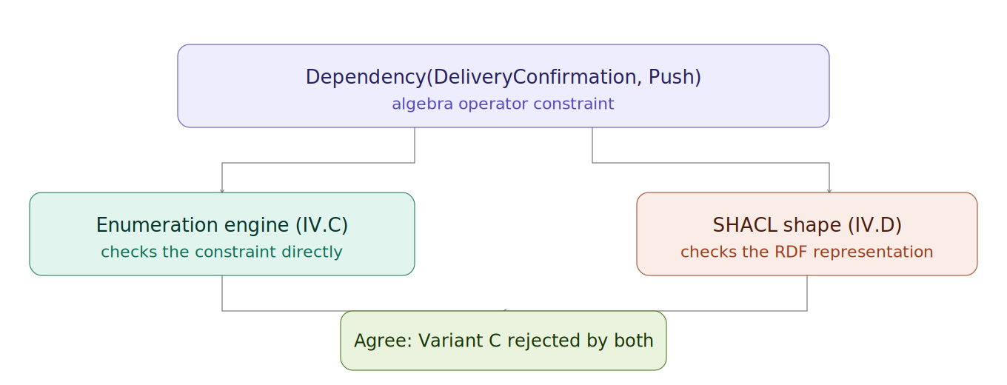
Figure 3. The same Dependency constraint checked through two independent routes, agreeing on Variant C's rejection.
The SHACL shape reports a violation for exactly the variant Figure 2 rejected by hand, the one including DeliveryConfirmation without Push, and reports none of the constraints violated for either admissible variant. This is the same alignment self-coverage checks for every participating ontology before PIB accepts a wiring.

C. Variation Capacity
Variation Capacity is the count of admissible wirings for one profile. It is a single number that generally renders an otherwise qualitative claim, that an integration has been validated, into a quantitative and reproducible one (Altunel, 2013). For the worked capstone example examined in this paper, that number is nine.
This value of nine reproduces exactly against the exact pinned engine version the application depends on, with the match verified by SHA-256 comparison across all four core files rather than taken from the application's own documentation. Treating a formal-verification result as a value to reproduce independently, rather than merely cite, follows an evidentiary standard already evident elsewhere. Feature-model verification literature typically reports a reasoning engine's timing and outcome on a large test model as directly measured figures, not estimated ones (Wang et al., 2007).

VI. EMPIRICAL EVALUATION
This paper reports two disclosed empirical results rather than asserted claims. The first is a performance investigation carried through to an honest, partly unfavorable conclusion. The second is the formal closure of the framework's own development mission, including one objective withdrawn on evidence. This section presents both in turn.
Performance evaluation of a declarative reimplementation against its procedural original is an established empirical practice within the feature-modeling and knowledge-representation literature. A reasoning engine's runtime is typically reported directly rather than estimated, and a large-model evaluation specifically tests whether an approach scales (Wang et al., 2007).
The present evaluation follows that same direct-measurement standard, and its result diverges from what a favorable-outcome-oriented report would present. For two of the three converted calculi, the declarative implementation proves measurably slower than the procedural original, not faster, even after the one further optimization attempted. This finding is reported rather than omitted, on the reasoning that an evidentiary standard applied only when the result favors the approach under study would not, in any meaningful sense, be a standard at all.
For projects considering similar declarative reimplementation, execution-speed parity should not be assumed as an automatic byproduct of the conversion. Where speed matters operationally, it warrants its own direct measurement, rather than an inference drawn from the conversion's other genuine benefits, such as auditability and declarative expressiveness.

A. Performance Benchmark Result
The declarative SPARQL reimplementation of the framework's calculi was benchmarked against VAF's own intermediate Python implementation across three graph sizes (n=10, 50, and 200), not against the thesis's original Java version. The result is mixed rather than uniformly favorable. For the attribute-usage detection calculus, SPARQL execution measured 57.19, 26.13, and 20.02 times slower than Python at these three sizes respectively. For entailment, the ratios were considerably wider still: 186.80, 60.57, and 36.69 times slower at the same sizes. In both cases the ratio narrows as graph size grows but does not close. This generally indicates the two implementations scale at broadly similar asymptotic rates, while a fixed per-query overhead typically dominates at smaller sizes.
For a third calculus, normalization, SPARQL execution measured near parity with Python across all three sizes: 1.00, 1.08, and 1.00 times, respectively. This indicates the gap observed for the other two calculi is not an inherent property of the SPARQL reimplementation, but specific to computation profiles where per-query dispatch overhead dominates a comparatively cheap underlying calculation. Normalization's own pairwise-distribution work is itself quadratic in both implementations, leaving proportionally less room for dispatch overhead to dominate.
This explanation was tested, not merely assumed. A second, independent measurement pass removed avoidable benchmark overhead, repeated file reads inside the timed loop, and found the underlying gap barely moved: attribute-usage detection shifted from a first-pass 61x/25x/19x to the corrected 57x/26x/20x, and entailment from 204x/56x/37x to 187x/61x/37x. This indicates the measurement itself, rather than a methodological artifact, was the genuine source of the result. The corresponding performance objective, whose own real target had been a two-times slowdown ceiling, was subsequently withdrawn from the project's formal backlog on this evidence, once every other objective the withdrawal would affect was independently confirmed already met.

B. Mission Closure Record
The framework's own development mission, building a generic, domain-independent process workflow with an explicit profile mechanism and realizing software as its first profile, reached formal closure. Of nineteen tracked objectives, eighteen were met exactly. These span all eight scope areas finished and twenty-one governance conformance categories closed. Two objectives were risk-reduction targets, measured by failure-mode-and-effects-analysis risk priority number: conversion risk fell from a baseline of 448 to a target of 42, and probabilistic-resistance risk fell from 648 to 48, both met exactly (Altunel, 2013).
The nineteenth objective, concerning the SPARQL query performance discussed in Section 12, was withdrawn by explicit decision rather than met or silently redefined, once the evidence indicated it added no value to the mission's stated purpose. A closure report was filed prior to the mission being marked achieved, satisfying a governance requirement that a mission cannot be closed without an auditable record explaining why. This discipline is specific to the present project's own governance framework. It nonetheless parallels a broader principle in empirical software engineering, in which a negative or null result, properly disclosed and reasoned through, generally constitutes a legitimate closure condition rather than an incomplete one (Wang et al., 2007).

VII. CONCLUSION
This paper's central contribution is a formal, domain-independent mechanism for managing variability in structured, multi-step artifacts, demonstrated here on ontologies but not limited to them. The originating algebra's own definition of a variant, and the operators governing which combinations of parts constitute one, were designed for software components. This paper's own domain-independence extension, proven by demonstration on a domain containing no software-specific content and verified under full RDFS deductive closure, establishes that the same mechanism holds independently of that original motivation. Applied to ontologies, this mechanism becomes PIB: independent ontology-engineering tools are treated as participants in a variation space, and a real, working enumeration engine computes which configurations of that space are admissible, expressed as Variation Capacity, a single reproducible number, rather than a qualitative claim of compatibility. This answers a gap the ontology-modularity literature named in 2012 but had not, to this paper's knowledge, previously answered computably.
The reasoning that motivates this extension is not specific to ontologies. A roadmap, a workflow, and a governed lineage are each a structured, multi-step artifact built by combining a bounded set of parts under rules that admit only some combinations as valid; this is precisely the structural property the algebra's own operators are designed to check. Ontologies were chosen as the first domain to demonstrate this on because a real, working validation architecture, SHACL and OWL, already exists to check the algebra's output mechanically. The same argument does not depend on that particular checking mechanism: a roadmap or workflow variant is admissible or not by the same operator logic, whatever the concrete formalism used to encode and check it. This paper accordingly opens, rather than closes, a path from ontology-structure variability management toward a more general treatment of variability in roadmaps, workflows, and other multi-step, flow-based constructions, a direction this paper motivates on the strength of the ontology case and leaves for future work.
Two further points are worth stating plainly rather than leaving implicit. First, the genuine contribution lies in the underlying decision to represent the algebra in a declarative ontology language at all, a choice distinct from the specific implementation language used along the way, Java, then Python, then SPARQL. Representing the algebra declaratively is what makes its output machine-checkable against independently authored SHACL shapes, reusable across tools built on the same standard, and open to reasoning the original procedural code could not perform. Second, the honest performance result in Section VI, that the ontology-native reimplementation is measurably slower than its procedural predecessor for two of three calculi, is disclosed as a genuine cost of this choice, not concealed as an incidental detail; a future adopter of this same mechanism, in ontologies or elsewhere, should expect and budget for a comparable tradeoff rather than assume interoperability is free.
Future work should extend PIB's own real interface declarations to its remaining participants, explore whether the performance gap closes under a different SPARQL engine, pursue the LLM-assisted profile management direction motivated in Section III-C as its own dedicated study, and test directly whether the operator logic established here for ontologies transfers, as this paper argues it should, to roadmaps, workflows, and other governed, multi-step artifacts. Reaching a fully consulted evidentiary standard across every cited source, rather than the substantial majority achieved here, remains a further, disclosed limitation for subsequent revision.

REFERENCES
Morris, C. (1938). “Foundations of the Theory of Signs,” University of Chicago Press, Chicago, Illinois, United States. University of Chicago Press.
Parnas, D. L. (1972). “On the Criteria to Be Used in Decomposing Systems into Modules,” Communications of the ACM, vol. 15, no. 12, pp. 1053–1058. Association for Computing Machinery. [Available online]
Kang, K. C., Cohen, S. G., Hess, J. A., Novak, W. E., and Peterson, A. S. (1990). “Feature-Oriented Domain Analysis (FODA) Feasibility Study,” Software Engineering Institute, Carnegie Mellon University, Technical Report CMU/SEI-90-TR-21, Pittsburgh, Pennsylvania, United States. Carnegie Mellon University Software Engineering Institute. [Available online]
Clements, P., and Northrop, L. (2001). “Software Product Lines: Practices and Patterns,” Addison-Wesley, Boston, Massachusetts, United States. Addison-Wesley.
Rector, A. L. (2003). “Modularisation of Domain Ontologies Implemented in Description Logics and Related Formalisms Including OWL,” Proceedings of the 2nd International Conference on Knowledge Capture (K-CAP 2003), Sanibel Island, Florida, United States, pp. 121–128. Association for Computing Machinery. [Available online]
Altunel, Y., and Tolun, M. R. (2004). “Component-Based Software Design: Recursive Development and Variants,” Proceedings of IDPT 2004, pp. 235–241. ACTA Press.
Bachmann, F., and Clements, P. C. (2005). “Variability in Software Product Lines,” Software Engineering Institute, Carnegie Mellon University, Technical Report CMU/SEI-2005-TR-012, Pittsburgh, Pennsylvania, United States. Carnegie Mellon University Software Engineering Institute. [Available online]
Cuenca Grau, B., Parsia, B., Sirin, E., and Kalyanpur, A. (2005). “Modularizing OWL Ontologies,” Proceedings of the K-CAP 2005 Workshop on Ontology Management, Banff, Alberta, Canada. Association for Computing Machinery.
Pohl, K., Böckle, G., and van der Linden, F. J. (2005). “Software Product Line Engineering: Foundations, Principles, and Techniques,” Springer, Berlin, Germany. Springer-Verlag. [Available online]
Svahnberg, M., van Gurp, J., and Bosch, J. (2005). “A Taxonomy of Variability Realization Techniques,” Software: Practice and Experience, vol. 35, no. 8, pp. 705–754. John Wiley & Sons. [Available online]
Höfner, P., Khedri, R., and Möller, B. (2006). “Feature Algebra,” FM 2006: Formal Methods, Lecture Notes in Computer Science, vol. 4085, pp. 300–315. Springer-Verlag. [Available online]
Seidenberg, J., and Rector, A. (2006). “Web Ontology Segmentation: Analysis, Classification and Use,” Proceedings of the 15th International Conference on World Wide Web (WWW 2006), Edinburgh, Scotland, United Kingdom, pp. 13–22. Association for Computing Machinery. [Available online]
Asikainen, T., Männistö, T., and Soininen, T. (2007). “Kumbang: A Domain Ontology for Modelling Variability in Software Product Families,” Advanced Engineering Informatics, vol. 21, no. 1, pp. 23–40. Elsevier. [Available online]
Czarnecki, K., and Wasowski, A. (2007). “Feature Diagrams and Logics: There and Back Again,” Proceedings of the 11th International Software Product Line Conference (SPLC 2007), Kyoto, Japan, pp. 23–34. IEEE Computer Society. [Available online]
Rosemann, M., and van der Aalst, W. M. P. (2007). “A Configurable Reference Modelling Language,” Information Systems, vol. 32, no. 1, pp. 1–23. Elsevier. [Available online]
Wang, H. H., Li, Y. F., Sun, J., Zhang, H., and Pan, J. (2007). “Verifying Feature Models Using OWL,” Journal of Web Semantics, vol. 5, no. 2, pp. 117–129. Elsevier. [Available online]
Altunel, Y., and Tolun, M. R. (2008). “Component-Based Project Estimation Issues for Recursive Development,” Advances in Computer and Information Sciences and Engineering, T. Sobh, Ed., pp. 577–581. Springer. [Available online]
Apel, S., Lengauer, C., Möller, B., and Kästner, C. (2008). “An Algebra for Features and Feature Composition,” Algebraic Methodology and Software Technology (AMAST 2008), Lecture Notes in Computer Science, vol. 5140, pp. 36–50. Springer-Verlag. [Available online]
Goel, A. K., Rugaber, S., and Vattam, S. (2009). “Structure, Behavior, and Function of Complex Systems: The Structure-Behavior-Function Modeling Language,” Artificial Intelligence for Engineering Design, Analysis and Manufacturing, vol. 23, no. 1, pp. 23–35. Cambridge University Press. [Available online]
Stuckenschmidt, H., Parent, C., and Spaccapietra, S. (Eds.) (2009). “Modular Ontologies: Concepts, Theories and Techniques for Knowledge Modularization,” Lecture Notes in Computer Science, vol. 5445, Berlin, Germany. Springer-Verlag. [Available online]
Benavides, D., Segura, S., and Ruiz-Cortés, A. (2010). “Automated Analysis of Feature Models 20 Years Later: A Literature Review,” Information Systems, vol. 35, no. 6, pp. 615–636. Elsevier. [Available online]
Motik, B., Cuenca Grau, B., Horrocks, I., Wu, Z., Fokoue, A., and Lutz, C. (Eds.) (2012). “OWL 2 Web Ontology Language Profiles (Second Edition),” W3C Recommendation, 11 December 2012. World Wide Web Consortium. [Available online]
Rector, A., Brandt, S., Drummond, N., Horridge, M., Pulestin, C., and Stevens, R. (2012). “Engineering Use Cases for Modular Development of Ontologies in OWL,” Applied Ontology, vol. 7, no. 2, pp. 113–132. IOS Press. [Available online]
Altunel, Y. (2013). “An Algebraic Approach for Generation of Software Component Variants,” Doctoral dissertation, Istanbul University, Istanbul, Turkey. Istanbul University.
Apel, S., Batory, D., Kästner, C., and Saake, G. (2013). “Feature-Oriented Software Product Lines: Concepts and Implementation,” Springer, Berlin, Germany. Springer-Verlag. [Available online]
Langermeier, M., Rosina, P., Oberkampf, H., Driessen, T., and Bauer, B. (2014). “Management of Variability in Modular Ontology Development,” Service-Oriented Computing – ICSOC 2013 Workshops, Lecture Notes in Computer Science, vol. 8377, pp. 225–239. Springer-Verlag. [Available online]
Afriyanti, I., Falakh, F. M., Azurat, A., and Takwa, B. (2017). “Feature Model-to-Ontology for SPL Application Realisation,” arXiv preprint arXiv:1707.02511. arXiv. [Available online]
Le Clair, A., Marinache, A., El Ghalayini, H., MacCaull, W., and Khedri, R. (2023). “A Review on Ontology Modularization Techniques — A Multi-Dimensional Perspective,” IEEE Transactions on Knowledge and Data Engineering, vol. 35, no. 5, pp. 4376–4394. Institute of Electrical and Electronics Engineers. [Available online]
Jakubowski, M., Tomaszuk, D., and Hose, K. (2025). “A Community Survey on SHACL and ShEx: Bridging Gaps in RDF Validation,” Proceedings of SEMANTiCS 2025, pp. 70–84. SEMANTiCS. [Available online]
Ruckhaus, E., Toledo, J., Martínez Sarmiento, E. A., and Corcho, O. (2025). “Lessons Learned from the Combined Development of OWL and SHACL,” Proceedings of the 13th Knowledge Capture Conference (K-CAP 2025), pp. 1–4. Association for Computing Machinery. [Available online]
Oudshoorn, A. M., Ortiz, M., and Šimkus, M. (2026). “SHACL Validation in the Presence of Ontologies: Semantics and Rewriting Techniques,” Artificial Intelligence, vol. 352, article 104483. Elsevier. [Available online]

Note on Source Consultation
Of the 31 works cited, six (Altunel, 2013), (Afriyanti et al., 2017), (Wang et al., 2007), (Kang et al., 1990), and two arXiv preprints among (Czarnecki and Wasowski, 2007) and (Jakubowski et al., 2025) were consulted in full: their complete texts were retrieved and read, not only their abstracts, and are marked ConsultedSource in this paper's own supporting RDF. (Bachmann and Clements, 2005) was verified against its official abstract via the publisher's own catalog page, though the full PDF itself could not be retrieved. The remaining works are characterized from search results and abstracts, their full texts not retrieved, and are marked ReconstructedSource accordingly. This paper is certified under RDODI's CoursewareAuthoring academic-authoring profile, which permits reconstructed citations; it does not meet the stricter ConsultedOnly (research-grade) bar, which would require full consultation of every source.
Revision note (this version): reformatted to IEEE conventions (Roman-numeral sections, lettered subsections, numbered bracketed citations in order of first appearance). The standalone, non-standard "Summary of Contributions" section from the prior version was removed; its content was synthesized into the Conclusion, where such synthesis belongs. The prior version listed the ontology-native reimplementation itself as a contribution; this has been corrected, since an implementation-language choice is not a contribution on its own. What is retained as a genuine contribution is the underlying decision to represent the algebra in a formal, declarative ontology language, which is what enables machine-checkability and reasoning. Most substantively, this version restores the paper's own central motivation, previously underdeveloped: adapting the algebra to manage variability in ontological structures as a demonstration case for a more general claim, that the same mechanism applies to roadmaps, workflows, and other governed, multi-step, flow-based constructions. This is now stated in the Introduction, developed in the Conclusion, and left as motivated future work rather than an implemented result.
Revision note (this version): the ontology-modularity claim in the Abstract and Section V was previously grounded in a single, comparatively late citation. Five further works were verified directly and added to show this is a two-decade, actively researched concern, not a narrow or recent one: the earliest identified treatment arguing modularity is required for ontology reuse, maintainability, and evolution (Rector, 2003); a widely cited technical proposal for combining ontologies via a formal logical connective (Cuenca Grau et al., 2005); a segmentation approach evaluated on a real clinical ontology, whose extracted segments were not always semantically complete modules on their own (Seidenberg and Rector, 2006); the field's own comprehensive edited volume, which explicitly connects ontology modularity to software engineering's longer modularization tradition (Stuckenschmidt et al., 2009); and a systematic review confirming the area remains active without full methodological convergence (Le Clair et al., 2023). Each is described by what it did and left open, not cited by name alone, and the gap the present application closes is stated as more specific than any of them address individually.
Revision note (this version): in-text citations were converted from numbered IEEE brackets to (Surname, Year) style, each hyperlinked directly to its full entry in the References list. The References list itself was reordered chronologically rather than by order of first appearance, and every entry was independently re-verified and completed to a uniform level of detail: full, unabbreviated author names, full unabbreviated venue names, publisher, volume, issue, and page or article number where applicable, and a working link where one exists. This verification pass caught and corrected two real errors carried from the prior version: the SHACL-and-ontologies paper is dated 2026, not 2023, and is published in the journal Artificial Intelligence, volume 352, article 104483, not the abbreviated placeholder previously given; and the ontology-modularization review is published in IEEE Transactions on Knowledge and Data Engineering, volume 35, issue 5, pages 4376–4394, not IEEE Access as previously stated. A List of Abbreviations was added after the Index Terms.
Revision note (this version): two sentences defining the paper by what it is not were removed rather than rephrased, following the same edit already applied by hand to two others. Section II now closes with a subsection stating plainly what the 2013 thesis established (the formal structure, all six operators, one realized profile) against what this paper adds (domain-independence, the ontology-native reimplementation, and a second, independently defined profile), and states explicitly that a profile binds the existing operators to a use rather than adding to them. Two worked examples were added: Example 1, in Section II.A, applies all six operators to a small, concrete element set and evaluates two admissible and one inadmissible variant by hand; Example 2, at the close of Section IV, expresses the same Dependency constraint as a SHACL shape and confirms it rejects the identical variant Example 1 rejected. Both are original constructions built for this paper, not drawn from the interactive HTML artifact accompanying this work.
Revision note (this version): the two textual examples were replaced with five figures, embedded as images and referenced by number from the surrounding prose, rather than described in running text. Figure 1 reuses the real operator-class hierarchy from the accompanying interactive artifact (va:VariabilityOperator and its seven subclasses) rather than an invented structure. Figures 2 and 3 render what were previously Examples 1 and 2 as diagrams; Figure 3 now sits inside Section V.C, where the self-coverage gate it illustrates is actually discussed, correcting its earlier placement at the boundary between Sections IV and V. Figure 4 illustrates the thesis-versus-extension distinction from Section II.D directly. Figure 5 compares PIB against the three related approaches discussed in Section V by mechanism and result, addressing how this work is differentiated from prior literature visually rather than only in prose.

