AA TECH
EMPLOYEES USER MANUAL

Employees System — User Manual

Attendance · Leave · Salary · Reimbursement

Table of Contents

1. Introduction
2. Getting to the Employees Workspace
3. Employees Workspace Overview
4. Attendance
5. Leave
6. Salary (Coming Soon)
7. Reimbursement (Coming Soon)
8. Navigation Bar Reference
9. Frequently Asked Questions

1. Introduction
The Employees workspace is where you manage everything related to your day-to-day work life at Anant Avinya Technologies (AA Tech) — clocking in and out, requesting leave, and (soon) viewing salary slips and submitting reimbursement claims.
This manual walks you through each screen in the Employees workspace, explains what every button and field does, and gives step-by-step instructions for the most common tasks.

2. Getting to the Employees Workspace
- Sign in to AA Tech Workspaces. You'll land on the Workspaces picker screen, which greets you by name ("Welcome back, [Name]").
- You'll see five workspace cards: WMS, Pre Production, Admin, Employees, and User Manual.
- Click Enter workspace on the Employees card (attendance, leave, salary & team roster).
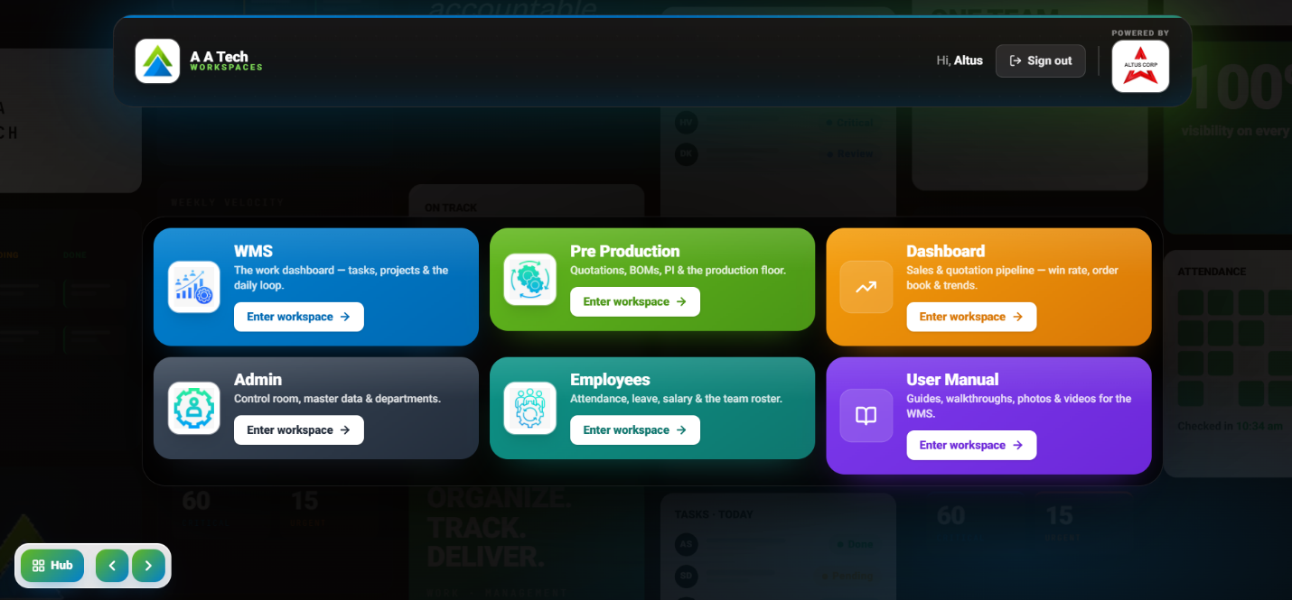

Tip: You can return to this picker at any time from inside a workspace by clicking Workspaces in the top navigation bar.

3. Employees Workspace Overview
Once inside, the Employees home screen presents four modules as cards. Each card shows a short description and an Open button.
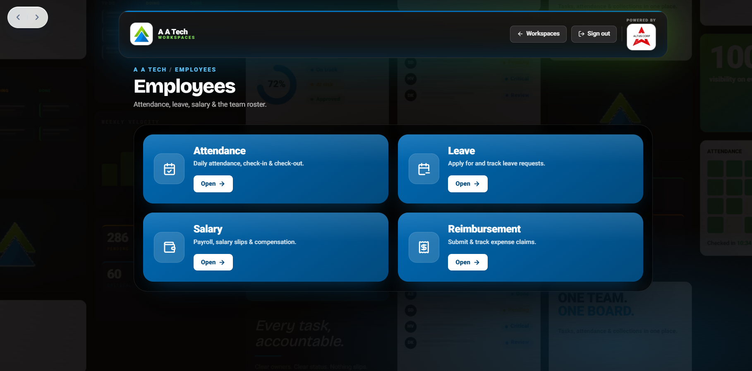

- Attendance — Daily attendance, check-in & check-out.
- Leave — Apply for and track leave requests.
- Salary — Payroll, salary slips & compensation.
- Reimbursement — Submit & track expense claims.
Every screen in this workspace shares the same top bar: the company logo and name on the left, the current date/time and system status in the centre, and quick navigation links (Dashboard, My Day, Tasks, Kanban) plus search, Admin, and your profile icon on the right.

4. Attendance
Open the Attendance card to check in when you start work and check out when you finish. The system allows one check-in and one check-out per day.
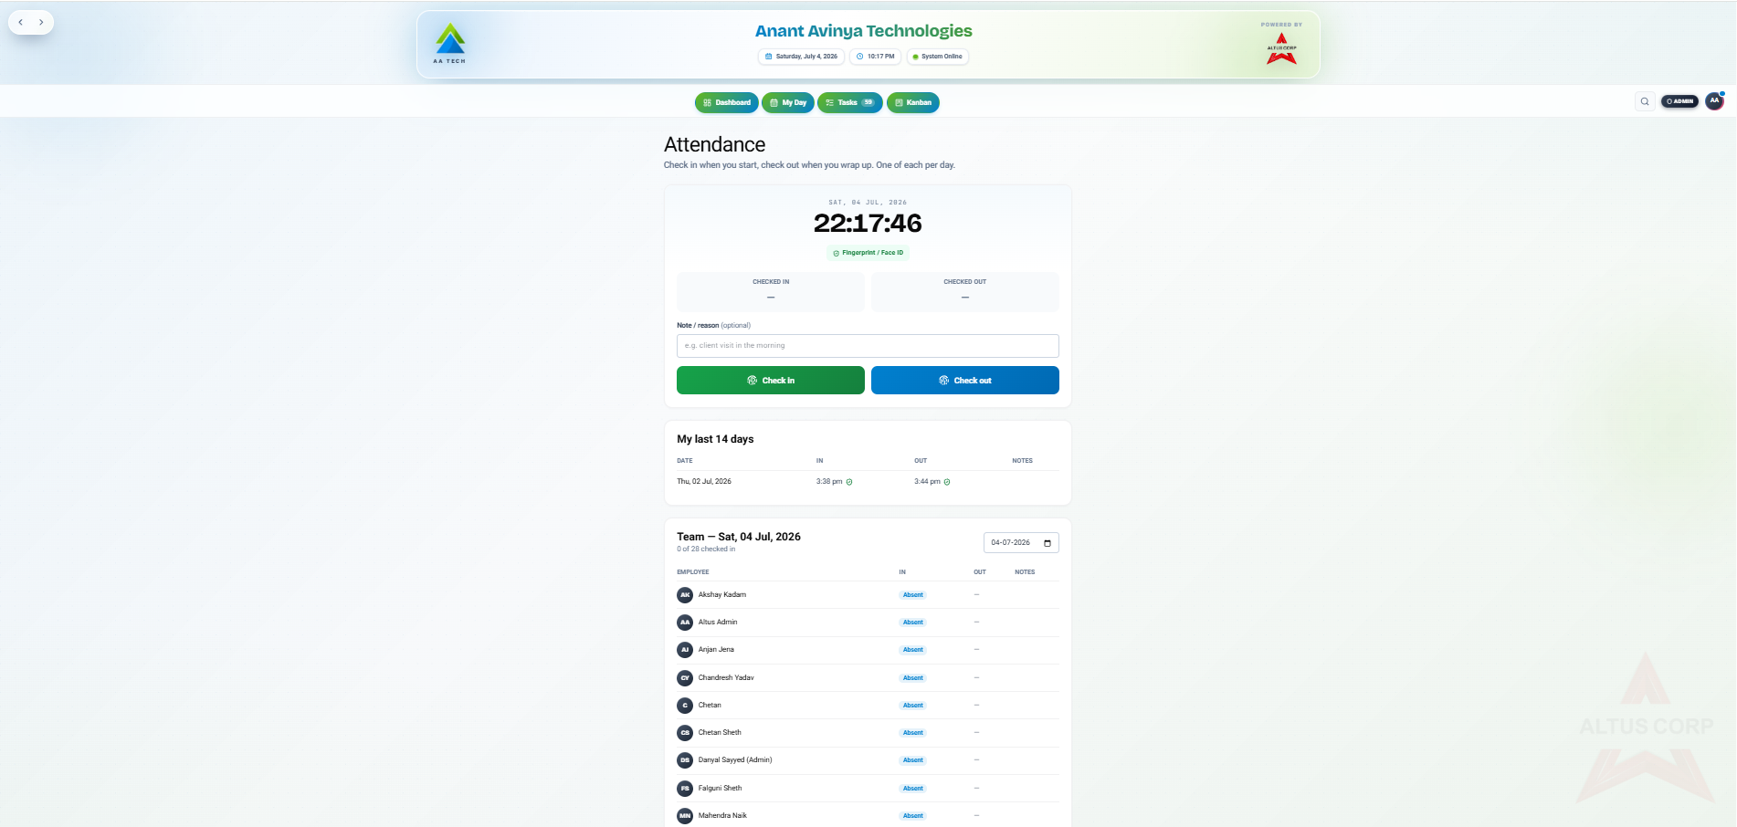

4.1 Checking in and out
- Look at the live clock at the top of the panel — it shows the current date and time so you can confirm you're on the right day.
- If you'd like to log a reason (e.g. a client visit or a late start), type it into the Note / reason (optional) field.
- Click Check in when you arrive. The Checked In field will fill in with your check-in time.
- Click Check out when you finish for the day. The Checked Out field will fill in with your check-out time.
Tip: Both check-in and check-out are verified with Fingerprint / Face ID, shown as a green badge once confirmed.

4.2 My last 14 days
Below the check-in panel, the My last 14 days table lists your own attendance history the date, your in-time, out-time, and any notes you added, so you can review your recent record at a glance.

4.3 Team attendance
The Team section shows every colleague's status for a selected date (defaulting to today), including how many of the team have checked in so far (e.g. "0 of 28 checked in"). Each row lists the employee's name and their in/out times, or Absent if they haven't checked in yet.
- Use the date field in the top-right of the Team panel to look up attendance for a different day.
- Scroll the list to find a specific colleague by name.

5. Leave
Open the Leave card to request paid or unpaid time off and to track the status of your requests.


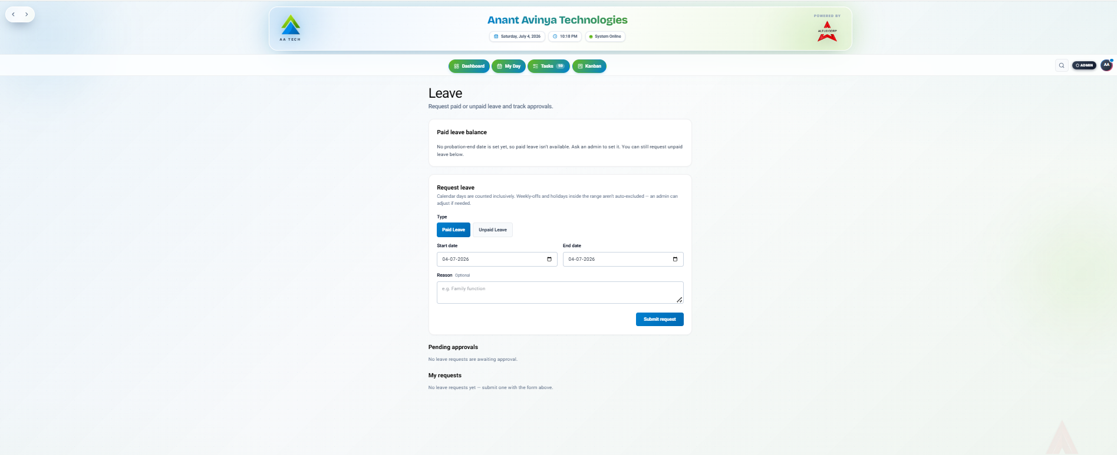

5.1 Paid leave balance
This panel shows your available paid leave. If your probation-end date hasn't been set yet by an admin, paid leave won't be available and you'll see a message asking you to contact an admin — you can still request unpaid leave in the meantime.

5.2 Requesting leave
- Choose a leave Type: Paid Leave or Unpaid Leave.
- Set the Start date and End date for your time off.
- Optionally add a Reason (e.g. "Family function").
- Click Submit request to send it for approval.
Tip: Calendar days are counted inclusively, and weekly-offs or holidays inside your date range are not automatically excluded — an admin can adjust the count if needed.

5.3 Tracking your requests
- Pending approvals — Shows any requests awaiting a manager or admin's decision.
- My requests — A running history of every leave request you've submitted, along with its status.

6. Salary (Coming Soon)
The Salary module will host payroll details, salary slips, and compensation information for the team. It is not yet active.


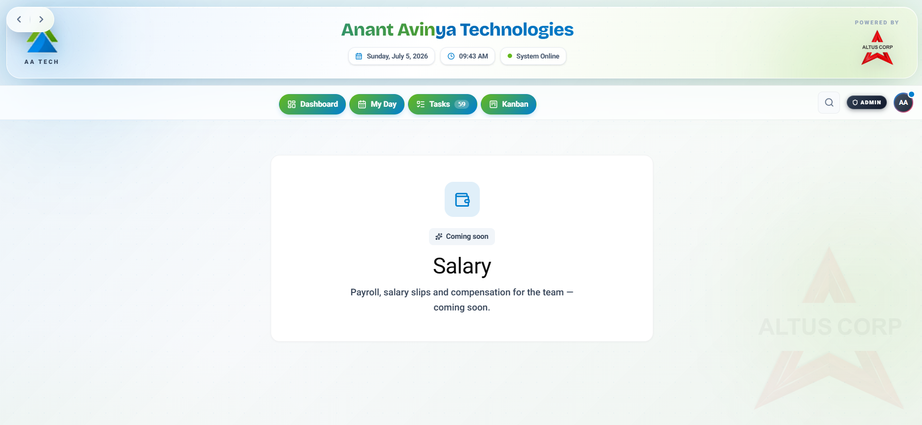

When you open Salary today, you'll simply see a "Coming soon" notice. No action is needed this manual will be updated once the feature goes live.

7. Reimbursement (Coming Soon)
The Reimbursement module will let you submit and track expense reimbursement claims. It is not yet active.


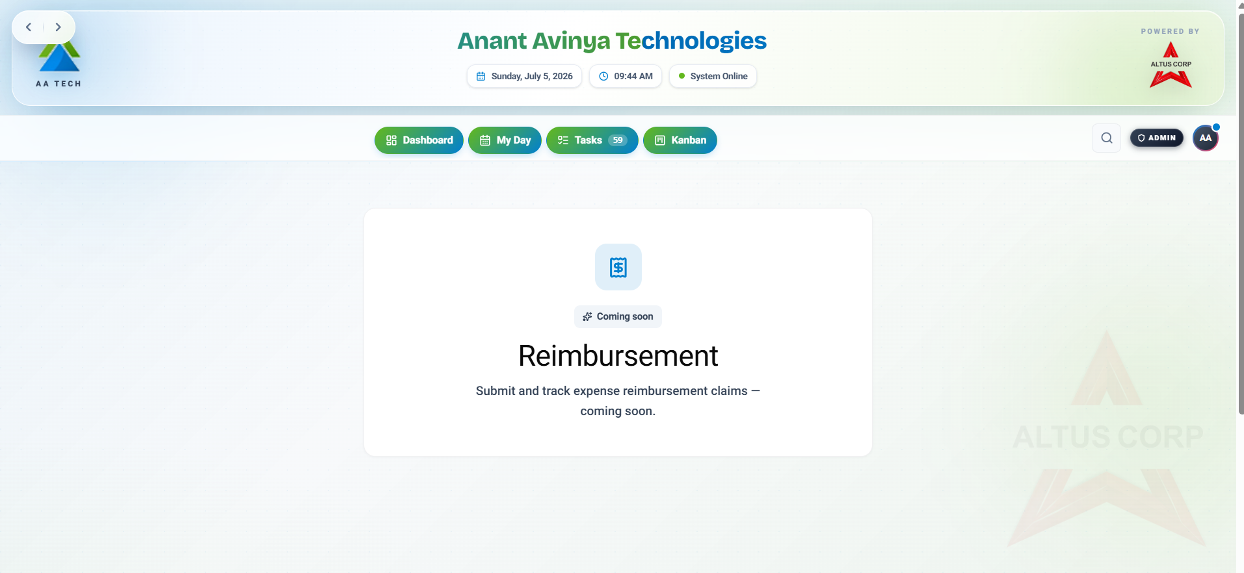

Like Salary, opening Reimbursement currently shows only a "Coming soon" notice.

8. Navigation Bar Reference
These controls appear at the top of every Employees screen:
- Dashboard — Returns you to the main workspace overview with your task and project summaries.
- My Day — Your personal daily view of tasks and priorities.
- Tasks — Opens your full task list (the number badge shows your current open task count).
- Kanban — Displays your tasks as a drag-and-drop Kanban board.
- Search icon — Quickly find people, tasks, or records.
- Admin — Shortcut to admin/control-room functions (visible to admins).
- Profile icon — Click your initials in the top-right to view your profile or sign out.

9. Frequently Asked Questions

Can I check in more than once a day?
No — the Attendance screen allows one check-in and one check-out per day.

Why can't I request paid leave?
Paid leave requires a probation-end date to be set on your profile. If it hasn't been set, ask an admin to configure it; you can still submit unpaid leave requests in the meantime.

Do weekends and holidays count against my leave?
Yes, by default. The system counts all calendar days inclusively in your selected range, and does not automatically remove weekly-offs or holidays. An admin can manually adjust your leave count if a holiday falls within your requested dates.

When will Salary and Reimbursement be available?
Both modules are under development and currently show a "Coming soon" placeholder. There's no action required from you until they launch — this manual will be updated at that time.

Where can I see my team's attendance for a past date?
On the Attendance screen, use the date picker above the Team list to select any date and view that day's check-in/check-out records for the whole team.

