AA TECH
Pre-Production

AA-Tech Pre-Production System— User Manual

Covering: Quote Status • SO Status • GA Approval • BOM • Work Order • Working Specification • Proforma Invoice

Table of Contents
1. Introduction
2. Accessing the Pre-Production Workspace
3. Module Hub
4. Quote Status
5. SO Status
6. GA Approval Status
7. BOM Status
8. Work Order Status
9. Working Specification
10. Proforma Invoice (PI)
11. Quick Reference: Common Actions

- Introduction
The Pre Production workspace — shown in the system as the “AA-Tech Production System” — is where AA Tech manages the full pre-manufacturing pipeline: from the first customer enquiry, through quotation and purchase order, sales order and GA drawing approval, bill of materials, work order, door specifications, and finally the proforma invoice.
This manual walks through each module in the Pre-Production workspace: what it is for, how to open it, and what each field on its entry form means.
Note: This manual is a living document and covers only the Pre-Production workspace. The WMS work dashboard is documented in a separate manual.

2. Accessing the Pre-Production Workspace
Like every module in the AA Tech system, you must sign in first. Once you have signed in, the system takes you to the official workspace selection screen, where Pre Production is one of the available cards.
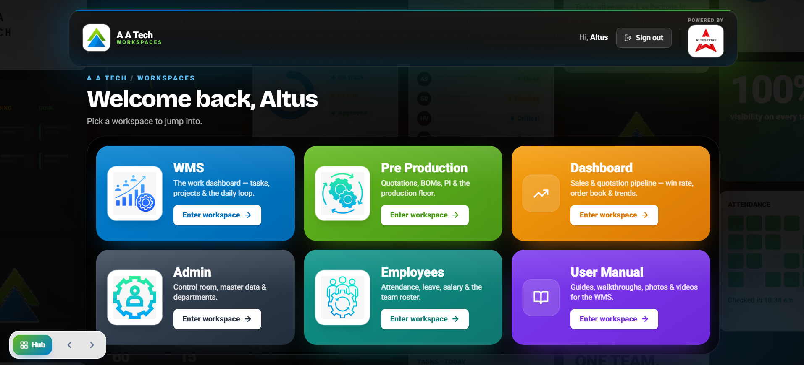
Click “Enter workspace” on the green Pre Production card to open the AA-Tech Production System.
Note: If you are not already signed in, you will be forced into the sign-in panel first — no workspace, including Pre Production, is accessible until sign-in is completed.

3. Module Hub
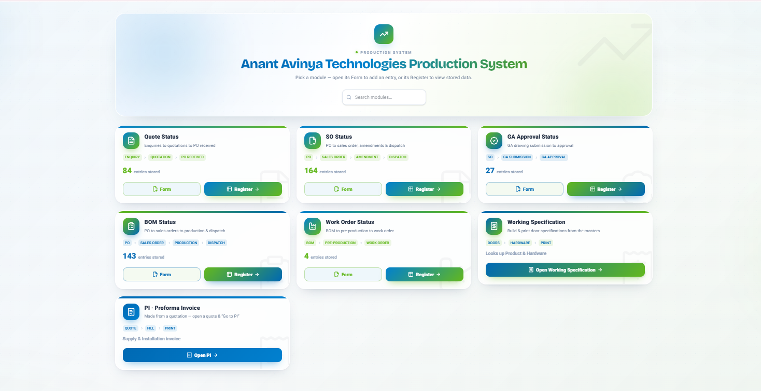
Entering Pre Production brings you to a hub screen listing every module as a card. Each card shows the workflow stages it covers, how many entries are currently stored, and a Form button (to add a new entry) alongside a Register button (to view stored data).

The modules available are:
- Quote Status — Enquiries to quotations to PO received.
- SO Status — PO to sales order, amendments & dispatch.
- GA Approval Status — GA drawing submission to approval.
- BOM Status — PO to sales orders to production to dispatch.

- Work Order Status — BOM to pre-production to work order.
- Working Specification — build & print door specifications from the masters.
- PI · Proforma Invoice — made from a quotation, filled in and printed.
Use the “Search modules...” box in the top right to quickly find a module by name.

4. Quote Status
Quote Status covers the very start of the pipeline: an enquiry coming in, being turned into a quotation, and — once accepted — a purchase order being received. Click Form on the Quote Status card to open the entry screen below.
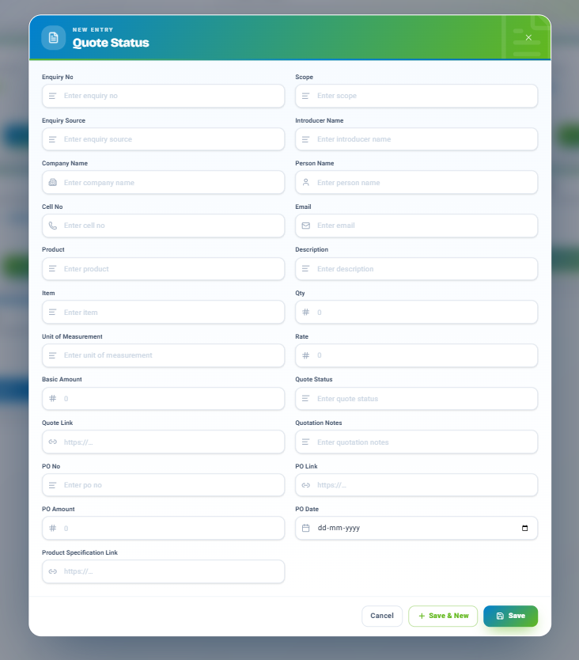

4.1 Fields
- Enquiry No, Enquiry Source — identify and source-tag the incoming enquiry.
- Company Name, Person Name, Cell No, Email — the customer's contact details.
- Introducer Name — who referred or introduced the enquiry, if applicable.
- Scope, Product, Description, Item, Qty, Unit of Measurement, Rate, Basic Amount — the details and pricing of what is being quoted.
- Quote Status, Quote Link, Quotation Notes — track where the quotation stands and link to the quotation document itself.
- PO No, PO Link, PO Amount, PO Date, Product Specification Link — captured once a purchase order is received against the quotation.

4.2 Saving
Click Save to store the entry and close the form, Save & New to store it and immediately open a fresh blank form for the next enquiry, or Cancel to discard without saving.

5. SO Status
SO Status takes over once a purchase order is in hand, tracking the sales order through to dispatch — including any amendments along the way.
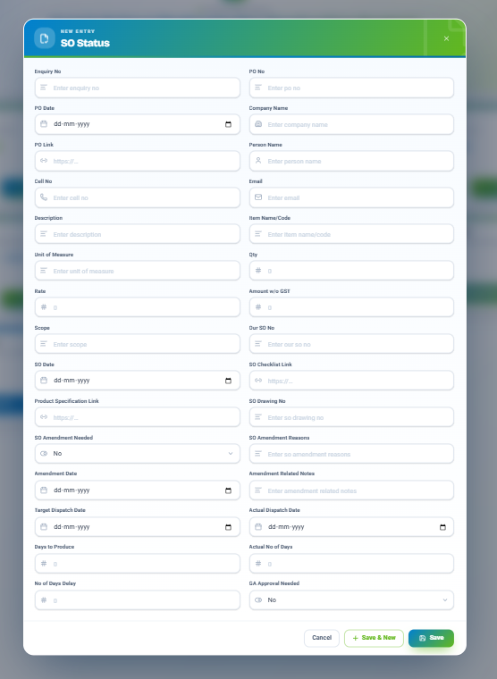

5.1 Fields
- Enquiry No, PO No, PO Date, PO Link, Company Name, Person Name, Cell No, Email — carried forward from the enquiry/PO stage.

- Description, Item Name/Code, Unit of Measure, Qty, Rate, Amount w/o GST — the line-item detail for the order.
- Scope, Our SO No, SO Date, SO Checklist Link, Product Specification Link, SO Drawing No — the sales order's own reference details.
- SO Amendment Needed, SO Amendment Reasons, Amendment Date, Amendment Related Notes — used if the order changes after it is raised.
- Target Dispatch Date, Actual Dispatch Date, Days to Produce, Actual No of Days, No of Days Delay — dispatch planning and delay tracking.
- GA Approval Needed — set to Yes if this order requires GA drawing sign-off (see Section 6) before it can proceed.

Note: Set SO Amendment Needed to Yes only when the order changes after the original SO is raised; leaving it at No keeps the amendment fields out of reporting.

6. GA Approval Status
GA Approval Status tracks a General Arrangement (GA) drawing from submission through to customer or internal approval — required only for orders where GA Approval Needed was set to Yes in SO Status.

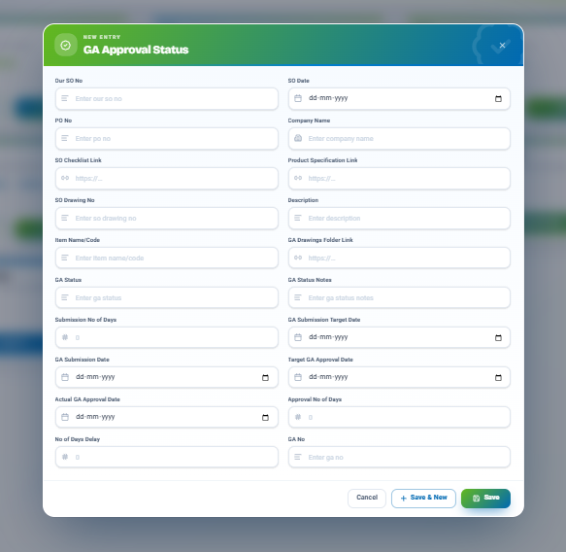

6.1 Fields
- Our SO No, SO Date, PO No, Company Name, SO Checklist Link, Product Specification Link, SO Drawing No, Description, Item Name/Code — references back to the sales order.
- GA Drawings Folder Link — link to the folder holding the actual GA drawing files.

- GA Status, GA Status Notes — the current state of the drawing and any notes on it.
- Submission No of Days, GA Submission Target Date, GA Submission Date — planning and tracking of when the drawing is submitted.
- Target GA Approval Date, Actual GA Approval Date, Approval No of Days, No of Days Delay — tracking of how long approval takes and any delay.
- GA No — the final drawing/approval number once granted.

7. BOM Status
BOM Status records the Bill of Materials stage of an order — from purchase order through sales order, into production, and on to dispatch.
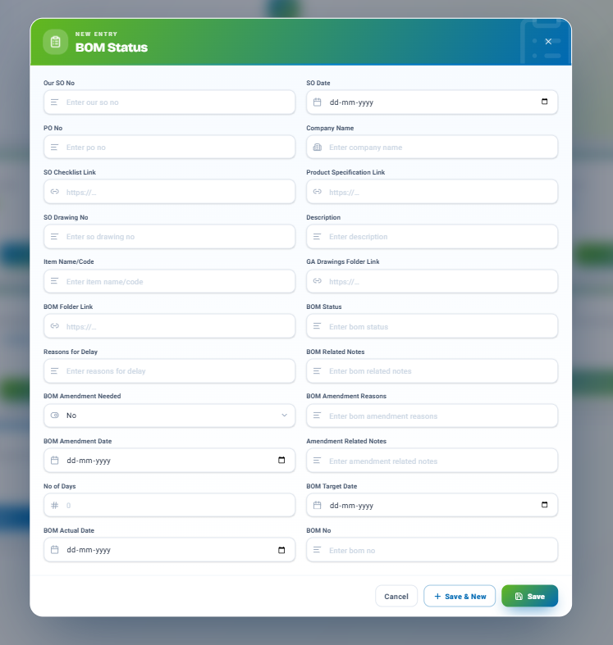

Until then, use the same fields as described in Section 5 (SO Status) when logging a BOM Status entry.

8. Work Order Status
Work Order Status takes a completed BOM through pre-production planning and turns it into an active work order on the shop floor.
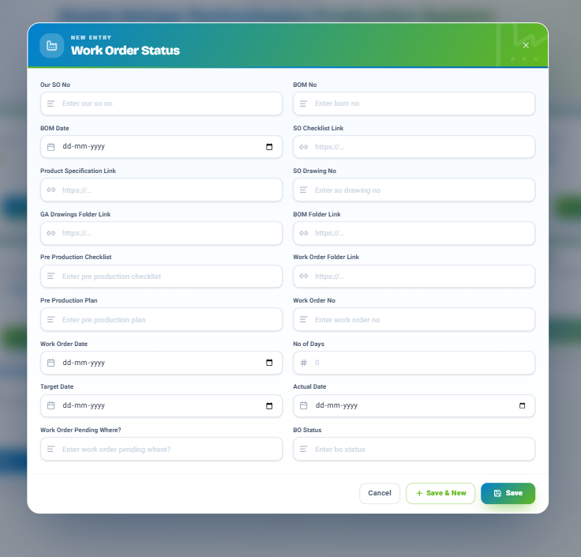

8.1 Fields
- Our SO No, BOM No, BOM Date — references back to the sales order and BOM.
- SO Checklist Link, Product Specification Link, SO Drawing No, GA Drawings Folder Link, BOM Folder Link — links to all the supporting documentation gathered so far.

- Pre Production Checklist, Pre Production Plan — the plan and checklist used to prepare for production.
- Work Order Folder Link, Work Order No, Work Order Date — the work order's own identifying details.
- No of Days, Target Date, Actual Date — the planned versus actual production timeline.
- Work Order Pending Where? — a free-text note on where the work order is currently stuck, if anywhere.
- BO Status — the overall status of the work order.

9. Working Specification
Working Specification is used to build and print door specifications, pulling data from the Product and Hardware masters. Open it from the hub using “Open Working Specification.”
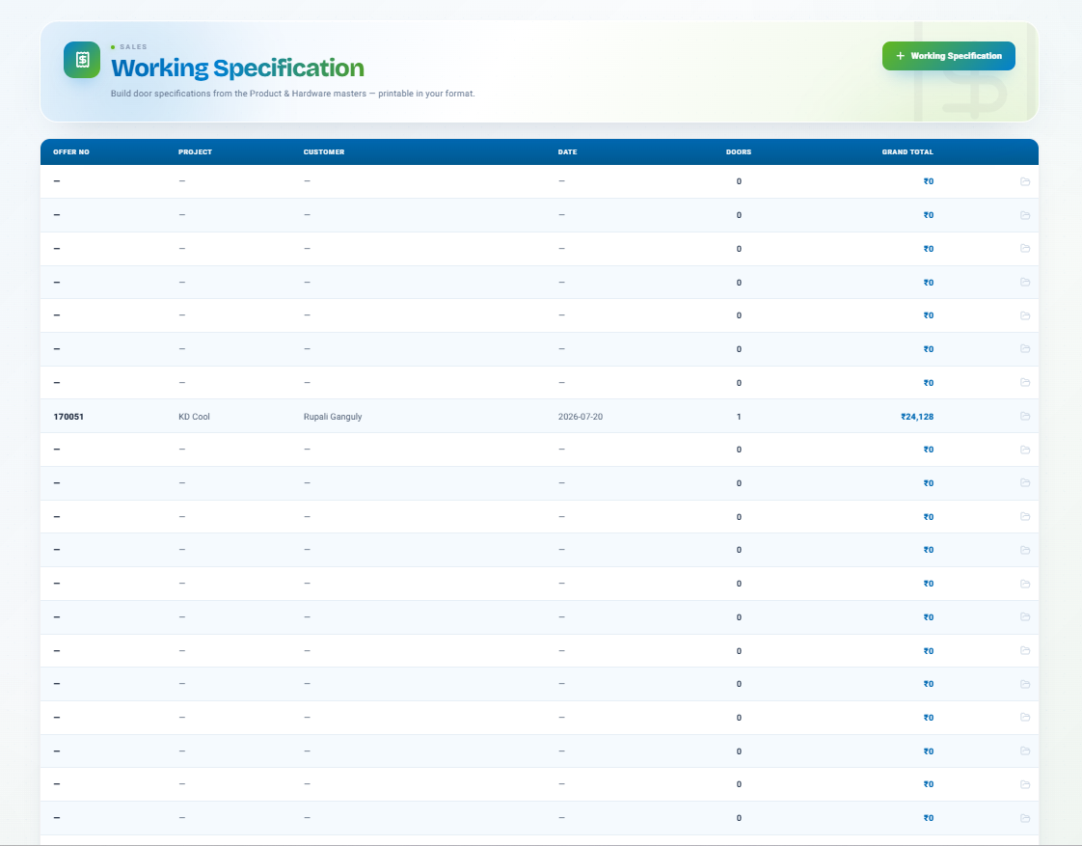
The register lists every specification created so far, with its Offer No, Project, Customer, Date, number of Doors, and Grand Total.

- Click the folder icon at the end of a row to open an existing specification.

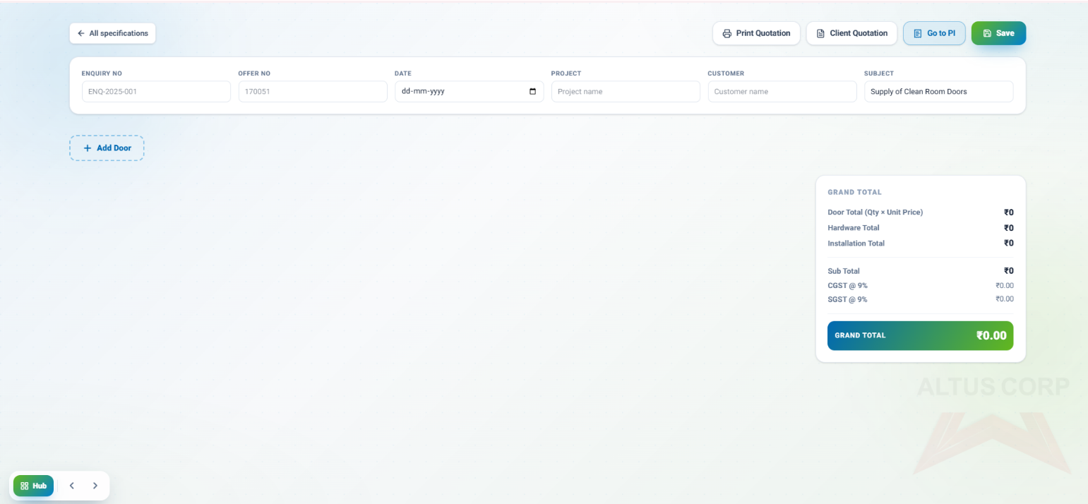
- Click “+ Working Specification” in the top right to start a new one.

10. Proforma Invoice (PI)
A Proforma Invoice (PI) is generated from an existing quotation. Open the relevant quote and use “Go to PI” — the invoice will be auto-filled from the quotation, ready for you to complete and print.
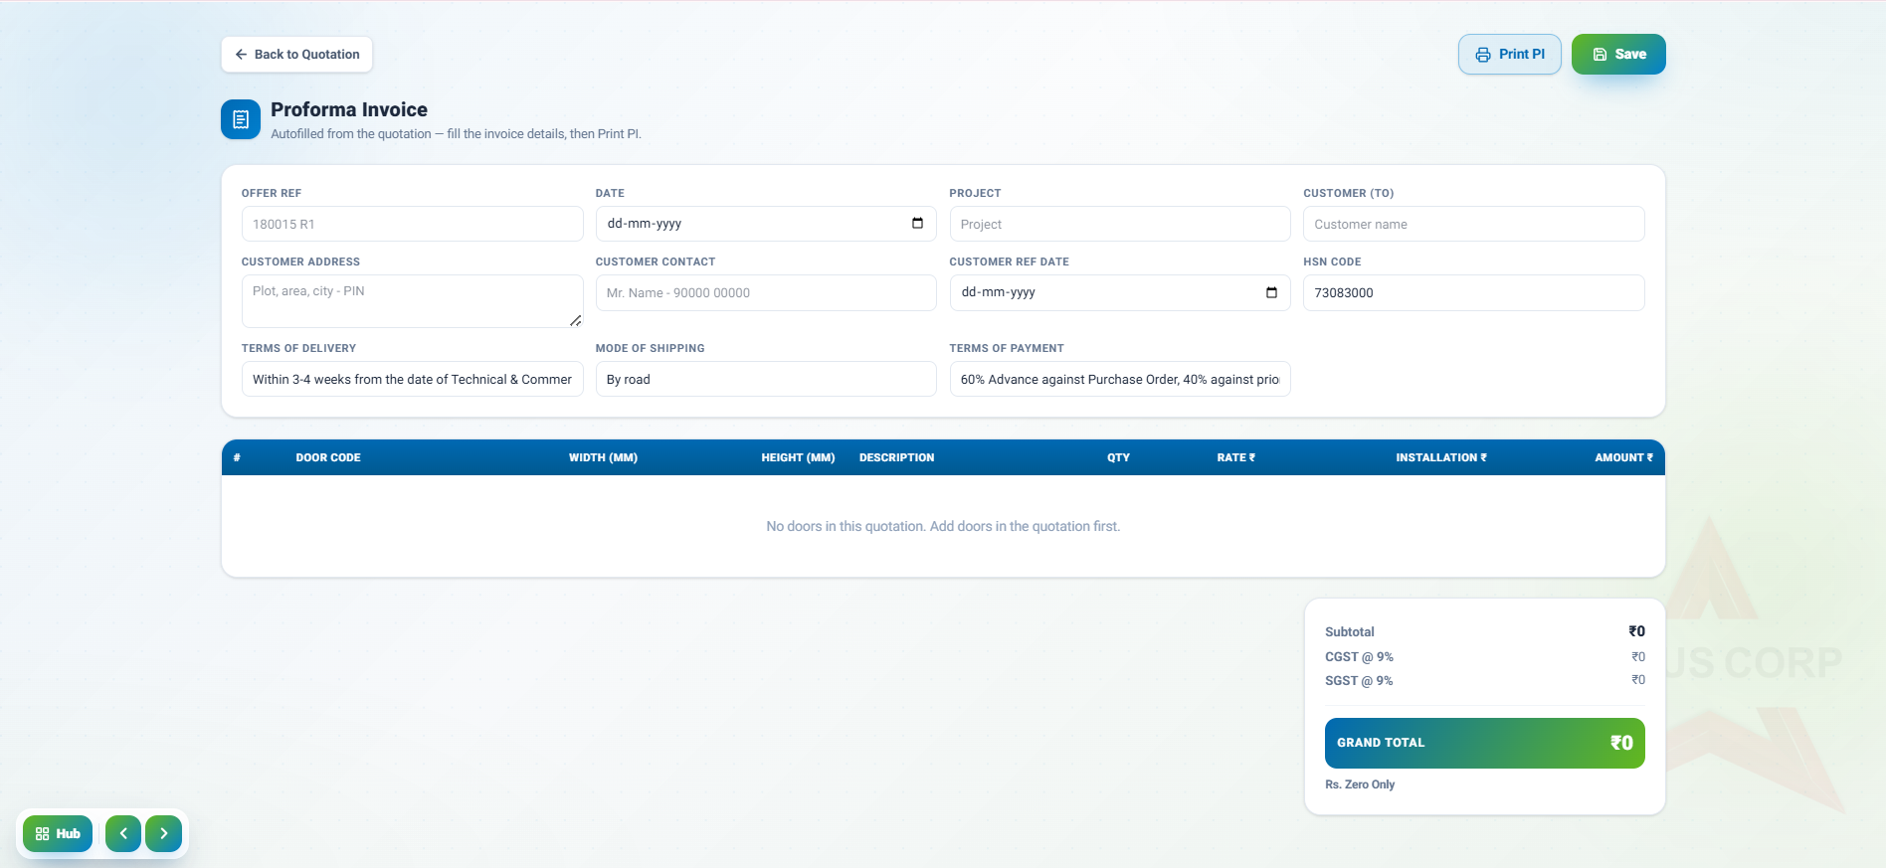
10.1 Fields
- Offer Ref, Project, Customer (TO), Customer Address, Customer Contact — auto-filled from the source quotation.
- Date, Customer Ref Date, HSN Code — invoice-specific details you fill in.
- Terms of Delivery, Mode of Shipping, Terms of Payment — the commercial terms shown on the printed invoice.
- Door table (Door Code, Width mm, Height mm, Description, Qty, Rate, Install, Amount) — one row per

- door included in the quotation; this stays empty until doors have been added to the quotation itself.
- Subtotal, CGST @ 9%, SGST @ 9%, Grand Total — calculated automatically, with the total also written out in words.

10.2 Actions
- Back to Quotation — returns to the source quote without saving changes.
- Save — stores the invoice.
- Print PI — generates a printable copy of the invoice.

11. Quick Reference: Common Actions
Action | Where to do it
Open the Pre-Production workspace | Workspace selection screen → Enter workspace on the Pre-Production card
Find any module quickly | Module hub → “Search modules...” box (top right)
Add a new record for a module | Module hub → Form button on the relevant card
View all stored records for a module | Module hub → Register button on the relevant card
Record a new enquiry / quotation | Quote Status → Form
Convert a quotation to a sales order | SO Status → Form → fill in PO and SO details
Request or track a GA drawing approval | GA Approval Status → Form
Track a Bill of Materials | BOM Status → Form
Move a BOM into production | Work Order Status → Form
Build/print a door specification | Working Specification → + Working Specification
Create a Proforma Invoice from a quote | Open the quotation → Go to PI → fill details → Print PI
Save a new entry and start another | Any form → Save & New
Discard an entry you're filling in | Any form → Cancel

