

**“Portal NS”**

**By**

**The Nearsoft Academy Interns**

**(2016-I)**

Hermosillo & Chihuahua, México. April 2016

**What is Portal NS?**

Portal NS is a project to establish real-time communication between the Nearsoft offices, which are located on different cities, through an audiovisual system build as a sci-fi portal, offering a realistic interface and a pleasant experience.

**Why Portal NS?**

In Nearsoft, the culture is very important, it is considered one of the main pillars, and due the offices are in different cities, maintain the same culture in them is a difficult task. Portal NS is a way for having a direct connection in real time with all the offices, so the Nearsoftians can share its culture more naturally just by cohabiting.

**Who are involved in Portal NS?**

This project is being developed by the interns of the Nearsoft Academy (2016-1).

**How Portal NS works?**

Portal NS is a “permanent” streaming through the offices of Nearsoft, the streaming will be sent through the Nearsoft internal infrastructure in a secure way, the streaming is broadcasted through an audiovisual communication set build as a portal.

**Features of Portal NS**

The main features of Portal NS are the following:

* Futuristic design to blend with the environment.
* Easy on/off switch.
* Uninterrupted video and voice communication.
* Secure & encrypted communication.

**Architecture & Design**

The design of Portal NS is one of the main features, this system is made to resemble a realistic sci-fi portal to provide a futuristic yet very realistic experience when using it.

The system runs a webRTC application over Node.js, Socket.io and Express.js.

It is recommended to use computers with good video processing, i.e. we use apple’s mac mini computers, to get the best experience.

The system uses two 1080p. Cameras for a realistic video transmission.

The system uses a Raspberry Pi v3.0 and two Arduinos configured to transmit and receive the on/off signal for starting the communication using a custom gun-like interface.

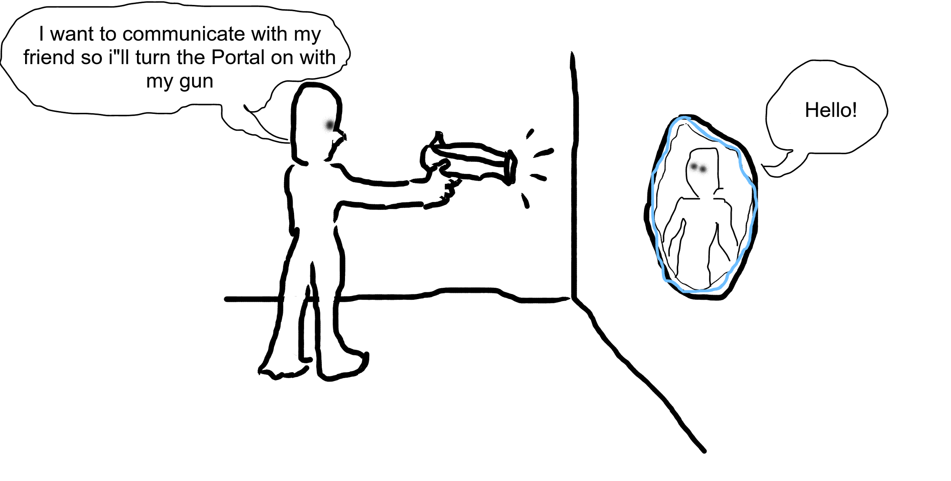

**Starting Guide for Portal NS**

***Developer Guide***

*Note: Portal-NS runs the application on your localhost, it is needed to configure your public ip address or use an application as “Ngrok” to connect Portal-NS with another machine.*

**Pre-requisites:**

**-** Have Node.js (v^4.4.3) installed on the machine that runs the application.

**Material Needed:**

* 2 Computers with speakers & microphone available.
* 2 high resolution cameras.
* Internet connection on both computers.

**How to Start?**

Copy the repository of the project from github:

<https://github.com/echavezNS/portal-ns.git>

Install the dependencies of the project using:

npm install

superstylin groove armada}

bower install

Once the project is downloaded you can start the service using:

npm start

You can test the health of the project using:

npm test

***User Guide***

Instructions:

The application starts automatically when two devices get connected.

1) You can pause or continue the transmission with your computer keyboard using the key

“R”.

Enjoy!.

Thanks for using Portal-NS.