

FINAL PROJECT
Project stage 3: the finished system and its users
Course: Information and Communication Technologies
Academic year 2026/2027, 1st trimester

Astana 2026
Assessment | Scored out of 100. The Final assessment makes up 40% of the course grade
Form of work | The same team as in the earlier stages. A report of eight to ten pages, an A1 poster and an oral defense
Deadline | Set on the LMS (lms.astanait.edu.kz). Poster defenses take place in the Week 10 practice sessions
Submission | Each member uploads two files to the LMS: the report as PDF or Word under the name FirstName_LastName_Final_ICT, and the poster as a PDF at A1 size under FirstName_LastName_Final_Poster_ICT. Anyone who uploads only one of them, or neither, gets 0

1 Purpose
The Final Project closes the course project. You present the finished system, test it with people from your main user group, work out what it costs to run and describe its effect on your setting. All of it goes into a report and a poster. Someone who has never heard of your project should be able to follow the poster in two minutes.

2 Tasks

2.1 Project summary
- Fill in Table 1 with a sentence or two per row. If the End-term defense proved an earlier answer wrong, give the corrected version.
Table 1 – Project summary
Item | Your answer
Domain and setting
Problem and main user group
Main task, and the screen where its main step happens
The most serious threat and the measure that stops it
IoT device, and the decision your data analysis supports
What changed after the End-term defense
- The last row needs at least one change the team made after the End-term defense, and what prompted it. Nothing changed? Then quote the defense question that tested your choice and explain why you kept it.

2.2 Final system map and course map
- Turn the End-term system map into the final system map. Draw everything that changed since the End-term in a second color, with a legend. Keep the web components, the database server and its backup, the IoT device, the numbered threats and the dashed logical connection. This map becomes the largest figure on the poster.
- Every label on the map has to be readable. If the map is hard to read at page width, add a larger copy as an appendix.
- Fill in Table 2 with one row for each of Weeks 1 to 9. Each row names the decision your team made for its own system and points to the table or figure in this report where it appears, and to the poster section if it is on the poster. A row that only repeats the lecture topic gets no points. Table 2 – What each week added to your system
Week | Topic | Decision the team made for its system | Where it is shown: report table or figure, poster section if any
1 | Introduction to ICT
2 | Computer systems and architecture
3 | Software, operating systems and HCI
4 | Networks and telecommunications
5 | Internet, cloud and mobile
6 | Database systems
7 | Cybersecurity
8 | Multimedia technologies
9 | Smart technology and data analysis

2.3 Test with real users
- Prepare a prototype of the main task. It can be the wireframes from Assignment 2 on paper, or a clickable prototype in Figma. It has to include the first screen, the main step and the error screen.
- Give the main task to at least five people outside your team, from your main user group where you can. Do not explain the interface in advance. If a participant cannot go on, you may help once and record the task as completed with help. Record each session in Table 3 under a code such as P1, and collect no names, phone numbers or IINs.
Table 3 – User test results
Participant | User group and device | Task completed: yes, with help, no | Time, minutes | Where they got stuck: flowchart step and screen | What they said
P1
...
- Under the table, give the number of participants who finished without help and the average time. Then score the prototype from 1 to 5 on the four qualities of a usable system, intuitive, efficient, memorable and forgiving, and point each score to a row of Table 3.
- Change at least one screen because of what you saw. Show it before and after the change in one figure, and say which participant's problem the change fixes.

2.4 Cost of running the system
- Estimate the cost of the first year in Table 4. Take the hardware, network equipment, hosting, domain, IoT devices and software from your earlier reports and check each price again. Add the people who would run the system, with a salary from a current job listing on hh.kz or enbek.kz.
Every price needs a source and the date you checked it.
Table 4 – First-year cost
Item | Quantity | Price per unit,  KZT | Source and date checked | Total, KZT
...
Total for the first year
- Under the table, name the item that costs the most and one way to reduce it without taking away what the main user group needs.

2.5 Impact and limits
- Fill in Table 5 about what your system changes in your setting.
Table 5 – Impact of the system
Question | Your answer
What becomes faster, cheaper or possible for the main user group, with a number where you can give one
Who could be left out, for example people without a smartphone, a stable connection or computer skills, and what the system offers them
Question | Your answer
What the system depends on that the team does not control, such as power, the ISP, a cloud provider or a law
One risk to privacy or security that remains after your protection plan
- In one paragraph, say what the team would do differently if it started the project again, and why.

2.6 Team contribution
Add a contribution table with each student's name, the report sections, tables and figures that student made, the poster sections that student prepared and a rough share of the work in percent.
These shares can change individual scores.

3 Poster
- Make one poster in A1 portrait format, 594 by 841 mm. Set the page size to A1 from the start and export the poster as a PDF at A1 size.
- Keep the title at 72 pt or larger, section headings at 40 pt or larger, body text at 24 pt or larger, and labels inside figures at 18 pt or larger. Keep the running text under about 700 words, not counting labels inside figures. Photos and screenshots need at least 150 dpi at the size they appear on the poster.
- Put the sections of Table 6 on the poster, in a reading order that goes from top to bottom and from left to right. Figure 1 shows one possible layout for a clinic booking system. You can arrange the sections differently, as long as all eight are there and the final system map gets the most space.
Table 6 – Poster sections
No | Section | What it shows
1 | Header | Project name, domain, team members, group, course and year
2 | Problem and users | The problem in your setting, and the main user group with its limitation
3 | Final system map | The map from 2.2, the largest figure on the poster
4 | One record and the decision | The record you followed from capture to decision in the Endterm, and the chart from Assignment 4
5 | Security | The three top-ranked threats and the measures against them
6 | User test | Participants, how many finished, the average time and the screen you changed
7 | Cost and impact | First-year cost, who gains and who could be left out
8 | What changed | The main changes from Assignment 1 to the final system
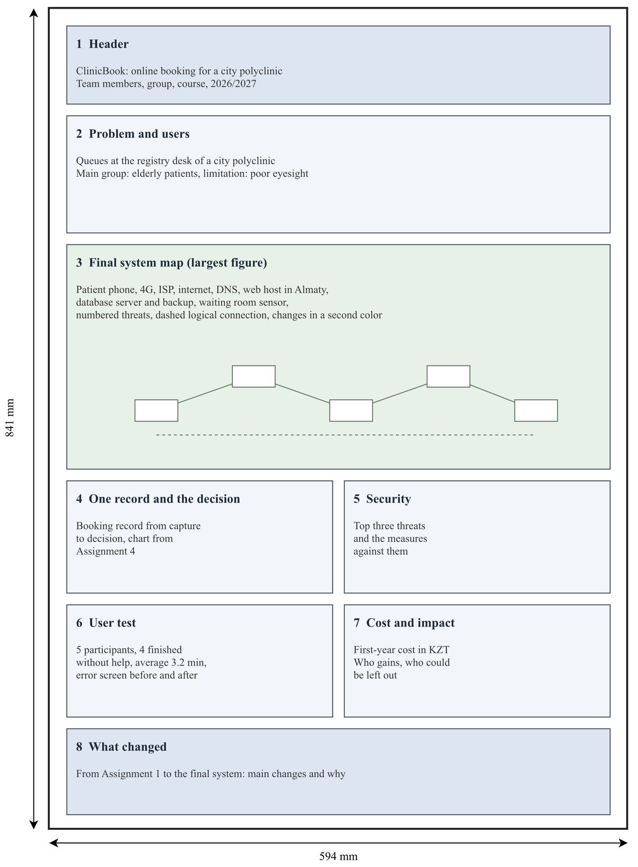

Figure 1 – Example layout of an A1 portrait poster for a clinic booking system
4) Templates are allowed. Every diagram, chart, screenshot and photo on the poster has to be the team's own, and every number on the poster has to match the report.

4 Report requirements
Eight to ten pages, not counting the title page, the list of sources and appendices. A4, Times
New Roman 12 pt, line spacing 1.5, first line indent 1.25 cm, justified text. Margins are 30 mm on the left, 10 mm on the right and 20 mm at the top and bottom, with page numbers at the bottom right. A table caption goes above the table on the left, a figure caption below the figure in the center, and the text mentions each table or figure before it appears. Every figure must be readable on A4.
After the text, give a numbered list of the sources you used, in the order you first mention them, with the URL and the date you checked each one.
This document can be used as a template for the report. Upload the files themselves. A link to Google Drive or any other cloud storage scores 0.

5 Defense
Defenses take place in the Week 10 practice sessions, with slots on the LMS, and the poster is shown on the screen from the PDF uploaded there. Each team gets ten minutes to present the poster and seven to eight minutes for questions, and the talk is cut off at ten minutes. Every member presents at least one section of the poster.
Each member also answers at least two questions alone, graded under criterion 10. One of them may change the system. The instructor might name a new user group, a power cut in the building, a new threat or a cloud provider leaving Kazakhstan, and the student shows where it lands on the final system map and which rows of the report tables change. Questions may cover any stage of the project, including parts you did not write. Bring the Assignment 4 spreadsheet and the records of your user test, because you may be asked to open them.

6 Grading
Table 7 splits the 100 points between the report, the poster and the defense. The total is the Final assessment score, which makes up 40% of the course grade.
Table 7 – Distribution of points
No | Criterion | Points
 | Report | 50
1 | Project summary. Table 1 is up to date and names a change after the End-term defense with its reason | 6
2 | Final system map and course map. The map keeps the End-term components and marks the changes, and every row of Table 2 names the team's own decision and where it is shown | 12
3 | User test. At least five real participants recorded without personal data, the results summed up, the four qualities scored against the evidence, and one screen changed, shown before and after | 12
4 | Cost of running the system. Every price in Table 4 is real, sourced and dated, the staff are included, and the most expensive item is discussed | 8
No | Criterion | Points
5 | Impact and limits. Specific answers in Table 5, and a reasoned paragraph on what the team would change | 6
6 | Report quality. Eight to ten pages, structure, formatting, captioned and referenced tables and figures, the list of sources and the contribution table | 6
 | Poster | 35
7 | Poster content. All eight sections, a readable final system map, and numbers that match the report | 15
8 | Poster design. A1 portrait, the font sizes and word limit kept, readable on screen, a clear reading order and the team's own figures | 10
9 | Poster presentation. Every member speaks, someone new to the project can follow the story, and the team finishes within ten minutes | 10
 | Defense | 15
10 | Individual defense. Accurate answers, a change traced through the map and the tables, and a grasp of the whole project | 15
 | Total | 100

7 Rules
Late submissions get 0. An exception needs approval before the deadline, and only for serious circumstances.
Plagiarism, copying from another team, borrowed diagrams, charts, screenshots or photos, a made-up price, user test or source, and unauthorized collaboration all score 0 and go to a disciplinary case.

