

ASSIGNMENT 2
Human-computer interaction

Course: Information and Communication Technologies Academic year 2026/2027, 1st trimester
Group: Kira Kogay, Altynay Aitbayeva, Medet Azimkhan

Astana 2026

1. Users and their main task
This assignment has the same topic as the Assignment 1- an appointment booking and notification system for Polyclinic No. 5 in Astana.
Table 1. User groups
User group | Who they are | What they need to do | Device | Computer skills | Limitation
1 | Patients of the polyclinic, including many elderly and working-age residents. | View free slots, book or cancel an appointment, receive a reminder. | Personal smartphone (most common) or a home PC/laptop. | Can range from confident daily smartphone users to first-time app users. | A large share are elderly patients with limited eyesight and little experience with apps/websites, so small text and multi-step menus are hard for them to use.
2 | Receptionists at the front desk of the polyclinic. | Confirm walk-in bookings, view and adjust the shared daily schedule, create new appointments. | Desktop PC at the reception desk (Configuration A from Assignment 1). | Trained on the system but not IT specialists. | High time pressure: a queue of waiting patients leaves very little time for each.

Table 2. Steps for booking an appointment
Step | What the user does | What the system shows in reply
1 | Opens the booking app/website. | Shows the login screen.
2 | Enters phone number and password. | Checks the credentials and either shows an error or moves on.
3 | Selects a specialty (therapist, cardiologist, etc.). | Shows the list of doctors in that specialty who are currently accepting bookings
4 | Selects a doctor from the list. | Shows that doctor's calendar with free and booked slots for the coming week.
5 | Selects a free time slot. | Highlights the chosen slot and shows an optional field for the reason for the visit.
6 | Taps "Confirm this slot". | Checks the slot is still free. If it was just taken, shows an error but keeps the doctor and specialty choice saved.
7 | Reviews the confirmation. | Shows the finished booking (doctor, date, time) with a reference number.
8 | Closes the app/website. | Sends an SMS or push reminder to the patient closer to the appointment time.

2. Interface teardown

We decided to analyze the usablity of DamuMed.kz website, as it is a system very comparable to ours. All screenshots were taken on 21.09.2026.

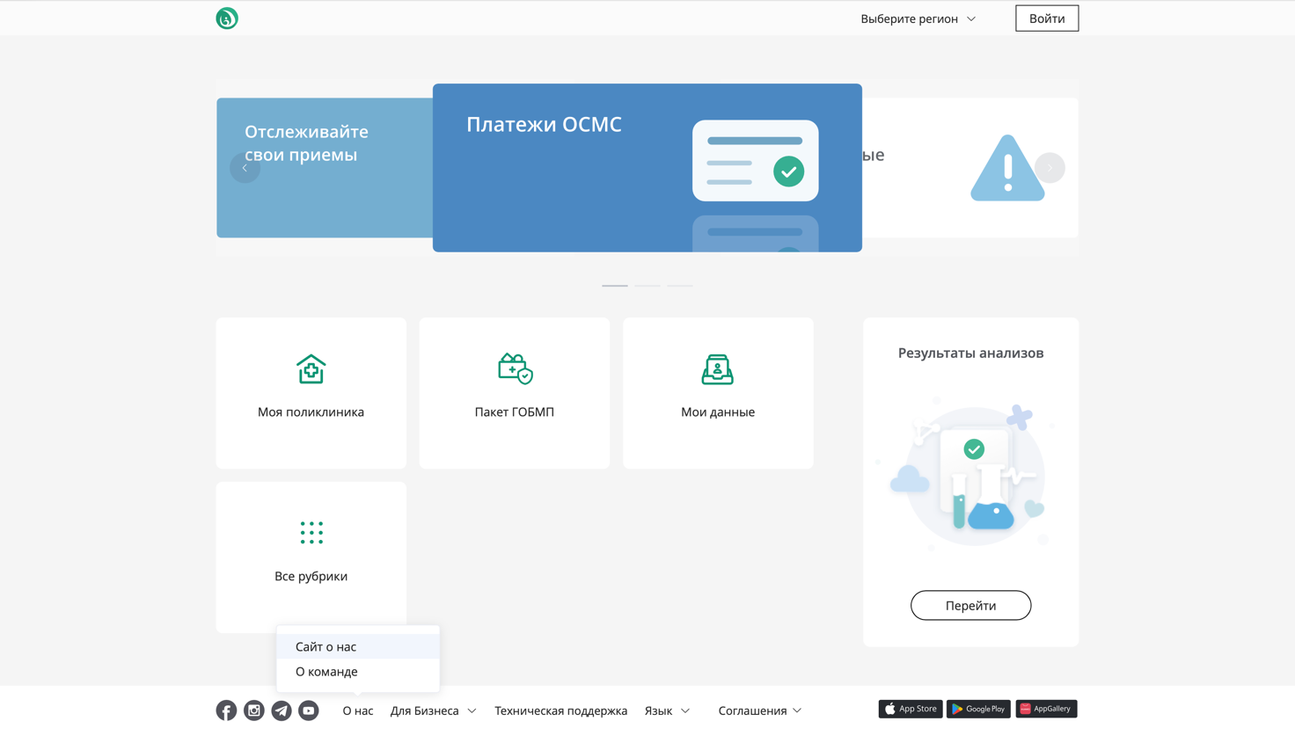

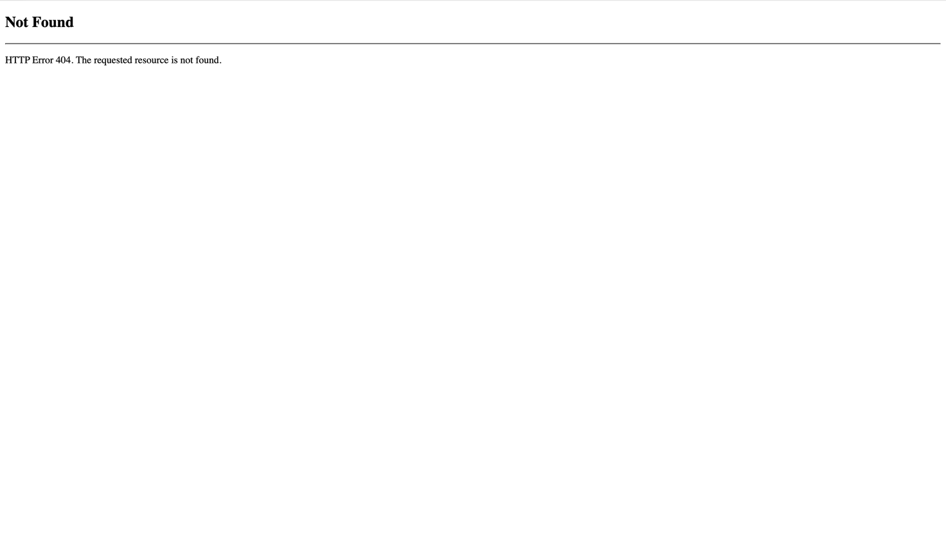

Figure 1

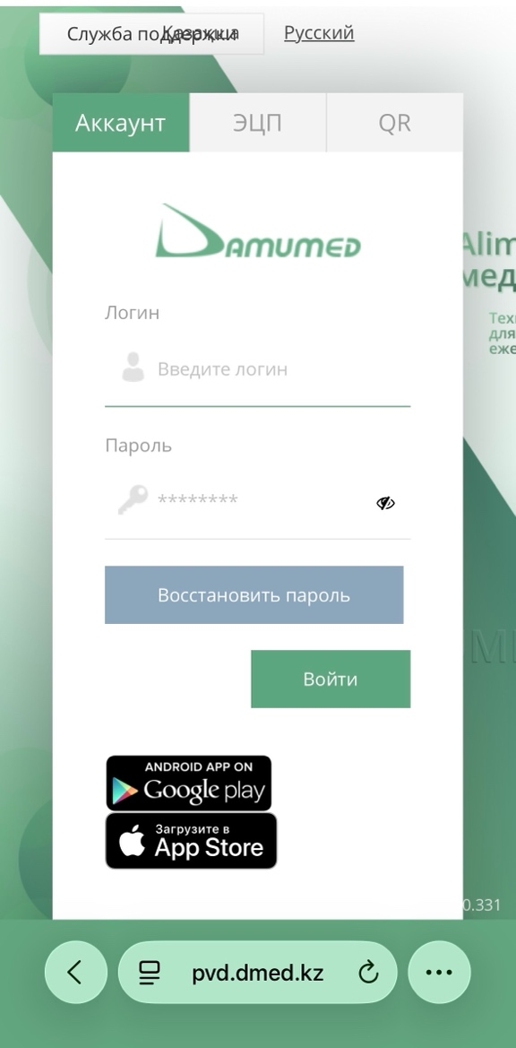

Figure 2

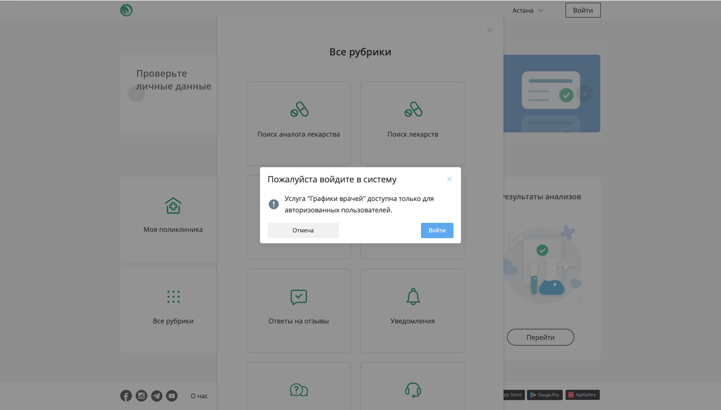Figure 3

Table 3. Usability problems
No | Figure | What goes wrong for the user | Type of problem | How you would fix it
1 | 1 | When the user clicks “Website About Us” it leads them to a dead end (Error 404). | Path that leads to an obstacle | To add an actual “About Us” page, with all necessary information about the system.
2 | 2 | In the mobile version of this website, functionality is limited and the usability is decreased. Some buttons are not aligned on the centre and some text fields are overlapped. For phones, online booking is available only through mobile application. | A control in an unexpected pace | To make the website adjustable for different kinds of devices. Increase the functionality of the website, allowing patients to book an appointment through it without needing to download a separate application.
3 | 3 | Most of the functions (not only booking but also viewing feedback, doctors’ schedule and details, etc.) require log in to be accessed. | - | The fucnctions that are not directly connected to patient’s personal information (appointments, results of medical tests, documents or certificates) should be available to everyone, without log in.
4 | 1 | The main page consists of many fields and menus that might be too complicated for a novice user (especially elderly patients). | - | To make “Make Appointment” field/button more noticable and hence easy to find.

Table 4. Usability score
Quality | Score | Evidence from your figures
Intuitive | 4 | As it can be seen on the first screenshot of Figure 1, the interface of the main page is simple and so is relatively easy to navigate (for a more or less experienced user). All the buttons and hyperlinks are clearly labeled and visible.
Efficient | 4 | The system is effective in terms of booking and some general functions (finding drug alternatives, pharmacies), but could be improved by making more functions available without log in (Figure 3).
Memorable | 3 | The colors and the interface is too simple to be memorable. The logo at the upper-left corner is very small, so not all users can notice or remember it (Figure 1).
Forgiving | 5 | Although it is hard to assess this criteria of the system without actually booking an appointment at least once, the other functions allow the user to go back and try again when the error occurs (as shown by Figure 3).

3. Task flow diagram
Figure 4 is the flowchart representation of Table 2. It was drawn using Lucidchart on 20.09.2026.
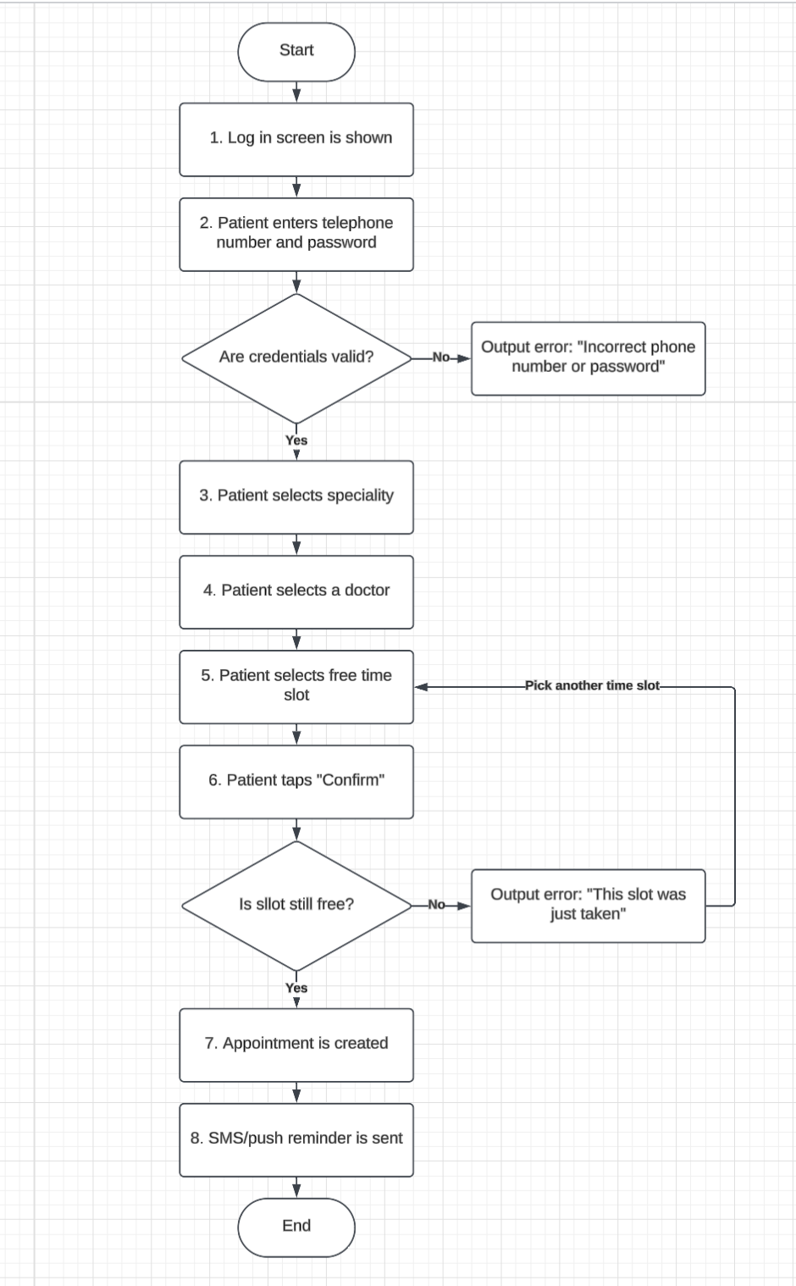
Figure 4. Task flow for booking an appointment

4. Wireframes
Figures 5 to 7 show three screens of our own system for the same task. Each screen is labelled with its flowchart step number from Figure 3. The designs were drawn using Microsoft Paint on 21.09.2026.
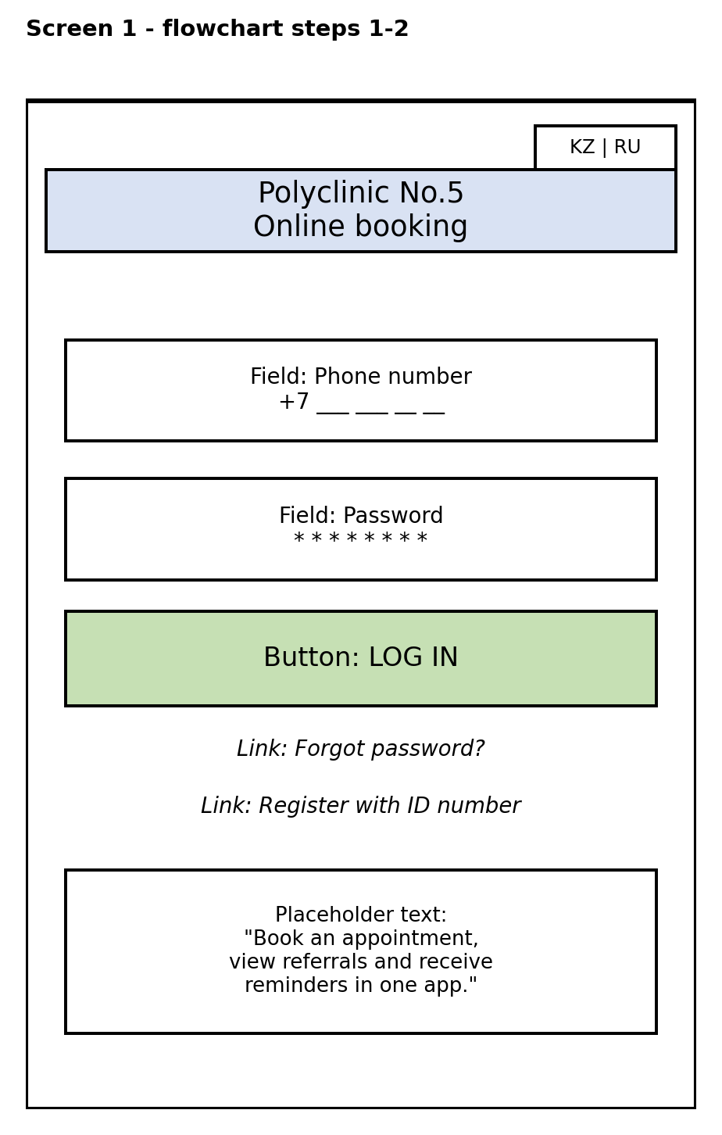
Figure 5. Log in screen
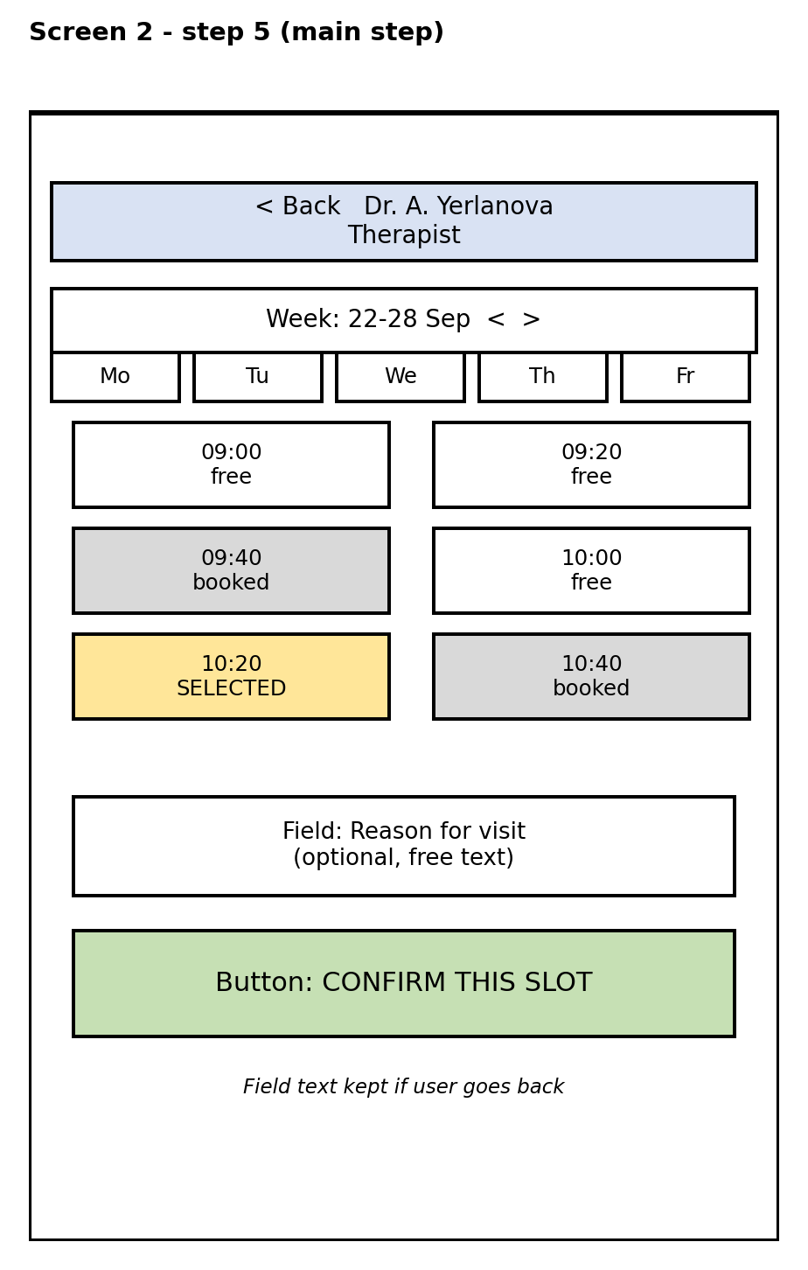
Figure 6. Booking screen
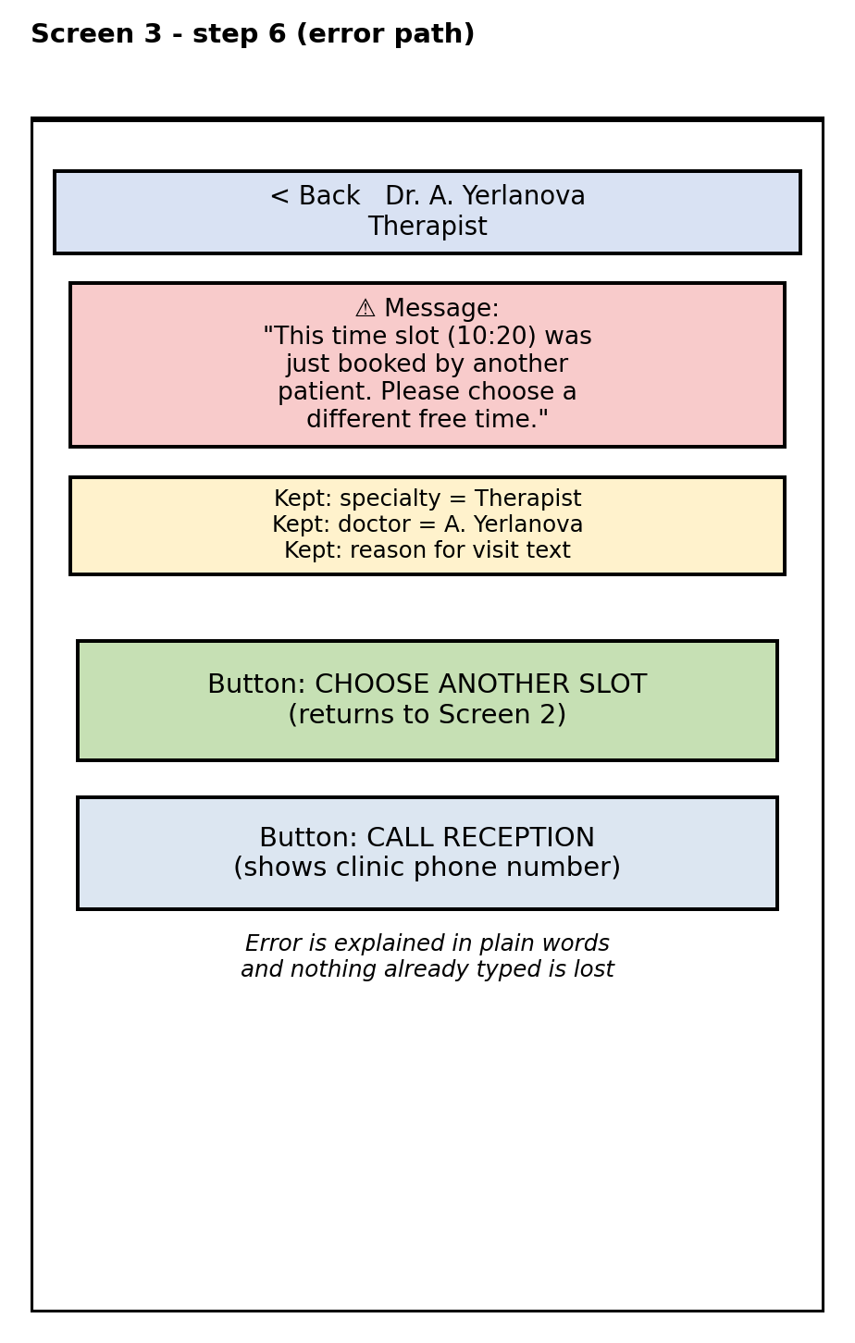
Figure 7. Error screen
The error screen in Figure 7 shows what happens when the chosen slot was taken by another patient. The system saves all the details that were already specified and asks to only choose another time slot.
Table 5. Screens and what they are for
Screen | Flowchart step | Limitation from Table 1 and the element that deals with it | Problem from Table 3 it avoids
First screen | 1-2 | Group 1 limitation: elderly patients with little app experience who might find it confusing to navigate through website/mobile app by themselves.  Elements: large, single-purpose fields and a bilingual KZ/RU interface, website, adjustable for different devices. | 2 (both mobile app and website can be used to book an appointment through cell phones)
Main step | 5 | Group 1 limitation: poor eyesight of elderly patients, for whom it is difficult to read small heavy-on-the-text labels.  Elements: free/booked/selected slots are shown with both colour and text ("free", "booked") rather than colour alone. The buttons are big enough and the text is kept as short as possible to still be understandable. | 4
Error screen | 6 (“no” path) | Group 2 limitation: receptionists at the front desk who are under time pressure and have low patience for lost input  Elements: even if the error is generated, the system keeps every earlier choice instead of discarding it. | -

5. Software behind the task
Table 6 lists the software running while a patient performs the booking task on the reception PC specified in Assignment 1 (Configuration A) or on a personal PC/laptop (it should be noted that in this case some details may vary depending on the personal computer).
Table 6. Software used in the main task
Software name | Category | What it does during the task
Windows 11 Pro | System software (operating system) | Schedules the browser process, manages memory and runs the network stack that carries the booking request.
Realtek Gigabit Ethernet driver (onboard, Gigabyte B760M DS3H) | System software (driver) | Translates the OS's network requests into signals the network card can send over the clinic's LAN.
Antivirus agent | System software (utility) | Scans files and network traffic in the background to protect patient data while the booking app runs.
Google Chrome | Application software (general-purpose) | Runs the booking web portal as a web page and renders the calendar and forms on screen.
Booking web portal | Application software (specialized) | Shows free slots, validates the booking form and sends the confirmed request to the server.
Kaspi Pay merchant app | Application software (specialized) | Charges the patient for paid services once the appointment is confirmed.

Table 7 details the operating system named above against its six functions, with examples drawn from our own system.
Table 7. The operating system during the task
Item | Our system
Name and family | Windows 11 Pro, Windows family.
Types it belongs to | Multitasking, single-user desktop OS with a graphical user interface.
Memory management | Example: Windows allocates RAM to the Chrome process when the receptionist opens the booking portal and reclaims that memory once the tab is closed.
Processor management | Example: while the calendar page loads in the background, Windows still lets the receptionist type into a search box in another window, by giving each process a share of CPU time.
Device management | Example: Windows loads the Realtek network driver so the booking request can reach the network card and the printer driver when a referral needs to be printed.
File management | Example: Windows keeps the locally cached copy of the day's schedule as a file on the SSD and organises the browser's temporary files separately from the OS's own files.

The booking web portal itself would most likely be written in JavaScript (with a framework such as React for the interface and Node.js for the server side), because it needs to run inside an ordinary browser on both the patients' phones/laptops and the reception PCs without any separate install. JavaScript is an interpreted language: the browser's engine reads and executes the source code directly at run time rather than compiling it into a separate stand-alone executable file beforehand.

6. Team contribution
Table 8
Student | Sections written | Figures drawn | Approximate share
Medet Azimkhan | 1. Users and main task; 6. Team contribution | None (tables only) | 33%
Kira Kogay | 2. Interface teardown; 3. Task flow diagram | Figure 4 and the screenshots in Section 2 (Figures 1-3) | 34%
Altynay Aitbayeva | 4. Wireframes; 5. Software behind the task | Figures 5-7 | 33%

GrammarlyAI was used to check and correct any grammatical and punctuational mistakes.

