

ASSIGNMENT 3
Database systems and cybersecurity

Course: Information and Communication Technologies Academic year 2026/2027, 1st trimester
Group: Kira Kogay, Altynay Aitbayeva, Medet Azimkhan

Astana 2026

1. Business rules
Table 1 lists the rules for the data behind the main task (booking an appointment).
Table 1
No | Rule | Source | What it becomes in the model
1 | A patient can book many appointments, and each appointment belongs to one patient. | Interview with the clinic receptionist | Relationship books, Patient 1:N Appointment
2 | A doctor can have many appointments, and each appointment is with exactly one doctor. | Interview with the head physician | Relationship attends, Doctor 1:N Appointment
3 | A doctor can hold several specialties, and a specialty can be held by many doctors. | Written documentation | Relationship holds, Doctor M:N Specialty
4 | A doctor cannot have two appointments at the same date and time. | Observation (Analysis of the automated scheduling system workflow) | Limit on a value: unique (doctor, date_time) in Appointment
5 | A patient and doctor have at most one login account. | Our design. | Relationship has, Patient 1:1 User account

2. ER diagram
Figure 1 is the crow's foot ER diagram of the rules in Table 1. Figure 2 is the Chen diagram.
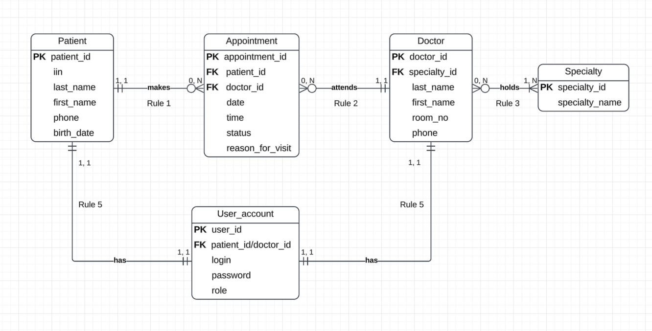
Figure 1
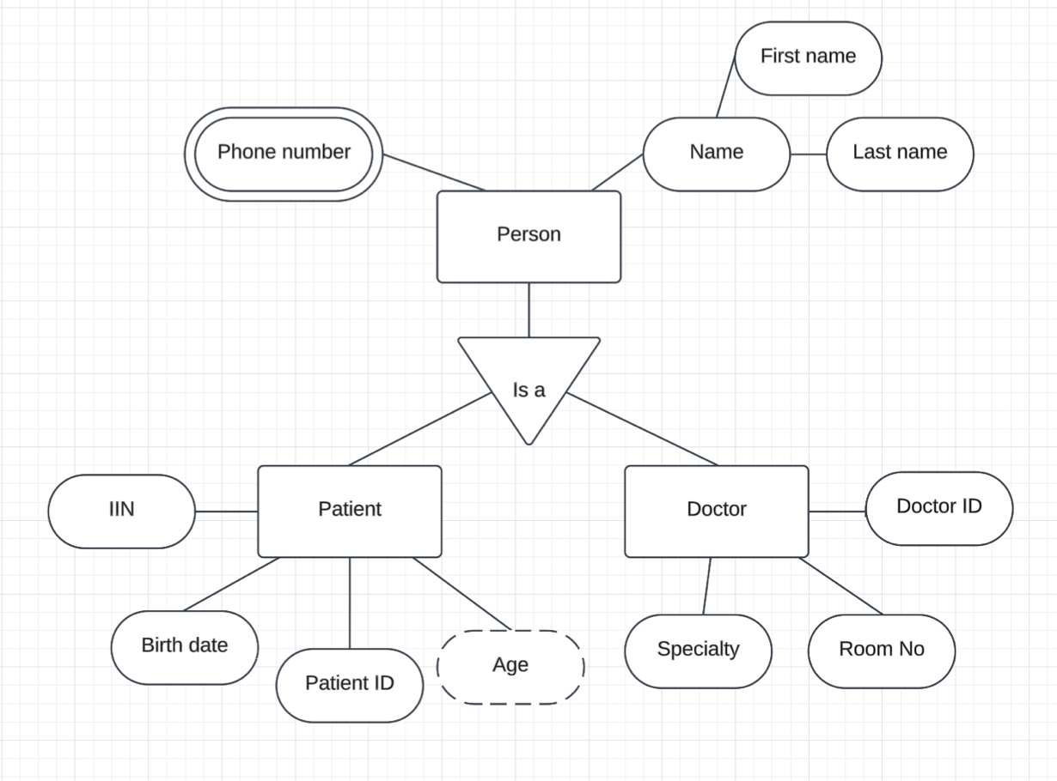
Figure 2

3. Relational tables
Table 2. Relations and keys
Relation | Attributes | Primary key | Foreign keys, and the relation each points to | Can a foreign key be empty, and why | Personal data
patient | patient_id, iin, last_name, first_name, phone, birth_date | patient_id | none | - | iin, last_name, first_name, phone, birth_date
doctor | doctor_id, last_name, first_name, room_no, phone, specialty_id | doctor_id | specialty_id | No, each doctor working and accepting appointments in the polyclinic must have at least one specialty. | last_name, first_name, phone
specialty | specialty_id, specialty_name | specialty_id | none | - | none
doctor_specialty | doctor_id, specialty_id | doctor_id, specialty_id | In doctor: specialty_id - specialty | No, each doctor working and accepting appointments in the polyclinic must have at least one specialty. | none
appointment | appointment_id, patient_id, doctor_id, date, time, status, reason_for_visit | appointment_id | patient_id - patient; doctor_id - doctor | No, according to rules 1 and 2 in Table 1 every appointment has exactly one patient and one doctor. | reason_for_visit
user_account | user_id, patient_id/doctor_id, login, password, role | user_id | patient_id – patient / doctor_id - doctor | No, for the account to exist there must be a user behind it. | phone number, password

Table 3. Sample rows of patient
patient_id | iin | last_name | first_name | phone | birth_date
1 | 123456789 | Sample | Aigerim | +7 700 000 00 01 | 12.03.1990
2 | 987654321 | Example | Dauren | +7 700 000 00 02 | 30.11.1965
3 | 090909090 | Demo | Zarina | +7 700 000 00 03 | 04.07.1991
4 | 121212121 | Test | Nurlan | +7 700 000 00 04 | 25.01.2001
5 | 918273645 | Invented | Saltanat | +7 700 000 00 05 | 18.06.1972
Table 4. Sample rows of appointment
appointment_id | patient_id (FK - patient) | doctor_id | date | time | status | reason_for_visit
1001 | 1 | 005 | 14.10.2026 | 09:00 | completed | Headache
1002 | 3 | 007 | 14.10.2026 | 09:20 | booked | Bad vision
1003 | 3 | 009 | 15.10.2026 | 10:40 | cancelled | Stomach ache
1004 | 2 | 002 | 16.10.2026 | 11:00 | booked | Seasonal allergy
1005 | 1 | 002 | 17.10.2026 | 14:20 | booked | Cold
All the personal information in Table 3 and Table 4 is fake and has no connection to real people.

4. The database system
Table 5
Part | What it is in your system
Hardware | Megahost.kz Cloud-12 virtual server (12 vCPU, 12 GB RAM, 100 Mbit/s), in Megahost's data centre in Astana.
Software: operating system, DBMS with exact name and version, applications. | Ubuntu Server 24.04 LTS. PostgreSQL 18.6. Applications: the booking API (Node.js), psql for administration, pgBackRest for backups.
People: administrator, designer, end users | Administrators: specialists assigned by the polyclinic. Designers: us (meaning the members of this team). End users: patients, receptionists and doctors.
Procedures | Nightly backup and a quarterly test restore. Monthly security updates of the OS and PostgreSQL. A written request-and-approval step before anyone gets access to the database.
Data, and the city where the physical schema is stored | The relations in Table 2 (patients, doctors, appointments, accounts, specialities), stored physically in Astana, Kazakhstan.
Table 6
Property | What it means for your action | What goes wrong without it
Atomicity | The appointment row is saved only with all information intact. Otherwise, no processing happens. | The appointment is not complete (important pieces of information missing) and, therefore, is not valid.
Consistency | Before and after the transaction the rules should hold: the patient and doctor exist, the doctor has no other appointment at that time. | Two appointments for the same doctor at the same time, or an appointment linked to a deleted doctor/patient ID.
Isolation | If two people confirm the same slot at the same moment, the DBMS handles them as if one came after the other, while the second is refused. | Both bookings succeed and the doctor is double-booked.
Durability | Once the confirmation screen appears, the booking survives a server crash or restart. | The patient sees a confirmation and gets an SMS reminder, but the booking has disappeared from the database after a restart or server crash.

5. Who sees what
Table 7 shows the level of access for different user groups. R means read, W means read and write, a dash means no access.
Table 7
User group | patient | doctor | specialty | doctor_specialty | appointment | user_account
Patients | W (only their own row) | R | R | R | W (only their own row) | W (only their own password)
Receptionists | W | R | R | R | W | -
Administrator | R | W | W | W | R | W

One cell that we argued over the most is the access of an administrator to patient information. On the one hand, if any issues with personal information occured, an administrator could act as technical support without any mediator needed. Conversely, we decided that a receptionist should be responsible for everything related to appointments (including those made without log in), while an administrator everything related to accounts and polyclinic’s own records, so that their responsibilities would not be overlapped.

6. Threats to your system
Table 8
No | Threat | Who would do it | Category of computer crime | What it hits in your system
1 | Data leak: SQL injection on the booking portal. | Crackers and hackers | Computer as the target | patient, appointment, user_account relations
2 | Ransomware: encrypts the booking server and demands payment. | Criminals | Computer as the target | The Megahost server and every relation on it
3 | Phishing email with an attachment carrying a Trojan horse, opened on the reception PC (unsolicited email). | Criminals | Computer as a tool | Reception PC and the staff passwords in user_account
4 | Open guest Wi-Fi in the waiting room lets an outsider reach the clinic LAN. | Script kiddies | Computer as the target | TP-Link Archer AX53 access point and the doctor's laptop
5 | Stolen patient records offered for sale on a forum. | Criminals | Selling illicit goods | patient relation (iin, phone, birth_date)

Data leak can be considered the most dangerous threat to our system due to the sensitive nature of information stored in the database.

Figure 3 presents a threat map marked on top of the network diagram (Midterm Figure 1). It shows where each threat from Table 8 gets into the system.

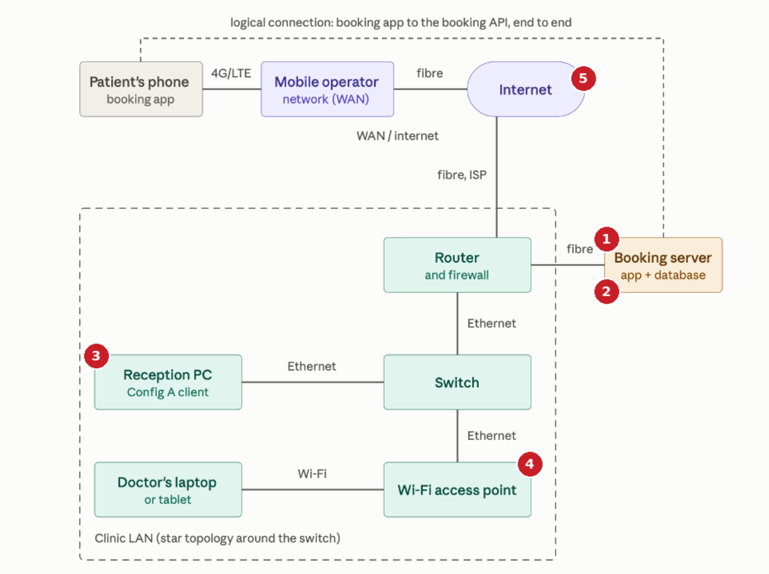

Figure 3

7. A real incident
Table 9 describes an incident of a large-scale data leak that happened in Kazakhstan in 2025 and is allegedly connected to unsatisfactory protection of personal data in medical organizations.
Table 9
Item | Your answer
What happened, when and where | In July 2025 the Kazakhstani centre TSARKA reported that data on about 16 million citizents, including names, birth dates, IIN, addresses and phone numbers, was openly available online. The Prime Minister said the data dated from 2022 and that preliminary findings pointed to medical organizations, which have access to state databases but did not always keep them safe.
Source: URL and the date you checked it | https://www.zakon.kz/obshestvo/6484253-olzhas-bektenov-ob-utechke-dannykh-kazakhstantsev-sliv-mozhet-byt-svyazan-s-medorganizatsiyami.html and inform.kz:  https://www.inform.kz/ru/utechka-dannih-16-mln-kazahstantsev-v-minzdrave-soobshili-o-proverke-po-faktu-intsidenta-b5ed6f. Checked on 13.10.2026.
Category of computer crime | Computer as the target (unauthorised access to a data store). The leaked data then enters the illicit goods market.
Cause: misconfigured system, vulnerable code, end-user error or targeted attack | Officially not yet established; the Prime Minister's preliminary statement points to improper storage in medical organisations. It is most likely caused by a misconfigured system, targeted attack or both.
What data was exposed or lost | Names, birth dates, IIN, addresses and mobile numbers.
What would have stopped it | All personal information within the database ahould be encrypted and the password hashed. Strict restrictions for software installations and data transmission over the system. Only accepting parametrised queries.
Could it happen to your system, and which threat in Table 8 matches it | Threat 1 (Data leak) matches this situation. It could happen to our system as well to to the sensitive nature of data stored.

8. Protection plan
Threat numbers in the first column refer to Table 8. Table 11 contains login rules for the users.
Table 10
Threat No | What the system does | Rule for users | Tool or product | DBMS function it uses | Recovery
1 | Parameterised queries only; the database accepts connections only from the API server; iin and phone stored encrypted; every read of patient data is logged. | Staff never export patient lists to personal devices or messengers. | PostgreSQL 18.6 with pgcrypto; pgAudit extension. | Roles and GRANT, row-level security, column encryption. | Nightly backup; leaked credentials revoked and all passwords reset within one hour.
2 | Server reachable by SSH keys only; backup credentials are stored elsewhere. | Nobody installs software on the server; only the administrator logs in. | pgBackRest; Ubuntu unattended-upgrades. | Write-ahead-log archiving for point-in-time recovery | Full backup daily and WAL archive every 5 minutes, kept at a second Kazakhstani provider's object storage using write-only credentials, so ransomware on the server cannot delete or encrypt it.
3 | Reception PCs block executable and archive attachments from outside senders. | Staff forward any unexpected email to the administrator and never open its attachment; the clinic never asks for passwords by email. | Microsoft Defender on Windows 11 Pro; mail filtering. | None (protection is outside the DBMS). | Reimage the PC from a clean image, force password changes for that user, restore data from backup if needed.
Table 11
Item | Login rules
Minimum password length, and whether passphrases are allowed | 12 characters minimum. Passphrases of several words are allowed.
Two-factor authentication: for which user groups, and how | Required for receptionists and the administrator, using an authenticator app. Patients get an SMS one-time code when logging in from a new device.
Lock after how many wrong attempts, and for how long | 5 wrong attempts lock the account for 15 minutes. The administrator is alerted after 10.
How a password reset works, and how the user can tell the reset email is real | A single-use link, valid for 15 minutes, sent to the registered contact. The message shows the clinic's exact domain, never asks for the old password or any personal information.
Attributes in Table 2 stored encrypted | iin, phone, reason_for_visit; password is stored hashed with Argon2id, not encrypted.
What the user sees after a wrong password | “Incorrect phone number or password”, without saying which, with the phone number kept in the field.

9. Team contribution
Table 12
Student | Sections and tables | Figures drawn | Share
Altynay Aitbayeva | 1. Business rules; 3. Relational tables; 9. Team contribuation | Figure 1 (Chen diagram) | 33%
Kira Kogay | 2. ER diagram; 4. The database system; 5. Who sees what | Figure 2 (ER diagram) | 33%
Medet Azimkhan | 6. Threats to your system; 7. A real incident; 8. Protection plan | Figure 3 (Threat map) | 34%

GrammarlyAI was used to check and correct any grammatical and punctuational mistakes.

