

ASSIGNMENT 4
Smart technology and data analysis

Course: Information and Communication Technologies Academic year 2026/2027, 1st trimester
Group: Kira Kogay, Altynay Aitbayeva, Medet Azimkhan

Astana 2026

1. Media in the system
Table 1 classifies the media in the booking system (Audio and Video rows are an upgrade to the system, not mentioned in the previous Assignments).
Table 1
Type of media | Where it appears in your system | File format | Lossless or lossy | Why this format, or why not used
Text | Booking forms, doctor and specialty names, confirmation and reminder messages. | UTF-8 text in JSON and HTML | Lossless | Text must arrive exactly as written; one wrong character in a date or time would change the booking.
Images | Doctor photos on the doctor selection screen; clinic logo and icons. | JPEG (photos); PNG (logo, icons) | JPEG lossy; PNG lossless | A small JPEG loads quickly on a phone over 4G; the logo and icons have sharp edges and stay crisp in PNG.
Audio | Voice during an online follow-up consultation (streamed, not stored). | Opus (WebRTC audio codec) | Lossy | Speech stays clear at a low bit rate, which suits even a weak mobile connection.
Animation | Not used | - | - | A booking form needs no animation; moving elements could distract novice users and slow the page.
Video | Live video of an online follow-up consultation (streamed, not stored). | VP8 or H.264 inside a WebRTC stream | Lossy | Lossless video is far too large to stream over a mobile connection.
The content is nonlinear: patients choose their own path through specialties, doctors and time slots and can step back at any point, instead of following one fixed sequence (only the video consultation itself is linear).

Table 2 lists the components of multimedia system, using the equipment chosen in Assignments 1 and 3.
Table 2
Component | What it is in your system | Model or product
Capture devices | The patient's phone camera (referral photo) and microphone and camera (video call); the doctor's webcam | Patient's own smartphone (BYOD); Logitech C920 HD Pro webcam (1080p, USB).
Storage devices | The reception PC's SSD, the server's disk, and the backup copy at a second provider. | Apacer AS2280P4 512 GB NVMe SSD; Megahost.kz Cloud-12 VPS disk.
Networks | The clinic LAN, the mobile network for patients, and the ISP's fibre link to the server. | TP-Link Archer AX53 router, TP-Link TL-SG1008D switch; 4G/LTE; fibre ISP uplink.
Computer systems | The reception PC and the cloud server that stores and serves the media. | Configuration A (Intel Core i5-12400, Gigabyte B760M DS3H); Megahost.kz Cloud-12 VPS, Astana.
Output devices | The monitor at reception, the patient's phone screen and speaker, a headset for the doctor. | LG 24MS500-B 24-inch IPS monitor; Logitech H390 USB headset.

Table 3 shows the comparison between three formats of the same 15 second audio. It was recorded by the team using Audacity.
Table 3
Format | Lossless or lossy | File size, KB | Smaller than the WAV file by, % | What you hear compared with the WAV file
WAV (original) | Lossless (uncompressed) | 1323 | - | -
FLAC | Lossless | 850 | 35.8 | No noticable difference, audio quality is identical to the ear.
MP3 | Lossy | 240 | 81.9 | Slight quality loss, but the speech is clear and understandable

The size reductions are approximately consistent with the Week 8 lecture, although, the reduction in FLAC turned out to be less than claimed on the slide (35.8% compared to 50-60%).

2. IoT device
The chosen device is a motion and light sensor in the clinic waiting room, so the booking system knows whether the room is busy (Table 4, Table 5).
Table 4
Device | What it senses or does | Model and source | How it connects | What data it sends, and how often
Waiting-room motion and light sensor | Detects movement (infrared, up to 7 m, 170° view) and the light level in the waiting room. | Aqara Motion Sensor P1 (MS-S02), with an Aqara Hub M2 as its gateway. Both can be purchased on aqara.kz online store for 14 500 and 30 000 KZT respectively.  https://aqara.kz/shop/datchiki/datchik-dvizheniya-aqara-motion-sensor-p1/  https://aqara.kz/shop/hab/czentr-umnogo-doma-aqara-hub-m2/ | Zigbee 3.0 from the sensor to the hub; Ethernet from the hub to the clinic router, then HTTPS to the booking server. | Motion detected / not detected whenever it changes, the light level in lux, and the battery level; roughly a few messages per minute in a busy room.
Table 5
Characteristic | Your device
Connectivity | The sensor reaches the hub over Zigbee, and the hub reaches the clinic LAN and the internet through the router.
Things | The sensor itself: a small battery-powered box with an infrared motion sensor and a light sensor, fixed to a waiting-room wall.
Data | Motion on/off events, light level in lux and battery level.
Communication | Zigbee between sensor and hub, Ethernet between hub and router, then HTTPS from the clinic to the booking server.
Intelligence | The sensor decides when movement has stopped using a timeout, and the server turns the stream of events into a status such as “waiting room busy” or “empty”.
Action | Automated: the status on the reception screen updates by itself; any decision based on it, such as asking a patient to arrive later, is manual.
Ecosystem | The sensor, the Aqara hub and its app, the clinic network, the booking server and database, and the reception dashboard.

Figure 1 is the network diagram from Midterm, altered to accomodate the light and motion sensor and to show its connection to the clinic’s system.
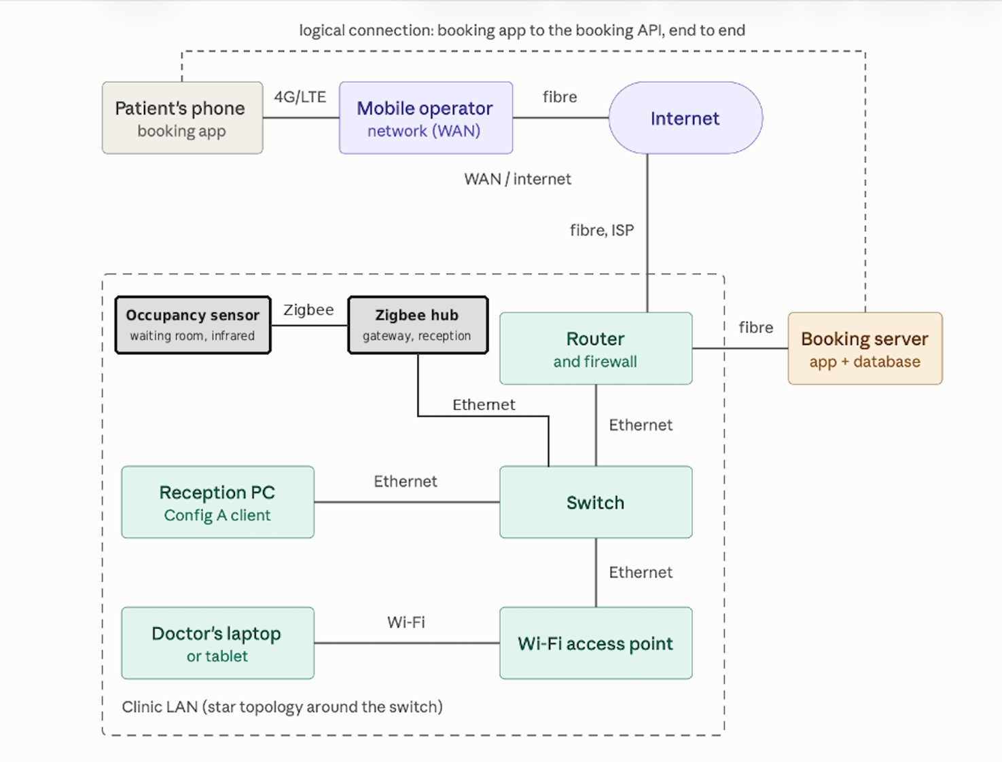
Figure 1

3. Smart building and power
Table 6 describes two home automation applications.
Table 6
Application | What it would do in your setting | Sensors and devices it needs | Manual or automated
Leak detection | Warns staff when water appears near the server cupboard, the toilets or the pharmacy store, before it damages equipment or paper records. | Zigbee water-leak sensors (Aqara makes one) on the same Aqara Hub M2. | Automated alert, but closing the water supply is manual.
Lighting control system | Switches waiting-room and corridor lights on when people are present and off when the rooms are empty, saving electricity. | The waiting-room motion sensor from Table 4, plus an Aqara Single Switch Module T1 (Zigbee relay) on the same Aqara Hub M2. | Automated

Table 7 describes a blackout and how it affects the user.

Table 7
Item | Your answer
What stops working in your system | The clinic router, switch, reception PC and Wi-Fi stop, and so does the sensor hub; the cloud server in Astana keeps running, so patients can still book from their phones/personal computers over the network.
What a user of your system sees | Patients can still book and get reminders, but reception cannot see or confirm bookings, so the staff falls back on a printed copy of the day's schedule until power returns.
One smart grid benefit your setting needs, and why | Quicker restoration: a clinic cannot work without reception for long, so a shorter outage means less time on paper.

4. Data analysis
Table 8. The question
Item | Your answer
Question | At which time of day do people prefer to see a doctor, and how do they book now?
Who decides, and what they decide | The head of the polyclinic's registry decides how many appointment slots to open in the morning, afternoon and evening.
Is this data analysis or data science, and why? | Data analysis: it counts and compares answers already collected to describe a situation, and does not build a model to predict anything.
Table 9. Columns of your dataset
Column | What it holds | Values it can take
respondent_id | A running number for each survey answer, not a name | 1, 2, 3, …
age_group | The respondent's age range | under 18, 18–25, 26–40, 41–60, over 60
occupation | Whether the respondent studies, works or is retired | student, employed, retired, other
preferred_time | The time of day they would choose for a doctor's visit | morning, afternoon, evening
booking_method | How they usually book a visit now | phone, in person, app or website, other
waiting_minutes | Minutes waited at their last visit | a whole number
Table 10. Cleaning the data
Problem | Number of records | What you did
Missing values | 2 | Removed respondent 17 (no preferred_time) and respondent 21 (no booking_method).
Repeated records | 1 | Removed respondent 27, an exact copy of respondent 14.
Values in the wrong format | 2 | Corrected respondent 23’s waiting time from the text “half an hour” to 30. Removed respondent 28, whose waiting time was “don’t remember”.
Records left after cleaning: 24.

Figure 2 shows the chart of cleaned data from preferred_time column.
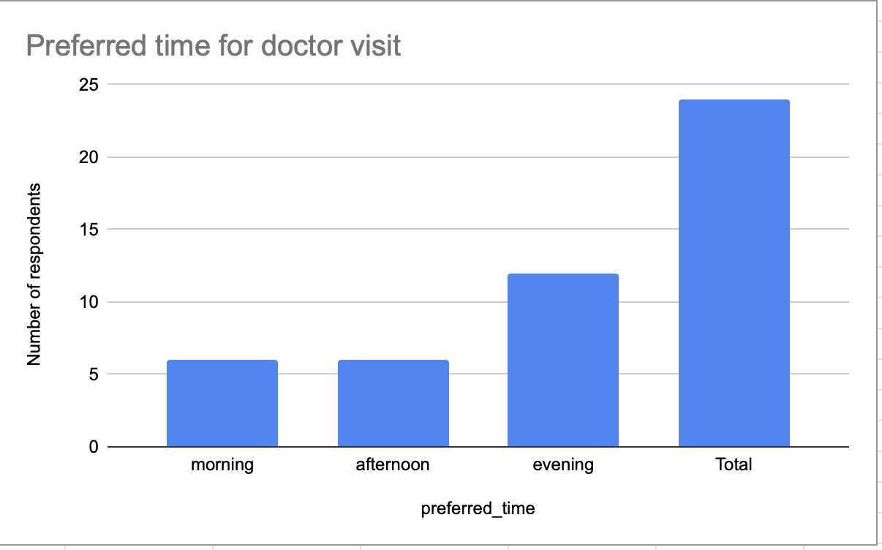
Figure 2
Half of the respondents (12 of 24) prefer an evening visit. Morning and afternoon are each preferred by a quarter (6 of 24). The head of the polyclinic’s registry should therefore open about half of the appointment slots in the evening and split the rest evenly between morning and afternoon. They should keep some morning slots, because retired respondents mostly chose the morning.

5. Team contribution
Table 11
Student | Sections and tables | Figures | Share
Altynay Aitbayeva | Sections 1, 5 | None | 33%
Kira Kogay | Sections 2, 3 | Figure 1 (network diagram) | 34%
Medet Azimkhan | Section 4 | Figure 2 (chart) | 33%

Appendix
Table A.1

respondent_id | age_group | occupation | preferred_time | booking_method | waiting_minutes
1 | 18–25 | student | evening | app or website | 15
2 | 18–25 | student | afternoon | app or website | 20
3 | 26–40 | employed | evening | phone | 45
4 | 26–40 | employed | evening | app or website | 30
5 | 41–60 | employed | morning | phone | 60
6 | over 60 | retired | morning | phone | 40
7 | over 60 | retired | morning | in person | 90
8 | 41–60 | employed | evening | phone | 35
9 | under 18 | student | afternoon | in person | 25
10 | 18–25 | student | afternoon | app or website | 10
11 | 26–40 | employed | evening | app or website | 20
12 | 41–60 | other | morning | phone | 50
13 | over 60 | retired | morning | phone | 75
14 | 26–40 | employed | evening | phone | 55
15 | 18–25 | student | evening | app or website | 25
16 | 41–60 | employed | afternoon | in person | 40
17 | 26–40 | other |  | app or website | 15
18 | over 60 | retired | afternoon | in person | 120
19 | 18–25 | employed | evening | app or website | 30
20 | 26–40 | employed | evening | phone | 65
21 | 41–60 | retired | morning |  | 80
22 | under 18 | student | afternoon | app or website | 0
23 | 26–40 | employed | evening | app or website | half an hour
24 | 41–60 | employed | evening | phone | 45
25 | 18–25 | student | evening | other | 10
26 | over 60 | retired | morning | phone | 60
27 | 26–40 | employed | evening | phone | 55
28 | 41–60 | employed | morning | phone | don’t remember
Records highlighted in yellow are the cleaned ones.

