

END-TERM
Project stage 2: what your system keeps and how people reach it

Course: Information and Communication Technologies Academic year 2026/2027, 1st trimester
Group: Kira Kogay, Altynay Aitbayeva, Medet Azimkhan

Astana 2026

1. Project summary
Table 1 summarizes our project.
Table 1
Item | Our answer
Domain and setting | Telemedicine / digital health: an appointment booking and notification system for Polyclinic No. 5 in Astana.
Problem and main user group | Patients can only book by a busy phone line or an early queue, and the paper schedule causes double bookings and no warning when a doctor is absent. The main user group is patients, many of them elderly with limited eyesight and little app experience.
Main entities, and the relation with personal data | The main entities are patient, doctor, specialty, appointment, notification and user_account. Personal data is stored in patient (iin, name, phone, birth_date), appointment (patient_id, reason_for_visit) and user_account (login, password_hash). Passwords are stored as salted hashes rather than plain text.
The most serious threat and the measure that stops it | A data leak through the booking portal or an open database. The measures are parameterised queries, a database reachable only from the API server, least-privilege roles, and encrypted iin and phone.
Media your system uses, with file formats | Text (UTF-8 in JSON and HTML), images (JPEG photos, PNG logo and icons), audio and video (Opus, VP8 or H.264) streamed during online consultations.
IoT device, and the decision your data analysis supports | An Aqara Motion Sensor P1 with an Aqara Hub M2 in the waiting room. Data analysis showed that half of the appointment slots should be opened in the evening and the rest split evenly between morning and afternoon.
What changed after the defenses | During the Assignment 2 defense, we were asked what happens when a patient selects a slot that is no longer available. The original flowchart ended at “Slot unavailable” without a next step. We added a return to the available-slot list and an explanation asking the patient to choose another time. This removed the dead end and allowed the booking process to continue.

2. System map
Figure 1 is the map of the whole system. Table 2 lists the web components on it.
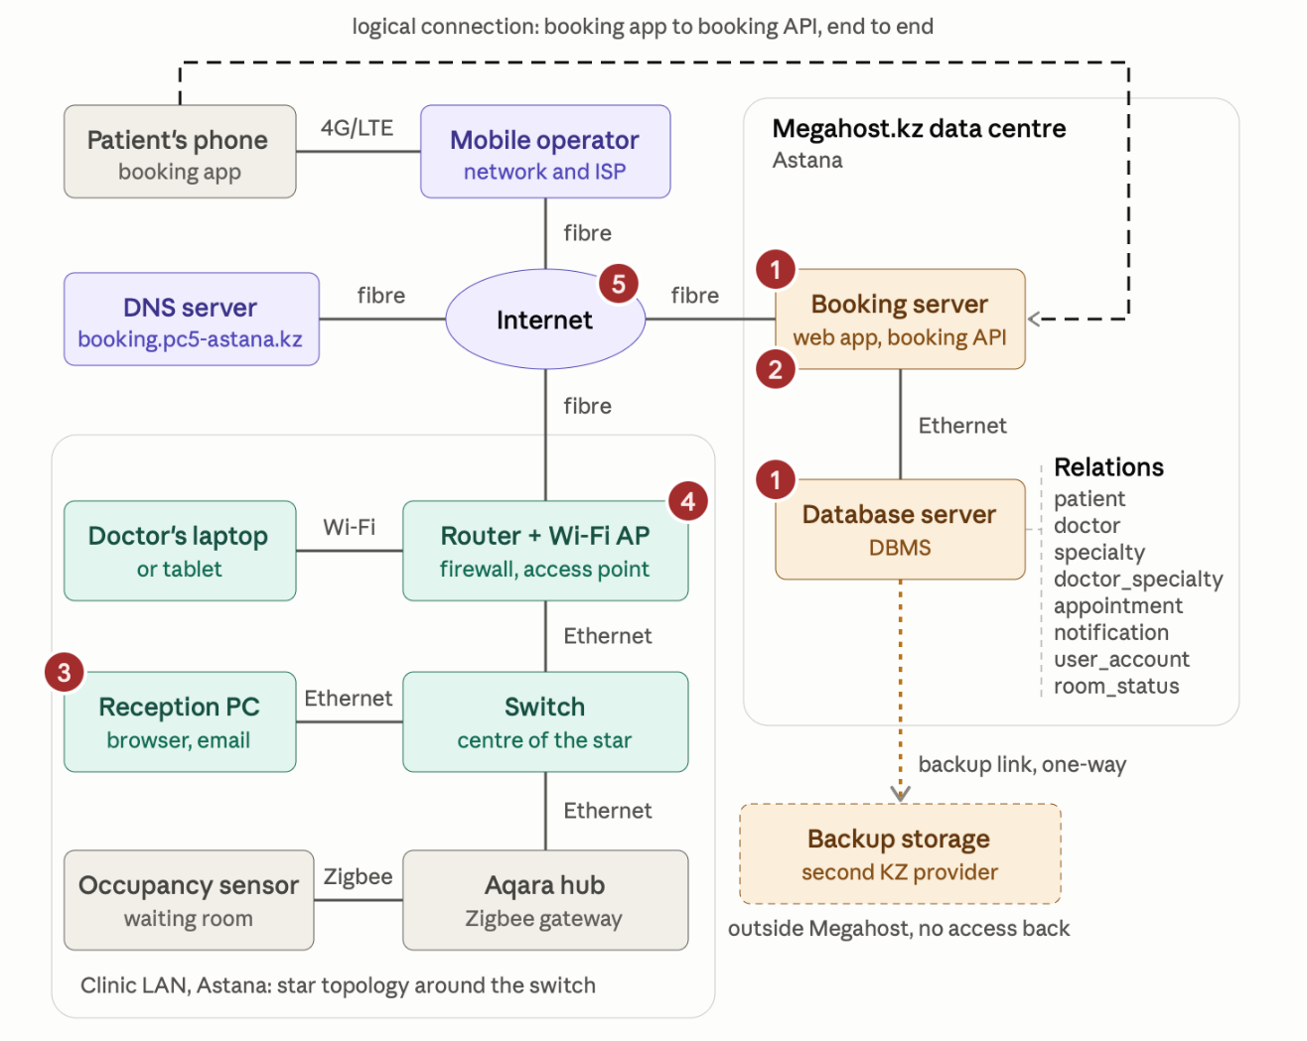
Figure 1
Table 2
Component | What it is in our system | Company, product or value
Client and its connection (fibre, DSL or mobile data) | The patient's own smartphone, usually on mobile data, some patients on home fibre Wi-Fi | Patient's smartphone. 4G/LTE mobile data.
ISP of the main user group | The operator that carries the patients' traffic | Kcell/Tele2/Beeline (or any operator of the patients’ choosing); Kazakhtelecom for home fibre.
Web host or data centre, with its city | The data centre that runs the booking server and database | Megahost.kz Cloud-12 VPS in Astana.
Domain name and registrar, yearly price, date checked | The address patients type or tap | booking.pc5-astana.kz; registrar: Megahost.kz; price per year: 8600 KZT; date checked: 27.10.2026.
Address the host would give your server (IPv4, IPv6 or both) | The public address the DNS record points to | IPv4, one public address with the VPS (IPv6 is also offered by Megahost).
nslookup of a live system (domain, IPv4, IPv6 if any, date) | A command run in a terminal on a real Kazakhstani system in your field | damumed.kz; IPv4: 89.218.81.28; date checked: 27.10.2026.

3. From URL to stored record
The page where the main step happens (choosing and confirming a slot) has the URL https://booking.pc5-astana.kz/doctors/12/slots. Its protocol is https, its domain name is booking.pc5-astana.kz (top-level domain is .kz), its path is /doctors/12/slots. This page needs HTTPS because on public Wi-Fi, unencrypted traffic could be intercepted or modified by other people on the same network. This could expose the patient's login credentials and personal information, such as the reason for the visit. HTTPS protects the communication through TLS encryption and allows the phone to verify the identity of the server.
Table 3 follows one action (the patient tapping “Confirm”) through the system.
Table 3
Step | What happens to our data | Device on our map | Protocol
1 DNS lookup | The app asks for the IP address of booking.pc5-astana.kz and receives the server's IPv4 address. | Patient's phone, the domain's DNS server | DNS (UDP port 53)
2 TCP handshake (SYN, SYN-ACK, ACK) | The phone sends SYN to booking.pc5-astana.kz on port 443, the server answers SYN-ACK, and the phone sends ACK. A TCP connection is established, which will carry the HTTPS POST request for the selected appointment. | Patient's phone, booking server | TCP
3 HTTP request | After the encrypted session is set up, the app sends a small POST request containing the doctor, the chosen appointment slot and the reason for the visit as JSON. TLS encrypts the HTTP request, so the network carries encrypted data. | Patient's phone | HTTPS (HTTP over TLS)
4 Packets split and routed | This small encrypted JSON request may fit into only one or two IP packets. These packets travel through the cell tower, the mobile operator network, internet routers and the ISP uplink to the data centre. | Mobile operator network, routers on the internet | IP
5 Packets rebuilt at the server | TCP puts the received packets back in order using their sequence numbers and requests retransmission if any data is missing. The server's TLS layer decrypts the request and passes the complete JSON data to the booking API. | Booking server | TCP
6 DBMS transaction and the relation it writes to | The booking API starts a database transaction and checks whether the selected appointment slot is still available. If it is free, the system inserts a new record into the appointment table and creates a related notification record. Both changes are committed together. If the slot is unavailable, the transaction is cancelled and no booking is saved. | Database server (PostgreSQL), relations appointment and notification | SQL over the PostgreSQL protocol
7 Response and what the user sees | The server replies with the booking details and a reference number. The phone displays the confirmation screen, and the patient can later find the confirmed appointment in “My appointments”. | Booking server to patient's phone | HTTPS
If packets arrive out of order, the user usually notices nothing, or at most a short delay, because TCP puts them back in order before the API receives the request. Atomicity means that the booking transaction is completed as a whole: if something goes wrong before the transaction is committed, neither the appointment nor its notification is saved. This means that a half-saved booking cannot exist. If the connection drops between steps 6 and 7, Durability keeps the record because the transaction has already been committed. When the patient reopens the app, “My appointments” shows the confirmed booking with its reference number, so the patient does not need to book the same slot again.

4. Our system in the cloud

Table 4 shows the deployment model and characteristics.
Table 4
Item | Our answer | When it matters in our setting
Deployment model | Public cloud, with the provider's data centre in Astana. The database is not on clinic premises, so no hybrid is needed, and personal data stays in Kazakhstan as Article 12 of Law No. 94-V requires. | Whenever the data protection question comes up: the data never leaves the country.
Self-service on demand | The provider's control panel lets the team create or change a server without phoning anyone. | Setting up a test server before the clinic goes live.
Broad network access | The server is reachable over the internet, not only from the reception PC's browser. | When patients book from home with their phones/personal computers.
Resource pooling | The virtual server shares physical machines with the provider's other customers, so the clinic does not buy hardware. | The clinic's small budget.
Rapid elasticity | A larger plan can be chosen when needed, but it is a manual process needed to be done through personal account. | The first week after launch (if the actual number of bookings exceeds the expected), or flu season, when many patients book at 8:00.
Measured service | The provider bills by plan and period. The higher the level of virtual hosting, the higher the cost per month (varies between 2000-9000 KZT) | Monthly cost control by the clinic manager.

Table 5 shows the details for mobile cloud computing.
Table 5
Item | Our answer
What runs on the phone | The booking app or browser page: screens, form checks, and the cache of the chosen doctor and slot.
What runs in the cloud | The booking API, the PostgreSQL database and the reminder service.
One advantage for this user group | Patients need no computer or queue. They can book from anywhere and the heavy work does not slow an older phone.
One issue for this group | Network availability: mobile coverage can drop inside a clinic building or on the way.
What your system does about that issue | It keeps the chosen doctor, specialty and slot on screen and offers a Retry button. The booking is only confirmed after the server's reply.

5. One record from capture to decision
The record followed in Table 6 is one appointment from the main task.
Table 6
Stage | What happens to the record | Device, format, relation or product | Week
Capture | The patient taps Confirm. The app creates a text record (doctor, slot, reason). | Patient's phone; UTF-8 text in JSON | 8
Transmission | The record travels over mobile data and the internet to the server. | 4G/LTE and fibre, HTTPS over TCP/IP | 5
Storage | Saved in one row in appointment (appointment_id, patient_id, doctor_id, date, time, status, reason_for_visit). | PostgreSQL 18, Megahost.kz in Astana | 6
Access | Patients read and write only their own rows. Receptionists read and write everything concerning appointments. Administrator reads and writes everything concerning user accounts. | Table 7 of Assignment 3, row-level security | 6
Protection | Threat: unauthorised access to an appointment and its reason_for_visit through the booking portal. The API checks that the patient owns the appointment or that the staff member has permission to access it. Parameterised queries prevent SQL injection, and the database accepts connections only from the API server. | Booking API, PostgreSQL row-level security, roles and GRANT | 7
Backup | The appointment is included in daily full backups and transaction-log archives every five minutes. Copies are transferred through the one-way backup link to separate storage at a second provider in Kazakhstan, outside Megahost. The production server can upload new backups but cannot delete or overwrite existing copies, protecting them from ransomware on the production server. | pgBackRest; separate backup storage at a second KZ provider | 7
Analysis | Appointment times show when slots fill, but not when people would prefer to visit. Our survey of preferred times answers that. | appointment.date, appointment.time; survey spreadsheet | 9
Decision | The head of registry decides how many slots to open in the morning, afternoon and evening. | Registry head | 9

The riskiest stage is storage because the database links patient identities with appointment details and reasons for visits. Unauthorised access could expose many patients’ records, while ransomware could corrupt them or make them unavailable.

6. Team contribution
Table 7. Team contribution
Student | Sections | Figures drawn | Share
Altynay Aitbayeva | Project summary, One record. | None | 33%
Kira Kogay | System map, Our system in the cloud. | Figure 1 | 34%
Medet Azimkhan | From URL to stored record, Team contribution. | None | 33%

GrammarlyAI was used to correct any grammatical and punctuational mistakes.

