

MIDTERM
Project stage 1: how your system connects

Course: Information and Communication Technologies Academic year 2026/2027, 1st trimester
Group: Kira Kogay, Altynay Aitbayeva, Medet Azimkhan

Astana 2026

1. Project summary
Table 1. Project summary
Item | Our project
Domain and setting | Telemedicine. Polyclinic No. 5 in Astana, a district outpatient clinic.
Problem | Booking relies on one phone line and a paper appointment book, causing double bookings, lost appointments, and no way to warn patients when a doctor is absent.
Main user group and its limitation | Patients of the polyclinic: many are elderly with limited eyesight and little experience with apps, which makes small text and multi-step menus hard to use.
Main task, from Table 2 of Assignment 2 | A patient books an appointment with a doctor: logs in, picks a specialty and doctor, selects a free time slot, confirms, and receives a confirmation and reminder.
Architecture and number of tiers | Client-server, three tiers: presentation tier (browser/app on the patient's or staff member's device), application tier (the booking API) and data tier (the database).
What changed after the defenses | During the Assignment 1 defense, the instructor asked why we chose a 3-tier client-server architecture instead of a microservices architecture. We explained that for a single clinic with ~27,000 attached patients, a standard 3-tier structure (Presentation, API, Database) is simpler to maintain, more cost-effective, and fully satisfies the load requirements without unnecessary complexity. Therefore, we kept our original architecture.

2. Network diagram

The diagram was drawn using Canva on 01.10.2026. It shows how the booking request travels from the patient’s phone to the clinic’s server.

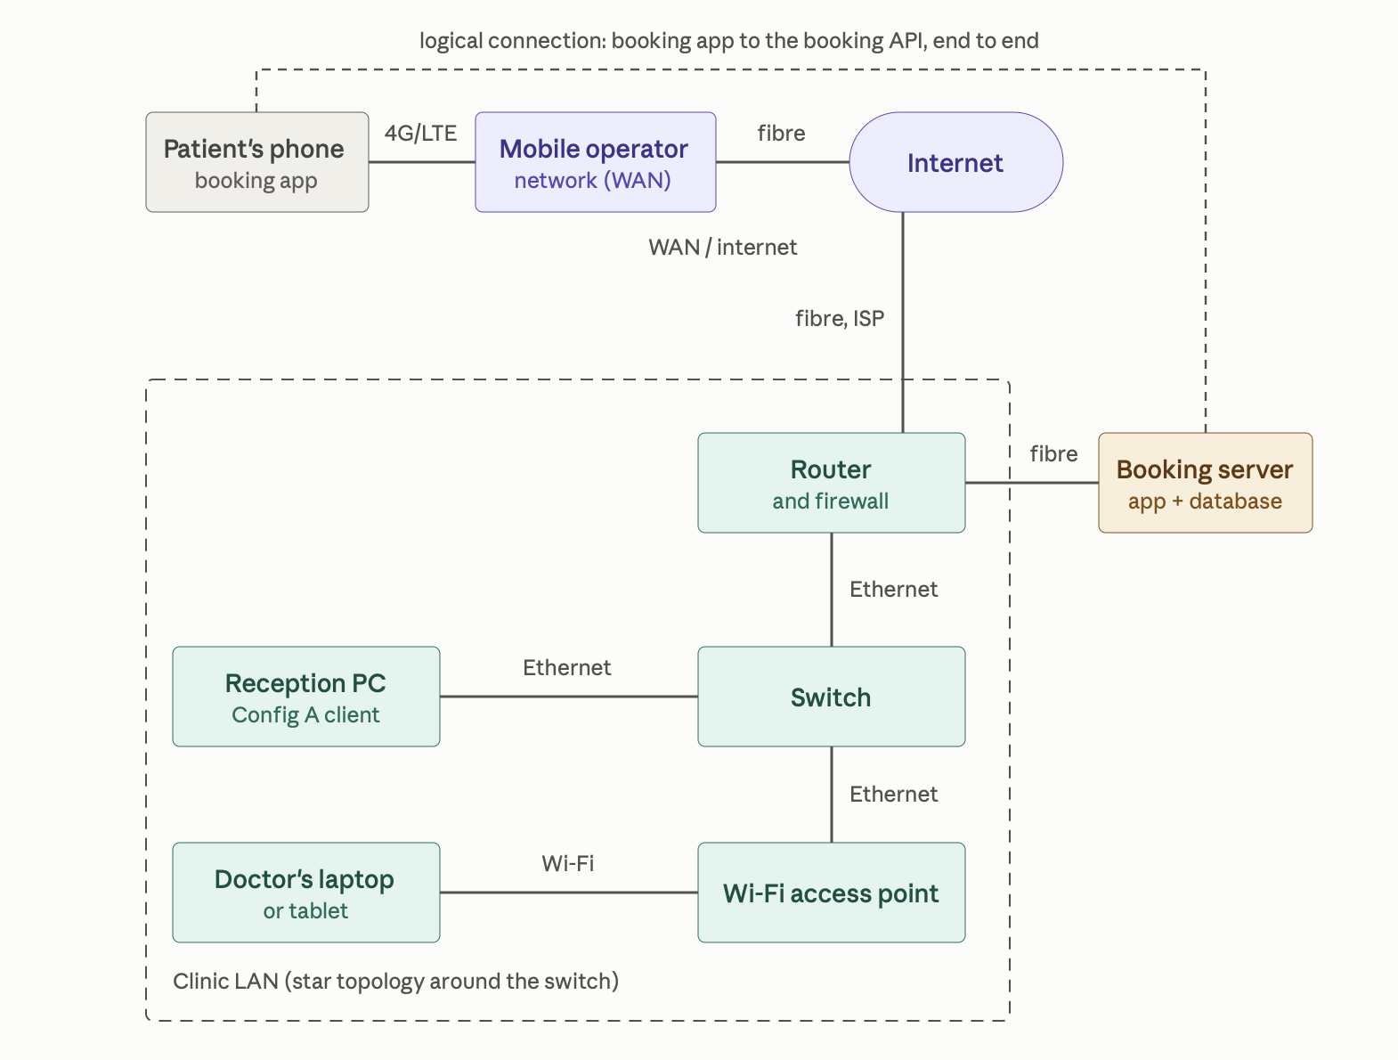

Figure 1
Table 2. Parts of the network
Part | What it is in your system | Model, product or name | Network scale
App | The booking web app the patient uses in a browser, and the booking API it talks to. | In-house booking web portal (JavaScript front end). | N/A - software, not a physical scale.
Host, client | The patient's own phone / personal computer, and the reception/doctor's PC from Assignment 1. | Patient's personal smartphone / laptop (models can vary from patient to patient); reception PC- Configuration A (Intel Core i5-12400, Windows 11 Pro). | PAN at the device itself; the reception PC sits on the clinic LAN.
Host, server | The virtual server running the booking API and the database. | Megahost.kz Cloud-12 VPS, 12 vCPU / 12 GB RAM, Megahost's own data centre in Astana. | WAN / internet - reached over the public internet from the clinic and from patients' phones.
Router, switch or access point | The clinic's internet gateway and local Wi-Fi. | TP-Link Archer AX53 Wi-Fi 6 router (4-port Gigabit, dual-band). | LAN - centre of the clinic's local network, and the clinic's connection to the WAN / internet.
Link, client side | Reception PC to the switch; patient's phone to the mobile network. | Ethernet (Cat6 patch cable) for the PC; 4G/LTE for the phone. | LAN (Ethernet) and WAN (4G mobile).
Link, server side | The data centre's uplink from the server out to the public internet. | Fibre-optic ISP uplink from Megahost's Astana data centre. | WAN / internet.

3. One action through the five layers
The step chosen is Assignment 2's step 6: the patient taps "Confirm" to submit the completed booking form (doctor, time slot and reason for visit) to the server. Table 3 follows that specific data down from the application layer to the physical layer.
Table 3. One action through the five layers
Layer | What happens to your data | Protocol or medium | Distance
5 Application | The browser packages the chosen doctor ID, time slot and reason-for-visit text as a JSON object and sends it as an HTTPS request to the booking API. | HTTPS (HTTP over TLS 1.3) | Process to process
4 Transport | TCP splits the request into segments, numbers them, opens a connection to port 443 on the server, and will resend any segment that is not acknowledged. | TCP, port 443 | Process to process
3 Network | IP addresses the packet from the phone's current IP address to the booking server's public IP address and routes it across the mobile network, the internet backbone and the clinic's / cloud's ISP link. | IP (IPv4/IPv6) | Host to host
2 Data | Each hop re-frames the same packet for the link it is crossing: an LTE radio frame from the phone to the nearest cell tower, then. Ethernet frames between the routers and switches along the way to the server. | LTE framing on the radio hop; Ethernet (802.3) on the wired hops | Node to node
1 Physical | The frame becomes an actual signal matched to each medium: radio waves from the phone to the cell tower, then light pulses over the fibre backbone, then electrical pulses over the final Ethernet cable into the server. | Radio (4G); fibre-optic; copper Ethernet | Node to node

The booking request travels over TCP. A booking form has several fields that must all arrive, in order and unchanged, for the appointment to be recorded correctly. TCP's confirmation and automatic retransmission guarantee that. If one packet of the request is lost, TCP on the sending side notices the missing confirmation of delivery and resends just that segment, so the patient experiences a short delay rather than a half-recorded or corrupted booking - the behaviour UDP would risk, since UDP neither confirms delivery nor preserves order.
Before the first HTTPS request, the phone's browser asks DNS to resolve the domain name the booking app uses, for example booking.pc5-astana.kz. The top-level domain is .kz, Kazakhstan's country-code top-level domain. This suits the project's users: Kazakhstani patients recognise a .kz address as belonging to a local organisation rather than a foreign one, which builds the trust a health-related booking service needs, and it fits the fact (covered in Table 4 below) that the clinic's own data is required by law to stay inside Kazakhstan.

4. Where the server side runs
Table 4. Where each tier runs
Tier | What runs there | Where it runs | Cloud model | Provider
1 | The presentation tier: the booking app's user interface, in a browser. | The user's own device - the patient's phone or the clinic's reception PC, not a rented service | N/A (owned hardware, not rented). | N/A
2 | The application tier: the booking API that validates requests and applies scheduling rules. | Cloud - Kazakhstan-based provider with its own Tier III data centres | PaaS - the team deploys its code to a managed application platform without administering the underlying OS. | SmartCloud.kz
3 | The data tier: the database holding patients, doctors and appointments. | Cloud - Megahost's own data centre, Astana, Kazakhstan | IaaS - the team rents a virtual server (the Cloud-12 plan) and installs and manages its own database engine on it. | Megahost.kz

The system stores patient names, phone numbers and the reason given for a visit, all of which are personal data. The Law of the Republic of Kazakhstan No. 94-V of 21 May 2013 "On Personal Data and their Protection" requires, in Article 12, that personal data of Kazakhstani citizens to be stored in a database physically located inside Kazakhstan. The data tier sits on Megahost.kz, whose data centre is physically in Astana; the application tier on SmartCloud.kz likewise runs on that provider's own Kazakhstan-based infrastructure.
If the connection drops after the patient taps "Confirm" but before the server's reply reaches the phone, the app should not assume the booking failed, because the request may already have reached the server. The screen should show "Connection lost - trying again" while it automatically retries, keeping the chosen doctor, time slot and reason-for-visit text exactly as entered. Once the connection returns, the app should ask the server whether this booking attempt already succeeded before creating a second one, to avoid a duplicate booking. This is a third failure path that is not yet in the Assignment 2 flowchart alongside the existing "wrong password" and "slot already taken" branches; we would add a new decision after step 6 - "Connected?" - with its "No" branch leading to the above message and looping back into step 6 once the connection is restored, so that, like the other two failure paths, it returns the patient to the task rather than ending in a dead end.

5. Team contribution
Table 5.
Student | Report sections and slides prepared | Figures drawn | Approximate share
Altynay Aitbayeva | 1. Project summary; | None (tables only) | 33%
Kira Kogay | 2. Network diagram; 3. One action through the five layers | Figure 1 (network diagram) | 34%
Medet Azimkhan | 4. Where the server side runs; | None (tables only) | 33%

GrammarlyAI was used to check for any punctuation or grammar mistakes.

