Freight Rate Prediction
Validation Approach & December Forecast

1. Train / Test Split & Validation Approach

Why a time-based split
The dataset is timestamped, and the model is ultimately deployed to predict future loads from past ones. A random split would let time-correlated market conditions (seasonal market_index swings, month-to-month quote_signal drift) leak across the split, producing an overly optimistic estimate of real-world performance. A chronological split was used instead: the model trains on earlier dates and is evaluated on later, unseen dates.
- Cutoff: the 80th percentile of dates in train-test.csv (2025-08-31).
- Train: 38,477 rows.
- Test (held out, never used for tuning): 9,523 rows.

Data-quality issues identified and how they were addressed
- Sign errors in weight: 292 rows had negative weight values, symmetric around zero relative to the positive distribution (–47,500 to 47,500) — consistent with a data-entry sign error rather than corrupted data. Fixed with abs().
- Missing values in weight (~0.6%) and market_index (~0.8%): filled with the mean, computed on the training split only, then reused unchanged on the test set, the validation set, and the December inputs.
- Target transform: the model predicts log1p(rate_per_mile) rather than raw posted_rate, then rescales by distance. Normalizing by distance first removes it as the dominant scale-driver before the model has to learn anything else, and the log transform stabilizes the remaining variance. This closed two segment-level weak spots found during error analysis: reefer equipment error dropped from ~11% to ~5% MAPE, and short-haul loads under 500 miles dropped from ~17% to ~5% MAPE.

Hyperparameter search
Rather than hand-picking settings against a single split, hyperparameters were selected with GridSearchCV over max_depth, n_estimators, and learning_rate, scored with a custom dollar-scale MAE metric (the log-transformed target is inverted back to real dollars before scoring, so selection optimizes the metric that actually matters) and validated with TimeSeriesSplit (5 chronological folds within the training set). The test set was not touched during this search — it remained a one-time hold-out check after the best configuration was chosen.
- Selected: max_depth=6, n_estimators=500, learning_rate=0.03 (XGBoost, objective=reg:absoluteerror).
One fold in the cross-validation (test window ~March–May) showed a notably higher error than the others. Investigation traced this to that fold's limited training history not yet covering the market_index range its own test window required — tree-based models don't extrapolate well past values seen in training. This does not affect the final production model: its full training set (through August 2025) already spans a market_index range of 0.73–1.47, which comfortably covers December's real observed value (~0.93, see Section 2), so no extrapolation risk applies to the December forecast.

Final held-out results
Metric | Value
MAE | $109.2
RMSE | $635.1

Segment-level error (MAPE) on the held-out test set:
Segment | MAPE
Dry Van | 4.3%
Flatbed | 5.3%
Reefer | 5.0%
Distance < 500 mi | 4.9%
Distance 500–1500 mi | 4.6%
Distance 1500–3000 mi | 4.6%
Distance 3000+ mi | 2.7%

2. December Prediction Chart
The December chart holds pickup (Lexington), delivery (Fort Wayne), distance (360 mi), equipment (Dry Van), and weight (32,000 lb) fixed across all 31 days — only the date changes, so the resulting pattern isolates the day-of-week effect the model has learned.
Training data covers only January–October, so it contains no December rows to average market_index and quote_signal from directly. validation.csv, however, already includes real November/December rows with observed values for both (the input features are visible even though posted_rate is not). Using their average (market_index ≈ 0.931, quote_signal ≈ 2.051) rather than the whole-year training mean removed a seasonal bias of roughly $11 (~1.3%) across the entire chart — the whole-year mean is pulled upward by the April–July seasonal peak in market_index, which December does not share.
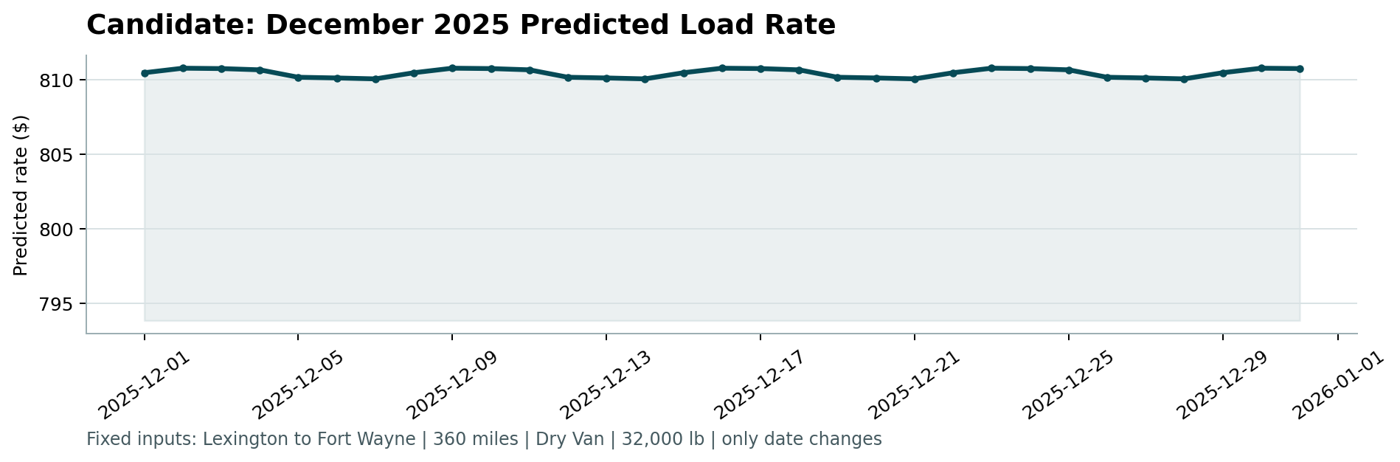
Chart generated by the provided score.py from the completed december-chart-inputs.csv.

