username : @i_mutamuriz

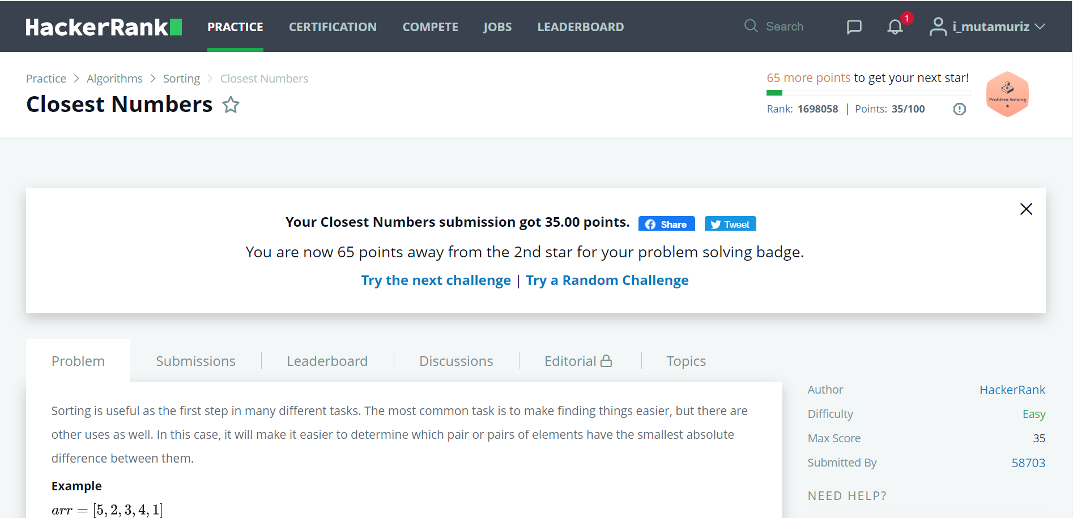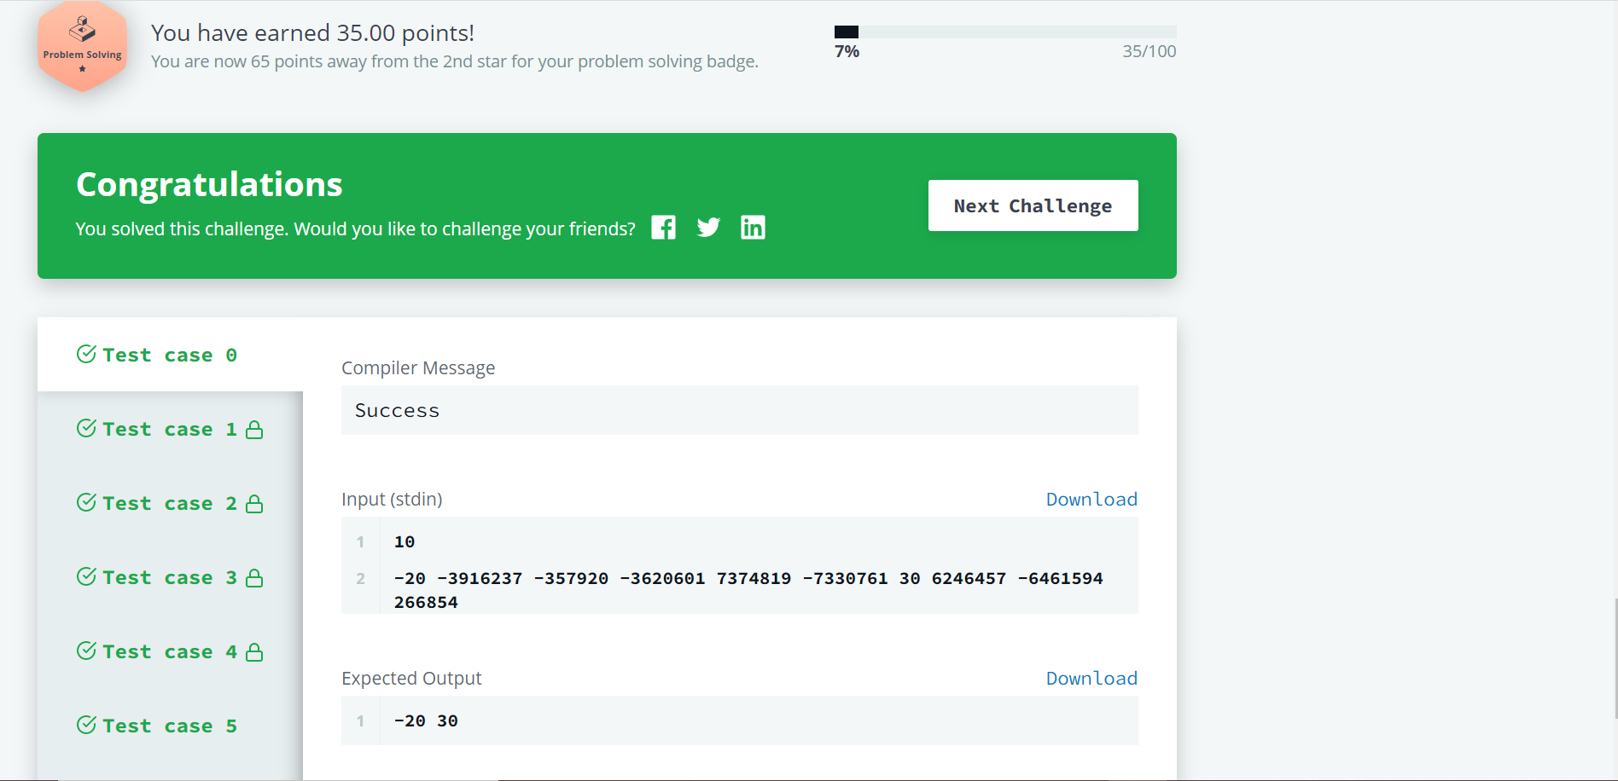

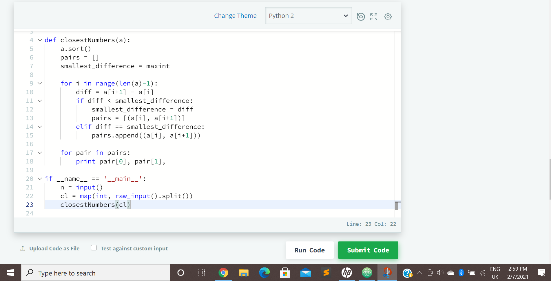

code:

#!/usr/bin/py

from sys import maxint

def closestNumbers(a):

a.sort()

pairs = []

smallest_difference = maxint

for i in range(len(a)-1):

diff = a[i+1] - a[i]

if diff < smallest_difference:

smallest_difference = diff

pairs = [(a[i], a[i+1])]

elif diff == smallest_difference:

pairs.append((a[i], a[i+1]))

for pair in pairs:

print pair[0], pair[1],

if __name__ == '__main__':

n = input()

cl = map(int, raw_input().split())

closestNumbers(cl)