《计算机视觉》实验报告

姓名：王子棠 学号：21122897

实验6

- 任务1
  - 核心代码：
# 提取单个图像的HOG特征
def hog_descriptor(image):
if (image.max()-image.min()) != 0:
image = (image - image.min()) / (image.max() - image.min())
image *= 255
image = image.astype(np.uint8)
hog = cv2.HOGDescriptor((64, 128), (16, 16), (8, 8), (8, 8), 9)
hog_feature = hog.compute(image)
return hog_feature
# 数据集读取，对于正样本，截取中间64×128大小的部分提取HOG特征。对于负样本，随机截取10个64×128的部分，提取HOG特征。
# 读取正样本，设置正样本标签为1
for i in range(len(poslist)):
posimg = io.imread(os.path.join(pos_dir, poslist[i]))
posimg = cv2.cvtColor(posimg, cv2.COLOR_RGBA2BGR)
posimg = cv2.resize(posimg, (64, 128), interpolation=cv2.INTER_NEAREST)
pos_hog = hog_descriptor(posimg)
hog_list.append(pos_hog)
label_list.append(1) # 1为正样本

# 读取负样本，标签为0
for i in range(len(neglist)):
negimg = io.imread(os.path.join(neg_dir, neglist[i]))
negimg = cv2.cvtColor(negimg, cv2.COLOR_RGBA2BGR)
# 在每张neg图像中截取10张标准大小的图片作为负样本
for j in range(10):
y = int(random.random() * (negimg.shape[0] - 128))
x = int(random.random() * (negimg.shape[1] - 64))
negimgs = negimg[y:y + 128, x:x + 64]
negimgs = cv2.resize(negimgs, (64, 128), interpolation=cv2.INTER_NEAREST)
neg_hog = hog_descriptor(negimgs)
hog_list.append(neg_hog)
label_list.append(0)

# 训练SVM
clf = SVC(
C = 1.0, # 正则化参数/惩罚系数。当C越大时，分类器的准确性越高，所以容错率越低，泛化能力就变差。当C越小时，分类器的准确性降低，但容错率增大，泛化能力越强
gamma='auto',
kernel='rbf',
probability=True
)
clf.fit(hog_list.squeeze(), label_list.squeeze())
joblib.dump(clf, "trained_svm.model") # 保存训练好的模型

# ROC曲线
prob = clf.predict_proba(test_hog.squeeze())[:, 1]
fpr, tpr, thresholds_2 = metrics.roc_curve(test_label.squeeze(), prob, pos_label=1)
plt.figure(figsize=(10, 8))
plt.plot(fpr, tpr, c='red')
plt.scatter(fpr, tpr, c='blue')
plt.xlabel("FPR", fontdict={'size': 16})
plt.ylabel("TPR", fontdict={'size': 16})
plt.title("ROC_curve", fontdict={'size': 20})
plt.savefig('ROC.png')
AUC=metrics.roc_auc_score(test_label.squeeze(), prob)
print(AUC)

# 在图像上给行人画框，NMS算法，去除重叠的边界框
def mynms(box_list,prob_list,threshold=0.4):
x1 = box_list[:,0]
y1 = box_list[:,1]
x2 = box_list[:,2]
y2 = box_list[:,3]
areas = (x2-x1+1)*(y2-y1+1)
box_result = []
flag = []
index = prob_list.argsort()[::-1] # 从大到小排序
while index.size>0:
i = index[0]
flag.append(i)
x11 = np.maximum(x1[i], x1[index[1:]])
y11 = np.maximum(y1[i], y1[index[1:]])
x22 = np.minimum(x2[i], x2[index[1:]])
y22 = np.minimum(y2[i], y2[index[1:]])
w = np.maximum(0, x22 - x11 + 1)
h = np.maximum(0, y22 - y11 + 1)
overlaps = w * h
ious = overlaps / (areas[i] + areas[index[1:]] - overlaps)
#idx = np.where(ious < threshold)[0]
index = np.delete(index,np.concatenate(([0],np.where(ious < threshold)[0])))
#index = index[idx + 1]
return box_list[flag].astype("int")

# 测试集图片行人检测
for i in range(101,len(imglist)):
img = io.imread(osp.join('INRIADATA/original_images/test/pos', imglist[i]))
img = cv2.cvtColor(img, cv2.COLOR_RGBA2BGR)
h,w,c= img.shape
patch_list = []
hog_feature = []
box_list = []
for j in range(minscale,maxscale+1,1):
winsize = [j*64,j*128]
for m in range(0,h-winsize[1],20):
for n in range(0,w-winsize[0],20):
patch = img[m:m+winsize[1],n:n+winsize[0]]
patch = cv2.resize(patch, (64,128), interpolation = cv2.INTER_NEAREST)
boxcoord = (m,n,m+winsize[1],n+winsize[0])
hogfea = hog_descriptor(patch)
hog_feature.append(hogfea)
box_list.append(boxcoord)
patch_list.append(patch)
hog_feature = np.array(hog_feature).squeeze()
box_list = np.array(box_list)
prob = clf.predict_proba(hog_feature)[:, 1]
mask = (prob>= 0.99)
box_list = box_list[mask]
prob = prob[mask]
boxzhong = mynms(box_list,prob)
for k in range(len(boxzhong)):
cv2.rectangle(img, (boxzhong[k][1], boxzhong[k][0]), (boxzhong[k][3], boxzhong[k][2]),(0, 0, 255),3)
cv2.imwrite('result/'+imglist[i]+".jpg",img)

  - 实验结果截图
·ROC曲线如下图所示，AUC=0.983
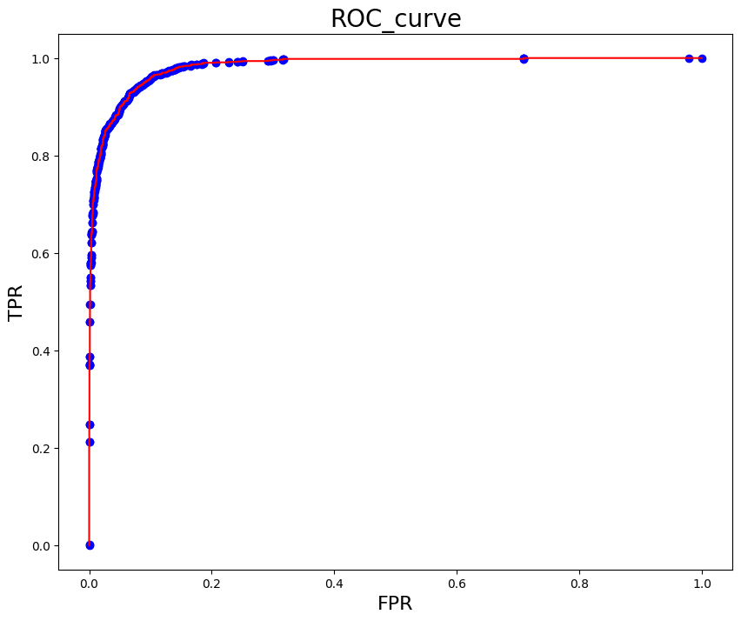
·检测结果
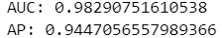
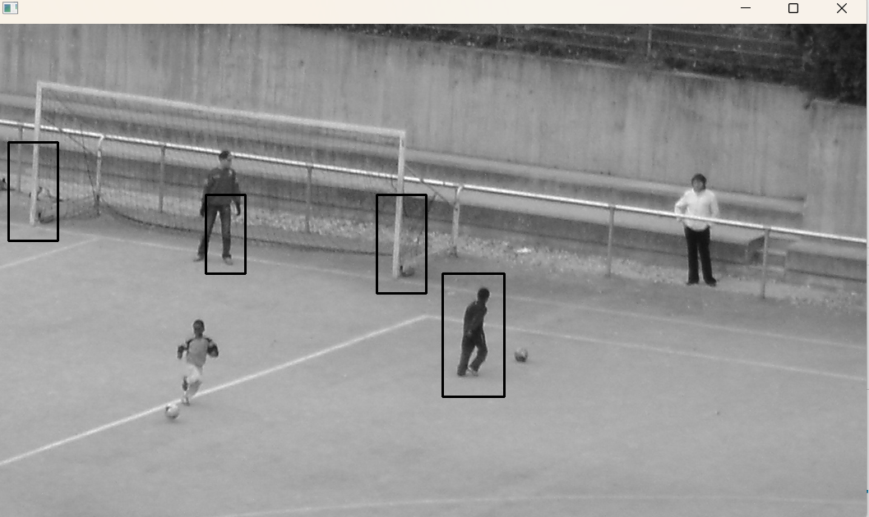
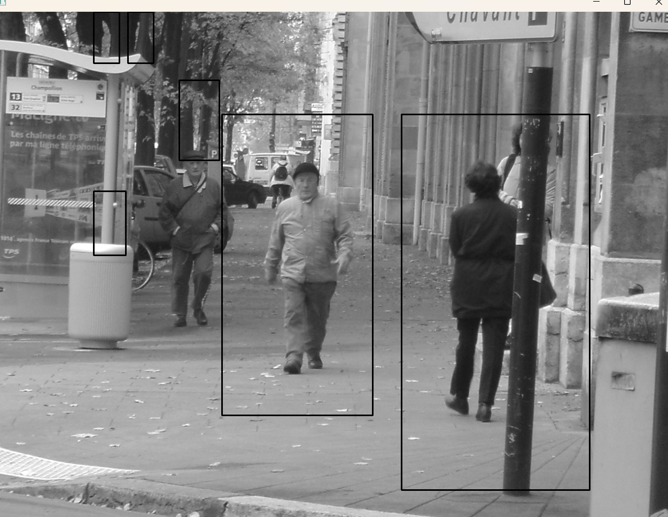
  - 实验小结
本次实验通过HOG和SVM实现了行人检测，从最后测试的结果可以看出hog和svm的结合很容易把柱状物体识别成行人，这可能是它们的HOG特征比较相似的缘故。并且在NMS算法中，设置IoU阈值为0.4，用于去除重复的边界框。此外，在SVM训练中，将正则化参数设置为1.0，使得检测效果略有提升。

