《计算机视觉》实验报告

姓名：王子棠 学号：21122897

实验10

- 任务1
  - 核心代码：
# 超参数设置
batch_size = 64
learning_rate = 0.01
momentum = 0.5
EPOCH = 10
# 数据集为MNIST，从torchvision.datasets中下载获取
train_dataset = datasets.MNIST(root='./data/mnist', train=True, download=False, transform=transform)
test_dataset = datasets.MNIST(root='./data/mnist', train=False, download=False, transform=transform) # train=True训练集，=False测试集
# CNN搭建
class Net(torch.nn.Module):
def __init__(self):
super(Net, self).__init__()
self.conv1 = torch.nn.Sequential(
torch.nn.Conv2d(1, 10, kernel_size=5), # 卷积
torch.nn.ReLU(), # 激活
torch.nn.MaxPool2d(kernel_size=2), # 池化
)
self.conv2 = torch.nn.Sequential(
torch.nn.Conv2d(10, 20, kernel_size=5),
torch.nn.ReLU(),
torch.nn.MaxPool2d(kernel_size=2),
)
self.fc = torch.nn.Sequential(
torch.nn.Linear(320, 50),
torch.nn.Linear(50, 10),
)
def forward(self, x):
batch_size = x.size(0)
x = self.conv1(x)
x = self.conv2(x)
x = x.view(batch_size, -1)
x = self.fc(x)
return x
# 使用交叉熵损失函数
criterion = torch.nn.CrossEntropyLoss()
optimizer = torch.optim.SGD(model.parameters(), lr=learning_rate, momentum=momentum)
# 训练
def train(epoch):
running_loss = 0.0
running_total = 0
running_correct = 0
for batch_idx, data in enumerate(train_loader, 0):
inputs, target = data
optimizer.zero_grad()

# forward + backward + update
outputs = model(inputs)
loss = criterion(outputs, target)

loss.backward()
optimizer.step()

# 把loss累加起来
running_loss += loss.item()
# 计算运行中的acc
_, predicted = torch.max(outputs.data, dim=1)
running_total += inputs.shape[0]
running_correct += (predicted == target).sum().item()
# 每300次计算一个平均损失和准确率
if batch_idx % 300 == 299:
print('[%d, %5d]: loss: %.3f , acc: %.2f %%'
% (epoch + 1, batch_idx + 1, running_loss / 300, 100 * running_correct / running_total))
running_loss = 0.0
running_total = 0
running_correct = 0
# 测试
def test():
correct = 0
total = 0
with torch.no_grad():
for data in test_loader:
images, labels = data
outputs = model(images)
_, predicted = torch.max(outputs.data, dim=1)
total += labels.size(0) # 张量之间的比较运算
correct += (predicted == labels).sum().item()
acc = correct / total
print('[%d / %d]: Accuracy on test set: %.1f %% ' % (epoch+1, EPOCH, 100 * acc)) # 计算测试的准确率
return acc
# 训练10次，每训练一轮就进行测试
acc_list_test = []
for epoch in range(EPOCH):
train(epoch)
acc_test = test()
acc_list_test.append(acc_test)
plt.plot(acc_list_test)
plt.xlabel('Epoch')
plt.ylabel('Accuracy On TestSet')
plt.show()
  - 实验结果截图
·数据集结构图
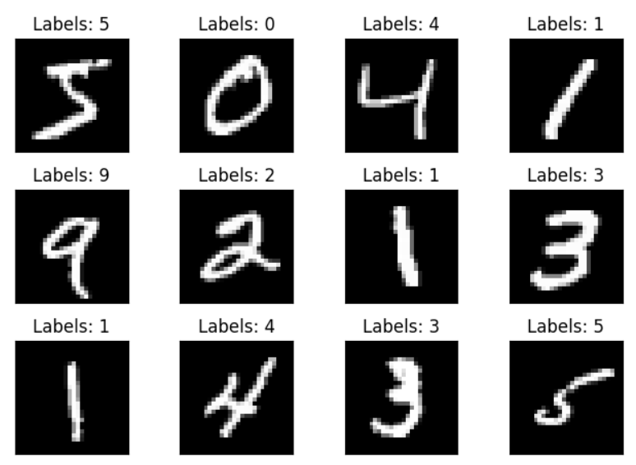
·训练和测试结果，可以看到每迭代300次就计算一次损失和准确率，随着训练轮数增加，测试集上的准确率也随之增加，训练集上的loss随之降低
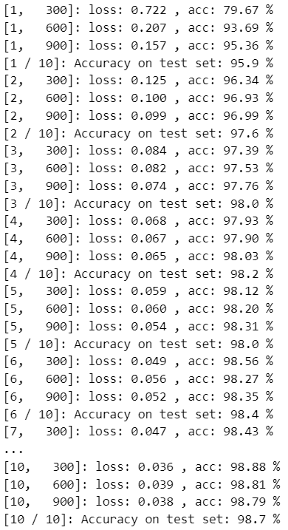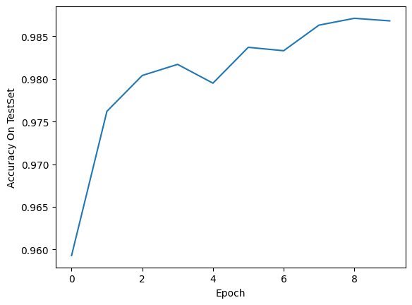
·CNN网络结构示意图
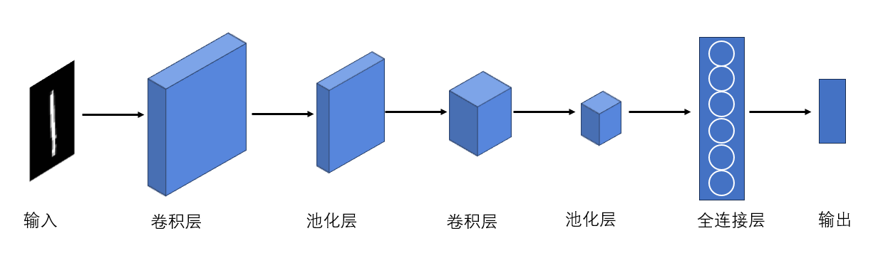
  - 实验小结
本次实验我学会自己搭建pytorch环境，搭建CNN卷积神经网络，并进行手写数字识别。卷积神经网络的基本结构是卷积层、激活函数、池化层、全连接层、输出层等，通过自己搭建CNN，我了解了这些组成部分的作用和工作原理，对于后续深度学习相关内容的学习有很大帮助。

