Name: Alexander Lu Date: 10/6/17

Pledge: I pledge my honor that I have abided by the Stevens Honor System

For each of the graphs below, list the order in which the vertices are visited in a **breadth-first search**, starting with vertex 1. If there are multiple vertices adjacent to a given vertex, visit the adjacent vertex with the lowest value first. Then repeat the process for **depth-first search**.

1. 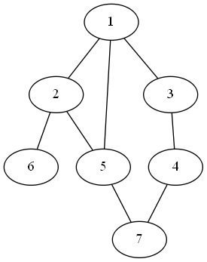

BFS: 1, 2, 3, 5, 6, 4, 7

DFS: 1, 2, 5, 7, 4, 3, 6

2. 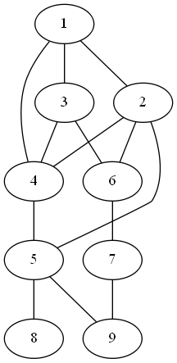

BFS: 1, 2, 3, 4, 5, 6, 8, 9, 7

DFS: 1, 2, 4, 3, 6, 7, 9, 5, 8

3. 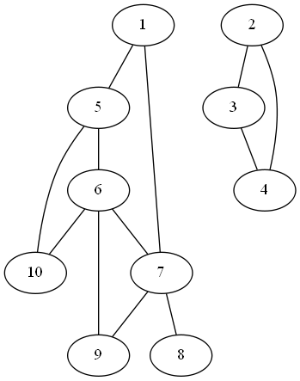

BFS: 1, 5, 7, 6, 10, 8, 9, 2, 3, 4

DFS: 1, 5, 6, 7, 8, 9, 10, 2, 3, 4

For each of the graphs below, list the order in which the vertices are visited in a **topological sort**, starting with vertex 1. If there are multiple vertices adjacent to a given vertex, visit the adjacent vertex with the lowest value first.

4.

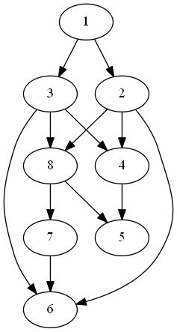

Topological sort: 1, 2, 3, 4, 8, 5, 7, 6

5.

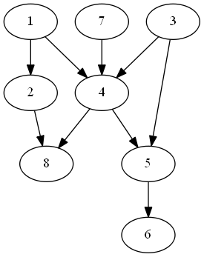

Topological sort: 1, 2, 3, 7, 4, 5, 6, 8