Assignment 3
Methodology and Core Practical Implementation

1 Research title
Predicting Regional Internal Migration in Kazakhstan Using Interpretable Machine Learning
Students: Aruzhan Rysbayeva and Alua Sagyndyk
Group: SE-2403
Version 2: education, healthcare and housing added

2 Research question aim and objectives
Research question: How does the predictive performance of interpretable machine-learning models compare with a statistical baseline for classifying the net internal migration balance of Kazakhstan’s regions?
Subquestion: Which socioeconomic indicators contribute most to the predictions of the best-performing model?
Aim: To compare models that predict the sign of internal migration and identify useful predictors. Version 2 checks whether education, healthcare and housing improve on the original five predictors.
1. Build a regional dataset from official migration and socioeconomic statistics.
2. Define the target and establish a statistical baseline.
3. Compare Decision Tree, Random Forest and Gradient Boosting with Logistic Regression using later years for evaluation.
4. Examine the indicators and groups that contribute most to the selected model’s predictions.
H1: Tree-based models will achieve higher accuracy on unseen observations than the statistical baseline. This remains the hypothesis from Assignment 2; the extension is exploratory because the 2024–2025 results were already inspected.
Initial finding: The extended Random Forest improves on the rerun five-feature model and reaches 95% accuracy in the 2024–2025 slice. It matches the previous-year-sign reference rather than clearly outperforming it.

3 Research approach and design
We use a quantitative approach and compare machine-learning models. The aim is to predict whether a region will have a positive or negative internal migration balance. A positive balance means that more people arrived from other parts of Kazakhstan than left for other parts of the country. We predict this sign, not the exact number of migrants.
Each observation is one region in one year. The original research question and hypothesis remain the same. Version 2 adds education, healthcare and housing indicators to the five original predictors. We compare the original and extended sets under the same rules, so differences in their results can be examined fairly. Logistic Regression is the statistical baseline; Decision Tree, Random Forest and Gradient Boosting are the alternatives.
A Kazakhstan study identifies employment, higher education and better living conditions among reported reasons for moving to large cities (Serikzhanova & Zhanuzakova, 2022). A Serbian study also applies machine learning to internal migration and includes education and health data (Delibašić et al., 2023). These studies support examining a wider set of indicators. Our experiment checks prediction performance; it does not prove the causes of migration. A survey alone would not answer this model-comparison question.

4 Dataset and selection
We use twelve official workbooks from Kazakhstan’s Bureau of National Statistics, archived on 24 October 2026 (BNS, 2026a–l). The original seven cover population, internal arrivals, departures, net migration, income, wages and unemployment. Five new tables contain schools, higher-education students, doctors, hospital beds and completed residential floor area. The population table also provides urban population. Original files and direct source links are included in the repository.
The initial panel contains 240 region-year records for 2014–2025. The intended coverage is 17 regions and the cities of Astana, Almaty and Shymkent. Data from 2014 are retained to create previous-year predictors for outcomes beginning in 2015. We select records with available predictors and comparable regional boundaries. This is a selection of eligible official records, rather than a random sample.
Boundary changes require exclusions. Abay, Zhetisu, Ulytau and their parent regions enter when predictor data are from 2022 or later. Turkistan and Shymkent require predictor data from 2018 or later. These rules exclude 56 of 220 candidate outcomes. All ten predictors are available for the remaining 164 observations for 2015–2025: 40 positive and 124 negative balances. Both feature sets use these same rows. All 20 units appear from outcome year 2023.

5 Variables and evaluation measures
The target is 1 for a positive internal migration balance and 0 for a negative balance. Internal arrivals minus internal departures must equal the published balance. There are no zero balances in the eligible sample. International migration is excluded from this target.
The original five predictors are relative income, relative wage, unemployment, urban population share and log population. Income and wage are divided by their national averages. The extended set adds schools, students, doctors and hospital beds per 10,000 residents, plus new housing floor area in square metres per person. These rates use the same region’s average annual population. They describe the scale of services or construction, not their quality or affordability.
Every predictor comes from the preceding year. For example, values from 2023 are used to predict the 2024 outcome. School and student data use the start year of the academic year. Region names and current-year migration are not model inputs.
Macro F1 is the main model-selection measure because it gives equal importance to positive and negative classes. Accuracy checks H1. Precision shows how often a predicted positive balance is correct; recall shows how many actual positive cases are found. We also save balanced accuracy, ROC AUC, average precision and confusion matrices. These help interpret results when negative balances are more common.

6 Data preparation and experimental procedure
The Python pipeline reads the original workbooks, matches regional names and codes, and combines the indicators by year. It checks duplicates, missing values and migration totals. Different official spellings of Zhetisu are matched to the same region. The housing data sheet reports thousand square metres, so values are multiplied by 1,000 before dividing by population. Missing historical values are not invented.
We train on earlier years and check the next year, repeating this for 2019 through 2025. The first round trains on 2015–2018 and checks 2019. The 2024 round uses 124 training and 20 evaluation observations; the 2025 round uses 144 and 20. Therefore, the 2025 model includes 2024 outcomes in training. We report average yearly scores and a combined 2024–2025 slice.
For each feature set, we choose the learned model family using average macro F1 from 2019–2023 only. Settings are fixed before the run, with seed 42 and a classification threshold of 0.5. Logistic Regression scales inputs using training data only. Training weights give more attention to the less common class. We do not search for better settings after seeing results.
The 2024–2025 outcomes were already examined in Version 1. We therefore describe Version 2 as an exploratory extension, not a new untouched test. Its five-feature comparison is rerun with the new yearly training rules rather than copied from Version 1.

7 Data analysis plan
For Objective 1, we describe years, regional coverage, class counts and missing values. We compare the original five-predictor set with the extended ten-predictor set on identical observations. This prevents a change in sample composition from being mistaken for a benefit from new indicators.
For Objective 2, Logistic Regression provides the main baseline. Two simple reference methods always predict the majority class or repeat the previous year’s migration sign. The second reference checks whether the models improve on the tendency for regional migration patterns to continue.
For Objective 3, we compare all models’ yearly scores and the combined 2024–2025 results. We inspect accuracy and macro F1 together with precision, recall and errors. H1 receives descriptive support if tree models exceed Logistic Regression in accuracy under these fixed rules. Because the extension follows earlier inspection of results, this cannot provide independent confirmation on a new test set.
For Objective 4, we shuffle predictors to see how much the prediction score falls. We also shuffle all indicators within each group together: original predictors, education, healthcare and housing. This is repeated 50 times in each 2019–2023 validation year. A larger fall suggests greater model reliance. SHAP provides an additional explanation of the 2023 predictions (Lundberg & Lee, 2017). Its technical details are in the appendix. We also identify the region and year of each incorrect prediction.

8 Research quality ethics and reproducibility
The comparison uses the same observations, model settings and year order for both feature sets. No future outcomes are included in a training round. Preprocessing uses training data only. The original files, code, settings, predictions and software versions are saved so another researcher can reproduce the calculation.
Important limits remain. The sample is small and the same regions appear repeatedly, so rows are not fully independent. Boundary exclusions reduce earlier coverage. More schools per resident may reflect small rural schools rather than better education. Doctor and bed counts do not measure actual access or quality. Housing construction is not a measure of affordability. The World Bank (2018) discusses registration barriers to services for internal migrants, illustrating why service counts alone are incomplete.
The data were revised and downloaded in 2026. Some previous-year indicators may have been released after the outcome year began. This is therefore a historical comparison, not proof of a forecast available on 1 January. We use public regional totals and collect no personal information. AI tools assisted the code, analysis and writing; numerical results come from executed code. Both students remain responsible for checking and explaining the work. Predictor importance and SHAP describe the model, not causal effects on people’s decisions.
Methodology word count for Sections 3–8: 1,254 words, excluding headings, references, tables and appendices.

9 Core practical implementation
The executed Python project reads twelve official workbooks, creates the matched dataset, compares both feature sets and saves predictions, errors and explanations. The notebook contains nine executed code cells. Its source and outputs are available in the repository.
https://github.com/aluasagyndyk2/kazakhstan-internal-migration-ml

9.1 Setup
The final dataset contains 164 observations and no missing model inputs. The original set has five predictors; the extended set has ten. All four learned models use fixed settings, seed 42 and training class weights. Random Forest uses 300 trees, maximum depth 4 and minimum leaf size 3. The remaining configurations are visible in Appendix Figure A2 and the code. The implementation uses scikit-learn (Pedregosa et al., 2011); the ensemble methods follow Breiman (2001) and Friedman (2001).

9.2 Results
Table 1. Previously inspected 2024–2025 slice; all rows use the same Version 2 yearly training rules.
Model | Core accuracy | Extended accuracy | Core macro F1 | Extended macro F1
Majority dummy | 0.775 | 0.775 | 0.437 | 0.437
Logistic Regression | 0.850 | 0.900 | 0.785 | 0.844
Decision Tree | 0.875 | 0.900 | 0.813 | 0.844
Random Forest | 0.900 | 0.950 | 0.844 | 0.922
Gradient Boosting | 0.900 | 0.950 | 0.844 | 0.922
Previous-year sign | 0.950 | 0.950 | 0.922 | 0.922
Across the seven evaluation years, mean yearly macro F1 increases from 0.883 to 0.939 for Random Forest. The previous-year-sign reference scores 0.938. Its mean yearly accuracy is slightly higher than extended Random Forest (0.958 versus 0.955), so there is no clear overall winner between these two methods.
In 2024–2025, extended Random Forest correctly classifies 38 of 40 cases: 31 true negatives, no false positives, two false negatives and seven true positives. Positive precision is 1.000 and recall is 0.778. Its accuracy is higher than extended Logistic Regression (0.950 versus 0.900), giving descriptive support to H1 in this extension. This is not independent confirmation on a new test set.

9.3 Interpretation and remaining errors
Education is the most useful group in validation permutation importance. Schools per resident are the largest individual contributor in both permutation importance and the 2023 SHAP summary. This does not mean that increasing school counts would cause migration to rise: school density can also distinguish rural and urban regional patterns.
The extended model corrects the core model’s Atyrau error in 2024 and Almaty region error in 2025. It still misses positive balances in Almaty region in 2024 and Akmola in 2025. Further work should use additional years and better measures of service access before making policy recommendations.

10 Methodology alignment table
Research objective | Data or evidence | Source or sample | Collection or instrument | Analysis method | Evidence for the RQ
1 Build dataset | Migration and ten lagged indicators | Twelve BNS files; 164 rows | Python extraction; territorial and unit checks | Coverage, missingness and class counts | A comparable sample
2 Establish baseline | Labels and reference predictions | Same eligible region-years | Logistic Regression; majority and previous-year sign | Earlier-year training and next-year scores | Reference performance
3 Compare models | Predictions from both feature sets | Same 2019–2025 origins | Fixed four-model comparison | Macro F1, accuracy, precision, recall and errors | Whether extra indicators improve predictions
4 Interpret indicators | Selected model and validation cases | 2019–2023 importance; 2023 SHAP | Joint group shuffling and SHAP | Score loss and probability contributions | Useful predictors without causal claims

11 References
Breiman, L. (2001). Random forests. Machine Learning, 45, 5–32. https://doi.org/10.1023/A:1010933404324
Bureau of National Statistics of the Republic of Kazakhstan. (2026a). Average annual population [Data set; source updated 27.03.2026]. Retrieved October 24, 2026. https://stat.gov.kz/api/iblock/element/6576/file/ru/
Bureau of National Statistics of the Republic of Kazakhstan. (2026b). Average monthly wages [Data set; source updated 10.09.2026]. Retrieved October 24, 2026. https://stat.gov.kz/api/iblock/element/5676/file/ru/
Bureau of National Statistics of the Republic of Kazakhstan. (2026c). Completed residential floor area [Data set; source updated 02.07.2026]. Retrieved October 24, 2026. https://stat.gov.kz/api/iblock/element/4289/file/ru/
Bureau of National Statistics of the Republic of Kazakhstan. (2026d). Higher education students [Data set; source updated 21.01.2026]. Retrieved October 24, 2026. https://stat.gov.kz/api/iblock/element/3736/file/ru/
Bureau of National Statistics of the Republic of Kazakhstan. (2026e). Hospital beds [Data set; source updated 29.09.2026]. Retrieved October 24, 2026. https://stat.gov.kz/api/iblock/element/3692/file/ru/
Bureau of National Statistics of the Republic of Kazakhstan. (2026f). Internal migration arrivals [Data set; source updated 25.09.2026]. Retrieved October 24, 2026. https://stat.gov.kz/api/iblock/element/449808/file/ru/
Bureau of National Statistics of the Republic of Kazakhstan. (2026g). Internal migration departures [Data set; source updated 25.09.2026]. Retrieved October 24, 2026. https://stat.gov.kz/api/iblock/element/449809/file/ru/
Bureau of National Statistics of the Republic of Kazakhstan. (2026h). Net internal migration [Data set; source updated 25.09.2026]. Retrieved October 24, 2026. https://stat.gov.kz/api/iblock/element/449807/file/ru/
Bureau of National Statistics of the Republic of Kazakhstan. (2026i). Number of general education schools [Data set; source updated 13.08.2026]. Retrieved October 24, 2026. https://stat.gov.kz/api/iblock/element/3759/file/ru/
Bureau of National Statistics of the Republic of Kazakhstan. (2026j). Per capita nominal income [Data set; source updated 02.10.2026]. Retrieved October 24, 2026. https://stat.gov.kz/api/iblock/element/19298/file/ru/
Bureau of National Statistics of the Republic of Kazakhstan. (2026k). Physicians of all specialties [Data set; source updated 29.09.2026]. Retrieved October 24, 2026. https://stat.gov.kz/api/iblock/element/3690/file/ru/
Bureau of National Statistics of the Republic of Kazakhstan. (2026l). Unemployment rate [Data set; source updated 19.06.2026]. Retrieved October 24, 2026. https://stat.gov.kz/api/iblock/element/102790/file/ru/
Delibašić, B., Radovanović, S., & Vukanović, S. (2023). A decision support system for internal migration policy-making. IPSI Transactions on Internet Research, 19(2), 55–63. https://doi.org/10.58245/ipsi.tir.2302.07
Friedman, J. H. (2001). Greedy function approximation: A gradient boosting machine. The Annals of Statistics, 29(5), 1189–1232. https://doi.org/10.1214/aos/1013203451
Lundberg, S. M., & Lee, S.-I. (2017). A unified approach to interpreting model predictions. Advances in Neural Information Processing Systems, 30. https://arxiv.org/abs/1705.07874
Pedregosa, F., et al. (2011). Scikit-learn: Machine learning in Python. Journal of Machine Learning Research, 12, 2825–2830. https://www.jmlr.org/papers/v12/pedregosa11a.html
Serikzhanova, S. S., & Zhanuzakova, A. A. (2022). Motives of internal migration in Kazakhstan: A comparative analysis on the example of three large cities. The Journal of Psychology & Sociology, 81(2), 219–230. https://doi.org/10.26577/JPsS.2022.v81.i2.021
SHAP developers. (n.d.). shap.PermutationExplainer [Documentation]. Retrieved October 24, 2026. https://shap.readthedocs.io/en/latest/generated/shap.PermutationExplainer.html
World Bank. (2018). A new growth model for building a secure middle class: Kazakhstan systematic country diagnostic (Report No. 125611-KZ), section 4.2. https://documents1.worldbank.org/curated/en/664531525455037169/pdf/KAZ-SCD-April-2018-FINAL-eng-with-IDU-05012018.pdf

12 Appendix

A Data and reproduction
The dataset is data/processed/model_dataset.csv. Outcomes cover 2015–2025; predictors use 2014–2024. School years are 2014/15–2024/25, mapped to their start year. The original Excel files are in data/raw. Full source-cell records, exclusions and variable definitions are provided with the code.
Group | Previous-year indicators and units
Original five | Income/national income; wage/national wage; unemployment (%); urban share; log population
Education | Schools and higher-education students per 10,000 average annual residents
Healthcare | Doctors and hospital beds per 10,000 average annual residents
Housing | Completed residential floor area in m² per average annual resident
Open the notebook and run its first setup cell, then run all cells in order. The setup downloads the complete repository. The local notebook execution is verified; the project is prepared for Colab without claiming execution on Google’s servers.
Open Version 2 in Google Colab
Download the full modelling dataset
Independent checks reproduce 84 yearly metric rows and 12 final-slice rows from 1,392 predictions. Seven unit tests check source values, units, shared observations, lagging, dictionary wording, yearly splits and group shuffling. All twelve original source hashes are verified.
SHAP detail: shap.PermutationExplainer explains positive-class probabilities for 20 cases in 2023. Its background is 32 observations from earlier training years, seed 42 and maximum evaluations 210. SHAP contributions plus the background probability reconstruct each saved probability with maximum error below 10⁻⁸. These are model explanations, not causal estimates (SHAP developers, n.d.).
The following screenshots show actual code and saved outputs from the executed notebook, rendered in a local HTML view for readability. They are not screenshots of a Google Colab session.
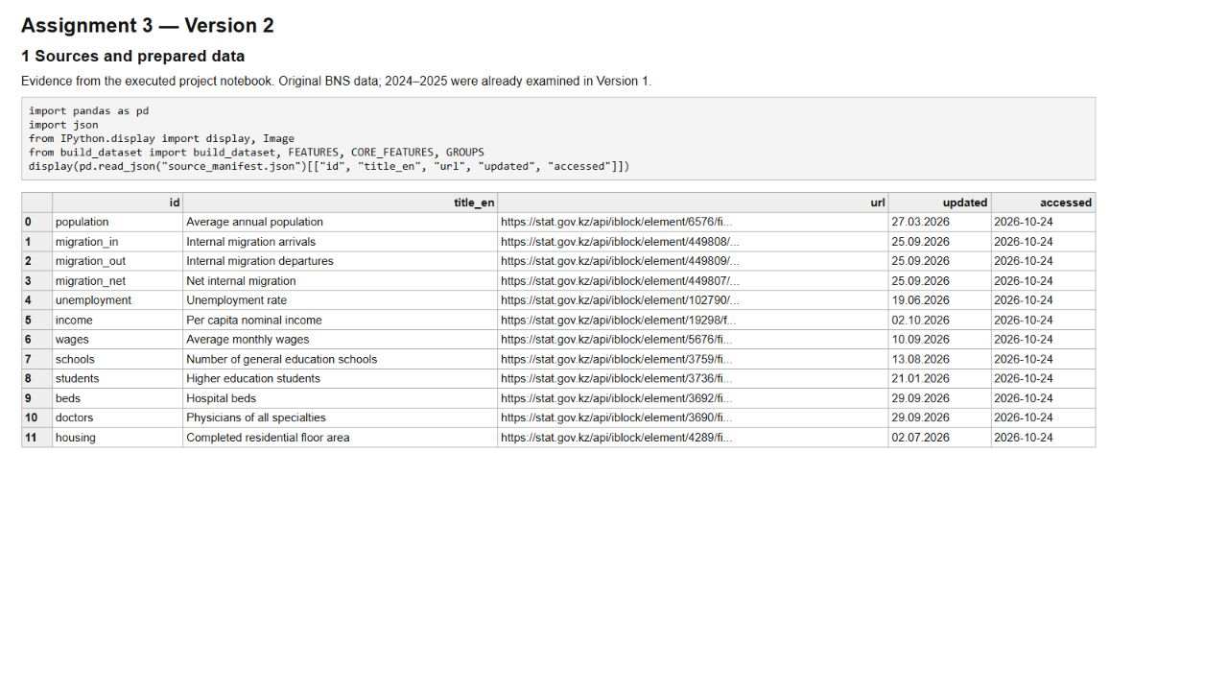
Figure A1. Executed notebook source inventory, showing all twelve BNS workbooks and their update and access dates. Complete URLs are in the reference list and manifest.

B Model code and year order
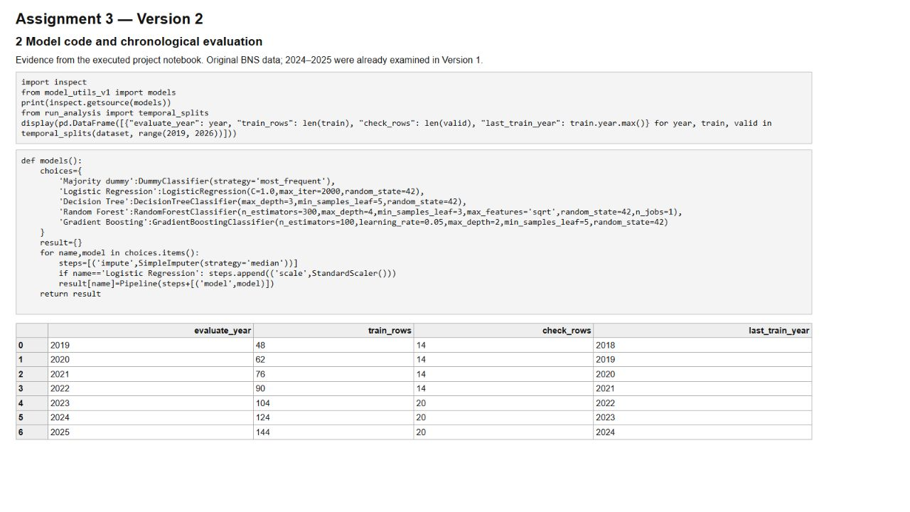
Figure A2. Actual notebook code and output: fixed model configurations and every chronological training/evaluation split.

C Comparison and errors
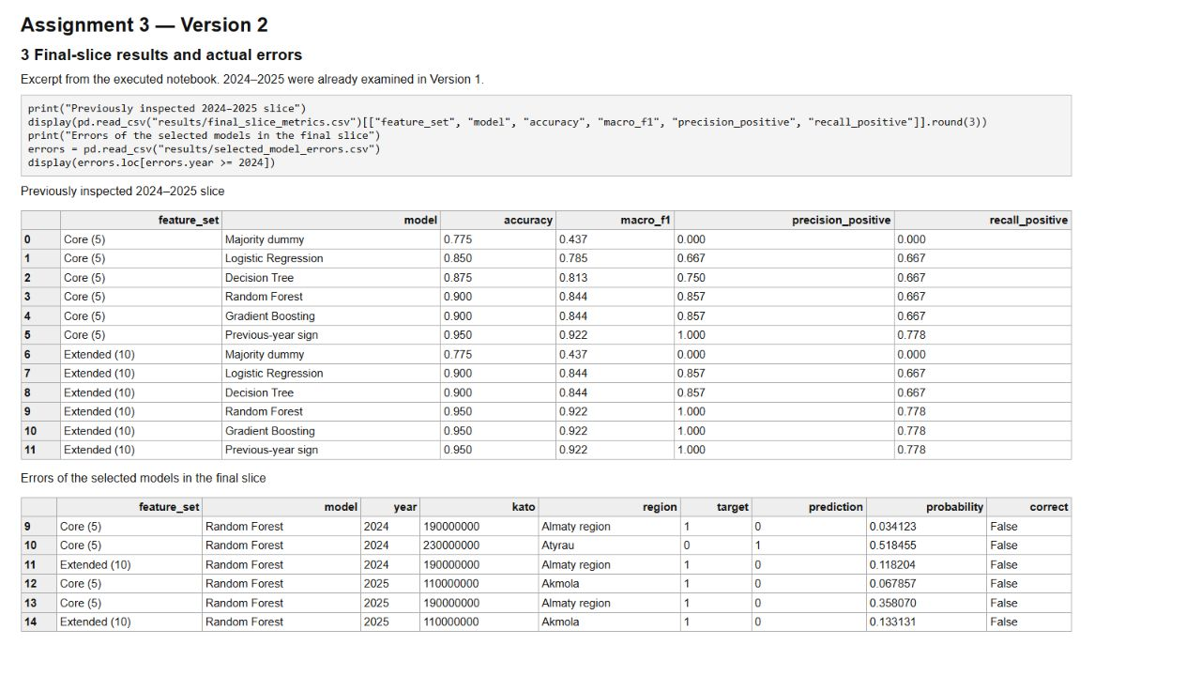
Figure A3. Actual notebook results for the previously inspected 2024–2025 slice and the selected models’ remaining errors.

D Interpreting the selected model
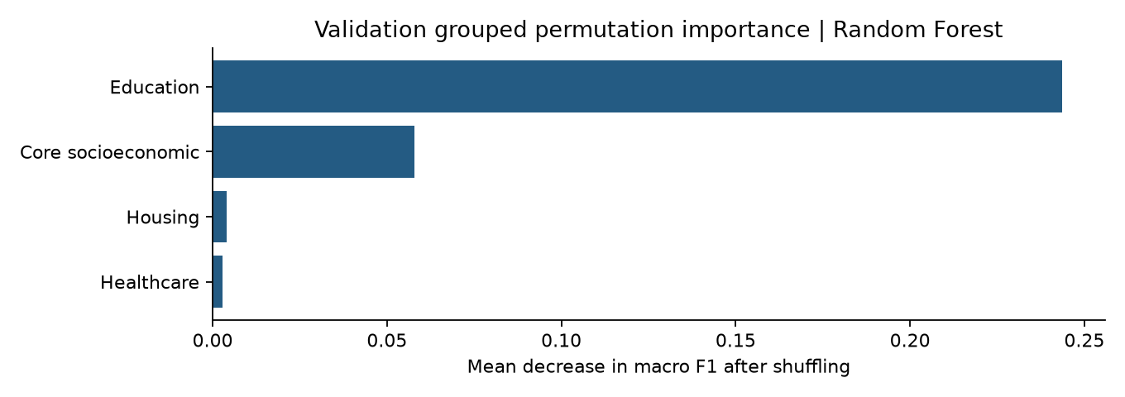
Figure A4. Mean validation score loss when all predictors in each group are shuffled together. Education has the largest estimated contribution.
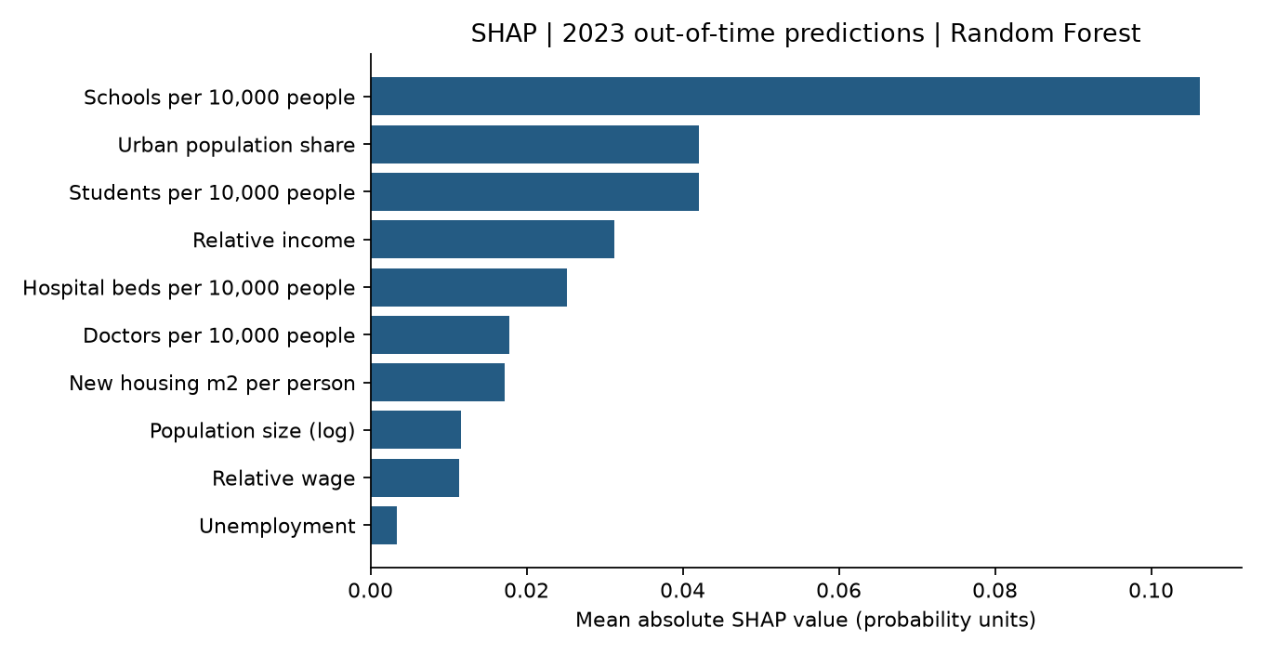
Figure A5. Actual SHAP summary for 2023 cases. Larger bars mean larger average contributions to model probability, without showing a causal effect.
GitHub repository and version history:
https://github.com/aluasagyndyk2/kazakhstan-internal-migration-ml
The original experiment is retained as v1-economic-only. Version 2 is recorded as v2-extended-features. New results must not be substituted for Version 1’s original fixed-split results.

