Assignment 3
Methodology and Core Practical Implementation

1 Research title
Predicting Regional Internal Migration in Kazakhstan Using Interpretable Machine Learning
Students: Aruzhan Rysbayeva and Alua Sagyndyk
Group: SE-2403
Data snapshot and execution date: 24 October 2026

2 Research question aim and objectives
Primary research question: How does the predictive performance of interpretable machine-learning models compare with a statistical baseline for classifying the net internal migration balance of Kazakhstan’s regions?
Subquestion: Which socioeconomic indicators contribute most to the predictions of the best-performing model?
Aim: To evaluate how accurately interpretable machine-learning models can predict the net internal migration balance of Kazakhstan’s regions and identify the indicators contributing most to the predictions.
Objective 1: Construct a region-year dataset of internal-migration data and socioeconomic indicators from official statistics.
Objective 2: Define the target variable and establish a simple statistical baseline model.
Objective 3: Compare Decision Tree, Random Forest and Gradient Boosting with the baseline using out-of-sample validation.
Objective 4: Identify the most influential indicators in the best-performing model using feature importance.
H1 retained from Assignment 2: Tree-based models will achieve higher out-of-sample accuracy than the statistical baseline. This is a testable expectation, not an assumed result.
Initial finding: The validation-selected Random Forest equals Logistic Regression on held-out accuracy. The initial implementation therefore does not support H1; the persistence benchmark performs better.

3 Research approach and design
This study uses a quantitative, observational and computational design: a comparative benchmark of binary classifiers on annual regional statistics. The unit of analysis is a region-year, not an individual migrant. The outcome is whether registered internal arrivals exceed registered internal departures in that region and year. Kazakhstan-focused research establishes the relevance of economic and demographic differences to migration (Mussina et al., 2020; Baidybekova et al., 2026), while the present study evaluates predictive performance rather than estimating a policy effect.
The design directly addresses Assignment 2 by comparing Logistic Regression with Decision Tree, Random Forest and Gradient Boosting using identical socioeconomic inputs and chronological evaluation. Random Forest combines multiple randomised trees (Breiman, 2001); gradient boosting builds an additive sequence of trees (Friedman, 2001). These approaches can represent nonlinear relationships without requiring a large neural network. A majority-class classifier and a previous-year-sign rule provide additional practical reference points.
A questionnaire was considered less suitable because reported intentions would not directly measure official regional migration balances or answer the comparative prediction question. A causal policy evaluation, such as the separate Kazakhstan study by Akhmetova et al. (2025), would require a different estimand and identification strategy. The evidence produced here consists of reproducible out-of-time predictions, classification errors and descriptive model explanations. It cannot establish why individuals move or whether changing a regional indicator would change migration.

4 Dataset and selection
The target population is Kazakhstan's 17 regions and the cities of Astana, Almaty and Shymkent. Seven public Bureau of National Statistics (BNS) workbooks were downloaded on 24 October 2026. They contain internal arrivals, internal departures, internal net migration, average annual population, unemployment, nominal per capita monetary income and average monthly wages. The population workbook also supplies urban population. Archived originals, direct URLs, source-update dates and SHA-256 hashes identify the exact data snapshot (BNS, 2026a-g).
The initial extraction contains 240 region-year records for 2014-2025. Outcomes cover 2015-2025, with 2014 retained to construct previous-year predictors. Selection is an attempted census of eligible regional observations, rather than random sampling. Eligibility requires a nonzero observed migration balance, all five lagged predictors and a defensible territorial match. National totals, district records, sex-specific unemployment columns and repeated rural/urban migration blocks are excluded.
BNS migration and population metadata explicitly state that observations from 2009 were recalculated for the newer territorial structure. Economic series do not provide equivalent certification across all earlier years. Therefore, Abay, Zhetisu, Ulytau and their parent regions, Almaty, Karaganda and East Kazakhstan, enter only when the feature year is at least 2022. Turkistan and Shymkent require a feature year of at least 2018. This conservative rule excludes 56 of 220 candidate outcome records and yields an unbalanced panel of 164 observations: 40 positive and 124 negative. All 20 units appear from outcome year 2023. No missing historical values are fabricated. Earlier coverage favours unaffected territories; this selection bias limits national historical generalisation and is documented in the exclusion log.

5 Variables and evaluation measures
The dependent variable equals one when internal net migration is strictly positive and zero when it is strictly negative. An exact zero would be excluded because the research question specifies positive versus negative balance; none occurs in the final sample. Internal net migration is checked against internal arrivals minus departures. International migration and total migration balance are not substituted for this outcome.
Five predictors describe the preceding calendar year: regional per capita monetary income divided by national per capita income; regional average monthly wage divided by the national wage; total unemployment rate in percent; urban population divided by total population; and the natural logarithm of average annual population. Income and wage ratios express relative national position, reducing common nominal trends without claiming to adjust regional living costs. The income and wage annual tables report average monthly monetary levels, not sums of monthly payments. Region names, current-year arrivals, current-year departures and current-year net migration are excluded from model inputs.
Macro F1 is the primary model-selection measure because it gives equal weight to positive and negative classes. Balanced accuracy averages class-specific recall; positive-class precision and recall quantify false alarms and missed inflow regions. Accuracy remains a secondary measure to assess the original hypothesis. ROC AUC and average precision assess ranking, while confusion matrices expose error counts. Definitions and implementation follow scikit-learn documentation (scikit-learn developers, n.d.-a). The previous-year migration sign is used only as an additional benchmark, outside the five-feature socioeconomic models.

6 Data preparation and experimental procedure
The procedure begins by downloading and freezing the seven source files. Their metadata, legends, header rows and footnotes are inspected before extraction. The script checks each source hash, reads the relevant worksheet and records every extracted value with its source identifier, sheet and cell. KATO codes link migration, population and income records. Normalised official names link wages and unemployment; the obsolete subregional Shymkent row is explicitly excluded to avoid confusing it with the republic-level city.
Only the total-population migration block, both-sex regional unemployment values and official annual wage columns are selected. Urban share is calculated from matching population blocks. Income and wage ratios use the national value for the same feature year. The scripts check duplicate keys, positive denominators, feasible urban shares, the arrivals-minus-departures identity and zero nationwide internal net migration. Source symbols are not interpreted as invented zero incomes or unemployment rates. Territorial exclusions are applied before generating the modelling sample. The retained predictors contain no missing values; a median-imputation pipeline remains a safeguard and is fitted only on training data.
Predictors from year t minus one are paired with migration in year t. Five expanding validation folds use 2019, 2020, 2021, 2022 and 2023 as separate validation years, each trained on earlier years starting in 2015. The final test comprises 2024-2025. Logistic Regression additionally receives training-fitted standardisation. All learned models receive inverse-frequency training weights, identical features and a fixed probability threshold of 0.5. Fixed, modest-capacity parameters avoid an extensive search on this small sample. The random seed is 42. Python 3.12.14, pandas 3.0.1 and scikit-learn 1.9.1 implement the pipeline; exact package versions and configuration are saved. CPU execution is sufficient; no GPU is required.

7 Data analysis plan
Objective 1 is answered through the source manifest, cell-level lineage, territorial exclusions, missingness diagnostics and annual class counts. These establish what the dataset represents and whether variables can be compared. Descriptive summaries identify the imbalance between inflow and outflow observations before interpreting classification accuracy.
Objective 2 defines the binary label and fits regularised Logistic Regression as the statistical baseline. A majority-class dummy establishes the performance obtainable without meaningful predictors. A persistence rule predicts the preceding year's migration sign, testing whether socioeconomic models add value beyond the stability of regional migration patterns.
Objective 3 compares the four learned model families through mean macro F1 over the five temporal validation folds. Configurations are fixed before fitting, and the selected family is recorded before test evaluation. It is then refitted on all 124 development observations through 2023. Every predeclared comparator is evaluated on the same 40 test observations from 2024-2025. Test results are also reported separately by year. The test set is not reused for parameter, threshold or feature selection. The original hypothesis is supported descriptively only if tree-based models improve held-out accuracy over Logistic Regression; a tie or decline does not support it. No significance claim is made from this small, dependent panel.
Objective 4 uses permutation importance for the validation-selected model family. Within each validation year, each feature is shuffled 50 times while others remain unchanged. The mean decline in macro F1 across folds describes predictive reliance. Zero or negative importance is retained rather than hidden and does not imply a causal effect. Error analysis names misclassified region-years and compares their labels with the source tables. This links numerical performance to concrete limitations and priorities for subsequent research.

8 Research quality ethics and reproducibility
Measurement validity depends on registered changes of residence: official migration records do not necessarily capture every temporary or unregistered move. Regional aggregates cannot justify individual-level conclusions. Income, wages and urbanisation can be correlated, making feature rankings unstable. Repeated observations of the same regions and shared national shocks reduce effective sample independence; 164 rows do not represent 164 independent regions.
Chronological validation prevents random mixing of future and earlier outcome years. Lagging features prevents direct use of contemporaneous outcome components, while training-only preprocessing prevents distributional leakage. However, this is a retrospective benchmark using revised statistics downloaded in 2026. Some previous-year annual indicators were released or revised during the outcome year. Consequently, the experiment does not demonstrate what could have been forecast in real time on 1 January. Operational forecasting would require release-date-aware historical vintages and potentially longer lags.
The dataset contains public aggregate statistics, with no recruited participants or individual identifiers. No questionnaire is required. Original workbooks are preserved, and derived tables contain only regional observations. Reproduction uses the frozen files, scripts, executed notebook, package versions, configuration and prediction logs. Public source updates are kept distinct from the years measured. Reported metrics come from actual execution; hypothesis confirmation is not assumed. The small test set, changing territorial coverage, registration bias and limited predictors constrain conclusions, so subsequent work should expand comparable data and evaluate robustness before policy use.
Methodology word count for Sections 3-8: 1,496 words, excluding headings, references, tables and appendices.

9 Core practical implementation
The submitted implementation reads the seven frozen official workbooks, constructs the eligible panel, trains all predeclared classifiers and writes validation metrics, test predictions, error records and figures. The executed notebook and Python scripts are supplied with the source files. This component supports all four research objectives; a questionnaire is not used.

9 1 Dataset and temporal checks
Stage | Observed count or period
Extracted regional panel | 240 rows; 20 units × 12 years, 2014-2025
Candidate labelled outcomes | 220 rows; 2015-2025
Territorial exclusions | 56 rows; listed individually in excluded_rows.csv
Final modelling dataset | 164 rows; 40 positive and 124 negative
Development sample | 124 rows; outcome years 2015-2023
Held-out test | 40 rows; 2024-2025; 9 positive and 31 negative
Missing model features | 0; no feature values were imputed in this run

Source controls passed: internal arrivals minus internal departures equals published internal net migration for every extracted region-year; the sum of all 20 regional internal balances is zero in each year. For 2024 the source reproduces Astana +73,238, Almaty city +36,061, Shymkent +9,361 and Almaty region +2,639. Duplicate model keys and invalid temporal lags were not found.

9 2 Model configuration and selection
Model | Fixed configuration
Logistic Regression | C=1; default L2 regularisation; lbfgs; max_iter=2000; standardised features
Decision Tree | max_depth=3; min_samples_leaf=5
Random Forest | 300 trees; max_depth=4; min_samples_leaf=3; max_features=sqrt
Gradient Boosting | 100 estimators; learning_rate=0.05; max_depth=2; min_samples_leaf=5
Additional benchmarks | Most-frequent class; previous-year migration sign

All learned models use inverse-frequency training weights and seed 42. They receive the same five lagged features. No oversampling, synthetic observations, neural network, SHAP analysis or hyperparameter search is used. Feature importance is calculated by validation permutations. The software implementation uses scikit-learn (Pedregosa et al., 2011); technical definitions follow its documentation (scikit-learn developers, n.d.-b-d).
Model | Mean validation macro F1 | Validation SD
Majority dummy | 0.430 | 0.019
Logistic Regression | 0.803 | 0.083
Decision Tree | 0.801 | 0.065
Random Forest | 0.899 | 0.108
Gradient Boosting | 0.871 | 0.087
Previous-year sign | 0.945 | 0.051

Random Forest has the highest mean rolling-validation macro F1 among the four learned socioeconomic models, 0.899. It is selected before test scoring. The previous-year-sign rule scores 0.945 in validation, demonstrating a strong temporal benchmark. Fold SD describes variation across years, not a confidence interval.

9 3 Held out results and interpretation
Model | Accuracy | Balanced accuracy | Macro F1 | Positive recall
Majority dummy | 0.775 | 0.500 | 0.437 | 0.000
Logistic Regression | 0.875 | 0.801 | 0.813 | 0.667
Decision Tree | 0.825 | 0.769 | 0.758 | 0.667
Random Forest | 0.875 | 0.801 | 0.813 | 0.667
Gradient Boosting | 0.875 | 0.801 | 0.813 | 0.667
Previous-year sign | 0.950 | 0.889 | 0.922 | 0.778

Random Forest correctly classifies 35 of 40 test observations: 29 true negatives and 6 true positives, with 2 false positives and 3 false negatives. Positive-class precision is 0.750, recall is 0.667, ROC AUC is 0.667 and average precision is 0.735. Logistic Regression and Gradient Boosting obtain the same thresholded accuracy and macro F1. Their ranking metrics differ; equal accuracy does not mean identical probabilities.
H1 is not supported by this test: no tree-based model exceeds Logistic Regression in accuracy. The previous-year-sign rule achieves 38/40 correct predictions, or 0.950 accuracy, showing that the selected socioeconomic model does not beat simple persistence. The majority dummy reaches 0.775 accuracy while detecting none of the positive cases, illustrating why accuracy alone is insufficient.
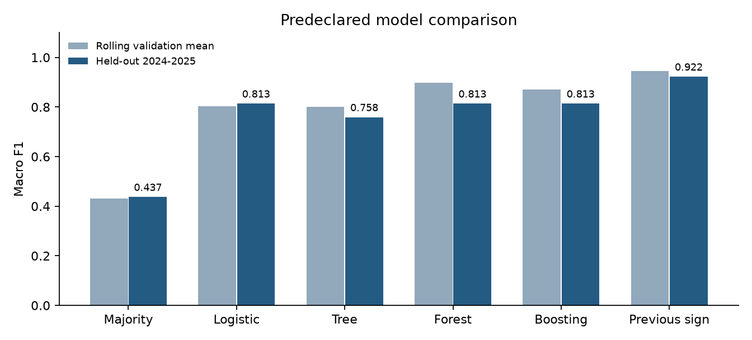
Figure 1. Actual rolling-validation and held-out macro F1. Random Forest was selected on validation only.

9 4 Errors and practical limitations
Region | Year | Actual | Predicted
Almaty region | 2024 | Positive | Negative
Atyrau | 2024 | Negative | Positive
Akmola | 2025 | Positive | Negative
Almaty region | 2025 | Positive | Negative
Atyrau | 2025 | Negative | Positive

The forest repeatedly misses positive balances in Almaty region and incorrectly predicts positive balance in high-income Atyrau. It also misses Akmola’s small positive balance in 2025. These are concrete failure cases: urban concentration and relative income alone do not represent all regional migration dynamics. Akmola’s +292 balance comes from the archived annual series updated on 25 September 2026; the exact data vintage matters when comparing with earlier releases.

9 5 Model explanation and next steps
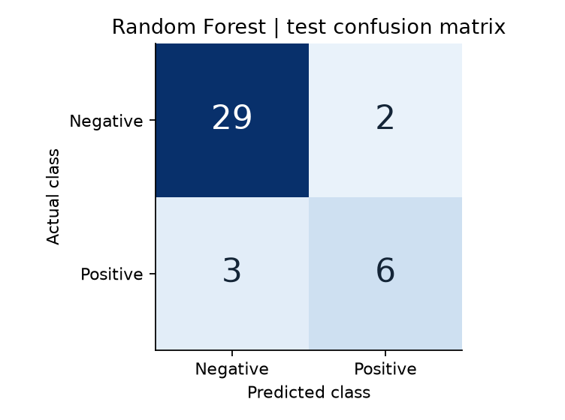
Figure 2. Selected Random Forest confusion matrix for the 40 held-out region-years.
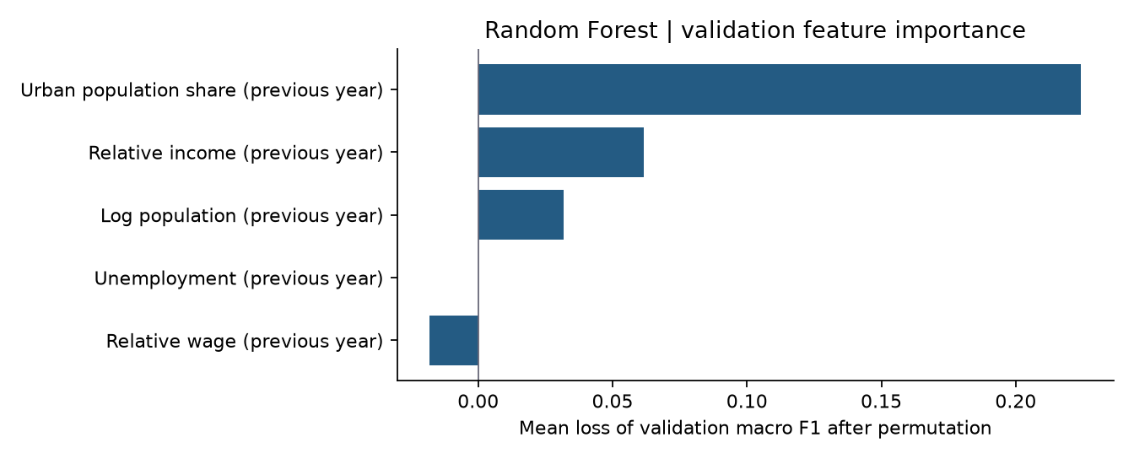
Figure 3. Actual validation permutation importance. Shuffling takes place within each validation year.
Mean validation macro-F1 losses are 0.224 for urban share, 0.062 for relative income and 0.032 for log population. Unemployment has zero estimated importance, while relative wage has a small negative estimate (-0.018). A negative permutation estimate means the model did not benefit consistently from that variable under this procedure; it does not mean that wages cause migration to fall. Correlated inputs and small validation sets make these rankings uncertain.
Next steps are to expand comparable historical economic series, assess stability across model seeds and spatial holdouts, and test whether lagged migration adds value beyond persistence. Any revised modelling choices require a new untouched evaluation period or nested validation. This initial benchmark must not be presented as a production forecast or causal policy recommendation.

10 Methodology Alignment Table
Research objective | Data or evidence needed | Source sample or dataset | Collection or instrument | Analysis method | Evidence for the RQ
1 Construct dataset | Migration totals and socioeconomic inputs | Seven BNS workbooks; 240 audit rows; 164 eligible rows | Hash check; worksheet extraction; KATO/name joins; cell lineage; territorial eligibility | Counts, missingness, source identities and exclusions | Auditable sample with defined coverage and limits
2 Define target and baseline | Migration sign and five prior-year inputs | Eligible region-year dataset; BNS internal migration series | Binary label; Logistic Regression pipeline; majority and persistence comparators | Baseline temporal validation and held-out classification | Reference performance for the ML comparison
3 Compare model performance | Out-of-time predictions and true labels | Same 164 eligible rows for all comparators | Five expanding validation folds; final test years 2024-2025 | Mean validation macro F1; test accuracy, balanced accuracy, F1, ranking metrics and errors | Direct evidence on whether trees improve on the statistical baseline
4 Interpret predictors | Inputs and selected-model validation predictions | Random Forest; validation years 2019-2023 | 50 within-year permutations per feature in each validation fold | Average macro-F1 decline; inspect error region-years | Predictive reliance without causal claims

11 References
Akhmetova, G., Davletbayeva, Z., Ismailova, R., & Torebekova, Z. (2025). Education as an economic instrument of internal migration regulation in Kazakhstan: Analysis and evaluation of state initiatives. Journal of Social Studies Education Research, 16(1), 163-187. https://files.eric.ed.gov/fulltext/EJ1468493.pdf
Baidybekova, S., Tolamisova, A., Dyrka, S., & Turysbekova, R. (2026). Internal migration in Kazakhstan: Urbanization, regional inequality and economic development. Economic Research and Management Decisions, 1(1), 21-33. https://rep.buketov.edu.kz/handle/data/22872
Breiman, L. (2001). Random forests. Machine Learning, 45, 5-32. https://doi.org/10.1023/A:1010933404324
Friedman, J. H. (2001). Greedy function approximation: A gradient boosting machine. The Annals of Statistics, 29(5), 1189-1232. https://doi.org/10.1214/aos/1013203451
Mussina, S. T., Khusainova, Zh. S., & Vechkinzova, Y. A. (2020). Migration processes in Kazakhstan: Trends, specifics, factors. Bulletin of the Karaganda University Economy Series, 100(4), 53-67. https://doi.org/10.31489/2020Ec4/53-67
Pedregosa, F., Varoquaux, G., Gramfort, A., Michel, V., Thirion, B., Grisel, O., Blondel, M., Prettenhofer, P., Weiss, R., Dubourg, V., Vanderplas, J., Passos, A., Cournapeau, D., Brucher, M., Perrot, M., & Duchesnay, E. (2011). Scikit-learn: Machine learning in Python. Journal of Machine Learning Research, 12, 2825-2830. https://www.jmlr.org/papers/v12/pedregosa11a.html
scikit-learn developers. (n.d.-a). Metrics and scoring: Quantifying the quality of predictions. Documentation, version 1.9.1. Retrieved October 24, 2026, from https://scikit-learn.org/stable/modules/model_evaluation.html
scikit-learn developers. (n.d.-b). Permutation feature importance. Documentation, version 1.9.1. Retrieved October 24, 2026, from https://scikit-learn.org/stable/modules/permutation_importance.html
scikit-learn developers. (n.d.-c). Cross-validation: Evaluating estimator performance. Documentation, version 1.9.1. Retrieved October 24, 2026, from https://scikit-learn.org/stable/modules/cross_validation.html
scikit-learn developers. (n.d.-d). LogisticRegression. Documentation, version 1.9.1. Retrieved October 24, 2026, from https://scikit-learn.org/stable/modules/generated/sklearn.linear_model.LogisticRegression.html
Bureau of National Statistics of the Republic of Kazakhstan. (2026a). Среднегодовая численность населения (по годам) [Data set; source page updated 27.03.2026]. Retrieved October 24, 2026, from https://stat.gov.kz/api/iblock/element/6576/file/ru/
Bureau of National Statistics of the Republic of Kazakhstan. (2026b). Внутренняя миграция по всем потокам - прибытие (по годам) [Data set; source page updated 25.09.2026]. Retrieved October 24, 2026, from https://stat.gov.kz/api/iblock/element/449808/file/ru/
Bureau of National Statistics of the Republic of Kazakhstan. (2026c). Внутренняя миграция по всем потокам - выбытие (по годам) [Data set; source page updated 25.09.2026]. Retrieved October 24, 2026, from https://stat.gov.kz/api/iblock/element/449809/file/ru/
Bureau of National Statistics of the Republic of Kazakhstan. (2026d). Сальдо внутренней миграции по всем потокам (по годам) [Data set; source page updated 25.09.2026]. Retrieved October 24, 2026, from https://stat.gov.kz/api/iblock/element/449807/file/ru/
Bureau of National Statistics of the Republic of Kazakhstan. (2026e). Уровень безработицы [Data set; source page updated 19.06.2026]. Retrieved October 24, 2026, from https://stat.gov.kz/api/iblock/element/102790/file/ru/
Bureau of National Statistics of the Republic of Kazakhstan. (2026f). Среднедушевые номинальные денежные доходы населения (годовые) [Data set; source page updated 02.10.2026]. Retrieved October 24, 2026, from https://stat.gov.kz/api/iblock/element/19298/file/ru/
Bureau of National Statistics of the Republic of Kazakhstan. (2026g). Среднемесячная заработная плата по регионам Республики Казахстан (2010-2026гг.) [Data set; source page updated 10.09.2026]. Retrieved October 24, 2026, from https://stat.gov.kz/api/iblock/element/5676/file/ru/

12 Appendix

A Source provenance and extraction specification
The following are downloaded official source workbooks, not datasets taken from journal articles. Source-page update dates identify publication snapshots; they are not the years of observation. The complete source_manifest.json preserves direct URLs, resolved download URLs, hashes and file sizes. The cell_lineage.csv file records the worksheet and cell for every extracted value.
Среднегодовая численность населения (по годам)
File: data/raw/population.xlsx. Source-page update: 27.03.2026. Download: 24 October 2026.
URL: https://stat.gov.kz/api/iblock/element/6576/file/ru/
Worksheet: 2009-2025. Year header row 7; total rows 9-29; urban rows 75-95. Used: 2014-2025; predictors use 2014-2024.
Внутренняя миграция по всем потокам - прибытие (по годам)
File: data/raw/migration_in.xlsx. Source-page update: 25.09.2026. Download: 24 October 2026.
URL: https://stat.gov.kz/api/iblock/element/449808/file/ru/
Worksheet: Показатель. Year header row 6; all-population rows 8-28. Used: 2014-2025; checks only.
Внутренняя миграция по всем потокам - выбытие (по годам)
File: data/raw/migration_out.xlsx. Source-page update: 25.09.2026. Download: 24 October 2026.
URL: https://stat.gov.kz/api/iblock/element/449809/file/ru/
Worksheet: Показатель. Year header row 6; all-population rows 8-28. Used: 2014-2025; checks only.
Сальдо внутренней миграции по всем потокам (по годам)
File: data/raw/migration_net.xlsx. Source-page update: 25.09.2026. Download: 24 October 2026.
URL: https://stat.gov.kz/api/iblock/element/449807/file/ru/
Worksheet: Показатель. Year header row 5; all-population rows 7-27. Used: 2015-2025 outcomes; 2014-2024 persistence.
Уровень безработицы
File: data/raw/unemployment.xlsx. Source-page update: 19.06.2026. Download: 24 October 2026.
URL: https://stat.gov.kz/api/iblock/element/102790/file/ru/
Worksheet: Показатель. Year header row 4; first column per year = both sexes; regional rows only; obsolete row 182 excluded. Used: 2014-2024 eligible feature years.
Среднедушевые номинальные денежные доходы населения (годовые)
File: data/raw/income.xlsx. Source-page update: 02.10.2026. Download: 24 October 2026.
URL: https://stat.gov.kz/api/iblock/element/19298/file/ru/
Worksheet: Показатель. Year header row 4; rows 5-26; national and regional totals. Used: 2014-2024 eligible feature years.
Среднемесячная заработная плата по регионам Республики Казахстан (2010-2026гг.)
File: data/raw/wages.xlsx. Source-page update: 10.09.2026. Download: 24 October 2026.
URL: https://stat.gov.kz/api/iblock/element/5676/file/ru/
Worksheet: квартал. Year header row 3; select row 4 label за год; rows 6-27. Used: 2014-2024 eligible feature years.

B Dataset dictionary and temporal coverage
Model field | Definition and unit
target | 1 for positive internal balance; 0 for negative
income_ratio_lag1 | Previous-year regional income / national income; ratio
wage_ratio_lag1 | Previous-year regional wage / national wage; ratio
unemployment_lag1 | Previous-year total unemployment rate; percent
urban_share_lag1 | Previous-year urban / total average population; fraction
log_population_lag1 | Natural log of previous-year average annual population

The full dictionary is in data/processed/data_dictionary.csv. The regional_panel.csv audit extraction retains source values that can have incompatible early territorial coverage; its economic_geometry_comparable field flags this. Only model_dataset.csv is the eligible modelling sample. Current-year migration fields are retained there for audit and label construction but are never selected as predictors.
Year | Eligible rows | Positive | Negative
2015 | 12 | 6 | 6
2016 | 12 | 2 | 10
2017 | 12 | 3 | 9
2018 | 12 | 2 | 10
2019 | 14 | 4 | 10
2020 | 14 | 4 | 10
2021 | 14 | 4 | 10
2022 | 14 | 3 | 11
2023 | 20 | 3 | 17
2024 | 20 | 4 | 16
2025 | 20 | 5 | 15

C Exact temporal folds
Training outcome years | Validation year | Training rows | Validation rows
2015-2018 | 2019 | 48 | 14
2015-2019 | 2020 | 62 | 14
2015-2020 | 2021 | 76 | 14
2015-2021 | 2022 | 90 | 14
2015-2022 | 2023 | 104 | 20

After model selection, all development outcome years 2015-2023 are used for refitting (124 rows). The held-out evaluation uses 2024-2025 (40 rows). Each year is kept intact. This evaluates future observations of the same national regional system; it is not a test on entirely unseen regions.

D Reproduction and evidence files
Artifact | Purpose
build_dataset.py | Extract archived BNS tables; verify hashes; write panel, eligible dataset, dictionary and lineage
run_analysis.py | Fit models, select on temporal validation, evaluate held-out data and export real results
Assignment3_Executed.ipynb | Executed notebook including source inventory, dataset creation, model run and displayed figures
test_data.py and verify_results.py | Independent source-control, temporal-integrity and saved-prediction checks
results/experiment_config.json | Exact parameters, splits, features, weighting, seed and selection rule
results/run_log.txt | Actual execution output, performance, errors, importance and package versions
results/test_predictions.csv | Every held-out prediction, true label and probability
source_manifest.json | Direct source links, source dates and SHA-256 hashes

Reproduce from the project folder with Python 3.12: install requirements.txt; run python build_dataset.py; run python test_data.py; run python run_analysis.py; run python verify_results.py. Downloading is not required because the exact official source files are included. Re-downloaded source revisions must be treated as a new experiment, with a new manifest and potentially different results.
AI assistance disclosure: AI tools assisted code drafting, analysis execution and report composition. The submitted numerical results derive from executed code on archived official statistics and were checked against independent source controls. This disclosure does not replace the course rules on permitted assistance or each student’s individual oral defence.

