**subscribers galore: exoloring world’s top youtube channels**

**Project BasedExperiential Learning Program**

**1.INTRODUCTION**

1.1 Overview

1.2 Purpose

**2.PROBLEM DEFINITION AND DESIGN THINKING**

2.1 Empathy Map

2.2 Ideation And Brainstorming Map

**3.RESULT**

3.1 Data Model

3.2 Activity and Screenshot

**4.TRAILHEAD PROFILE PUBLIC URL**

**5.ADVANTAGES AND DISADVANTAGES**

**6.APPLICATIONS**

**7.CONCLUSION**

**8.FUTURES**

* 1. **Overview:**

"Subscribers Galore: Exploring World's Top YouTube Channels" would be a comprehensive project aimed at shedding light on the world's most successful YouTube channels, their creators, and the dynamics that drive their popularity. It would offer valuable insights for content creators, marketers, and anyone interested in the ever-evolving landscape of online video content.

**1.2 Purpose**

**1.** Inform and Educate

**2.** Business and Marketing Insights

**3.** Trends and innovation

**4.** Entertainment

**MILESTONE 1:**

**Problem Definition and Design Thinking:**

**EMPATHY MAP:**

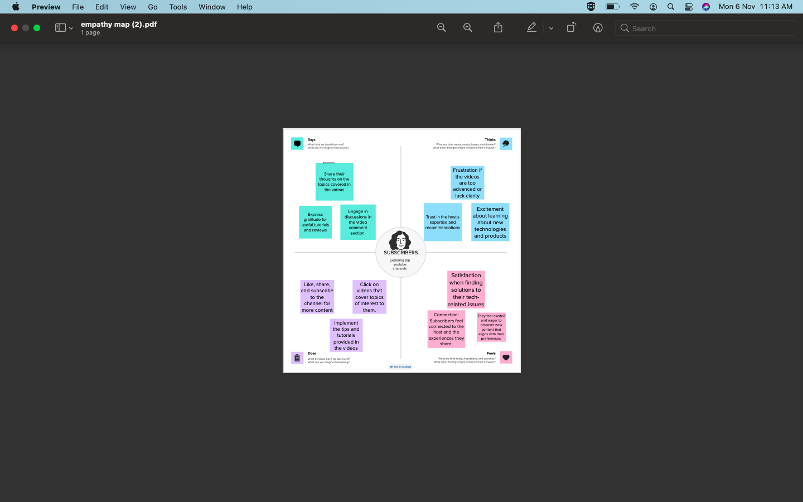

<https://app.mural.co/t/subscribersgaloreexploringwo4950/m/subscribersgaloreexploringwo4950/1693502107735/8a9524f7a9604978923a308a47bd5633d246084a?wid=0-1690755190273>

**BRAINSTORMING:**

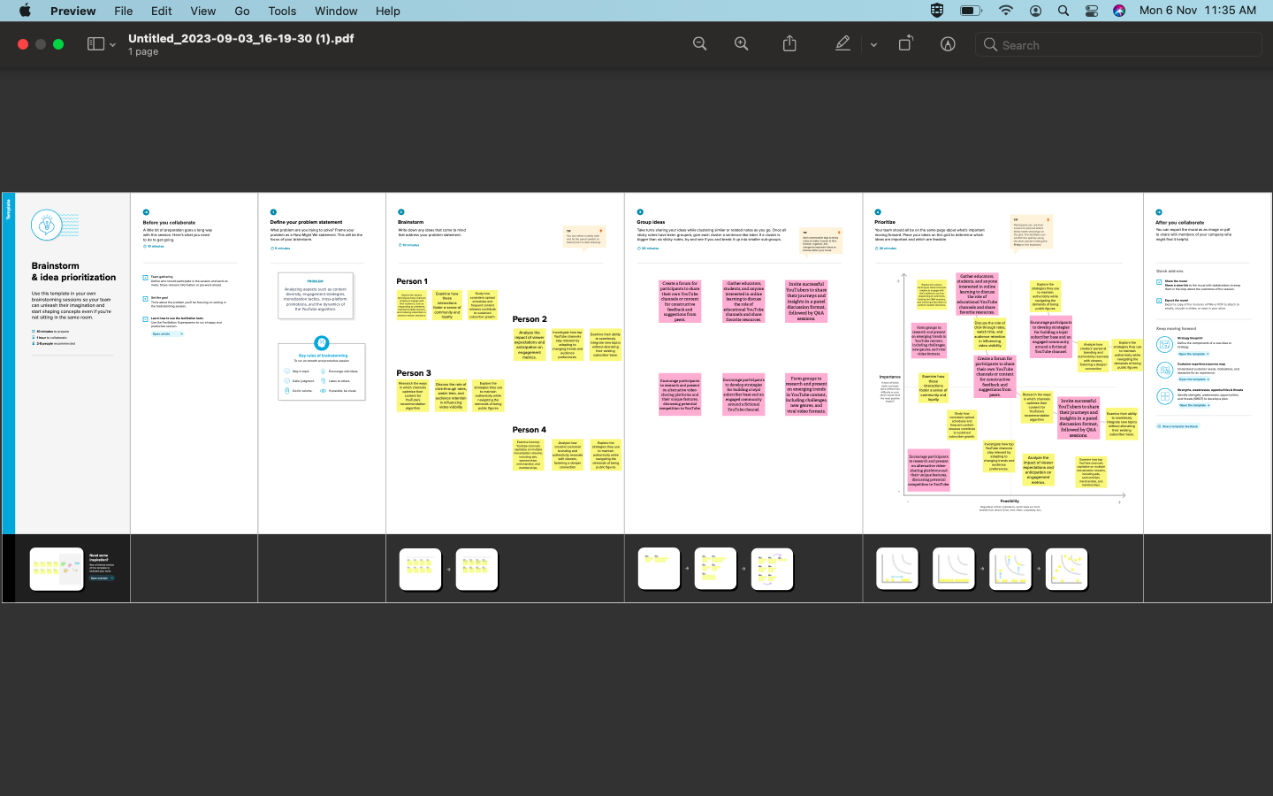

<https://app.mural.co/t/subscribersgaloreexploringwo4950/m/subscribersgaloreexploringwo4950/1693537683303/4a4315663293ee8f2c1599989a5f8a50d707dd58?sender=u7abc194c579aa649a9c25943>

**RESULT:**

The project would identify and list the most popular and successful YouTube channels across various genres and niches. Detailed analysis of the types of content, production quality, and engagement strategies used by these top channels.

**MILESTONE 2:**

**DATA COLLECTION AND PREPARATION:**

**ACTIVITY1:**

**COLLECT THE DATASET:**

Please use the link to download the dataset: [link](https://www.kaggle.com/datasets/rajkumarpandey02/list-of-most-subscribed-youtube-channels-in-world)

**ACTIVITY 1.1 : Understand the data**

Data contains all the meta information regarding the columns described in the CSV files. We have provided CSV file.

**Column Description for Youtube_Channels.csv:**

* (17) Countries: * India, United States, Sweden, Ukraine, Russia, South Korea, Cyprus[a], Canada, Brazil, Argentina, Romania, United Kingdom, Chile, Mexico, El Salvador, United States (Puerto Rico), Belarus.
* (8) Categories: Music, Education, Entertainment, Games, Sports, Film, How-to, News.
* (7) Primary Languages: English, Hindi, Spanish, Korean, Portuguese, Russian, Bhojpuri.
* (49)Name:

●  T-Series

●  Cocomelon

●  Sony Entertainment

●  MrBeast

●  PewDiePie

●  Kids Diana Show

●  Like Nastya

●  Vlad and Niki

●  WWE

●  Zee Music Company

●  Blackpink

●  Goldmines

●  5-Minute Crafts

●  Sony SAB

●  BangtanTV

●  Justin Bieber

●  Hybe Labels

●  Canal KondZilla

●  ZeeTV

●  Pinkfong

●  Shemaroo

Entertainment

* ●  ChuChu TV
* ●  Colors TV
* ●  Dude Perfect
* ●  Movieclips
* ●  T-Series Bhakti Sagar
* ●  Tips Industries
* ●  Wave Music
* ●  Marshmello
* ●  Sony Music India
* ●  El Reino Infantil
* ●  Aaj Tak
* ●  Eminem
* ●  LooLoo Kids
* ●  Ed Sheeran
* ●  Yash Raj Films
* ●  Ariana Grande
* ●  Taylor Swift
* ●  BillionSurpriseToys
* ●  Infobells
* ●  JuegaGerman
* ●  Billie Eilish
* ●  Badabun
* ●  Fernanfloo
* ●  Bad Bunny
* ●  SonyMusicIndiaVEVO
* ●  Shemaroo
* ●  Get Movies
* ●  Felipe Neto
* ●  A4

**ACTIVITY 2: CONNECT DATASET WITH TABLEAU**

1. Reference video link: [https://drive.google.com/file/d/1iilFRgZFKWrwQAwZPzYPOCq6YRACD7uK/view?usp =sharing](https://drive.google.com/file/d/1iilFRgZFKWrwQAwZPzYPOCq6YRACD7uK/view?usp%20=sharing)

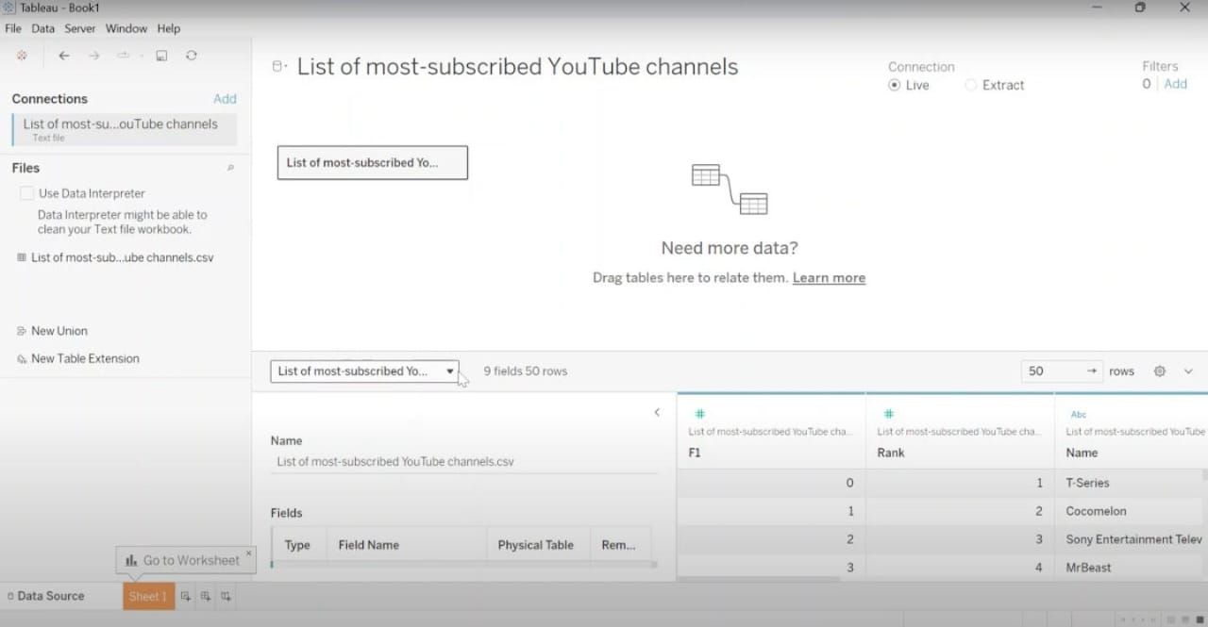

**MILESTONE 3: Data Preparation**

**Activity 1: Prepare the Data for Visualization**

Preparing the data for visualization involves cleaning the data to remove irrelevant or missing data, transforming the data into a format that can be easily visualized, exploring the data to identify patterns and trends, filtering the data to focus on specific subsets of data, preparing the data for visualization software, and ensuring the data is accurate and complete.

**Milestone 4: Data Visualization**

Data visualization is the process of creating graphical representations of data in order to help people understand and explore the information. The goal of data visualization is to make complex data sets more accessible, intuitive, and easier to interpret.

**Activity 1: No of Unique Visualizations**

The number of unique visualizations that can be created with a given dataset. Some common types of visualizations that can be used to analyze the performance and efficiency of project include bar charts, line charts, heat maps, scatter plots, pie charts, Maps etc.

**Activity 1.1: Rank wish Channel, No of Channels with Brand And Channel Brand Reference video link:** [**https://drive.google.com/file/d/1ugnhFw4DczVBAQKw5oXoo0v1iJtkWP3Y/view?usp= drive_link**](https://drive.google.com/file/d/1ugnhFw4DczVBAQKw5oXoo0v1iJtkWP3Y/view?usp=%20drive_link)

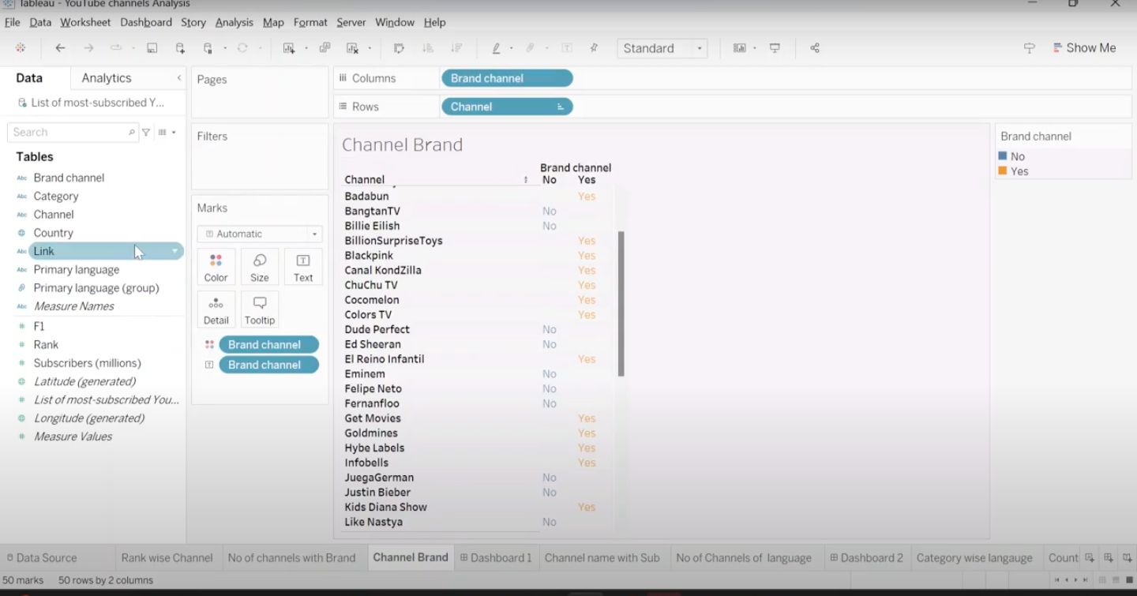

**Activity 1.2: Channel name with subscribers and No of channels for particular language.**

**Reference video link:** [**https://drive.google.com/file/d/1MCVdEoDtUsGDG_QfLe6HRjZQ8zbmZdVw/view?u sp=drive _link**](https://drive.google.com/file/d/1MCVdEoDtUsGDG_QfLe6HRjZQ8zbmZdVw/view?u%20sp=drive%20_link)

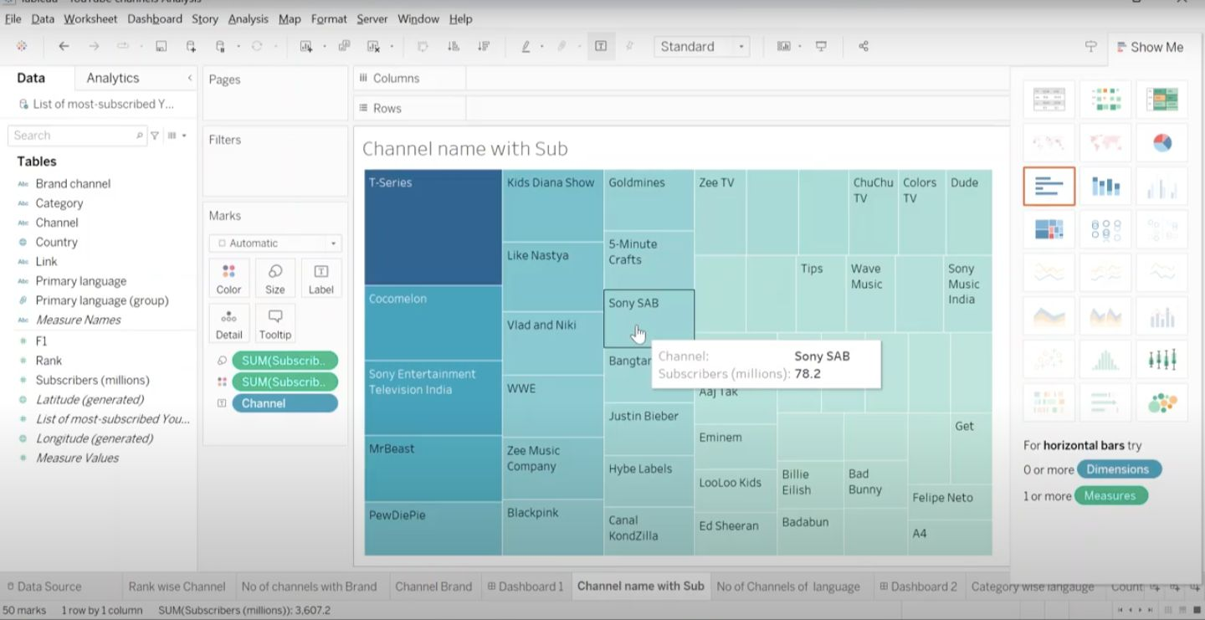

**Activity 1.3: Country and Language wise subscribers**

**Reference video link:** [**https://drive.google.com/file/d/1ljMrX6NQ-Ocy8vN3Pom9E3dc0- oWebCr/view?usp=sharing**](https://drive.google.com/file/d/1ljMrX6NQ-Ocy8vN3Pom9E3dc0-%20oWebCr/view?usp=sharing)

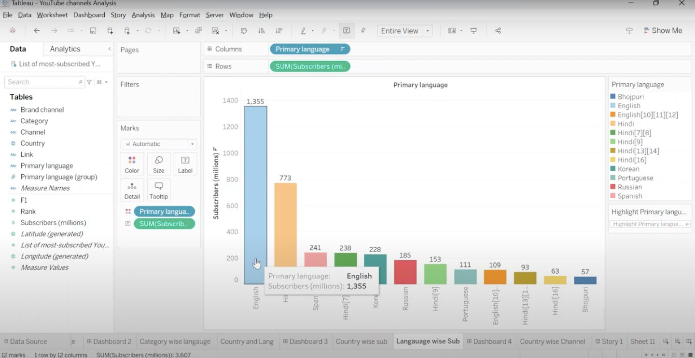

**Activity 1.4: Country wish Channel**

**Reference video link:** [**https://drive.google.com/file/d/1R4_xYlmmPmGQWXTOLGglUPc- Cxfvhsry/view?usp=sharing**](https://drive.google.com/file/d/1R4_xYlmmPmGQWXTOLGglUPc-%20Cxfvhsry/view?usp=sharing)

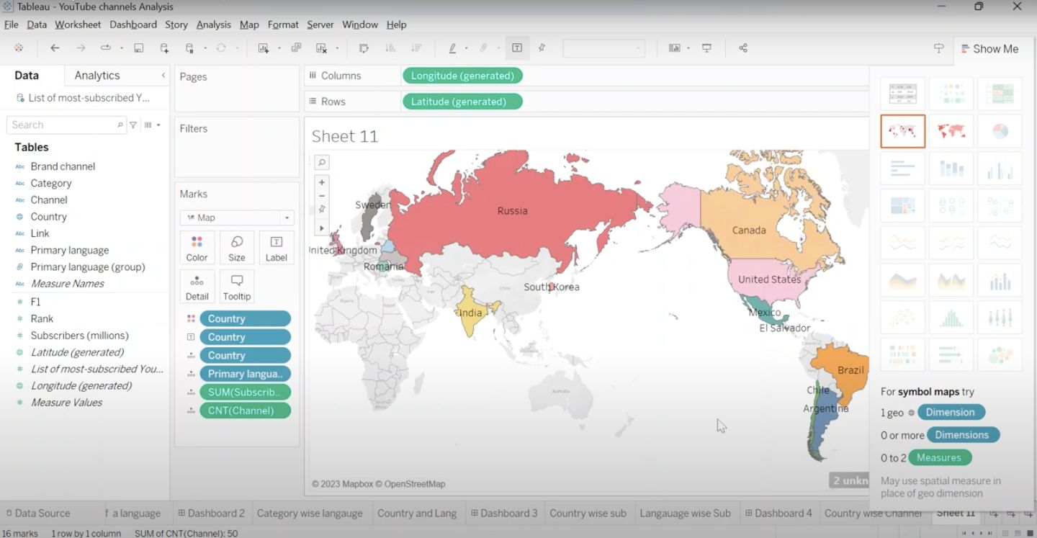

**Milestone 5: Dashboard**

A dashboard is a graphical user interface (GUI) that displays information and data in an organized, easy-to-read format. Dashboards are often used to provide real- time monitoring and analysis of data, and are typically designed for a specific purpose or use case. Dashboards can be used in a variety of settings, such as business, finance, manufacturing, healthcare, and many other industries. They can be used to track key performance indicators (KPIs), monitor performance metrics, and display data in the form of charts, graphs, and tables.

**Activity :1- Responsive and Design of Dashboard**

The responsiveness and design of a dashboard for Data-Driven insights on YouTube channels Analysis is crucial to ensure that the information is easily understandable and actionable. Key considerations for designing a responsive and effective dashboard include user-centered design, clear and concise information, interactivity, data-driven approach, accessibility, customization, and security. The goal is to create a dashboard that is user-friendly, interactive, and data-driven, providing actionable insights.

**DASHBOARD 1:**

* Add a new dashboard.
* In the left side we will see the sheets.
* Dashboard 1 is created by dragging the 3 sheets.
* Drag Rank wise channel, No of channel with brand, channel brand sheets to the dashboard.

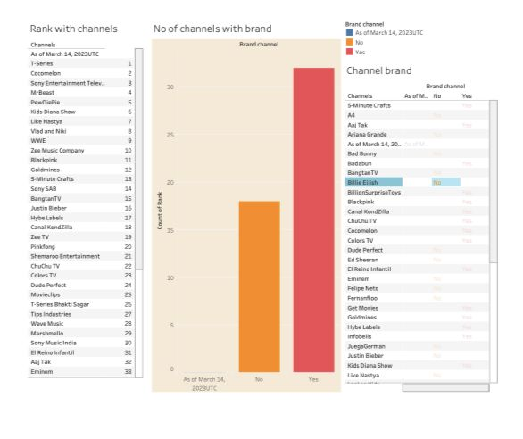

DASHBOARD 2:

* Add new dashboard.
* Drag channel name with subscribers and no of channels of a language sheets to the dashboard.
* Click the sheet. In the top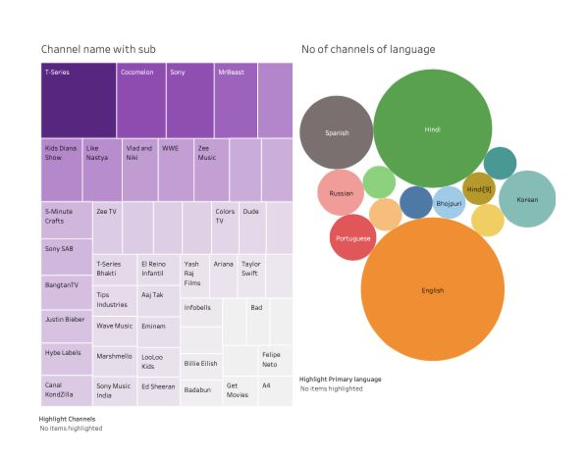 right side click options and click highlight channel.
* Highlight the primary language in the no of channels of language sheet.

**Dashboard 3:**

* Add new dashboard. Drag the category wise language and country and language.

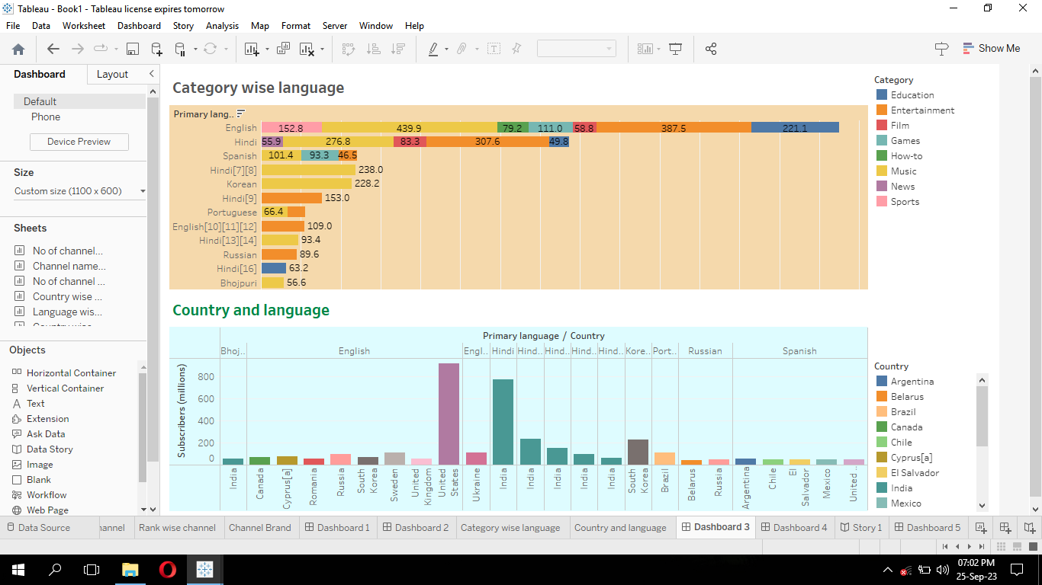

**Dashboard 4:**

* Add new dashboard. Drag the language wise subscribers sheet.
* Drag the country wise subscribers worksheet.

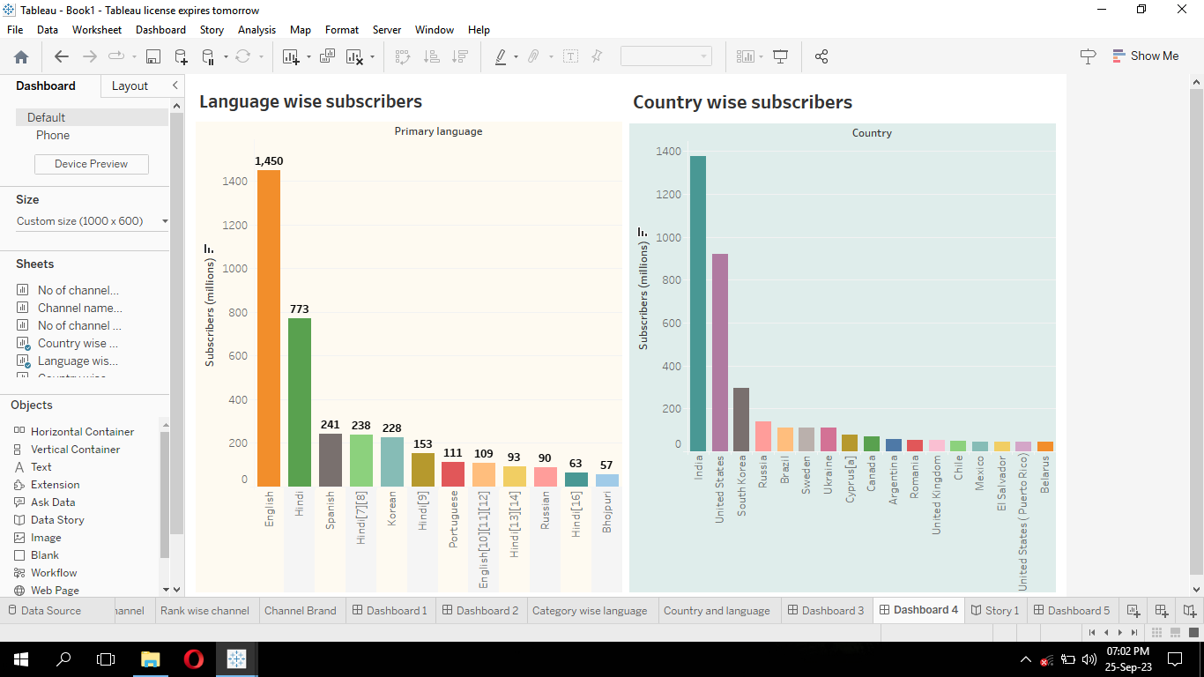

**Dashboard 5:**

* Add new dashboard.
* Drag the country wise channel worksheet to the dashboard.
* Highlight country by clicking options 🡪 highlight 🡪 country.

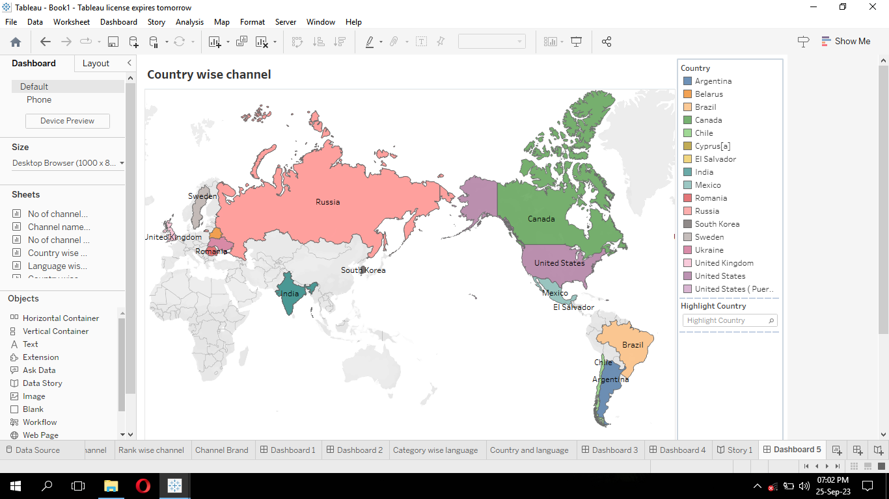

**MILESTONE:6**

**Story:**

* Add a story. In the right hand side we will see all the sheets and dashboards.
* Drag the dashboard1. In the top rectangular box type channel details.
* In the right hand side we see new story point. Click blank. The new one is created.
* Drag the dashboard2. In the top rectangle box type ‘list of channels with no of subscribers and language.
* Again click blank in the new story point.
* Drag the dashboard3. In the top box type ‘Category wise language and country wish language’.
* In new story point click blank. The new one is created.
* Drag the dashboard4. In the box type ‘language and country wise subscribers’.
* In new story point click blank. The new story point is created.
* Drag dashboard 5. Type into the box ‘country wise primary language, number of subscribers and total number of subscribers’.

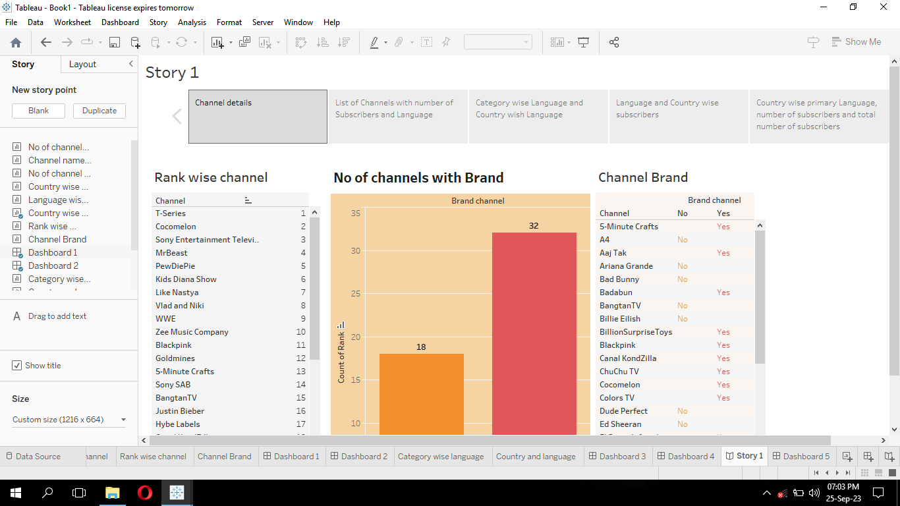

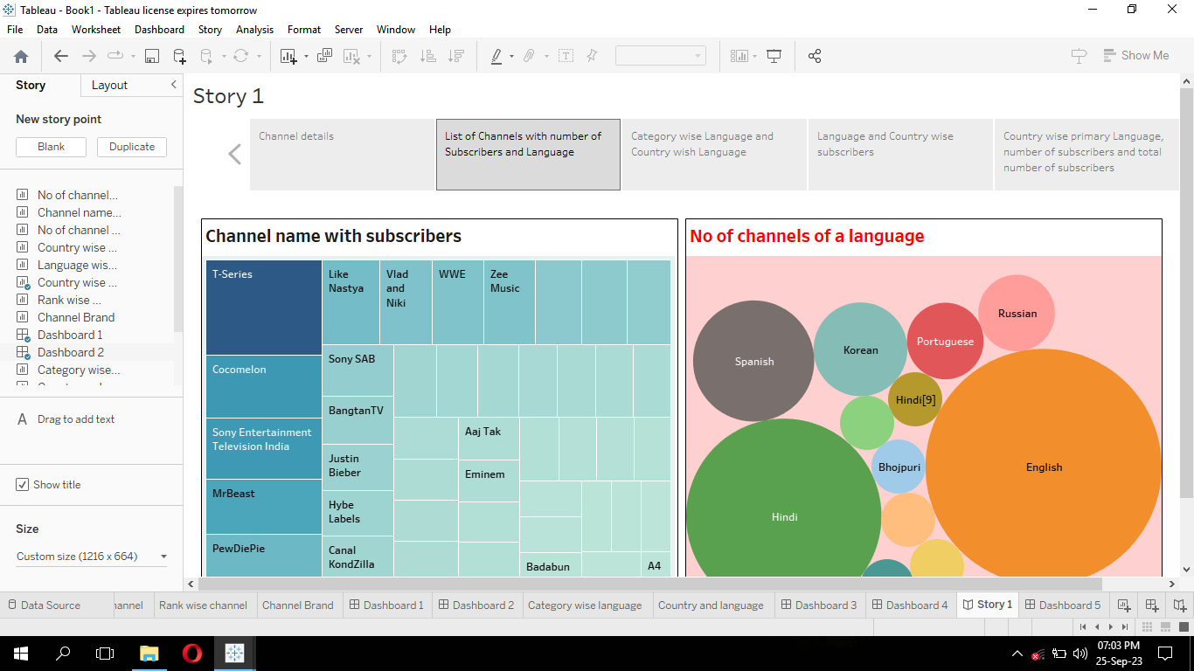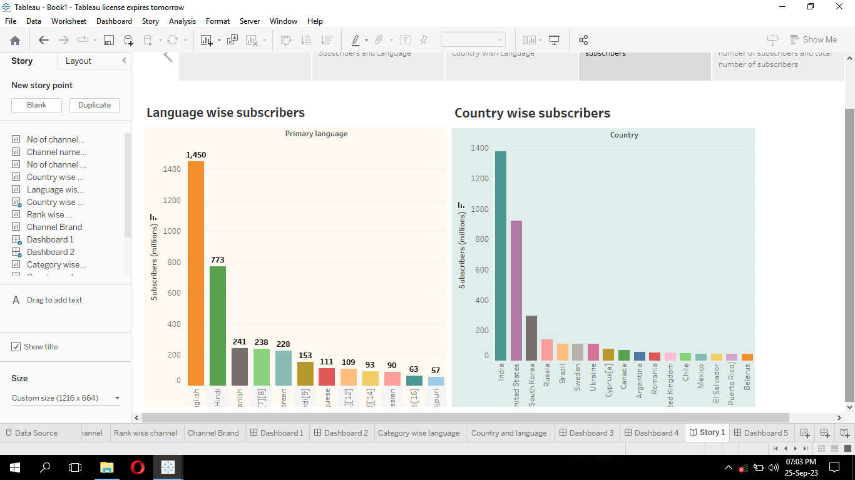

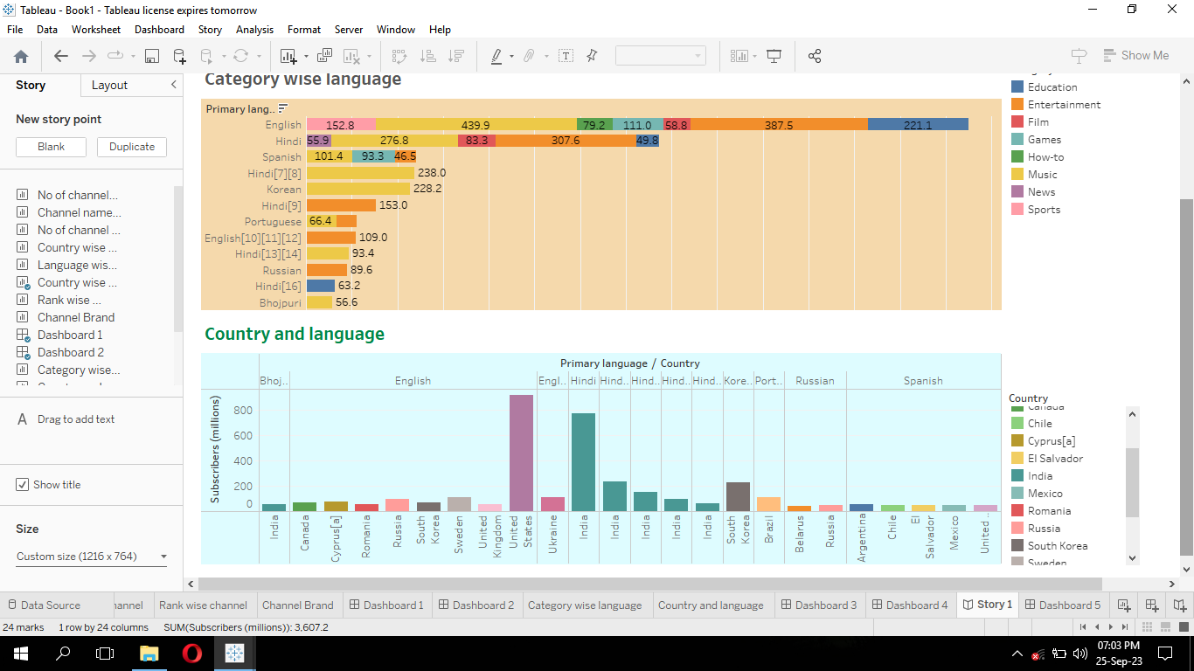

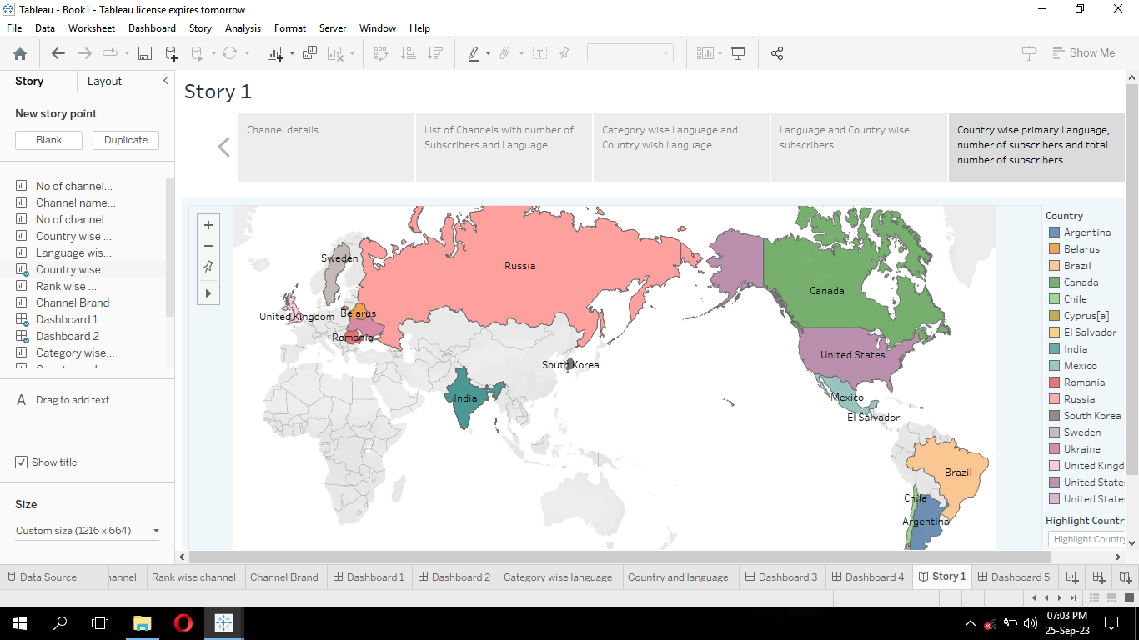

**MILESTONE:7**

**Uploading the dashboard & story:**

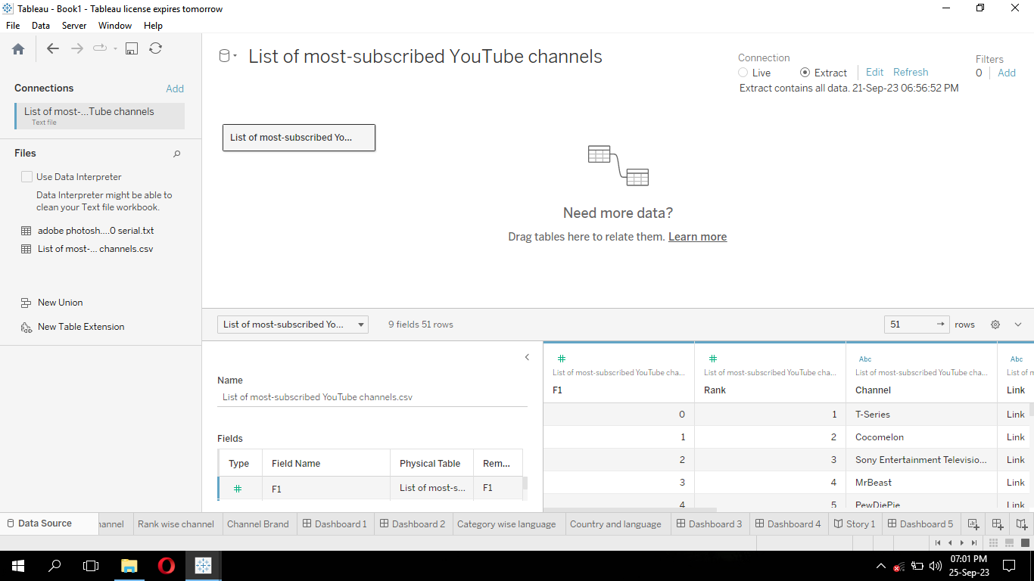

* Go to story, click on share button on the top.
* Give the server address of your tableau public account and click on connect.

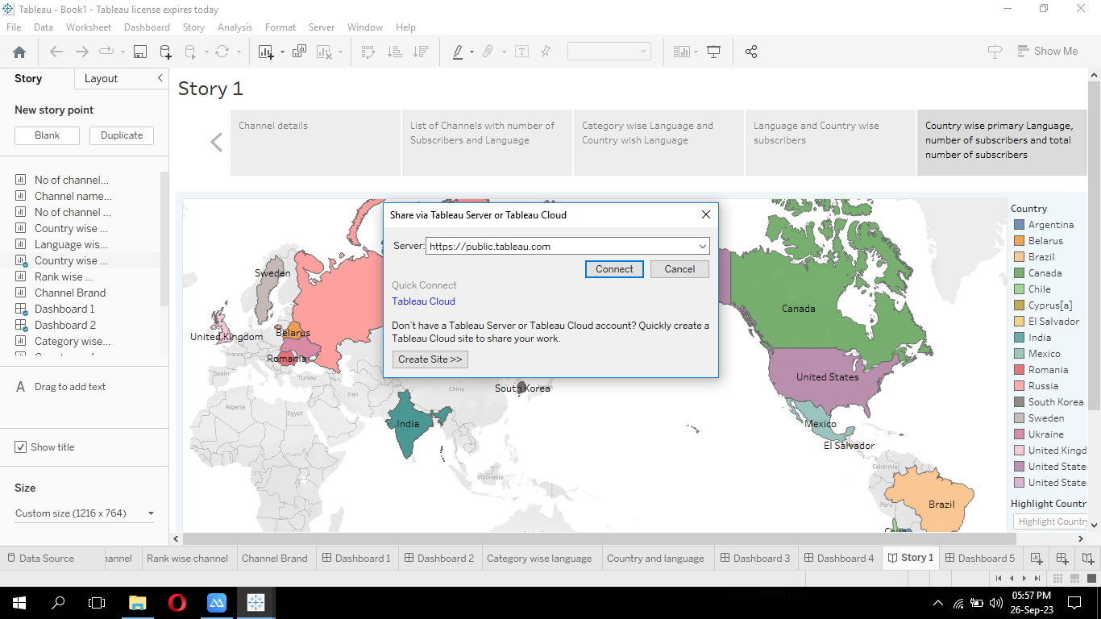

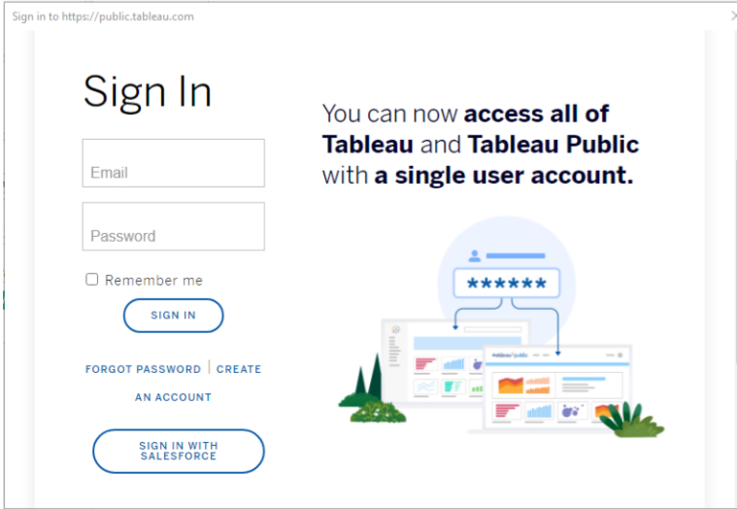

* Sign in to your tableau public account or create a new account if you don’t have one (or) create an account. You can visit the tableau public website (public.tableau.com) and click on the “sign in”.
* In the “Tableau public sign in” window, enter your tableau public account credentials and click “sign in”.
* Next, we will provide a title for the workbook. Fill in the appropriate details in the provided field of workbook title.

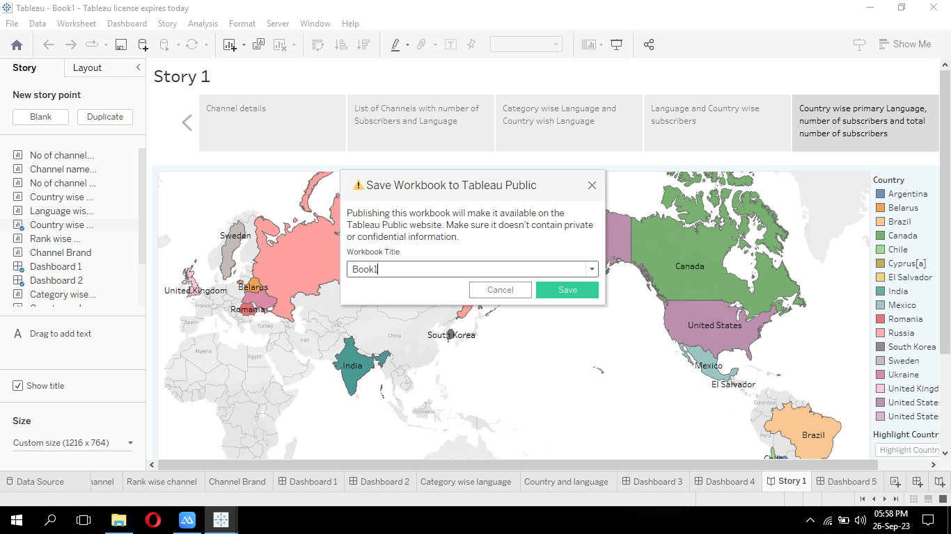

* Click “save” to start publishing process. Tableau desktop will upload workbook to tableau public.
* Once the upload is complete, a browser window will automatically open and displaying published workbook on tableau public.

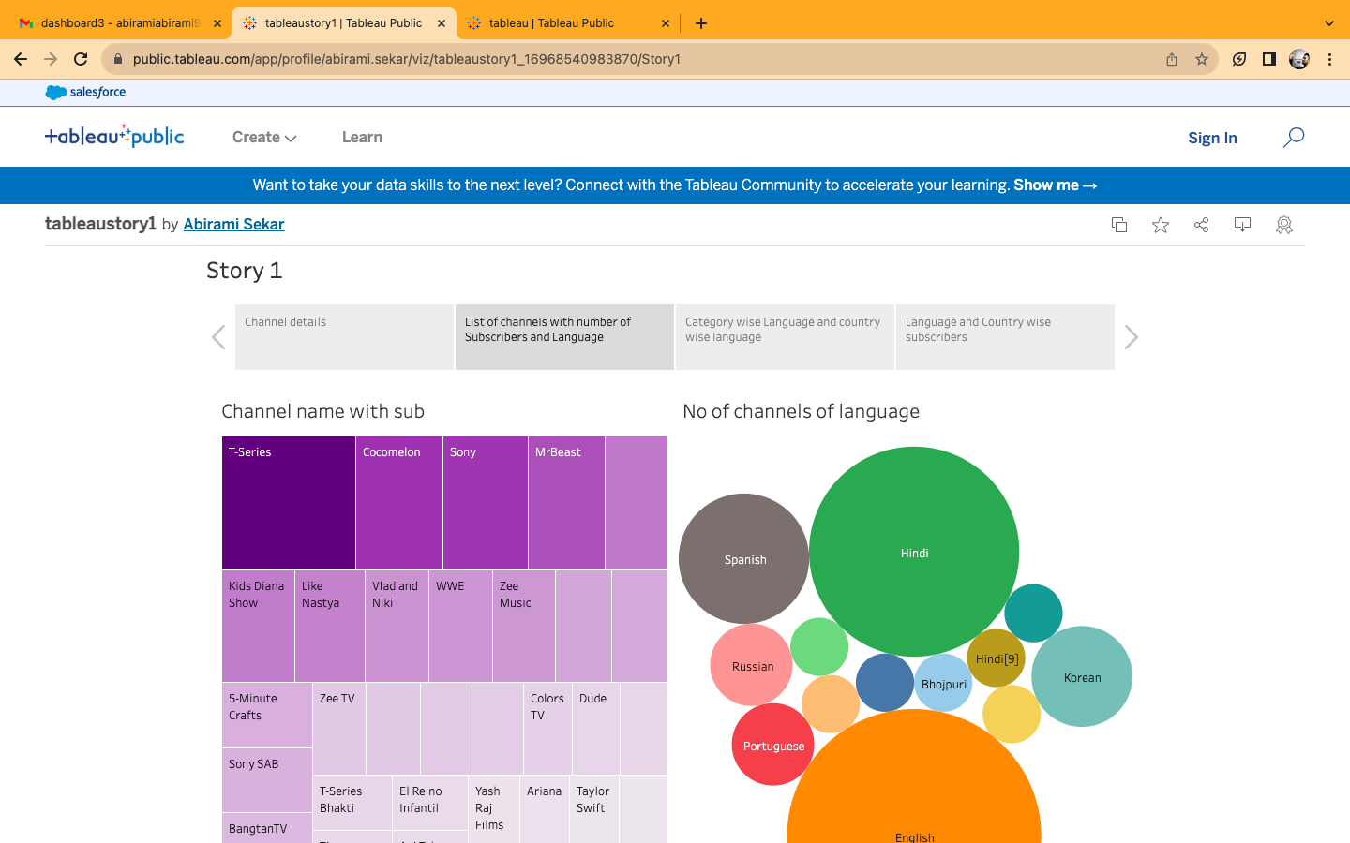

Similarly we can also publish dashboards to tableau public.

**MILESTONE:8**

**ADVANTAGES:**

* Inspiration for Aspiring Content Creators.
* Business and Marketing Insights.
* Cultural and Social Awareness.
* Predicting Emerging Trends.

**DISADVANTAGES:**

* Overshadowing Smaller Creators.
* Homogenization of Content.
* Emphasis on Quantity Over Quality.
* Potential for Misleading Metrics.

**CONCLUSION:**

Exploring the world's top YouTube channels provides valuable insights, it is crucial to approach this topic with sensitivity, ethics, and a comprehensive understanding of the broader content creation landscape. Balancing the advantages and disadvantages will enable a more comprehensive and responsible analysis of this dynamic and influential platform.

**FUTURE SCOPE:**

The future scope of exploring top YouTube channels and online content creation is expansive, with opportunities for research, innovation, and ethical considerations in a rapidly evolving digital landscape. Understanding the dynamic interplay between content creators, audiences, and the platforms they use will continue to be a vital and enriching field of exploration.

**MILESTONE:9**

**TABLEAU PUBLIC DASHBOARD URL:**

[https://public.tableau.com/app/profile/abirami.sekar/viz/tableau_16966540480910/Dashboard1?publish=yes](https://public.tableau.com/app/profile/abirami.sekar/viz/tableau_dashboard2_16966553939760/Dashboard2?publish=yes)

<https://public.tableau.com/app/profile/abirami.sekar/viz/tableau_dashboard2_16966553939760/Dashboard2?publish=yes>

<https://public.tableau.com/app/profile/abirami.sekar/viz/tableau_dashbaord3/Dashboard3?publish=yes#WelcomeQuestionnaire>

<https://public.tableau.com/app/profile/abirami.sekar/viz/tableau_dashboard4/Dashboard4>

**TABLEAU PUBLIC STORY URL:**

<https://public.tableau.com/app/profile/abirami.sekar/viz/tableaustory1_16968540983870/Story1>

TABLEAU PUBLIC PROFILE URL:

<https://public.tableau.com/app/profile/abirami.sekar/vizzes>

VIDEO DEMONSTRATION LINK:

<https://drive.google.com/file/d/13pUcX2-MLfW7ckiveTlf2pFOb0hZ5lzy/view?usp=drive_link>