INTRODUCTION:

Overview:

Indian agriculture is characterized by its diversity in crops, with staples like rice and wheat, pulses, oilseeds, sugarcane, and cotton being significant contributors to the sector. Despite challenges, the Indian government continues to focus on improving agricultural practices and supporting the livelihoods of millions of farmers.

PURPOSE:

1. **Food Security**

2.Economic contribution

3.Export and Trade

4.Rural development

MILESTONE 1:

PROBLEM DEFINITION AND DESIGN THINKING:

EMPATHY MAP:

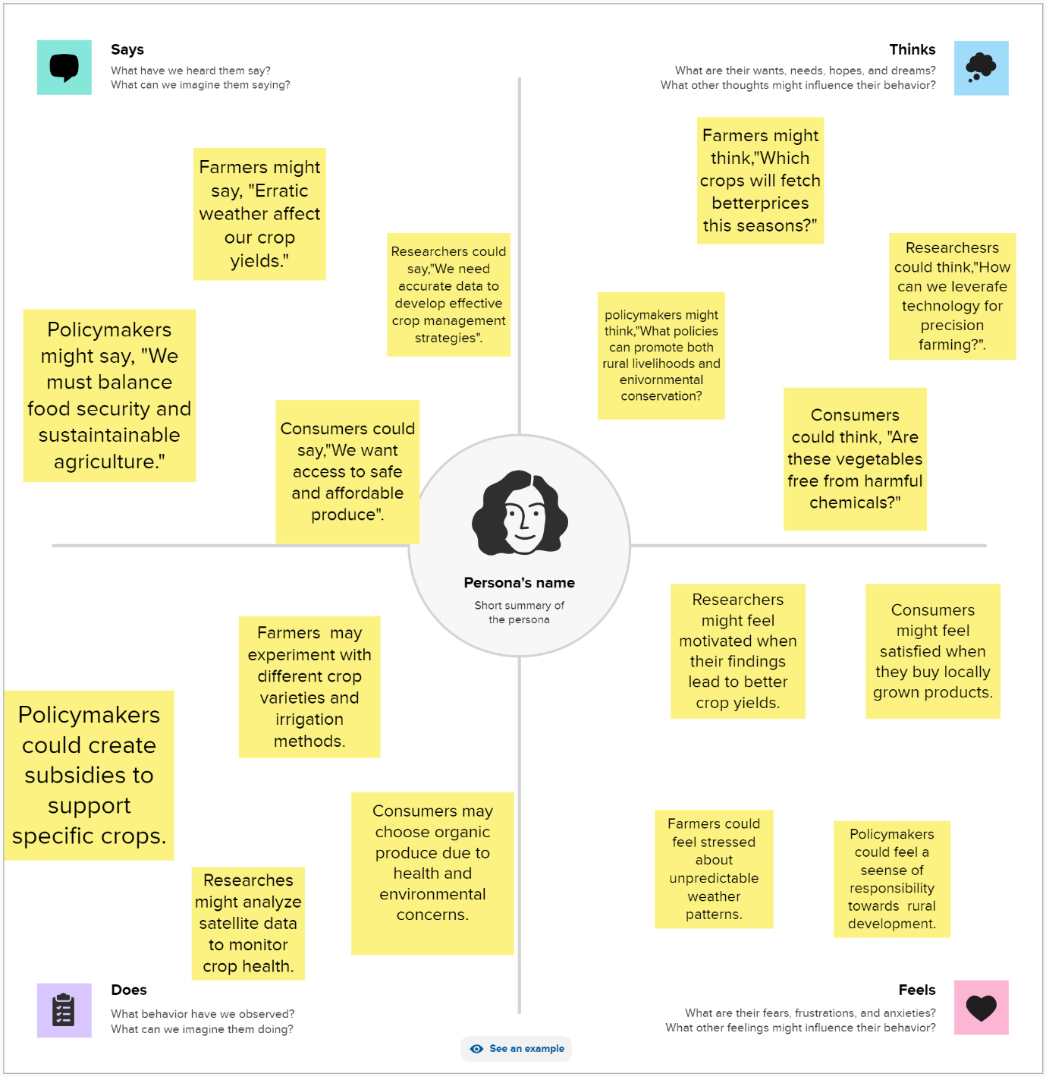

[**https://github.com/alau0121bma0428/indian-agricultural-NM8103F7A6F81AD08B3BE48FDA3AD232CC/blob/main/Empathy%20team%206.pdf**](https://github.com/alau0121bma0428/indian-agricultural-NM8103F7A6F81AD08B3BE48FDA3AD232CC/blob/main/Empathy%20team%206.pdf)

BRAINSTORMING:

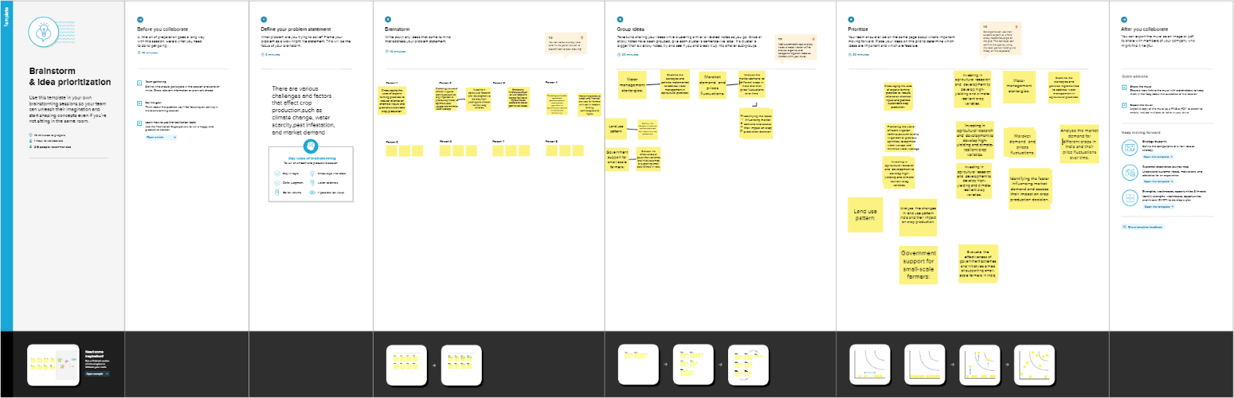

<https://github.com/aluau0121bma0428/Indian-agricultural-NM8103F7A6F81AD08B3BE48FDA3AD232CC/blob/main/Brainstorming%20team6.pdf>

**RESULT:**

It's important to note that crop production can vary from year to year due to factors like monsoon patterns, droughts, and other environmental conditions. Government policies, subsidies, and market demand also influence crop production in India.

**MILESTONE:2**

**DATA COLLECTION AND PREPARISION:**

**ACTIVITY 1:**

**COLLECT THE DATASET:**

<https://www.kaggle.com/datasets/pyatakov/india-agriculture-crop-production>

**ACTIVITY 1.1: Understand the data**

Data consists of 345409 rows and 10 columns that correspond to different values.

**COLUMN DESCRIPTION OF THE DATASET:**

States: The name of the Indian state

District: The name of the districts of Indian states.

crop: Name of different crops grown in India

Year: Date

Season: India has 5 seasons for crop cultivation: kharif, rabi, autumn, winter and summer.

Area: Area for crop cultivation in acres.

Production: Production of crops in tones.

Yield: Yield by the crops under cultivation.

**Activity 3: Connect Dataset with Tableau**

**Reference video link:**

[https://drive.google.com/file/d/1lFkX-rmppN Z9-R5fTj5RoEpUqF4 eJI/view?usp=sharing](https://drive.google.com/file/d/1lFkX-rmppN%20Z9-R5fTj5RoEpUqF4)

**Milestone 3: Data Preparation**

**Activity 1: Prepare the Data for Visualization**

Preparing the data for visualization involves cleaning the data to remove

irrelevant or missing data, transforming the data into a format that can be easily

visualized, exploring the data to identify patterns and trends, filtering the data

to focus on specific subsets of data, preparing the data for visualization

software, and ensuring the data is accurate and complete. This process helps to

make the data easily understandable and ready for creating visualizations to

gain insights into the performance and efficiency.

<https://drive.google.com/drive/folders/1pGP1zAVkHZFPWK4iy8IYOSf2HIOM2h>

[XS?usp=sharing](https://drive.google.com/drive/folders/1pGP1zAVkHZFPWK4iy8IYOSf2HIOM2h)

**Milestone 4: Data Visualization**

Data visualization is the process of creating graphical representations of data

to help people understand and explore the information. The goal of data

visualization is to make complex data sets more accessible, intuitive, and easier

to interpret. By using visual elements such as charts, graphs, and maps, data

visualizations can help people quickly identify patterns, trends, and outliers in

the data.

**Activity 1: No of Unique Visualizations**

The number of unique visualizations that can be created with a given dataset.

Some common types of visualizations that can be used to analyse the

performance and efficiency of banks include bar charts, line charts, heat maps,

scatter plots, pie charts, Maps etc.

**Activity 1.1: State wise Agricultural Land**

Add the dataset in country wise share and connect the set. you to see latitude and longitude are in generated.

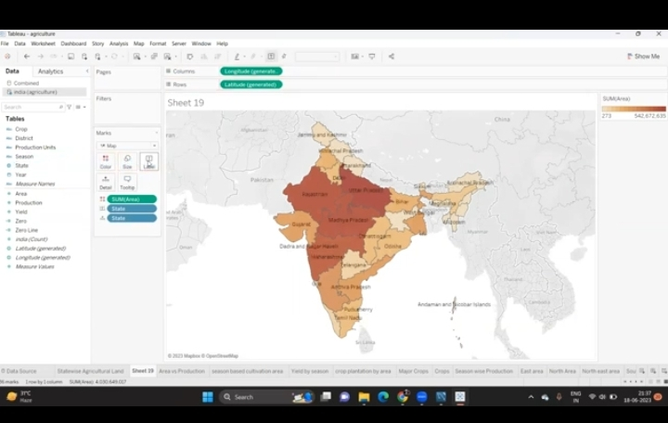

Drag in the latitude in rows and longitude in columns.

You can take any other map in filters.

Now country in color difference between these two.

Filter it click on India click ok and apply they will be show.

We get a single value drop down drag in Lable.

Then model can be label &sales share as dimension.

Go to format make it as percentage.

Next is our creativity.

Finally save your workbook.

**Reference Video Link:**

<https://drive.google.com/file/d/1_wIicW-o9q1QzZhy22sq4xB4->

[Av2gXzl/view?usp=sharing](https://drive.google.com/file/d/1_wIicW-o9q1QzZhy22sq4xB4-)

**Activity 1.2 Area Vs Production**

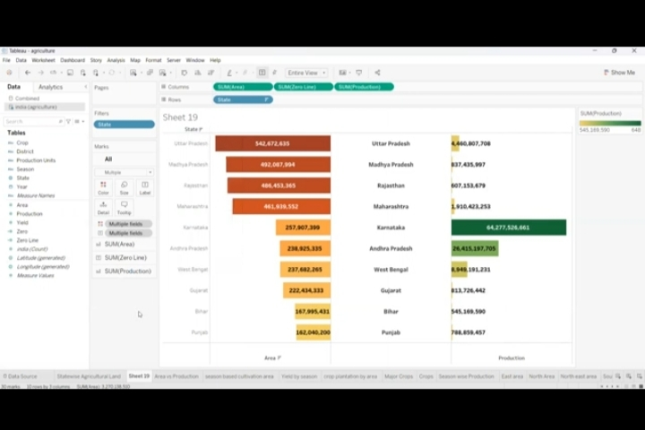

**Reference video Link :**

**<https://drive.google.com/file/d/10KqvbE9GjHlO_MG6pJFu2yVcT8NO4e6>**

**[2/view?usp=sharing](https://drive.google.com/file/d/10KqvbE9GjHlO_MG6pJFu2yVcT8NO4e6)**

Activity 1.3: Season based cultivation

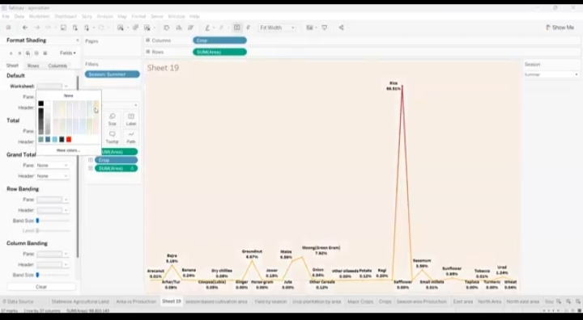

Reference video Link:

<https://drive.google.com/file/d/10KqvbE9GjHlO_MG6pJFu2yVcT8NO4e6>

[2/view?usp=sharing](https://drive.google.com/file/d/10KqvbE9GjHlO_MG6pJFu2yVcT8NO4e6)

**Activity 1.4: Yield by Season**

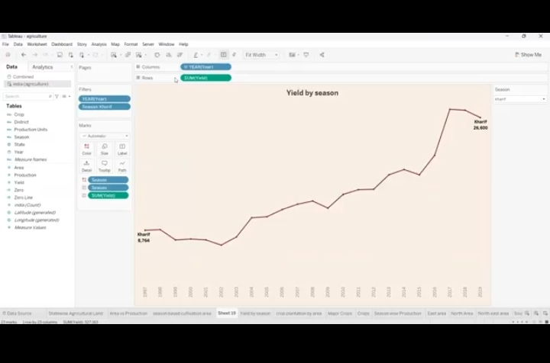

* **Drag the revenue in rows and year in columns and right click the format option change the grid lines in very small.**
* **Make ever think none.**
* **Then year wise annual share is making .**
* **Now click control and press year I drag it in same columns .**
* **First one is making a line it and change in chart, 2nd one is change in circle.**
* **Then change in usual chart.**
* **Decrease the size as both.**
* **Year in colour and change the different types of colour.**
* **Again right click the dual axis the annual revenue show on it .**
* **Finally save our workbook.**

Reference video Link:

<https://drive.google.com/file/d/10KqvbE9GjHlO_MG6pJFu2yVcT8NO4e62/view?usp=sharing>

**Activity 1.5: crop plantation by area**

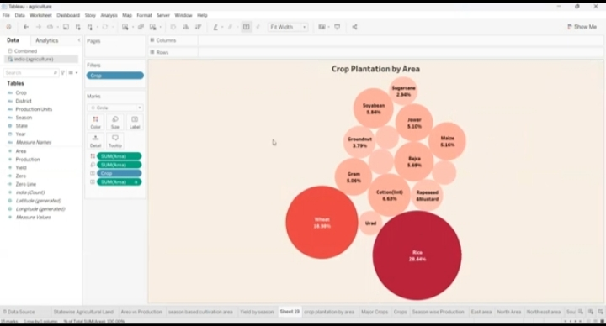

* **Click &drag the models on X-axis and sales price in Y-axis.**
* **We can go for bubble chat ,means of bubble chat is according to the size of the share it will increase or decrease the shape of the share instant of circle we can go for shape &choose circle.**
* **Model wise also select any other colour & click ok.**
* **Then drag the sales share in label.**
* **Instant of sum of sales share go for dimension .**
* **Now go an format option go to axis then custom 1& you can change the number of decimals to percentage.**
* **Finally save the changes in the workbook click save as & save.**

**Reference Video Link:**

[**https://drive.google.com/file/d/1l_Zl-_BqrTr9VkP4SHToaMoVSAZ-eBXw/view?usp=sharing**](https://drive.google.com/file/d/1l_Zl-_BqrTr9VkP4SHToaMoVSAZ-eBXw/view?usp=sharing)

**Activity 1.6: Major crops growth**

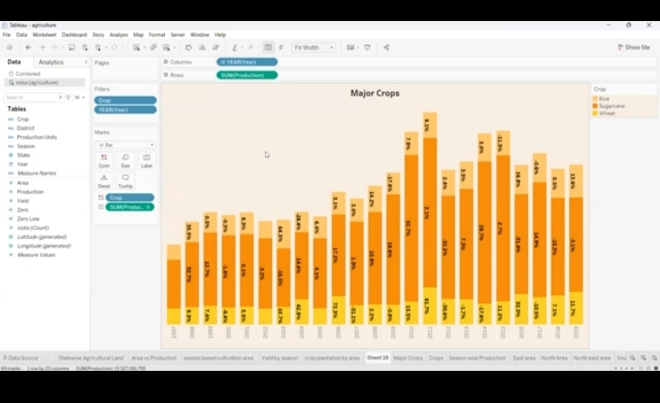

* **Drag model in columns then sales share in rows .**
* **What we can do this filter in country wise select India and click ok.**
* **Right click the format option go to gridlines none .**
* **Remove this first price column and click on entire view, show filter then increase &decrease the size on the graph.**
* **Drag the models in colour .now create a line bar chat range it assending wise and do is control drag it two type of bar chart appear.**
* **Click on any one price and see the brand, model, size ,version.**
* **We can already on bar and change the line chart &see this now complain right click to marge the chart .**
* **Go to Labels and show the price on each country wise selling.**
* **Next step is our creativity .**
* **Finally save the workbook.**

**Reference video Link:**

[**https://drive.google.com/file/d/1xF7NT_6MQ7isCmpjj6_bPqo2yLSI6a8o/view?usp=sharing**](https://drive.google.com/file/d/1xF7NT_6MQ7isCmpjj6_bPqo2yLSI6a8o/view?usp=sharing)

**Activity 1.7: Crops**

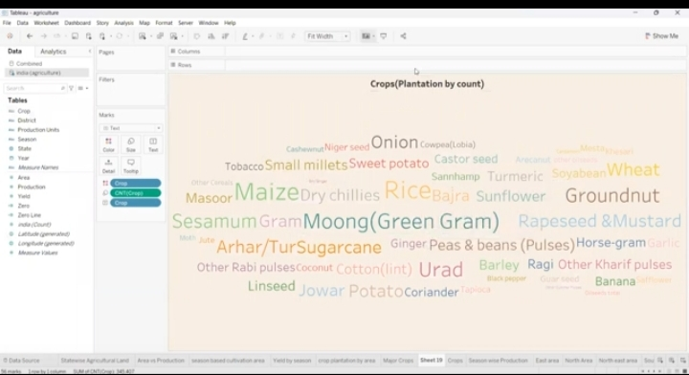

**Reference video Link:**

[**https://drive.google.com/file/d/10FeRXh0m68fE3kYRQP2OL7tlTgeuCLCG/view?usp=drive**](https://drive.google.com/file/d/10FeRXh0m68fE3kYRQP2OL7tlTgeuCLCG/view?usp=drive) **link**

**Activity 1.8: Season wise production**

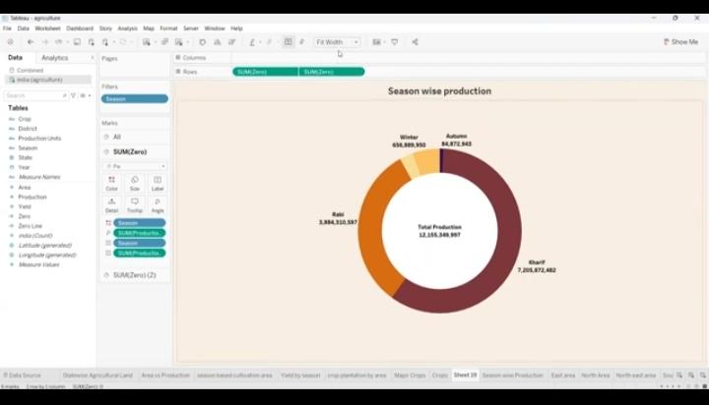

* **Creat one calculated field annual share.**
* **Click & drag the brand in colour, annual share in sum click entire view.**
* **Now I want brand in colour and annual share in label .**
* **Percentage will see in the graph.**
* **Q1 ,Q2, Q3,Q4 go to format in percentage label.**
* **Rows in sum 0 press control and drag it same in share . two bie chart will creat.**
* **Change the colour something do this in label.**
* **Next is our creativity .**
* **Finally save our workbook.**

**Reference video Link:**

<https://drive.google.com/file/d/1pf8mxXV3llCjT2-pUD5PMBhHW_zkMdXl/view?usp=sharing>

**Milestone 5:**

**Dashboard**

**A dashboard is a graphical user interface (GU1) that display information and data in an organized , easy-to-read format . dashboards are often used to provide real-time monitoring and analysis of data, and are typically designed for a specific purpose or use case. Dashboard can be used in a variety of settings, such as business, finance, manufacturing, healthcare, and many other industries. they can be used to track key performing indicators (KPIs), monitor performance metrics, and display data in the form of charts, graphs, and tables .**

**Activity 1:**

**Dashboard 1:**

**Drag all the graphs in the dashboard first two sheets.**

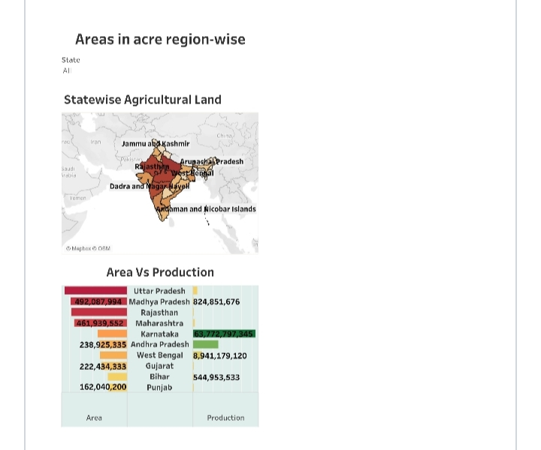

[**https://github.com/aluau0121bma0428/Indian-agricultural--NM8103F7A6F81AD08B3BE48FDA3AD232CC/blob/main/Dashboard%203.PDF**](https://github.com/aluau0121bma0428/Indian-agricultural--NM8103F7A6F81AD08B3BE48FDA3AD232CC/blob/main/Dashboard%203.PDF)

**Dashboard 2**

**Drag the remaining sheets.**

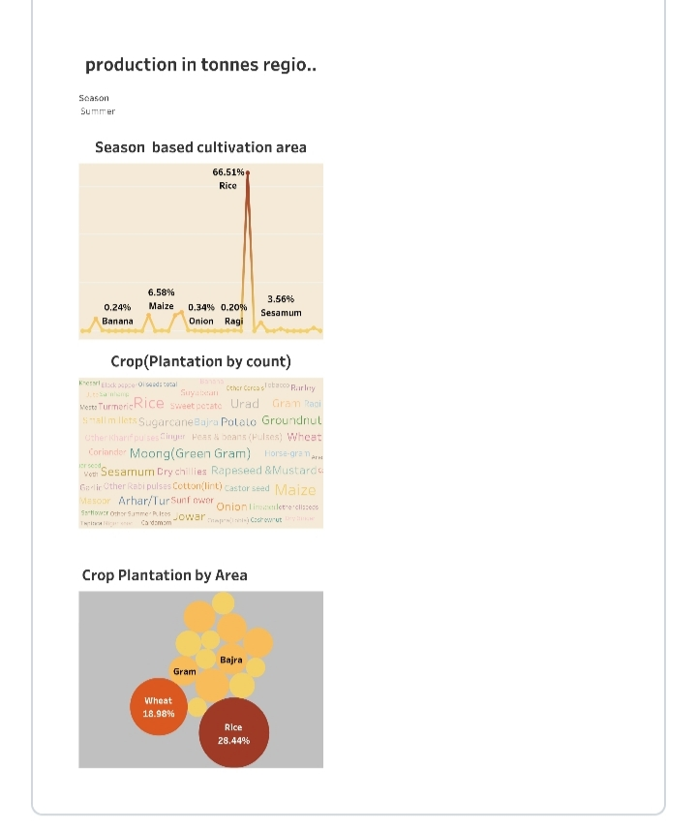

**<https://github.com/aluau0121bma0428/Indian-agricultural--NM8103F7A6F81AD08B3BE48FDA3AD232CC/blob/main/production%20in%20tonnes%20region%20wise%20(1).PDF>**

**Activity 1.3:**

**Dashboard 3**

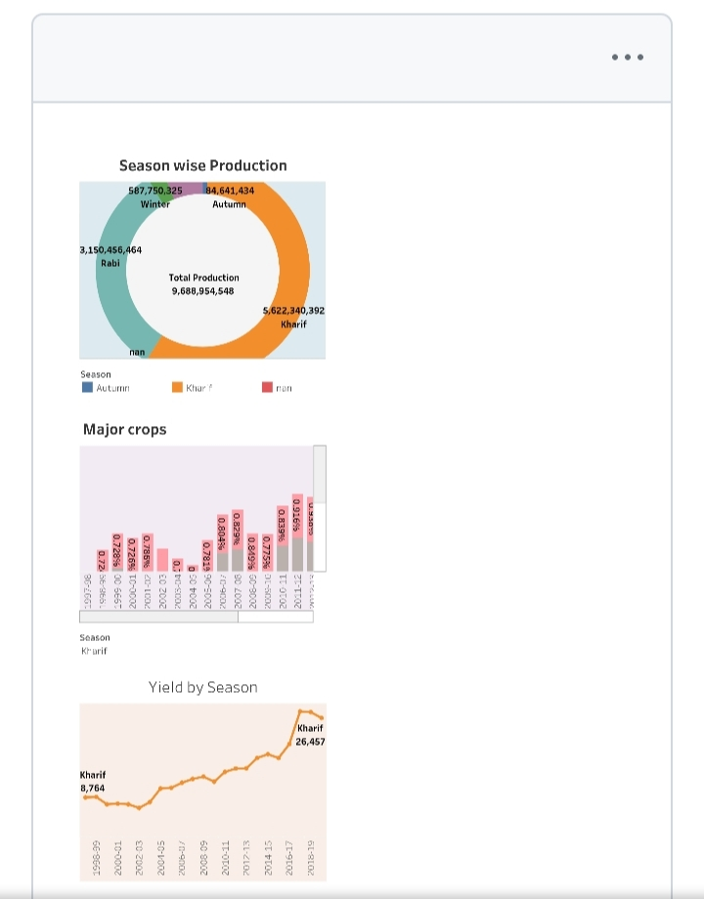

**Reference video Link:**

**<https://github.com/aluau0121bma0428/Indian-agricultural--NM8103F7A6F81AD08B3BE48FDA3AD232CC/blob/main/production.PDF>**

**Milestone 6:**

**Story**

**A data story is a way of presenting data and analysis in a narrative format,**

**intending to make the information more engaging and easier to understand. A**

**data story typically includes a clear introduction that sets the stage and**

**explains the context for the data, a body that presents the data and analysis**

**logically and systematically, and a conclusion that summarizes the key findings**

**and highlights their implications. Data stories can be told using a variety of**

**mediums, such as reports, presentations, interactive visualizations, and videos.**

**Activity 1:**

**Number of scenes in a story**

**The number of scenes in a storyboard for a data visualization analysis of the**

**performance of banks will depend on the complexity of the analysis and the**

**specific insights that are trying to be conveyed. A storyboard is a visual**

**representation of the data analysis process and it breaks down the analysis**

**into a series of steps or scenes.**

**Activity 1.1: Story 1**

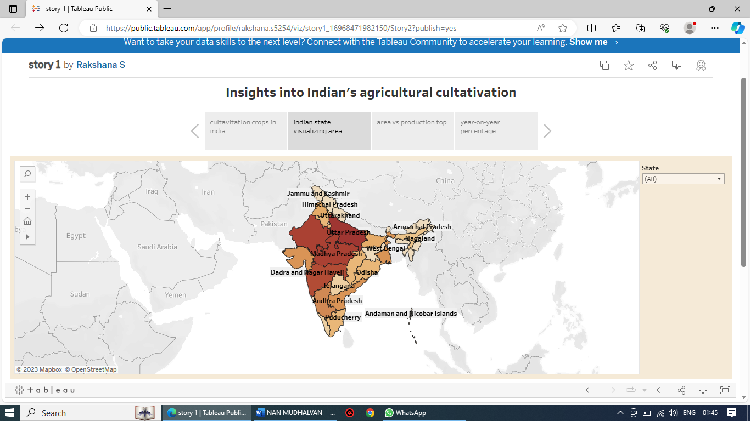

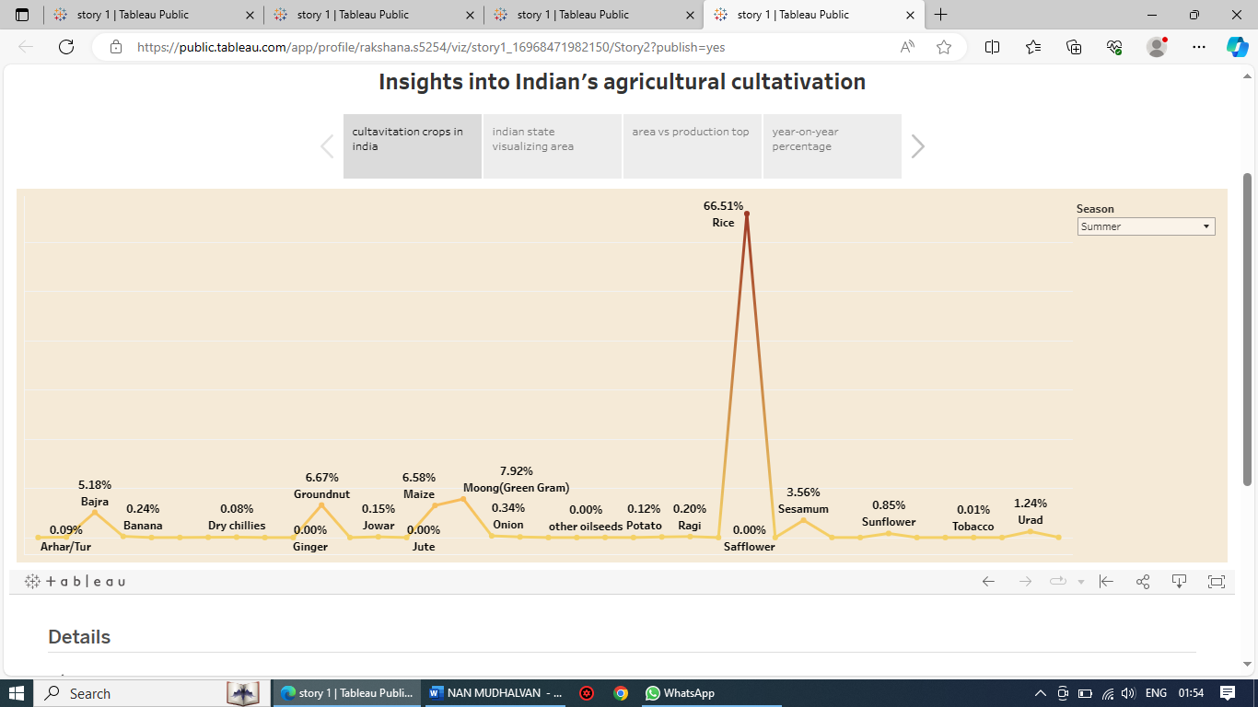

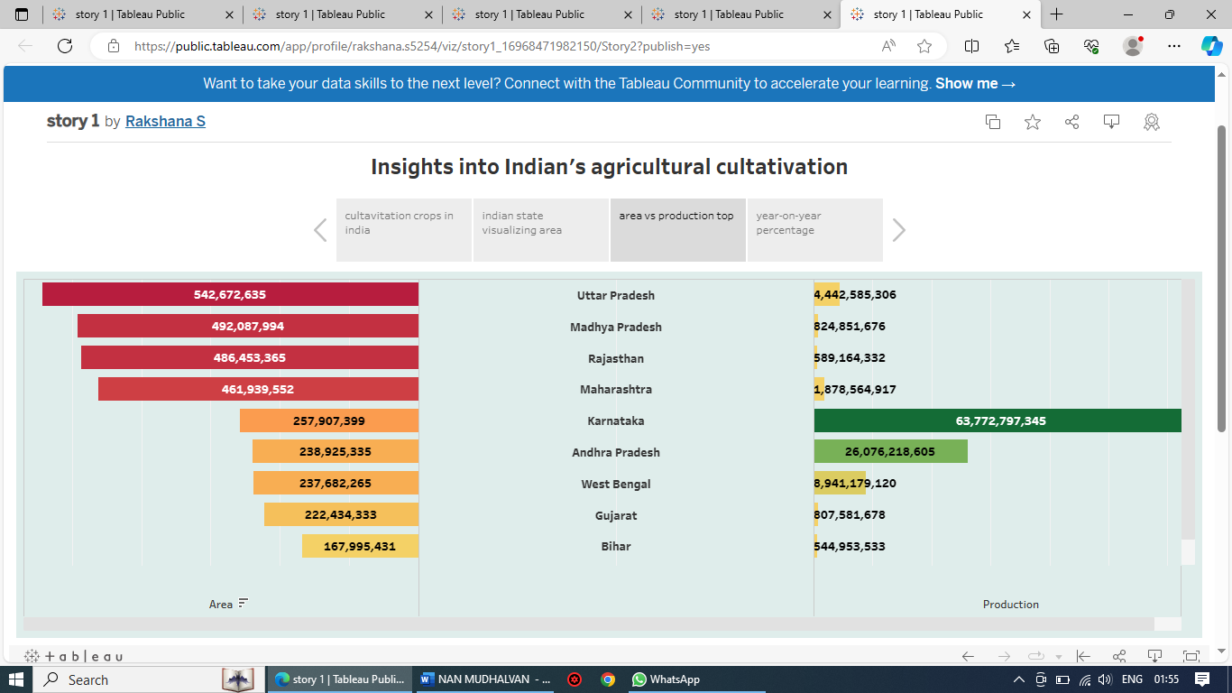

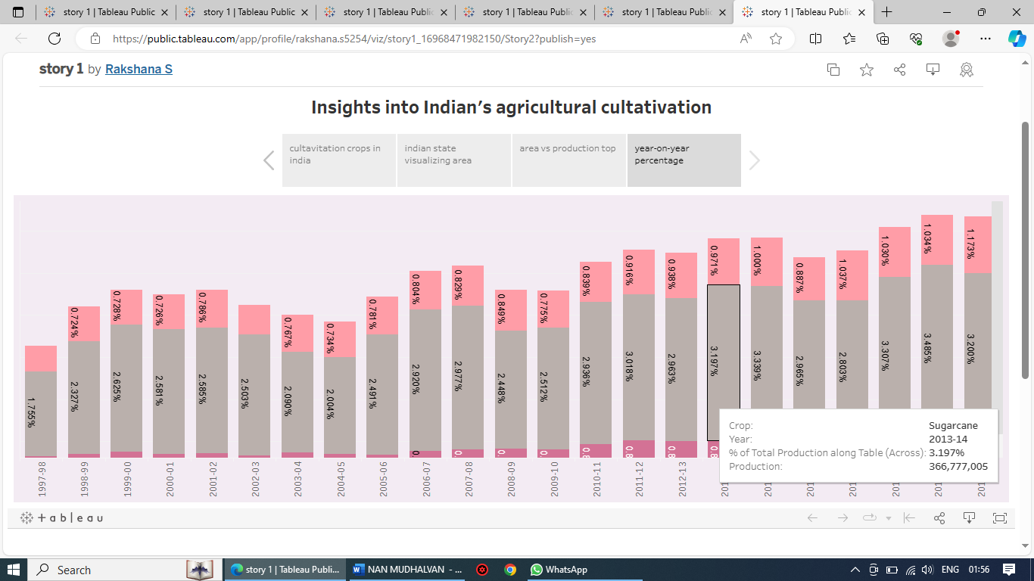

**Reference video Link:**

<https://github.com/aluau0121bma0428/Indian-agricultural--NM8103F7A6F81AD08B3BE48FDA3AD232CC/blob/main/Story%202.PDF>

**Activity 1.2: Story 2**

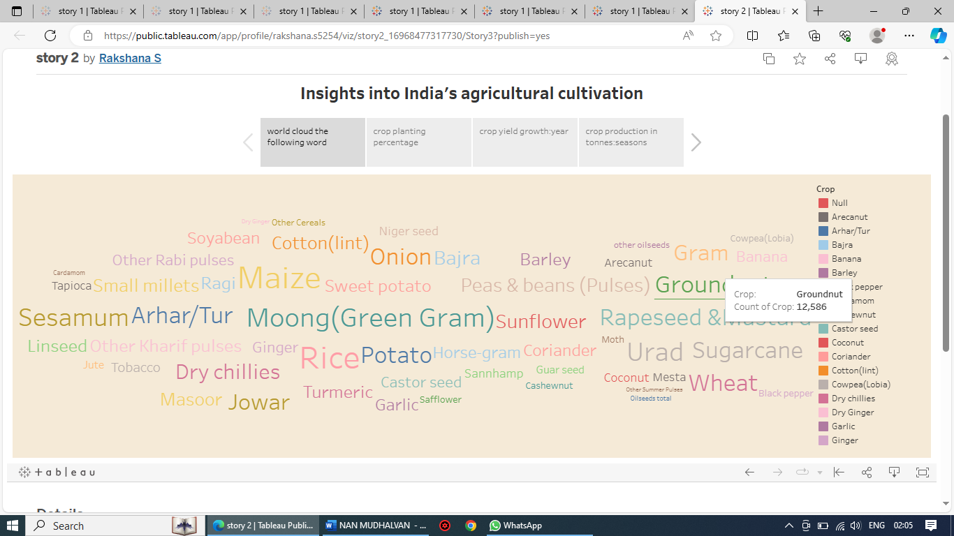

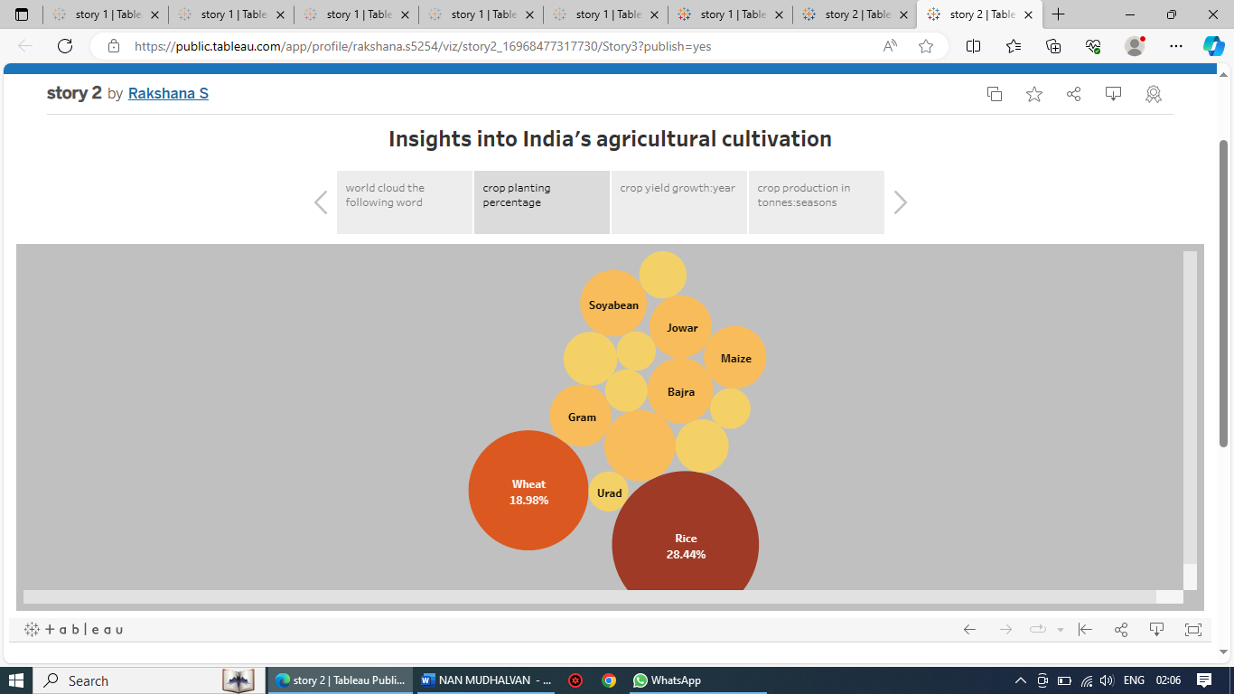

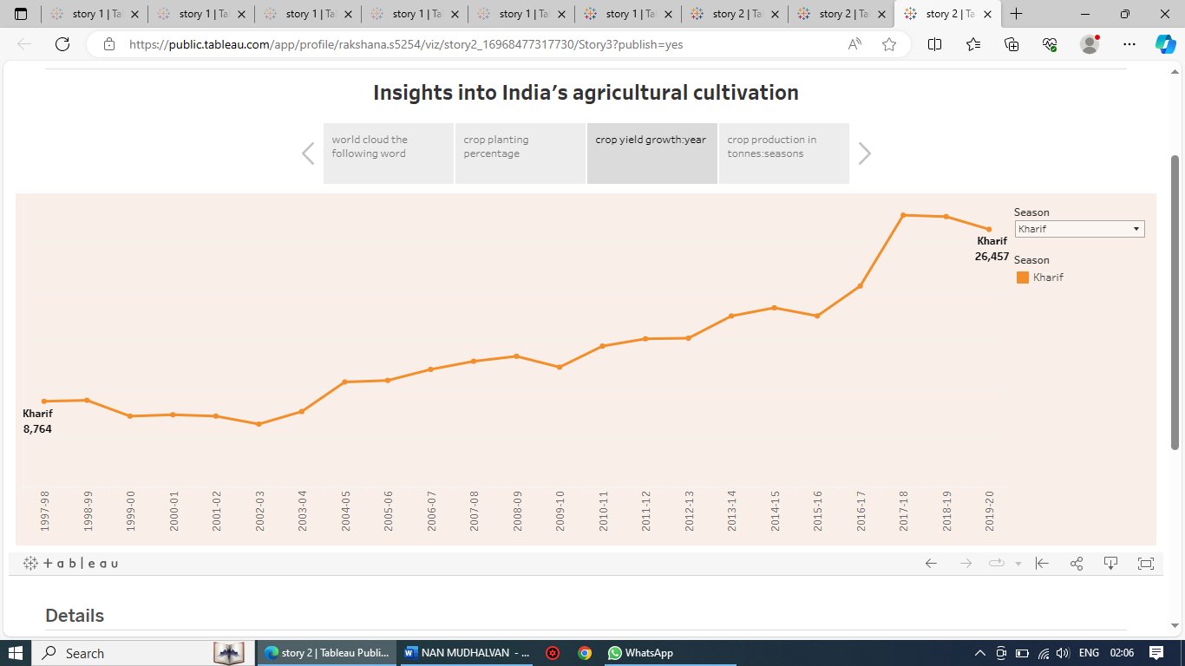

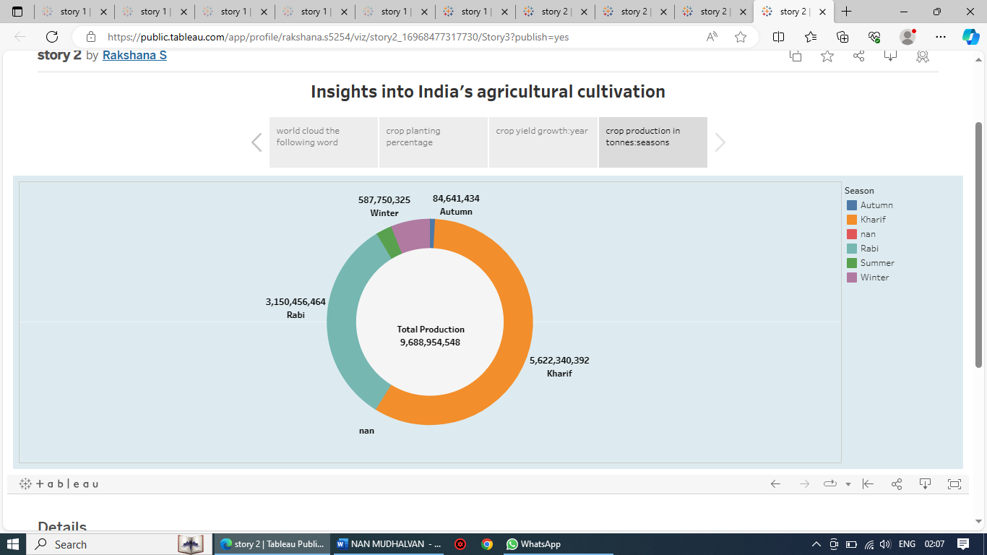

**Reference video Link:**

[**https://github.com/aluau0121bma0428/Indian-agricultural--NM8103F7A6F81AD08B3BE48FDA3AD232CC/blob/main/Story%203.PDF**](https://github.com/aluau0121bma0428/Indian-agricultural--NM8103F7A6F81AD08B3BE48FDA3AD232CC/blob/main/Story%203.PDF)

**Milestone 7:**

**Performance Testing**

**Activity 1:**

**1: Amount of Data Rendered to Tableau**

**● The amount of data that is rendered to a Tableau depends on the size of**

**the dataset**

**Activity 2: Utilization of Filters**

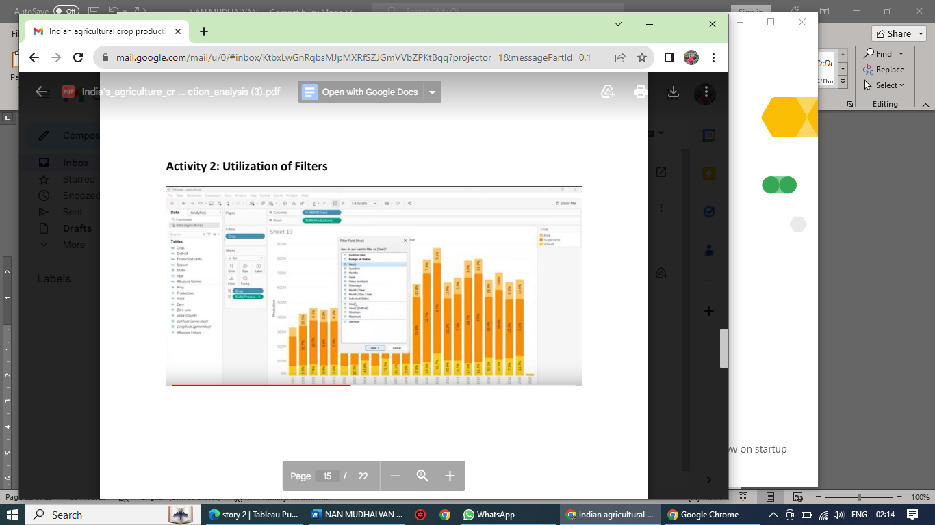

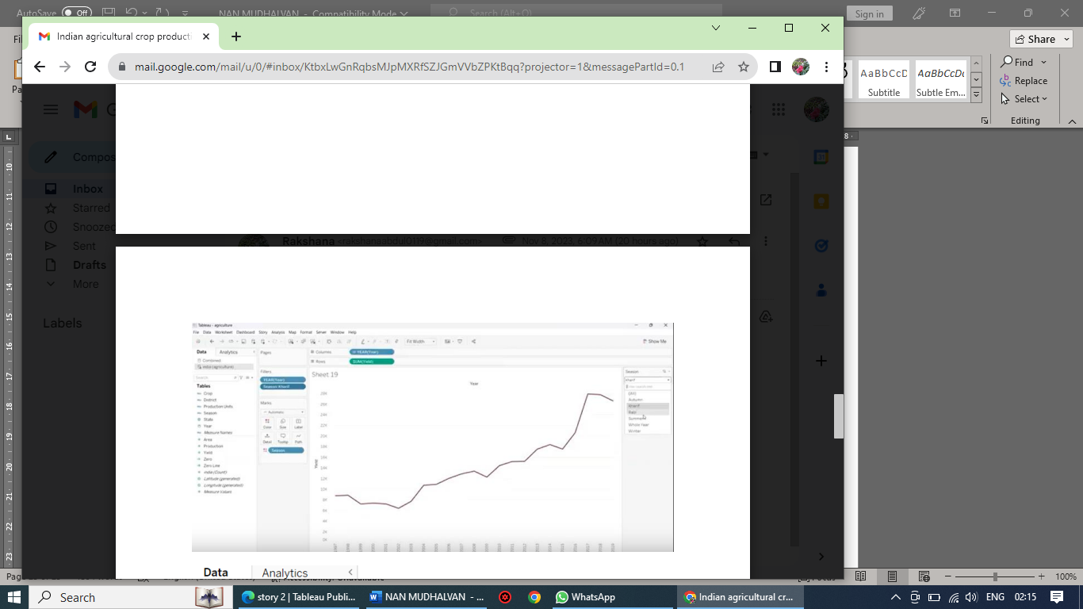

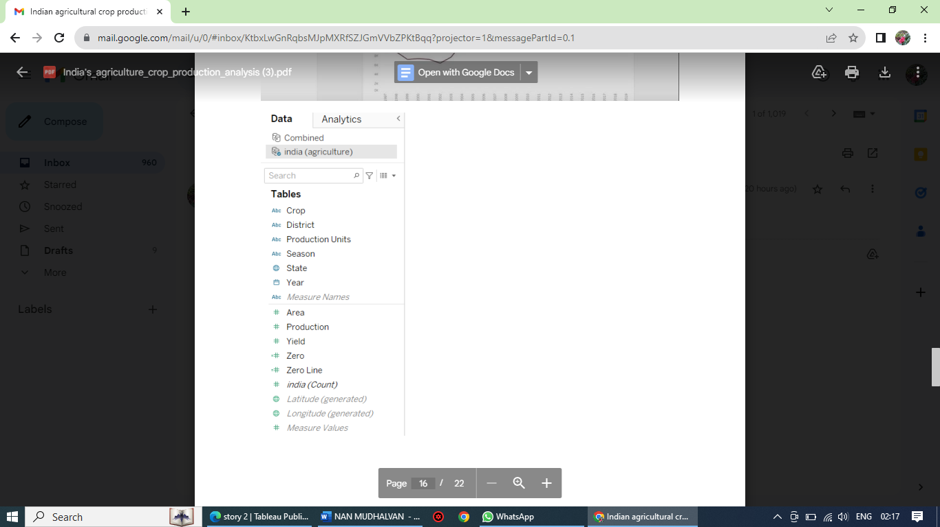

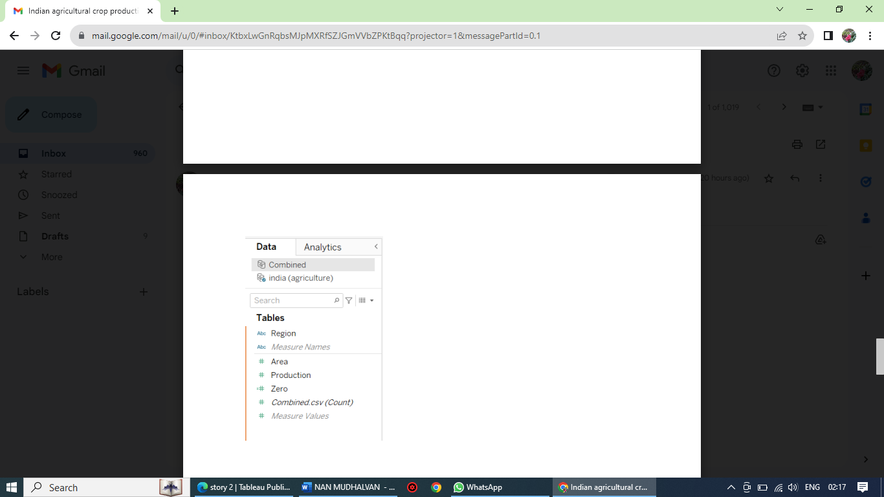

**Activity 3: Number of visualizations**

**1. State Wise Agricultural Land**

**2. Area vs Production**

**3. Season based cultivation by area**

**4. Yield by season**

**5. Crop plantation by area**

**6. Major crops growth Yoy**

**7. Crops Plantation By count**

**8. Season wise production**

**Milestone 8: publishing**

Publishing helps us to track and monitor key performance metrics and to communicate results and progress. help a publisher stay informed, make better decisions, and communicate their performance to others.

**Publishing dashboard and reports to tableau public**

Step 1 Go to data Source and Select Extract so that .hyper extension files are created and save it at your desktop. (please wait for pop up of file to save)

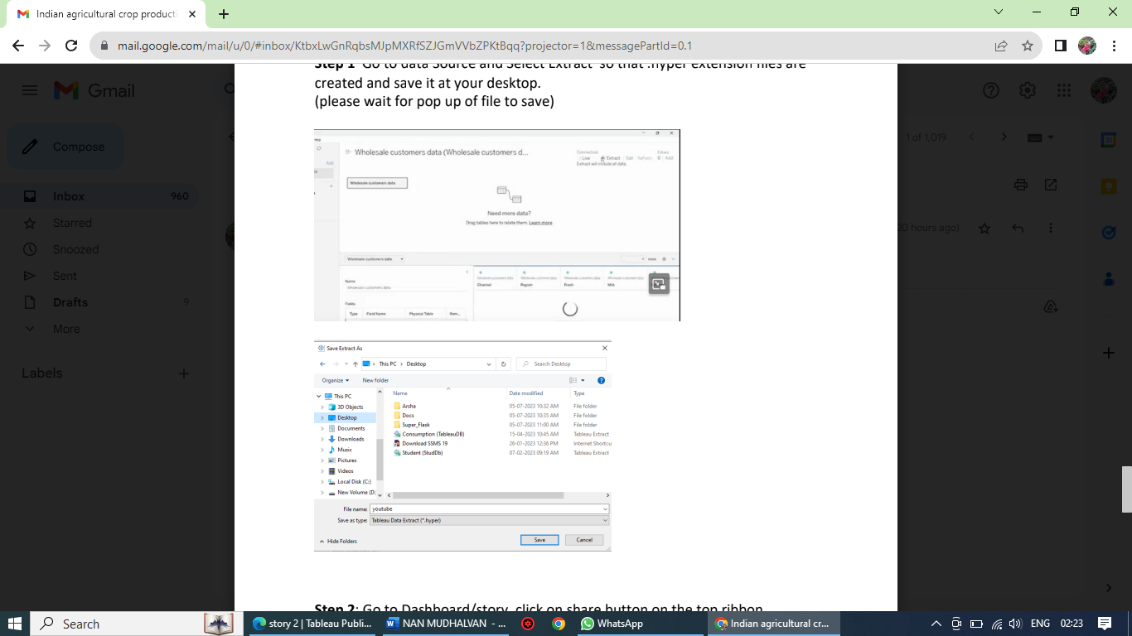

**Step 2: Go to Dashboard/story, click on share button on the top ribbon**

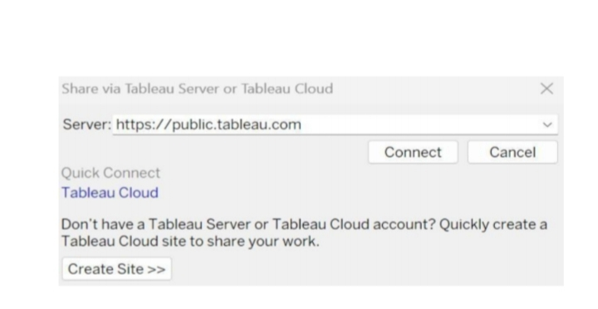

**Give the server address of your tableau public account and click on connect.**

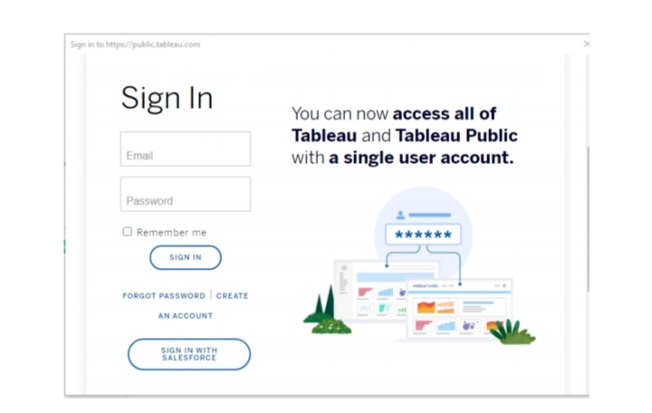

Sign in to your Tableau Public account or create a new account if you don't have one. You can visit the Tableau Public website (public.tableau.com) and click on the "Sign In" or "Join" button.

In the "Tableau Public Sign In" window, enter your Tableau Public account credentials and click "Sign In."

Next, you'll need to provide a title and description for your workbook. Fill in the appropriate details in the provided field of workbook Title

Click on the "Save" button to start the publishing process. Tableau Desktop will upload your workbook to Tableau Public.

Once the upload is complete, a browser window will automatically open, displaying your published workbook on Tableau Public. Review the workbook to ensure that everything appears as expected.

So in Similar way we can also publish Story to tableau public.

**Milestone :9**

**Tableau public dashboard url:**

**<https://public.tableau.com/app/profile/rakshana.s5254/viz/dashboard1_16968452301650/productionintonnesregionwise?publish=yes>**

[**https://public.tableau.com/app/profile/rakshana.s5254/viz/dashboard2_16968468935020/production?publish=yes**](https://public.tableau.com/app/profile/rakshana.s5254/viz/dashboard2_16968468935020/production?publish=yes)

**<https://public.tableau.com/app/profile/rakshana.s5254/viz/dashboard3_16968459023710/Dashboard3?publish=yes>**

**Tableau public story url:**

[**https://public.tableau.com/app/profile/rakshana.s5254/viz/story1_16968471982150/Story2?publish=yes**](https://public.tableau.com/app/profile/rakshana.s5254/viz/story1_16968471982150/Story2?publish=yes)

[**https://public.tableau.com/app/profile/rakshana.s5254/viz/story2_16968477317730/Story3?publish=yes**](https://public.tableau.com/app/profile/rakshana.s5254/viz/story2_16968477317730/Story3?publish=yes%20)

**Tableau public Profile url:**

[**https://public.tableau.com/app/profile/rakshana.s5254/vizzes**](https://public.tableau.com/app/profile/rakshana.s5254/vizzes)

**Video Demonstration Link:**

**<https://drive.google.com/file/d/1g8tAc__4wTCeZFCL5mFYUPrW8zAb_04H/view?usp=drive_link>**