**RESUME**

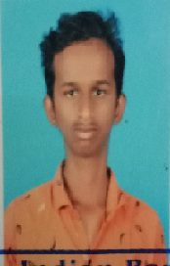

R.ANAND AGARAKAVI

S/O:Rajaraman,27 Manjinipatti

Thirumayam(Thaluk)

Pudukkattai-622 503 PhoneNo:9345613085

EMailID:ranandgarakavi@gamil.com

ACADEMIC PERFOMNCE

* **HIGHER SECONDRY EDUCATION**

Awared with 80% in S R M S S SCHOOL.

Karsikudi,Sivangai-Dt

* **SECONDARY EDUCATION**

Awared with in 70% S R M S S SCHOOL.

Karsikudi,Sivangai-Dt

SKILL

* I know **JAVA**  program
* **C** program
* **I** know **COMPUTER KNOWLEDGE**

OPTIMISTIC IN NATURE

**Name**  : R. Anand Agarakavi

**Father Name** : AR.Raja Raman

**Date of Birth** : 26.05.2004

**Blood group**  : B+

**Gender** : Male

**Religion** : Hindu

**Address** : S/O:Rajaraman,27 Manjinipatti

Thirumayam(Thaluk) Pudukkattai-622 503

**Mobile**  : 9345613085

**Email – Id**  : [ranandagarakavi@gmail.com](mailto:ranandagarakavi@gmail.com)

DECLARATION

I hereby declare that the above given details are true to the best of my knowledge.

YoursFaithy

R.Anand Agarakavi