INTRODUCTION

OVERVIEW

1. Find the right template choose from hundreds of professionally designed resume templates

2) Personalize your resume after picking a template use canvas drag and drop design tools to tweak your resume

3) Get creative with more features

4) Order your prints

PURPOSE

1. I can use our content in a canva design for a wide range of personal and commercial uses

1. I can use our content in marketing or social media or even sell merchandise with your design
2. Don’t resell redistribute or take credit for content provided through canva.
3. Empathy map

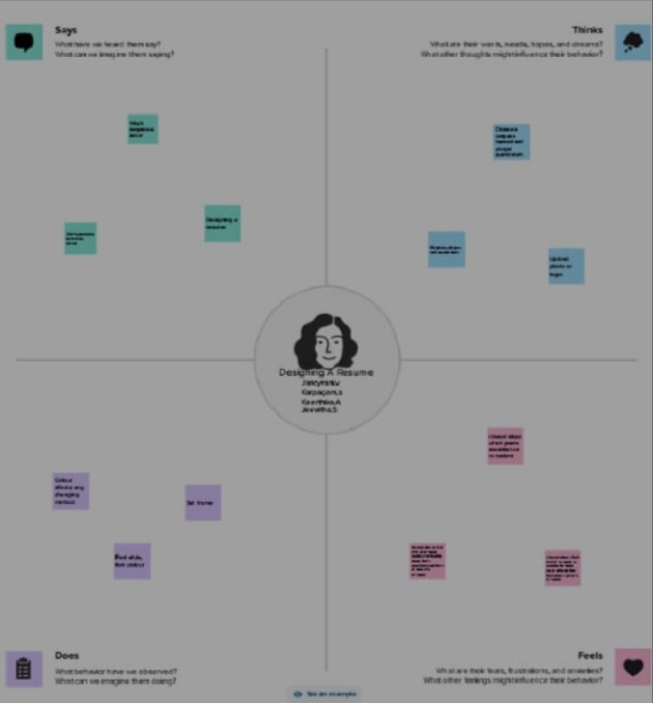

1. Brainstorm map

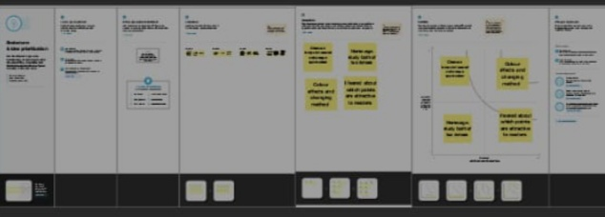

6)Resultof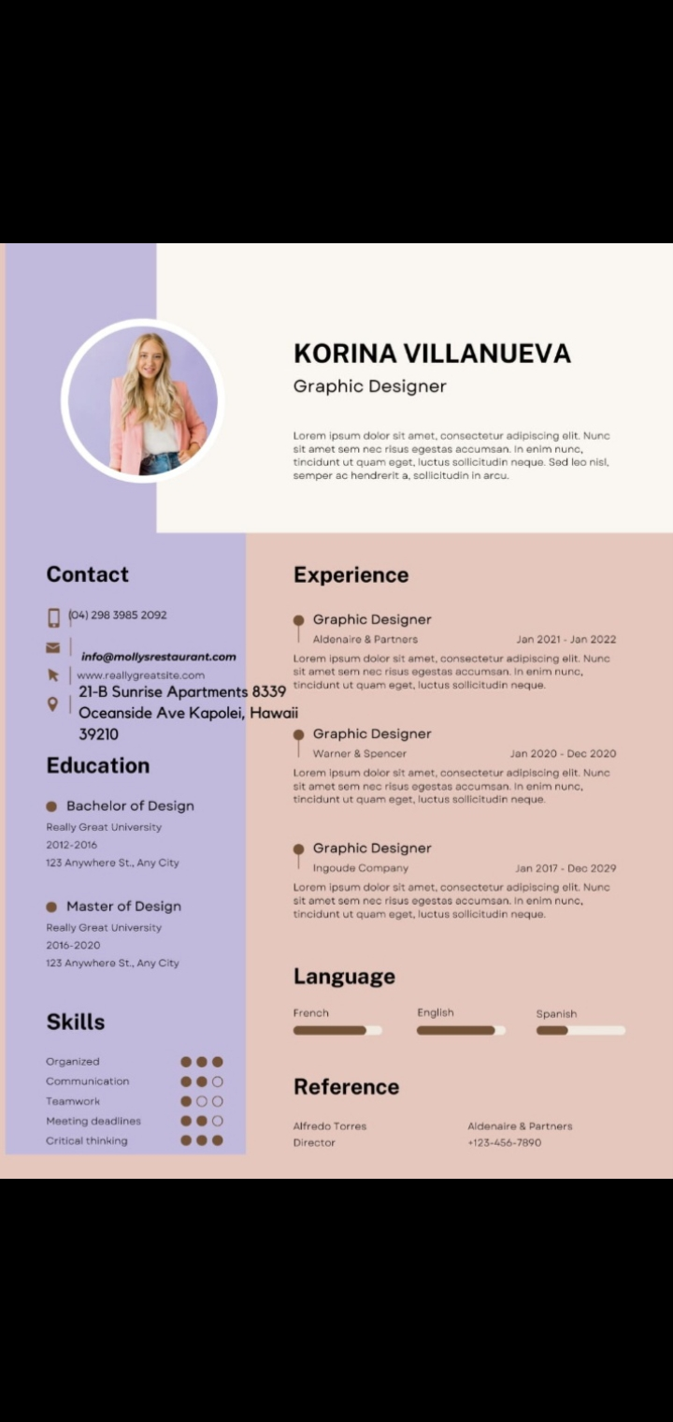

7)Advantage

A professionally written resume is a powerful marketing tool that helps your application stand out . you can highlight your relevant accomplishments and suitability for a position or education .program , so the reader can see how well you’d fit into their organization.

D

Disadvantages

Empahasizes gaps in jobs.

Highlights frequent job changes.

Does not emphasize skill development.

Points out career setbacks.

8)Application

The resumes sole purpose is to land you an interview.

Aresume is to give your potential employer a feel for your past experience and skills .

Remember you are trying to sell yourself ,so emphasize your strengths

CONCLUSION

I Look forward to any opportunity to discuss the

Position and what I can do for your company

I belive my vision align with the brand and that the

Be an excellent fit for your organization thank your

Time in reviewing my resume