COLLEGE MARKS SHEET - PROJECT REPORT

Introduction
This project presents a comprehensive analysis of college students' performance using an interactive Power BI dashboard. The report visualizes key metrics such as attendance percentage, SSC marks, HSC marks, and overall college marks.

Dashboard Overview
The Power BI dashboard provides a detailed breakdown of student performance across different classes and grades. It includes KPIs, bar charts, pie charts, and tabular views representing student-level data.
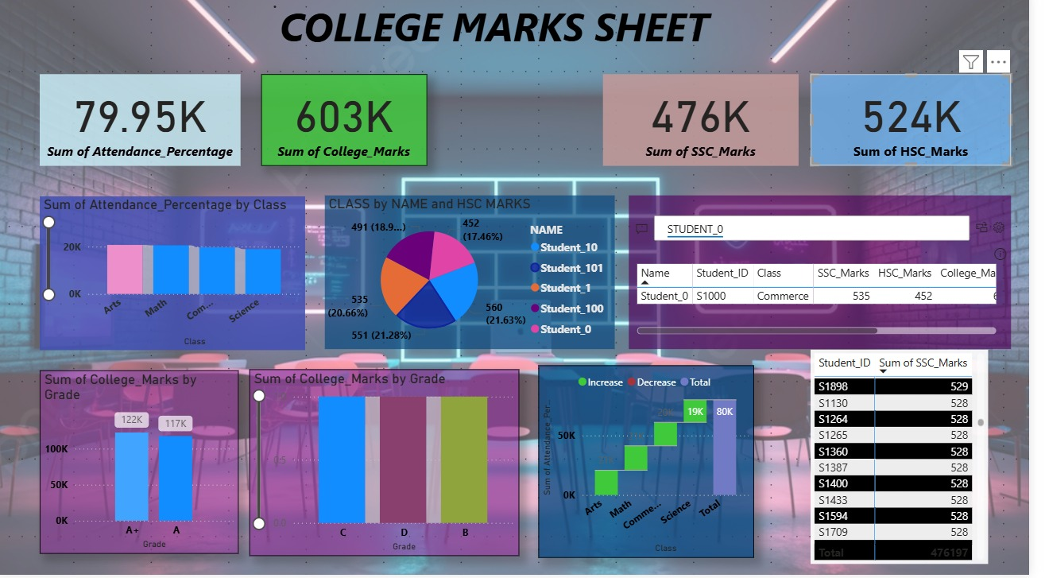

Key Performance Indicators (KPIs)
The dashboard includes the following KPIs:
- Total Attendance Percentage
- Total College Marks
- Total SSC Marks
- Total HSC Marks

Visual Insights
1. Attendance Percentage by Class: Shows how attendance varies across Arts, Math, Commerce, and Science.
2. College Marks by Grade: Displays marks distribution for grades A+, A, B, C, and D.
3. SSC and HSC Performance: Highlights performance trends among different students.
4. Pie Chart by Class and HSC Marks: Represents proportional distribution of HSC mamong students.

Conclusion
This report effectively summarizes the performance of students using visual analytics. Power BI helps convert raw data into meaningful insights for decision-making and evaluation.

