FACULTY EVALUATION
Programme Name: Sisters’ Blended Value Program (Sbvp)Social Entrepreneurship Development Program (SEDP) Advance Module 3 Zambia (26th January 2026 - 30th January 2026)
Session: Governance and succession planning
Faculty Name: Dr. David Mutua Mathuva
No. of Respondents: 13
No. of Participants: 13
Evaluation Parameter | (%) Individual Score | (%) Programme Average
Intake | 0 | 0
Year of Study | 0 | 0
Sentiment | 0 | 0
Topic Analysis | 0 | 0
Punctuality | 0 | 0
Clarity of presentation of concepts, course material, content and use of practical examples. | 0 | 0
Degree of preparation for the lessons | 0 | 0
Course design and organisation | 0 | 0
Content and methodology | 0 | 0
Quality of discussions | 0 | 0
The information presented was relevant to my work | 0 | 0
Punctuality (Commencement and Completion of Sessions) | 92 | 95
How well do you understand the core concepts presented? | 92 | 91
Rate your confidence in applying the new skills learnt | 91 | 92
Degree of Faculty preparedness for the sessions | 92 | 95
Content and methodology of the program | 94 | 96
Quality of class and group discussions | 94 | 95
The information presented in the course is relevant to my work (ministry) | 91 | 92
Availability of materials-at SBS app | 0 | 0
Quality of materials uploaded-at SBS app | 0 | 0
Usability(Ease of Use)-of SBS app | 0 | 0
Reliability of app | 0 | 0
Responsive-of sbs app | 0 | 0
General Administration | 0 | 0
Administrative Staff | 0 | 0
Response to feedback | 0 | 0
Cafeteria | 0 | 0
Library services | 0 | 0
IT Support | 0 | 0
Security | 0 | 0
Overall Quality of food/Service | 0 | 0
Professionalism of Cafeteria Staff (Attitude of the serving staff,Communication etc) | 0 | 0
Variety of food | 0 | 0
Courtesy of the security guards | 0 | 0
Security and Safety measures adopted by the school overall | 0 | 0
Effectiveness of the Security services | 0 | 0
Housekeeping staff is responsive to your needs. | 0 | 0
Quality of the tasks completed by housekeeping staff. | 0 | 0
Overall satisfaction with Housekeeping Services. | 0 | 0
Overall program evaluation | 0 | 0
Timeliness | 0 | 0
Communication skills | 0 | 0
Response to feedback and participant needs | 0 | 0
Organization and attention to detail | 0 | 0
Quality of service/professionalism | 0 | 0
Timely distribution of program materials | 0 | 0
Punctuality in sending materials and programme information | 0 | 0
Communication skills(verbal and written) | 0 | 0
Response to programme enquiries via email, whatsapp and calls | 0 | 0
Accessibility and willingness to support when needed | 0 | 0
Quality of service / professionalism | 0 | 0
Suitability of training venue (space, layout, facilties) | 0 | 0
Comfort and cleanliness of the training environment | 0 | 0
Availability and quality of training amenities(projector, sound, Wi-Fi) | 0 | 0
Comfort and cleanliness of the accomodation | 0 | 0
Quality of meals and dining services provided | 0 | 0
Overall satisfaction with the accomodation experience | 0 | 0
Quality of the pre-visit planning & information shared | 0 | 0
Quality of the visit | 0 | 0
Quality of content discussed | 0 | 0
Extent of your learning | 0 | 0
Overall company visit evaluation | 0 | 0
Service at the hotel () | 0 | 0
Accessibility of Accomodation rooms | 0 | 0
Meals: Variety & Quality | 0 | 0
Customer Services | 0 | 0
General Comfort of the Room | 0 | 0
Room Privacy | 0 | 0
General cleanliness | 0 | 0
Timeliness.1 | 0 | 0
Response to participant enquiries | 0 | 0
Organization and attention to detail.1 | 0 | 0
Quality of service/professionalism.1 | 0 | 0
Classes are engaging | 0 | 0
Classes start and end on time | 0 | 0
The learning environment is participative, learning by doing and group based | 0 | 0
The subject content is according to the course outline and my expectations | 0 | 0
The topics are clear and logically developed | 0 | 0
The course assists me to develop my reflective, critical reasoning | 0 | 0
The assessment methods assist me to learn | 0 | 0
I receive relevant feedback | 0 | 0
There are recommended readings, notes and eLearning materials provided | 0 | 0
I am developing my writing and oral/practical skills | 0 | 0
Speaker's Quality of discussions | 0 | 0
Speaker's degree of preparation for the session | 0 | 0
Information presented in the course was relevant to my work | 0 | 0
Presentation was well structured | 0 | 0
Delivery methodology was appropriate | 0 | 0
Speaker's quality of discussion | 0 | 0
Speakers degree of preparation | 0 | 0
Information presented was relevant and sufficient | 0 | 0
I had sufficient technical resources to engage in online learning | 0 | 0
My social environment was favourable to learning | 0 | 0
The facilitator was knowledgeable on the use of ICT | 0 | 0
The administrative support received from the School was adequate | 0 | 0
The eLearning platform was easily accessible | 0 | 0
The video platform was sufficient for online interaction] | 0 | 0
I had access to the class recordings | 0 | 0
Quality of the pre-visit planning & information shared.1 | 0 | 0
Quality of the plant visit | 0 | 0
Quality of content discussed.1 | 0 | 0
Overall company visit evaluation.1 | 0 | 0
How many individual(one-on-one) coaching sessions have you attended? [Coaching Session]ng | 0 | 0
How many group coaching sessions did you attend? [Coaching Session] | 0 | 0
Average scores | 6 | 6

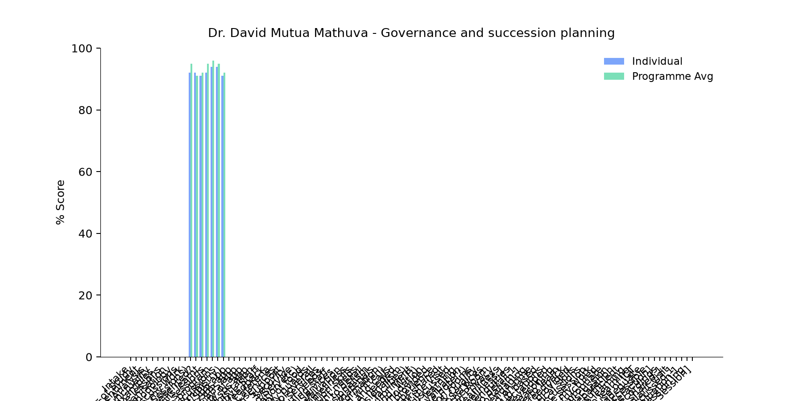

Comments & Feedback
- • No barriers will prevent me to applying it,i have learnt how to ,plan and to sale my business
- • Nothing because it's so inspiring
- • Thank a lot. The day last day was wonderful. Learning of what ZRA. I learnt how they operate in order to maintain the country 's economy and Budget how the money will be divided to different ministries and the different types of Tax that are to be paid and that you can as well be exempted from paying Tex.
- • As well an understanding mind that if not able to pay may go to the offices to let them know you are unable to pay.
- • Thanks to Dr Nancy for the highlights to finish our enterprise planning and to Dr. William to make aware of the people we can interact with who can be influencial to our enterprise in a positive way or negative way and who can take over when the person in charge has been transferred or died. Thanks as well to SR Slestine for making it a point on the leadership as well on the synod of hope.
- • Thank you so much for your insight
- • It might be time or resources but I will try to level to utilize what I have learned
- • The challenges of audibility interfered with concentration.
- • Finances
- • Lecture was very good
SUBMITTED THROUGH:
SBS Evaluation Automation System

