FACULTY EVALUATION
Programme Name: SBVP ALUMNI MASTERCLASS - GROW Module II Online Kenya (16th March 2026 - 20th March 2026)
Session: Review (identify gaps/challenges) your business plan from module 1 || Decide key issues for long-term sustainability || Identify areas where support is needed
Faculty Name: Dr. William Karani Murithi
No. of Respondents: 11
No. of Participants: 11
Evaluation Parameter | (%) Individual Score | (%) Programme Average
Intake | 0 | 0
Year of Study | 0 | 0
Sentiment | 0 | 0
Topic Analysis | 0 | 0
Punctuality | 0 | 0
Clarity of presentation of concepts, course material, content and use of practical examples. | 0 | 0
Degree of preparation for the lessons | 0 | 0
Course design and organisation | 0 | 0
Content and methodology | 0 | 0
Quality of discussions | 0 | 0
The information presented was relevant to my work | 0 | 0
Punctuality (Commencement and Completion of Sessions) | 98 | 98
How well do you understand the core concepts presented? | 93 | 93
Rate your confidence in applying the new skills learnt | 85 | 88
Degree of Faculty preparedness for the sessions | 98 | 98
Content and methodology of the program | 92 | 96
Quality of class and group discussions | 95 | 93
The information presented in the course is relevant to my work (ministry) | 96 | 98
Availability of materials-at SBS app | 0 | 0
Quality of materials uploaded-at SBS app | 0 | 0
Usability(Ease of Use)-of SBS app | 0 | 0
Reliability of app | 0 | 0
Responsive-of sbs app | 0 | 0
General Administration | 0 | 0
Administrative Staff | 0 | 0
Response to feedback | 0 | 0
Cafeteria | 0 | 0
Library services | 0 | 0
IT Support | 0 | 0
Security | 0 | 0
Overall Quality of food/Service | 0 | 0
Professionalism of Cafeteria Staff (Attitude of the serving staff,Communication etc) | 0 | 0
Variety of food | 0 | 0
Courtesy of the security guards | 0 | 0
Security and Safety measures adopted by the school overall | 0 | 0
Effectiveness of the Security services | 0 | 0
Housekeeping staff is responsive to your needs. | 0 | 0
Quality of the tasks completed by housekeeping staff. | 0 | 0
Overall satisfaction with Housekeeping Services. | 0 | 0
Overall program evaluation | 0 | 0
Timeliness | 0 | 0
Communication skills | 0 | 0
Response to feedback and participant needs | 0 | 0
Organization and attention to detail | 0 | 0
Quality of service/professionalism | 0 | 0
Timely distribution of program materials | 0 | 0
Punctuality in sending materials and programme information | 0 | 0
Communication skills(verbal and written) | 0 | 0
Response to programme enquiries via email, whatsapp and calls | 0 | 0
Accessibility and willingness to support when needed | 0 | 0
Quality of service / professionalism | 0 | 0
Suitability of training venue (space, layout, facilties) | 0 | 0
Comfort and cleanliness of the training environment | 0 | 0
Availability and quality of training amenities(projector, sound, Wi-Fi) | 0 | 0
Comfort and cleanliness of the accomodation | 0 | 0
Quality of meals and dining services provided | 0 | 0
Overall satisfaction with the accomodation experience | 0 | 0
Quality of the pre-visit planning & information shared | 0 | 0
Quality of the visit | 0 | 0
Quality of content discussed | 0 | 0
Extent of your learning | 0 | 0
Overall company visit evaluation | 0 | 0
Service at the hotel () | 0 | 0
Accessibility of Accomodation rooms | 0 | 0
Meals: Variety & Quality | 0 | 0
Customer Services | 0 | 0
General Comfort of the Room | 0 | 0
Room Privacy | 0 | 0
General cleanliness | 0 | 0
Timeliness.1 | 0 | 0
Response to participant enquiries | 0 | 0
Organization and attention to detail.1 | 0 | 0
Quality of service/professionalism.1 | 0 | 0
Classes are engaging | 0 | 0
Classes start and end on time | 0 | 0
The learning environment is participative, learning by doing and group based | 0 | 0
The subject content is according to the course outline and my expectations | 0 | 0
The topics are clear and logically developed | 0 | 0
The course assists me to develop my reflective, critical reasoning | 0 | 0
The assessment methods assist me to learn | 0 | 0
I receive relevant feedback | 0 | 0
There are recommended readings, notes and eLearning materials provided | 0 | 0
I am developing my writing and oral/practical skills | 0 | 0
Speaker's Quality of discussions | 0 | 0
Speaker's degree of preparation for the session | 0 | 0
Information presented in the course was relevant to my work | 0 | 0
Presentation was well structured | 0 | 0
Delivery methodology was appropriate | 0 | 0
Speaker's quality of discussion | 0 | 0
Speakers degree of preparation | 0 | 0
Information presented was relevant and sufficient | 0 | 0
I had sufficient technical resources to engage in online learning | 0 | 0
My social environment was favourable to learning | 0 | 0
The facilitator was knowledgeable on the use of ICT | 0 | 0
The administrative support received from the School was adequate | 0 | 0
The eLearning platform was easily accessible | 0 | 0
The video platform was sufficient for online interaction] | 0 | 0
I had access to the class recordings | 0 | 0
Quality of the pre-visit planning & information shared.1 | 0 | 0
Quality of the plant visit | 0 | 0
Quality of content discussed.1 | 0 | 0
Overall company visit evaluation.1 | 0 | 0
How many individual(one-on-one) coaching sessions have you attended? [Coaching Session]ng | 0 | 0
How many group coaching sessions did you attend? [Coaching Session] | 0 | 0
Average scores | 6 | 6

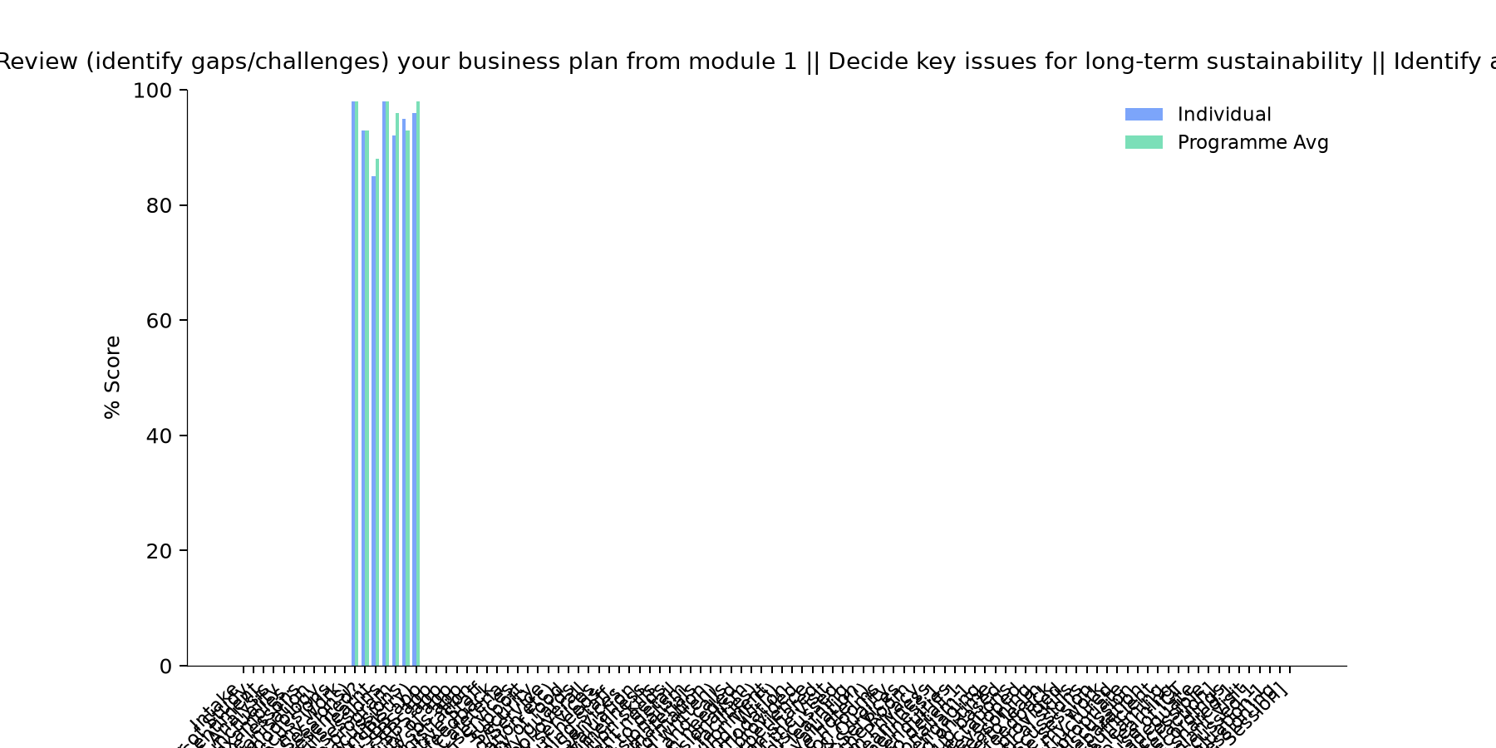

Comments & Feedback
- • Financial thanks to Hilton foundation and Strathmore University
- • Financial constraints
- • Any unplanned changes in the project administration. Otherwise we are committed to applying for he knowledge gained in implementation of the project.
- • Inadequate finances
- • Slowness in engaging the partners and stakeholders in the enterprise
- • The input was very rich
- • Lack of review of our business plan and genuine evaluation of the social enterprise.
- • Lack of enough finance especially during long holidays when we have students out of our hostel facility
SUBMITTED THROUGH:
SBS Evaluation Automation System

