FACULTY EVALUATION
Programme Name: Social Entrepreneurship Development Program (SEDP)- Advance Uganda (2nd March 2026 - 6th March 2026)
Session: IT and Technology
Faculty Name: Dr. Evelyn Kahiigi
No. of Respondents: 22
No. of Participants: 22
Evaluation Parameter | (%) Individual Score | (%) Programme Average
Intake | 0 | 0
Year of Study | 0 | 0
Sentiment | 0 | 0
Topic Analysis | 0 | 0
Punctuality | 0 | 0
Clarity of presentation of concepts, course material, content and use of practical examples. | 0 | 0
Degree of preparation for the lessons | 0 | 0
Course design and organisation | 0 | 0
Content and methodology | 0 | 0
Quality of discussions | 0 | 0
The information presented was relevant to my work | 0 | 0
Punctuality (Commencement and Completion of Sessions) | 78 | 91
How well do you understand the core concepts presented? | 85 | 92
Rate your confidence in applying the new skills learnt | 77 | 87
Degree of Faculty preparedness for the sessions | 87 | 97
Content and methodology of the program | 84 | 95
Quality of class and group discussions | 81 | 89
The information presented in the course is relevant to my work (ministry) | 93 | 97
Availability of materials-at SBS app | 0 | 0
Quality of materials uploaded-at SBS app | 0 | 0
Usability(Ease of Use)-of SBS app | 0 | 0
Reliability of app | 0 | 0
Responsive-of sbs app | 0 | 0
General Administration | 0 | 0
Administrative Staff | 0 | 0
Response to feedback | 0 | 0
Cafeteria | 0 | 0
Library services | 0 | 0
IT Support | 0 | 0
Security | 0 | 0
Overall Quality of food/Service | 0 | 0
Professionalism of Cafeteria Staff (Attitude of the serving staff,Communication etc) | 0 | 0
Variety of food | 0 | 0
Courtesy of the security guards | 0 | 0
Security and Safety measures adopted by the school overall | 0 | 0
Effectiveness of the Security services | 0 | 0
Housekeeping staff is responsive to your needs. | 0 | 0
Quality of the tasks completed by housekeeping staff. | 0 | 0
Overall satisfaction with Housekeeping Services. | 0 | 0
Overall program evaluation | 0 | 0
Timeliness | 0 | 0
Communication skills | 0 | 0
Response to feedback and participant needs | 0 | 0
Organization and attention to detail | 0 | 0
Quality of service/professionalism | 0 | 0
Timely distribution of program materials | 0 | 0
Punctuality in sending materials and programme information | 0 | 0
Communication skills(verbal and written) | 0 | 0
Response to programme enquiries via email, whatsapp and calls | 0 | 0
Accessibility and willingness to support when needed | 0 | 0
Quality of service / professionalism | 0 | 0
Suitability of training venue (space, layout, facilties) | 0 | 0
Comfort and cleanliness of the training environment | 0 | 0
Availability and quality of training amenities(projector, sound, Wi-Fi) | 0 | 0
Comfort and cleanliness of the accomodation | 0 | 0
Quality of meals and dining services provided | 0 | 0
Overall satisfaction with the accomodation experience | 0 | 0
Quality of the pre-visit planning & information shared | 0 | 0
Quality of the visit | 0 | 0
Quality of content discussed | 0 | 0
Extent of your learning | 0 | 0
Overall company visit evaluation | 0 | 0
Service at the hotel () | 0 | 0
Accessibility of Accomodation rooms | 0 | 0
Meals: Variety & Quality | 0 | 0
Customer Services | 0 | 0
General Comfort of the Room | 0 | 0
Room Privacy | 0 | 0
General cleanliness | 0 | 0
Timeliness.1 | 0 | 0
Response to participant enquiries | 0 | 0
Organization and attention to detail.1 | 0 | 0
Quality of service/professionalism.1 | 0 | 0
Classes are engaging | 0 | 0
Classes start and end on time | 0 | 0
The learning environment is participative, learning by doing and group based | 0 | 0
The subject content is according to the course outline and my expectations | 0 | 0
The topics are clear and logically developed | 0 | 0
The course assists me to develop my reflective, critical reasoning | 0 | 0
The assessment methods assist me to learn | 0 | 0
I receive relevant feedback | 0 | 0
There are recommended readings, notes and eLearning materials provided | 0 | 0
I am developing my writing and oral/practical skills | 0 | 0
Speaker's Quality of discussions | 0 | 0
Speaker's degree of preparation for the session | 0 | 0
Information presented in the course was relevant to my work | 0 | 0
Presentation was well structured | 0 | 0
Delivery methodology was appropriate | 0 | 0
Speaker's quality of discussion | 0 | 0
Speakers degree of preparation | 0 | 0
Information presented was relevant and sufficient | 0 | 0
I had sufficient technical resources to engage in online learning | 0 | 0
My social environment was favourable to learning | 0 | 0
The facilitator was knowledgeable on the use of ICT | 0 | 0
The administrative support received from the School was adequate | 0 | 0
The eLearning platform was easily accessible | 0 | 0
The video platform was sufficient for online interaction] | 0 | 0
I had access to the class recordings | 0 | 0
Quality of the pre-visit planning & information shared.1 | 0 | 0
Quality of the plant visit | 0 | 0
Quality of content discussed.1 | 0 | 0
Overall company visit evaluation.1 | 0 | 0
How many individual(one-on-one) coaching sessions have you attended? [Coaching Session]ng | 0 | 0
How many group coaching sessions did you attend? [Coaching Session] | 0 | 0
Average scores | 6 | 6

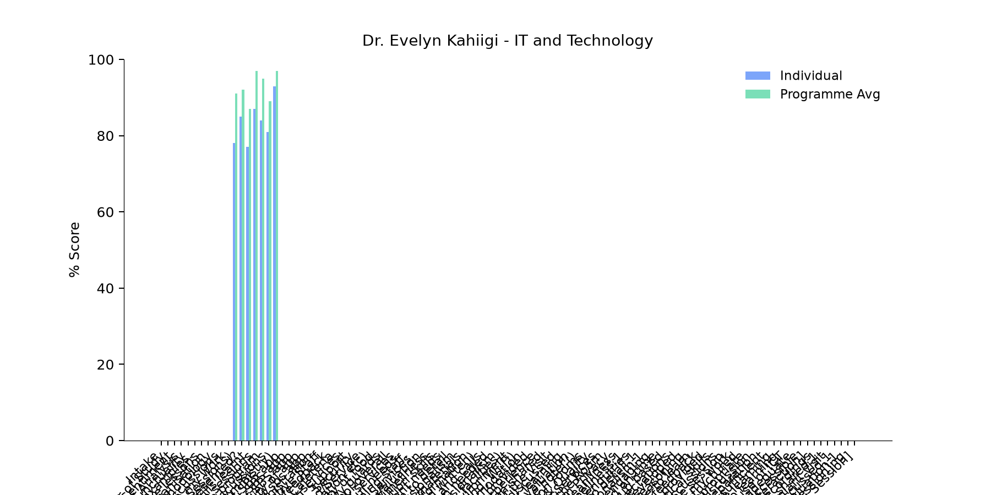

Comments & Feedback
- • Need to Learn more on IT
- • The content presented was good but not practically done.Maily theory
- • Lack of data because most of the online things needs data and it's not regularly provided in some communities like mine
- • Not being so practical I computer programs
- • The class was more of theory we needed more of practice
- • Limited know how
- • network problem, Internet data
- • Slow network
- • Lack of some tools like the computer
- • Data
- • No barriers
- • The most like barriers can be when I may run short of data since it requires data so as to connected on line. otherwise it is doable.
- • Am going to try to apply them
- • Limited support from superiors, colleagues, or management can discourage implementation. And also, time constraints—being too busy or overloaded with work—can prevent me from practicing new knowledge. Another barrier is lack of follow-up and supervision. After training, there is no guidance.
SUBMITTED THROUGH:
SBS Evaluation Automation System

