Below you will find a programming challenge, please use C#, .NET Core 3.0 (or greater) for backend and vanilla JavaScript (the only allowed external library is jQuery) for frontend.

We will evaluate your skills in object-oriented, web (HTML) and JavaScript programming.

We expect the code to be production-quality, and can easily be maintained and evolved, not just a barebones algorithm, your submission should be no later than April 14 morning, create public repo on GitHub.com and provide us a link.

**Premium Calculator**

1. Build a web service, that receives following parameters:

* Date of Birth
* State
* Age

And provide a premium as a result, based on the following table.

|  |  |  |  |
| --- | --- | --- | --- |
| **State** | **MonthOfBirth** | **Age** | **Premium** |
| NY | August | 18-45 | 150.00 |
| NY | January | 46-65 | 200.50 |
| NY | * | 18-65 | 120.99 |
| AL | November | 18-65 | 85.5 |
| AL | * | 18-65 | 100.00 |
| AK | December | 65+ | 175.20 |
| AK | December | 18-64 | 125.16 |
| AK | * | 18-65 | 100.80 |
| * | * | 18-65 | 90.00 |

* represents a criteria wildcard that matches anything within the context of use. I.e., for State ‘*’ means any valid US state, for MonthOfBirth ‘*’ means any month.

Age and Date of Birth should be validated that they do match each other. I.e., if DOB is 01.01.1958, value 5 for Age is invalid.

Result should be provided in a JSON format like so:

{

   "premium":"123455.12"

}

1. Build a web site that consumes the web service created in the previous task; result needs to be printed in a textbox in the page, next to it there should be a drop down with frequencies (Monthly, Quarterly, Semi-Annually, Annually) and next to it two textboxes for the calculated values of Annual and Monthly; these values need to be calculated automatically each time the drop-down value selected changes. Age control should be auto-populated based on Date of Birth.

Bonus points:

* Validate fields before calculation.
* Disable controls if value has not been retrieved.
* Validate only numeric entries on fields.
* Handle all possible exception when calculating values.

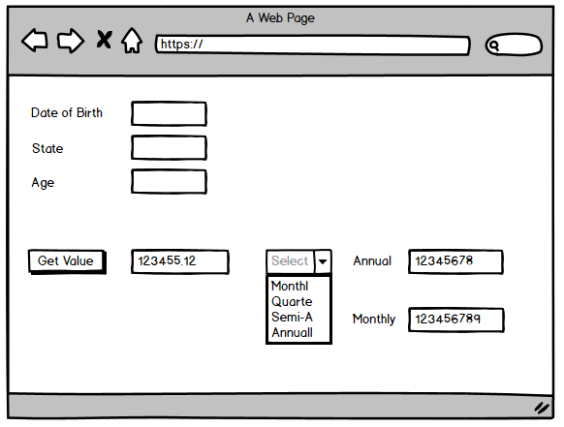

Frequencies meaning:

* Monthly: each month
* Quarterly: each 3 months
* Semi-Annually: each 6 months
* Annually: (each 12 months)

**Example**:

If URL/webservice returns 300.0 and selected frequency is quarterly, that means that 300.0 will be paid every 3 months.

Expected results:

Monthly = 100.0 (300.0 / 3)

Annually = 1200.0 (300.0 * 4)