You can use.Net Core C# or Python for your implementation.

We will evaluate your skills in object oriented programming and design. We expect the code to be **production-quality**, and can easily be maintained and evolved, not just a barebones algorithm.

Please commit your solution to <https://github.com/> and provide us link to your repo (do not create any security on this repo). **Do not** upload Zip/Rar files. Make sure that solution can be downloaded without any modifications. It would be a plus if you would have docker file in your solution as well.

**Programming Challenge:**

The Wikimedia Foundation provides all pageviews for Wikipedia site since 2015 in machine-readable format. The pageviews can be downloaded in gzip format and are aggregated per hour per page. Each hourly dump is approximately 50MB in gzipped text file and is somewhere between 100MB and 250MB in size unzipped.

Technical documentation of the service:

<https://wikitech.wikimedia.org/wiki/Analytics/Data_Lake/Traffic/Pageviews>

Sample link:

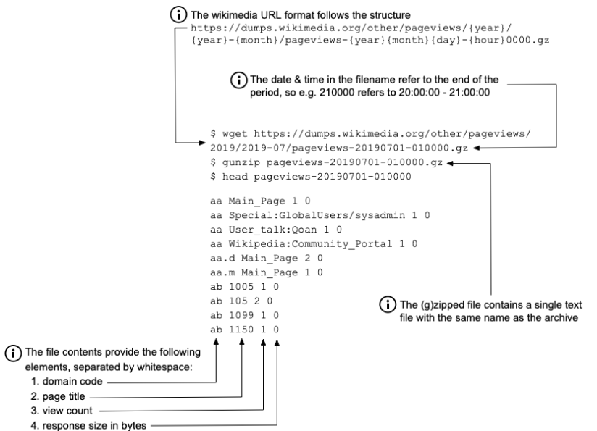<https://dumps.wikimedia.org/other/pageviews/2015/2015-05/pageviews-20150501-010000.gz>

Please create a command line application.

Your code should get data for last **5 hours** and provide the following counts in file (grouped by **hours**):

1. Language & Domain trailing part - display the **max viewed count** for language & domain combination

(see <https://wikitech.wikimedia.org/wiki/Analytics/Data_Lake/Traffic/Pageviews> for domain)

1. Page title with **max** count of views per page (should include all languages)

Result of your execution should be printed in console like this:

Language & Domain count

**Period Language Domain ViewCount**

1PM en wikipedia 2000

2PM en wikimedia 5000

3PM en wikinews 8000

5PM zu wikipedia 10

Language page max view count

**Period Page ViewCount**

1PM Apple_Watch 20200

2PM Apple_Watch 10000

3PM Google_Cloud 50200

4PM AWS 70000

5PM FaceBook 70000