|  |
| --- |
| The State oF  CINEMA |
| Luckenson Antoine 07/22/2025 |



**Overview**

**Objective:** Launch a new film studio that creates successful commercial films by leveraging data-driven insights.

**Approach:** Use audience behavior and box office data to inform creative and business decisions.

**Goal:** Produce compelling stories that resonate with audiences while minimizing financial risks.

**Business Understanding**

**Context:** The film industry thrives on great storytelling, with growing demand for fresh content across theaters and streaming platforms.

**Challenge:** As a new studio, we face competition from established players.

**Solution:** Analyze real viewer preferences and market trends to guide film production, ensuring both creative vision and commercial success.

**Data Understanding**

**Data Source:** IMDb database and box office data.

**Key Metrics:**

**Genre performance:** Which film genres (e.g., Action, Adventure) attract the largest audience?

**Total revenue:** Domestic and international earnings to identify global appeal.

**Audience ratings:** IMDb ratings and vote counts to gauge viewer satisfaction.

**Preparation:**

Validated data for completeness.

Addressed potential biases in user-generated ratings to ensure reliable insights.

**Data Analysis**

**Tools Used:**

**Python:** A programming language used to process and analyze data.

**Pandas:** A tool for organizing and summarizing datasets.

**Matplotlib:** Libraries for creating charts and visualizations.

**Key Findings:**

Top genres by box office revenue.

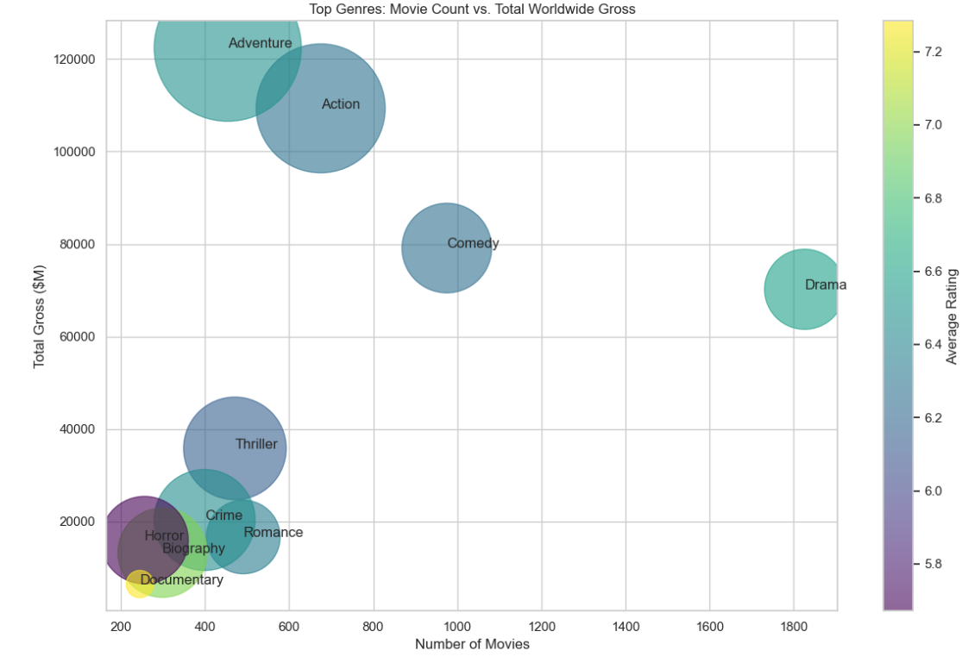Adventure, Action, and Comedy films consistently generate high revenue.

Domestic vs. international box office revenue.

Foreign markets often contribute more revenue than domestic markets.

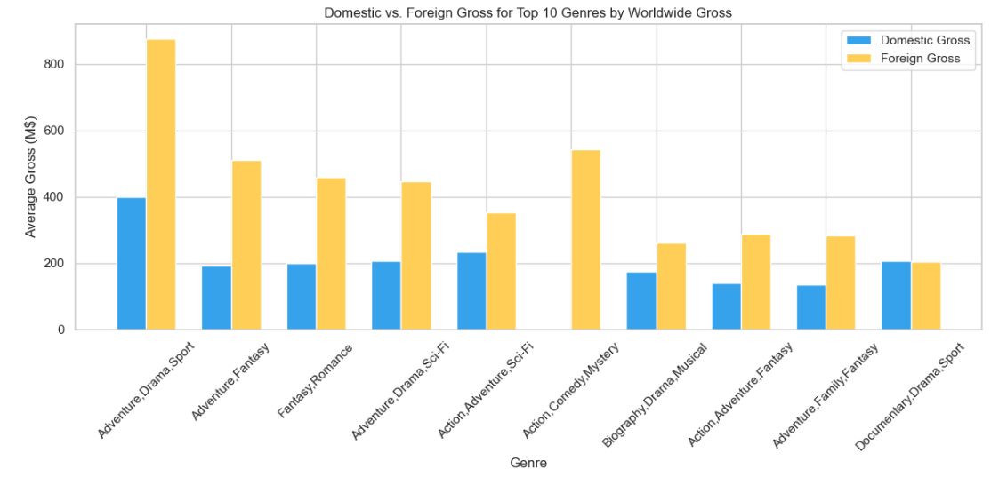

Top studios by average gross per film.

Studios like BV, Fox, and LG/S outperform others, indicating potential partnership opportunities.

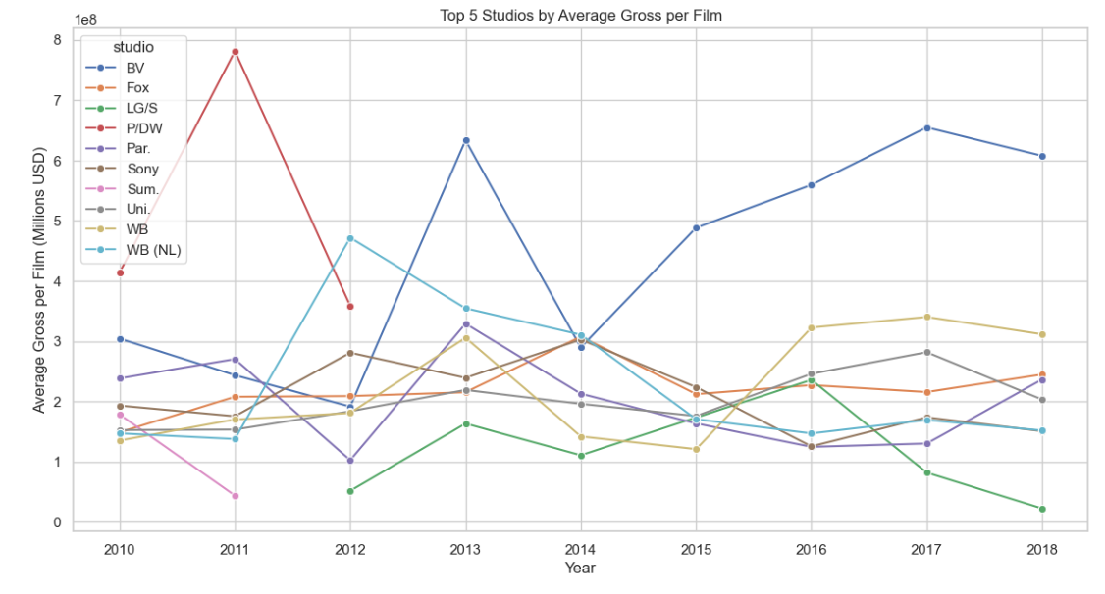

**Recommendations**

1. **Focus on High-Grossing Genres**:
   * **Why?** These genres consistently attract large audiences, increasing the likelihood of commercial success.
2. **Leverage International Markets**:
   * **Why?** International box office revenue often exceeds domestic earnings, offering significant growth opportunities.
3. **Partner with Top-Performing Studios**:
   * **Why?** Partnering with high-performing studios reduces risks and accelerates market entry for a new studio.

**Next Steps**

**Partnerships:** Finalize collaboration agreements with leading studios.

**Production Slate:** Develop a mix of franchise films and original content in high-grossing genres.

**Market Research:** Conduct in-depth studies for international market expansion.

**Budget Monitoring:** Implement systems to optimize resource allocation and track spending.

**Thank You!**

Emaill : [a.luckenson@gmail.com](mailto:a.luckenson@gmail.com)

Github : [@aluckens](https://github.com/aluckens)

LinkedIn : https://linkedin.com/in/luckenson-antoine/