Software Design Document
GPIO Driver Module
Lab 01 – Microcontrollers and Embedded Systems

Module | GPIO Driver
Version | 1.0.0
Author(s) | J.M. Paez Sandoval, C.A. Martínez, D. Lopez Moreno, L.A. Lugo Muñiz
Institution | CETYS Universidad — Facultad de Ingeniería
Date | 23/04/2026

1. Introduction

1.1 Purpose
This document describes the design and architecture of the gpio_driver module for Lab 1. It covers the CMSIS-based implementation that provides pin mode configuration, pull-up/pull-down control, atomic BSRR-based writes, toggle, and digital read operations.

1.2 Scope
The gpio_driver is a low-level C module for the STM32F411RE. It uses CMSIS GPIO_TypeDef pointers from stm32f411xe.h and provides a clean API for configuring digital I/O pins. It is used by the button module (PC13 input) and can be used by any module that needs direct GPIO control.

1.3 Definitions, Acronyms, and Abbreviations

Term | Definition
GPIO | General-Purpose Input/Output peripheral
CMSIS | Cortex Microcontroller Software Interface Standard
RCC | Reset and Clock Control - manages peripheral clock gating
AHB1 | Advanced High-performance Bus 1 - connects GPIO peripherals
MODER | Mode Register - 2 bits per pin: 00=Input, 01=Output, 10=AF, 11=Analog
PUPDR | Pull-Up/Pull-Down Register - 2 bits per pin
IDR | Input Data Register - read-only current pin state
ODR | Output Data Register - write pin state (used for toggle via XOR)
BSRR | Bit Set/Reset Register - atomic set (bits[15:0]) / reset (bits[31:16])

1.4 Requirements
All requirements for this module are allocated in Docs/SRS/GPIO_Driver_SRS.md (provided by the instructor without modification).

2. System Architecture

2.1 High-Level Design
The gpio_driver sits between the application/middleware layer and the hardware registers. Peripheral clock is enabled automatically inside gpio_init() via the private rcc_gpio_clk_enable() helper.

Layer | Modules
Application | main.c — calls led and button APIs; no register access
Middleware | button.c, led.c — use gpio_driver or direct CMSIS access
GPIO Driver | All GPIO register operations via gpio_init, gpio_write, gpio_read, gpio_toggle
Hardware | STM32F411RE GPIO registers via CMSIS GPIO_TypeDef pointers

2.2 Module Interfaces
Public API declared in gpio_driver.h. Dependencies: stm32f4xx.h (CMSIS GPIO_TypeDef, RCC), stdint.h. No HAL. The button module depends on gpio_driver.

3. Detailed Design

3.1 Class Diagram

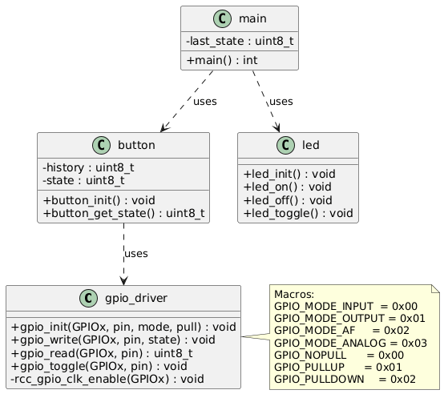
Figure 1. Class Diagram — gpio_driver module and dependent modules

3.2 Module Behavior
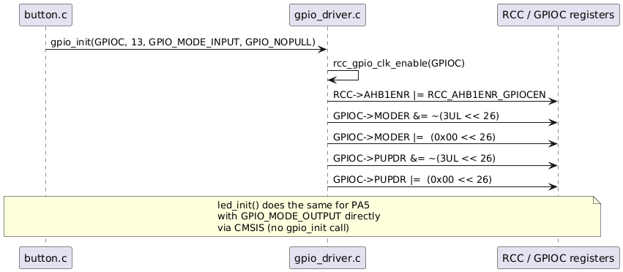
Figure 2. Sequence Diagram — gpio_init() + gpio_write() initialization sequence

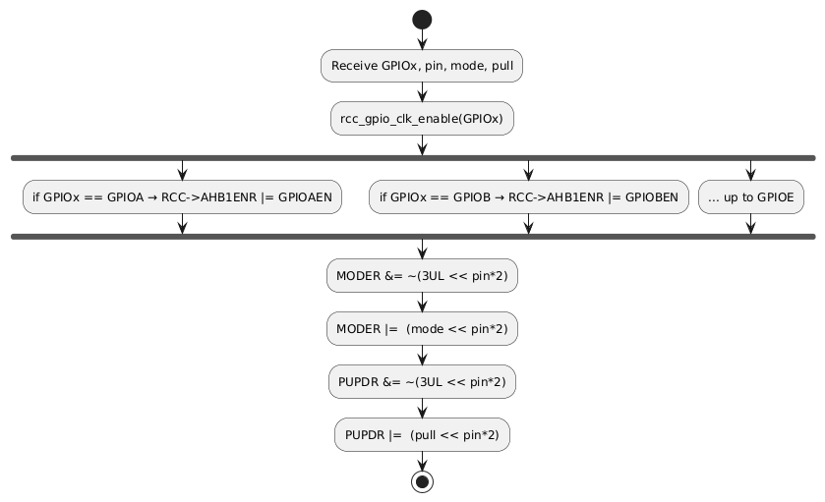
Figure 3. Activity Diagram — gpio_init() clock enable and mode/pull configuration
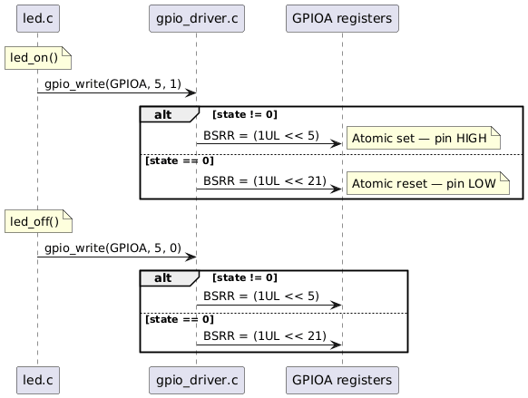
Figure 4. Sequence Diagram — gpio_write() branching on state parameter

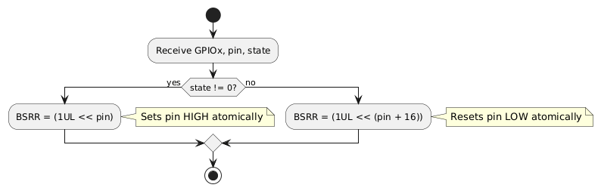
Figure 5. Activity Diagram — gpio_write() BSRR conditional branch

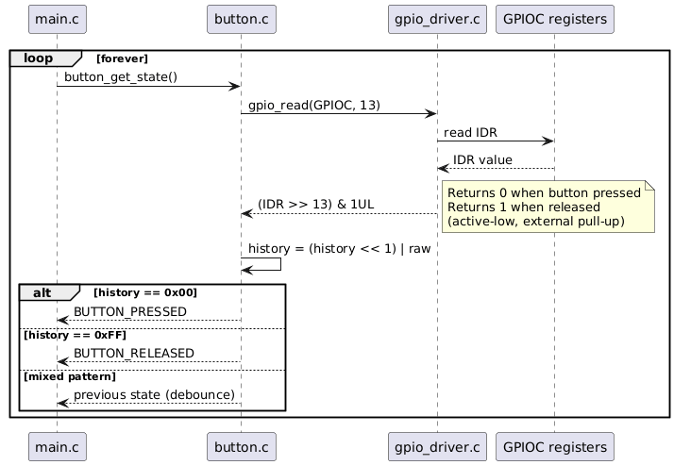
Figure 6. Sequence Diagram — gpio_read() inside button_get_state() polling loop

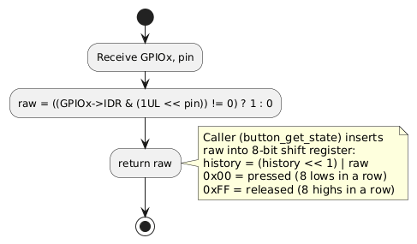
Figure 7. Activity Diagram — gpio_read() with caller loop context
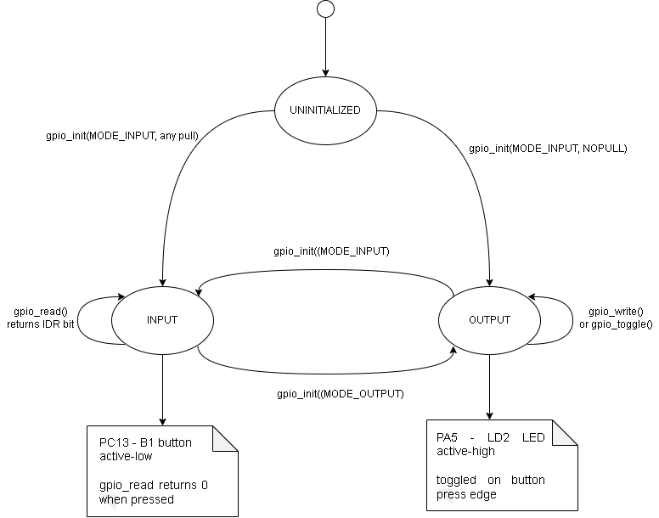

Figure 8. State Diagram - GPIO pin states managed by gpio_driver

3.3 GPIO Driver Module Description
gpio_init() enables the peripheral clock by calling the private static helper rcc_gpio_clk_enable(), which sets the matching GPIOxEN bit in RCC->AHB1ENR. It then configures MODER[2n+1:2n] and PUPDR[2n+1:2n] using read-modify-write for both mode and pull in a single call.

gpio_write() drives an output pin atomically via BSRR. Writing bit n of BSRR[15:0] sets ODR bit n HIGH; writing bit n of BSRR[31:16] resets it LOW. No read-modify-write on ODR is needed, eliminating race conditions.

gpio_toggle() XORs the ODR register directly to invert the current pin state. This is non-atomic and should only be used in single-threaded contexts.

gpio_read() reads the IDR register and masks the target bit: (IDR >> pin) & 1UL. Returns 1 if HIGH, 0 if LOW. For B1 on PC13, which is active-low, gpio_read returns 0 when the button is pressed and 1 when released.

rcc_gpio_clk_enable() is a private static function that handles GPIOA through GPIOE. It is called automatically at the start of gpio_init() and is not accessible outside gpio_driver.c.

4. Application Programming Interfaces

4.1 Data Types and Macros

Macro | Value | Description
GPIO_MODE_INPUT | 0x00U | MODER field value — digital input
GPIO_MODE_OUTPUT | 0x01U | MODER field value — general purpose output
GPIO_MODE_AF | 0x02U | MODER field value — alternate function
GPIO_MODE_ANALOG | 0x03U | MODER field value — analog mode
GPIO_NOPULL | 0x00U | PUPDR field value — no internal resistor
GPIO_PULLUP | 0x01U | PUPDR field value — internal pull-up enabled
GPIO_PULLDOWN | 0x02U | PUPDR field value — internal pull-down enabled

4.2 Error Codes
The gpio_driver functions do not return error codes. All public functions are void or uint8_t (gpio_read only). No input validation is performed — invalid parameters produce undefined hardware behavior.

4.3 Function Definitions

gpio_init

Function Name | gpio_init
Syntax | void gpio_init(GPIO_TypeDef *GPIOx, uint32_t pin, uint32_t mode, uint32_t pull)
Parameters (in) | GPIOx — CMSIS pointer to GPIO port (GPIOA…GPIOE)pin — Pin number 0–15mode — GPIO_MODE_INPUT, OUTPUT, AF, or ANALOGpull — GPIO_NOPULL, PULLUP, or PULLDOWN
Parameters (inout) | None
Parameters (out) | None
Return value | void
Description | Enables the AHB1 peripheral clock for the port via rcc_gpio_clk_enable(), then configures MODER[2n+1:2n] and PUPDR[2n+1:2n] using read-modify-write. Combines clock enable, mode, and pull in a single call.
Constraints | Does not configure OTYPER or OSPEEDR. Does not configure AFR for alternate function pins.
Available via | gpio_driver.h

gpio_write

Function Name | gpio_write
Syntax | void gpio_write(GPIO_TypeDef *GPIOx, uint32_t pin, uint8_t state)
Parameters (in) | GPIOx — CMSIS pointer to GPIO portpin — Pin number 0–15state — 1 = drive HIGH, 0 = drive LOW
Parameters (inout) | None
Parameters (out) | None
Return value | void
Description | Drives output pin atomically via BSRR. state!=0 writes bit n of BSRR[15:0] (set); state==0 writes bit n of BSRR[31:16] (reset). No read-modify-write on ODR is needed.
Constraints | Pin must be configured as output. No NULL or range check performed.
Available via | gpio_driver.h

gpio_read

Function Name | gpio_read
Syntax | uint8_t gpio_read(GPIO_TypeDef *GPIOx, uint32_t pin)
Parameters (in) | GPIOx — CMSIS pointer to GPIO portpin — Pin number 0–15
Parameters (inout) | None
Parameters (out) | None
Return value | uint8_t — 1 if pin is HIGH, 0 if pin is LOW
Description | Returns the current logic state of the pin from IDR: ((IDR >> pin) != 0) ? 1 : 0. For B1 on PC13 (active-low), returns 0 when pressed and 1 when released.
Constraints | Reads IDR regardless of pin mode. No NULL or range check performed.
Available via | gpio_driver.h

gpio_toggle

Function Name | gpio_toggle
Syntax | void gpio_toggle(GPIO_TypeDef *GPIOx, uint32_t pin)
Parameters (in) | GPIOx — CMSIS pointer to GPIO portpin — Pin number 0–15
Parameters (inout) | None
Parameters (out) | None
Return value | void
Description | Inverts the current output pin state via XOR on ODR: ODR ^= (1UL << pin).
Constraints | Non-atomic (read-modify-write on ODR). Do not use in concurrent contexts. Pin must be configured as output.
Available via | gpio_driver.h

4.4 Internal Function Definitions

rcc_gpio_clk_enable (static)

Function Name | rcc_gpio_clk_enable
Syntax | static void rcc_gpio_clk_enable(GPIO_TypeDef *GPIOx)
Parameters (in) | GPIOx — CMSIS GPIO pointer (GPIOA…GPIOE)
Return value | void
Description | Sets the matching GPIOxEN bit in RCC->AHB1ENR using CMSIS named masks (RCC_AHB1ENR_GPIOAEN, etc.). Called automatically at the start of gpio_init(). Not accessible outside gpio_driver.c.
Constraints | Only handles GPIOA–GPIOE. Ports beyond GPIOE are ignored silently.

5. Future Enhancements
- Add OTYPER configuration (open-drain support) via a new gpio_set_output_type() function.
- Add OSPEEDR configuration via a new gpio_set_speed() function.
- Add gpio_set_af() to configure the AFRx registers for alternate function pins.
- Add a GPIO_Status_t return type with input validation for port address range and pin <= 15.
- Add GPIOH support in rcc_gpio_clk_enable() for NUCLEO boards that use it.

