Software Design Document
GPIO_Driver Module
Version 1.0.0
Authors: J.M. Páez Sandoval · L.A. Lugo Muñiz · D. Lopez Moreno · A. Higuera Lopez
CETYS Universidad — Facultad de Ingeniería
Microcontroladores y Sistemas Embebidos

1. Introduction

1.1. Purpose
This document describes the design and architecture of the GPIO_Driver module, based on the requirements defined in the SRS. It provides details on data structures, algorithms, and control flow to guide implementation and testing.

1.2. Scope
The GPIO_Driver is a low-level software component for the STM32F411RE embedded system. It abstracts hardware GPIO peripheral registers and provides a clean API for higher-level modules to configure pin direction, read digital inputs, and drive digital outputs without accessing hardware registers directly.

1.3. Definitions, Acronyms, and Abbreviations
Term | Definition
GPIO | General-Purpose Input/Output — configurable digital I/O peripheral
RCC | Reset and Clock Control — STM32 peripheral that manages clock gating
AHB1 | Advanced High-performance Bus 1 — bus connecting GPIO peripherals
MODER | Mode Register — 2-bit field per pin: 00=Input, 01=Output
ODR | Output Data Register — controls pin output state when in output mode
IDR | Input Data Register — reflects current pin input state
PUPDR | Pull-up/Pull-down Register — configures internal pull resistors
BSRR | Bit Set/Reset Register — atomic set/clear of ODR bits
ISR | Interrupt Service Routine
DXA | Device-independent units used by OOXML (1 inch = 1440 DXA)
HAL | Hardware Abstraction Layer (not used in this project)

1.4. Requirements
All requirements specific to this module are allocated in Docs/SRS/GPIO_Driver_SRS.md (provided by the instructor without modification).

2. System Architecture

2.1. High-Level Design
The firmware follows a three-layer architecture:
Application Layer: The main() function and SysTick_Handler. Calls GPIO_Driver and button module APIs; contains no register access.
GPIO_Driver Layer: Provides the public API (GPIO_ClockEnable, GPIO_PinMode, GPIO_PinPullUpDown, GPIO_WritePin, GPIO_TogglePin, GPIO_ReadPin). All STM32 GPIO register access is isolated here.
Hardware Layer: STM32F411RE GPIO peripheral registers mapped at fixed memory addresses via the GPIO_RegDef_t struct pointer macros (GPIOA, GPIOB, GPIOC).

2.2. Module Interfaces
Public API: Functions declared in GPIO_Driver.h. All functions are available to any module that includes the header.
Dependencies: stdint.h (CMSIS type definitions). No HAL, CubeMX, or other middleware. The button module depends on GPIO_Driver.

3. Detailed Design

3.1. Class Diagram
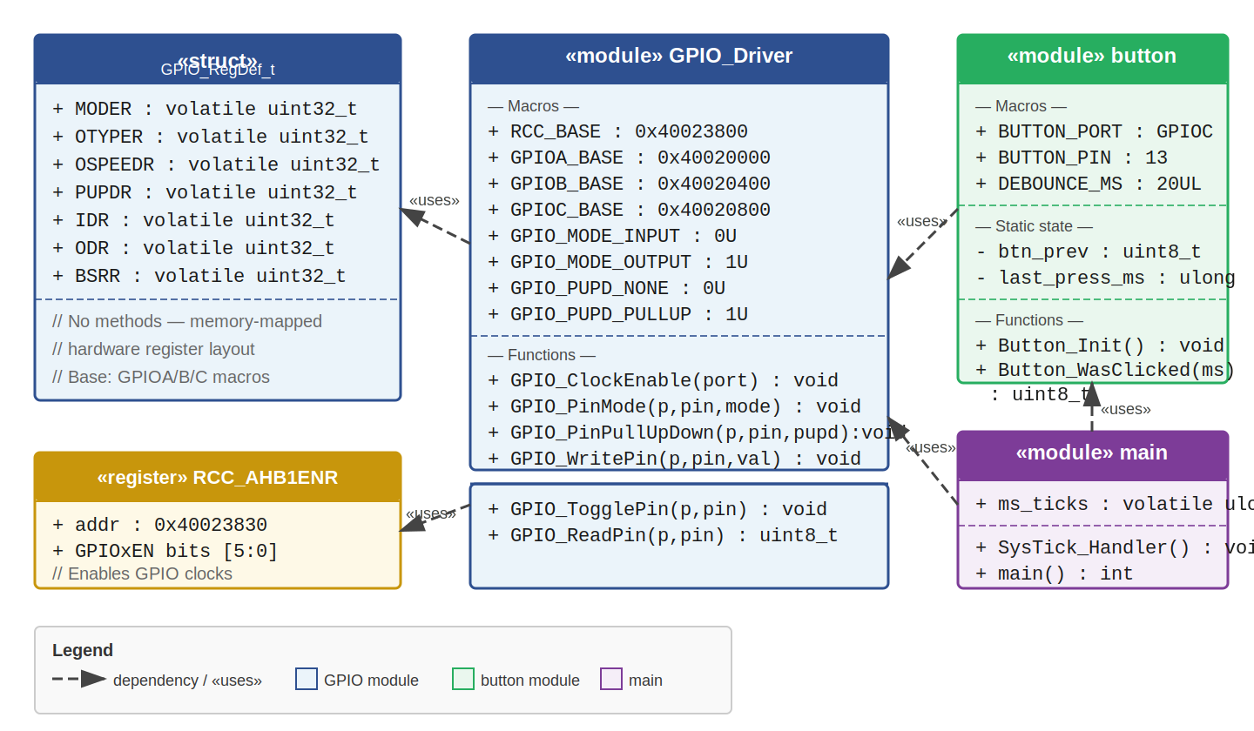
Figure 1. Class Diagram — GPIO_Driver module and its relationships

3.2. Module Behavior

Sequence Diagram 1 — GPIO Initialization
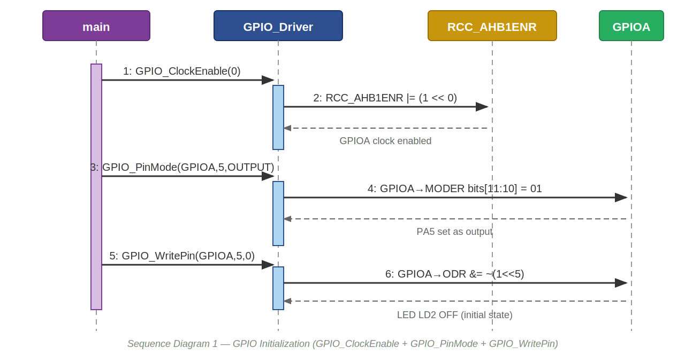
Figure 2. Sequence Diagram — GPIO_ClockEnable() + GPIO_PinMode() + GPIO_WritePin() initialization sequence

Activity Diagram 1 — GPIO_ClockEnable() + GPIO_PinMode()
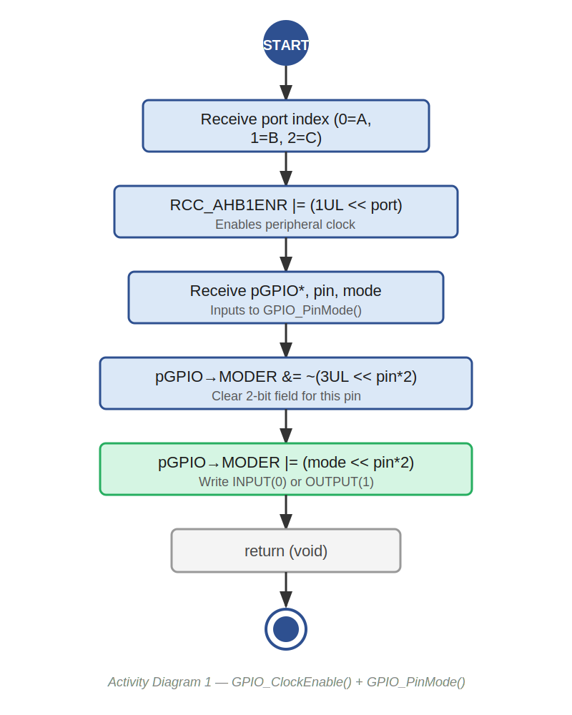
Figure 3. Activity Diagram — GPIO clock enable and pin mode configuration

Sequence Diagram 2 — GPIO_WritePin() with Conditional
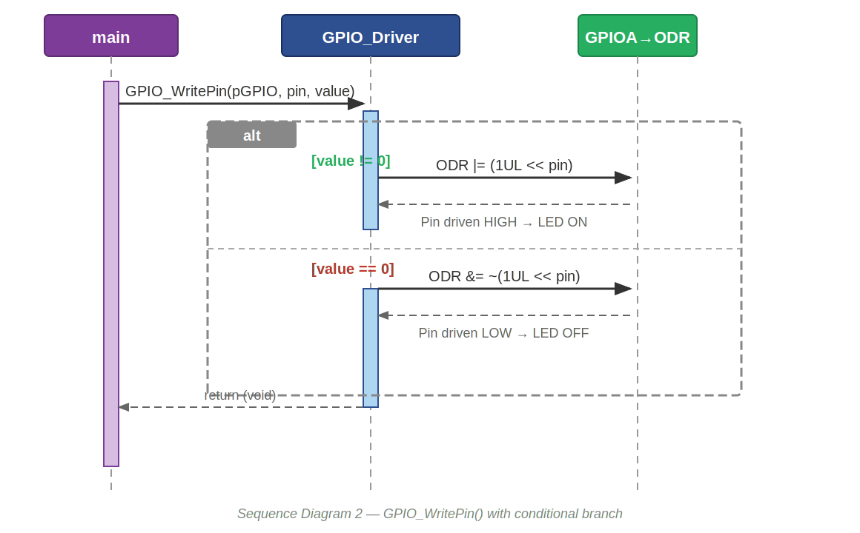
Figure 4. Sequence Diagram — GPIO_WritePin() branching on value parameter

Activity Diagram 2 — GPIO_WritePin()
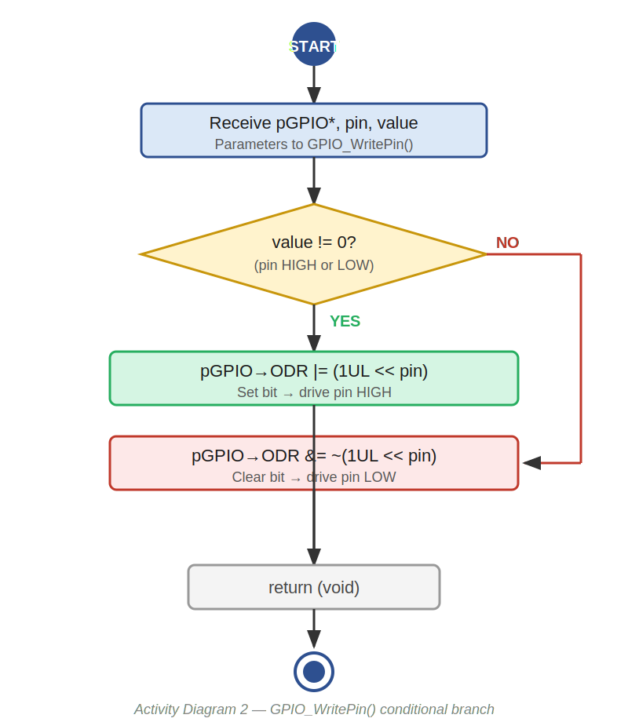
Figure 5. Activity Diagram — GPIO_WritePin() conditional branch logic

Sequence Diagram 3 — GPIO_ReadPin() in Polling Loop
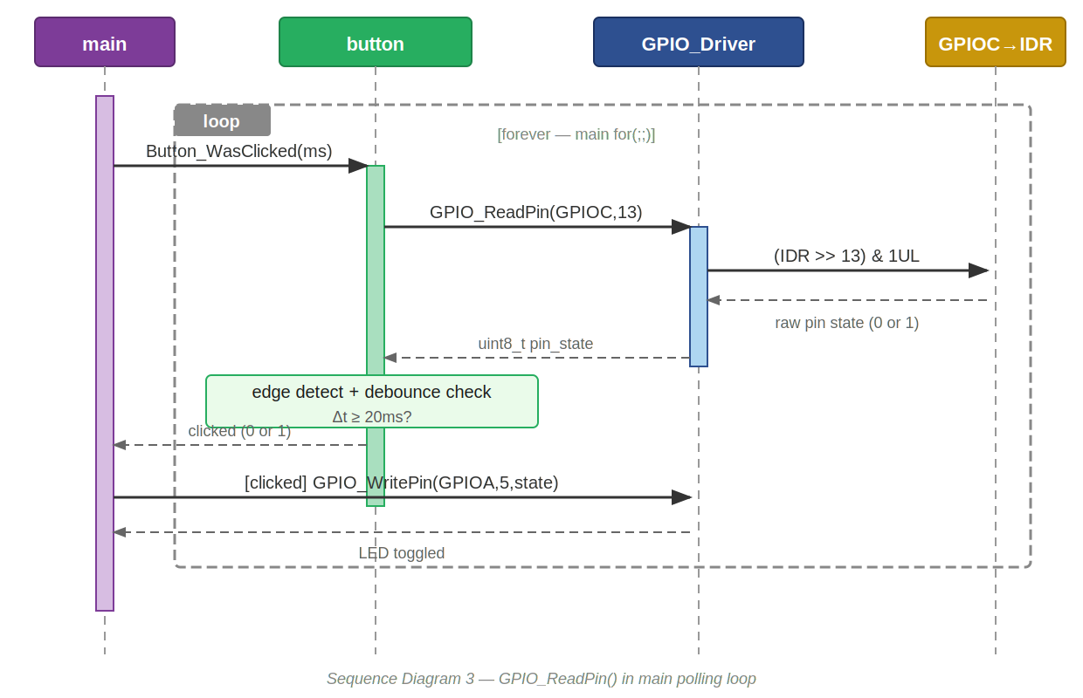
Figure 6. Sequence Diagram — GPIO_ReadPin() within the main polling loop

Activity Diagram 3 — GPIO_ReadPin()
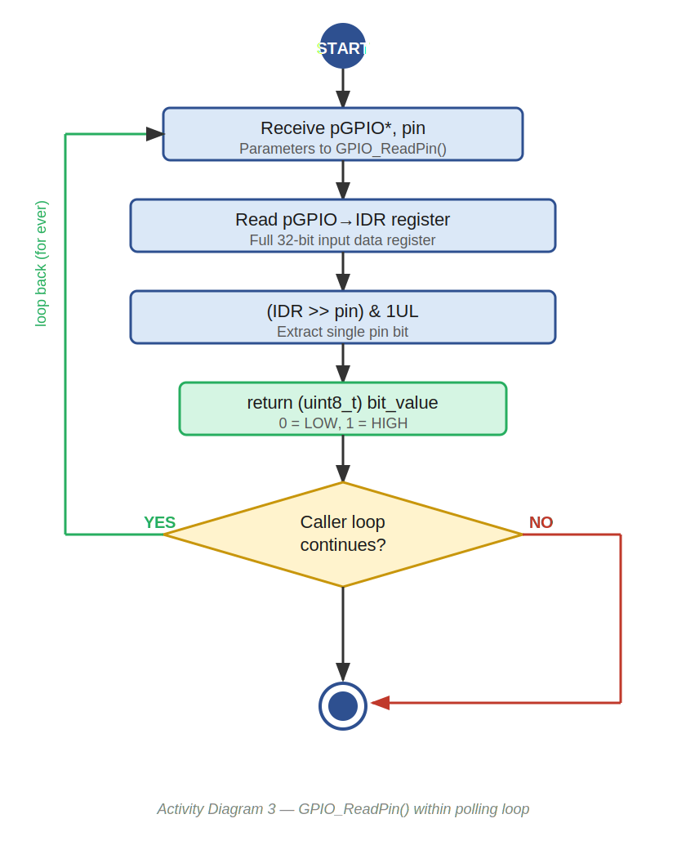
Figure 7. Activity Diagram — GPIO_ReadPin() with caller loop context

State Diagram — GPIO Pin Lifecycle
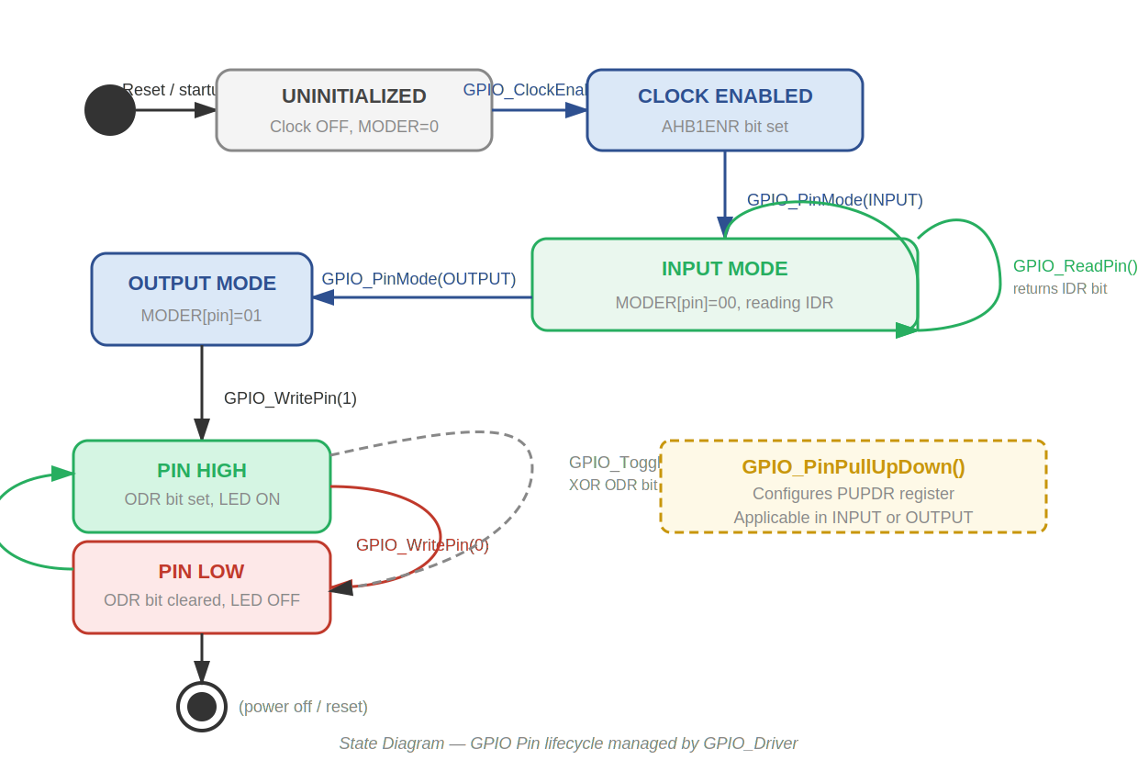
Figure 8. State Diagram — GPIO pin states managed by GPIO_Driver

3.3. GPIO_Driver Module Description
The GPIO_Driver module provides complete control over the STM32F411RE GPIO peripheral through direct register access. No HAL layer is used; all operations are performed by reading and writing hardware registers through volatile pointers.
The GPIO_RegDef_t struct (Figure 1) maps a C structure directly onto the GPIO peripheral memory layout defined in the STM32F4 Reference Manual (RM0383). Pointer macros GPIOA, GPIOB, and GPIOC cast each port's base address to this struct type, enabling field-level access to every GPIO register. Only the registers required by this driver (MODER, OTYPER, OSPEEDR, PUPDR, IDR, ODR, BSRR) are included in the struct.
Clock enabling (Figure 2, Figure 3): Before any GPIO port can be used, its clock must be enabled by setting the corresponding bit in RCC_AHB1ENR (bit 0 = GPIOA, bit 1 = GPIOB, bit 2 = GPIOC). GPIO_ClockEnable() performs a bitwise OR with a shifted mask to avoid disturbing other clock enable bits.
Pin mode configuration (Figure 2, Figure 3): GPIO_PinMode() configures the MODER register using a read-modify-write: the two-bit field for the target pin is first cleared with a NOT-masked AND, then set with an OR. This guarantees that other pins in the same port are not affected.
Digital write with conditional (Figure 4, Figure 5): GPIO_WritePin() evaluates the value parameter. A non-zero value sets the pin HIGH by ORing the ODR bit; a zero value drives it LOW by ANDing with the inverted mask. GPIO_TogglePin() performs an XOR on the ODR bit for atomic state inversion without reading current state.
Digital read in polling loop (Figure 6, Figure 7): GPIO_ReadPin() shifts the IDR register right by the pin number and masks with 1UL, returning the single-bit pin state as uint8_t. This value is consumed by the button module for edge detection and debounce filtering.
Pull-up/Pull-down configuration: GPIO_PinPullUpDown() uses the same read-modify-write pattern on the PUPDR register. For button input on PC13, the driver is called with GPIO_PUPD_NONE because the board has an external 4.7 kΩ pull-up resistor. The function is available for configurations that require internal pull resistors.

4. Application Programming Interfaces

4.1. Data Types and Macros
GPIO_RegDef_t: Struct type that maps directly onto a GPIO port's hardware registers. Cast via GPIOA/GPIOB/GPIOC macros.

Member Name | Type | Offset | Notes
MODER | volatile uint32_t | 0x00 | Pin mode: 00=Input, 01=Output, 10=Alternate, 11=Analog
OTYPER | volatile uint32_t | 0x04 | Output type: 0=Push-pull, 1=Open-drain
OSPEEDR | volatile uint32_t | 0x08 | Output speed (not configured in this driver)
PUPDR | volatile uint32_t | 0x0C | Pull-up/down: 00=None, 01=Pull-up, 10=Pull-down
IDR | volatile uint32_t | 0x10 | Input data register — read-only pin state
ODR | volatile uint32_t | 0x14 | Output data register — write pin state
BSRR | volatile uint32_t | 0x18 | Bit set/reset register (not used in this driver)

Macros defined in GPIO_Driver.h:
Macro | Value | Description
RCC_BASE | 0x40023800UL | Base address of RCC peripheral
RCC_AHB1ENR | *(volatile uint32_t*)(RCC_BASE + 0x30) | AHB1 clock enable register
GPIOA_BASE | 0x40020000UL | Base address of GPIOA port
GPIOB_BASE | 0x40020400UL | Base address of GPIOB port
GPIOC_BASE | 0x40020800UL | Base address of GPIOC port
GPIOA | (GPIO_RegDef_t*) GPIOA_BASE | Pointer to GPIOA registers
GPIOB | (GPIO_RegDef_t*) GPIOB_BASE | Pointer to GPIOB registers
GPIOC | (GPIO_RegDef_t*) GPIOC_BASE | Pointer to GPIOC registers
GPIO_MODE_INPUT | 0U | MODER field value for digital input
GPIO_MODE_OUTPUT | 1U | MODER field value for push-pull digital output
GPIO_PUPD_NONE | 0U | PUPDR field value: no pull resistor
GPIO_PUPD_PULLUP | 1U | PUPDR field value: internal pull-up enabled

4.2. Error Codes
The GPIO_Driver functions do not return error codes. All public functions are void or uint8_t (GPIO_ReadPin only). Invalid parameters (out-of-range pin numbers or null pointers) produce undefined hardware behavior; input validation is the caller's responsibility.

4.3. Function Definitions

GPIO_ClockEnable
Function Name | GPIO_ClockEnable
Syntax | void GPIO_ClockEnable(uint8_t port)
Parameters (in) | port — Index of the GPIO port (0 = GPIOA, 1 = GPIOB, 2 = GPIOC)
Parameters (inout) | None
Parameters (out) | None
Return value | void — No return value
Description | Enables the AHB1 peripheral clock for the specified GPIO port by setting the corresponding bit in RCC_AHB1ENR. Must be called before any other GPIO_Driver function on that port.
Constraints | Does not validate the port index. Calling with port > 7 sets undefined RCC bits.
Available via | GPIO_Driver.h

GPIO_PinMode
Function Name | GPIO_PinMode
Syntax | void GPIO_PinMode(GPIO_RegDef_t *pGPIO, uint8_t pin, uint8_t mode)
Parameters (in) | pGPIO — Pointer to the GPIO port (GPIOA, GPIOB, GPIOC)  pin — Pin number 0–15  mode — GPIO_MODE_INPUT (0) or GPIO_MODE_OUTPUT (1)
Parameters (inout) | None
Parameters (out) | None
Return value | void — No return value
Description | Configures the MODER register for the specified pin using a read-modify-write operation. Clears the 2-bit field then writes the requested mode without affecting other pins.
Constraints | Only INPUT and OUTPUT modes are defined. Alternate function (10) and Analog (11) modes are not supported by this driver.
Available via | GPIO_Driver.h

GPIO_PinPullUpDown
Function Name | GPIO_PinPullUpDown
Syntax | void GPIO_PinPullUpDown(GPIO_RegDef_t *pGPIO, uint8_t pin, uint8_t pupd)
Parameters (in) | pGPIO — Pointer to the GPIO port  pin — Pin number 0–15  pupd — GPIO_PUPD_NONE (0) or GPIO_PUPD_PULLUP (1)
Parameters (inout) | None
Parameters (out) | None
Return value | void — No return value
Description | Configures the PUPDR register for the specified pin using a read-modify-write. Enables or disables the internal pull-up resistor. Pull-down (10) is defined in hardware but not exposed as a macro in this version.
Constraints | GPIO_PUPD_PULLUP internally writes 01 to the 2-bit PUPDR field. Writing raw value 2 (pull-down) directly is possible but not documented as a macro.
Available via | GPIO_Driver.h

GPIO_WritePin
Function Name | GPIO_WritePin
Syntax | void GPIO_WritePin(GPIO_RegDef_t *pGPIO, uint8_t pin, uint8_t value)
Parameters (in) | pGPIO — Pointer to the GPIO port  pin — Pin number 0–15  value — 0 drives pin LOW; any non-zero value drives pin HIGH
Parameters (inout) | None
Parameters (out) | None
Return value | void — No return value
Description | Drives the specified output pin HIGH or LOW by setting or clearing the corresponding bit in the ODR register. Uses a conditional branch: non-zero value → ODR |= mask; zero → ODR &= ~mask.
Constraints | Pin must be configured as output before calling this function. Calling on an input-configured pin writes to ODR but the value is reflected on the output latch, not the pad.
Available via | GPIO_Driver.h

GPIO_TogglePin
Function Name | GPIO_TogglePin
Syntax | void GPIO_TogglePin(GPIO_RegDef_t *pGPIO, uint8_t pin)
Parameters (in) | pGPIO — Pointer to the GPIO port  pin — Pin number 0–15
Parameters (inout) | None
Parameters (out) | None
Return value | void — No return value
Description | Inverts the current state of an output pin by performing a bitwise XOR on the ODR register. Does not require reading the current pin state.
Constraints | Pin must be configured as output. Not used directly in Lab 1 (led_state software variable used instead), but available for future use.
Available via | GPIO_Driver.h

GPIO_ReadPin
Function Name | GPIO_ReadPin
Syntax | uint8_t GPIO_ReadPin(GPIO_RegDef_t *pGPIO, uint8_t pin)
Parameters (in) | pGPIO — Pointer to the GPIO port  pin — Pin number 0–15
Parameters (inout) | None
Parameters (out) | None
Return value | uint8_t — 0 if pin is LOW, 1 if pin is HIGH
Description | Reads the current logic state of the specified input pin from the IDR register. Shifts IDR right by pin and masks with 1UL to isolate the target bit.
Constraints | Reads IDR regardless of pin mode. For output pins, IDR reflects the pad voltage (not necessarily the ODR value if the load pulls the line).
Available via | GPIO_Driver.h

4.4. Internal Function Definitions
The GPIO_Driver module has no internal (static) functions. All logic is implemented directly within the public functions. There are no helper or private routines.

5. Future Enhancements
• Add GPIO_PUPD_PULLDOWN macro and pull-down support in GPIO_PinPullUpDown().
• Implement GPIO_MODE_AF (alternate function) configuration via MODER and AFR registers.
• Add atomic pin write using BSRR register to replace ODR read-modify-write (eliminates read-modify-write race on multi-threaded systems).
• Add OTYPER configuration (open-drain support) via an extended GPIO_PinMode() or a new GPIO_SetOutputType() function.
• Add input validation with a defined error-code return type (e.g., GPIO_Status_t) for robustness in production firmware.

