ENDTERM PROJECT
Real-Time Monitoring, Time-Series Analysis,
and Stream Intelligence
ISS Telemetry Analytics System
Technologies: Python, Pandas, NumPy, Matplotlib, scikit-learn, Streamlit
Dataset: 8,640 International Space Station telemetry events sampled every 10 seconds
Technical Report

1. Executive Summary and Requirement Coverage
This project extends a timestamped ISS telemetry stream into an intelligent analytics system that combines continuously updated visualization, temporal analysis, anomaly detection, real-time machine learning, and a distributed stream-processing simulation. The implementation is based on the supplied one-day dataset and is designed to be reproducible in Python without requiring external real-time infrastructure during defence. A Streamlit dashboard is provided for the visual demonstration, while the notebook and Python modules reproduce the analytical results and stream-processing metrics.
The dataset contains 8,640 chronologically ordered observations from 7 June 2025, covering exactly 24 hours at a 10-second sampling interval. The processed version includes position, altitude, speed, trailing rolling statistics, altitude rate and a supplied anomaly label. There are 457 labeled anomalies, or approximately 5.29% of all observations. This allows the anomaly component to be evaluated quantitatively instead of only presenting visually selected points.
Requirement | Implementation | Evidence
Continuously updated visualization | Streamlit replay dashboard | Live altitude and speed charts plus KPIs
Time-series analysis | 1-minute resampling, 5-minute rolling trends, FFT period estimate | Dominant period ≈ 102.9 min
Anomaly detection | Isolation Forest | Precision/Recall/F1 on chronological test segment
Real-time ML | Random Forest classifier | Next-altitude direction prediction
Prediction-time features | Current and trailing-only features | No future feature used as input
Distributed processing | Producer + 3 FIFO partitions + 3 workers | Parallel partition consumers and aggregation
Operational metrics | Event count, throughput, latency, backlog | Saved automatically to JSON

2. Dataset, Preprocessing, and Online-Safe Features

2.1 Dataset structure
The raw ISS dataset contains timestamp, latitude, longitude, altitude in kilometers, speed in kilometers per hour, hemisphere, and region. The processed dataset preserves these variables and adds streaming-oriented attributes: speed in meters per second, rolling average altitude, rolling average speed, rolling altitude standard deviation, historical minimum and maximum altitude, altitude rate, anomaly flag, and cumulative event count. No missing values are present in the 8,640 processed rows.
Property | Value | Property | Value
Events | 8,640 | Time span | 24 hours
Sampling | 10 seconds | Anomaly labels | 457
Altitude range | 365.61–385.82 km | Mean altitude | 374.98 km
Mean speed | 27672.86 km/h | Missing values | 0

2.2 Feature design and leakage prevention
A central project requirement is that prediction features must contain only information available at prediction time. The classifier therefore uses the current latitude, longitude, altitude and speed, plus trailing rolling averages, trailing rolling altitude standard deviation, and altitude rate computed from the current and previous observation. These variables can be calculated immediately when event t arrives. The future sample t+1 is used only to create the training target and is never included as a feature.
- rolling_avg_altitude and rolling_avg_speed summarize the recent stream without looking ahead;
- rolling_altitude_std measures short-term altitude variability;
- altitude_rate captures the current change relative to the previous timestamp;
- chronological train/test splitting prevents observations from the future portion of the day from being randomly mixed into training.

2.3 Reproducibility
The project folder contains the original and processed CSV files, Python modules, a defense-friendly notebook, trained model artifacts, generated figures, JSON metric files, and a README with local and Google Colab instructions. The fixed random seed is 42. Running run_all.py retrains the models, repeats the time-series analysis, and executes the distributed stream simulation.

3. System Architecture and Distributed Stream Design
The system is organized as a streaming pipeline rather than a single batch script. The producer replays the timestamped ISS events. A deterministic round-robin partitioner sends events to three FIFO queues. Three worker threads consume their assigned partitions independently. Each worker applies the anomaly detector and next-altitude classifier, attaches model outputs and latency information, and forwards the processed event to an aggregation stage. The final stage writes processed stream results and operational metrics and supplies the information used by the dashboard.
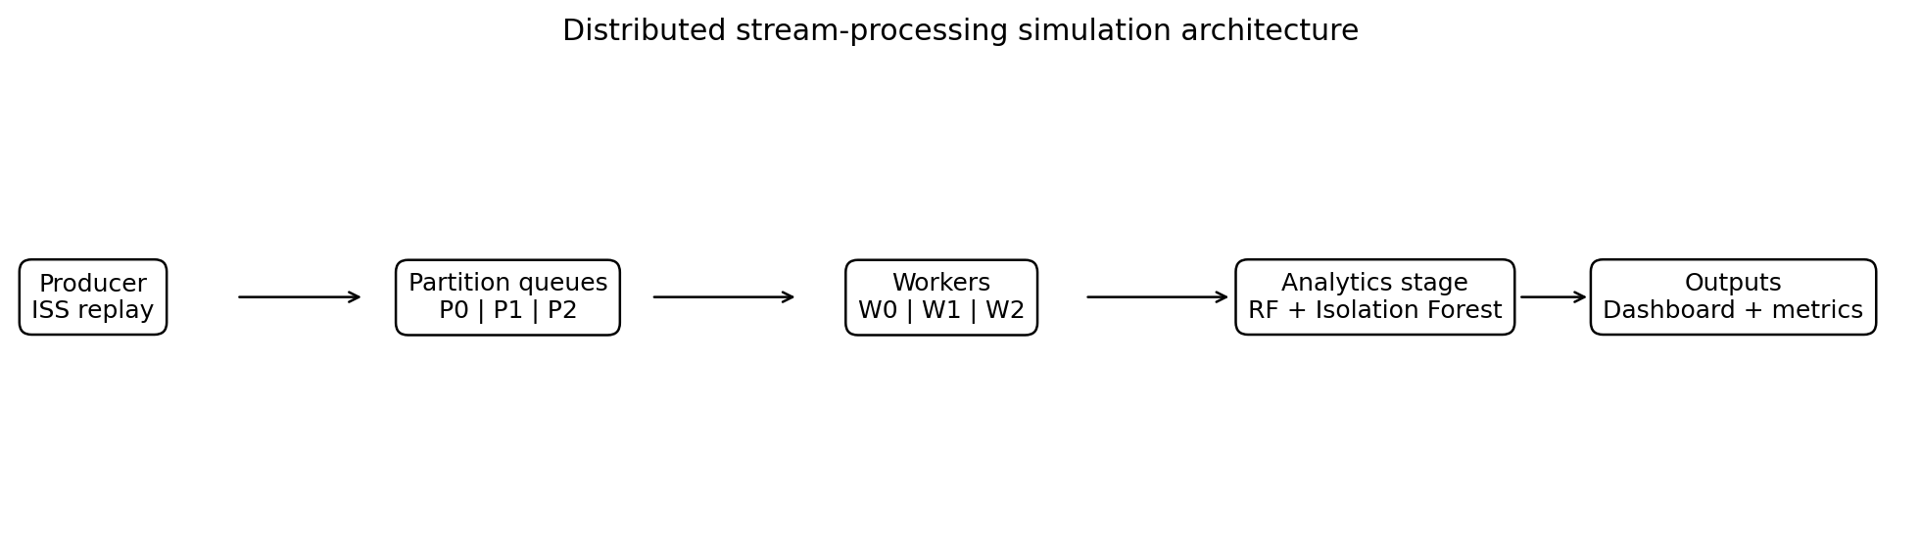
Figure 1. Distributed stream-processing simulation architecture.

3.1 Why the simulation satisfies the distributed requirement
The assignment explicitly allows Kafka, Spark, Flink, or a suitable simulation. The implemented prototype demonstrates the core concepts that a framework such as Kafka would provide for this project: a producer, partitioned streams, independent consumers, order preservation inside each partition, parallel processing stages, and aggregation. Using standard Python queues makes the demonstration portable to a classroom computer or Colab environment while preserving the conceptual architecture.

3.2 Partition ordering and parallelism
Global ordering is not guaranteed once multiple partitions are used, but the FIFO queue of each partition preserves its local sequence. Results contain the original sequence number, so the aggregation stage can reconstruct global order when required. This mirrors a common distributed-streaming trade-off: partitioning improves parallelism but ordering is naturally scoped to each partition.

4. Time-Series Analysis and Real-Time Visualization

4.1 Temporal aggregation and trend extraction
The original stream is sampled every 10 seconds. For higher-level temporal interpretation, altitude and speed are resampled to one-minute means, resulting in 1,440 points across the day. A trailing five-minute rolling mean is then applied to each one-minute series. The resampled values preserve the broader trajectory while the rolling mean makes the trend easier to interpret and reduces short-term variation.
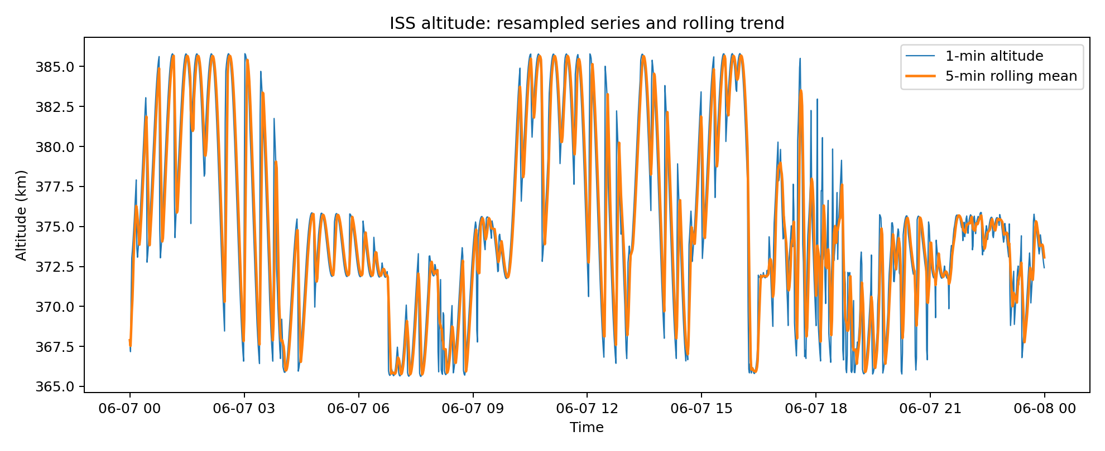
Figure 2. One-minute ISS altitude with a five-minute rolling trend.
A frequency-domain check was also performed on the one-minute altitude series. Within the 60–120 minute search band, the strongest repeating component has an estimated period of approximately 102.9 minutes. This value is reported as a characteristic of this dataset rather than as a claim about an exact physical orbital period.

4.2 Continuously updated dashboard
The Streamlit dashboard replays incoming events in batches and updates two required charts continuously: altitude with its rolling average, and speed with its rolling average. Additional KPI panels show the number of processed events, anomaly count, current altitude, and the classifier probability that the next altitude will increase. The dashboard therefore combines monitoring and model output in one demonstration surface.

5. Anomaly Detection

5.1 Method
Isolation Forest was selected because it is an unsupervised anomaly-detection method and can therefore identify unusual telemetry patterns without using the anomaly label during fitting. The model is trained on the first 70% of the chronological stream and evaluated on the final 30%. Two compact current-event features are used: altitude_rate and speed_kmph. A contamination setting of 0.03 represents the assumption that unusual observations are rare.
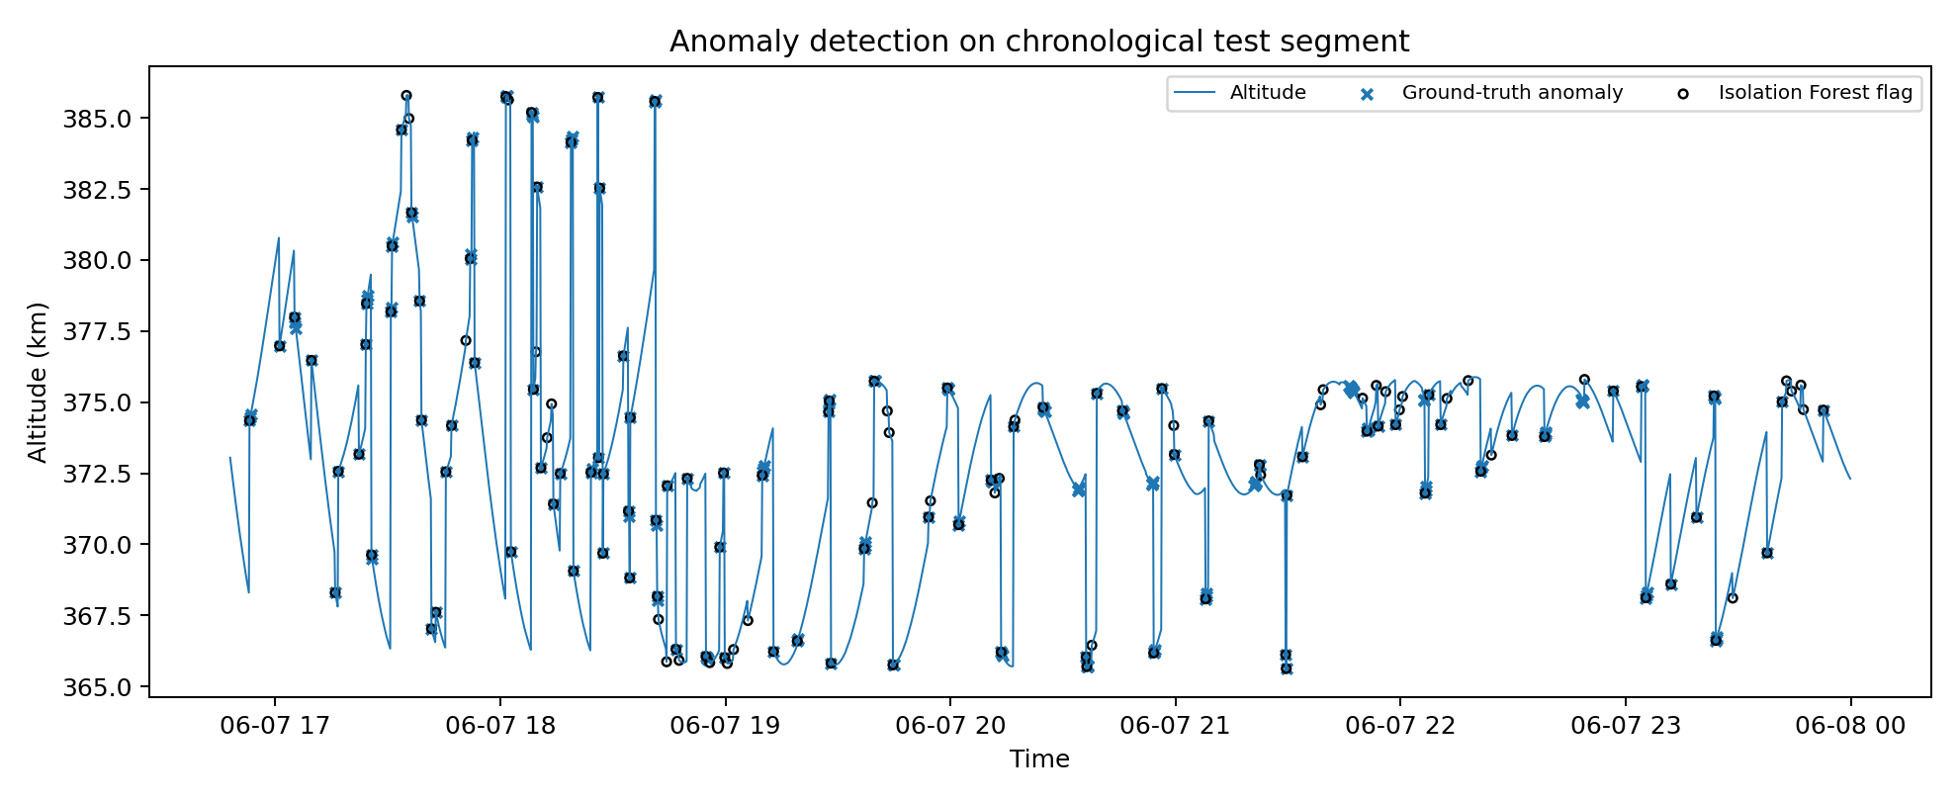
Figure 3. Isolation Forest detections compared with supplied anomaly labels on the test segment.

5.2 Evaluation
Precision | Recall | F1 | True anomalies | Predicted anomalies
0.718 | 0.510 | 0.596 | 200 | 142
On the chronological test segment, the detector achieves precision 0.718, recall 0.510, and F1 0.596. The confusion matrix contains 102 true positives, 40 false positives, 98 false negatives, and 2352 true negatives. Precision is higher than recall, meaning the model is comparatively selective: when it flags an event it is often correct, but it does not recover every supplied anomaly.
This result is appropriate for a realistic anomaly-detection demonstration. The supplied labels capture more than one type of unusual behavior, while the Isolation Forest receives only two current-event features. A production extension could incorporate additional rolling residuals, multivariate trajectory features, or an adaptive threshold to improve recall.

6. Real-Time Machine-Learning Component

6.1 Prediction task and model
The real-time ML task is binary classification: given the current event, predict whether the next altitude sample will be higher than the current altitude. This task is well suited to streaming because every new event can immediately produce a prediction for the next step, and the prediction can later be evaluated when the next event arrives. A Random Forest classifier is trained on the first 70% of the data and tested on the final 30% in chronological order.
Accuracy | F1 | ROC-AUC | Test events
0.959 | 0.964 | 0.975 | 2592
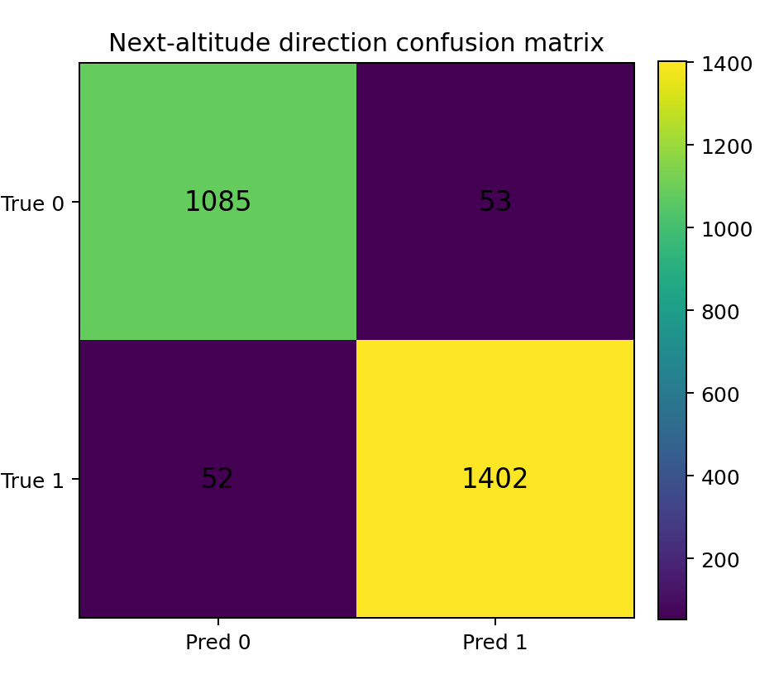
Figure 4. Confusion matrix for next-altitude direction prediction.
The classifier achieves 95.95% accuracy, F1 0.964, and ROC-AUC 0.975 on 2592 unseen chronological test events. The confusion matrix shows 1085 correctly predicted non-up events and 1402 correctly predicted up events, with only 105 total misclassifications.

6.2 Feature interpretation
The Random Forest uses current spatial coordinates, altitude, speed, trailing altitude and speed averages, rolling altitude variability, and altitude rate. Feature importance is reported for transparency, but the primary validity check is temporal: every feature is known at the moment the current event is processed. The future altitude is used only to create the label for supervised learning.

7. Operational Evaluation of the Stream Pipeline
The distributed demonstration was executed over all 8,640 events using three workers. The benchmark intentionally sends the events as an accelerated burst rather than respecting the original 10-second interval. This stress-tests the queueing behavior and makes backlog visible during a short classroom demonstration. Therefore the measured latency below is end-to-end queue latency under overload, not the latency expected if events arrive every 10 seconds in real time.
Events | Workers | Throughput | P95 latency | Max backlog
8640 | 3 | 794.2 ev/s | 9916 ms | 8478
In the recorded run, throughput was approximately 794.2 events per second. The maximum observed backlog was 8478 queued events and the p95 end-to-end latency was approximately 9.92 seconds. The large backlog is expected because the producer intentionally injects the complete day much faster than the original stream rate. This creates a clear operational example of what happens when arrival rate temporarily exceeds processing capacity.

7.1 Operational interpretation
- Event count verifies that the complete supplied stream was processed.
- Throughput measures how quickly the analytics workers can complete events in the accelerated replay.
- Backlog shows queue pressure when the producer outruns consumers.
- P95 latency measures the time from enqueueing to completion for 95% of events under the stress-test workload.
- The separate dashboard replay uses a slower human-readable refresh pace, so it demonstrates live monitoring rather than overload.

7.2 Scaling options
A future implementation can replace the Python queues with Kafka partitions and deploy consumers as separate processes or containers. Additional partitions can increase parallelism, while batching model inference can improve throughput. Monitoring can also be extended with per-partition lag, consumer utilization, rolling throughput and service-time percentiles.

8. Reproducibility, Limitations, and Conclusion

8.1 How to reproduce the project
- Install dependencies from requirements.txt.
- Run python run_all.py to train models, produce analytical figures and execute the stream benchmark.
- Open ISS_Endterm_Project.ipynb for the step-by-step defense version; the executed copy contains stored outputs.
- Run streamlit run dashboard.py and press Start / restart replay to demonstrate continuously updated charts.
- All model and operational metrics are saved under outputs/ and can be cited directly in the report or presentation.

8.2 Limitations
The project uses a single 24-hour dataset, so conclusions about longer-term behavior should be made cautiously. The anomaly ground truth is supplied with the processed dataset; it is not independently verified against external spacecraft events. The stream distribution layer is a Python simulation rather than a production message broker, although it explicitly models partitioning, independent consumers, order preservation and backlog. Finally, the ML task predicts only the direction of the next altitude movement rather than a long-horizon physical trajectory.

8.3 Conclusion
The endterm project meets the requested coverage across Weeks 5–8 in one coherent ISS telemetry application. It provides continuously updated monitoring, timestamp-based resampling and rolling analysis, a quantitatively evaluated anomaly detector, a strong real-time classification component with prediction-time-safe features, and a distributed stream-processing demonstration with measured throughput, latency, event count and backlog. The design is intentionally reproducible and defense-friendly: the same project can be demonstrated in a notebook, through individual Python scripts, or with the live Streamlit dashboard.

8.4 Short demonstration sequence
- Show the dataset and explain the 10-second timestamped stream.
- Run the time-series cell and point out one-minute resampling and five-minute rolling trends.
- Show Isolation Forest metrics and explain the precision–recall trade-off.
- Show Random Forest F1/ROC-AUC and explain why no future feature is used.
- Run the three-worker stream benchmark and point to throughput, latency and backlog.
- Finish with the Streamlit dashboard and two continuously updating charts.

References
Liu, F. T., Ting, K. M., & Zhou, Z.-H. (2008). Isolation Forest. Proceedings of the IEEE International Conference on Data Mining.
Breiman, L. (2001). Random Forests. Machine Learning, 45, 5–32.
scikit-learn documentation: IsolationForest, RandomForestClassifier, model evaluation metrics.
Pandas documentation: time-series resampling and rolling-window operations.

