Homework: 1 CS 205. Introduction to Artificial Intelligence
Due Date: Jan 26th
Crossing the River
On the bank of a river are 1 adult, 2 children and a very small rowboat. We want to get all of the people across the river by rowing.
The boat will hold:

- 2 children or
- a single child or
- a single adult (it is too small to hold an adult and a child)

All of the people can row.

I) Draw the search space, you may use a computer drawing package (MS PowerPoint works reasonably well) or you may do it by hand (in which case I expect it to be extremely neat).
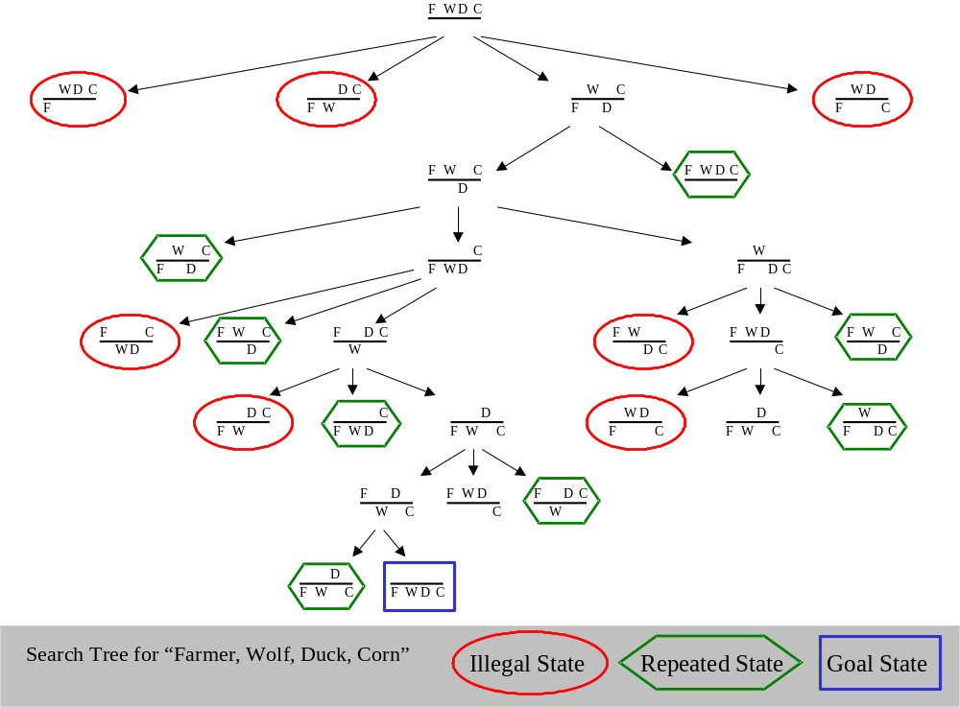
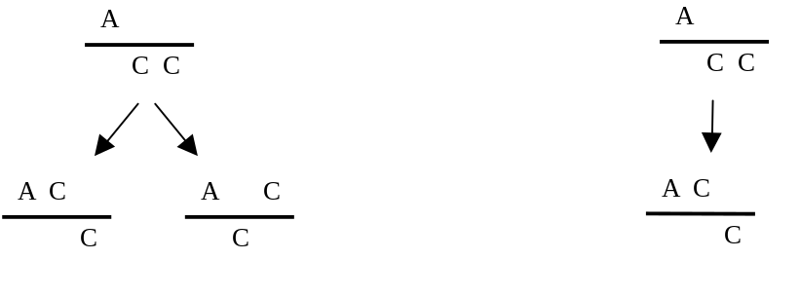
Note that you should take advantage of the symmetry to reduce the branching factor. There is really no difference between the two children and your tree should reflect this (to be clear look at the examples below and assume that the boat is with the children in the parent node).
Don’t do this!
It is wasteful, since the left and right children are logically equivalent.
Do this.
Sample of desired format

2) Exhaustive search

Consider the 8-queens problem. Imagine that we are going to try to solve it using exhaustive search (we are simply going to enumerate every possible arrangement of the 8-queens on a standard chessboard and check each arrangement to see if it is a solution). Note that for this assignment we are going to be a little inefficient and generate all arrangements, including arrangements that are identical after rotation and reflection. For each question, be sure to show all work.

A) Assume that you can generate and check 1,000 arrangements per second. Approximately how long will it take to test all arrangements (give the answer in meaningful units, ie don’t write “Approximately 1805 seconds”, write “Approximately 30 minutes”). Clearly state any assumptions you are making.

B) Assume you just want to find any answer (not all of them). I happen to know that there are 12 possible solutions. Approximately how long will we have to wait for a solution?

C) Consider the following problem. We want to put 9 queens on a standard chessboard such that none are attacking each other. We can quickly see that this impossible, but even if we could not, we could do exhaustive search, and as soon as the search ended without finding an answer, we could be convinced that no such solution existed.
Can you come up with a problem for which exhaustive search cannot show that a solution does not exist? (Your answer does not have to involve games, but it may) Hint, I can think of several answers to this question that could be written on a single line. If you are spending more than 15 minutes on this question, come see me for hints (but do not email me for hints on just this question).

D) The more general version of the 8-queens problem is called the n-queens problem, where we try to find an arrangement of n-queens on an n by n board such that none are attacking each other. Draw a complete search tree for n = 4 and find all the solutions (if any). Draw only the legal states to save space (although you should realize that any algorithm (including your mind!) has to actually generate the illegal states in order to prune them).
To reduce the size of the tree we can use a little common sense. Once we place a queen on a row, we can never place another queen on the same row. So we can systemically start with an empty board, and expand to every possible placement of a queen on row one, then expand those nodes to every legal possible placement of a queen on row two etc.
I have done a little to get you started…
Row 1
Row 2
Row 3
Row 4

