國立臺北大學資訊工程學系
Department of Computer Science & Information Engineering
National Taipei University

碩士論文
Master Thesis

指導教授：陳裕賢 博士
Advisor：Dr. Yuh-Shyan Chen
基於鯰魚式的深度強化學習之射頻鏈與反射元件之節能聯合開關控制在 RIS 輔助 6G 網路
CDRL: Catfish-Effect-Based Deep Reinforcement Learning for Energy-Efficient Joint Switching of RF Chains and Reflecting Elements in RIS-Aided 6G Networks

研究生：柯博瀚
Student：Bo-Han, Ke

中華民國 114 年 7 月
July, 2025

Abstract
A reconfigurable intelligent surface (RIS) is an emerging communications technology that enhances link performance by reflecting electromagnetic signals. To address the challenges of high-power consumption and hybrid discrete-continuous control introduced by active/passive RIS in millimeter-wave downlink MU-MISO systems. This thesis proposes a Catfish-effect-based deep reinforcement learning framework (Catfish-effect-based DRL, CDRL) for simultaneously optimizing BS and RIS element‐switch control and beamforming, ultimately maximizing energy efficiency (EE). In this thesis, the CDRL framework comprises two agents: the catfish agent and the main agent. The catfish agent diverts according to an energy-efficiency threshold to focus on collecting high-reward experiences, and is paired with a larger discount factor and a competitive reward mechanism. The main agent handles general scenarios and, during the random intervention phase, the catfish agent injects its long-term knowledge into the main agent, achieving experience-level knowledge transfer and improved sample efficiency. This dual-agent, dual-replay design advances DRL-based EE optimization for RIS systems with joint switching control, and effectively mitigates policy stagnation issues often observed in single-agent settings. Simulation results demonstrate that CDRL outperforms baseline DRL, the analytical method BPOF, and Teacher-Student frameworks in both active and passive RIS scenarios. CDRL achieves significant power savings under rate constraints, validating the feasibility of integrating the catfish effect with DRL for wireless resource allocation. This thesis highlights a new direction for green communications in 6G, motivated by the synergy between BS control strategies and active RISs to reduce energy consumption while maintaining transmission quality.
Keywords: 6G Mobile Network, Deep Learning, Reconfigurable Intelligent Surfaces (RIS), Energy Efficiency, Beamforming, Phase Shift.

可重構智慧表面（RIS）是一種新興的通訊技術，透過反射電磁訊號來增強鏈路性能。為因應 6G 毫米波下行 MU-MISO 系統中主/被動 RIS 帶來的高功耗與高維離散–連續混合控制難題。本文提出一套鯰魚式深度強化學習架構 (Catfish-effect-based DRL，簡稱 CDRL) ，用以同時最佳化 BS 與 RIS 的元件開關控制及波束成形，最終達到最大化能源效率的目的。本文提出的 CDRL 是由 catfish 與 main 雙代理組成。 Catfish agent 透過能效門檻分流專注蒐集高獎勵經驗，並配以較大折扣係數及競爭獎勵機制。 Main agent 則處理一般情境，並在隨機干預階段 catfish agent 透過將自身的長期知識注入 main agent ，實現經驗級知識轉移與樣本效率提升。此「雙代理-雙回放」設計為將 DRL 應用於主動 RIS 結合元件開關之能源效率最佳化研究，並有效避免單代理策略僵化。模擬結果顯示，CDRL 於主/被動 RIS 場景的能源效率均優於基礎 DRL、數學解析法 BPOF 及 Teacher-Student 框架。能在滿足速率約束下顯著降低總功耗，驗證了鯰魚效應結合 DRL 於無線資源配置問題的可行性，並為 6G 綠色通訊提供新方向。這項研究的動機在於透過基地台控制技術與主動智能反射面的協同作用，在維持一定的傳輸品質下，實現 6G 綠色通訊的節能和省電的目標。

1. Introduction
To accommodate the massive transmission demands of 6G, millimeter-wave (mmWave) massive multiple-input single-output/multiple-input multiple-output (Massive MISO/MIMO) technology has become a popular research direction and practical strategy in this field [4-5][7-14][16-17][19-20]. mmWave transmission enables increased spectrum utilization and enhanced data rates. However, due to its high-frequency characteristics, it results in relatively short propagation distances and severe path loss [10][14]. MIMO technology effectively addresses these issues by supporting multiple users, improving signal strength, and extending communication coverage. MIMO allows the multiple antennas at the base station to perform beamforming, which significantly enhances the performance of wireless systems by enabling directional signal transmission. This improves the signal-to-noise ratio (SNR), mitigates co-channel interference, and increases network capacity [1]. Conventionally, MIMO precoding is realized through a fully digital (FD) method, where each antenna element is equipped with a dedicated radio frequency (RF) chain [23]. However, deploying an RF chain for every antenna at the base station leads to high hardware cost and power consumption [13][14]. Therefore, hybrid beamforming (HBF) is commonly adopted under this architecture to achieve satisfactory beamforming gains with reasonable hardware complexity and power consumption [10][13][14].
Due to the susceptibility of millimeter-wave (mmWave) communications to environmental blockages such as walls and trees, which cause severe penetration loss, reconfigurable intelligent surfaces (RIS) have been proposed to assist hybrid beamforming (HBF) [14]. RIS is an emerging next-generation technology that controls the reflection of electromagnetic waves by reconfiguring the electromagnetic properties of the surface. RIS can effectively improve signal transmission efficiency [5][10][14], expand wireless network coverage, and enhance transmission quality [4][16][18]. These reflective surfaces are strategically deployed between the transmitter and receiver, providing users with an additional communication link and improving signal strength [10]. However, this induces multiplicative fading, leading to limited capacity gains for conventional RIS [9]. Specifically, the communication channel reflected via RIS experiences two stages of propagation loss, meaning that the equivalent path loss of the transmitter-RIS-receiver link is the product of the transmitter-to-RIS and RIS-to-receiver path losses [10]. In general, conventional RIS consists of a large number of passive elements, each capable of independently adjusting the phase of the incident electromagnetic wave to redirect the signal toward the target receiver [18]. In contrast, active RIS is a new type of RIS that can simultaneously adjust the phase shift and amplify the received signal, thereby mitigating signal attenuation and eliminating the double fading effect associated with multiplicative fading [9]. This enables active RIS to provide better communication performance under weak signal power conditions.
Network energy saving is critical for environmental sustainability, reducing environmental impact (e.g., greenhouse gas emissions), and lowering operational costs [2]. In wireless communications, although the use of beamforming techniques at the transmitter via MIMO and RIS-assisted transmission brings several advantages as mentioned above, such considerations often lead to high power consumption. Therefore, improving energy efficiency while maintaining acceptable transmission performance has become a vital issue. Laselva et al. evaluated the potential of each radio domain, where radio adaptation in the antenna domain involves adjusting the number of antennas (or antenna ports) used for transmission by the base transceiver station (BTS), which in turn affects the total transmit power [3]. This implies that deactivating specific antenna elements can reduce energy consumption, and this concept can also be extended to RIS. Since RIS requires power supply to enable effective signal reflection, selectively activating and deactivating reflecting elements can optimize RIS energy usage [9]. However, due to the large number of elements involved and the mutual interference among multiple users and multiple RIS units, jointly adjusting the phase shifts and on-off states becomes a complex challenge. Therefore, the proposed solution adopted in this thesis will be presented in the following chapters.
With the increasing structural and functional complexity of RIS, efficiently controlling a large number of RIS elements—including phase adjustment, on-off switching, and even power amplification—has become a major challenge, especially under multi-user scenarios, dynamic channels, or imperfect channel state information [12][19][20][17]. Traditional optimization approaches, such as convex programming and heuristic methods, often struggle to balance efficiency and accuracy in these high-dimensional and non-convex problems [11][12][17]. As a result, machine learning (ML) is increasingly regarded as a promising tool for assisting resource allocation in communication systems, particularly due to its ability to model unknown environments and complex dependencies. Among various ML techniques, deep reinforcement learning (DRL) exhibits strong advantages in handling high-dimensional and sequential decision-making problems [19][20]. Compared with traditional methods, DRL is especially beneficial in wireless systems with time-varying radio channels. By modeling the communication system as a Markov Decision Process (MDP), DRL can solve complex optimization problems without explicitly formulating system models such as channel or mobility models, instead learning through interaction with the environment and observing reward signals [11][15][20][17]. DRL is particularly well-suited for hybrid action spaces involving both discrete actions (e.g., RIS switching) and continuous actions (e.g., power amplification) [19][20][17]. These features make DRL one of the most active research directions for intelligent RIS control.
To address these issues, we propose a novel Catfish-effect-based Deep Reinforcement Learning algorithm (CDRL), as illustrated in Fig. 1. We design two task-oriented agents, where the Catfish Agent provides differentiated experiences to effectively stimulate the Main Agent to explore better policies, thereby avoiding local optima. In summary, the contributions of this thesis are outlined as follows:
- To the best of our knowledge, the proposed Catfish-effect-based Deep Reinforcement Learning (CDRL) framework is the first to address the integration of active RIS with element switching control using DRL. CDRL employs two competing DRL agents to optimize communication performance.
- In the proposed CDRL approach, we design three core mechanisms: all experiences are separated based on an energy efficiency (EE) threshold, the two DRL agents are assigned different discount factors to focus on distinct objectives, and the catfish agent is provided with an adaptive competitive reward mechanism to promote mutual competition between the agents.
- In this study, we evaluate our method against a baseline DRL approach, an analytical solution under the same communication environment, and a teacher-student framework. Experimental results demonstrate that our method outperforms both the mathematical solution and teacher-student models under the same conditions, validating the superiority of our approach.
The rest of the thesis is organized as follows. Chapter 2 describes related work and motivation. Chapter 3 introduces the system model, problem formulation, basic concepts, and comparison of Catfish-DRL with adversarial models. Chapter 4 describes the CDRL scheme. Chapter 5 shows the simulation results. Finally, chapter 6 concludes the thesis.

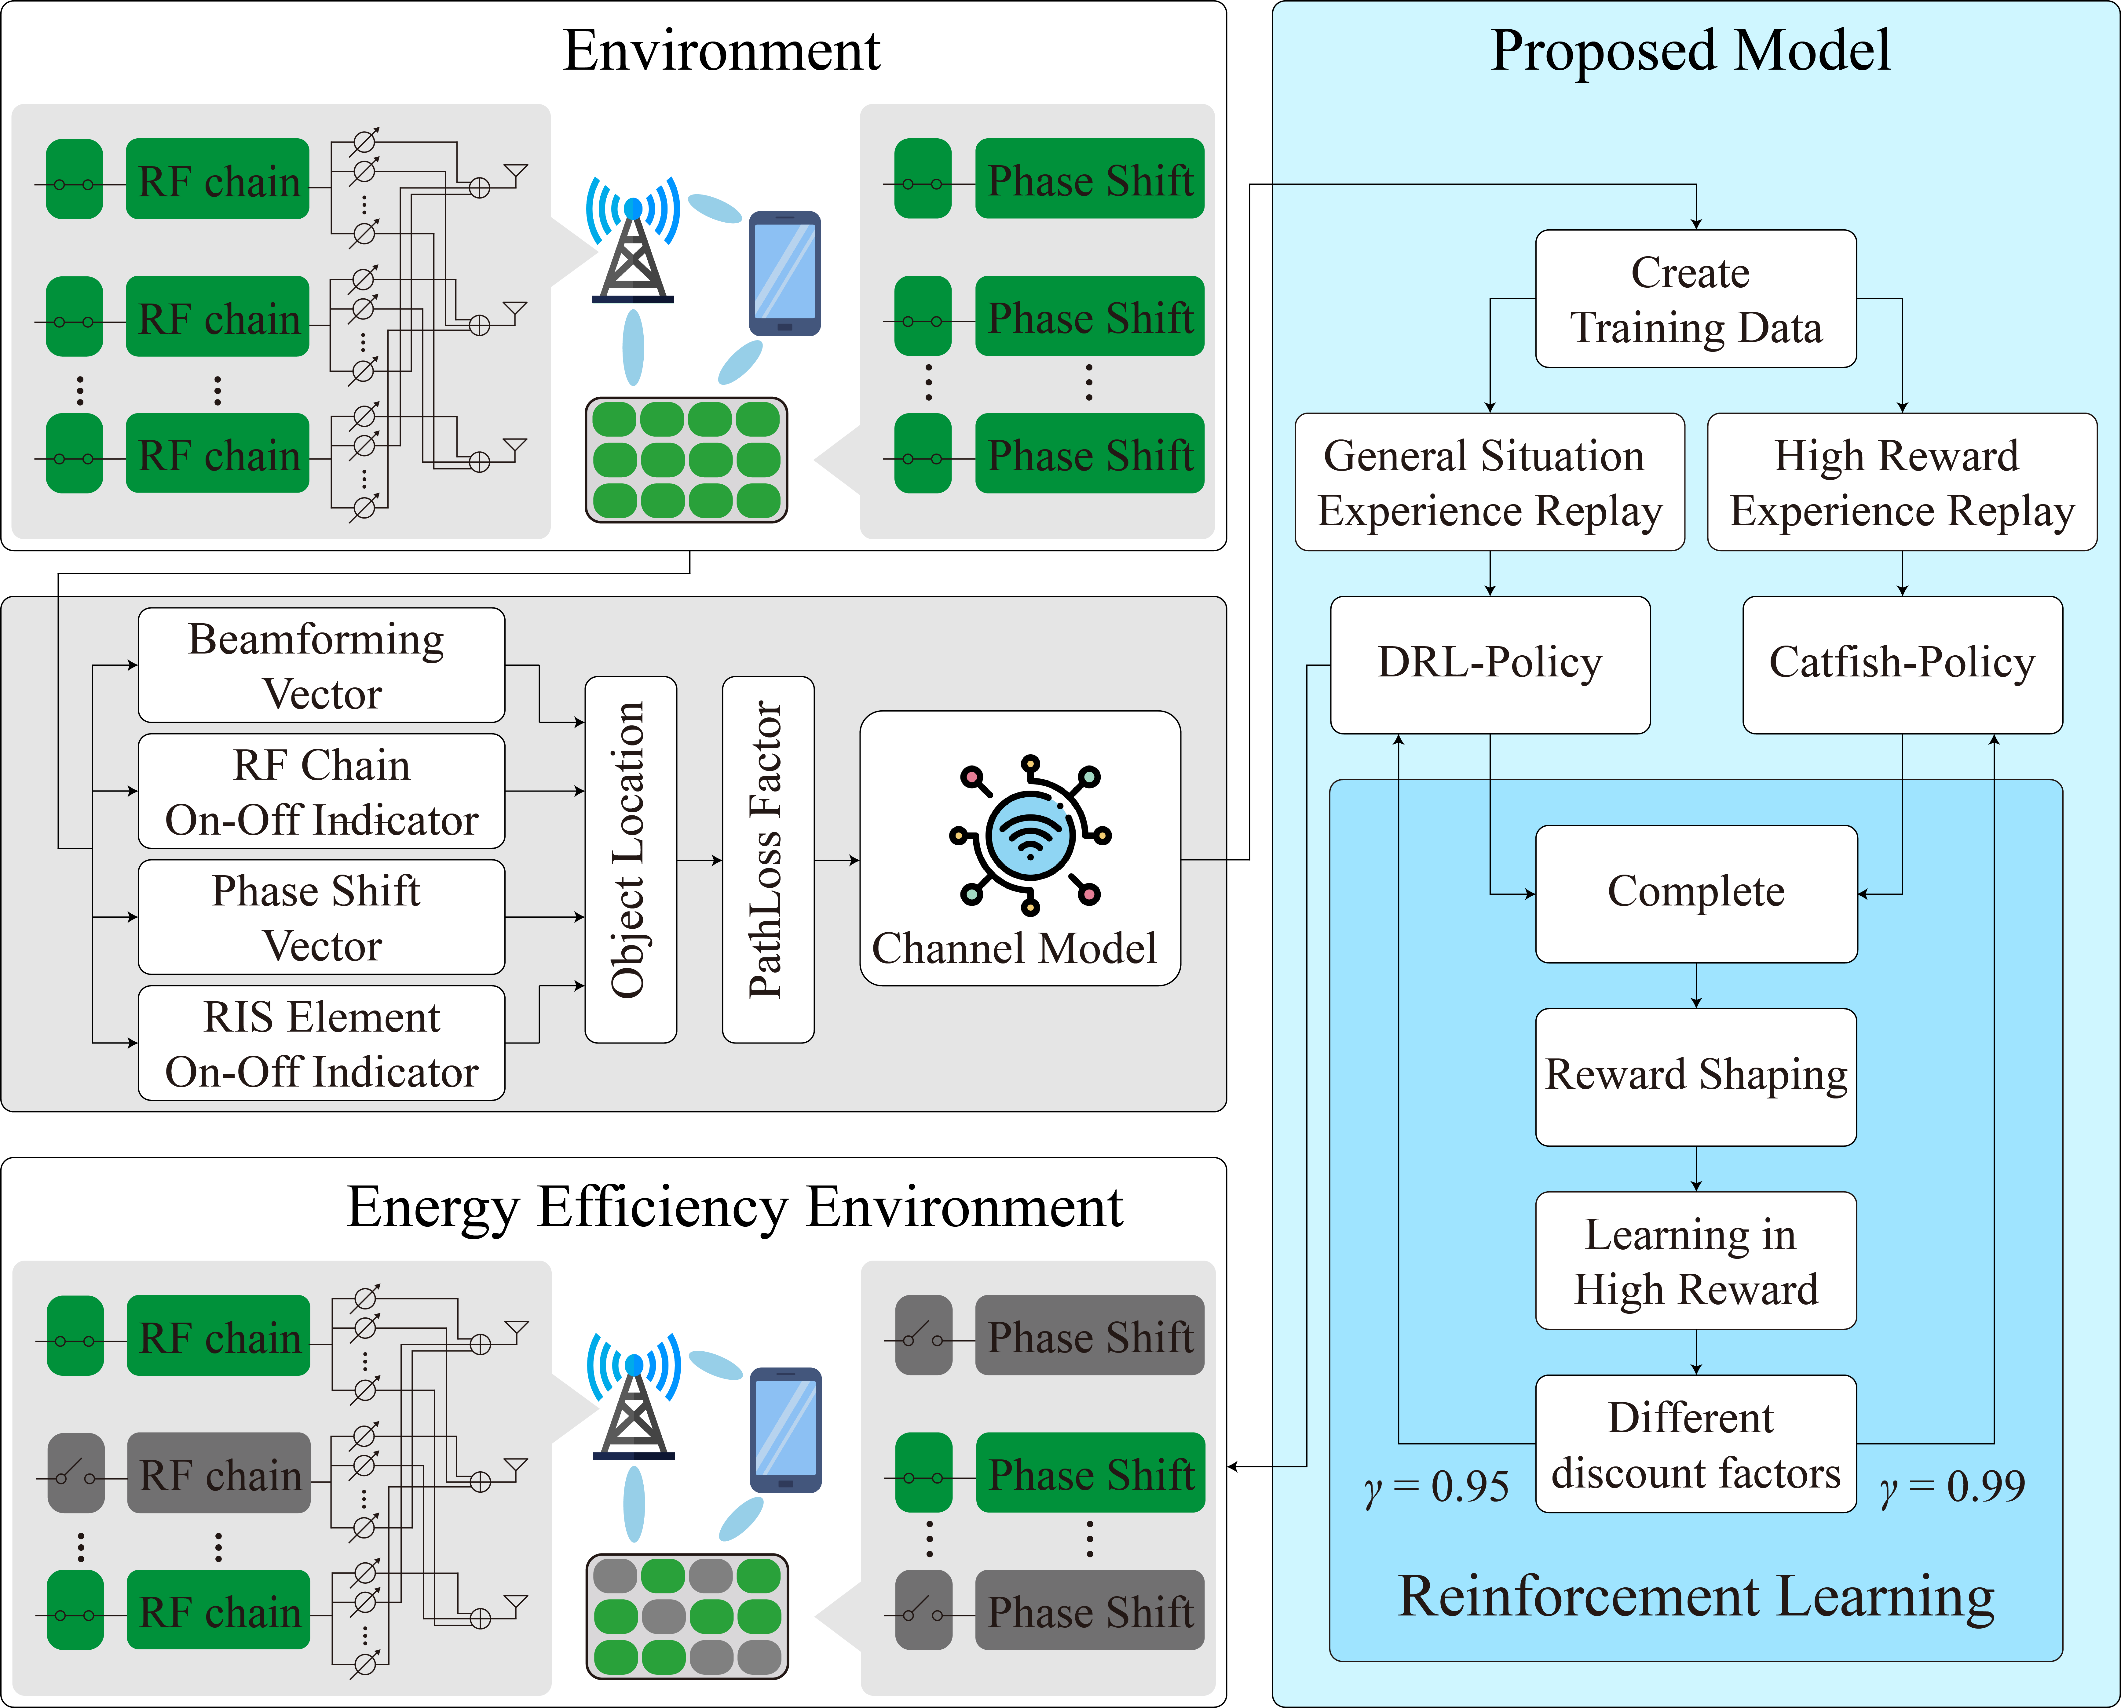
Figure 1. Our proposed CDRL scheme.

為了應對 6G 大量的傳輸需求，採用擁有多天線的毫米波大規模多輸入單輸出/多輸入多輸出 (mmWave Massive MISO/MIMO) 技術為已成為這領域熱門研究方向和實踐策略 [4-5][7-14][16-17][19-20]。其中毫米波傳輸可以增加頻譜使用量並且提升傳輸速度，但因為高頻率的特性導致高頻率，所以傳播距離相對較短，且傳播衰減較大 [10][14]。而 MIMO 技術可以很好的應對這點，同時對多個使用者服務、改善信號強度並且使通信範圍更廣。 MIMO 技術使得基地台的多天線可以使用波束賦形來對通訊增益，原理是波束成形可透過允許定向訊號傳輸來顯著增強無線系統的效能，從而提高訊號雜訊比 (SNR) 、同頻道幹擾和網路容量 [1]。傳統上，MIMO 預編碼是透過每一個天線元件配備一個射頻 (RF) 鏈的全數位 (FD) 方法來實現的 [13]。但是如果基地台的每根天線皆配有一條昂貴的 RF-chain ，將會在硬體成本與功耗上造成嚴重的負擔 [13][14]。因此，此架構下通常會採用混合波束成型 (hybrid beamforming, HBF) ，以合理的硬體成本和功耗實現令人滿意的波束賦形增益 [10][13][14]。
由於毫米波通訊很容易被牆壁和樹木等環境阻擋 (有著嚴重的穿透損耗) ，因此提出了智慧反射表面 (reconfigurable intelligent surface, RIS) 來輔助混合波束成型 (HBF) [14]。 RIS 是一種新興的下一代技術，可通過調控表面的電磁特性來控制電磁波的反射。RIS 能有效改善信號傳輸效率 [5][10][14]，並擴大無線網路的覆蓋範圍和提高傳輸品質 [4][16][18]。這些反射面策略性地部署於發射端與接收端之間，使得用戶端多了一條通訊鏈路接收訊息，訊號強度得到了提升 [10]。然而，這會引發乘性衰落 (multiplicative fading) ，導致傳統 RIS 獲得的容量增益有限 [9]。意思是透過 RIS 反射的通訊通道需要經歷兩次的路徑傳播衰落，即發射端-RIS-接收端鏈路的等效路徑損耗是發射端-RIS和RIS-接收端的路徑損耗的乘積 [10]。一般來說，傳統 RIS 是一種由大量被動元件組成的可重構智慧表面。每個元件都可以獨立調整入射電磁波的相位，以便將訊號重新導向到目標接收器 [18]。相較之下，主動 RIS (active RIS) 作為一種新型 RIS ，可以同時調整相移和放大接收訊號，並可以消除訊號衰減和乘性衰落中的雙衰落 (double fading) 效應 [9]。這使得主動 RIS 能夠在信號功率較弱的情況下提供更好的通訊性能。
網路節能對於環境永續發展、減少環境影響 (溫室氣體排放) 以及節省營運成本非常重要 [2]。在無線通訊中，發射端採用 MIMO 的波束成型技術，並且以 RIS 輔助通訊雖然有上述的諸多好處。但如此考慮會導致功耗很高，因此考慮如何在維持一定的傳輸效率下，提升能量效率成了重要的課題。 Laselva 等人評估每個無線電域 (radio domains) 的潛力，其中在天線域 (antenna domain) 中的無線電適配涉及調整基地台 (Base Transceiver Station, BTS) 用於發射的天線 (或天線連接埠) 的數量，這反過來又影響總發射功率 [3]。意思是如果透過停用特定天線的元件，可以減少能耗，此舉也可以應用到 RIS 上。因為 RIS 的需要通電才能形成有效的反射，透過選擇性地啟動和停用反射元件，可以優化 RIS 的能量消耗 [9]。但因為該技術所涉及到元件數量眾多，在多用戶與多個 RIS 元件的相互干擾下，同時調整其相移與開關成了一件棘手的事情。因此，我們將在後續段落介紹本計畫預計使用的解決方法。
隨著 RIS 結構與功能的複雜度提升，如何有效控制大量的 RIS 元件 (包含相位調整、開關控制、甚至功率放大) 成為一項挑戰，特別是在多使用者、動態通道或不完美通道資訊的情境下 [12][19][20][17]。傳統最佳化方法 (如凸規劃、啟發式) 在此類高維、非凸問題上常難以找到效率與精度兼顧的解法[11][12][17]。因此，機器學習 (Machine Learning, ML) 逐漸被視為輔助通訊系統資源配置的潛力工具，特別適用於建模未知環境與複雜關聯。而在眾多 ML 方法中，深度強化學習 (Deep Reinforcement Learning, DRL) 更具處理高維、序列決策問題的優勢 [19][20]。相較傳統方法， DRL 對於無線電頻道隨時間變化的無線通訊系統特別有益。DRL 將通訊系統建模為馬可夫決策過程 (Markov Decision Process, MDP) ， DRL 無需顯性建模系統公式 (通道模型和移動模式) ，透過觀察環境的獎勵來找到複雜優化問題的解決方案 [11][15][20][17]。且特別適合控制離散 (如 RIS 開關) 與連續 (如功率放大) 混合動作空間 [19][20][17]。這些特性使得 DRL 成為目前 RIS 智慧控制的熱門研究方向之一。
為了解決這些問題，我們提出了一種新的基於鯰魚的深度強化學習演算法 (CDRL) ，如圖 1 所示。我們設計了兩個任務導向不同的智能體 (agents)，其中 catfish agent 透過提供差異化經驗，有效刺激 main agent 探索更優策略，進而避免陷入區域最優。總而言之，此篇論文的貢獻整理如下列：
- 據我們所知，所提出的 CDRL 是首個研究 DRL 用於解決主動 RIS 結合元件開關設計的方法。透過兩個 DRL agents 相互競爭來達到最佳化通訊性能的目的。
- 在所提出的 CDRL 方法中，我們設計了三個核心機制，讓所有經驗按照能量效率 (EE) 門檻分流，兩個 DRL agents 擁有不同的折扣係數設置，分別關注不同目標， catfish 有額外的獎勵機制，鼓勵兩個 DRL agents 相互競爭。
- 在本研究中，我們分別與基礎 DRL 方法、相同通訊環境的數學解方法和老師學生模型進行評估。實驗結果表明，我們的方法略優於相同通訊環境下的數學解和老師學生模型，證明了我們方法的優異性。
本文的其餘部分安排如下。第 2 節描述了相關工作和動機。第三節介紹了本文的系統模型、問題表達、基本思想和 CDRL 與對手模型比較。第 4 節描述了提議的方案。第 5 節討論了性能結果。最後，第 6 節總結了本文。

2. Background
This chapter 2.1 describes related work, and chapter 2.2 discusses research motivation.
本章的 2.1 小節描述了相關工作， 2.2 小節討論了研究動機。

2.1 Related works
Previous research on network transmission rate or energy efficiency has often relied on mathematical optimization. Under the passive RIS setting, Dejonghe et al. [4] proposed a practical, low-cost, and high-performance RIS system design based on semi-definite programming (SDP) to achieve RIS beamforming optimization. In the domain of artificial intelligence–based approaches, Huang et al. [11] investigated the joint design of BS transmit beamforming and RIS phase shifts to maximize the sum rate of a multi-user downlink MISO system using DRL, successfully opening a new research direction for deep reinforcement learning. As a result, a growing number of studies have explored deep reinforcement learning and other AI-based solutions. For example, Saglam et al. [12] proposed a novel DRL-based modification for RIS-assisted systems, highlighting the adaptability and flexibility of deep reinforcement learning under hardware impairments and limited channel state information. Zhou et al. [15] introduced an innovative Co-HDRL algorithm for intelligent hierarchical decision-making in wireless networks to address problems characterized by different time scales.
The multiplicative fading effect limits the capacity gains of passive RIS in wireless communication environments, leading to increasing research on active RIS architectures [6][7][8]. Active RIS can actively reflect and amplify signals, functioning similarly to relay base stations. Fotock et al. [6] considered maximizing energy efficiency (EE) in interference-limited RIS-assisted wireless networks and compared the performance of active and near-passive RIS. Their developed algorithm jointly optimizes RIS reflection coefficients, mobile user transmit power, and the base station’s linear receive filters. Wang et al. [7] applied an alternating optimization (AO) algorithm based on majorization-minimization (MM) and fractional programming (FP) methods to solve the problem. The objective is to maximize the achievable downlink rate under the transmit power constraints of the base station (BS) and the dual active RISs. de Souza et al. [8] proposed an EE optimization framework for active RIS-assisted massive MIMO (mMIMO) systems and designed a low-complexity RIS configuration algorithm. They reformulated the problem as an equivalent quadratically constrained quadratic program (QCQP), from which novel closed-form solutions for the phase and amplitude of each active RIS element were derived to maximize EE. These results demonstrate that active RIS positively contributes to enhancing energy efficiency.
However, a high count of active elements drives up the system’s total energy draw, thereby lowering energy efficiency (EE). As a result, growing research has focused on element switching control [19][20]. Under the passive RIS setting, Faisal et al. [19] focused on optimizing the states of quantized phase shifters and RIS elements using an efficient DRL-based approach. The agent determines which RIS elements to activate or deactivate based on dynamic information from cellular networks under varying channel state information and total rate requirements. Cao et al. [20] studied ON/OFF-based reflection and binary phase-shift keying modulation schemes, developing a new RIS-assisted MISO SR system and a DRL-based framework to solve the EE maximization problem. In contrast, this thesis investigates the effect of switching under active RIS conditions [9][10]. Previously, Xie et al. [9] studied and analyzed the switching mechanism of RIS elements and evaluated its impact on EE performance in both passive and active RIS-assisted communication networks. They developed two algorithms based on alternating optimization (AO), employing variable substitution, quadratic transformation, and successive convex approximation (SCA) methods to obtain corresponding suboptimal solutions. Chen et al. [10] proposed the BPOF scheme, which demonstrates a beamforming optimization strategy based on communication-element switch control, applied to EE-optimized RIS-assisted wireless systems.

此前關於網路傳輸速率或能量效率的研究有很多是使用數學進行優化，在被動 RIS 的條件下， Dejonghe 等人 [4] 提供了一種基於 semi-definite programming（SDP）實現 RIS 波束最佳化的實際可部署、低成本又高效能的 RIS 系統設計方法。而研究人工智慧解法的方面有像 Huang 等人 [11] 研究了 BS 發射波束成形和反射 RIS 相移的聯合設計，以最大化利用 DRL 的多用戶下行鏈路 MISO 系統的總速率，成功的開拓了深度強化學習的這條研究方向。因此，接下來有許多深度強化學習或是人工智慧解法相關的文獻產生。像是 Saglam 等人 [12] 提出了將 DRL 應用於 RIS 輔助系統的新修改，強調了深度強化學習在硬體不完美與通道資訊受限下的適應能力與彈性設計。而 Zhou 等人 [15] 提出了一種新穎的 Co-HDRL 演算法，用於無線網路中的智慧分層決策，以處理具有不同時間尺度的問題。
「乘性衰退」效應會阻礙了被動 RIS 在無線通訊環境中的容量增益，因此開始有主動 RIS 架構的相關研究 [6][7][8]。主動式 RIS 能夠主動反射訊號並進行放大，類似於中繼基地臺的功能。Fotock 等人 [6] 考慮在幹擾受限的 RIS 輔助無線網路中最大化 EE，並比較主動和近被動 RIS 的性能。他們開發的演算法聯合優化了 RIS 反射係數、行動用戶的發射功率以及 BS 線性接收濾波器。 Wang 等人 [7] 使用基於主要化-最小化 (MM) 演算法和分離式規劃 (FP) 方法的交替最佳化 (AO) 演算法來解決問題。目標是在基地台 (BS) 和雙主動 RIS 的發射功率限制下最大化下行鏈路可實現速率。 de Souza 等人 [8] 提出主動 RIS 輔助 mMIMO 系統的能量效率（EE）最佳化框架，並且設計低複雜度的 RIS 配置演算法。他們將問題重新表述為等效的二次約束二次規劃 (QCQP)，從而可以推導出每個主動 RIS 元件的相位和振幅的新型閉式解，以最大化 EE。由此可見主動式 RIS 對於提升 EE 有著正向的幫助。
但是大量的有源元件會使得系統整體的能耗上升，進而拖累能量效率的表現。因此，開始有許多關心元件開關的研究產生 [19][20]。在被動 RIS 的條件下， Faisal 等人 [19] 專注於利用高效的 DRL 方法優化有限級移相器和 RIS 元件的狀態。其中代理在不同的通道狀態資訊和總速率要求下使用蜂窩網路上的動態資訊來決定開啟或關閉哪些 RIS 元素。 Cao 等人 [20] 研究了基於 ON/OFF 的反射和二進位相移鍵控調變方案，開發了一種新的 RIS 輔助 MISO SR 系統與一種新的基於 DRL 的框架來解決能量效率最大化問題。而本文研究的重點則是在主動 RIS 的條件下，開關能帶來的效果 [9][10]。此前 Xie 等人[9]，研究並分析了元素開關機制，並評估了該機制對被動 RIS 和主動 RIS 輔助通訊網路中能源效率性能的影響。他們開發了兩種基於交替最佳化 (AO) 的演算法，採用變數替換法、二次變換法和逐次凸逼近（SCA）法來獲得相應的次優解。 Chen 等人 [10] 提出的 BPOF 方案展示了基於通訊元件開關控制的波束成型優化策略，並將其應用於具能源效率的RIS輔助無線網路系統。

2.2 Motivation
In current wireless communication system research, active reconfigurable intelligent surfaces (active RIS) are regarded as a key technology to overcome the limitations of traditional passive RIS in terms of energy efficiency (EE) and transmission performance, due to their ability to provide active gain. However, the components required for active RIS, such as radio frequency (RF) amplifiers, introduce additional power consumption, which may prevent the overall EE of the system from improving. To address this issue, recent studies have begun exploring the design of active RIS systems incorporating element switching control mechanisms. By selectively activating or deactivating certain RIS elements, unnecessary power consumption can be reduced, thereby enhancing EE. Nevertheless, most existing research relies on mathematical optimization techniques, such as alternating optimization (AO), or successive convex approximation (SCA)[9][10]. Although these methods are theoretically sound, they face challenges in implementation and computational complexity when applied to dynamic channel environments or high-dimensional control scenarios.
On the other hand, deep reinforcement learning (DRL) has been proven effective in addressing RIS element control, phase adjustment, and beamforming without requiring precise channel models [17]. DRL is particularly suitable for scenarios involving unknown models, high-dimensional state spaces, and dynamic environments. However, current applications of DRL in RIS systems remain limited to passive architectures [19][20], and research on DRL-based optimization for active RIS combined with element switching control has yet to emerge. Therefore, this study aims to fill this research gap by proposing a DRL-based optimization framework for active RIS, which jointly considers RIS element switching control and transmit beamforming design to effectively improve energy efficiency of the system.
This thesis considers the same two types of communication system architectures as in BPOF [10]. They are the switching control of passive RIS–assisted communication system and the switching control of active RIS–assisted communication system. The former enhances transmission efficiency by adjusting the phase shifts of passive reflecting elements and reduces power consumption by controlling the ON/OFF states of the elements to improve energy efficiency, as illustrated in Fig. 2 (a). The latter further incorporates active amplifier components to provide additional signal gain, thereby overcoming the multiplicative fading limitations faced by conventional passive RIS, as illustrated in Fig. 2 (b). By comparing the performance of these two architectures under different channel conditions and element switching configurations, this thesis aims to explore the potential benefits of element switching control in active RIS architectures and to design reinforcement learning algorithms suitable for high-dimensional continuous action spaces, with the goal of optimizing energy efficiency.


(a)

(b)

Figure 2. (a) Passive RIS architecture diagram and (b) active RIS architecture diagram.

在現今無線通訊系統的研究中，主動式可重構智慧表面 (active RIS) 因具備主動增益能力，被視為突破傳統被動 RIS 在能量效率與傳輸性能限制的重要技術。然而，主動 RIS 所需的射頻放大器等元件會引入額外的功耗，導致系統整體能量效率 (EE) 不一定隨之提升。為改善此問題，近期已有文獻開始探討結合「元件開關控制機制」的主動 RIS 系統設計，透過控制部分 RIS 元件啟用與否以減少不必要的能耗，進而提升 EE。然而，現有相關研究大多依賴數學解析方法進行優化，如交替最佳化 (AO) 或逐次凸逼近 (SCA) 等 [9][10]。這些方法雖具有理論基礎，卻在動態通道環境或高維控制場景中面臨實作與計算複雜度的挑戰。
另一方面，深度強化學習 (DRL) 在無需精確通道模型的條件下，已被證實能有效處理 RIS 元件控制、相位調整與 beamforming 等問題 [17]。特別適用於模型未知、高維狀態空間與動態環境的場景。然而，目前 DRL 在 RIS 系統的應用仍侷限於被動式架構 [19] [20]，針對主動 RIS 結合元件開關設計的相關研究尚未出現。因此，本研究旨在填補此研究縫隙，提出一套以深度強化學習為基礎的主動 RIS 最佳化架構，能同時考量 RIS 元件之開關控制與發射波束成形設計，有效提升系統的能源效率。
本文考慮與 BPOF [10] 相同的兩種通訊系統架構。他們是開關控制的被動 RIS 輔助通訊系統和開關控制的主動 RIS 輔助通訊系統。前者透過調整被動反射單元的相位移來提升傳輸效率，並且控制元件的開啟與關閉來降低能耗和改善能量效率，如圖 2 (a) 所示；後者則進一步引入主動放大器元件，以提供額外的訊號增益，克服傳統被動 RIS 所面臨的乘性衰退限制，如圖 2 (b) 所示。藉由比較這兩種架構在不同通道環境與元件開關配置下的表現，本文旨在探討主動 RIS 架構中進行元件開關控制的潛在效益，並設計適用於高維連續動作空間的強化學習演算法，以達成能源效率最佳化的目標。

3. Preliminaries
This chapter 3.1 describes the system model, chapter 3.2 formulates the problem statement, chapter 3.3 introduces basic idea, and chapter 3.4 compares the differences between Catfish-DRL and competing models.
本章的 3.1 小節描述了系統模型、3.2 小節表達了問題表述、3.3 小節中介紹了基本思想並且 3.4 小節比較了 Catfish-DRL 與對手模型的差異。

3.1 System model
In this work, a hybrid active/passive reconfigurable intelligent surface (RIS) is considered in a multi-user multiple-input single-output (MU-MISO) for downlink communication system. The base station (BS) is assumed to employ a hybrid beamforming (HBF) architecture [10, 13, 14]. Let $N_{UE}$ denote the numbers of single-antenna users, $N_{RIS}$ the numbers of the RIS elements, $N_{t}$ the numbers of transmit antennas, $N_{RF}$ the numbers of RF chains, where $N_{RF}<N_{t}$. As illustrated in Fig. 3, a total of $N_{UE}$ single-antenna users are served by a BS featuring with $N_{t}$ transmit antennas and $N_{RF}$ switchable radio frequency (RF) chains. Additionally, the communication environment is supported by an active or passive RIS composed of $N_{RIS}$ switchable reflecting elements. The RIS provides an indirect transmission path that complements the direct link, thereby enhancing or extending the system’s communication capabilities.

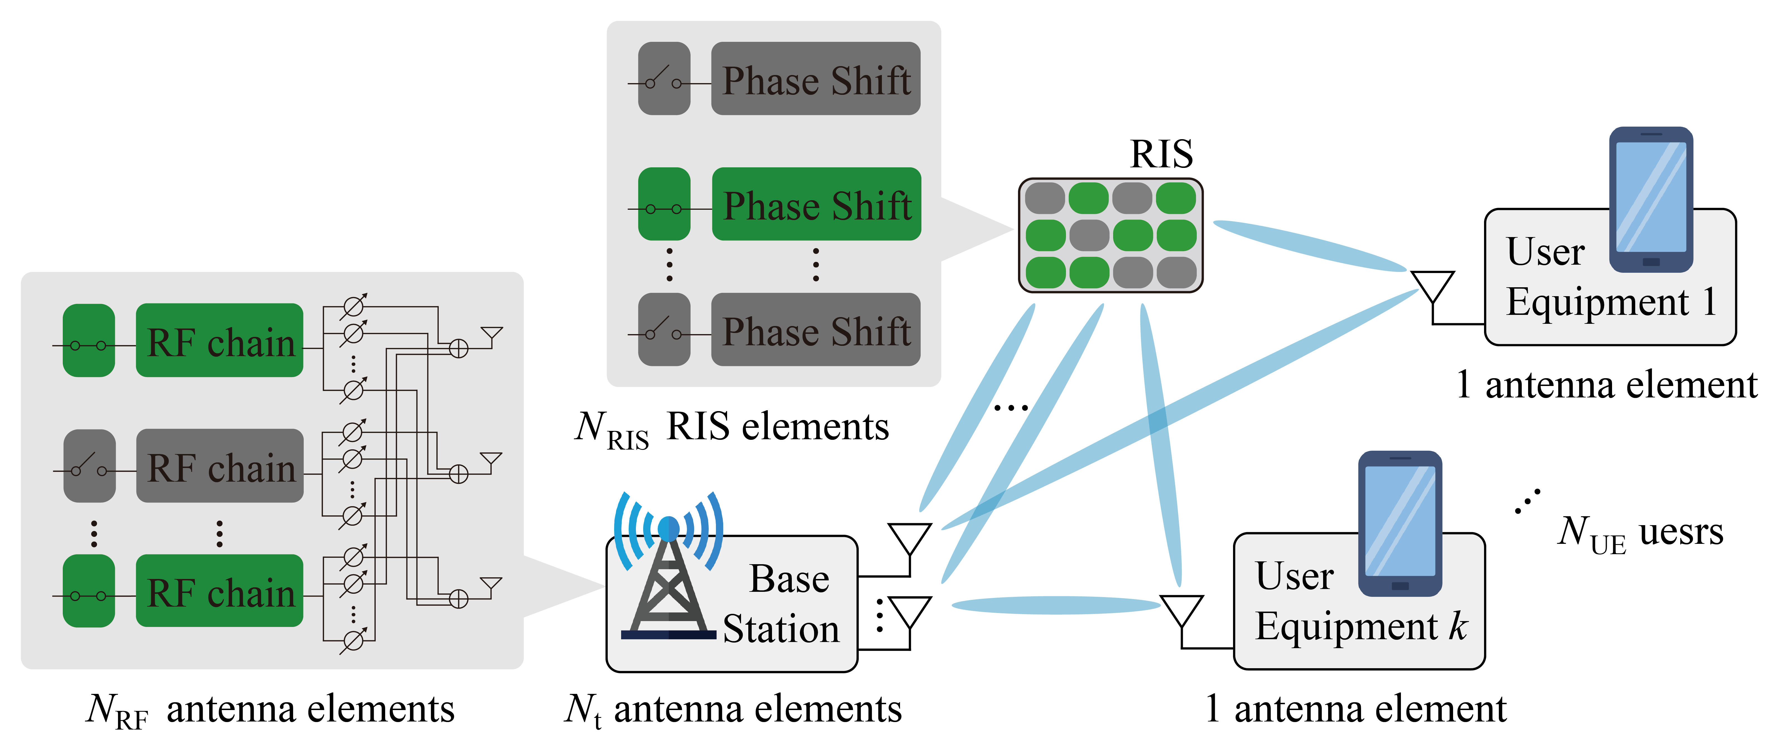
Figure 3. A downlink communication system design.

考慮一個多用戶-多輸出多輸入 (MU-MISO) 主/被動式智慧反射表面 (RIS) 輔助的下行通訊系統。此基地台為混合波束成型 (hybrid beamforming) 設計 [10, 13, 14]。設 $N_{UE}$ 為單天線用戶數， $N_{RIS}$ 為 RIS 的元件數量， $N_{t}$ 為發射天線數量， $N_{RF}$ 為射頻鏈數量，其中 $N_{RF}<N_{t}$。如圖 3 所示， $N_{UE}$ 個單天線的用戶被一個擁有 $N_{t}$ 個發射天線與 $N_{RF}$ 個可以開關射頻鏈 (RF-chain) 的基地台服務。除此之外，這個通訊環境被一個擁有 $N_{RIS}$ 個可開關的反射元件的主/被動式智慧反射表面輔助。 RIS 提供了相對於直接鏈路 (direct link) 以外的間接鏈路 (indirect link) ，以提升或延展此系統的通訊能力。本節分為 A. 主被動智慧反射表面訊號傳輸模型 B. 功耗模型

A. Hybrid beamforming model
Consider a hybrid beamforming architecture at the base station that combines a baseband digital precoder with an RF analog beamformer. We adopt the notation as defined in our previous work [10]. The base station in this system consists of three components. Let $F^{RF}∈C^{N_{t}×N_{RF}}$ denote the RF analog beamformer, which controls the beam direction. Let $w_{k}^{BB} ∈C^{N_{RF}×1}$ denote the baseband digital precoder, which precodes the information transmitted to the k-th user, where $1≤k≤N_{UE}$. Finally, the switch controller of the RF chains is represented by a binary diagonal matrix $C^{RF}=diag(c_{1}^{RF},…c_{i}^{RF}…,c_{N_{RF}}^{RF}) ∈C^{N_{RF}×N_{RF}}$. The switch $c_{i}^{RF}∈R$ of the l-th RF chain can be defined as:

$$\begin{aligned}c_{j}^{RF}=\left\{\begin{aligned}1, if RF chain j in BS is turn on \\ 0,if RF chain j in BS is turn off. \end{aligned}\right.\#\left( seq equation 1\right)\end{aligned}$$

where $1≤j≤N_{RF}$. This matrix determines whether the signal generated by the baseband digital precoder $w_{k}^{BB}$ for the k-th user is forwarded to the RF analog beamformer $F^{RF}$ for analog weighting (e.g., via phase shifters).
Therefore, the transmit matrix of the base station for the k-th user can be expressed as:

$$\begin{aligned}x_{k}= F^{RF}{C^{RF}w}_{k}^{BB}s_{k}\#\left( seq equation 2\right)\end{aligned}$$

Here, $s_{k}$ denotes the data symbol transmitted by the base station to the k-th user. Here, we assume a unit-power symbol, set $E\left\{{\left|s_{k}\right|}^{2}\right\}=1$.

考慮基地台為混合波束成型，其組合了基帶數位波束成形器與條射頻類比波束成形器。我們採用先前工作 [10] 中定義的符號。本系統的基地台一樣擁有三個元件: 設 $F^{RF}∈C^{N_{t}×N_{RF}}$ 為控制方向的射頻類比波束成形器。 $w_{k}^{BB} ∈C^{N_{RF}×1}$ 為傳輸給第 k 個用戶資訊預編碼的基帶數位波束成形器，其中$1≤k≤N_{UE}$。最後射頻鏈的開關器定義為一個二值對角矩陣 $C^{RF} ∈R^{N_{RF}×N_{RF}}$。第 j 個射頻鏈開關 $c_{j}^{RF}∈R$ 可以被定義為:
公式(1)
其中 $1≤j≤N_{RF}$ 。這個矩陣控制服務第 k 的用戶的基帶數位波束成形器 $w_{k}^{BB}$ 的產生的資料是否通過至射頻類比波束成形器 $F^{RF}$ 做類比加權 (如 phase shifte )。
因此，將基地台第 k 的用戶的發射矩陣被表示為:
公式(2)
其中 $s_{k}$ 為基地台傳輸給第 k 個用戶的資料。這裡我們假設一個單位功率符號，設 $E\left\{{\left|s_{k}\right|}^{2}\right\}=1$。

B. Passive RIS and active RIS models
Following the method described in [10], consider three component matrices constituting the reconfigurable intelligent surface (RIS) in the system: Let $ϕ^{RIS} =diag\left(e_{1}^{jθ_{1}},…,e_{n}^{jθ_{n}},…,e_{N_{RIS}}^{jθ_{N_{RIS}}}\right) ∈C^{N_{RIS}×N_{RIS}}$ denote the diagonal phase shift matrix controlling the direction of signal transmission, where the phase shift coefficient $θ_{n} ∈\left[0, 2π\right), j= \sqrt{-1}$ and $1≤n≤N_{RIS}$. $Λ^{RIS} =diag\left(ρ_{1},…,ρ_{i},…ρ_{N_{RIS}}\right) ∈R^{N_{RIS}×N_{RIS}}$denote the power amplification (PA) diagonal matrix specific to active RIS, where $1≤n≤N_{RIS}$ and $ρ_{n}≥0$. Since each element has an amplification factor, it can consume additional energy to boost the signal, similarly to a relay base station. Finally, the switch controller of the intelligent reflecting elements in passive and active modes are modeled respectively as binary diagonal matrices $B^{RIS}=diag(β_{1}^{RIS},…,β_{n}^{RIS},…β_{N_{RIS}}^{RIS}) ∈R^{N_{RIS}×N_{RIS}}/A^{RIS}=diag(α_{1}^{RIS},…,α_{n}^{RIS},…α_{N_{RIS}}^{RIS}) ∈R^{N_{RIS}×N_{RIS}}$. The switch $β_{n}^{RIS}∈R$ of the n-th passive RIS element and the switch $α_{n}^{RIS}∈R$ of the n-th active RIS element can be defined as follows, respectively:

$$\begin{aligned}\left\{\begin{aligned}β_{n}^{RIS}=\left\{\begin{aligned}1, if RIS element n in RIS is turn on \\ 0,if RIS element n in RIS is turn off.\end{aligned}\right. \\ α_{n}^{RIS}=\left\{\begin{aligned}1, if RIS element n in RIS is turn on \\ 0,if RIS element n in RIS is turn off.\end{aligned}\right.\end{aligned}\right.\#\left( seq equation 3\right)\end{aligned}$$

Indicating that theni-th RIS element is activated when set to 1 and deactivated otherwise, with $1≤n≤N_{RIS}$. This matrix determines whether each RIS element performs effective reflection and can be used to adjust power consumption in both active and passive RIS scenarios.

遵循 [10] 中所描述的方法，考慮本系統的智慧反射表面的三個的部件構成的矩陣: 設 $ϕ^{RIS} =diag\left(e_{1}^{jθ_{1}},…,e_{n}^{jθ_{n}},…,e_{N_{RIS}}^{jθ_{N_{RIS}}}\right) ∈C^{N_{RIS}×N_{RIS}}$ 為控制方向訊號傳輸的對角相移矩陣，其中相移係數 $θ_{n} ∈\left[0, 2π\right), j= \sqrt{-1}, 1≤n≤N_{RIS}$。 $Λ^{RIS} =diag\left(ρ_{1},…,ρ_{n},…ρ_{N_{RIS}}\right) ∈R^{N_{RIS}×N_{RIS}}$ 為主動智慧反射表面 (active-RIS) 特有的功率放大 (power amplifier, PA) 對角矩陣，其中 $1≤n≤N_{RIS} , ρ_{i}≥0$ 。因為每個元件皆有放大因子，所以能夠如同中繼基地台一般消耗額外能源將訊號增強。最後智慧反射元件的開關器按照被動/主動模式分別表示為二值對角矩陣 $B^{RIS}=diag(β_{1}^{RIS},…,β_{n}^{RIS},…β_{N_{RIS}}^{RIS}) ∈R^{N_{RIS}×N_{RIS}}/A^{RIS}=diag(α_{1}^{RIS},…,α_{n}^{RIS},…α_{N_{RIS}}^{RIS}) ∈R^{N_{RIS}×N_{RIS}}$。第 n 個被動 RIS 元件開關 $β_{n}^{RIS}∈R$ 與第 n 個主動 RIS 元件開關 $α_{n}^{RIS}∈R$ 可以分別被定義為:
公式(3)
代表第 n 個 RIS 元件開啟時設為 1 ，否則設為 0 ，其中 $1≤n≤N_{RIS}$ 。這個矩陣控制此 RIS 元件是否要做有效反射，不論主動被動 RIS 皆可以此矩陣調整能耗。

C. Signal transmission model
Assuming that all involved channels are perfectly known at the BS [8], the system considers three communication channel matrices for each k $∈$ [1, 2, …, $N_{UE}$]. The direct channel between the base station and the k-th user is denoted as $g_{k}∈C^{1×N_{t}}$. The channel between the base station and the reconfigurable intelligent surface is denoted as $Q∈C^{N_{RIS}×N_{t}}$. The channel between the RIS and the k-th user is denoted as $h_{k}∈C^{1×N_{RIS}}$. Let $x_{k}$ denote the transmit signal vector of the base station. The base station transmits signals to the users through both the direct channel $g_{k}$and the indirect channel via the RIS. This thesis models the channel matrices $Q, h_{k}$ and $g_{k}$ corresponding to the BS–RIS, RIS–UE, and BS–UE links, using Rician fading [8]:

$$\begin{aligned}\left\{\begin{aligned}\begin{matrix}Q = \sqrt{\frac{L^{BR}K^{BR}}{K^{BR}+1}}Q^{Los}+\sqrt{\frac{L^{BR}}{K^{BR}+1}}Q^{NLos} \\ h_{k} = \sqrt{\frac{L_{k}^{RU}K^{RU}}{K^{RU}+1}}h_{k}^{Los}+ \sqrt{\frac{L_{k}^{RU}}{K^{RU}+1}}h_{k}^{NLos}\end{matrix} \\ g_{k}= \sqrt{\frac{L_{k}^{BU}K^{BU}}{K^{BU}+1}}g_{k}^{Los}+ \sqrt{\frac{L_{k}^{BU}}{K^{BU}+1}}g_{k}^{NLos}\end{aligned}\right. , k ∈N_{UE}\#\left( seq equation 4\right)\end{aligned}$$

Here, LoS and NLoS represent the line-of-sight and non-line-of-sight components, respectively. For the NLoS components of $Q, h_{k}$ and $g_{k}$, i.e. $Q^{NLos}∼CN\left(0, 1\right), h_{k}^{NLos}∼CN\left(0, 1\right), g_{k}^{NLos}∼CN\left(0, 1\right), k ∈N_{UE}$, they are assumed to be independently and identically distributed (i.i.d.) complex circularly symmetric Gaussian random variables with zero mean and unit variance. $L^{BR}$ denotes the large-scale path loss coefficient for the BS–RIS link; $L_{k}^{RU}$ and $L_{k}^{BU}$ are the large-scale path loss coefficients for the RIS–UE and BS–UE links for the k-th UE, respectively. $K^{BR}, K^{RU}$ and $K^{BU}$ denote the corresponding Rician K-factors.
Therefore, the received transmission signal at the $k$-th user can be expressed, under the passive and active RIS modes respectively, as follows:

$$\begin{aligned}\left\{\begin{aligned}&y_{k}^{pas}=\sum_{k=1}^{N_{UE}}{\left(g_{k}+h_{k}{ϕ^{RIS}B}^{RIS}Q\right)x_{k}}+ n_{k} \\ &y_{k}^{act}=\sum_{k=1}^{N_{UE}}{\left(g_{k}+h_{k}ϕ^{RIS}{Λ^{RIS}A}^{RIS}Q\right)x_{k}}+ h_{k}ϕ^{RIS}{Λ^{RIS}A}^{RIS}z + n_{k}\end{aligned}\right.\#\left( seq equation 5\right)\end{aligned}$$

Here, $n_{k}∼CN(0,δ^{2})$ denotes the additive white Gaussian noise (AWGN) at the receiver of the k-th user, with zero mean and variance $δ^{2}$. $z∼CN(0,σ^{2})$ represents the thermal noise introduced by the active RIS, also modeled as AWGN with zero mean and variance $σ^{2}$, which arises due to the signal amplification process performed by the active reconfigurable intelligent surface.
The signal-to-interference-plus-noise ratio (SINR) for the k-th user can be expressed under the passive and active modes, respectively, as follows:

$$\begin{aligned}\left\{\begin{matrix}ζ_{k}^{pas}= \frac{{\left|\left(g_{k}+h_{k}{ϕ^{RIS}B}^{RIS}Q\right)x_{k}\right|}^{2}}{\sum_{k^{'}=1,k^{'}≠k}^{N_{UE}}{{\left|\left(g_{k}+h_{k}{ϕ^{RIS}B}^{RIS}Q\right)x_{k^{'}}\right|}^{2}}+δ^{2}} \\ ζ_{k}^{act}= \frac{{\left|\left(g_{k}+h_{k}ϕ^{RIS}{Λ^{RIS}A}^{RIS}Q\right)x_{k}\right|}^{2}}{\sum_{{k^{'}=1,k}^{'}≠k}^{N_{UE}}{({\left|\left(g_{k}+h_{k}ϕ^{RIS}{Λ^{RIS}A}^{RIS}Q\right)x_{k^{'}}\right|}^{2}}+σ^{2}{\left\|h_{k}ϕ^{RIS}{Λ^{RIS}A}^{RIS}\right\|}_{F}^{2}) +δ^{2}}\end{matrix}\right.\#\left( seq equation 6\right)\end{aligned}$$

Here, ${\left\|\text{·}\right\|}_{F}$ denotes the squared Frobenius norm (L2 norm), representing the total energy of all elements in a matrix. The entire expression is defined as the ratio between the power of the desired signal and the total power of interference from other users. The term $δ^{2}$ represents the AWGN power at the receiver. Under the active RIS mode, the active elements introduce additional amplified thermal noise, represented by $σ^{2}{\left\|h_{k}ϕ^{RIS}{Λ^{RIS}A}^{RIS}\right\|}_{F}^{2}$​, which measures the total energy transferred through the active reconfigurable intelligent surface.
According to Shannon’s theorem, the spectral efficiency (SE) of the base station for the k-th user under passive and active modes is expressed as follows, respectively:

$$\begin{aligned}\left\{\begin{matrix}R_{k}^{pas}(w_{k}^{BB},F^{RF},C^{RF},ϕ^{RIS},B^{RIS}) =BW •\log_{2}\left(1+ζ_{k}^{pas}\right) \\ R_{k}^{act}(w_{k}^{BB},F^{RF},C^{RF},Λ^{RIS},ϕ^{RIS},A^{RIS}) = BW •\log_{2}\left(1+ζ_{k}^{act}\right)\end{matrix}\right.\#\left( seq equation 7\right)\end{aligned}$$

The bandwidth BW is set to 1 Hz.

假設所有資訊在基地台上都是完全已知的 [8]。考慮 k $∈$ [1, 2, …, $N_{UE}$] ，本系統的三條通訊矩陣為: 基地台與第 $k$ 個用戶之間的通道矩陣 $g_{k}∈C^{1×N_{t}}$ ，基地台與智慧反射表面之間的通道矩陣 $Q∈C^{N_{RIS}×N_{t}}$ ，智慧反射表面與第 $k$ 個用戶之間的通道矩陣 $h_{k}∈C^{1×N_{RIS}}$ 。 $x_{k}$ 定義為基地台的發射矩陣。基地台透過直接通道 $g_{k}$ 與基地台到智慧反射表面向用戶發射訊號。本文將 BS-RIS, RIS-UE, BS-UE 通道矩陣的公式$Q, h_{k}, g_{k}$ 建模為 Rician fading [8]:
公式(4)
其中 LOS 和 NLOS 分別表示直視路徑 (line-of-sight, LoS) 和非直視路徑 (non-line-of-sight, NLoS) 。對於 $Q, h_{k}$ 和 $g_{k}$ 的 NLoS 分量，即 $Q_{ NLos}∼CN\left(0, 1\right), h_{ NLos, k}∼CN\left(0, 1\right), g_{ NLos, k}∼CN\left(0, 1\right), k ∈N_{UE}$ ，假設獨立同分佈 (identically distributed, iid) 複雜循環對稱高斯隨機變量，其平均值為零，方差為單位。 $L^{BR}$ 是 BS-RIS 路徑的大規模路徑損耗係數； $L_{k}^{RU}, L_{k}^{BU}$ 是 RIS-UE 和 BS-UE 路徑第 k 個 UE 的大規模路徑損耗係數。 $K^{BR}, K^{RU} 與 K^{BU}$ 為萊斯因子。
因此，將第 $k$ 用戶接收到的傳輸訊號按照被動/主動模式分別表示為:
公式(5)
其中 $n_{k}∼CN(0,δ^{2})$ 代表加性高斯白雜訊 (additive white Gaussian noise, AWGN) ，為第 $k$ 個用戶之間的接收雜訊，方差為 $δ^{2}$ ，均值為 0。 $z∼CN(0,σ^{2})$ 代表 active-RIS 的熱噪聲 (AWGN) 方差為 $σ^{2}$ ，均值為 0 ，產生的原因為訊號經過主動智慧反射表面放大所致。
將對於第 k 個用戶的信號干擾加噪聲比 (SINR) 按照被動/主動模式分別表示為:
公式(6)
其中 ${\left\|\text{·}\right\|}_{F}$ 表示 Frobenius norm 的平方 (L2 範數)，代表矩陣中所有元素的能量總和。整個公式為有效訊號能量/自其他使用者之干擾訊號的總能量。而 $δ^{2}$ 則為接收端的加性高斯白雜訊（AWGN）功率。在主動智慧反射表面模式下，主動元件引入額外放大的熱噪聲，表現在 $σ^{2}{\left\|h_{k}ϕ^{RIS}{Λ^{RIS}A}^{RIS}\right\|}_{F}^{2}$​ ，用以度量透過主動智慧反射表面傳遞的總能量。
根據向農極限 (Shannon's theorem)，基地台對於第 k 位用戶按照被動/主動模式下的頻譜效率 (SE) 分別表示為:
公式(7)
其中頻寬 BW 設置為 1 Hz。

D. Power model
Considering this thesis’s RIS‐assisted communication system, its energy consumption can be divided into non‐transmission power consumption and transmission power consumption. $P^{static}$ is defined as the static power consumed by the electronic components of each device, while $P^{dynamic}$ refers to the transmission power.
Therefore, the total power consumption of the system is expressed as:

$$\begin{aligned}P^{total} = P^{static} + P^{dynamic}\#\left( seq equation 8\right)\end{aligned}$$

Here, the transmission power consumption can also be divided into two parts, with the base station’s contribution expressed as:

$$\begin{aligned}P^{BS} ={\text{∥}C^{RF}\text{∥}}_{0}P^{RF}+ \underset{k=1}{\overset{N_{UE}}{∑}}{\left\|F^{RF}{C^{RF}w}_{k}^{BB}\right\|}_{F}^{2} \#\left( seq equation 9\right)\end{aligned}$$

Here, $P^{RF}$ indicates the fixed power consumption per RF chain. ${\text{∥}\text{·}\text{∥}}_{0}$ represents the L₀ norm, which is defined as the number of non-zero elements in a vector.
The power consumption of the reconfigurable intelligent surface is expressed under the passive and active modes, respectively, as follows:

$$\begin{aligned}\left\{\begin{matrix}P^{pas}={\text{∥}C^{RIS}\text{∥}}_{\text{0}}P_{C} \\ P^{act}={\text{∥}C}^{RIS}{\text{∥}}_{\text{0}}\left(P_{C}+P_{DC}\right)+\underset{k=1}{\overset{N_{UE}}{∑}}{\left\|ϕ^{RIS}{Λ^{RIS}A}^{RIS}QF^{RF}{C^{RF}w}_{k}^{BB}\right\|}_{F}^{2} + σ^{2}{\left\|ϕ^{RIS}{Λ^{RIS}A}^{RIS}\right\|}_{F}^{2}\end{matrix}\right.\#\left( seq equation 10\right)\end{aligned}$$

Here, $P_{C}$ denotes the power consumption of a single RIS element, and $P_{DC}$ represents the DC bias power consumption.
After obtaining the fixed and transmission power consumption of all communication devices. The system’s total energy consumption is expressed under the passive and active modes, respectively, as follows:

$$\begin{aligned}\left\{\begin{aligned}&P_{Tot}^{pas}(w_{k}^{BB},F^{RF},C^{RF},ϕ^{RIS},B^{RIS}) =P^{static}+ P^{BS} +P^{pas} \\ &P_{Tot}^{act}(w_{k}^{BB},F^{RF},C^{RF},Λ^{RIS},ϕ^{RIS},A^{RIS}) =P^{static}+ P^{BS} + P^{act}\end{aligned}\right.\#\left( seq equation 11\right)\end{aligned}$$

考慮本文的 RIS 輔助通訊系統，其能量消耗可以分為非傳輸與傳輸功耗兩部分。定義 $P^{static}$ 為每個設備的電子元件所消耗的固定功耗 (static power) ，而 $P^{dynamic}$ 定義為傳輸功耗（transmission power）。
因此，系統總功耗被表示為:
公式(8)
其中，傳輸功耗亦可分為兩部分，基地台的部分被表示為:
公式(9)
其中 $P^{RF}$ 代表一個 RF-chain 的固定功耗。 ${\text{∥}\text{·}\text{∥}}_{0}$ 表示 L0 範數，其定義為向量中非零元素的數量。
智慧反射表面的部分按照被動/主動模式分別表示為:
公式(10)
其中 $P_{C}$ 代表一個智慧反射表面元件的電力功耗， $P_{DC}$ 代表直流偏置功耗。
在得到所有通訊設備的固定與傳輸功耗之後。系統的總能源消耗分按照被動/主動模式分別表示為:
公式(11)

3.2 Problem formulation
The objective of this chapter is to formulate a transmission energy efficiency (EE) problem suitable for the Catfish-effect-based Deep Reinforcement Learning (CDRL) framework. The goal is to maintain a certain transmission rate while precisely adjusting the BS beamforming and RIS phase shifts, minimizing the number of active elements, and maximizing the system’s energy efficiency to achieve the ultimate objective of energy-efficient communications.
Considering the environment where the base station serves all users with the assistance of a passive reconfigurable intelligent surface, the system energy efficiency optimization problem can be defined as [10]:

$$\begin{aligned}\left(P_{0}\right):\max_{\text{\{}w_{k}^{BB},F^{RF},C^{RF},ϕ^{RIS},B^{RIS}\text{\}}}{\frac{\sum_{k=1}^{N_{UE}}{R_{k}^{pas}\left(w_{k}^{BB},F^{RF},C^{RF},ϕ^{RIS},B^{RIS}\right)}}{P_{Tot}^{pas}\left(w_{k}^{BB},F^{RF},C^{RF},ϕ^{RIS},B^{RIS}\right)}}\#\left( seq equation 12\right)\end{aligned}$$
$\begin{aligned}s.t.C_{1} :R_{k}^{pas}≥R^{min}\#\left(12a\right)\end{aligned}$
$$\begin{aligned}C_{2} : \underset{k=1}{\overset{N_{UE}}{∑}}{\left\|F^{RF}C^{RF}w_{k}^{BB}\right\|}_{F}^{2}≤P_{BS}^{max}\#\left(12b\right)\end{aligned}$$
$$\begin{aligned}C_{3} : \left|f_{i,j}^{RF}\right|=1\#\left(12c\right)\end{aligned}$$
$$\begin{aligned}C_{4} : θ_{n} ∈ [0, 2π)\#\left(12d\right)\end{aligned}$$
$$\begin{aligned}C_{5} : c_{j}^{RF}∈\left\{0, 1\right\}\#\left(12e\right)\end{aligned}$$
$$\begin{aligned}C_{6} : β_{n}^{RIS}∈\left\{0, 1\right\}\#\left(12f\right)\end{aligned}$$
$\begin{aligned}∀j∈N_{RF}, ∀n∈N_{RIS}, ∀k∈N_{UE}, ∀i∈N_{t}.\end{aligned}$

Considering the environment where the base station serves all users with the assistance of an active reconfigurable intelligent surface, the system energy efficiency optimization problem can be defined as:

$$\begin{aligned}\left(P_{1}\right):\max_{\text{\{}w_{k}^{BB},F^{RF},C^{RF},Λ^{RIS},ϕ^{RIS},A^{RIS}\text{\}}}{\frac{\sum_{k=1}^{N_{UE}}{R_{k}^{act}\left(w_{k}^{BB},F^{RF},C^{RF},Λ^{RIS},ϕ^{RIS},A^{RIS}\right)}}{P_{Tot}^{act}\left(w_{k}^{BB},F^{RF},C^{RF},Λ^{RIS},ϕ^{RIS},A^{RIS}\right)}}\#\left( seq equation 13\right)\end{aligned}$$
$\begin{aligned}s.t.C_{1} :R_{k}^{act}≥R^{min}\#\left(13a\right)\end{aligned}$
$$\begin{aligned}C_{2} : \underset{k=1}{\overset{N_{UE}}{∑}}{\left\|F^{RF}C^{RF}w_{k}^{BB}\right\|}_{F}^{2}≤P_{BS}^{max}\#\left(13b\right)\end{aligned}$$
$$\begin{aligned}C_{3} : \left|f_{i,j}^{RF}\right|=1\#\left(13c\right)\end{aligned}$$
$$\begin{aligned}C_{4} : θ_{n} ∈ [0, 2π)\#\left(13d\right)\end{aligned}$$
$$\begin{aligned}C_{5} : c_{j}^{RF}∈\left\{0, 1\right\}\#\left(13e\right)\end{aligned}$$
$$\begin{aligned}C_{6} : α_{n}^{RIS}∈\left\{0, 1\right\}\#\left(13f\right)\end{aligned}$$
$$\begin{aligned}C_{7} : ρ_{n} ≥ 0\#\left(13g\right)\end{aligned}$$
$$\begin{aligned}C_{8} : \underset{k=1}{\overset{N_{UE}}{∑}}{\left\|ϕ^{RIS}{Λ^{RIS}A}^{RIS}QF^{RF}{C^{RF}w}_{k}^{BB}\right\|}_{F}^{2} + σ^{2}{\left\|ϕ^{RIS}{Λ^{RIS}A}^{RIS}\right\|}_{F}^{2}≤P_{RIS}^{max}\#\left(13h\right)\end{aligned}$$
$\begin{aligned}∀j∈N_{RF}, ∀n∈N_{RIS}, ∀k∈N_{UE}, ∀i∈N_{t}.\end{aligned}$

$C_{1} :$ When the base station serves the k-th user, the transmission rate $R_{k}^{pas}$ / $R_{k}^{act}$ must be maintained above the predefined threshold $R^{min}$ to ensure user experience. $C_{2} :$ The total transmission power when the base station serves the k-th user, expressed as $\underset{k=1}{\overset{N_{UE}}{∑}}{\left\|F^{RF}{C^{RF}w}_{k}^{BB}\right\|}_{F}^{2}$, must remain below the power budget $P_{BS}^{max}$. $C_{3} :$ Each element in $F^{RF}$ is constrained to have unit magnitude, as $F^{RF}$ is responsible only for beam direction control. $C_{4} :$ The phase shift $θ_{n}$ of the n-th reflective element is constrained within $[0, 2π)$, modeling the periodic phase control capability of the phase shifters. $C_{5} :$ The RF-chain switch variable $c_{j}^{RF}$ at the base station must remain in {0, 1}, where 1 indicates the link is active, and 0 indicates it is inactive. $C_{6} :$ The RIS switch variable $β_{n}^{RIS}$ and $α_{n}^{RIS}$ must remain in {0, 1}, where 1 indicates the reflecting element is active, and 0 indicates it is inactive. $C_{7} :$ The amplifier gain $ρ_{n}$ at the active RIS must be constrained to non-negative real values, as each power amplifier (PA) can only provide non-negative gain. $C_{8} :$ When the RIS serves the k-th user, the total transmission power, expressed as $\underset{k=1}{\overset{N_{UE}}{∑}}{\left\|ϕ^{RIS}{Λ^{RIS}A}^{RIS}QF^{RF}{C^{RF}w}_{k}^{BB}\right\|}_{F}^{2} + σ^{2}{\left\|ϕ^{RIS}{Λ^{RIS}A}^{RIS}\right\|}_{F}^{2}$, must remain below the predefined threshold $P_{PIS}^{max}$.

本節的目標是制定出一個適合鯰魚式深度強化學習架構 (Catfish-effect-based DRL, CDRL) 的傳輸能量效率 (energy efficiency, EE) 問題定義。期望在維持一定的傳輸速率下，調整出精確的 BS 波束成型和 RIS 相移並且盡量降低開啟的元件，最大化系統能源效率以達到節能通訊的最終目的。
考慮基地台對於所有用戶的被動智慧反射表面輔助下的環境，系統能源效率問題可以被定義為 [10]:
公式(12)
考慮基地台對於所有用戶的主動智慧反射表面輔助下的環境，系統能源效率問題可以被定義為:
公式(13)
$C_{1} :$ 限制基地台服務第 k 個用戶時，其傳輸速率 $R_{k}^{pas}$ / $R_{k}^{act}$ 必須維持在設定的標準 $R^{min}$ 之上以維護使用者體驗。 $C_{2} :$ 限制基地台服務第 k 個用戶時，其傳輸功耗 $\underset{k=1}{\overset{N_{UE}}{∑}}{\left\|F^{RF}{C^{RF}w}_{k}^{BB}\right\|}_{F}^{2}$ 必須維持在設定的 $P_{BS}^{max}$ 預算之下。 $C_{3} :$ 表示 $F^{RF}$ 中的每個元素的長度限制為 1 ，因為 $F^{RF}$ 只負責波束的指向。 $C_{4} :$ 表示反射元件的第 n 個相移 $θ_{n}$ 保持在 $[0, 2π)$ ，以模擬相移元件能夠產生的週期性相位調控能力。 $C_{5} :$ 表示基地台上的開關元素 $c_{j}^{RF}$ 保持在 {0,1} ，其中值為 1 表示該鏈路處於啟用狀態， 0 則為關閉狀態。 $C_{6} :$ 表示智慧反射表面上的開關元素 $β_{n}^{RIS}$ 和 $α_{n}^{RIS}$ 保持在 {0,1} ，其中值為 1 表示該鏈路處於啟用狀態， 0 則為關閉狀態。 $C_{7} :$ 限制主動智慧反射表面上的放大器增益元素 $ρ_{n}$ 保持在為非負實數，每個元素所配置的功率放大器 (PA) 只能提供非負的放大能力。 $C_{8} :$ 限制智慧反射表面服務第 k 個用戶時，其傳輸功耗 $\underset{k=1}{\overset{N_{UE}}{∑}}{\left\|ϕ^{RIS}{Λ^{RIS}A}^{RIS}QF^{RF}{C^{RF}w}_{k}^{BB}\right\|}_{F}^{2} + σ^{2}{\left\|ϕ^{RIS}{Λ^{RIS}A}^{RIS}\right\|}_{F}^{2}$ 必須維持在設定的標準 $P_{PIS}^{max}$ 之下。

3.3 Basic idea
In [10], Chen et al. formulated a maximization problem based on passive and active RIS systems. To mathematically address the multiple coupled optimization variables, the Dinkelbach method and quadratic transformation were adopted, and alternating optimization (AO) was applied to approximate the optimal solution, as illustrated in Fig. 4. In [11], Huang et al. proposed a DRL-based algorithm, where the state $s_{t}$ is input to the reinforcement learning actor network to generate the resulting action $a_{t}$. The environment then transitions to the next state and returns a reward $r_{t}$ based on $a_{t}$, while the critic network updates the actor policy using the tuple $(s_{t}, a_{t}, r_{t},s_{t+1})$, as shown in Fig. 5. In [21], Zheng et al. introduced a teacher-student learning framework that leverages the teacher’s domain knowledge to improve the robustness of the student’s learning. They developed a confidence-check mechanism for identifying critical states, reward shaping for injecting teaching signals into the student network, and prioritized experience replay to address the challenge of limited teacher data, as illustrated in Fig. 6.
After formulating the energy efficiency (EE) maximization problem $P_{0}$ and $P_{1}$, this chapter proposes a deep reinforcement learning–based framework to solve it. As illustrated in Fig. 7, this study introduces an innovative Catfish-effect-based Deep Reinforcement Learning (CDRL) architecture, which enhances sample efficiency through a dual-agent, dual-replay mechanism. Inspired by the Catfish effect in management—where a newly introduced competitor stimulates existing members to perform better—the framework deploys a catfish agent dedicated to exploring and collecting rare, high-reward experiences in the EE-optimal region, which the high-reward experience replay buffer holds. In parallel, the main agent interacts with the environment under general conditions and accumulates data in the general situation experience replay buffer. At random intervals, the system triggers intervention by injecting high-reward batches filtered by the catfish agent into the main agent’s training process. This approach enables experience-level knowledge transfer, which differs from traditional Teacher–Student Learning based on weight or logit distillation (as shown in Fig. 6). It avoids strategy stagnation due to over-imitation and preserves policy diversity between the two agents.

Chen 等人在 [10] 中，基於被動和主動RIS系統建立了一個最大化優化問題。為了數學上解決這些多個耦合的優化變量，採用了 Dinkelbach 和二次變換，並使用交替優化 (AO) 來近似最優解，如圖 4 所示。 Huang 等人 [11] 採用基於 DRL 的演算法，將狀態 $s_{t}$ 送至 RL 的策略網路 (actor network) 進行決策生成對應的動作 $a_{t}$ 。環境 (Environment) 會根據 $a_{t}$ 轉移到下一步的狀態並回饋獎勵 $r_{t}$ 。價值網路 (critic network) 會根據 $(s_{t}, a_{t}, r_{t},s_{t+1})$ 來調整策略網路，如圖 5 所示。 [11]，如圖 6 所示。
在完成最大化 EE 問題 $P_{0}$ 與 $P_{1}$ 的建模後，本節提出一套基於深度強化式學習的框架來求解。如圖 7 所示，本研究提出一種創新的鯰魚深度強化學習法 (Catfish-effect-based Deep Reinforcement Learning, CDRL) 架構，以「雙代理、雙重經驗」機制強化樣本效率。引入管理學上的鯰魚效應 (Catfish effect) ，概念是以新加入的對手刺激原有個員工積極向上。具體而言，catfish agent 專責探索並蒐集能量效率 (Energy Efficiency, EE) 高峰區域之稀有且高獎勵的經驗，將其存入高獎勵經驗回放記憶體 (High‑Reward Experience Replay)；另一方面，main agent 透過一般情境經驗回放記憶體 (General Situation Experience Replay) 累積常態互動資料。系統於隨機間隔觸發干預，將 catfish agent 篩選之高獎勵批次注入 main agent 的訓練流程。此作法屬於經驗級知識轉移 (experience‑level knowledge transfer)，與典型的 Teacher–Student Learning 依賴權重或 logits 蒸餾不同，圖 6 所示。可避免過度模仿造成的策略僵化，同時維持兩代理策略的多樣性。

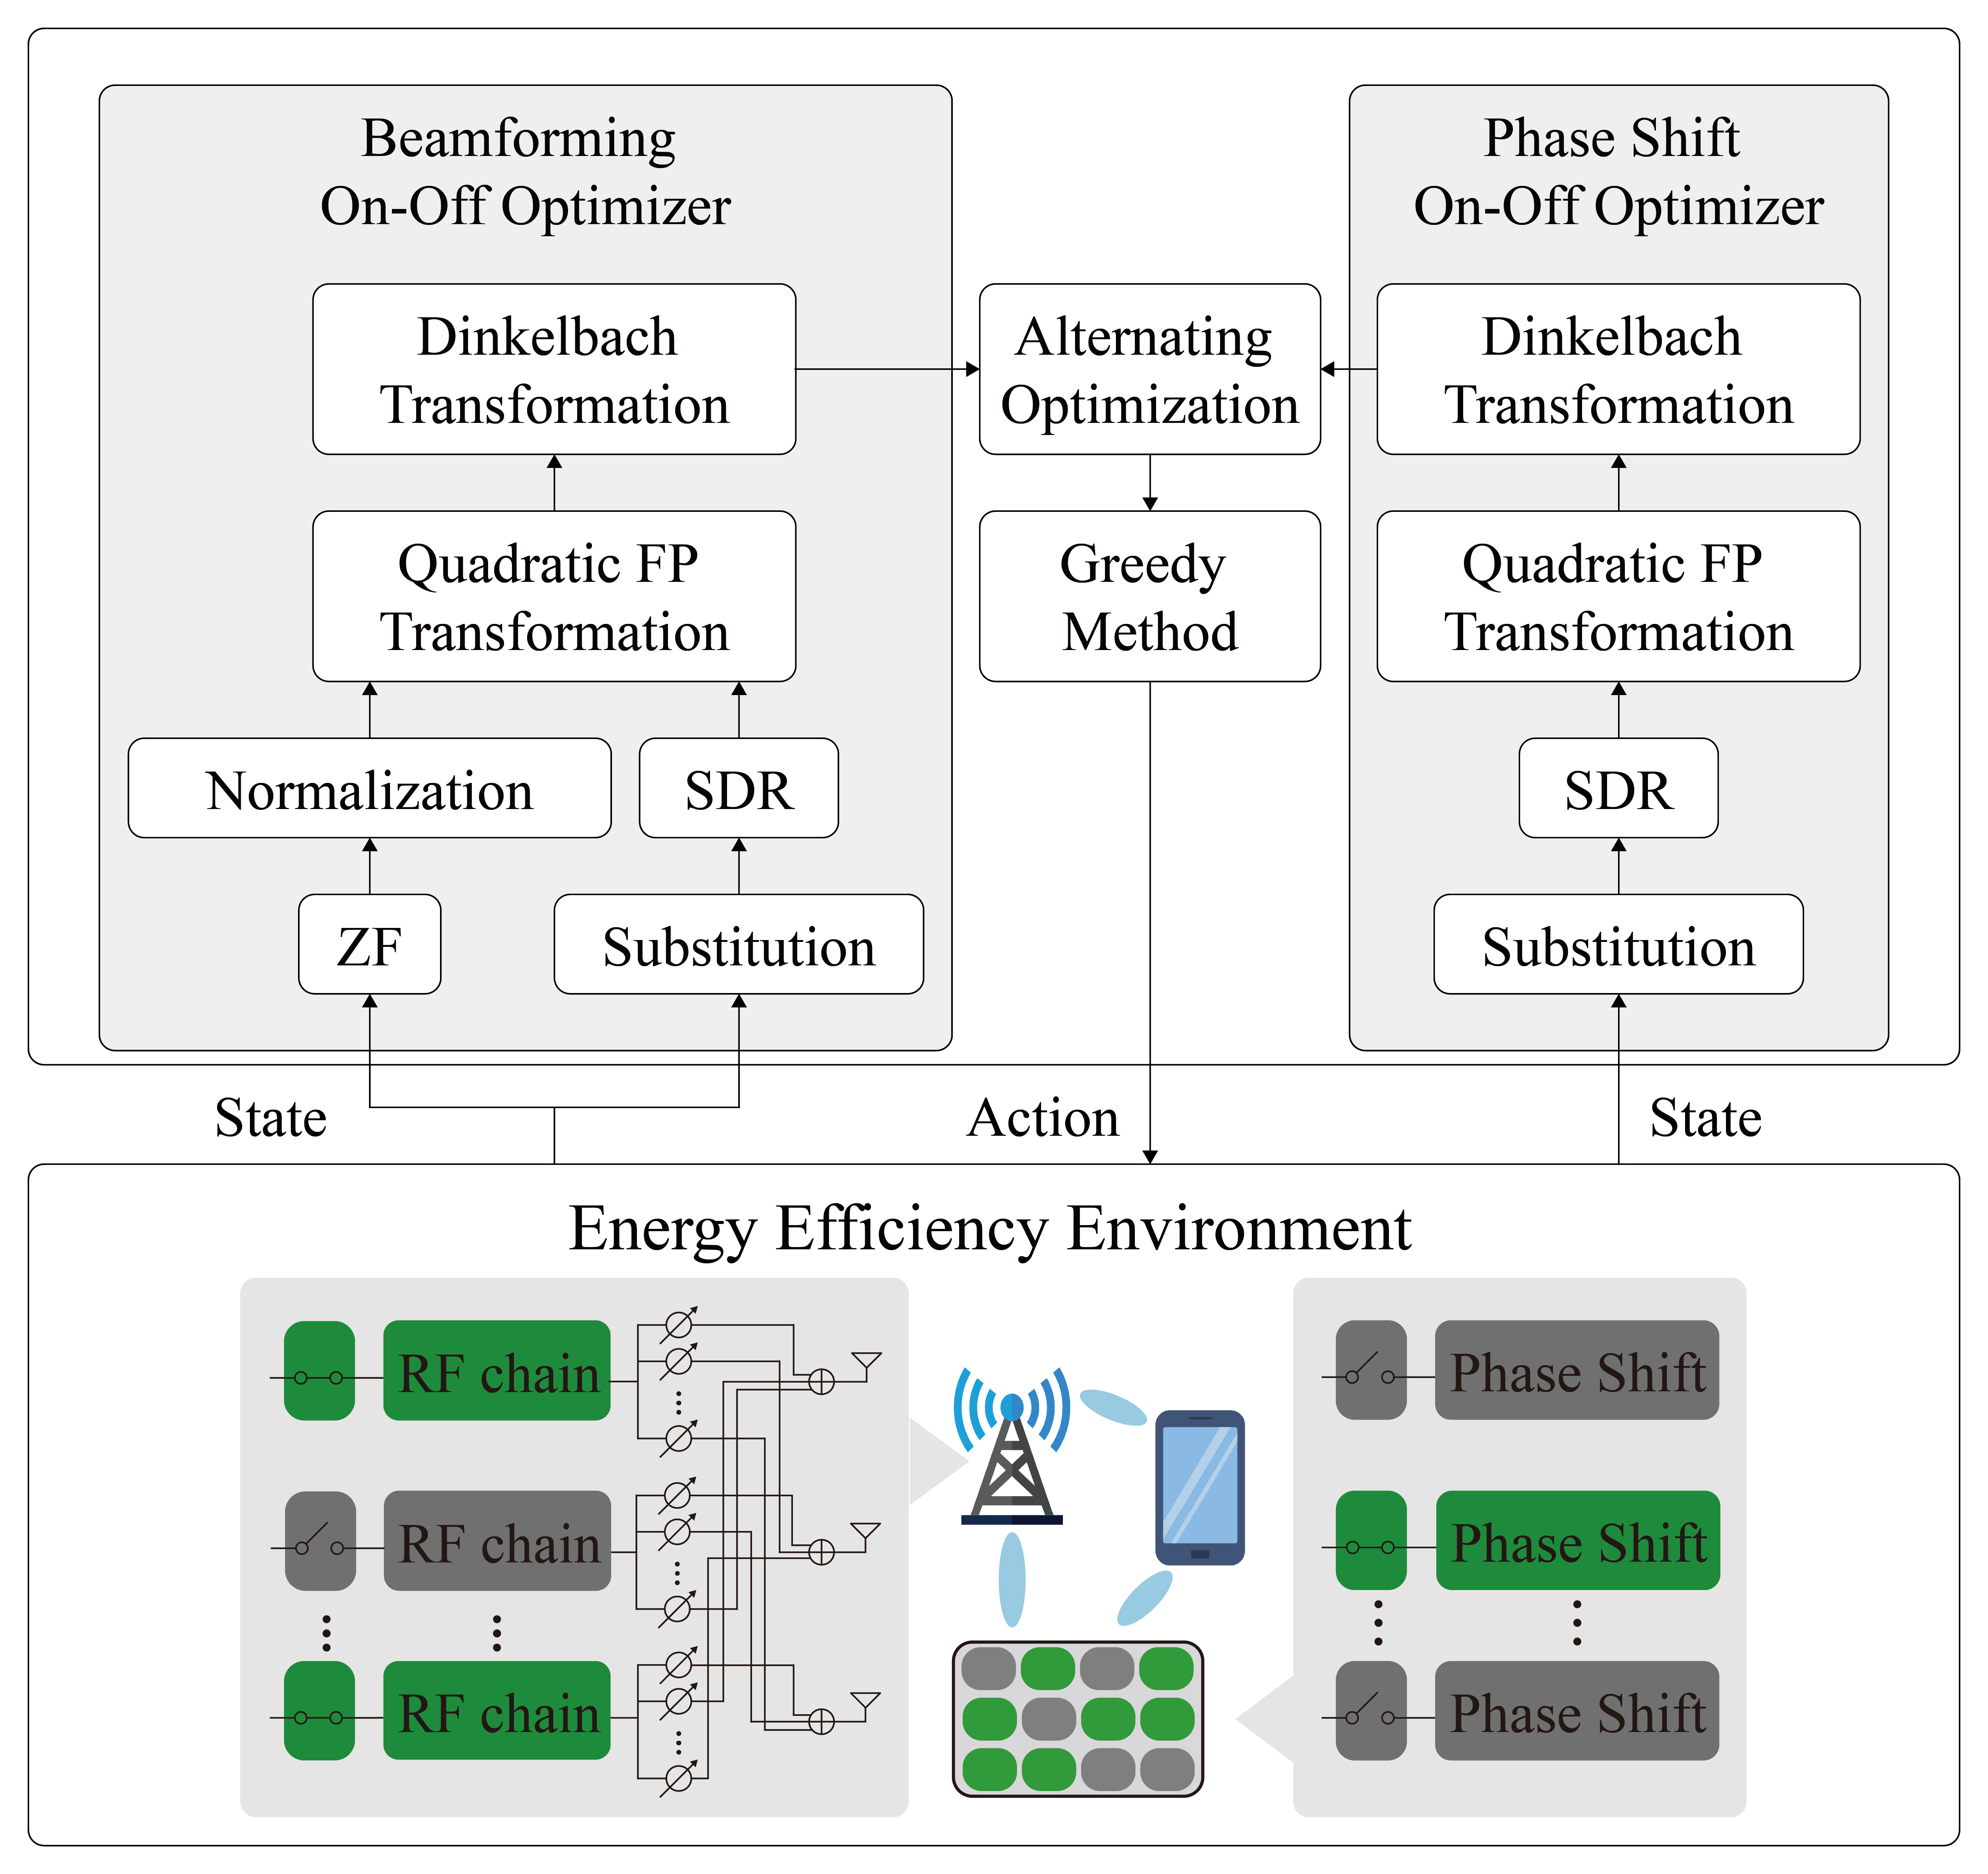
Figure 4. Basic idea of BPOF.
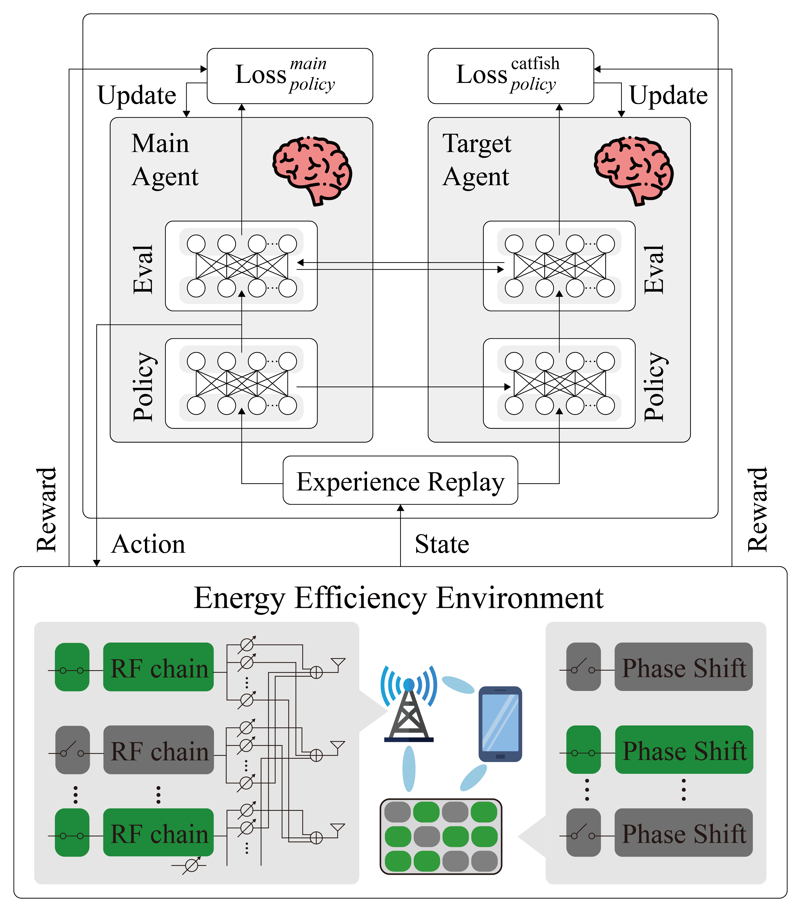
Figure 5. Basic idea of Actor-Critic.

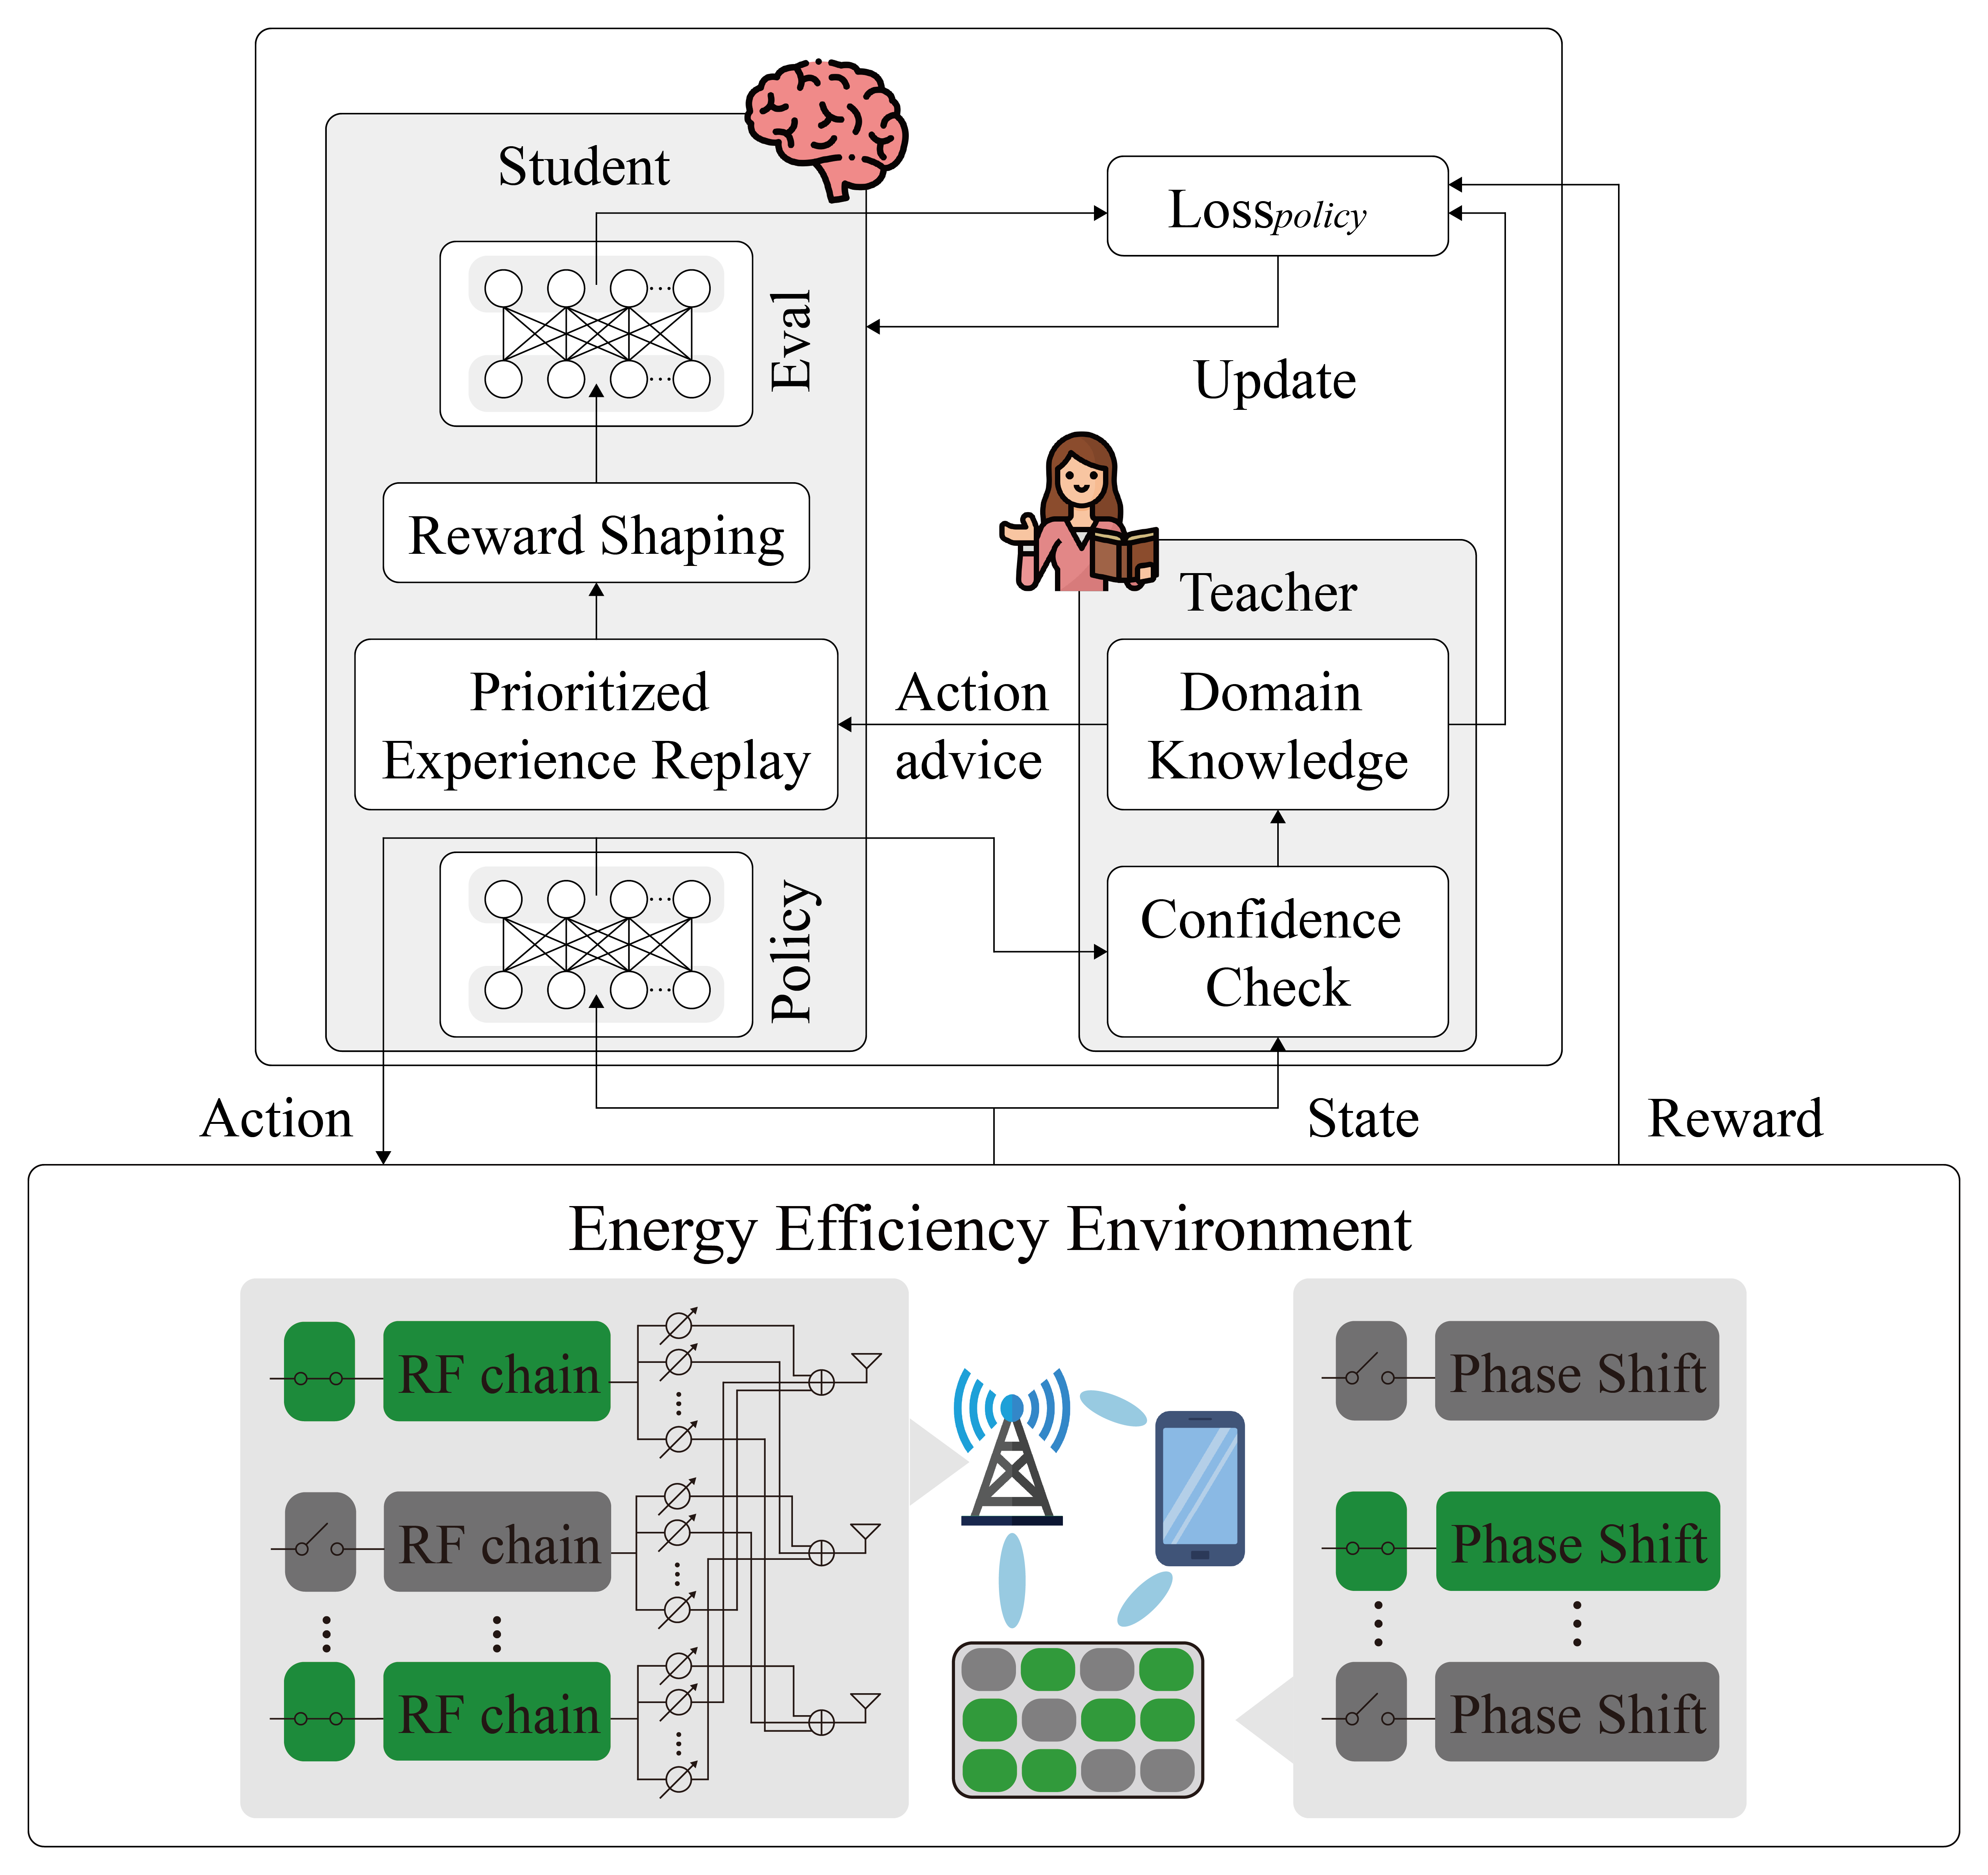
Figure 6. Basic idea of Teacher-Student Learning.
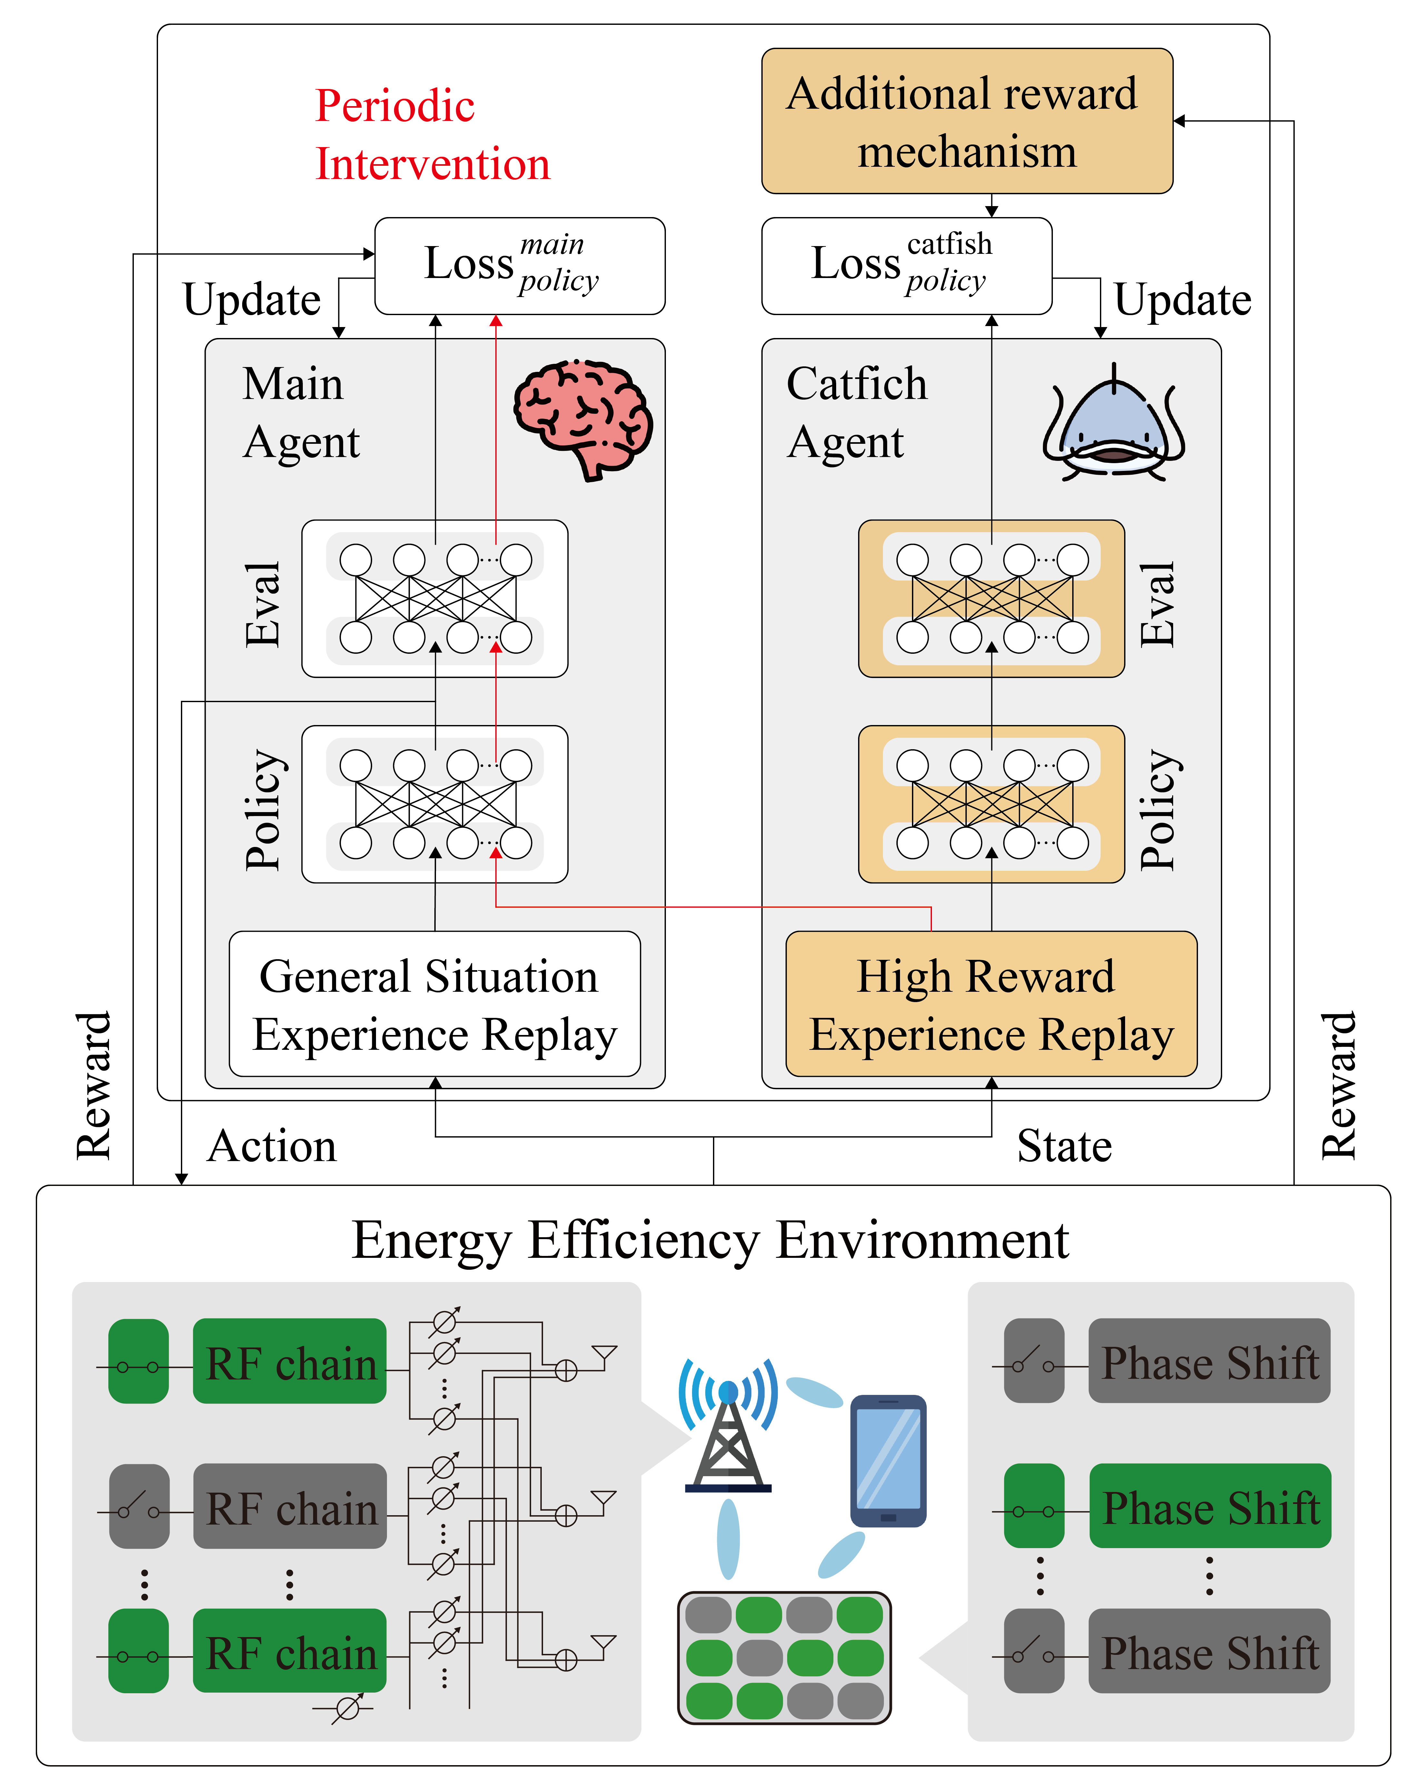
Figure 7. Basic idea of CDRL.

3.4 Comparison of Catfish-DRL with adversarial models
Table 1 shows the advantages and limitations of several competitor models relative to CDRL, including Actor-Critic [11], BPOF [10] and Teacher-Student [21]. The Actor-Critic [11] architecture combines policy-gradient and value-based methods, supports single-step updates and is suitable for continuous action spaces, learns through interaction with the environment and therefore does not rely on labeled samples, and has low implementation complexity that is easily extended to various reinforcement-learning improvement. However, the actor and critic alternate updates and depend on each other, ultimately leading to unstable training. BPOF [10] employs an alternating iterative optimization framework that jointly adjusts ZF, SDR and switch-weight parameters, uses a greedy method in the final stage to convert relaxed weights into actual on/off decisions to reduce search cost, but remains a heuristic approximation to a nonconvex problem and incurs high measurement and synchronization overhead in practice. In Teacher-Student learning [21], teacher provides advice to student at critical states to reduce performance disparity and achieve tail-end performance improvement. Instructor guidance can improve empirical performance and stability while preserving the student’s autonomous exploration ability, yet relies on heuristic domain rules whose inaccuracies may mislead learning and whose simplified design may limit the ultimate performance ceiling. This thesis’s CDRL adopts a strategy in which the catfish agent randomly perturbs the main agent during training to encourage the main agent to explore unvisited action spaces and avoid local optima. In other words, CDRL’s strategy may cause larger fluctuations in the reward curve during training, but under its high-risk, high-reward characteristic it has greater chance to achieve better energy-efficiency performance. Similar to BPOF [10], it presents higher implementation, computational and memory-cost issues.

Table 1. Comparison of Catfish-DRL with adversarial models.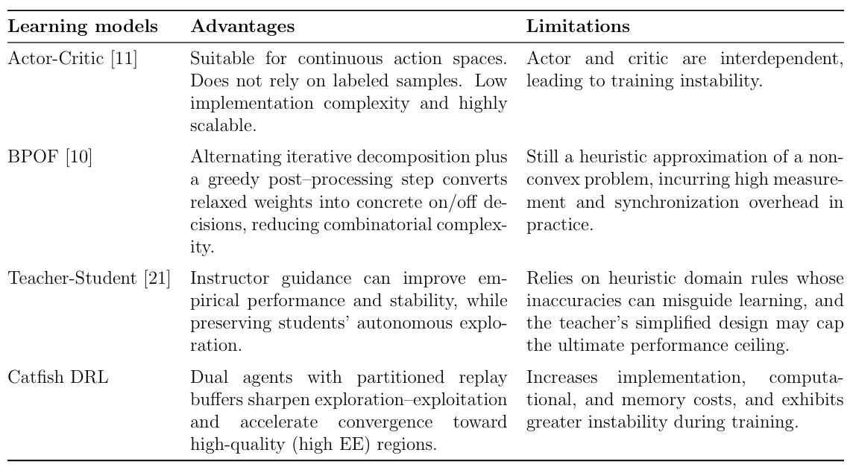

表格 1 展示了幾個對手模型與 CDRL 的優勢與限制，包括了 Actor-Critic [11] 、 BPOF [10] 與 Teacher-Student [21]。Actor-Critic [11] 架構結合了 Policy Gradient 與 Value-Based 方法，可以進行單步更新且適用於連續動作空間。透過與環境交互來學習所以不依賴標記樣本。其架構的實現複雜度低，易於擴展多種強化學習改進版本。但是 Actor 和 Critic 交替更新且相互依賴，最終導致訓練不穩定。BPOF [10] 擁有交替迭代式優化架構，結合 ZF、SDR 與開關權重聯合調整。利用貪婪法於最終階段將放鬆後的權重轉為實際 on/off 決策來降低搜尋成本。但是其仍然是非凸問題的啟發式近似。且在實務上會產生較高的測量和同步開銷。在 Teacher-Student 學習 [21] 中，師長在關鍵時刻的狀態下為學生提供建議，以降低性能差異的方式來獲得尾部性能提升。教師指導可以提升經驗表現與穩定性，同時保留學生的自主探索能力。依賴啟發式領域規則，這些規則的不準確性可能會誤導學習，而教師的簡化設計可能會限制最終的表現上限。本文的 CDRL 採取了 catfish agent 在訓練過程中隨機刺激 main agent 的策略。鼓勵 main agent 嘗試尚未探索的動作空間，避免陷入區域最優解。換句話說， CDRL 的策略可能導致獎勵曲線在訓練過程中呈現較大波動。但是在高風險高回報的特性下，更有機會取得更好的能量效率表現。與 BPOF [10] 有相似，擁有較高的實作、計算和記憶體成本問題。

4. Catfish-effect-based DRL for Energy-Efficient Joint Switching
In this chapter, we propose a catfish‐based deep reinforcement learning algorithm to optimize the energy efficiency of communication networks. The flowchart of the proposed CDRL algorithm is shown in Fig. 8, and the content of each subchapter is as follows:
- Catfish-effect-based data preparation: The first stage is data preprocessing, aimed at preparing the training data for the subsequent deep reinforcement learning phase by generating communication states in advance for experience replay with different EE criteria.
- Catfish-effect-based DRL training: The second stage is the general training of the catfish deep reinforcement learning with competitive periodic interventions, designed to transfer high‐reward knowledge from the catfish agent to the main agent and to stimulate the main agent to explore and pursue better optimization strategies.
- Catfish-effect-based DRL optimization of energy efficiency: The third stage uses the trained CDRL policy to optimize communication EE.

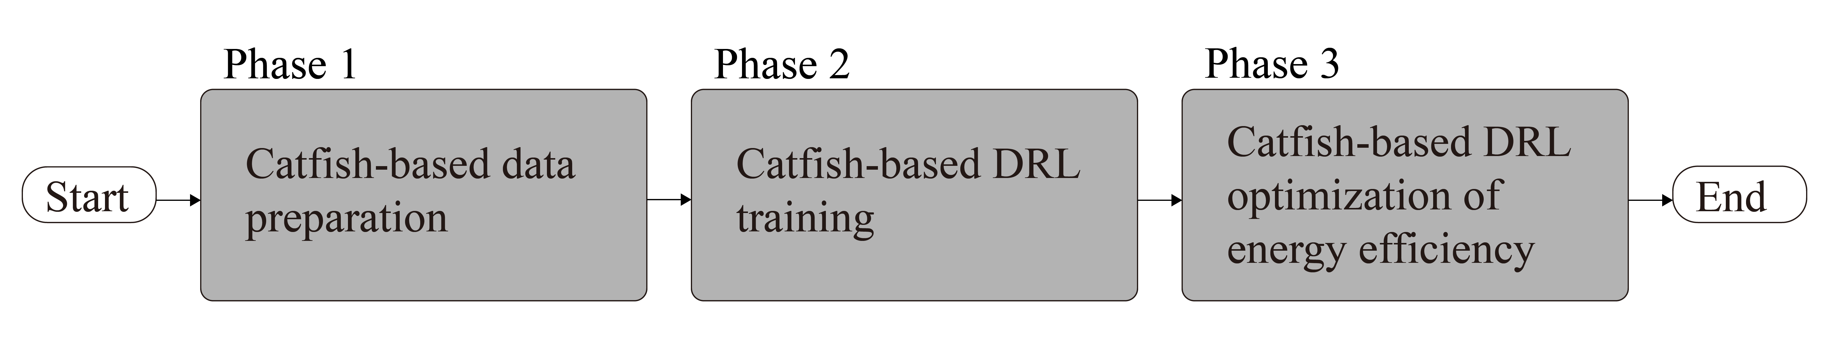
Figure 8. The flowchart of the proposed energy efficiency optimization.

在此章節，我們提出了一種基於鯰魚式的深度強化學習演算法優化通訊網絡的能源效率。所提出的 CDRL 演算法流程圖如圖 8 所示，每小節內容如下:
Catfish-effect-based data preparation: 第一階段是資料預處理，目的是準備下一個階段深度強化學習的訓練資料。預先產生一些通訊的狀態，用以在下個階段根據代理的不同分配不同EE 標準的經驗回放。
Catfish-effect-based DRL training: 第二個階段是鯰魚深度強化學習的一般訓練，與有競爭關係的隨機週期介入訓練，目的讓擁有高獎勵的 catfish agent 知識轉移給 main agent ，並且刺激 main agent 探索並追求更好的優化策略。
Catfish-effect-based DRL optimization of energy efficiency: 第三個階段是利用訓練好 CDRL 的策略優化通訊 EE。
4.1 Phase I: Catfish-effect-based data preparation
In this subchapter, the pre-generated simulated communication data will be referenced by the designed CDRL agents, enabling the CDRL to learn exemplary solution cases and derive optimal solutions for subsequent problems. The communication environment states to be learned include the digital beamforming matrix $w_{k}^{BB}$, the RF beamforming matrix $F^{RF}$, the RF-chain switch matrix $C^{RF}$, the active RIS power amplification matrix $Λ^{RIS}$, the phase shift matrix $ϕ^{RIS}$, the passive RIS element switch matrix $B^{RIS}$, and the active RIS element switch matrix $A^{RIS}$. These parameters represent the smallest adjustable units in the entire communication network. These six states are input to the evaluation network to enhance the communication quality output by the main agent, as shown in Fig. 11.
As illustrated in Fig. 9, efficient communication data is pre-generated to build the experience memory for CDRL. We first randomly generate the spatial layout of the BS, UEs, and RIS to obtain the three channel matrices Q, $h_{k}$, and $g_{k}$, referring to formula (4). For RIS-related matrix generation, we first process the passive RIS. Considering N-bit phase shifters, a set of candidate phase shifts ${\tilde{ϕ}}_{m}^{RIS}$ where 1 ≤ m ≤ $2^{N}$, is generated using the discrete Fourier transform (DFT) codebook ${\tilde{ϕ}}^{RIS} = \{{\tilde{ϕ}}_{1}^{RIS}…{\tilde{ϕ}}_{m}^{RIS}…{\tilde{ϕ}}_{2^{N}}^{RIS}\}$ [13]. For each candidate phase shift ${\tilde{ϕ}}_{m}^{RIS}$, it is multiplied by the corresponding random RF-chain switch matrix ${\tilde{B}}_{m}^{RIS}$, resulting in candidate passive RIS phase shifts ${\tilde{ϕ}}_{m}^{RIS}{\tilde{B}}_{m}^{RIS}$ with corresponding RIS elements turned off. For active RIS, a uniformly random active RIS power amplification matrix set ${\tilde{Λ}}^{RIS}=\{{\tilde{Λ}}_{1}^{RIS},…,{\tilde{Λ}}_{m}^{RIS},…,{\tilde{Λ}}_{2^{N}}^{RIS}\}$ where 1 ≤ m ≤ $2^{N}$, and ${\tilde{Λ}}_{m}^{RIS} ≥1$, is generated. Finally, the candidate active RIS phase shifts with corresponding RIS elements turned off are expressed as ${\tilde{ϕ}}_{m}^{RIS}{\tilde{A}}_{m}^{RIS}{\tilde{Λ}}_{m}^{RIS}$.
For the BS part, similarly, a set of candidate beams ${\tilde{F}}_{m}^{RF}$ where 1 ≤ m ≤ $2^{N}$, is generated using the discrete Fourier transform (DFT) codebook ${\tilde{F}}^{RF} = \{{\tilde{F}}_{1}^{RF}…{\tilde{F}}_{m}^{RF}…{\tilde{F}}_{2^{N}}^{RF}\}$. For each candidate beam ${\tilde{F}}_{m}^{RF}$, it is multiplied by the corresponding random RF-chain switch matrix ${\tilde{C}}_{m}^{RF}$, yielding candidate beams ${\tilde{F}}_{m}^{RF}{\tilde{C}}_{m}^{RF}$ with corresponding RF-chain elements turned off. Then, the weighted minimum mean square error (WMMSE) algorithm [22] is used to compute the corresponding digital baseband precoding matrix ${\tilde{w}}_{k,m}^{BB}$. Next, the spectral efficiency (SE) formula (6) calculates the user rates $R_{k}^{pas}$ and $R_{k}^{act}$. Combining the power amplifier consumption and the energy consumption of activated RF chains, the overall energy efficiency (EE) is calculated, referring to formulas (12) and (13). Finally, the candidate with the maximum EE is selected as the final analog precoding matrix ${\hat{F}}^{RF}$, as illustrated in Fig. 10.
After completing all steps, the system state, selected beam index, and EE triplet are stored in the replay buffer, providing accurate and consistent training samples for subsequent deep reinforcement learning. In chapter 4.2.2, the generated data can be stored into the catfish replay memory according to matching thresholds and is represented as $D=\{D_{1}, …, D_{n}, …, D_{N}\}$, where 1 ≤ n ≤ N, serving as the initial experience replay data for CDRL.

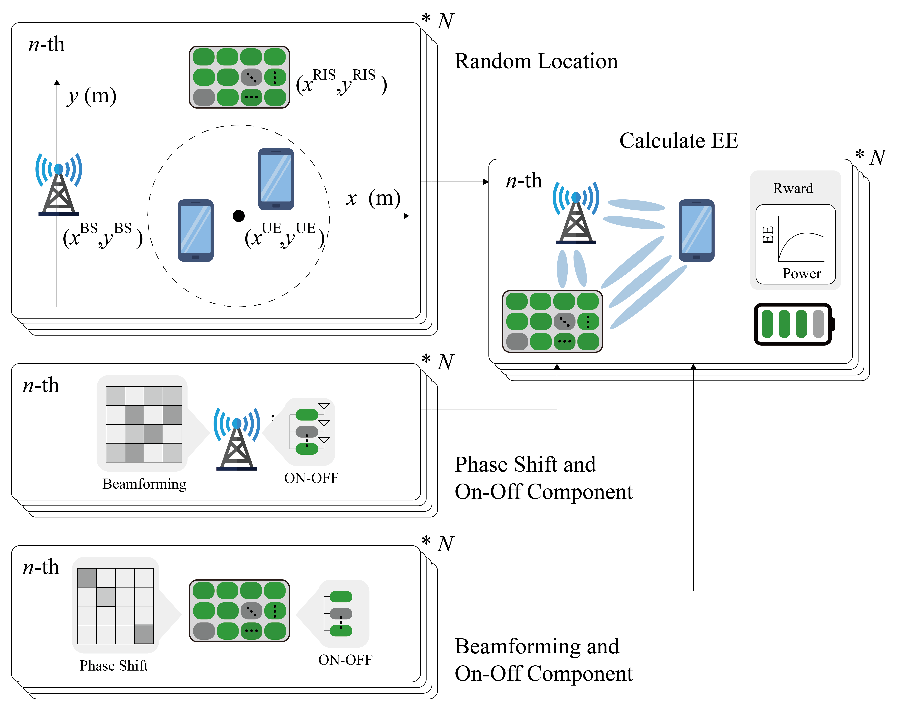
Figure 9. The flowchart of prepare training data.

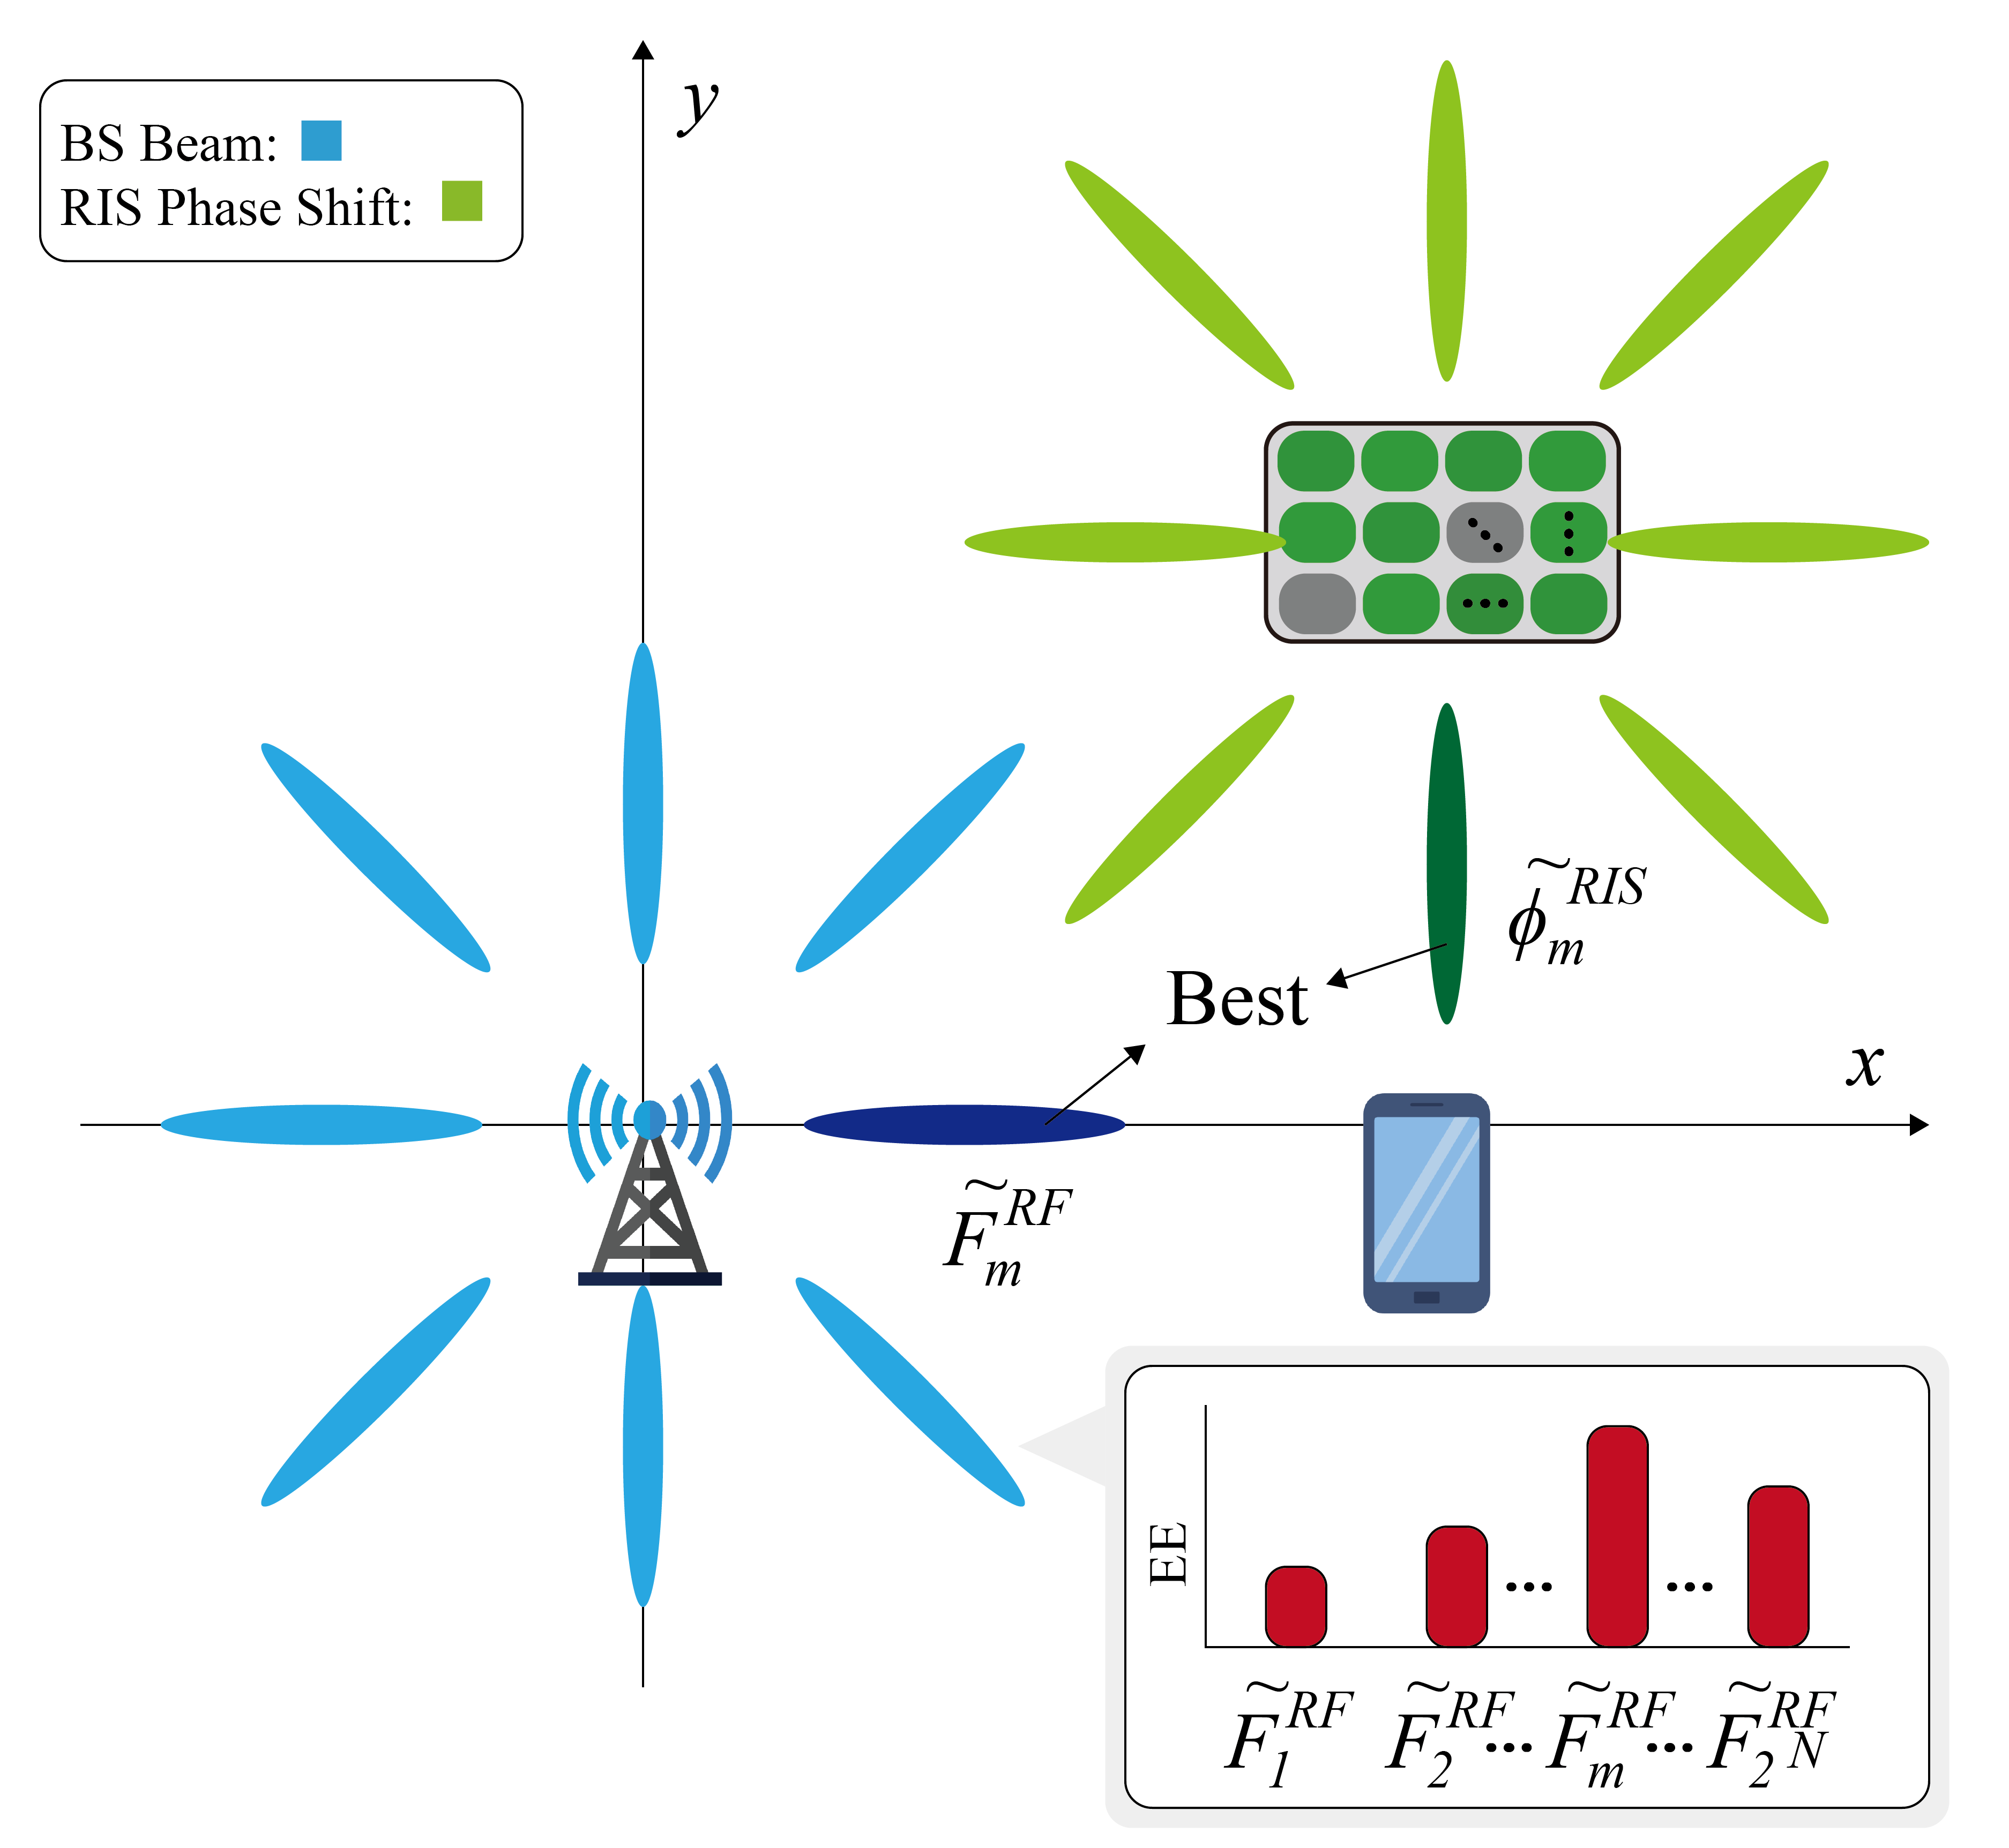
Figure 10. Beam generation diagram for prepare training data.

在這個小節中，預先產生的模擬通訊資料將被我們設計的 CDRL agent 參考。使得 CDRL 能學習優秀的解決案例，以推導出後續問題的最佳解法。要學習如何調整的通訊環境狀態包含了: 數位波束成形矩陣 $w_{k}^{BB}$、類比波束成形矩陣 $F^{RF}$、射頻鏈的開關矩陣 $C^{RF}、主動 RIS 功率放大矩陣 Λ^{RIS}、相移矩陣 ϕ^{RIS}、被動 RIS 元件開關矩陣 B^{RIS} 與主動 RIS 元件開關矩陣 A^{RIS}$ 。這些參數代表了整個通訊網路中每個可以調整的最小單位。這六個狀態將被輸入至評估網路中，以提升 main agent 輸出的通訊品質，如圖 11 所示。
如圖 9 所示，為了預先生成高效的通訊資料，用以建立 CDRL 的經驗記憶體。我們首先隨機生成 BS 、UE 與 RIS 的空間佈局，以獲得三條通道矩陣 $Q$、$h_{k}$、$g_{k}$ ，參考公式(4)。在 RIS 相關矩陣生成的部分，我們可以先處理被動 RIS。考慮配備 N-bit 相移器，我們以離散傅立葉轉換 (DFT) 生成一組包含 $2^{N}$ 條候選相移 ${\tilde{ϕ}}_{m}^{RIS}$ 之 N-bit DFT 碼本 ${\tilde{ϕ}}^{RIS} = \{{\tilde{ϕ}}_{1}^{RIS}…{\tilde{ϕ}}_{m}^{RIS}…{\tilde{ϕ}}_{2^{N}}^{RIS}\}$，其中 1 ≤ m ≤ $2^{N}$ [13]。對於每一條候選相移 ${\tilde{ϕ}}_{m}^{RIS}$ ，將其乘上對應的隨機射頻鏈的開關矩陣 ${\tilde{B}}_{m}^{RIS}$。這樣就獲得關閉對應 RIS 元件的候選被動 RIS 相移 ${\tilde{ϕ}}_{m}^{RIS}{\tilde{B}}_{m}^{RIS}$。如果是主動 RIS ，我們就以均勻隨機生成主動 RIS 功率放大矩陣組 ${\tilde{Λ}}^{RIS}=\{{\tilde{Λ}}_{1}^{RIS},…,{\tilde{Λ}}_{m}^{RIS},…,{\tilde{Λ}}_{2^{N}}^{RIS}\}$，其中 1 ≤ m ≤ $2^{N}$, ${\tilde{Λ}}_{m}^{RIS} ≥1$。最後得出關閉對應 RIS 元件的候選主動 RIS 相移 ${\tilde{ϕ}}_{m}^{RIS}{\tilde{A}}_{m}^{RIS}{\tilde{Λ}}_{m}^{RIS}$。
有了 RIS 的矩陣後，接著是 BS 的部分。相似的，我們以離散傅立葉轉換生成一組包含 $2^{N}$ 條候選波束 ${\tilde{F}}_{m}^{RF}$ 之 N-bit DFT 碼本 ${\tilde{F}}^{RF} = \{{\tilde{F}}_{1}^{RF}…{\tilde{F}}_{m}^{RF}…{\tilde{F}}_{2^{N}}^{RF}\}$，其中 1 ≤ m ≤ $2^{N}$ 。對於每一條候選波束 ${\tilde{F}}_{m}^{RF}$ ，將其乘上對應的隨機射頻鏈的開關矩陣 ${\tilde{C}}_{m}^{RF}$。這樣就獲得關閉對應 RF-chain 元件的候選波束 ${\tilde{F}}_{m}^{RF}{\tilde{C}}_{m}^{RF}$。之後，採用加權最小均方誤差 (WMMSE) 演算法[M12]算出對應的數位基帶預編碼矩陣 ${\tilde{w}}_{k,m}^{BB}$。隨後，我們使用 SE 公式 (6) 計算出各用戶速率 $R_{k}^{pas}$/$R_{k}^{act}$ 。並結合功率放大器功耗與已啟用 RF-chain 的能耗，計算出整體能源效率 EE ，參考公式(12)(13)。最後，選取 EE 最大者作為最終的類比預編碼矩陣 ${\hat{F}}^{RF}$ ，如圖 10 所示。
當所有步驟都完成後，將通訊系統中元件的狀態、設備位置及 EE 三元組存入回放緩衝區。為後續深度強化學習提供精准且一致的訓練樣本。在後續的 4.2.2 節中，生成的資料可以依符合的門檻分別放入 catfish replay memory。並且表示為 $D=\{D_{1}, …, D_{n}, …, D_{N}\}$，其中 $1 ≤ n ≤N$。作為 CDRL 的初始經驗回放資料。

4.2 Phase II: Catfish-effect-based DRL training
Since the energy efficiency problem discussed in chapter 3 is a non-convex optimization problem, traditional mathematical methods require non-convex-to-convex transformations, resulting in computational complexity [11]. Compared to conventional alternating optimization (AO) methods, deep reinforcement learning (DRL) can optimize complex dynamic problems without requiring prior mathematical relaxation [13]. This chapter provides an overview of the proposed CDRL model architecture and training methodology. The main agent is introduced in chapter 4.2.1, including the formulation of states $s_{t}^{pas}$/$s_{t}^{act}$, actions $a_{t}^{pas}$/$a_{t}^{act}$, and rewards $r_{t}^{pas}$/$r_{t}^{act}$. The catfish agent is also introduced in chapter 4.2.1, covering experience stratification, Asymmetric Discounting Strategy, and the adaptive competitive reward mechanism.

因為第三章提到的能量效率問題是個非凸最佳化問題。所以傳統的數學方法需要經過非凸轉凸的流程，計算上較為複雜[11]。與傳統的 AO 方法相比， DRL 可以優化複雜的動態問題，而無需事先進行數學鬆弛[13]。本節將會概述所提出的 CDRL 模型的架構和訓練方法。該模型的 main agent 將會於 4.2.1 節介紹，包含狀態 $s_{t}^{pas}$/$s_{t}^{act}$ 、動作 $a_{t}^{pas}$/$a_{t}^{act}$ 、獎勵 $r_{t}^{pas}$/$r_{t}^{act}$ 的制定。而 catfish agent 的部分將會於 4.2.1 節介紹，包含經驗分類、折扣係數、adaptive competitive reward mechanism制定。

4.2.1 Main agent of Catfish-effect-based DRL
The core of reinforcement learning lies in the interaction between the agent and the environment, where the agent iteratively adjusts its policy based on received rewards, aiming to maximize the cumulative reward. To solve for the optimal EE parameters using DRL, this chapter defines the state, action, and reward components [11].
State: used to represent the current status of each component in the environment. The state at time step t, includes the system's total power consumption $P_{Tot}^{pas} / P_{Tot}^{act}$, the three channel matrices $Q, h_{k}$ and $g_{k}$, and the actions at the time step t $a_{t}^{pas}/a_{t}^{act}$. The state at time step t is represented as:

$$\begin{aligned}\left\{\begin{matrix}s_{t}^{pas} = [P_{Tot}^{pas}, Q, h_{k}, g_{k}, a_{t}^{pas}] \\ s_{t}^{act} = [P_{Tot}^{act}, Q, h_{k}, g_{k}, a_{t}^{act}]\end{matrix}\right.\#\left( seq equation 14\right)\end{aligned}$$

Action: Represents the operations executed by each component in the current environment. It includes all component state matrices $w_{k}^{BB},F^{RF},C^{RF},Λ^{RIS},ϕ^{RIS},B^{RIS}/A^{RIS}$. The action at time step t is denoted as:

$$\begin{aligned}\left\{\begin{matrix}a_{t}^{pas} = [w_{k}^{BB},{ F}^{RF},{ C}^{RF},{ ϕ}^{RIS}, B^{RIS}] \\ a_{t}^{act} = [w_{k}^{BB},{ F}^{RF},{ C}^{RF},{ Λ}^{RIS},{ ϕ}^{RIS}, A^{RIS}]\end{matrix}\right.\#\left( seq equation 15\right)\end{aligned}$$

Reward: Represents the feedback from the environment in response to $a_{t}$. We are using energy efficiency as a reward. The reward at time step t is denoted as:

$$\begin{aligned}\left\{\begin{matrix}r_{t}^{pas} = \sum_{k=1}^{N_{UE}}{R_{k}^{pas}\left(w_{k}^{BB},F^{RF},C^{RF},ϕ^{RIS},B^{RIS}\right)} \\ r_{t}^{act} = \sum_{k=1}^{N_{UE}}{R_{k}^{act}\left(w_{k}^{BB},F^{RF},C^{RF},Λ^{RIS},ϕ^{RIS},A^{RIS}\right)}\end{matrix}\right.\#\left( seq equation 16\right)\end{aligned}$$

The CDRL framework is built upon the actor–critic architecture, which consists of two neural networks.
- Critic Network: The critic network takes the current state and action as input and outputs Q-value, denoted as $Q(s_{t},a_{t})$, where Φ represents the parameters of the value network.
- Actor Network: The actor network receives the current state of the environment as input and, based on a policy function, determines the action to take. The policy is represented as $π_{θ}(s_{t})$, where θ denotes the parameters of the policy network, which guides the agent’s action selection, as illustrated in Fig. 11.
Since the channel matrices and component state matrices are complex-valued while neural networks can only process real numbers, both inputs and outputs are split into real and imaginary parts. To enhance training stability, batch normalization is introduced in the hidden layers, normalizing the outputs of the previous layer to zero mean and unit variance.
The critic evaluates the value of the actions taken by the actor and provides correction signals. This is typically measured using temporal difference (TD) error $δ$, defined as:

$$\begin{aligned}δ_{t}= r_{t}+ γQ_{Φ}\left(s_{t+1},π_{θ}(s_{t+1})\right)- Q_{Φ}(s_{t},a_{t})\#\left( seq equation 17\right)\end{aligned}$$

Here, $π_{θ}(s_{t+1})$ denotes the action given by the actor at the next state. $γ$ is the discount factor that determines the importance of the future Q-value $Q_{Φ}\left(s_{t+1},π_{θ}(s_{t+1})\right)$, typically ranging between 0.9 and 0.99. Equation (17) measures the discrepancy between the current Q-value estimate and the one-step actual reward plus the estimated Q-value at the next step (target Q-value). This quantifies the difference between the estimate and reality, which is used to guide the update of the weighting parameters.
The critic uses a neural network to approximate the Q-value function $Q(s_{t},a_{t})$, and updates the network parameters by minimizing the mean squared error (MSE) loss, defined as:

$$\begin{aligned}L(Φ) ={(δ_{t})}^{2}\#\left( seq equation 18\right)\end{aligned}$$

Then, gradient descent is used to update the critic’s parameters $Φ$ as follows:

$$\begin{aligned}Φ_{t+1} = Φ_{t} - μ_{c}∇_{Φ}L(Φ_{t})\#\left( seq equation 19\right)\end{aligned}$$

Here, $μ_{c}$ denotes the learning rate, and ∇ represents the gradient with respect to $Φ$ of the loss function $L(Φ_{t})$.
The parameter update formula for the actor θ is:

$$\begin{aligned}θ_{t+1} = θ_{t}- μ_{a}{[∇_{a}Q_{Φ}\left(s_{t},a\right)]}_{a= π_{θ}(s_{t})}∇_{θ}π_{θ}(s_{t})\#\left( seq equation 20\right)\end{aligned}$$

Here, $μ_{a}$ denotes the learning rate. First, the critic computes the gradient with respect to the action to determine the direction that increases the Q-value. Then, the actor propagates this information back to its parameters θ through its own gradient.


Figure 11. The flowchart of main agent (Active RIS).

強化學習的核心在於透過智能體 (agent) 與環境 (environment) 之間的互動，根據所獲得的回饋 (reward) 逐步調整行動策略 (policy) ，以達到最大化累積報酬 (cumulative Reward) 的目標。為了以 DRL 求解出最佳 EE 的參數，本節將制定出狀態 (state) 、動作 (action) 與獎勵 (reward) [11]。
狀態：用來表示目前環境中各個元件的狀態。時間步長 t 的狀態包括了系統總功率消耗 $P_{Tot}^{pas} / P_{Tot}^{act}$ 、三個通道矩陣 $Q, h_{k}$ 和 $g_{k}$ 還有第 t 的時間步長的動作 $a_{t}^{pas}/a_{t}^{act}$ 。狀態在時間步長 t 表示為
公式(14)
動作：用來表示目前環境中各個元件執行的行動。包含了所有的元件狀態矩陣 $w_{k}^{BB},F^{RF},C^{RF},Λ^{RIS},ϕ^{RIS},B^{RIS}/A^{RIS}$ 。行動在時間步長 t 表示為
公式(15)
獎勵：用來表示目前環境對於 $a_{t}$ 的回饋。我們是使用能量效率作為獎勵。獎勵在時間步長 t 表示為
公式(16)
CDRL 以 actor-critic 架構為基底，它可分為兩種神經網路。
- Critic Network: 評論網路將目前狀態和動作作為輸入並輸出 Q 值，表示為 $Q(s_{t},a_{t})$ 。其中 Φ 為價值網路權重。
- Actor Network: 演員網路接收環境的當前狀態作為輸入，並基於策略函數確定要採取的行動。此策略表示為 $π_{θ}(s_{t})$ ，其中 θ 為策略網路權重，用於指導代理的動作選擇，如圖 11 所示。
由於通道矩陣與各個元件的狀態矩陣是複數。而神經網路只能處理實數。所以不論是輸入還是輸出的部分皆會平攤成實部和虛部兩塊。為提升訓練穩定性，我們在隱藏層引入了批量歸一化，將前一層的輸出標準化至零均值、單位方差。
Critic 負責評估Actor 採取行動的價值，並提供修正方向。這通常通過時間差分誤差 (Temporal Difference, TD) $δ$ 來衡量，即：
公式(17)
其中 $π_{θ}(s_{t+1})$ 為 Actor 在下個狀態給出的動作。 $γ$ 是折扣係數，它決定了未來Q價值 $Q_{Φ^{'}}\left(s_{t+1},π_{θ}(s_{t+1})\right)$ 的重要性，通常介於 0.9 – 0.99 之間。公式(17) 衡量當前 Q 值估計與一步的實際獎勵獎勵加上下一步的 Q 值估計(目標 Q 值)之間的落差。意思就是估計值與現實差異有多少，藉此差異來提供修正權重的指引。
Critic 使用一個神經網絡來近似Q值函數 $Q_{Φ}(s_{t},a_{t})$ ，並通過最小化均方誤差 (MSE) 損失來更新網絡參數，損失函數為：
公式(18)
然後使用梯度下降來更新 Critic 的參數 $Φ$ :
公式(19)
其中 $μ_{c}$ 是學習率， ∇ 表示對於 $L(Φ_{t})$ 的 $Φ$ 求導。
Actor的參數 $θ$ 更新公式為​:
公式(20)
其中 $μ_{a}$ 是學習率。先用 critic 對動作求梯度，得到哪個方向會讓 Q 值變大。再透過 actor 本身的梯度把訊息傳回參數 $θ$ ​。

4.2.2 Catfish agent of of Catfish-effect-based DRL
This chapter continues the work from chapter 4.2.1 by explaining the dedicated mechanisms of the catfish agent and how it collaborates with the main agent. The goal is to achieve both the stimulation of exploration by the main agent and experience-level knowledge transfer. The core design of the catfish agent includes three key aspects, all aimed at ensuring its policy outperforms that of the main agent: first, during the data pre-generation phase in chapter 4.1, all experiences are routed based on an energy efficiency (EE) threshold. Second, the discount factor of the catfish agent is set higher to emphasize long-term return estimation. Third, an adaptive competitive reward mechanism is established to encourage the catfish agent to maintain its leading advantage.
Next, the two training modes of CDRL are presented. As shown in Fig. 12(a), two agents are established simultaneously: the main agent and the catfish agent. The main agent learns experiences under general energy efficiency (EE) conditions using a smaller discount factor. The catfish agent uses a larger discount factor to learn high EE experiences, aiming to capture longer-term strategic cues. This study designs two training modes for CDRL. As shown in Fig. 12(a), in the normal training mode, the main agent and catfish agent each have independent experience replay memories, discount factors, and reward mechanisms, training independently without interference. As shown in Fig. 12(b), after a random period, the system enters the intervention training mode. In this mode, a portion of the high EE experiences collected by the catfish agent is sampled and mixed into the main agent’s training batches. The main agent performs standard policy updates on the entire mixed batch as usual. However, since the batch contains high EE state-action pairs, experience-driven knowledge transfer is achieved. In the mixed batch $S^{mix}= S^{M} ∪S^{CF}$, 70% of the samples are drawn from the main replay memory $S^{M}$, and 30% from the catfish replay memory $S^{CF}$, where $S^{M}∈D^{M}, S^{CF}∈D^{CF}$.
By orchestrating the above three components and the two‑mode schedule, the catfish agent persistently supplies high‑value trajectories while safeguarding the main policy from premature convergence.


(a)

(b)

Figure 12. (a) General training phase of CDRL, and
(b) CDRL randomized periodic intervention training phase.

本節接續 4.2.1 節的工作。一方面說明 catfish agent 的專屬機制，另一方面說明其如何與 main agent 協同運作。目標是達到「激發主代理探索」與「經驗級知識轉移」的成果。Catfish Agent 的核心設計包含下列三項，均旨在確保其策略表現優於 main agent : 第一點，在 4.1 節的資料預產生階段，所有經驗按照能量效率 (EE) 門檻分流。第二點，將 catfish agent 的折扣係數設置得更大，以側重長期回報估計。第三點，為 catfish agent 設置自適應競爭獎勵，鼓勵 catfish 持續維持領先優勢。
接下來介紹 CDRL 的兩個訓練模式。如圖 12(a) 所示，我們同時建立兩個代理：主代理 (main agent) 與 鯰魚代理 (catfish agent)。 Main agent以較小折扣係數學習一般能量效率 (EE) 狀況下的經驗。 Catfish agent以較大折扣係數來學習高 EE 經驗，以期擷取較長期的策略線索。本研究為 CDRL 設計了兩種訓練模式。如圖 12(a) 所示，在一般訓練情況下 main agent 與 catfish agent 擁有獨立的經驗回放記憶體、折扣係數與獎勵機制。獨立的兩個 agent 互不干擾各自訓練。如圖 12(b) 所示，在經過隨機週期後會進入介入訓練模式。在此模式下，我們將 catfish agent 所蒐集的高 EE 經驗部分抽樣，混入 main agent 的訓練批次。 main agent 對整個混合批次進行標準的 policy 更新 (與常規無異)。但因批次中含高 EE 狀態-動作，即可達成經驗驅動的知識轉移。在混合批次 $S^{mix}= S^{M} ∪S^{CF}$ 中，抽取的經驗 70% 來自 main replay memory $S^{M}$ ， 30% 來自 catfish replay memory $S^{CF}$，其中 $S^{M}∈D^{M}, S^{CF}∈D^{CF}$。
透過協調上述三個組件和雙模式調度，鯰魚代理持續提供高價值軌跡，同時保護主要策略免於過早收斂。

A. Catfish Strategy 1: Experience Stratification
The purpose of experience stratification is to establish an elite challenger role by positioning the catfish agent as the “ignition point for high-level experiences”, thereby attracting other users or agents to challenge upward. This action provides different training data to the main agent and the catfish agent, assigning distinct tasks at each experience level. This strategy guides the main agent to adjust its policy by observing the catfish agent’s behavior. It enables both agents to better exploit their respective discount-factor characteristics during learning. Experiences with higher EE are stored in the catfish replay memory, while those with moderate EE are stored in the main replay memory, allowing the catfish agent to focus on "high-quality experiences" during training. The experience stratification flowchart is shown in Fig. 13. We package the randomly generated communication scenarios into datasets and use EE as the label to determine their storage locations. The threshold ${EE}^{high}$ is set as the top 20% of the overall pre-generated data in chapter 4.1, while ${EE}^{min}$ is set as the top 50% performance of the pre-generated data.
- If EE ≥ ${EE}^{high}$, the dataset is stored in the catfish replay memory as high-value data for the catfish agent. This set of experiences is denoted as $D^{CF}=\{D_{1}^{CF}, …, D_{n}^{CF}, …, D_{N/5}^{CF}\}$, where $1 ≤ n ≤N/5$.
- Datasets with EE^high ≥ EE ≥ EE^min are stored as typical communication states in the agent replay memory. This set of experiences is denoted as $D^{M}=\{D_{1}^{M}, …, D_{n}^{M}, …, D_{N/2}^{M}\}$, where $1 ≤ n ≤N/2$.
- Datasets with ${EE}^{min}$ ≥ EE are discarded to ensure that the two memories contain data with corresponding characteristics.

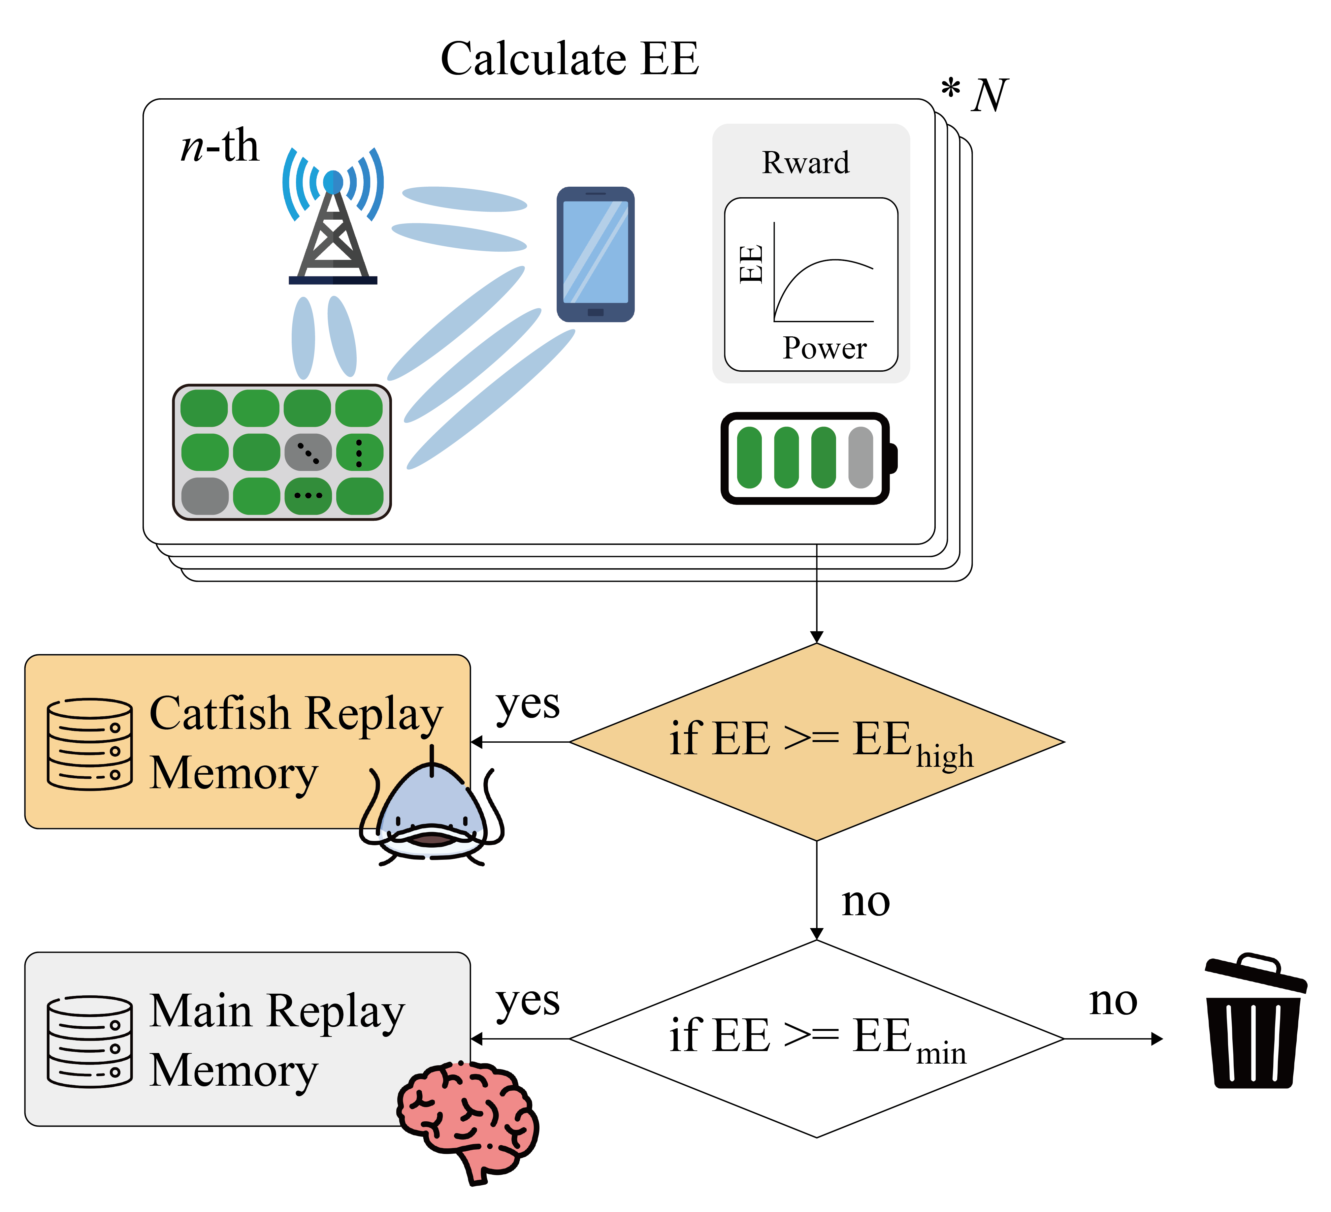
Figure 13. The flowchart of experience stratification.

經驗分類的目的是設計精英級挑戰者角色，也就是將 catfish agent 定位為「高層級經驗的引爆點」，吸引其他用戶或代理人向上挑戰。此動作會為 main agent 與 catfish agent 提供不同的訓練資料，在不同經驗層級設置不同任務。此策略引導 main agent 透過觀察 catfish agent 行為調整策略。使得它們能夠更好的利用自身不同折扣係數的特性來學習。較好 EE 的經驗進 catfish replay memory，較為一般 EE 的經驗進 main replay memory 。使得 catfish agent 自訓練專注於「優質經驗」。資料分類的流程圖如圖 13 所示。我們將隨機生成的通訊場景打包成一份資料，並且將 EE 作為 label 用以分配這些資料的存放位置。首先設定 ${EE}^{high}$ 的標準為 4.1 章節中所預產生資料整體的前 20% ，而 ${EE}^{min}$ 設定為預產生資料整體的前 50% 性能。
- 如果 EE ≥ ${EE}^{high}$ ，此份資料將存放進 catfish replay memory 裡，作為較高價值的資料供 catfish agent 使用。此份經驗設定為 $D^{CF}=\{D_{1}^{CF}, …, D_{n}^{CF}, …, D_{N/5}^{CF}\}$，其中 $1 ≤ n ≤N/5$。
- 而 ${EE}^{high}$ ≥ EE ≥ ${EE}^{min}$ 的資料，將會作為一般情況下的通訊狀態存放進 agent replay memory。此份經驗設定為 $D^{M}=\{D_{1}^{M}, …, D_{n}^{M}, …, D_{N/2}^{M}\}$，其中 $1 ≤ n ≤N/2$。
- 而剩下 ${EE}^{min}$ ≥ EE 的資料則會丟棄，確保這兩個 memory 能夠擁有對應特性的資料。

B. Catfish Strategy 2: Asymmetric Discounting Strategy
The discount factor is a critical hyperparameter in reinforcement learning that determines an RL agent’s emphasis on future rewards. This hyperparameter influences the agent’s policy, convergence speed, and long-term optimization capability. In A. Catfish Strategy 1: Experience Stratification, this thesis describes why experiences are stratified. Our purpose in adjusting the discount factor is to extend the idea of assigning different tasks to different tiers, configuring the discount factors of the main agent and the catfish agent according to their respective tasks. This approach helps avoid strategy homogenization, thereby encouraging differentiated strategies between agents. As a result, the main agent focuses on short-term demands to accelerate convergence, while the catfish agent emphasizes long-term objectives to pursue optimal outcomes.
Observing equation (17), the discount factor causes the weight of the Q-value to decay exponentially as $Q_{Φ}\left(s_{t+1},π_{θ}(s_{t+1})\right)$ unfolds into the future. The total return is given by $r_{t}^{acc}=r_{t}+ {γr}_{t+1}+ {γ^{2}r}_{t+1} + {γ^{3}r}_{t+1}+…$. Thus, the closer the discount factor is to 1, the slower the decay, and the greater the emphasis on future rewards, as shown in Fig. 14(a) and (b). As shown in Fig. 14(a), the discount factor for the main agent is set to $γ^{M}$, while that for the catfish agent is set to $γ^{CF}$. According to Hou et al. [23], when an RL agent approaches the final outcome, a larger discount factor is beneficial for achieving better results. Accordingly, based on the prior experience stratification, superior experiences are assigned a larger discount factor for the catfish agent’s tasks, while ordinary experiences receive a smaller discount factor for the main agent’s tasks. Therefore, we set $γ^{M}≤ γ^{CF}$, allowing the catfish agent to learn more farsighted and superior policies, while the main agent is relatively myopic compared to the catfish agent.

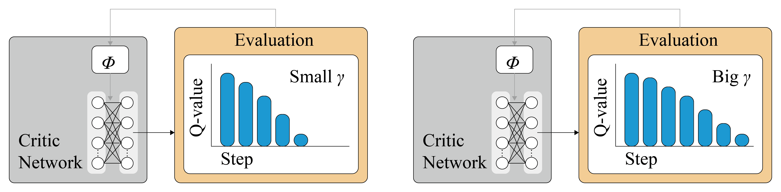
- (b)

Figure 14. (a) Illustration of a smaller discount factor, and
(b) Illustration of a larger discount factor.

折扣因子是在強化學習中至關重要的超參數，它決定了 RL agent 對於未來獎勵的重視程度。此超參數影響了 RL agent 的策略、收斂速度與長期的優化能力。本文在 A. Catfish Strategy 1: Experience Stratification 中有描述了為何將不同經驗做分層。我們調整折扣因子的目的是接續為不同層級之間分配不同任務的理念，將 main agent 與 catfish agent 的折扣因子按照不同任務有不同的配置。這麼做的好處是可以避免策略同質化，從而讓不同 agent 差異化策略。使得 main agent 注意短期需求以加速收斂。且使得 catfish agent 重視長期目標以追求最優成果。
觀察公式(17)可以發現，折扣係數會使得 Q-Value 的權重會隨著 $Q_{Φ}\left(s_{t+1},π_{θ}(s_{t+1})\right)$ 往後來展開，而成指數下降。整體回報就是 $r_{t}^{tot}=r_{t}+ {γr}_{t+1}+ {γ^{2}r}_{t+1} + {γ^{3}r}_{t+1}+…$ 。由此可知數字越接近 1 衰減越慢，遠期獎勵占比就越高，如圖 14 (a)(b)。如圖 14 (a) ，我們將 main agent 的折扣係數設置為 $γ^{M}$ ，而 catfish agent 的折扣係數設置為 $γ^{CF}$ 。參考 Hou 等人的研究 [23] 可知，當 RL agent 在接近最終結果時，折扣參數越大越有利於 RL agent 取得更好的成果。所以我們配合前面經驗分層的結果，將較為優秀的經驗配上較大的折扣因子交給 catfish agent 執行任務，而較為一般的經驗就配上較小的折扣因子交給 main agent 執行任務。因此我們設定 $γ^{M}≤ γ^{CF}$ ，使得 catfish agent 能夠更有遠見的學習較為優秀的策略，並且使得 main agent 相對於 catfish agent 較為短視近利。

C. Catfish Strategy 3: Adaptive Competitive Reward Mechanism
To further enhance the catfish agent’s own capabilities in order to fulfill its role as an elite-level challenger. We modified the catfish agent’s reward mechanism by incorporating an adaptive competitive reward mechanism (ACRM). By leveraging advanced heuristic methods to guide the agent in extracting meaningful value from learning experiences, the stability of DRL convergence can be improved. The ACRM is similar to the Self‐Adaptive Success Rate Sampling (SASR) proposed by Shen et al. [24]. This thesis expresses the ACRM’s augmented reward function as:

$$\begin{aligned}r^{C}=r+ ηr^{s}\#\left( seq equation 21\right)\end{aligned}$$

Here, $r$ denotes the original EE reward from the environment, $r^{s}$ represents the additional shaped reward, and η is the coefficient controlling the weight of this reward. When η approaches 0, the model degrades to the original reward model. As shown in Fig. 15, the additional shaped reward $r^{s}$ at time t is expressed as:

$$\begin{aligned}r_{t}^{s} =r_{t}^{CF} - r_{t}^{M}\#\left( seq equation 22\right)\end{aligned}$$

Here, $r_{t}^{M}$ denotes the reward (energy efficiency) achieved by the main agent in the passive/active RIS communication system, while $r_{t}^{CF}$ denotes the reward achieved by the catfish agent in the same system. The greater the lead of the catfish agent over the main agent on the same task, the larger the additional reward received by the catfish agent. Conversely, the catfish agent is penalized more when trailing behind, reinforcing the competitive dynamics.

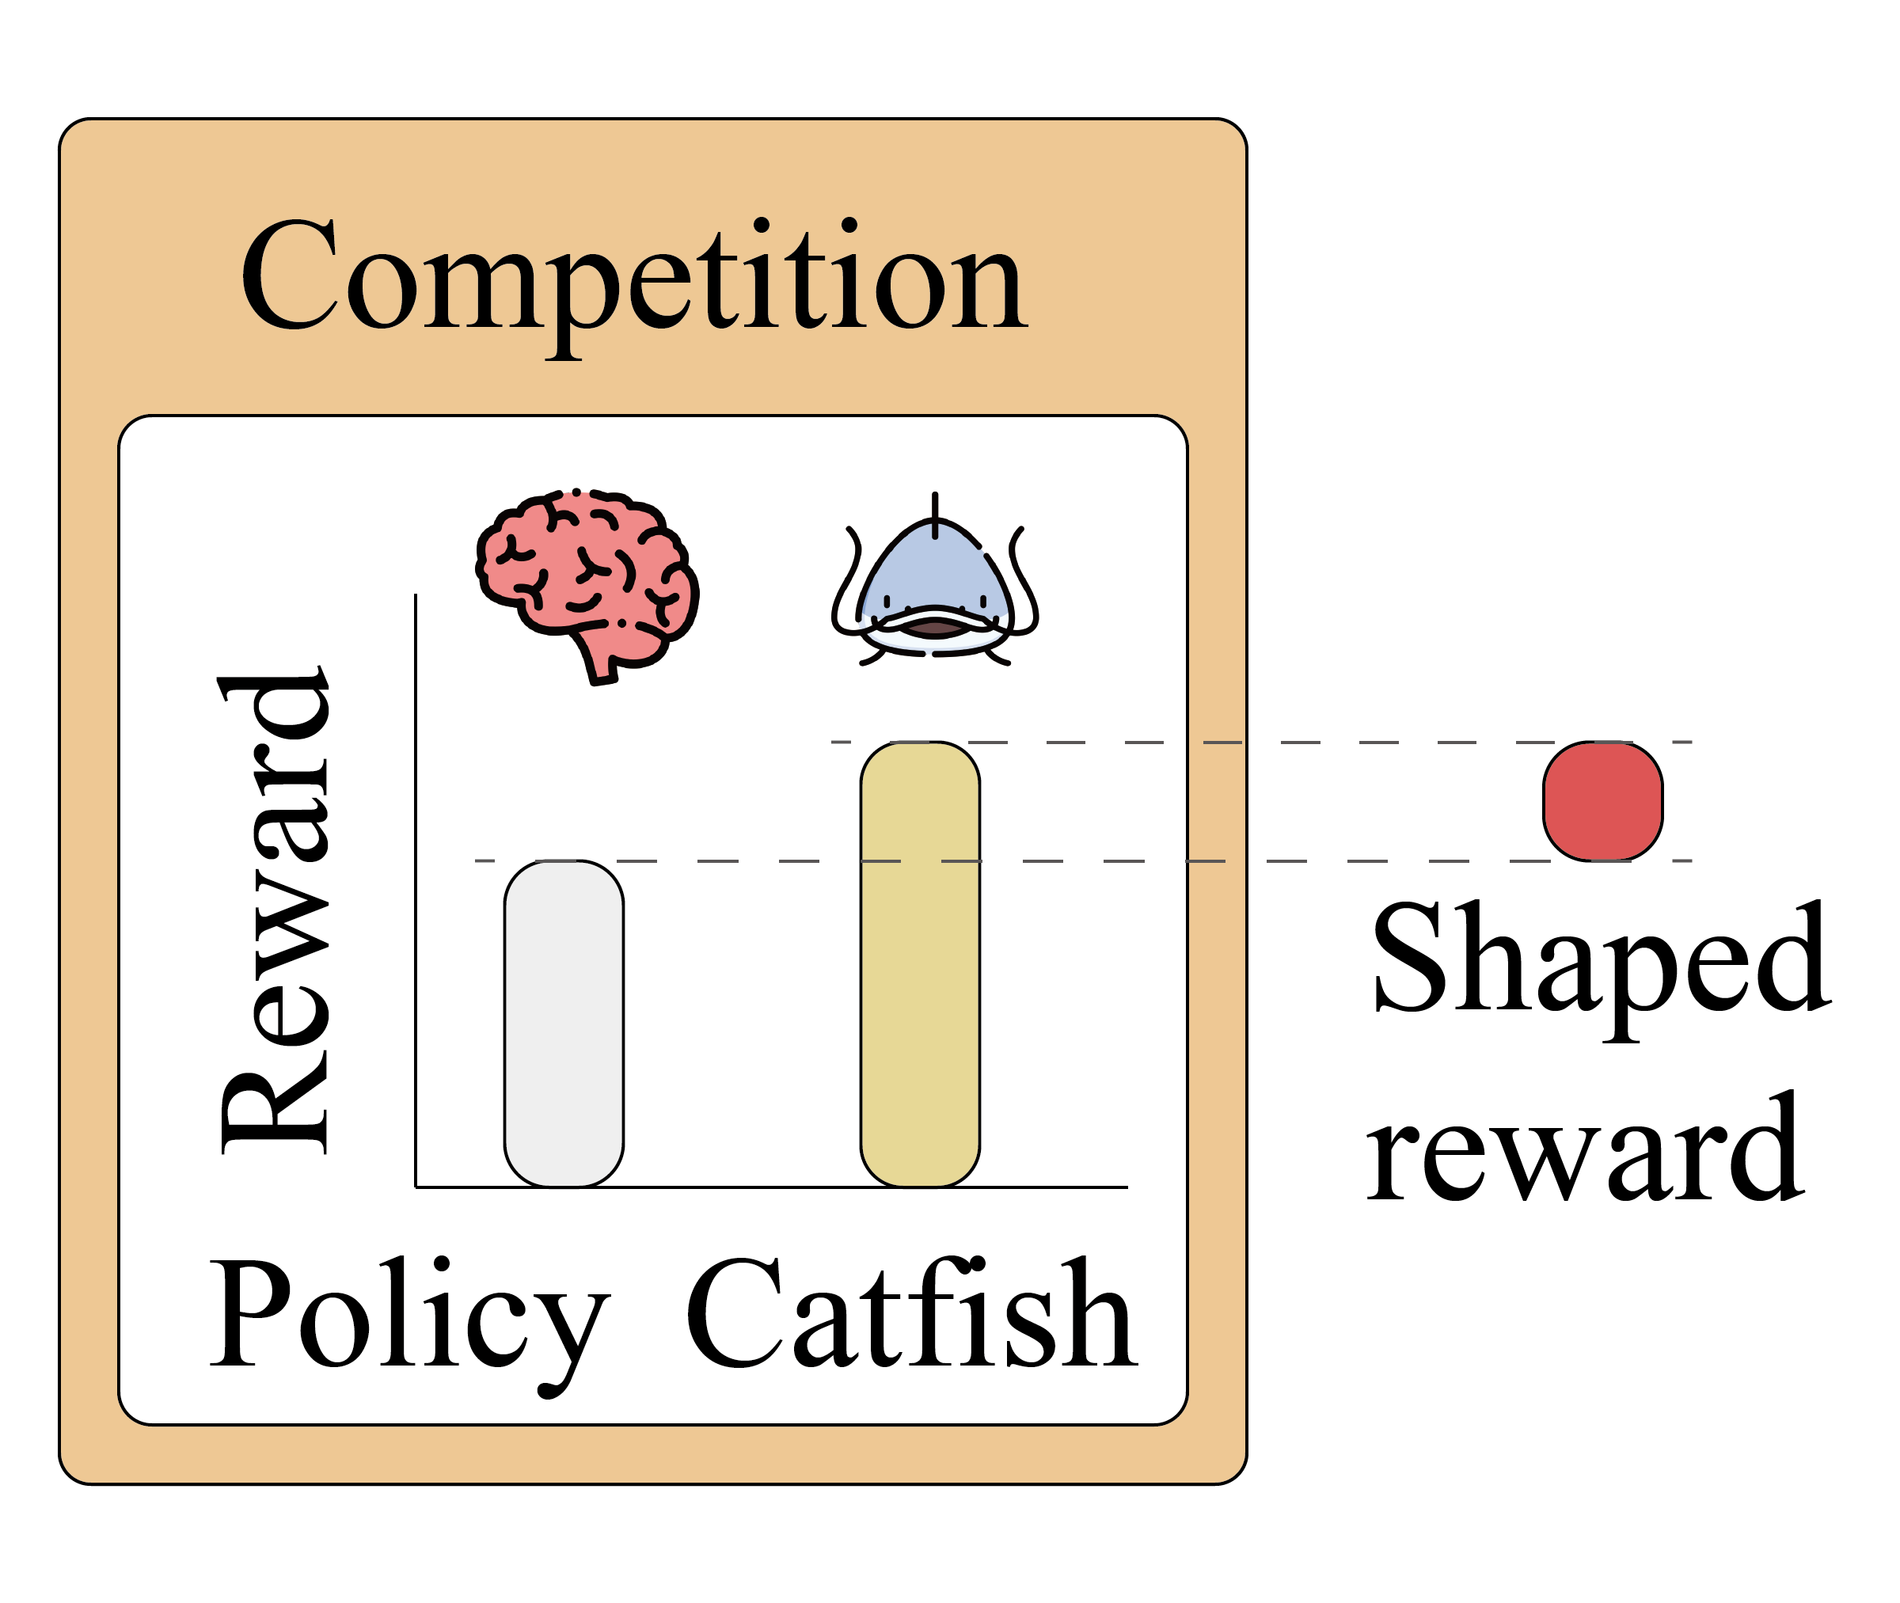
Figure 15. Illustration of adaptive competitive reward mechanism.

Referring to equations (17)–(20), the update formula for the catfish agent with the adaptive competitive reward mechanism is defined. The temporal difference (TD) error $δ^{CF}$ of the catfish agent is defined as:

$$\begin{aligned}δ_{t}^{CF}= r_{t}^{CF}+ ηr_{t}^{s}+ γ^{CF}Q_{Φ^{CF}}^{CF}\left(s_{t+1},π_{θ^{CF}}^{CF}(s_{t+1})\right)- Q_{Φ^{CF}}^{CF}(s_{t},a_{t}^{CF})\#\left( seq equation 23\right)\end{aligned}$$

Here, $π_{θ^{CF}}^{CF}(s_{t+1})$ denotes the action given by the catfish actor at the next state. $γ^{CF}$ is the discount factor of the catfish agent, determining the importance of the future Q-value $Q_{Φ^{CF}}^{CF}\left(s_{t+1},π_{θ^{CF}}^{CF}(s_{t+1})\right)$.

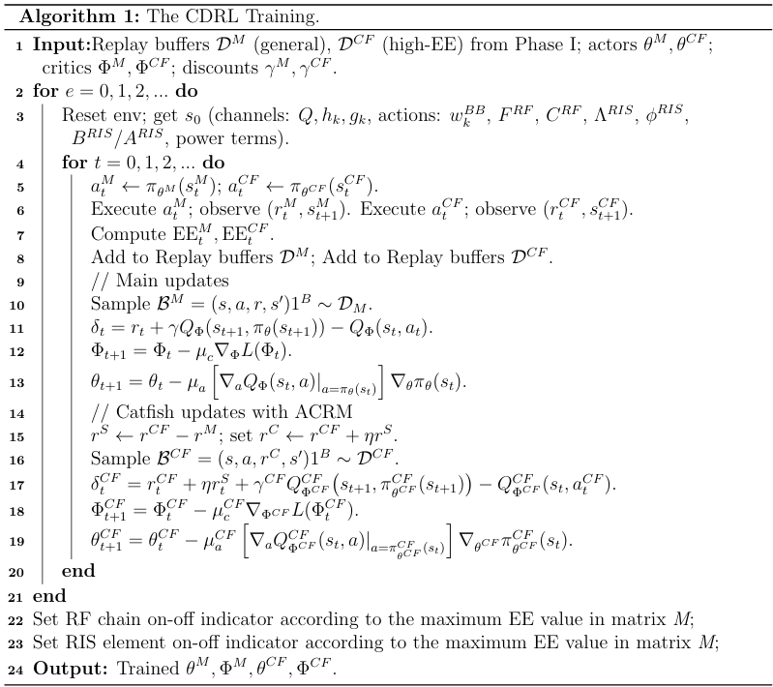

The catfish critic uses a neural network to approximate the Q-value function $Q_{Φ^{CF}}^{CF}(s_{t},a_{t}^{CF})$ and updates the network parameters by minimizing the mean squared error (MSE) loss. The loss function is defined as:

$$\begin{aligned}L(Φ^{CF}) ={(δ_{t}^{CF})}^{2}\#\left( seq equation 24\right)\end{aligned}$$

Then, gradient descent is used to update the critic’s parameters $Φ^{CF}$ as:

$$\begin{aligned}Φ_{t+1}^{CF} = Φ_{t}^{CF} - μ_{c}^{CF}∇_{Φ^{CF}}L(Φ_{t}^{CF})\#\left( seq equation 25\right)\end{aligned}$$

Here, $μ_{c}^{CF}$ is the learning rate, and $∇_{a}$ denotes the gradient with respect to $Φ^{CF}$ of the loss function $L(Φ_{t}^{CF})$.
The parameter update formula for the catfish actor $θ^{CF}$ is:

$$\begin{aligned}θ_{t+1}^{CF} = θ_{t}^{CF}- μ_{a}^{CF}{[∇_{a}Q_{Φ^{CF}}^{CF}\left(s_{t},a\right)]}_{a= π_{θ^{CF}}^{CF}(s_{t})}∇_{θ^{CF}}π_{θ^{CF}}^{CF}(s_{t})\#\left( seq equation 26\right)\end{aligned}$$

Here, $μ_{a}^{CF}$ is the learning rate.
The CDRL algorithm we proposed is shown in Algorithm 1.

為了進一步加強 catfish agent 的自身能力，以達到成為精英級挑戰者角色的目的。我們為此改變了 catfish agent的獎勵機制，加入了自適應競爭獎勵機制 (adaptive competitive reward mechanism, ACRM)。利用高階啟發式方法引導 agent 從學習經驗中提取有意義的價值，有助於 DRL 的穩定收斂。 ACRM 類似 Shen 等人[24]提出的自適應成功率採樣 (Self-Adaptive Success Rate Sampling, SASR) ，本文將 ACRM 的增強獎勵函數表示為:
公式(21)
其中 $r$ 為環境回饋的原始 EE 獎勵， $r^{s}$ 為額外形塑獎勵 (additional shaped reward) ，η 為控制該獎勵權重的係數。當 η→0 時，即退化為原始獎勵模型。如圖15所示，額外形塑獎勵 $r^{s}$ 在時間 t 表示為:
(22)
其中， $r_{t}^{M}$ 表示 main agent 達到被動/主動 RIS 通訊系統的獎勵(能量效率) ， $r_{t}^{CF}$ 表示 catfish agent 達到被動/主動 RIS 通訊系統的獎勵(能量效率)。當 catfish agent 做同一件任務時領先 main agent 越多，catfish agent 獲得的額外獎勵越大。反之會受到越大的懲罰，強化競爭動態。
參考公式(17)-(20)定義加入了額外獎勵機制的 Catfish agent 更新公式。 Catfish agent 的時間差分誤差 (Temporal Difference, TD) $δ^{CF}$ 定義為：
公式(23)
其中 $π_{θ^{CF}}^{CF}(s_{t+1})$ 為 catfish actor 在下個狀態給出的動作。 $γ^{CF}$ 是 catfish 的折扣係數，它決定了未來Q價值 $Q_{Φ^{CF}}^{CF}\left(s_{t+1},π_{θ^{CF}}^{CF}(s_{t+1})\right)$ 的重要性。
Catfish critic 使用一個神經網絡來近似Q值函數 $Q_{Φ^{CF}}^{CF}(s_{t},a_{t}^{CF})$ ，並通過最小化均方誤差 (MSE) 損失來更新網絡參數，損失函數為：
公式(24)
然後使用梯度下降來更新 Critic 的參數 $Φ^{CF}$ :
公式(25)
其中 $μ_{c}^{CF}$ 是學習率， ∇ 表示對於 $L(Φ_{t}^{CF})$ 的 $Φ^{CF}$ 求導。
Catfish actor的參數 $θ^{CF}$ 更新公式為​:
公式(26)
其中 $μ_{a}^{CF}$ 是學習率。
我們提出的 CDRL 演算法如演算法 1 所示。

4.3 Phase III: Catfish-effect-based DRL optimization of energy efficiency
In this subchapter, we describe how the trained CDRL is executed. In the preceding chapter 4.2, we optimized the main agent’s weights $Φ^{M}$ and $θ^{M}$ as well as the catfish agent’s weights $Φ^{CF}$ and $θ^{CF}$, whereby stimulation from the catfish agent enabled CDRL to acquire the optimal policy. As shown in Fig. 16, during this phase the main agent performs only state-input to action-output inference and no longer executes any gradient updates—i.e., only the main actor is required—and the catfish agent performs only performance monitoring—i.e., only the catfish actor is required. We use a different set of states in this phase than during training while maintaining the same input-output parameters. As in the previous stage, the experiment begins by configuring the required parameters according to the experimental specifications: the number of transmit antennas $N_{t}$, the number of RF chains $N_{RF}$, the number of RIS elements $N_{RIS}$, the number of single-antenna UEs $N_{UE}$, the maximum transmit power $P_{BS}^{max}$ and the RIS position. Next, following the experimental rules, we generate random spatial layouts for the BS, UE and RIS and compute the BS–RIS, RIS–UE and BS–UE channel matrices $Q$, $h_{k}$ and $g_{k}$. We then initialize the baseband digital beamformer $w_{k}^{BB}$, the RF analog beamformer $F^{RF}$, the RF-chain switch matrix $C^{RF}$, the active RIS power-amplification matrix $Λ^{RIS}$, the phase-shift matrix $ϕ^{RIS}$, the passive RIS element-switch matrix $B^{RIS}$ and the active RIS element-switch matrix $A^{RIS}$, and treat these initial parameters as the initial state [s_0] handed to the trained CDRL for subsequent inference.


Figure 16. The flowchart of trained CDRL.

在這小節中，會描述訓練完成的 CDRL 該如何執行。在先前的 4.2 節中，我們最佳化 main agent 的 $Φ^{M}$ 、 $θ^{M}$ 還有 catfish agent 的 $Φ^{CF}$ 、 $θ^{CF}$ 等權重。透過 catfish agent 的刺激使得 CDRL 獲得最佳優化策略。如圖 16 所示，在本階段中， main agent 僅進行以輸入狀態推論輸出動作的任務，不再執行梯度更新。意思是此階段只需要 main actor 即可。同時 catfish agent 只進行性能監測任務。這意味著此階段我們也只需要 catfish actor。我們在這階段會使用與訓練時不同的狀態來進行，但是依然會維持相同的輸入輸出參數。與先前相同的，一開始會依照實驗要求設置發射天線數量 $N_{t}$、射頻鏈數量 $N_{RF}$ 、 RIS 元件數量 $N_{RIS}$ 、單天線用戶端數量 $N_{UE}$ 、最大發射功率 $P_{BS}^{max}$ 與 RIS 的位置等實驗所需參數。接著，依照實驗規則生成隨機的 BS 、UE 與 RIS 的空間佈局，由此計算出 BS-RIS, RIS-UE, BS-UE 通道矩陣 $Q$、$h_{k}$、$g_{k}$。然後初始化基帶數位波束成形器 $w_{k}^{BB}$ 、頻類比波束成形器 $F^{RF}$ 、射頻鏈的開關矩陣 $C^{RF}、主動 RIS 功率放大矩陣 Λ^{RIS}、相移矩陣 ϕ^{RIS}、被動 RIS 元件開關矩陣 B^{RIS} 與主動 RIS 元件開關矩陣 A^{RIS}$ 。並將這些初始參數最為初始狀態 $s_{0}$ 交由訓練好的 CDRL 做後續推論。

5. Experimental Results
In this chapter, the experimental setup is explained in subchapter 5.1 , the performance evaluation is discussed in subchapter 5.2, the ablation studies are presented in subchapter 5.3, and the RIS simulator is introduced in subchapter 5.4.
在本章中，實驗設置在 5.1 小節中解釋，性能評估在 5.2 小節中討論，消融實驗在 5.3 小節中討論， RIS 模擬器在 5.4 小節呈現。

5.1 Experimental Setup
This chapter details the environment setup used for training the proposed model. The experiments are conducted on a system running Windows 10 as the underlying operating system. The programming environment is built using Python 3.8.16, with NumPy 1.26.4 and PyTorch 2.3.1 to support the implementation of reinforcement learning algorithms. All training and evaluation processes are performed using an NVIDIA GeForce RTX 2080 Ti GPU to ensure computational efficiency. The downlink communication system environment is configured in accordance with [10], with detailed parameters listed in Table 2.

Table 2. Simulation environment and system parameters.
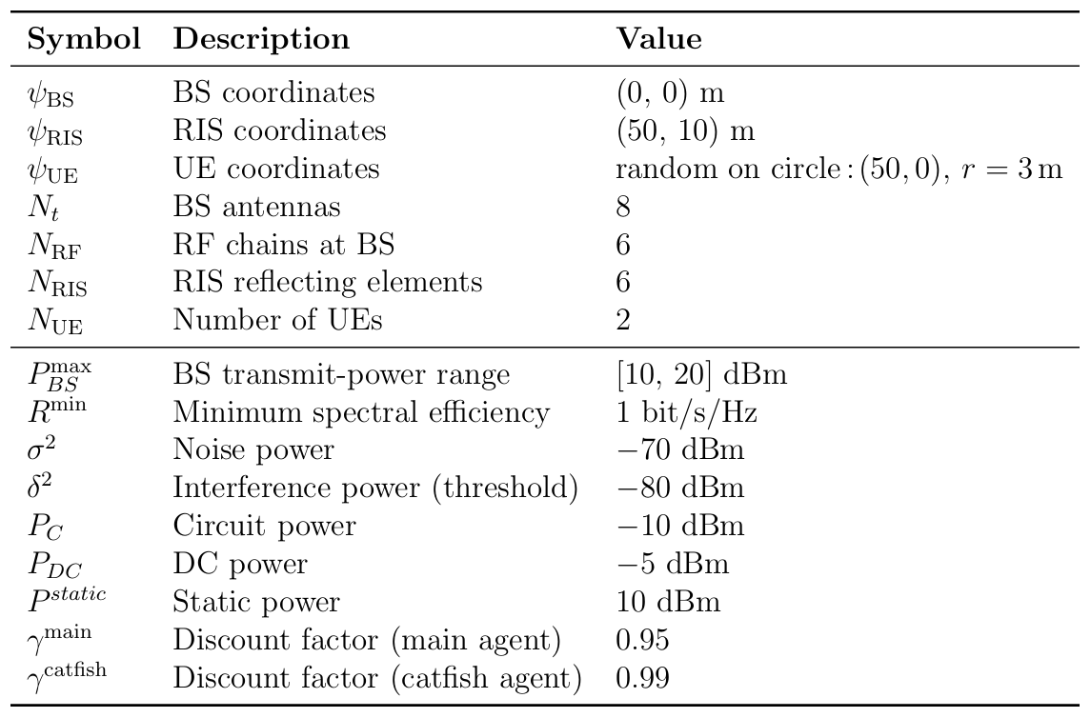

本節詳細介紹了用於訓練所提模型的環境設定。實驗在以 Windows 10 為底層作業系統的系統上進行。程式環境使用 Python 3.8.16、NumPy 1.26.4 和 PyTorch 2.3.1 構建，以支援強化學習演算法的實現。所有訓練和評估過程均使用 NVIDIA GeForce RTX 2080 Ti GPU 進行，以確保運算效率。下行通訊系統的環境考慮並依照 [10] 中的設定進行設定，詳細參數參照表格 2。

5.2 Performance analysis
This chapter presents a performance comparison between the proposed approach and its rivals. The experiments are divided into four scenarios based on active/passive RIS and the presence or absence of element switching. We use the energy efficiency and sum rate defined in chapter 3 as performance metrics. These performance metrics are:
- Energy efficiency is an overall system performance indicator and is defined as the ratio of sum rate to total energy consumption, evaluating the transmission capability per unit energy.
- Sum rate is the transmission speed metric, representing the total amount of data received by all users per unit time, used to assess the capacity of multi-user channel resources.
To assess the energy-efficiency performance of the proposed reinforcement learning model, we benchmark it against three methods, including BPOF. In addition to schemes with adjustable element switching, configurations with all RIS elements fully activated are included as reference benchmarks. Fully activated means that all reflecting elements on the RIS cannot be switched off. This aims to assess the impact of RIS element switching on the energy efficiency and sum rate of the communication system. The experiments are further divided into active and passive RIS to evaluate the effect of active RIS amplifiers on system energy efficiency and sum rate. The proposed CDRL scheme is represented by a red line with solid diamonds. The fully activated RIS scheme is shown as a red line with solid circles. The three baselines are as follows:
- The first is a basic actor-critic reinforcement learning model [11] (black line with hollow squares) serving as the baseline, with the fully activated RIS variant depicted as a black line with hollow triangles.
- The second is the BPOF mathematical analytical solution [10] (blue line with solid diamonds), based on the same communication system architecture, with the fully activated RIS variant shown as a blue line with solid circles.
- The third baseline is the teacher-student learning framework [21] (green line with hollow squares), serving as the primary competitor, with the fully activated RIS variant represented by a green line with hollow triangles. This comparison aims to evaluate differences in knowledge transfer mechanisms within dual-agent architectures.

本節對所提出的方法及其競爭對手的性能進行了比較。我們將實驗劃分為主/被動 RIS 還有有無使用元件開關，共 4 項實驗狀態。在此，我們使用第 3 章定義的能量效率 (EE) 和總速率 (sum rate) 作為性能指標。這些性能指標是:
- 能量效率 (EE) 作為總體系統的性能指標，是總速率除以總能量消耗，用以評估單位能量所能提供的傳輸能力。
- 總速率 (sum rate) 作為傳輸速度指標，是所有使用者每單位時間接收到的數據量總和，用以評估對多用戶通道資源的傳輸容量。
為了評估所提出的強化學習模型的能效性能，我們將其與包括 BPOF 在內的三種方法進行了比較。除了可調整開關的方案之外，也納入了完全開啟 RIS 元件的方案作為參考基準。完全開啟表示 RIS 上的所有反射元件皆無法關閉。此舉旨在評估開關 RIS 元件對於通訊系統能量效率/總速率的影響。並且實驗還會分為主動式 RIS 與被動式 RIS ，用以評估主動式 RIS 的放大器對於通訊系統能量效率/總速率的影響。本文提出的 CDRL 方案為(紅線帶有實心菱形)。完全開啟 RIS 元件的方案(紅線帶有實心圓形)。本文的三個對手如下:
- 第一個為基礎的強化學習模型演員-評論家 (Actor-Critic) 架構[11] (黑線帶有空心方形)，作為本研究的比較基線。完全開啟 RIS 元件的方案 (黑線帶有空心三角形)。
- 第二個為 BPOF 的數學解析解[10] (藍線帶有實心菱形)，有著相同的通訊系統架構。完全開啟 RIS 元件的方案 (藍線帶有實心圓形)。
- 第三個則為教師-學生學習 (Teacher-Student learning) 架構[21] (綠線帶有空心方形)，作為主要對手，我們將教師模型設定為 BPOF。完全開啟 RIS 元件的方案 (綠線帶有空心三角形)。目的在於比較同為雙智能體架構下，不同知識轉移機制的差異。

5.2.1 Energy Efficiency
“Energy efficiency” vs. “transmission power consumption” experimental results for active/passive RIS are plotted in Fig. 17(a)/18(a). According to the results, as the transmission power constraint is relaxed, the energy efficiency of all algorithms improves. The reason is that the reduced energy constraint increases schedulable elements, resulting in a higher total transmission rate. Observing Fig. 17(a), for the adjustable-switch active RIS scheme of this thesis’s CDRL, the best EE performance is achieved owing to the adjustable switches and active RIS, together with the catfish agent’s effective impetus for the main agent to explore strategies, thereby learning superior beamforming and component-configuration combinations. The all-on-switch active RIS scheme of this thesis’s CDRL exhibits lower EE performance because when all elements are fully on, excessive element power consumption reduces overall energy efficiency. Observing Fig. 18(a), for the adjustable-switch passive RIS scheme of this thesis’s CDRL, the best EE performance among all passive schemes is achieved. The all-on-switch passive RIS scheme of this thesis’s CDRL exhibits lower EE performance, and because optimization constraints such as the minimum-rate requirement must be satisfied, EE differences among passive RIS schemes are small. Compared with existing methods, the proposed CDRL framework demonstrates higher EE performance under various transmission power constraints.
“Energy efficiency” vs. “number of users” experimental results for active/passive RIS are plotted in Fig. 17(b)/18(b). According to the results, as the user number increases, the energy efficiency of all algorithms improves. The reason is that an increased number of users served by the BS yields a higher total transmission rate. Observing Fig. 17(b), for the adjustable-switch active RIS scheme of this thesis’s CDRL, the best EE performance is achieved owing to the adjustable switches and active RIS. The all-on-switch active RIS scheme of this thesis’s CDRL exhibits lower EE performance due to excessive element power consumption reducing overall energy efficiency. Observing Fig. 18(b), for the adjustable-switch passive RIS scheme of this thesis’s CDRL, the best EE performance among all passive schemes is achieved. The all-on-switch passive RIS scheme of this thesis’s CDRL exhibits lower EE performance. Compared with existing methods, the proposed CDRL framework demonstrates higher EE performance under various user numbers. To investigate both the overall energy efficiency and the average user energy efficiency, the results of the active RIS experiment are presented in Fig. 17(e). According to the results, while the overall energy efficiency improves, the average user energy efficiency inevitably decreases. This decline may be attributed to the mutual interference among users during signal reception.
“Energy efficiency” vs. “the location of RIS” experimental results for active/passive RIS are plotted in Fig. 17(c)/18(c). The results indicate a decline in EE across all algorithms as the RIS deployment is positioned increasingly farther from the reference point (50, 10). The reason is that the farther the RIS is from the UE, the weaker the channel gain from the BS to the UE, resulting in a lower total transmission rate. Observing Fig. 17(c), for the adjustable-switch active RIS scheme of this thesis’s CDRL, the best EE performance is achieved owing to the adjustable switches and active RIS. The all-on-switch active RIS scheme of this thesis’s CDRL exhibits lower EE performance due to excessive element power consumption reducing overall energy efficiency. Observing Fig. 18(c), for the adjustable-switch passive RIS scheme of this thesis’s CDRL, the best EE performance among all passive schemes is achieved. The all-on-switch passive RIS scheme of this thesis’s CDRL exhibits lower EE performance. Compared with existing methods, this thesis’s CDRL framework demonstrates higher energy efficiency performance under various RIS deployment positions.
“Energy efficiency” vs. “number of transmission antennas” experimental results for active/passive RIS are plotted in Fig. 17(d)/18(d). According to the results, as the number of transmit antennas increases, the energy efficiency of all algorithms improves. The reason is that an increased antenna number leads to higher transmission signal strength, resulting in a higher total transmission rate. Observing Fig. 17(d), for the adjustable-switch active RIS scheme of this thesis’s CDRL, the best EE performance is achieved owing to the adjustable switches and active RIS. The all-on-switch active RIS scheme of this thesis’s CDRL exhibits lower EE performance due to excessive element power consumption reducing overall energy efficiency. Observing Fig. 18(d), for the adjustable-switch passive RIS scheme of this thesis’s CDRL, the best EE performance among all passive schemes is achieved. The all-on-switch passive RIS scheme of this thesis’s CDRL exhibits lower EE performance. Compared with existing methods, this thesis’s CDRL framework demonstrates higher EE performance under various numbers of transmit antennas.

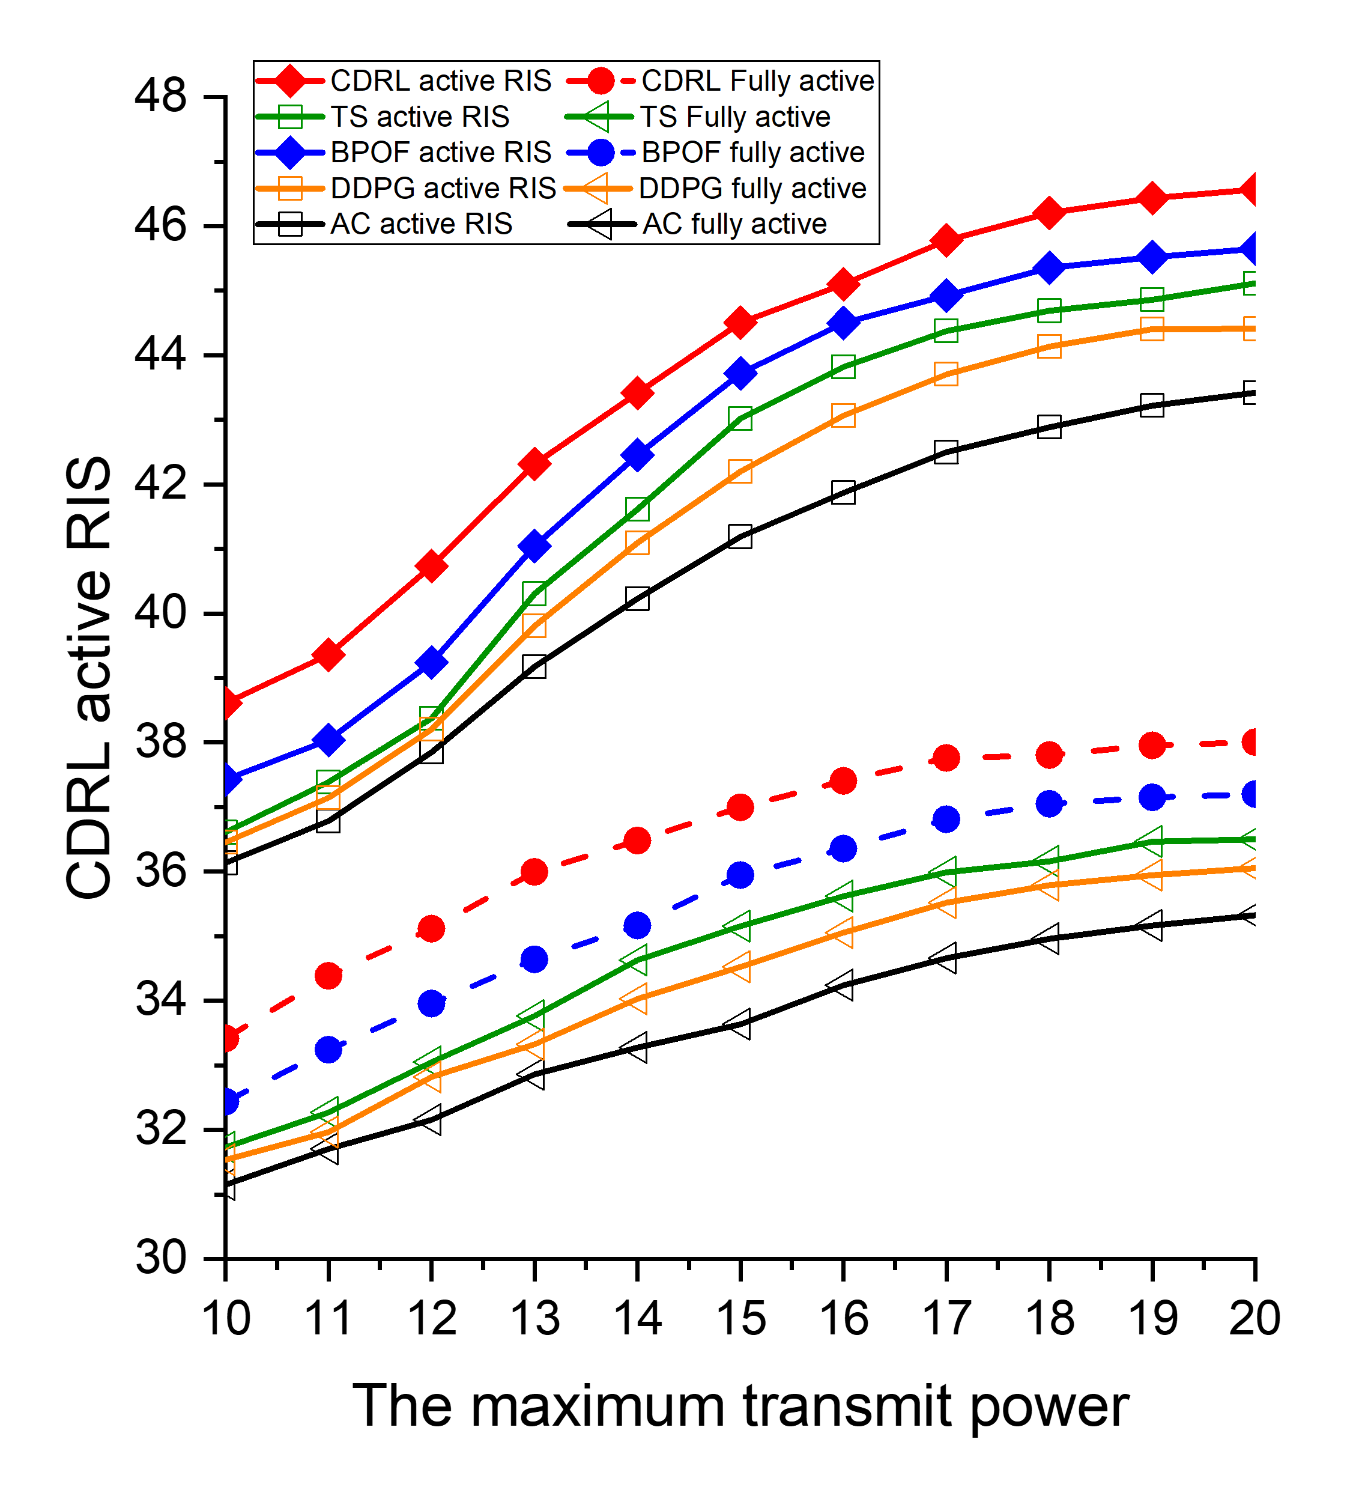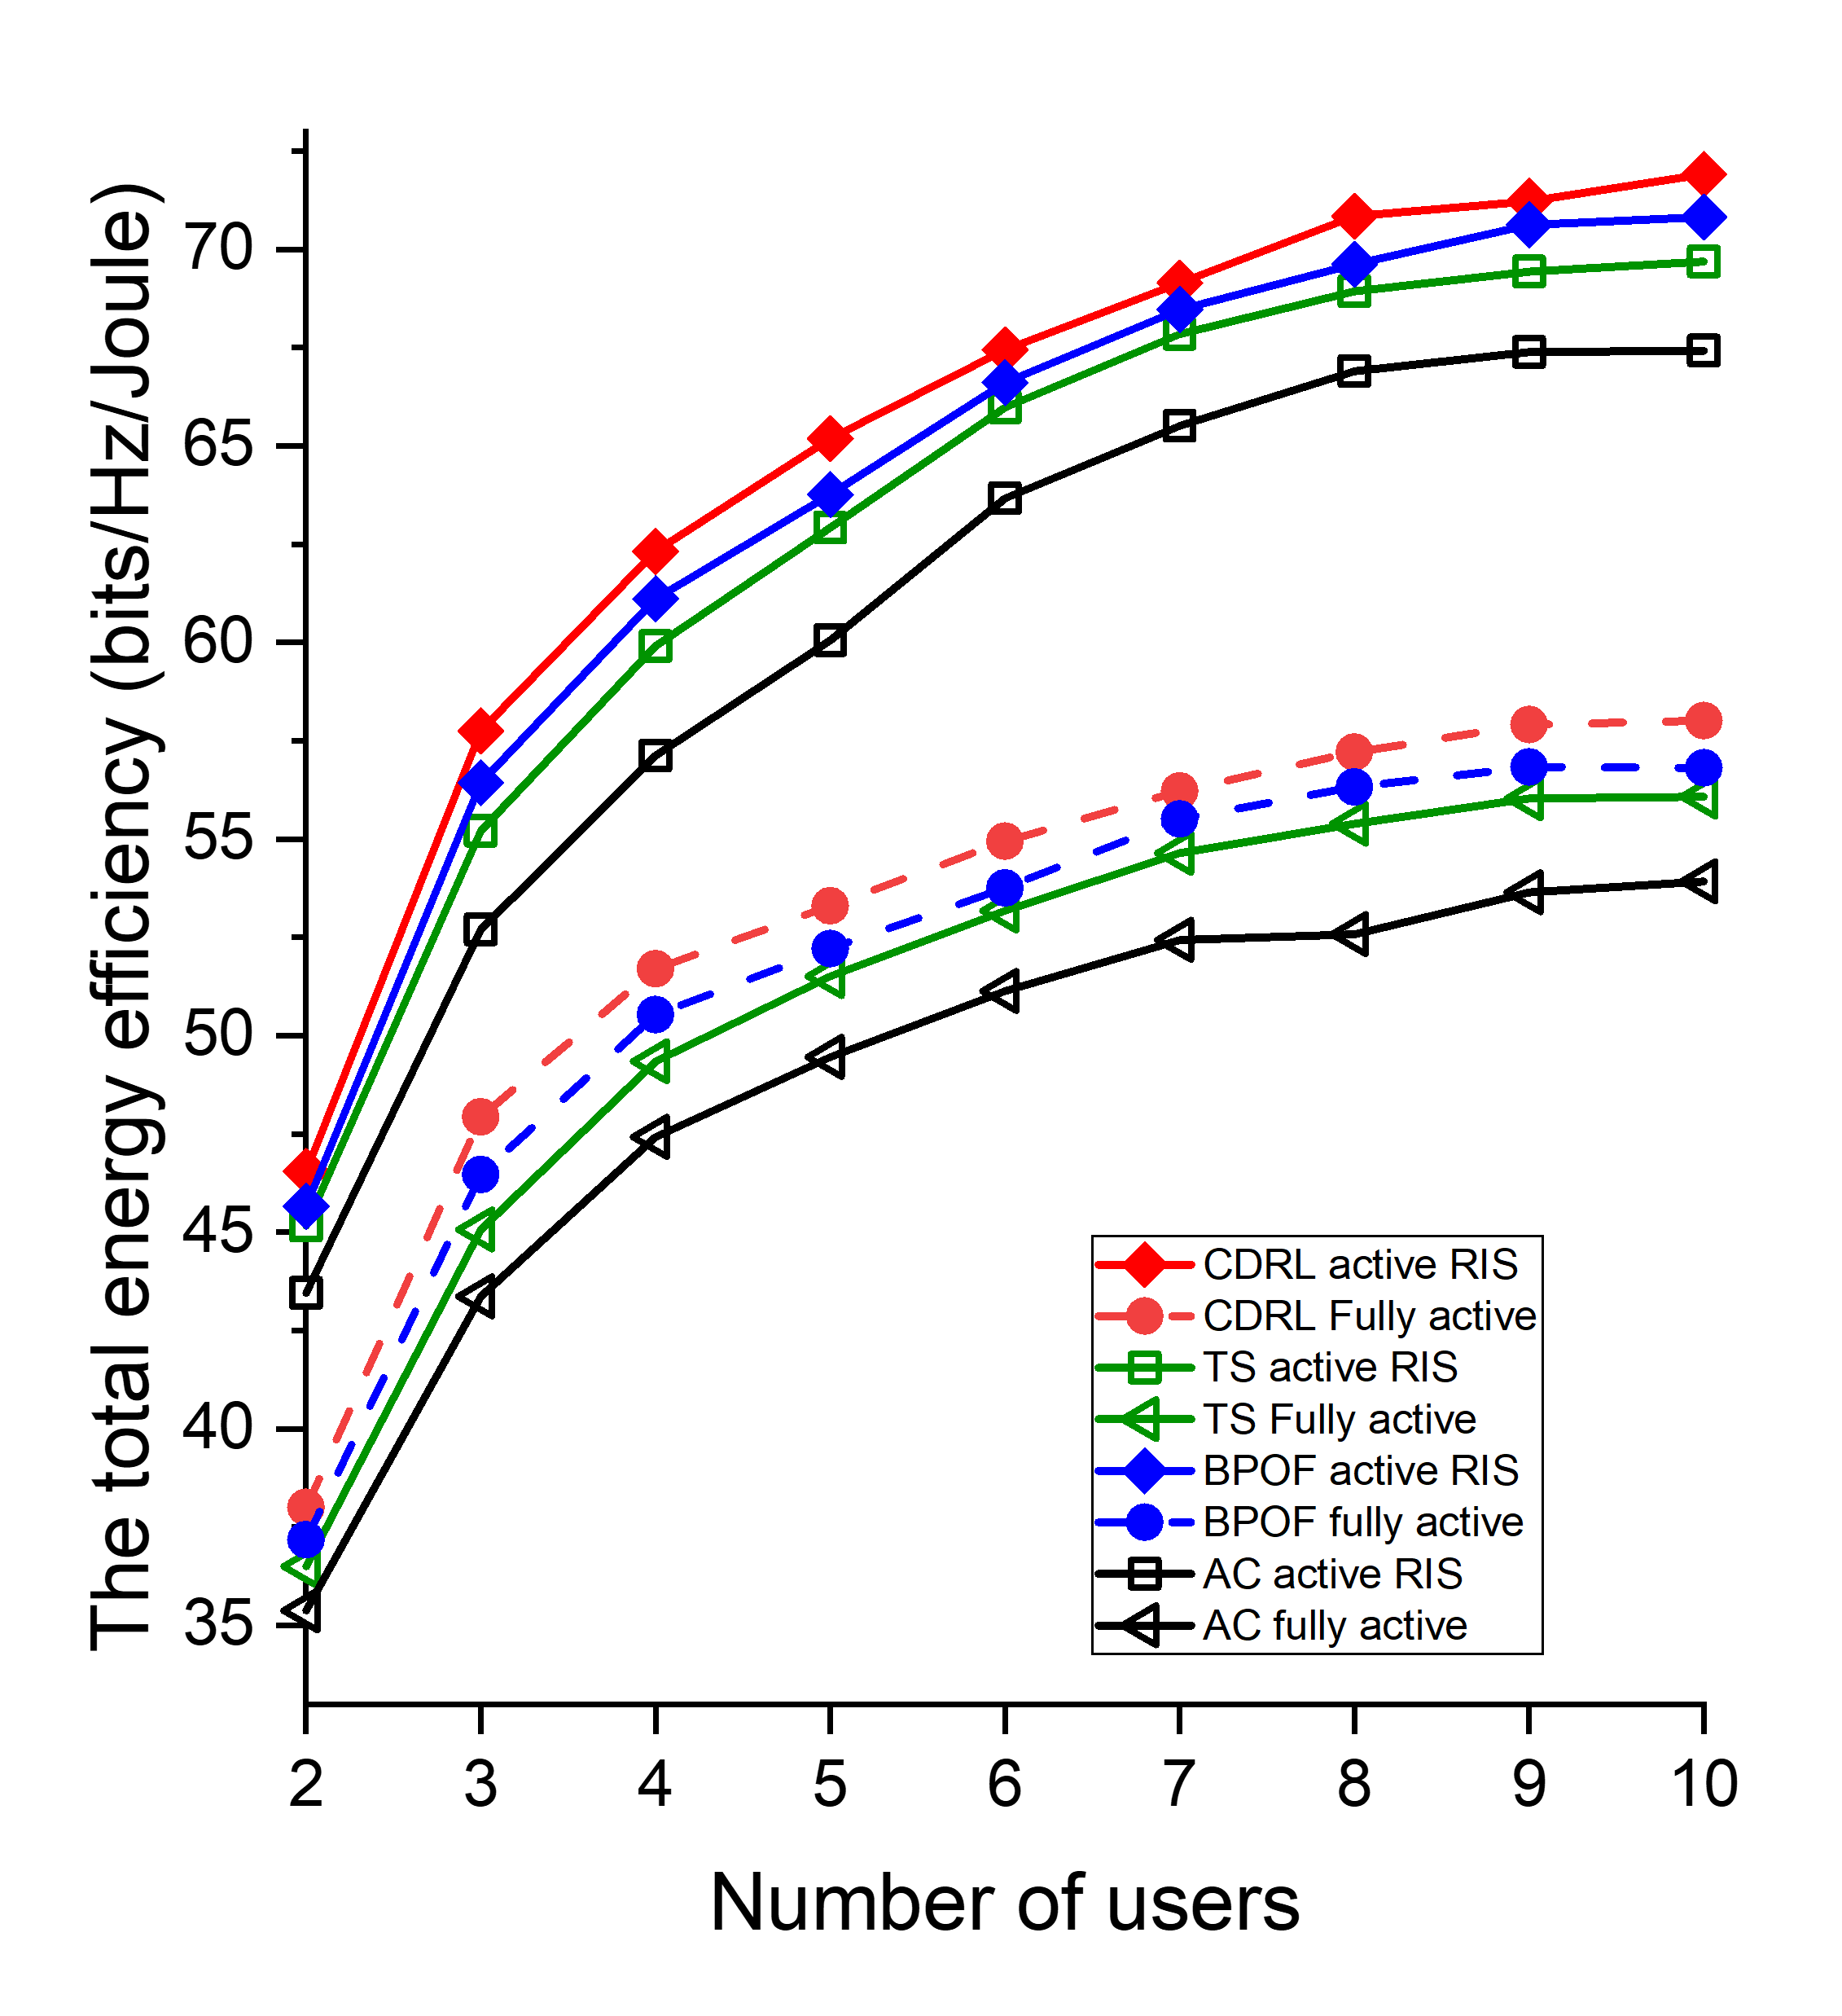
- (b)
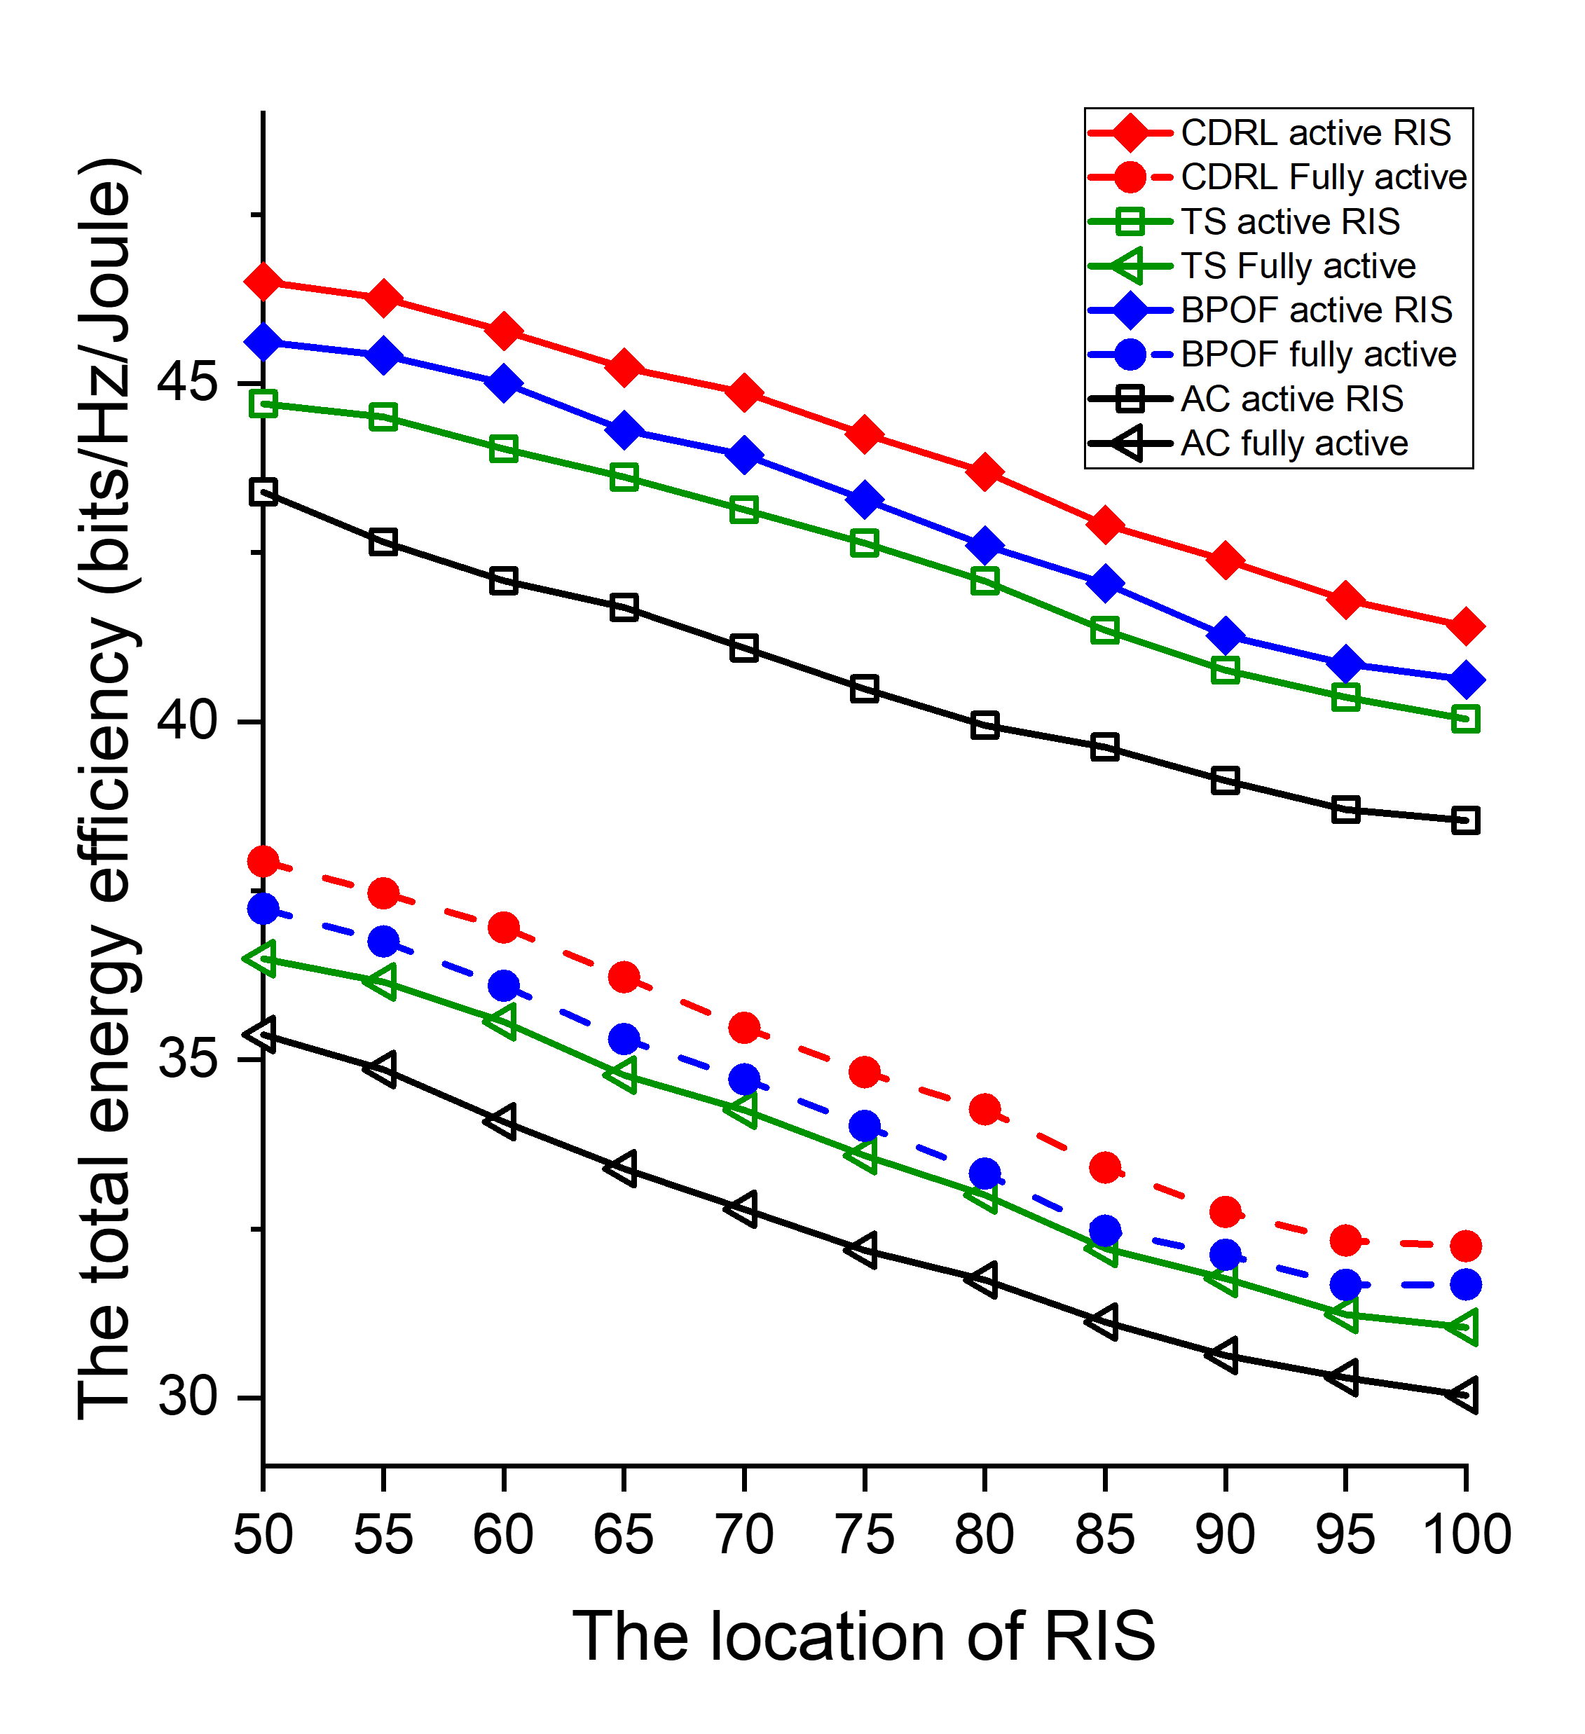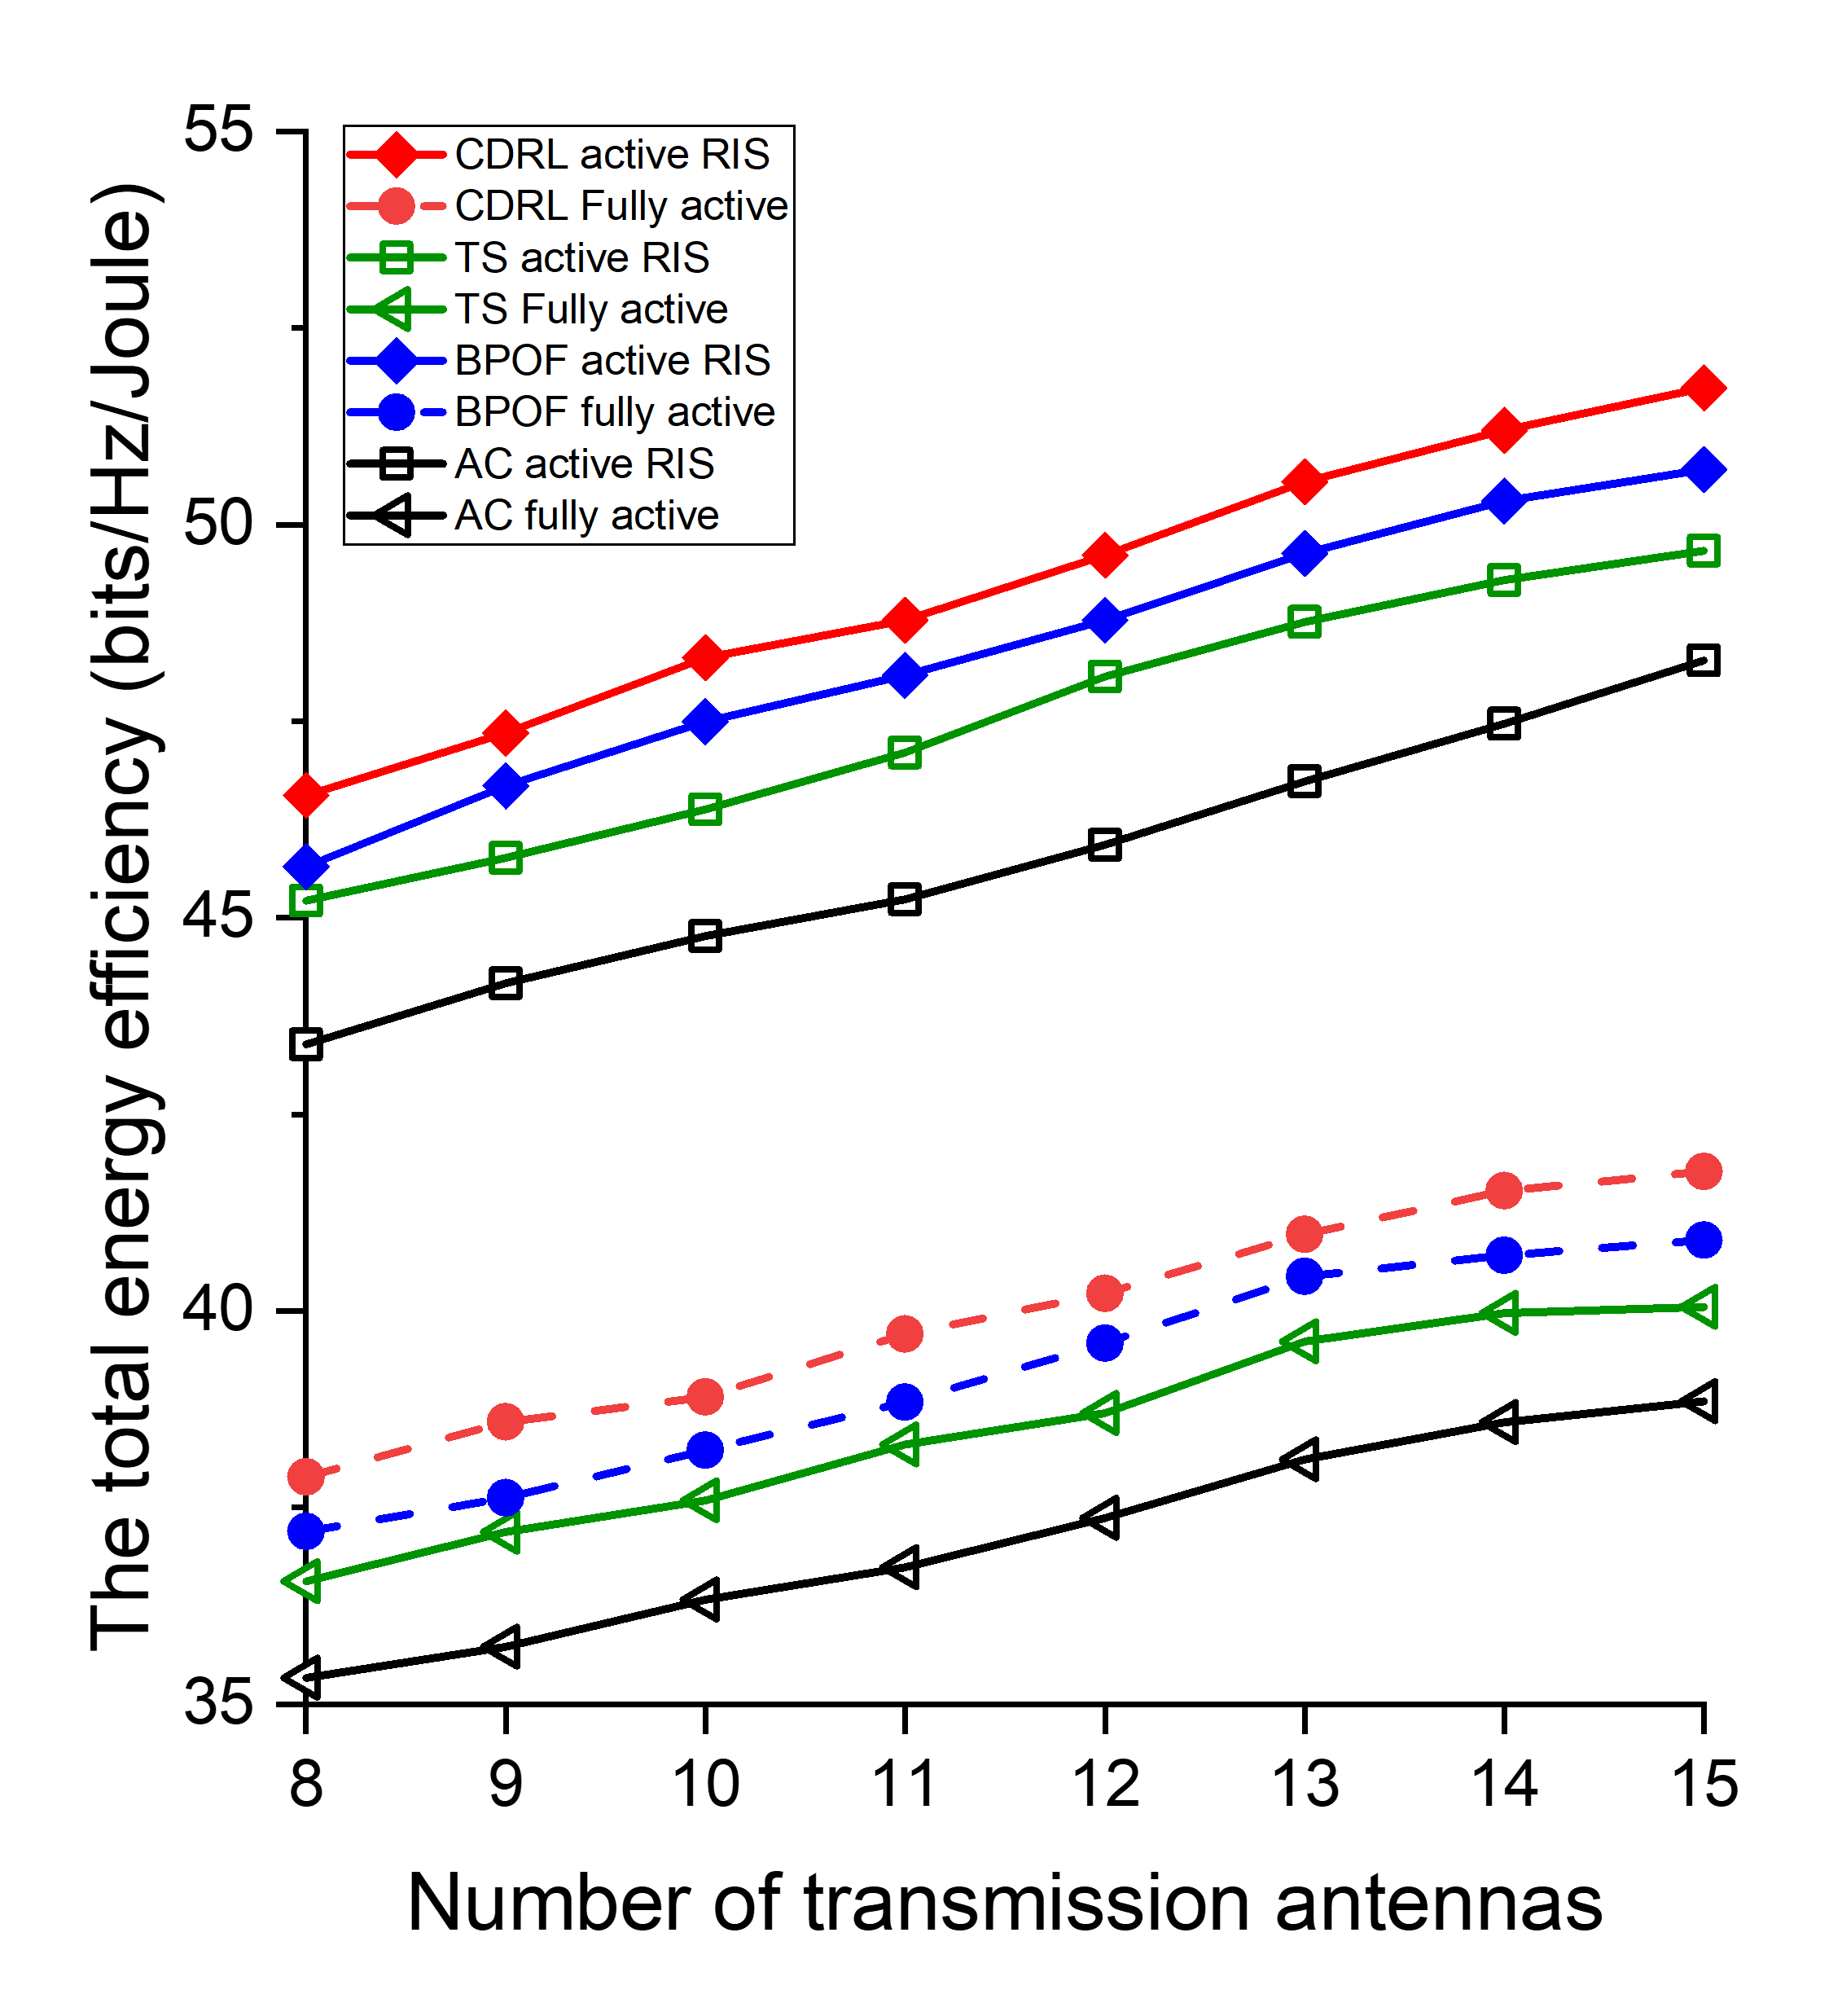
- (d)
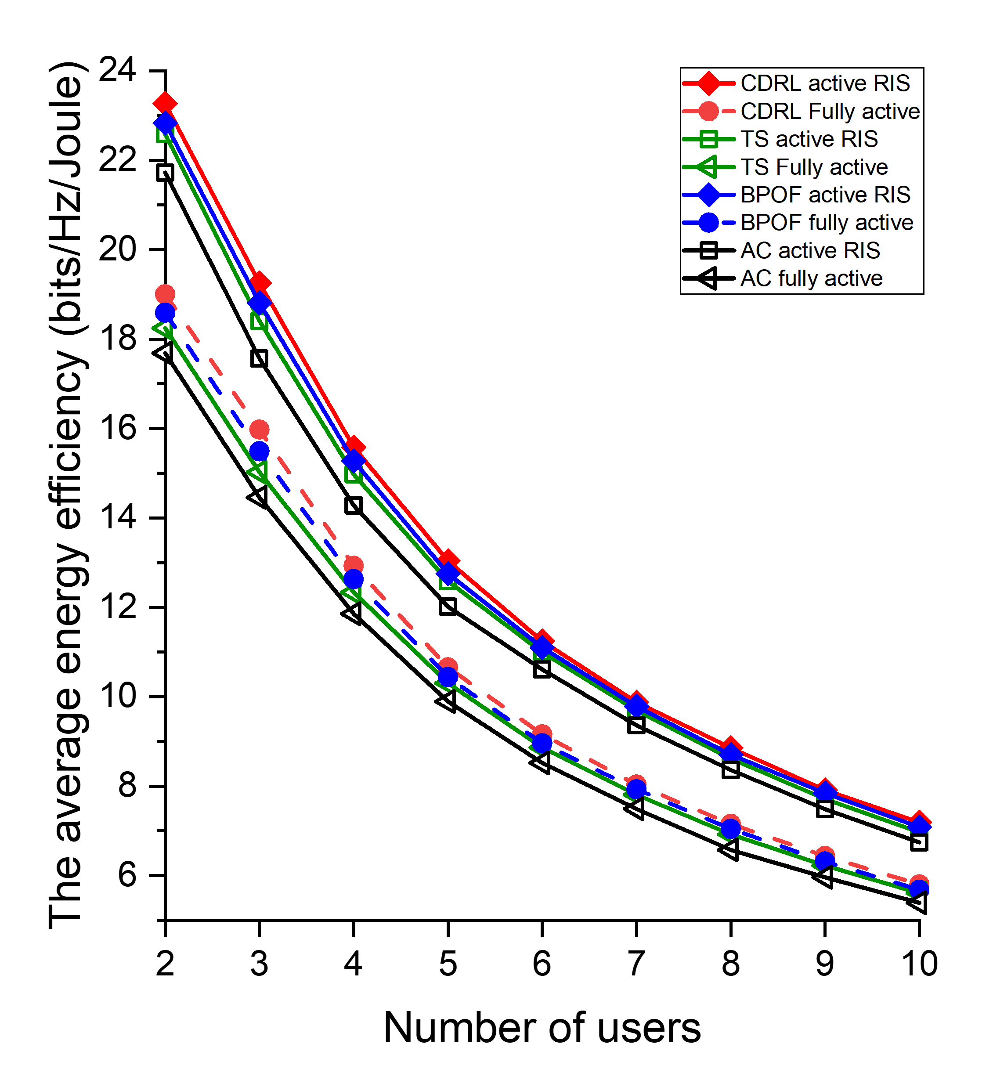
(e)
Fig. 17. The performance comparison of active RIS in terms of energy efficiency.

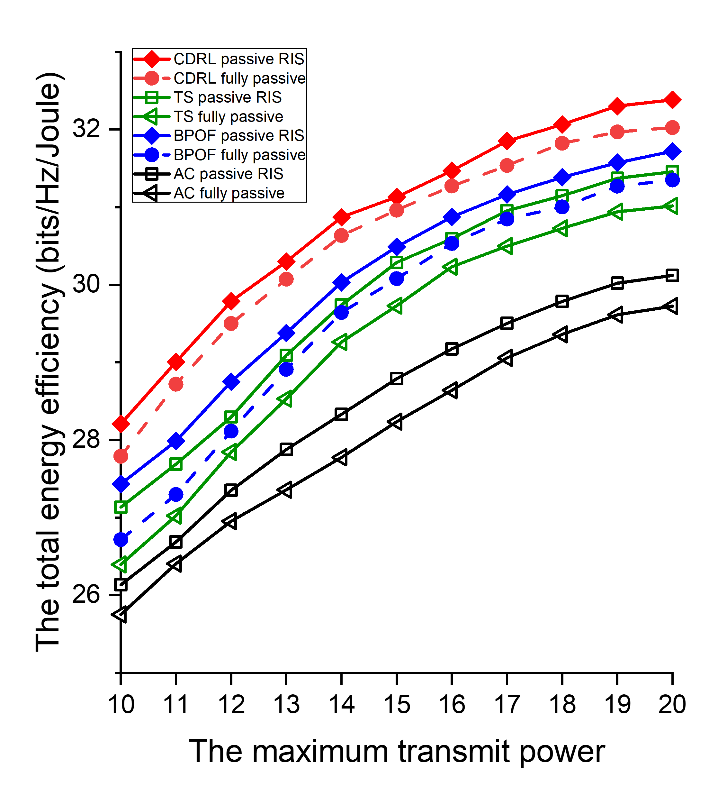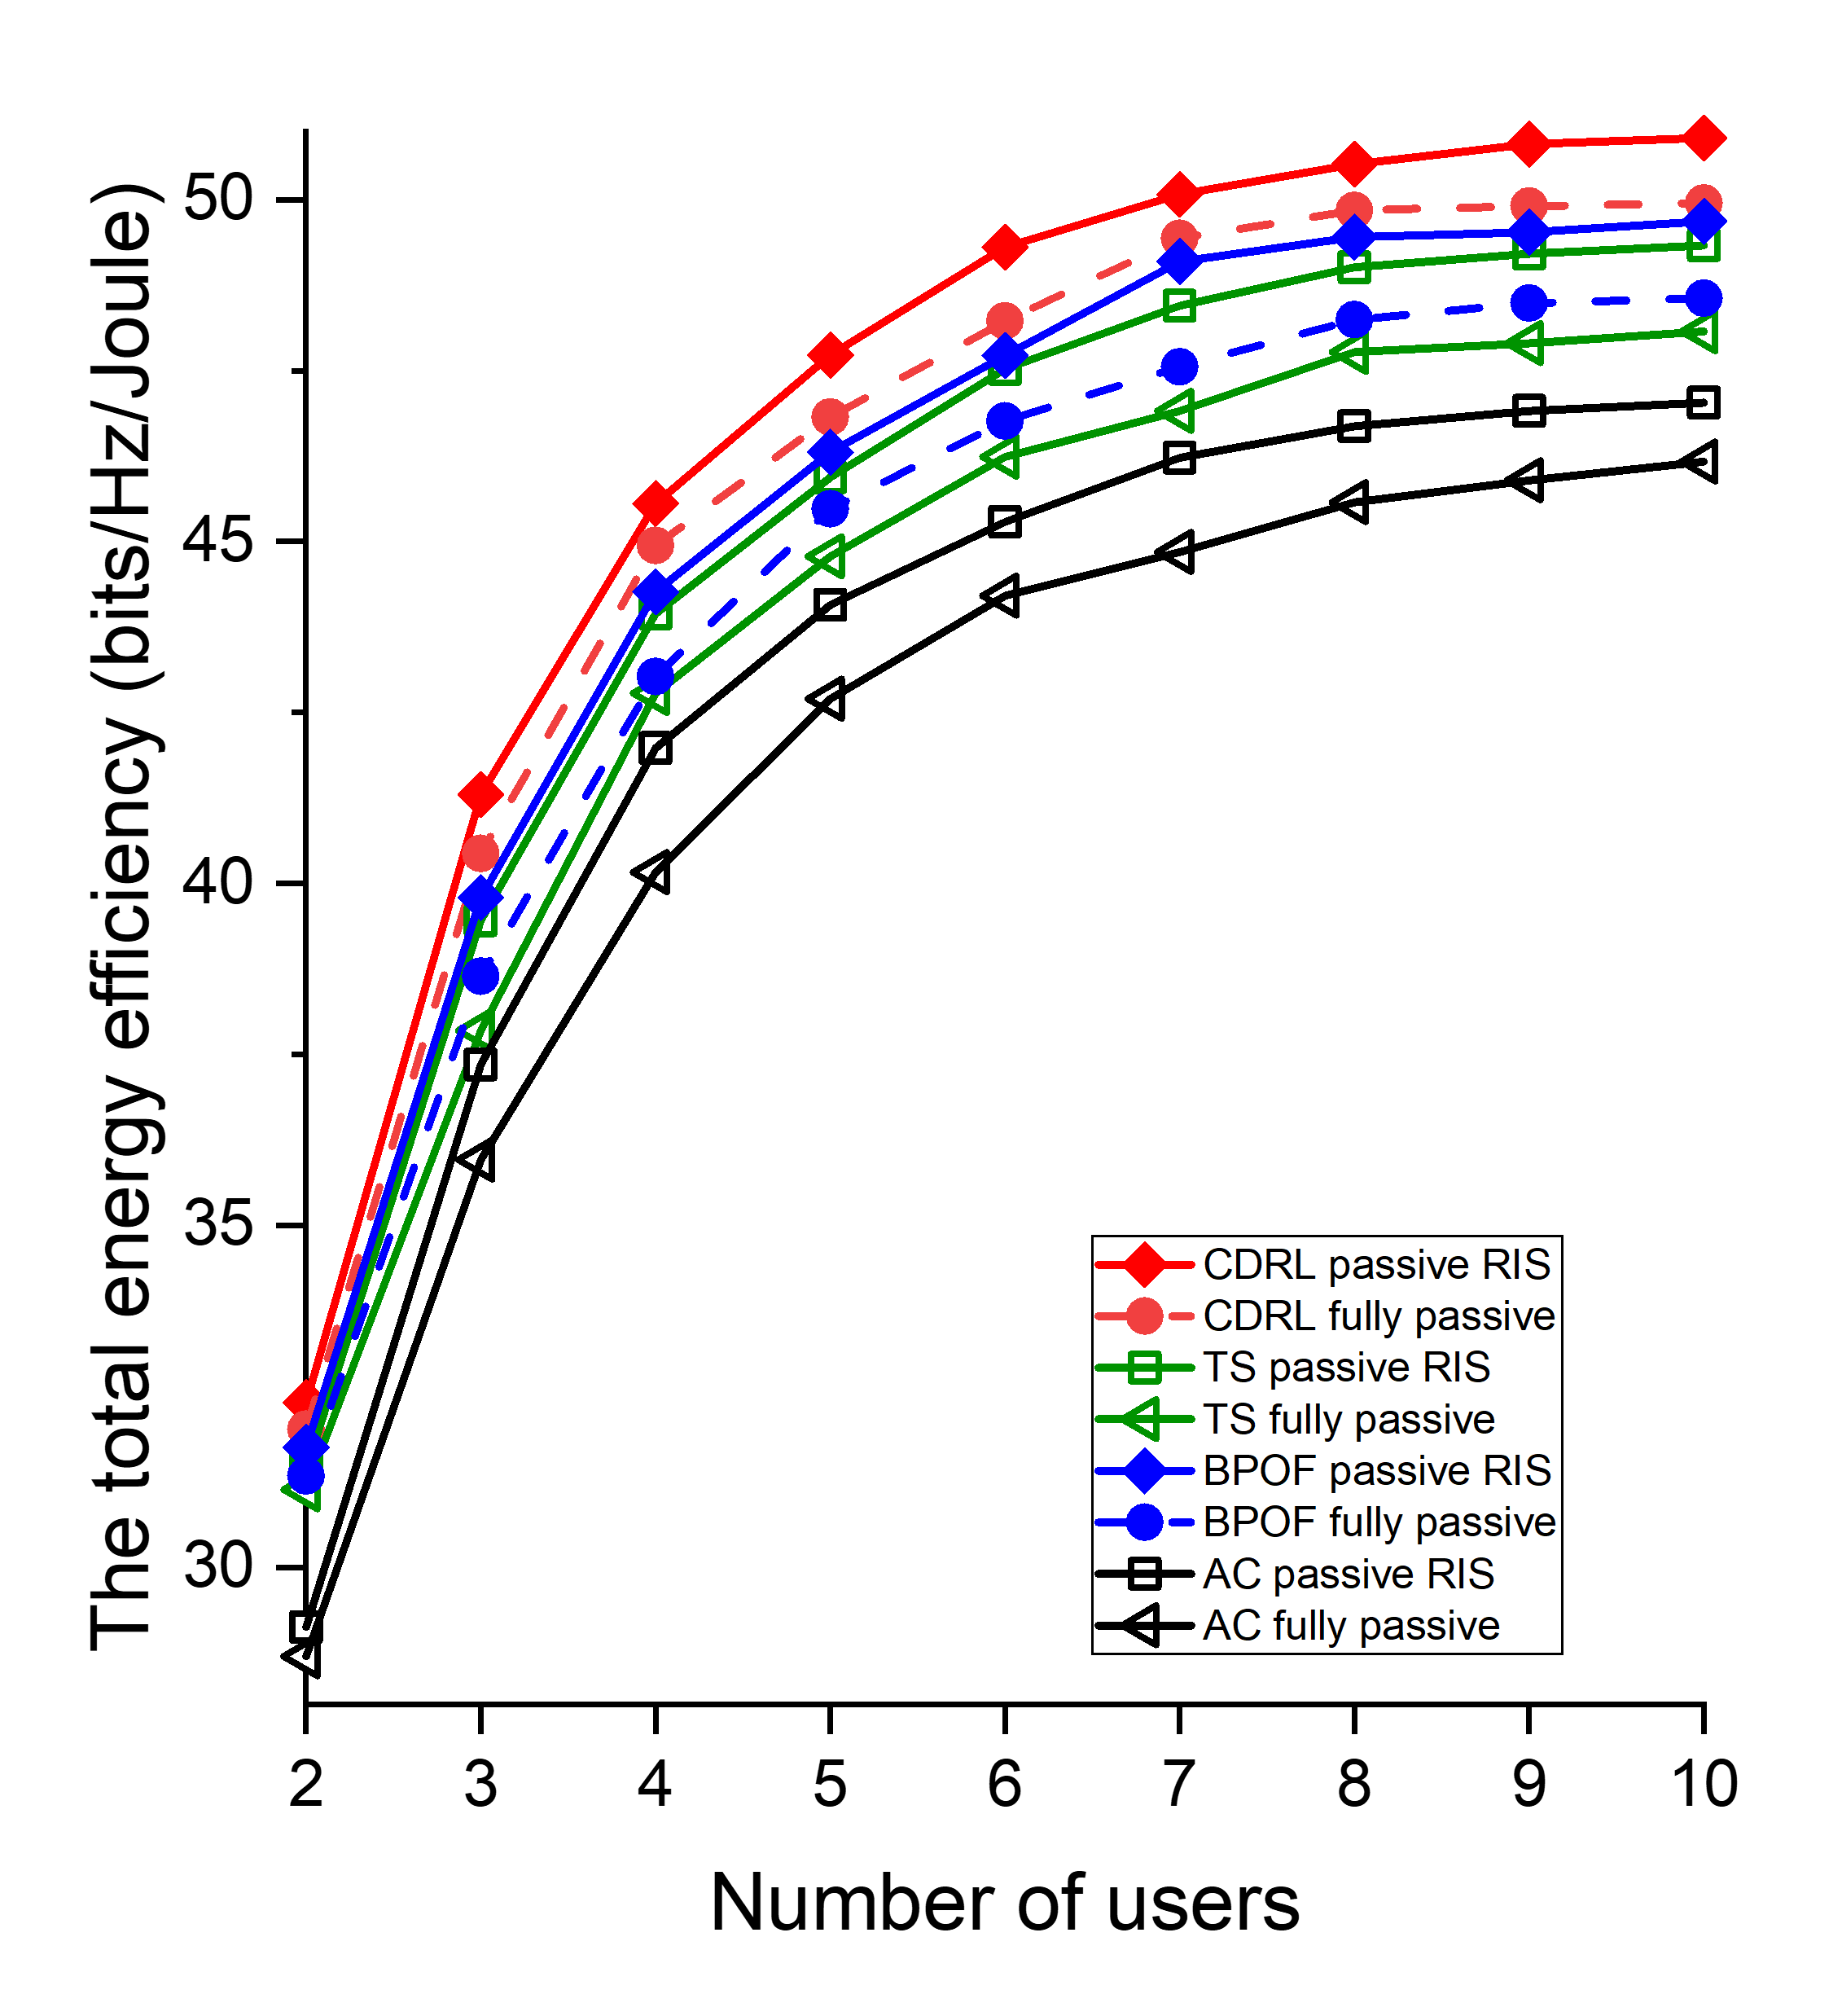
- (b)
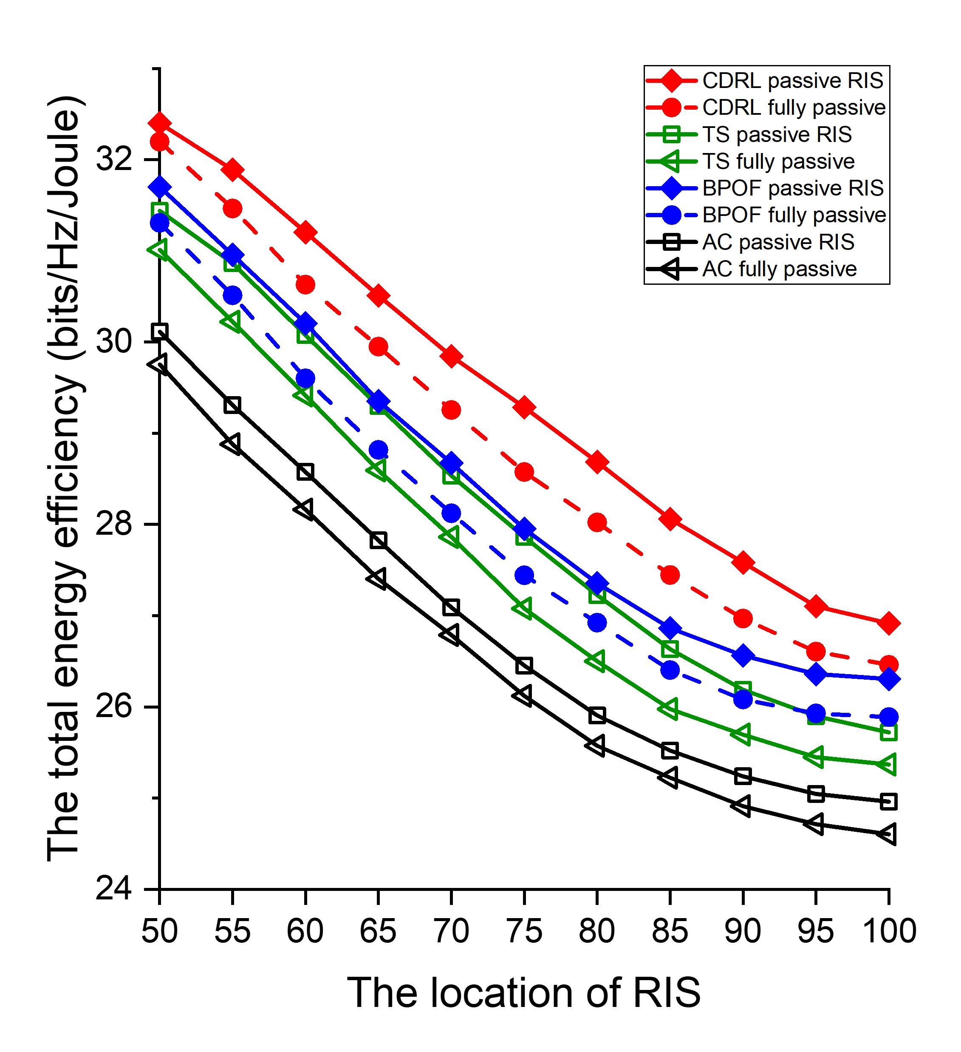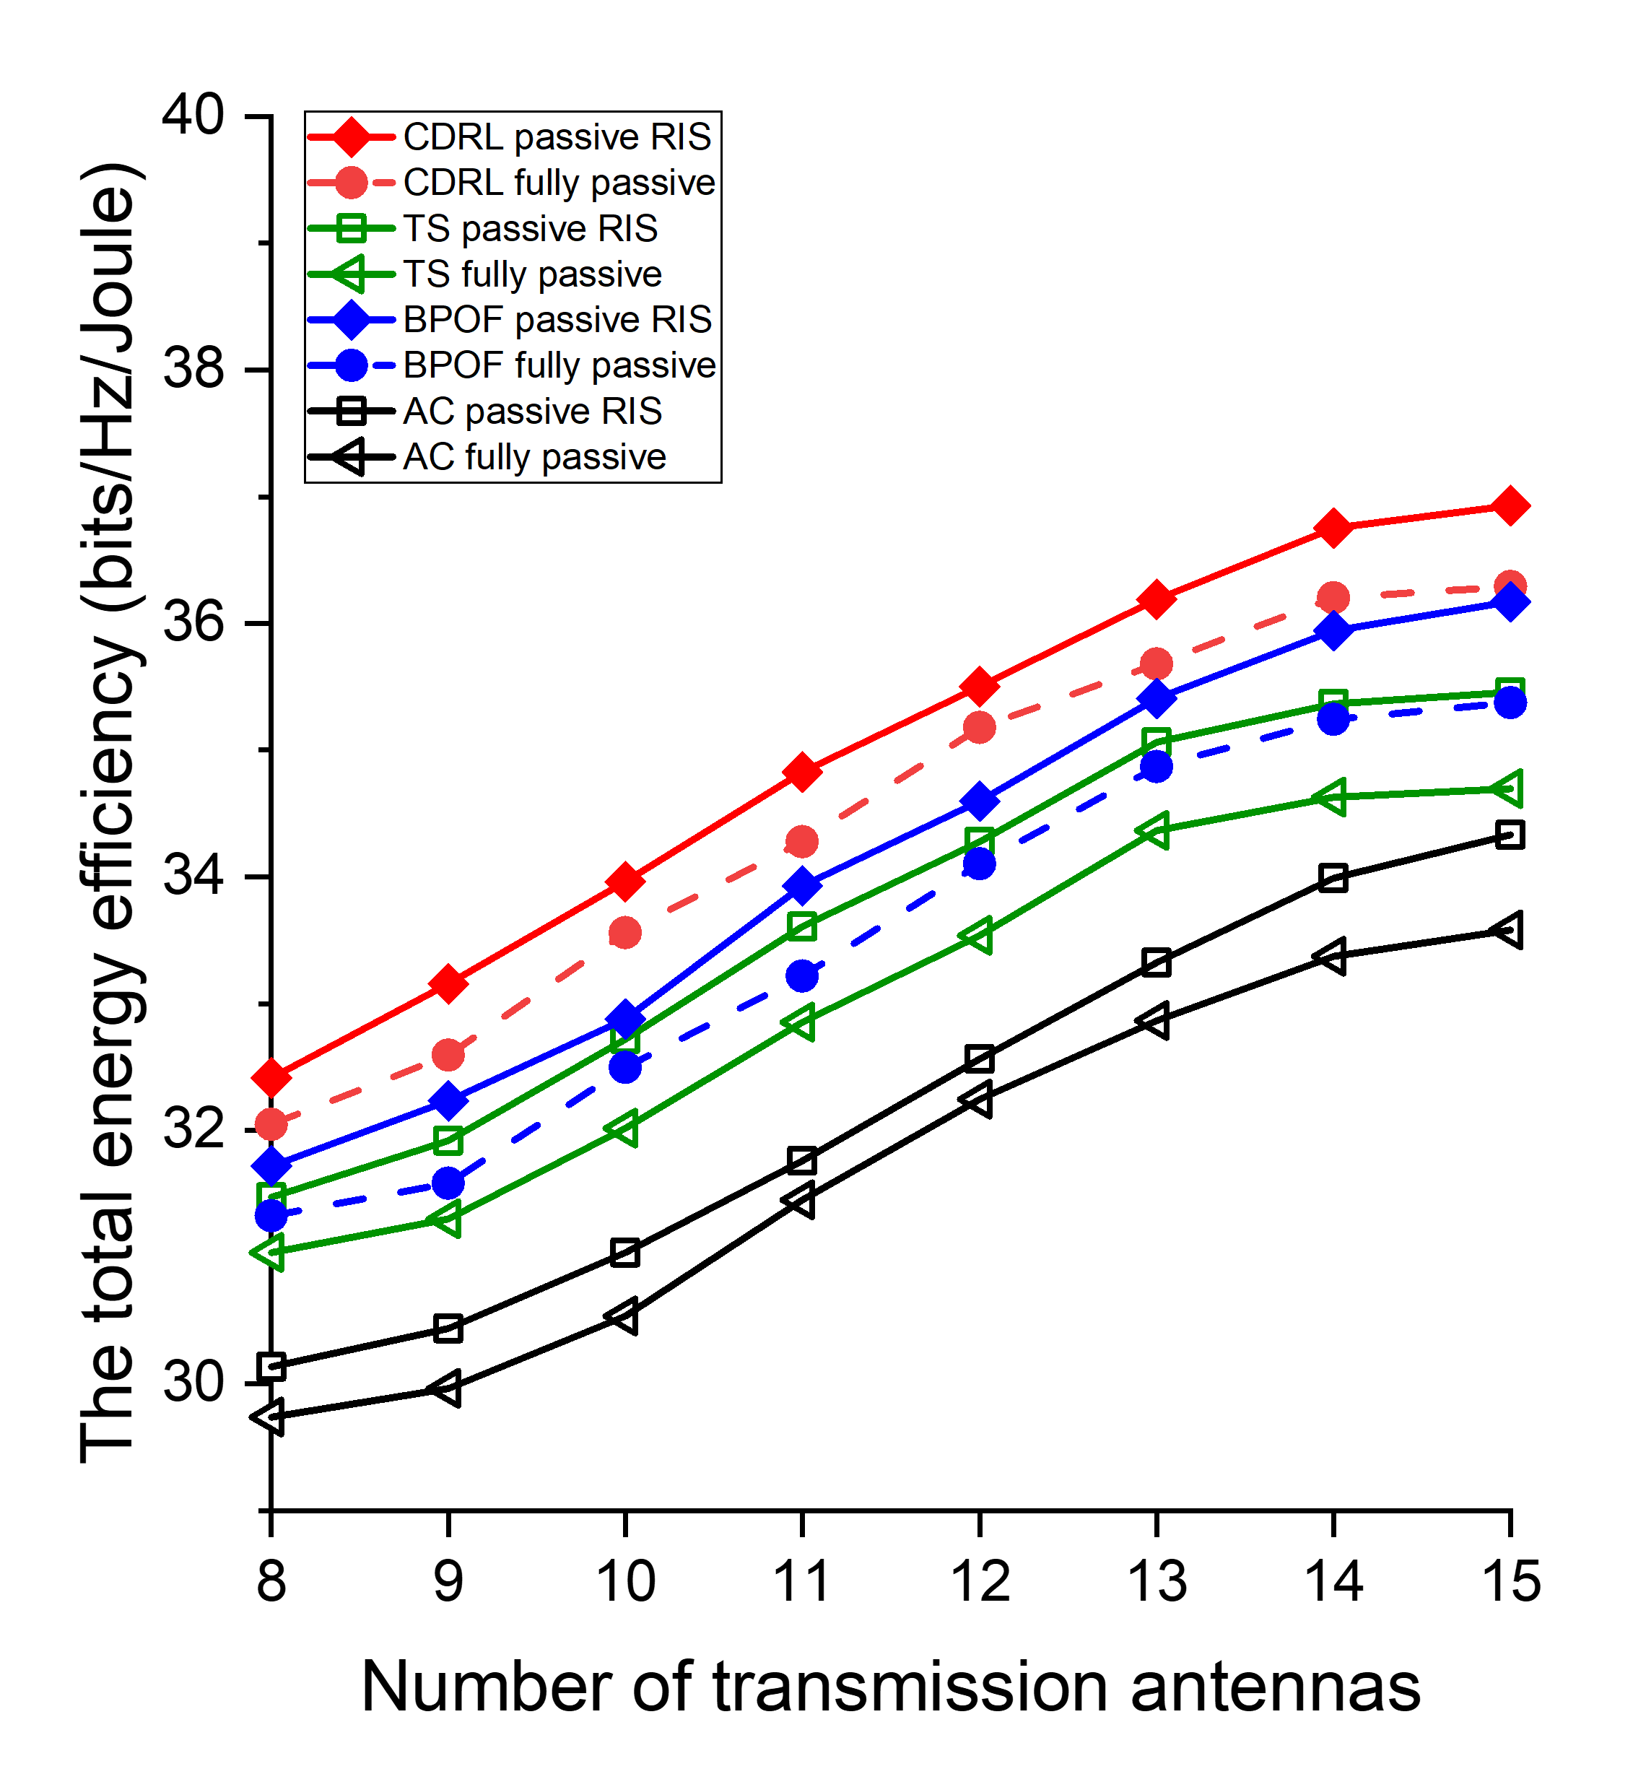
- (d)
Fig. 18. The performance comparison of passive RIS in terms of energy efficiency.

「能量效率」 vs. 「傳輸能耗上限」 的主動 / 被動 RIS 實驗結果繪製於圖 17(a) / 18(a) 所示。根據結果可以得知，隨著傳輸功率限制的放寬，所有演算法的能量效率均有所提升。原因是能量限制減少了導致可以調度的元件增加了，使得總傳輸速率的上升。觀察圖 17(a) 所示，對於本文 CDRL 的可調節開關主動 RIS 方案，擁有最好的 EE 效能。原因是可調節開關與主動 RIS 的幫助，加上鯰魚代理能有效激勵主代理進行策略探索，進而學習更優的波束成形方式與通訊元件配置組合。而本文 CDRL 的開關全開主動 RIS 方案， EE 效能較低。原因是當所有元件處於全開啟狀態時，過多的元件功耗導致整體能量效率下降。觀察圖 18(a) 所示，對於本文 CDRL 的可調節開關被動 RIS 方案，擁有所有被動方案中最好的 EE 效能。而本文 CDRL 的開關全開被動 RIS 方案， EE 效能較低。但因為需要滿足優化的限制條件，像是最小限制速率等，因此被動 RIS 方案間的 EE 差距不大。相較於現有方法，我們所提出的 CDRL 架構在各種傳輸功率限制下，皆展現出較高的能量效率表現。
「能量效率」 vs. 「用戶數量」 的主動 / 被動 RIS 實驗結果繪製於圖 17(b) / 18(b) 所示。根據結果可以得知，隨著用戶數量的增加，所有演算法的能量效率均有所提升。原因是 BS 服務的用戶數量增加造成總傳輸速率的上升。觀察圖 17(b) 所示，對於本文 CDRL 的可調節開關主動 RIS 方案，擁有最好的 EE 效能。原因是可調節開關與主動 RIS 的幫助。而本文 CDRL 的開關全開主動 RIS 方案， EE 效能較低。原因是過多的元件功耗導致整體能量效率下降。觀察圖 18(b) 所示，對於本文 CDRL 的可調節開關被動 RIS 方案，擁有所有被動方案中最好的 EE 效能。而本文 CDRL 的開關全開被動 RIS 方案， EE 效能較低。相較於現有方法，我們所提出的 CDRL 架構在各種用戶數量下，皆展現出較高的能量效率表現。為了瞭解總體用戶的能量效率與平均用戶的能量效率，繪製了主動 RIS 實驗結果於圖 17(e) 。根據結果可以得知，雖然總體能量效率上去了，但是平均用戶的能量效率不可避免的下降。原因可能是用戶接收時的相互干擾所致。
「能量效率」 vs. 「RIS 部署位置」 的主動 / 被動 RIS 實驗結果繪製於圖 17(c) / 18(c) 所示。結果表明，隨著 RIS 部署位置離參考點 (50, 10) 越來越遠，所有演算法的 EE 都下降。原因是 RIS 離 UE 越遠，能夠提供 BS 來服務 UE 的通道增益越弱，造成總傳輸速率的下降。觀察圖 17(c) 所示，對於本文 CDRL 的可調節開關主動 RIS 方案，擁有最好的 EE 效能。原因是可調節開關與主動 RIS 的幫助。而本文 CDRL 的開關全開主動 RIS 方案， EE 效能較低。原因是過多的元件功耗導致整體能量效率下降。觀察圖 18(c) 所示，對於本文 CDRL 的可調節開關被動 RIS 方案，擁有所有被動方案中最好的 EE 效能。而本文 CDRL 的開關全開被動 RIS 方案， EE 效能較低。相較於現有方法，我們所提出的 CDRL 架構在各種 RIS 部署位置下，皆展現出較高的能量效率表現。
「能量效率」 vs. 「傳輸天線數量」 的主動 / 被動 RIS 實驗結果繪製於圖 17(d) / 18(d) 所示。根據結果可以得知，隨著傳輸天線數量的增加，所有演算法的能量效率均有所提升。原因是天線數量的增加導致傳輸訊號的上升，造成總傳輸速率的上升。觀察圖 17(d) 所示，對於本文 CDRL 的可調節開關主動 RIS 方案，擁有最好的 EE 效能。原因是可調節開關與主動 RIS 的幫助。而本文 CDRL 的開關全開主動 RIS 方案， EE 效能較低。原因是過多的元件功耗導致整體能量效率下降。觀察圖 18(d) 所示，對於本文 CDRL 的可調節開關被動 RIS 方案，擁有所有被動方案中最好的 EE 效能。而本文 CDRL 的開關全開被動 RIS 方案， EE 效能較低。相較於現有方法，我們所提出的 CDRL 架構在各種傳輸天線數量下，皆展現出較高的能量效率表現。

5.2.2 Sum Rate
“Sum rate” vs. “transmission power consumption” experimental results for active/passive RIS are plotted in Fig. 19(a)/20(a). According to the results, as the transmission power constraint is relaxed, the spectral efficiency of all algorithms improves because fewer energy restrictions increase the number of schedulable elements, thus raising the total transmission rate. Observing Fig. 19(a), for this thesis’s CDRL adjustable-switch active RIS scheme, the best SE performance is achieved owing to the combined benefits of adjustable switches, active RIS and the catfish agent’s effective incentive of the main agent to explore new strategies, thereby learning superior beam-forming and component-configuration combinations. The all-on-switch active RIS scheme of this thesis’s CDRL exhibits lower SE performance because when all elements are fully on, redundant elements increase channel noise, causing a slight SE degradation. Observing Fig. 20(a), for this thesis’s CDRL adjustable-switch passive RIS scheme, the best SE performance among all passive schemes is achieved. The all-on-switch passive RIS scheme of this thesis’s CDRL exhibits lower SE performance, and because optimization constraints such as the minimum-rate requirement must be met, SE differences among passive RIS schemes remain small. Compared with existing methods, this thesis’s CDRL framework demonstrates higher transmission efficiency under various transmission power constraints.
“Sum rate” vs. “number of users” experimental results for active/passive RIS are plotted in Fig. 19(b)/20(b). According to the results, as the user number increases, the spectral efficiency of all algorithms improves because a larger number of users served by the BS yields a higher total transmission rate. Observing Fig. 19(b), for this thesis’s CDRL adjustable-switch active RIS scheme, the best SE performance is achieved owing to adjustable switches and active RIS. The all-on-switch active RIS scheme of this thesis’s CDRL exhibits lower SE performance because redundant elements increase channel noise, causing a slight SE degradation. Observing Fig. 20(b), for this thesis’s CDRL adjustable-switch passive RIS scheme, the best SE performance among all passive schemes is achieved. The all-on-switch passive RIS scheme of this thesis’s CDRL exhibits lower SE performance. Compared with existing methods, this thesis’s CDRL framework demonstrates higher transmission efficiency under various user numbers. To investigate both the overall transmission rate and the average user transmission rate, the results of the active RIS experiment are illustrated in Fig. 19(e). The results indicate that although the overall transmission rate increases, the average user transmission rate decreases. This degradation may be caused by mutual interference among users during signal reception.
“Sum rate” vs. “the location of RIS” experimental results for active/passive RIS are plotted in Fig. 19(c)/20(c). The results indicate a decline in SE across all algorithms as the RIS deployment is positioned increasingly farther from the reference point (50, 10). According to the results, as the RIS deployment position moves away from (50, 0), the spectral efficiency of all algorithms decreases because the farther the RIS is from the UE, the weaker the channel gain from the BS to the UE, resulting in a lower total transmission rate. Observing Fig. 19(c), for this thesis’s CDRL adjustable-switch active RIS scheme, the best SE performance is achieved owing to adjustable switches and active RIS. The all-on-switch active RIS scheme of this thesis’s CDRL exhibits lower SE performance because redundant elements increase channel noise, causing a slight SE degradation. Observing Fig. 20(c), for this thesis’s CDRL adjustable-switch passive RIS scheme, the best SE performance among all passive schemes is achieved. The all-on-switch passive RIS scheme of this thesis’s CDRL exhibits lower SE performance. Compared with existing methods, this thesis’s CDRL framework demonstrates higher transmission efficiency under various RIS deployment positions.
“Sum rate” vs. “number of transmission antennas” experimental results for active/passive RIS are plotted in Fig. 19(d)/20(d). According to the results, as the number of transmit antennas increases, the spectral efficiency of all algorithms improves because more antennas boost the transmission signal, increasing the total transmission rate. Observing Fig. 19(d), for this thesis’s CDRL adjustable-switch active RIS scheme, the best SE performance is achieved owing to adjustable switches and active RIS. The all-on-switch active RIS scheme of this thesis’s CDRL exhibits lower SE performance because redundant elements increase channel noise, causing a slight SE degradation. Observing Fig. 20(d), for this thesis’s CDRL adjustable-switch passive RIS scheme, the best SE performance among all passive schemes is achieved. The all-on-switch passive RIS scheme of this thesis’s CDRL exhibits lower SE performance. Compared with existing methods, this thesis’s CDRL framework demonstrates higher transmission efficiency under various numbers of transmit antennas.

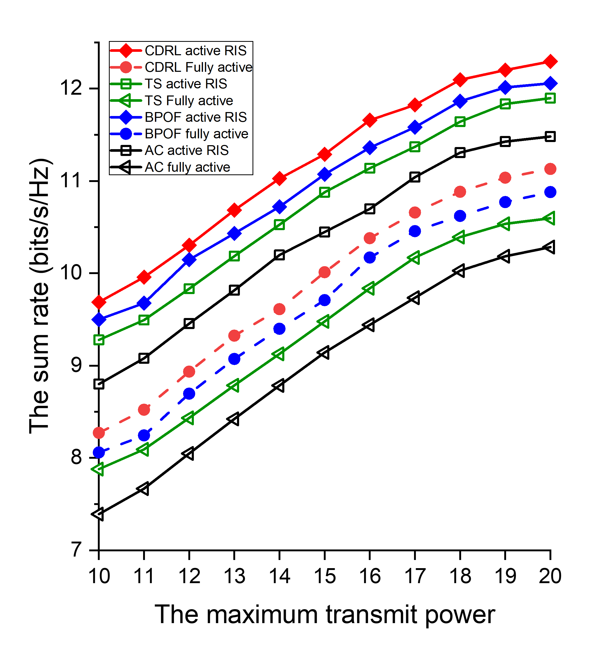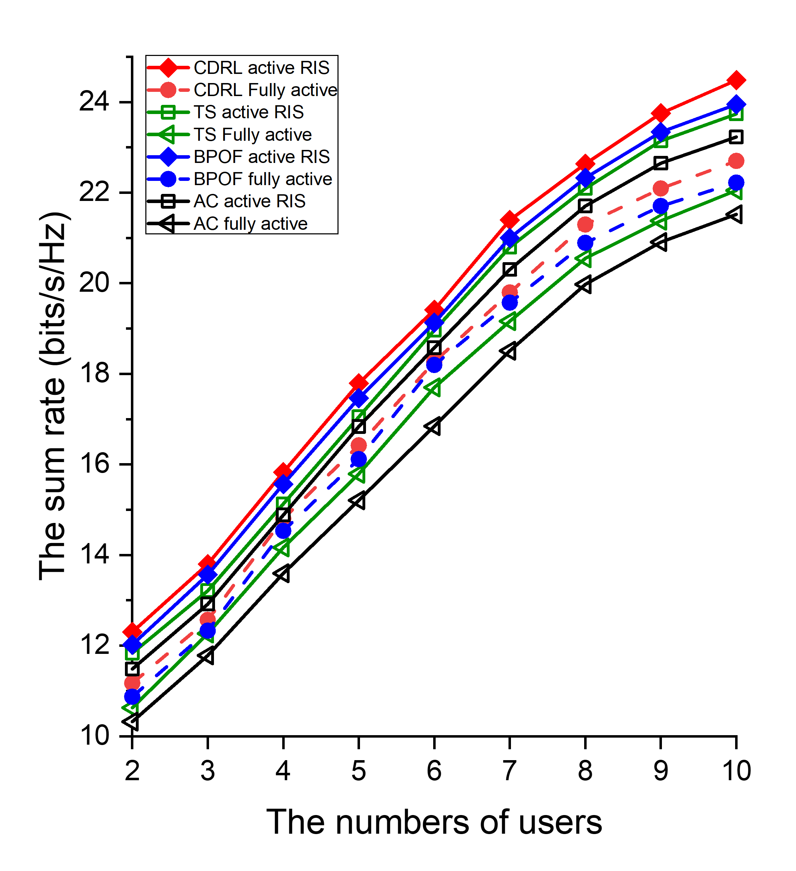
- (b)
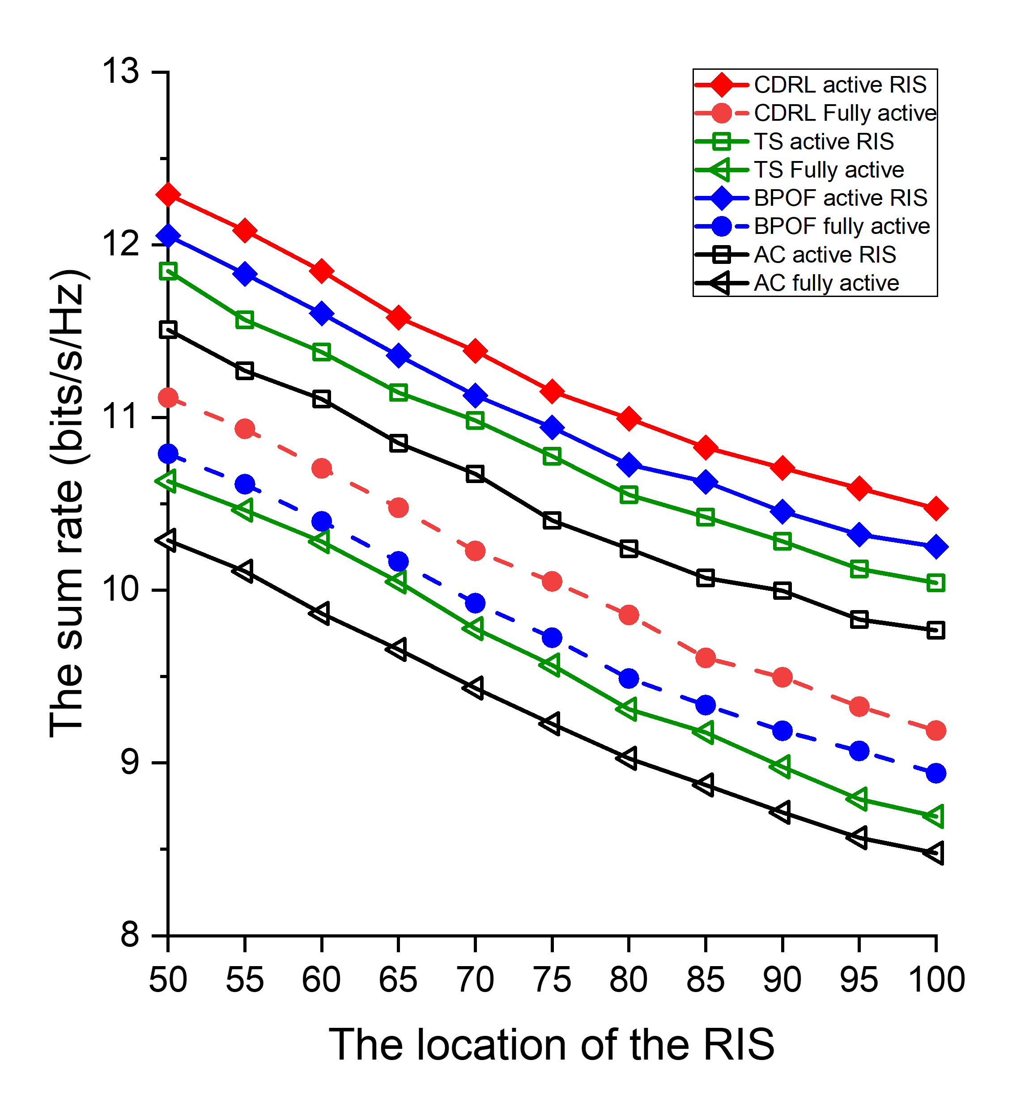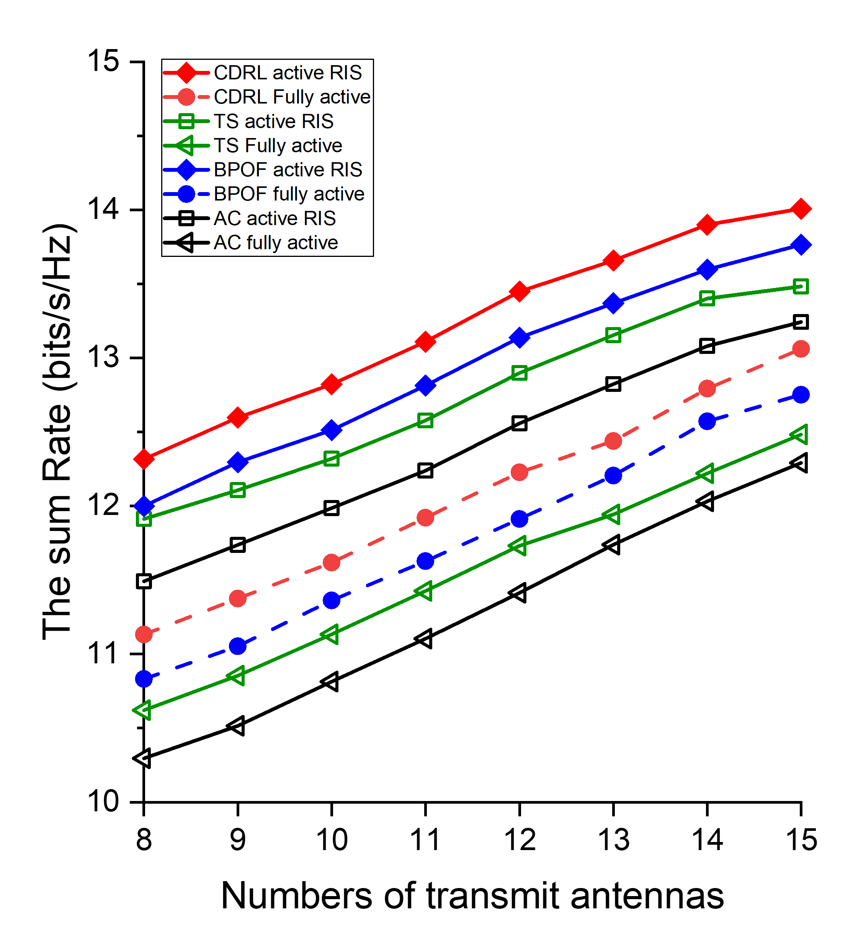
- (d)
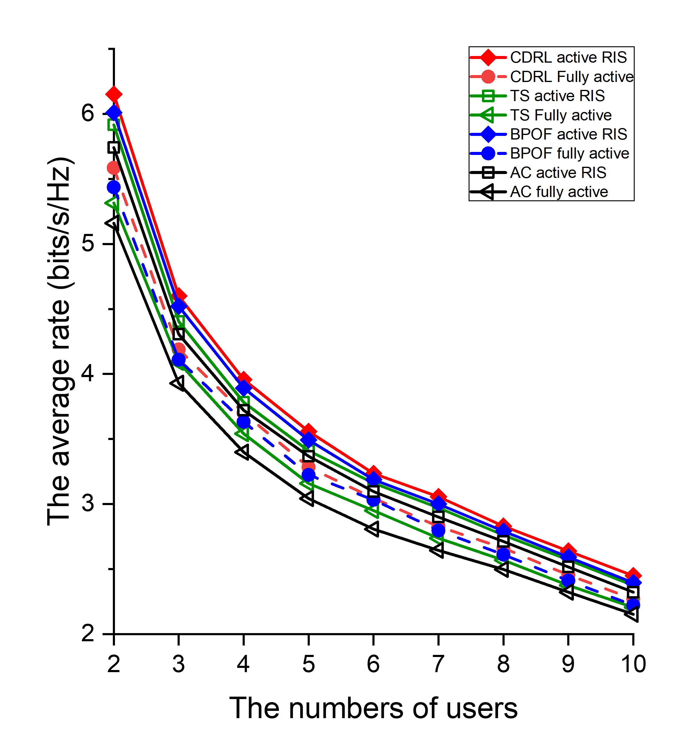
(e)
Fig. 19. The performance comparison of active RIS in terms of sum rate.

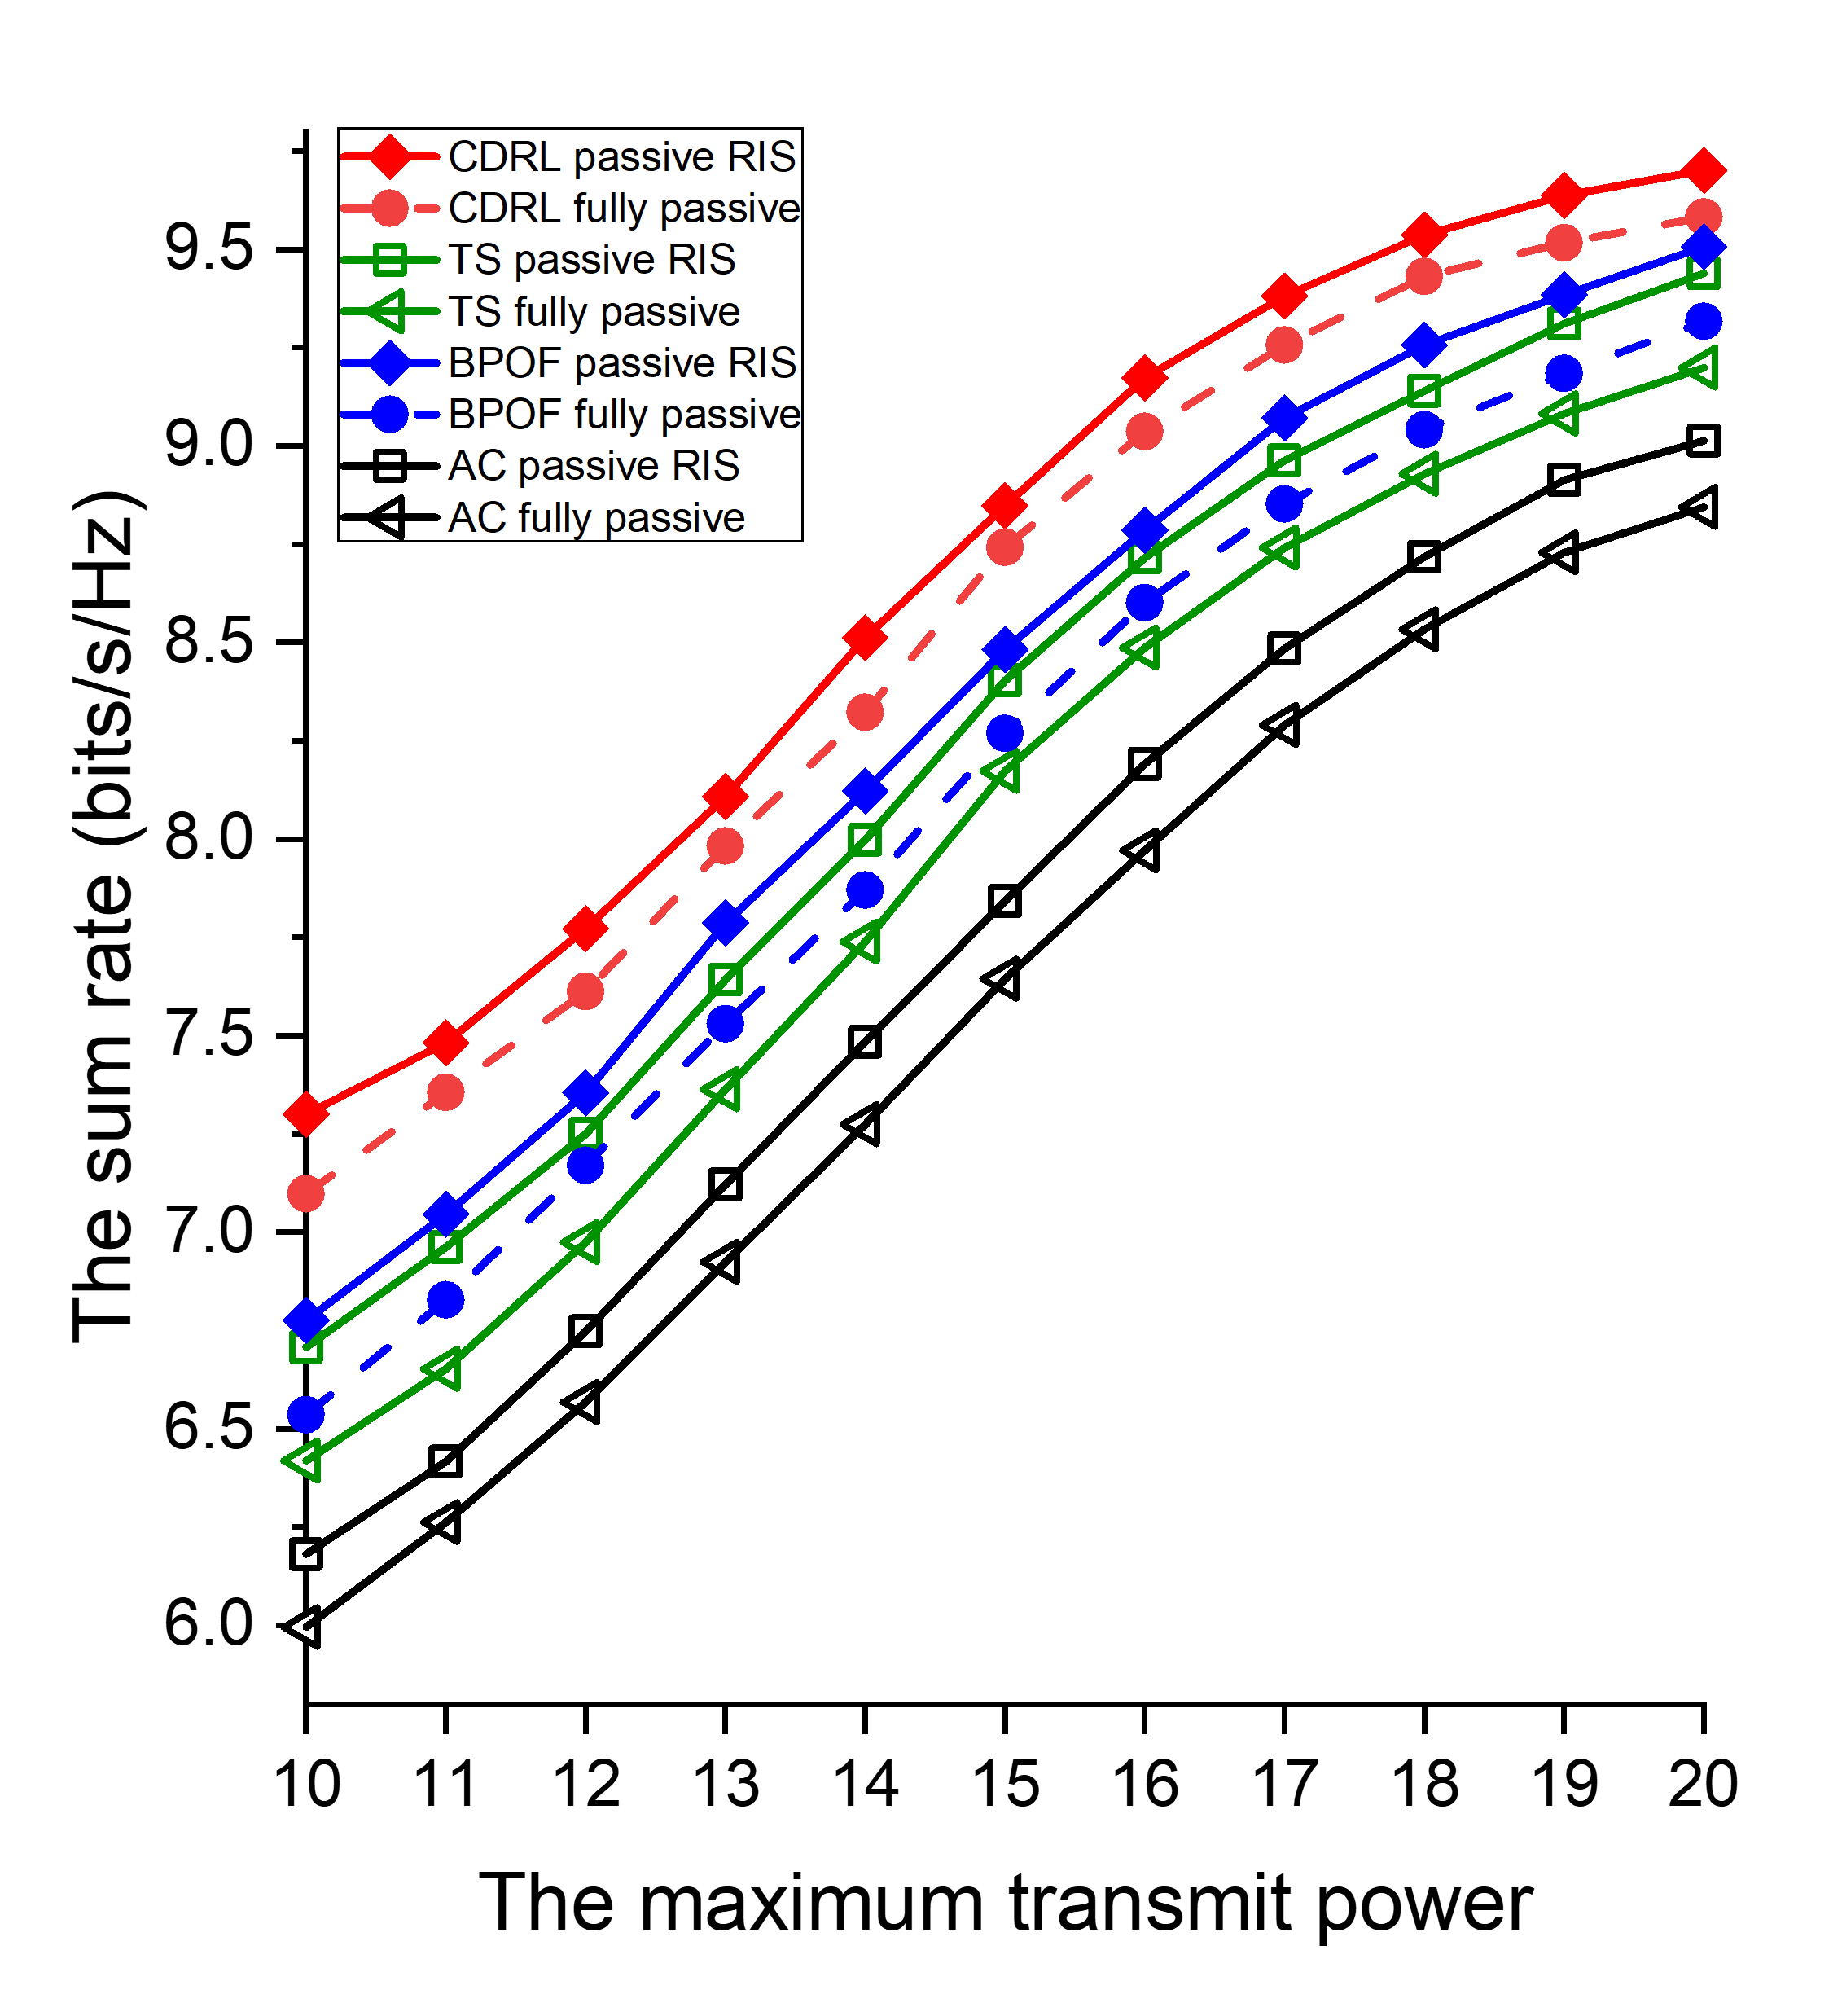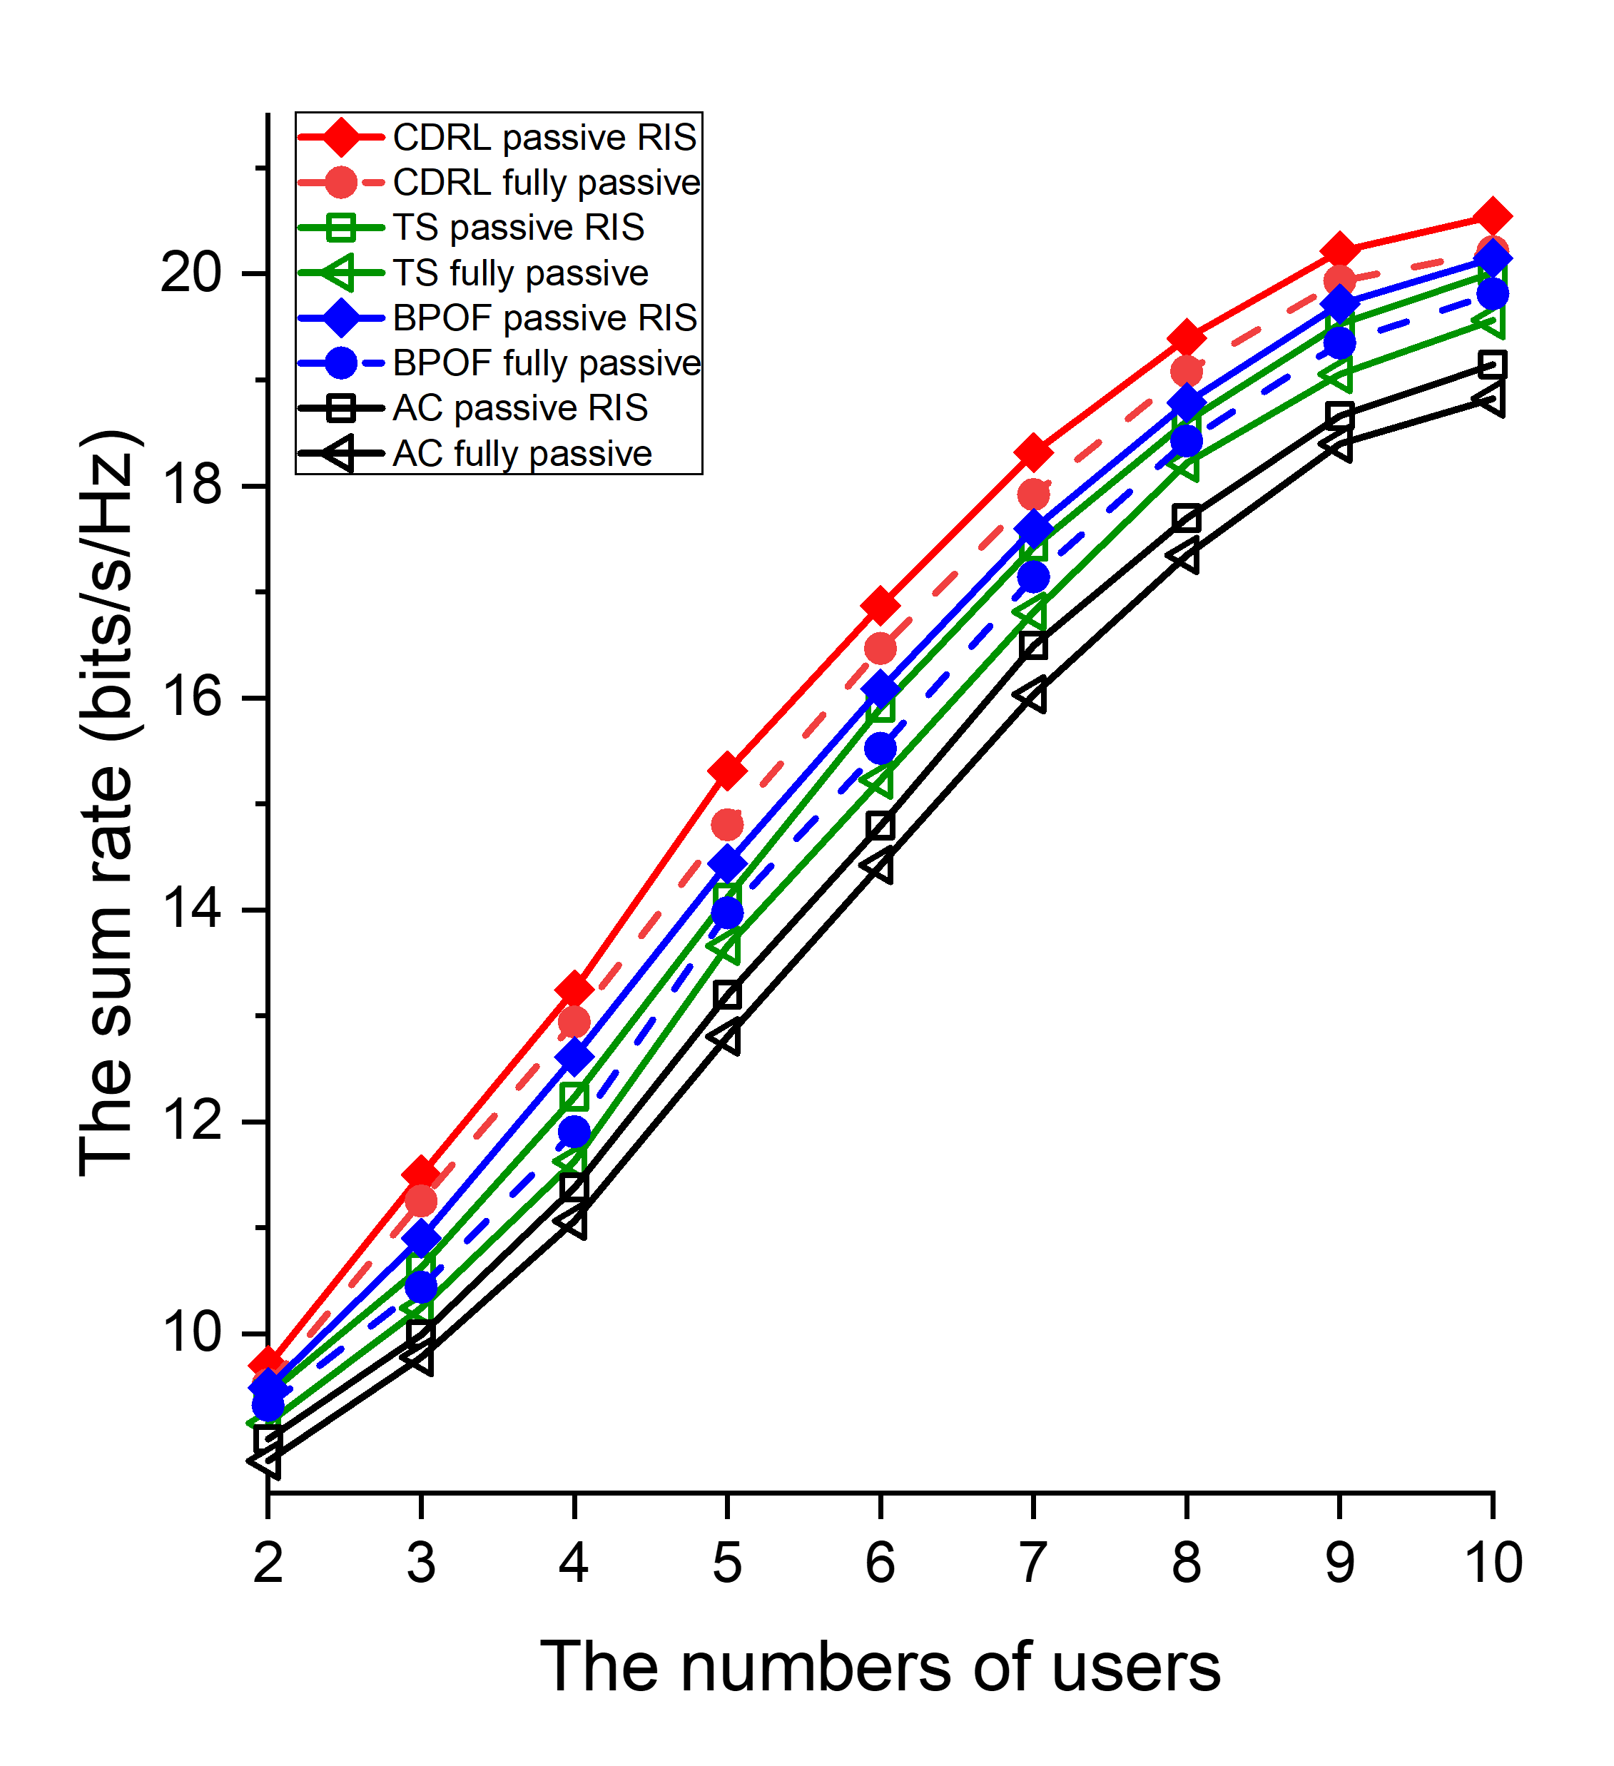
- (b)
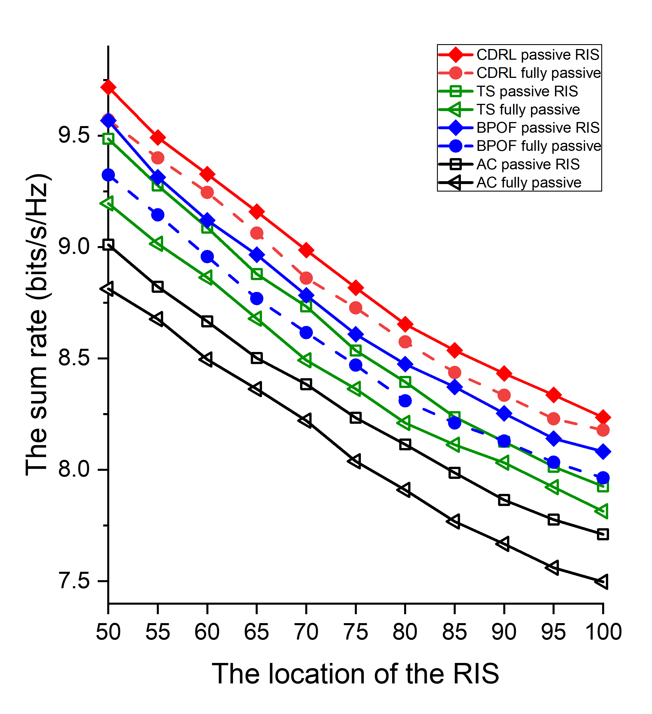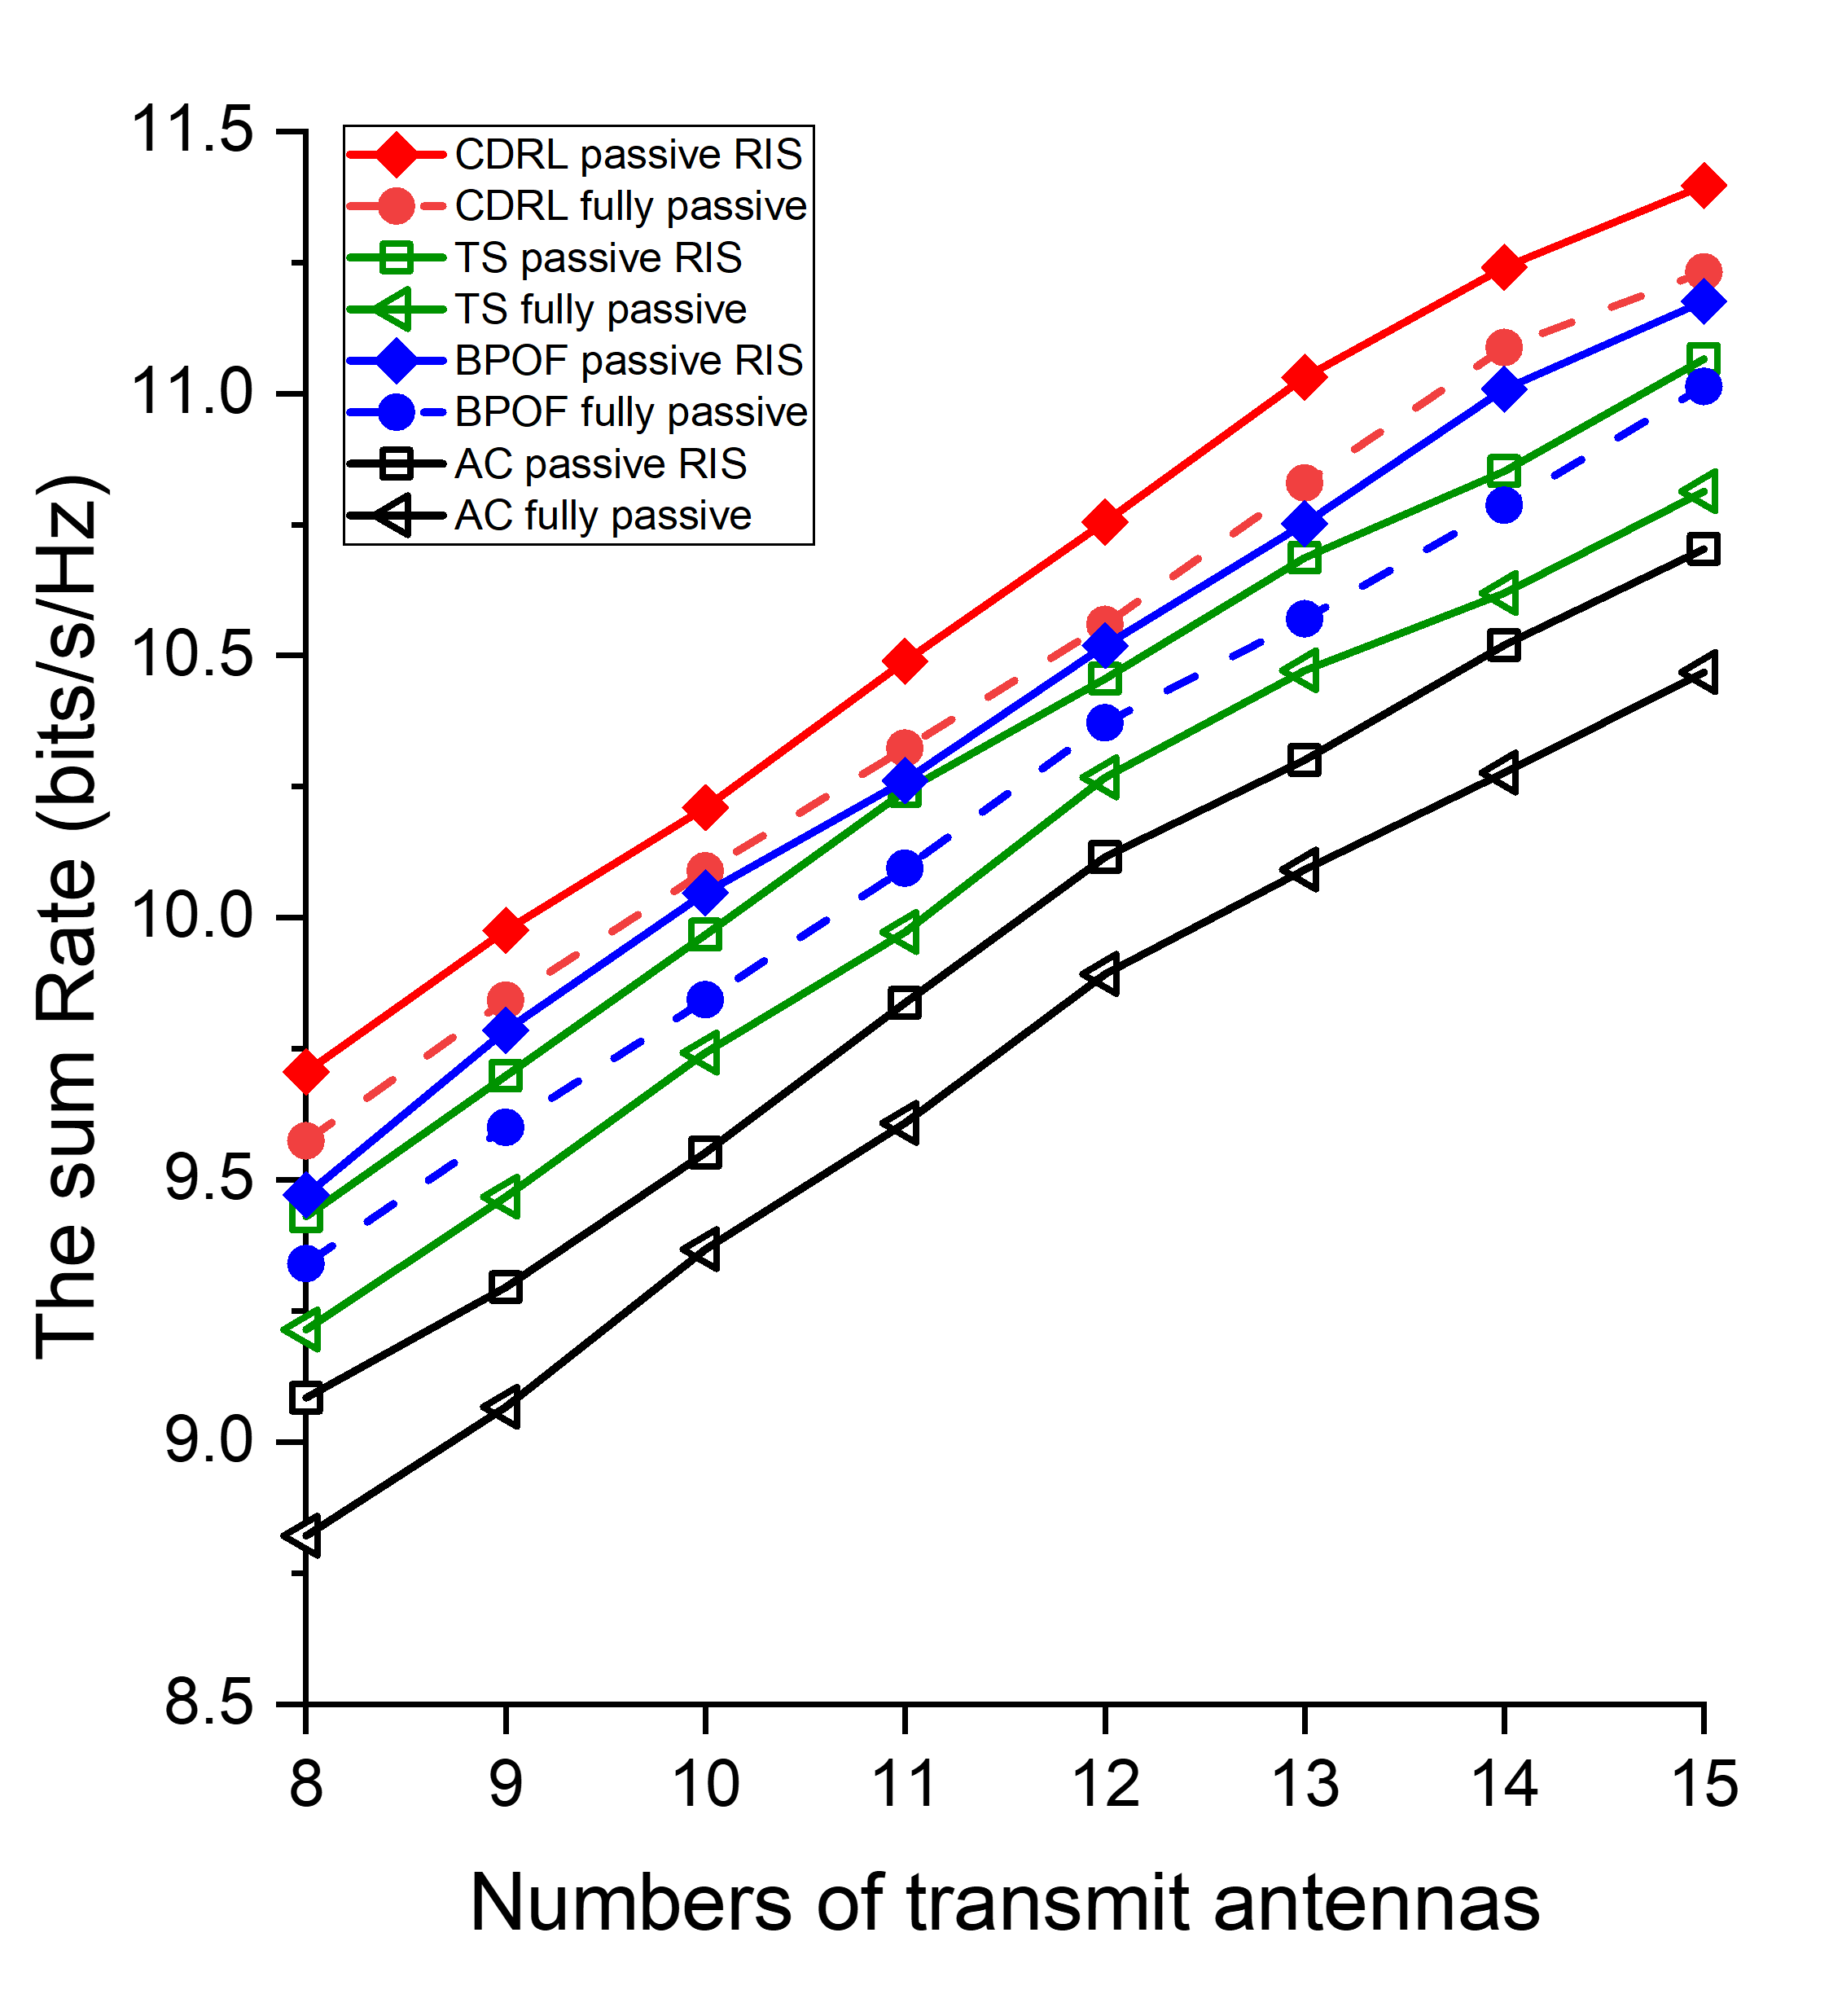
- (d)
Fig. 20. The performance comparison of passive RIS in terms of sum rate.

「傳輸速率」 vs. 「傳輸能耗上限」 的主動 / 被動 RIS 實驗結果繪製於圖 19(a) / 20(a)。根據結果可以得知，隨著傳輸功率限制的放寬，所有演算法的傳輸效率均有所提升。原因是能量限制減少了導致可以調度的元件增加了，使得總傳輸速率的上升。觀察圖 19(a)，對於本文 CDRL 的可調節開關主動 RIS 方案，擁有最好的 SE 效能。原因是可調節開關與主動 RIS 的幫助，加上鯰魚代理能有效激勵主代理進行策略探索，進而學習更優的波束成形方式與通訊元件配置組合。而本文 CDRL 的開關全開主動 RIS 方案， SE 效能較低。原因是當所有元件處於全開啟狀態時，多餘的元件導致通道雜訊上升，造成 SE 效能略微下降。觀察圖 20(a) ，對於本文 CDRL 的可調節開關被動 RIS 方案，擁有所有被動方案中最好的 SE 效能。而本文 CDRL 的開關全開被動 RIS 方案， SE 效能較低。但因為需要滿足優化的限制條件，像是最小限制速率等，因此被動 RIS 方間的 SE 差距不大。相較於現有方法，我們所提出的 CDRL 架構在各種傳輸功率限制下，皆展現出較高的傳輸效率表現。
「傳輸速率」 vs. 「用戶數量」 的主動 / 被動 RIS 實驗結果繪製於圖 19(b) / 20(b) 所示。根據結果可以得知，隨著用戶數量的增加，所有演算法的傳輸效率均有所提升。原因是 BS 服務的用戶數量增加造成總傳輸速率的上升。觀察圖 19(b) 所示，對於本文 CDRL 的可調節開關主動 RIS 方案，擁有最好的 SE 效能。原因是可調節開關與主動 RIS 的幫助。而本文 CDRL 的開關全開主動 RIS 方案， EE 效能較低。原因是多餘的元件導致通道雜訊上升，造成 SE 效能略微下降。觀察圖 20(b) 所示，對於本文 CDRL 的可調節開關被動 RIS 方案，擁有所有被動方案中最好的 SE 效能。而本文 CDRL 的開關全開被動 RIS 方案， SE 效能較低。相較於現有方法，我們所提出的 CDRL 架構在各種用戶數量限制下，皆展現出較高的傳輸效率表現。為了瞭解總體用戶的傳輸速率與平均用戶的傳輸速率，繪製了主動 RIS 實驗結果於圖 19(e) 。根據結果可以得知，雖然總體傳輸速率上去了，但是平均用戶的傳輸速率是下降的。原因可能是用戶接收時的相互干擾所致。
「傳輸速率」 vs. 「RIS 部署位置」 的主動 / 被動 RIS 實驗結果繪製於圖 19(c) / 20(c) 所示。結果表明，隨著 RIS 部署位置離參考點 (50, 10) 越來越遠，所有演算法的 SE 都下降。原因是 RIS 離 UE 越遠，能夠提供 BS 來服務 UE 的通道增益越弱，造成總傳輸速率的下降。觀察圖 19(c) 所示，對於本文 CDRL 的可調節開關主動 RIS 方案，擁有最好的 EE 效能。原因是可調節開關與主動 RIS 的幫助。而本文 CDRL 的開關全開主動 RIS 方案， EE 效能較低。原因是多餘的元件導致通道雜訊上升，造成 SE 效能略微下降。觀察圖 20(c) 所示，對於本文 CDRL 的可調節開關被動 RIS 方案，擁有所有被動方案中最好的 SE 效能。而本文 CDRL 的開關全開被動 RIS 方案， SE 效能較低。相較於現有方法，我們所提出的 CDRL 架構在各種 RIS 部署位置下，皆展現出較高的傳輸效率表現。
「傳輸速率」 vs. 「傳輸天線數量」 的主動 / 被動 RIS 實驗結果繪製於圖 19(d) / 20(d) 所示。根據結果可以得知，隨著傳輸天線數量的增加，所有演算法的傳輸效率均有所提升。原因是天線數量的增加導致傳輸訊號的上升，造成總傳輸速率的上升。觀察圖 19(d) 所示，對於本文 CDRL 的可調節開關主動 RIS 方案，擁有最好的 SE 效能。原因是可調節開關與主動 RIS 的幫助。而本文 CDRL 的開關全開主動 RIS 方案， SE 效能較低。原因是多餘的元件導致通道雜訊上升，造成 SE 效能略微下降。觀察圖 20(d) 所示，對於本文 CDRL 的可調節開關被動 RIS 方案，擁有所有被動方案中最好的 SE 效能。而本文 CDRL 的開關全開被動 RIS 方案， SE 效能較低。相較於現有方法，我們所提出的 CDRL 架構在各種傳輸天線數量下，皆展現出較高的傳輸效率表現。

5.3 Ablation Experiment
This thesis conducts an ablation experiment to elucidate the contributions of its three catfish strategies to CDRL. In each experiment, one strategy is removed from the complete CDRL scheme (red line with solid diamonds). The first ablation removes Catfish Strategy 1: Experience Stratification (orange line with solid circles) and replaces it with an unsegmented experience-replay buffer. The second ablation removes Catfish Strategy 2: Asymmetric Discounting Strategy (blue line with solid circles), instead using an identical discount factor ($γ^{M}= γ^{CF}= 0.95$). The third ablation removes Catfish Strategy 3: Adaptive Competitive Reward Mechanism (green line with solid circles), so the catfish agent receives no extra reward. The fourth one uses only Catfish Strategy 1: Experience Stratification (orange line with solid diamond markers), where the experience replay memory is replaced with classified experiences. The fifth one uses only Catfish Strategy 2: Asymmetric Discounting Strategy (blue line with solid diamond markers), where different discount factors are applied ($γ^{M}=0.95, γ^{CF}= 0.99$). The sixth one uses only Catfish Strategy 3: Adaptive Competitive Reward Mechanism (green line with solid diamond markers), where the catfish agent applies only the additional reward.
“Transmission rate vs. transmission power constraint” results for the active RIS ablation are plotted in Fig. 21. The unsegmented replay yields a moderate performance drop—likely because all experiences, regardless of reward magnitude, remain equally probable in sampling—while the identical discount-factor ablation causes a larger degradation, suggesting that similar objectives for catfish and main agents reduce the main agent’s exploratory stimulus. Omitting the adaptive competitive reward mechanism has the smallest effect, implying that the baseline reward density already sufficiently drives CDRL training. Using only the pre-classified experience replay memory yields a moderate improvement, possibly due to the lack of support from the other two strategies. Using only different discount factors achieves the greatest improvement, which may result from the effective division of tasks. Using only the catfish agent without the Adaptive Competitive Reward Mechanism shows a smaller improvement, possibly because the additional reward provides limited benefit.
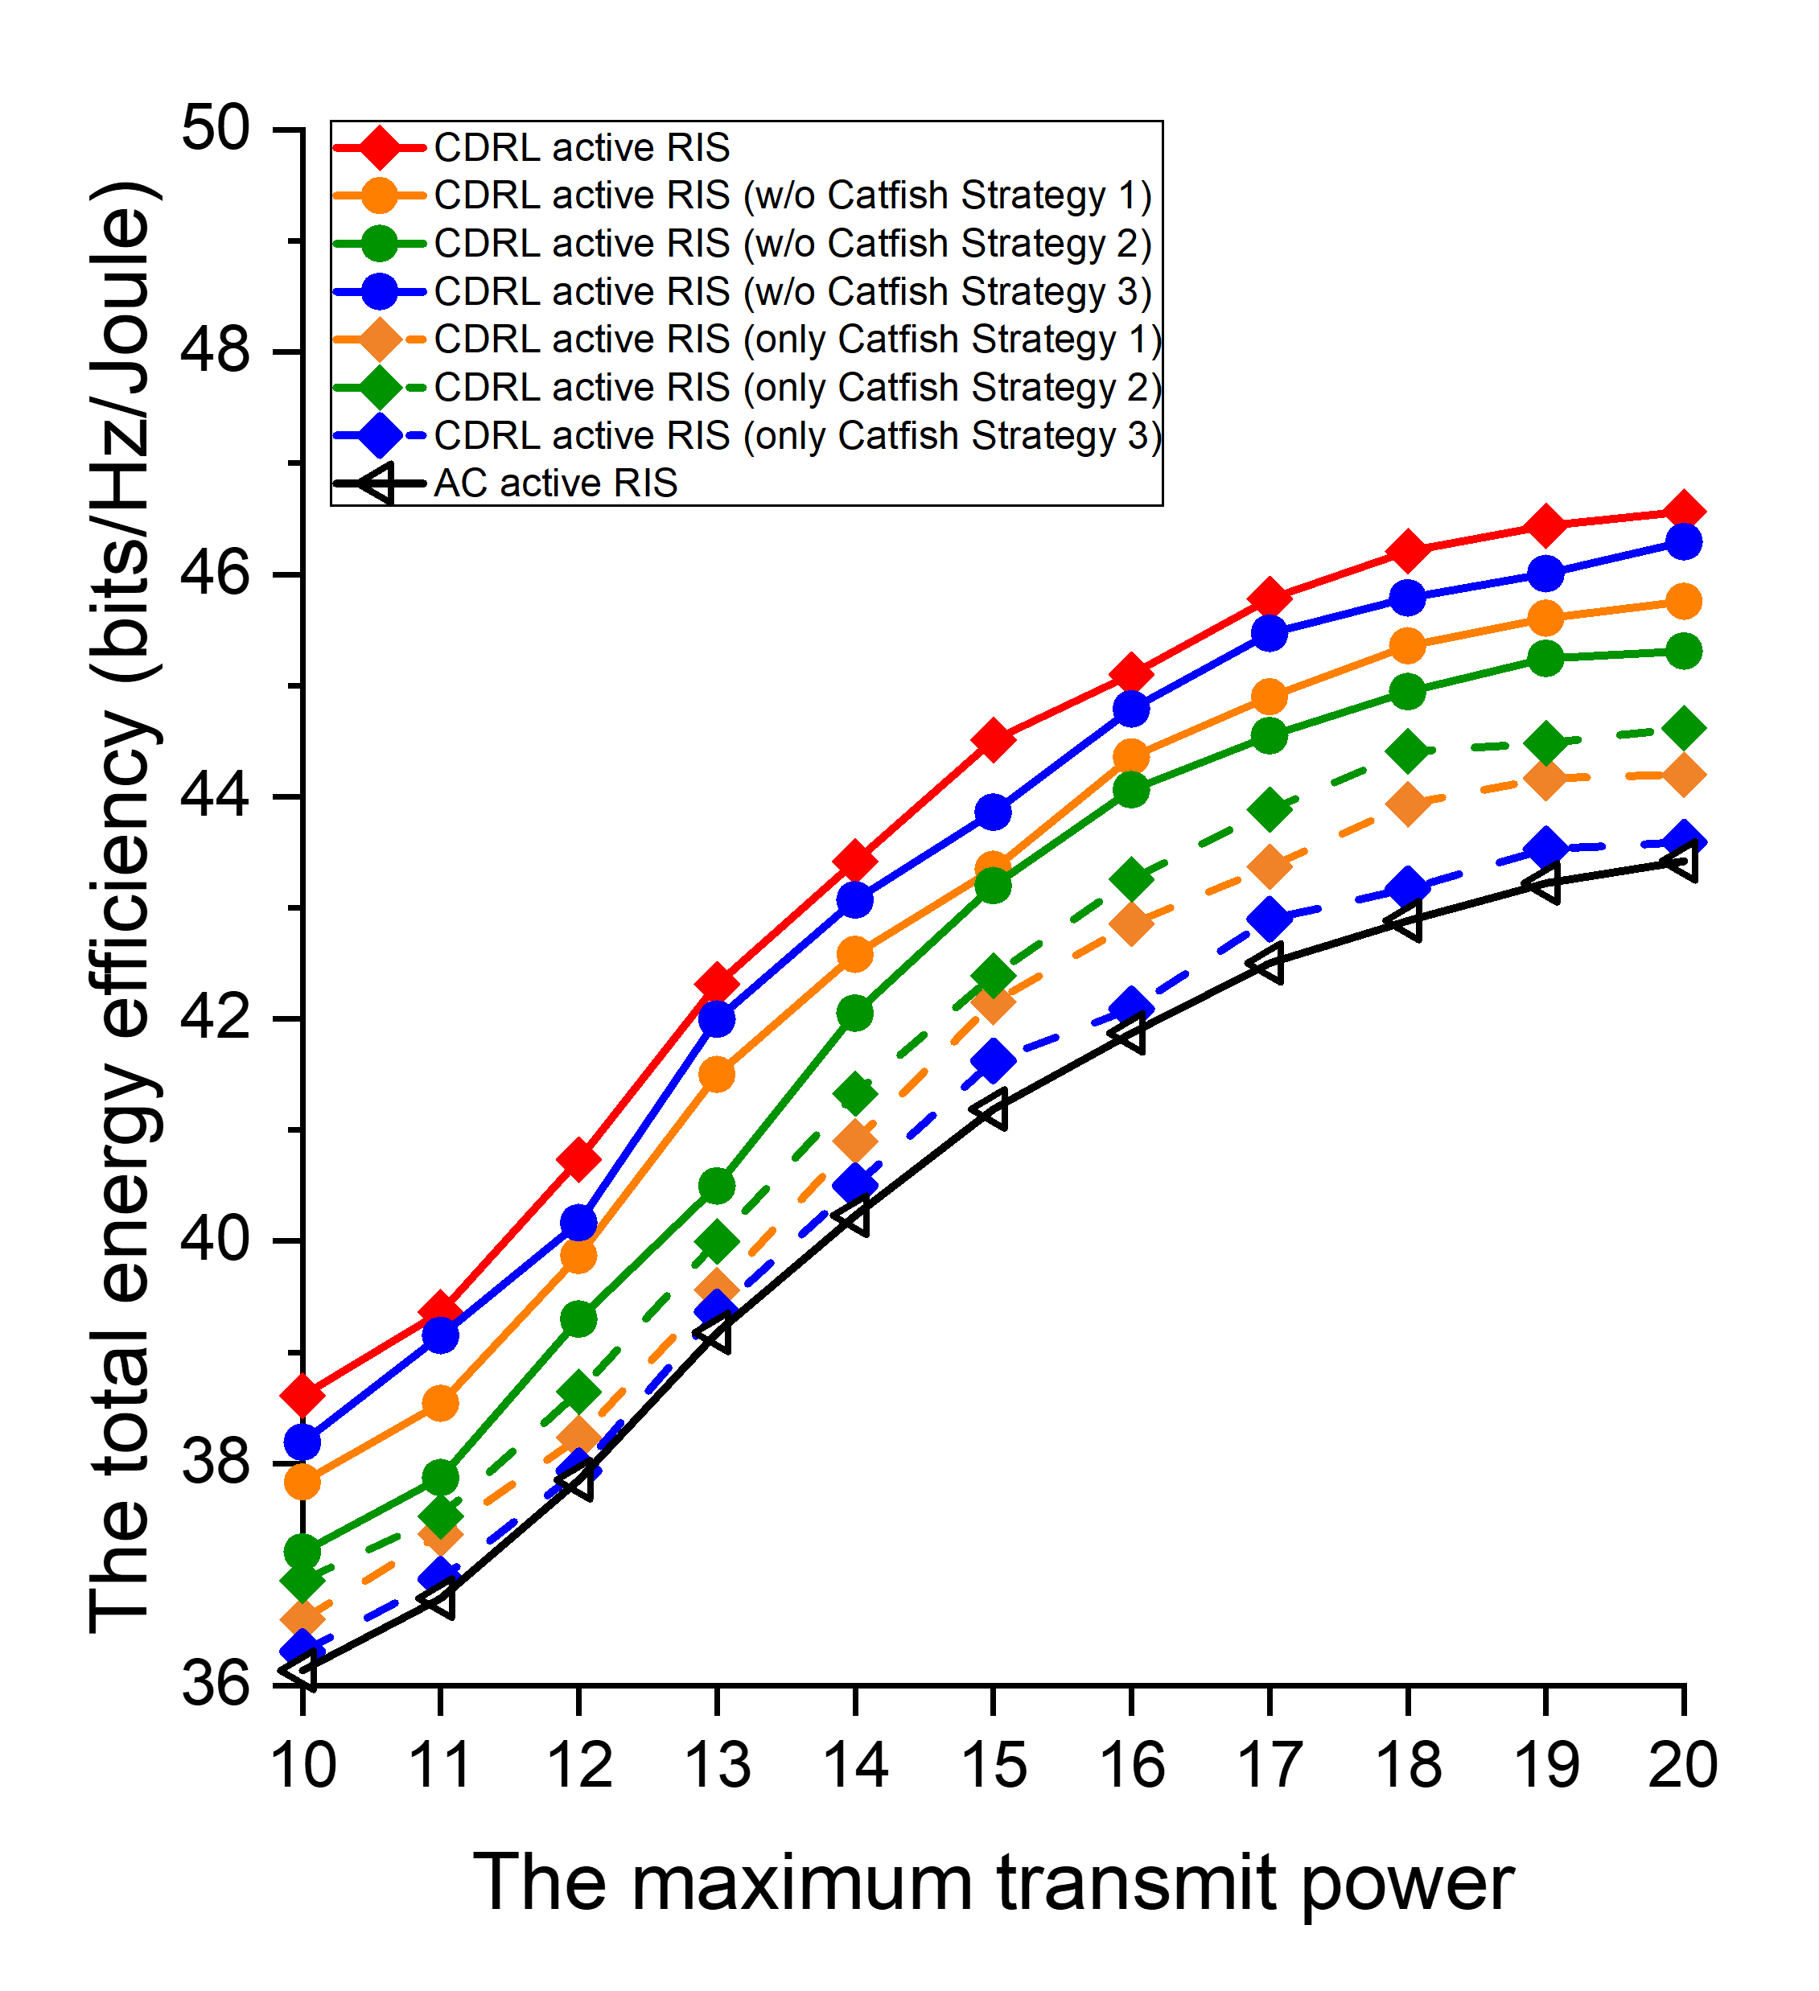
Fig. 21. The ablation experiment of active RIS in terms of energy efficiency.

為了更好得理解 CDRL 的三個策略對於 CDRL 的貢獻，我們對其進行了消融研究。在每次消融實驗中，我們從完整的 CDRL 策略組合中移除一個策略。本文提出的 CDRL 的完整方案為(紅線帶有實心菱形)。第一個移除了 Catfish Strategy 1: Experience Classification 策略(橘線帶有實心圓形)，改成使用不分類的經驗回放記憶體。第二個移除了 Catfish Strategy 2: Asymmetric Discounting Strategy (藍線帶有實心圓形)，改成使用相同的折扣因子 ($γ^{M}= γ^{CF}= 0.95$)。第三個移除了 Catfish Strategy 3: Adaptive Competitive Reward Mechanism 策略(綠線帶有實心圓形)，改成 catfish agent 不使用額外的獎勵。第四個只有 Catfish Strategy 1: Experience Classification 策略(橘線帶有實心菱形)，改成只使用分類的經驗回放記憶體。第五個只有 Catfish Strategy 2: Asymmetric Discounting Strategy (藍線帶有實心菱形)，改成只使用不同的折扣因子 ($γ^{M}=0.95, γ^{CF}= 0.99$)。第六個只有 Catfish Strategy 3: Adaptive Competitive Reward Mechanism 策略(綠線帶有實心菱形)，改成 catfish agent 只使用額外的獎勵。
「傳輸速率」 vs. 「傳輸能耗上限」 的主動 RIS 消融實驗結果繪製於圖 21。我們可以知道預先製作的經驗回放記憶體不先分類影響在中間。原因可能是不分類導致不管經驗的獎勵高低，每種經驗皆有機會被搜尋到，不分類的影響還好。而相同的折扣因子會導致更大的性能下降，因為對於 main agent 來說刺激不足。最後則是 catfish agent 沒有 Adaptive Competitive Reward Mechanism 的影響較小。原因可能是我們的獎勵較為密集，原本的獎勵已經能夠支撐 CDRL 強化學習。只使用有分類的預先製作的經驗回放記憶體提升在中間，可能的原因是缺少另外兩個策略的幫助。只使用不同折扣因子的提升最大，可能是任務不同的有效分工導致。只使用 catfish agent 沒有 Adaptive Competitive Reward Mechanism 的提升較小。可能的原因是增加額外獎勵幫助不大。

5.4 The RIS Simulator
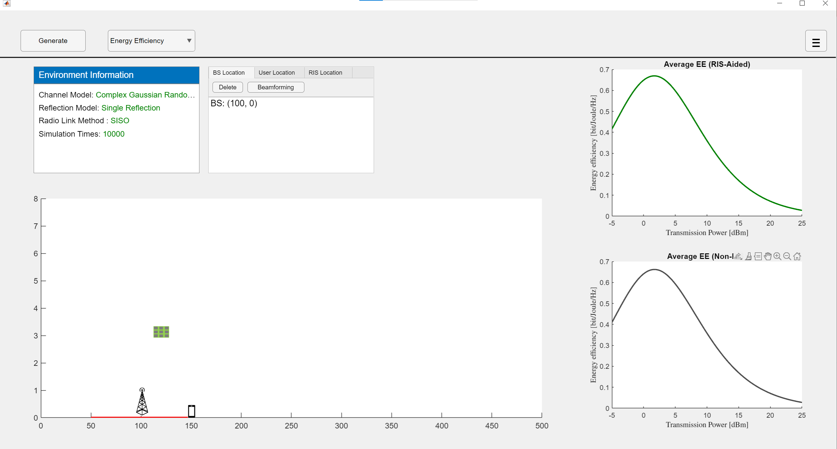
Fig. 22. The RIS simulator.

We extended the improved BPOF [10] to develop a simulator for the RIS communication environment, as shown in Fig. 22. By configuring the positions of the BS, RIS, and UE, as well as adjusting detailed parameters of the relevant components, the simulator can evaluate the EE performance in this communication scenario. Moreover, additional functions such as RIS element switching were incorporated to enable energy-efficient joint on/off control of RF chains and RIS elements.

我們有延續改進 BPOF [10] 用於模擬 RIS 通訊環境的模擬器，如圖 22 所示。經過設定 BS, RIS, UE 等位置，還有調整相關元件的細節參數，即可模擬此通訊環境下的 EE 表現。其中，新增了 RIS 元件開關等功能，用以實現射頻鍊和 RIS 單元的節能整合開關控制。

6. Conclusions
This thesis proposes a Catfish-effect-based Deep Reinforcement Learning (CDRL) framework for energy-efficient integrated switching control of RF chains and RIS elements in an RIS-assisted 6G network. Consider a hybrid beamforming architecture at the base station that combines a baseband digital precoder with an RF analog beamformer. Each element on the communication devices can be switched independently. Three core designs for the catfish agent are proposed, all aimed at ensuring its policy performance surpasses the main agent. First, in the data pre-generation phase, all experiences are routed according to an EE threshold. Second, the catfish agent’s discount factor is set larger to focus on long-term return estimation. Third, an adaptive competitive reward mechanism is implemented for the catfish agent, encouraging it to continually maintain its performance lead. Through the dual-agent design enables the Catfish Agent to guide the Main Agent toward better policies and avoid local optima. Simulation results show that CDRL outperforms baseline DRL, analytical methods, and teacher-student models under both active and passive RIS settings. Future work may explore extending the framework to more practical or large-scale scenarios.
這篇論文提出一種鯰魚式深度強化學習 (CDRL) 框架，用於 RIS 輔助 6G 網路中射頻鍊和 RIS 單元的節能整合開關控制。考慮一個多用戶-多輸出多輸入 (MU-MISO) 主/被動式智慧反射表面 (RIS) 輔助的下行通訊系統。其中每個通訊設備上的元件皆可獨立開關。我們設計了三個 Catfish Agent 的核心設計，均旨在確保其策略表現優於 main agent 。第一點，資料預產生階段的所有經驗按照 EE 門檻分流。第二點，將 catfish agent 的折扣係數設置得更大，以側重長期回報估計。第三點，為 catfish agent 設置自適應的競爭獎勵機制，鼓勵 catfish 持續維持領先優勢。接著透過雙智能體設計，鯰魚智能體能有效引導主智能體學習更優策略，避免陷入局部最優。模擬結果顯示，在主動與被動 RIS 情境下， CDRL 均優於傳統強化學習、數學解法與教師-學生模型。未來研究可進一步擴展至更實用或大規模的應用場景。

References
[1] S. Aisyah, A. Doufexi, S. Armour, and W. b. Abbas, "Impact of Number of RF Chains on Spectral and Energy Efficiency of Massive MIMO Systems," IEEE Wireless Communications and Networking Conference (WCNC), Dubai, United Arab Emirates, pp. 1-6, 2024.
[2] 3GPP TR 38.864 3rd Generation Partnership Project; Technical Specification Group Radio Access Network; Study on network energy savings for NR (Release 18).
[3] D. Laselva, S. Hakimi, M. Lauridsen, B. Khan, D. Kumar, and P. Mogensen, "On the Potential of Radio Adaptations for 6G Network Energy Saving," Joint European Conference on Networks and Communications & 6G Summit (EuCNC/6G Summit), pp. 1157-1162, Antwerp, Belgium, 2024.
[4] A. Dejonghe, Z. Altman, F. de Pellegrini, and E. Altman, "Design and Cross-Layer Optimization of Low Cost RIS-Assisted Communication Systems," IEEE Transactions on Wireless Communications, Vol. 23, No. 10, pp. 13752-13765, Oct. 2024.
[5] M. Soleymani, I. Santamaria, E. Jorswieck, M. Di Renzo, and J. Gutiérrez, "Energy Efficiency Comparison of RIS Architectures in MISO Broadcast Channels," IEEE 25th International Workshop on Signal Processing Advances in Wireless Communications (SPAWC), pp. 701-705, Lucca, Italy, 2024.
[6] R. K. Fotock, A. Zappone, and M. D. Renzo, "Energy Efficiency Optimization in RIS-Aided Wireless Networks: Active Versus Nearly-Passive RIS With Global Reflection Constraints," IEEE Transactions on Communications, Vol. 72, No. 1, pp. 257-272, Jan. 2024.
[7] B. Wang, C. Pan, H. Ren, G. Zhou, W. Liu, and Z. Yu, "Transmission Design for Double Cooperative Active RIS-Aided Communication," IEEE Wireless Communications and Networking Conference (WCNC), pp. 01-06, Dubai, United Arab Emirates, 2024.
[8] W. de Souza Junior, and T. Abrão, "Phase-Amplitude Design for Energy-Efficient Active RIS-aided Massive MIMO System," IEEE Wireless Communications and Networking Conference (WCNC), pp. 1-6, Milan, Italy, 2025.
[9] H. Xie and D. Li, "To Reflect or Not to Reflect: On–Off Control and Number Configuration for Reflecting Elements in RIS-Aided Wireless Systems," IEEE Transactions on Communications, Vol. 71, No. 12, pp. 7409-7424, Dec. 2023.
[10] Yuh-Shyan Chen, Jung-Chen Lee, and Bo-Han Li, "Hybrid Beamforming and Phase Shift Optimization for Energy Efficiency with On-Off Control of RF Chain and Reflecting Elements in 6G RIS-Aided Communications," Physical Communication, Vol. 72, No. 102724, Oct. 2025.
[11] C. Huang, R. Mo and C. Yuen, "Reconfigurable Intelligent Surface Assisted Multiuser MISO Systems Exploiting Deep Reinforcement Learning," IEEE Journal on Selected Areas in Communications, Vol. 38, No. 8, pp. 1839-1850, Aug. 2020.
[12] B. Saglam, D. Gurgunoglu, and S. S. Kozat, "Deep Reinforcement Learning Based Joint Downlink Beamforming and RIS Configuration in RIS-Aided MU-MISO Systems Under Hardware Impairments and Imperfect CSI," IEEE International Conference on Communications Workshops (ICC Workshops), pp. 66-72, Rome, Italy, 2023.
[13] B. Banerjee, R. C. Elliott, W. A. Krzymień, and M. Medra, "Hybrid Beamforming for mmWave Massive MIMO Systems Using Conditional Generative Adversarial Networks," IEEE Transactions on Vehicular Technology, Vol. 73, No. 10, pp. 15803-15808, Oct. 2024.
[14] X. He, L. Huang, J. Wang, and Y. Gong, "Learn to Optimize RIS Aided Hybrid Beamforming With Out-of-Distribution Generalization," IEEE Transactions on Vehicular Technology, Vol. 73, No. 7, pp. 10783-10787, July 2024.
[15] H. Zhou, M. Elsayed, M. Bavand, R. Gaigalas, S. Furr, and M. Erol-Kantarci, "Cooperative Hierarchical Deep Reinforcement Learning Based Joint Sleep and Power Control in RIS-Aided Energy-Efficient RAN," IEEE Transactions on Cognitive Communications and Networking, 2024.
[16] K. -L. Chan, F. -T. Chien, and R. Y. Chang, "Beamforming and Load-Balanced User Association in RIS-Aided Systems via Graph Neural Networks," IEEE International Conference on Communications, pp. 4997-5002, Denver, CO, USA, 2024.
[17] V. Sharma, A. Paul, S. K. Singh, K. Singh, and S. Biswas, "Robust Transmission for Energy-Efficient Sub-Connected Active RIS-Assisted Wireless Networks: DRL Versus Traditional Optimization," IEEE Transactions on Green Communications and Networking, Vol. 8, No. 4, pp. 1902-1916, Dec. 2024.
[18] H. Yang et al., "Codebook Configuration for RIS-Aided Systems via Implicit Neural Representations," IEEE International Conference on Communications, pp. 1449-1454, Denver, CO, USA, 2024.
[19] A. Faisal, I. Al-Nahhal, O. A. Dobre, and T. M. N. Ngatched, "On Discrete Phase Shifts Optimization of RIS-Aided FD Systems: Are All RIS Elements Needed?," IEEE International Conference on Communications, pp. 1382-1387, Rome, Italy, 2023.
[20] K. Cao and Q. Tang, "Energy Efficiency Maximization for RIS-Assisted MISO Symbiotic Radio Systems Based on Deep Reinforcement Learning," IEEE Communications Letters, Vol. 28, No. 1, pp. 88-92, Jan. 2024.
[21] Y. Zheng et al., "Enabling Robust DRL-Driven Networking Systems via Teacher-Student Learning," IEEE Journal on Selected Areas in Communications, Vol. 40, No. 1, pp. 376-392, Jan. 2022.
[22] X. Zhao, T. Lin, Y. Zhu, and J. Zhang, "Partially-Connected Hybrid Beamforming for Spectral Efficiency Maximization via a Weighted MMSE Equivalence," in IEEE Transactions on Wireless Communications, Vol. 20, No. 12, pp. 8218-8232, Dec. 2021.
[23] L. Hou, Z. Wang and H. Long, "An Improvement for Value-Based Reinforcement Learning Method Through Increasing Discount Factor Substitution," IEEE 24th International Conference on Computational Science and Engineering (CSE), pp. 1382-13873, Shenyang, China, 2021.
[24] MA, Haozhe, et al. Highly efficient self-adaptive reward shaping for reinforcement learning. arXiv preprint arXiv:2408.03029, 2024.

