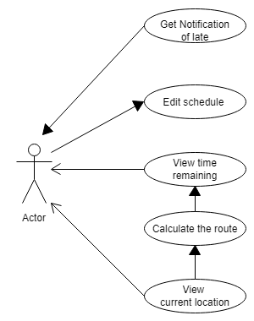

Use Case: View Time needed

Summary: The app shows the time to travel from user’s current location to the next destination.

Actor: User

Precondition: The route from current location to the next location, course’s beginning time are ready to use; User’s average velocity is pre-set

Description:

1. The app read route’s length from google api function
2. The app does calculation to get time needed C2: S/V (S is route length, V is average velocity)
3. The app prints/shows the result on the screen.

Use Case: Edit schedule

Summary: The app should allow users to edit schedule.

Actor: User

Precondition: The schedule is existed

Description:

1. User click the “Edit” bottom on the existing schedule.
2. User input destination location, class time into the schedule.
3. User click the “save” bottom to finish editing

Use Case: View time remaining

Summary: The app should show the time remaining to next class.

Actor: User

Precondition: course’s beginning time is in the schedule

Description:

1. The app does the calculation C1: T1-T2 (T1 is the next course’s beginning time, T2 is the current time)
2. The app shows the result: T1-T2

Use Case: Notify late

Summary: The app should pop out a notification, saying “you are going to be late” when the user is in danger of being late to class.

Actor: The user

Precondition: user is on the route to the next class

Description:

1. If C2>C1, notification pop out, else notification will be dismissed
2. If user arrives at the class location, notification procedure will be dismissed