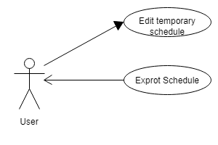

Use Case: Edit temporary schedule

Summary: The app should allow user to change the schedule temporarily.

Actor: User

Precondition: The general schedule has been created.

Description:

1. The schedule could be changed with two options: temporarily, generally
2. The temporarily change will not affect general schedule
3. The temporary change has higher priority than general schedule.

Use Case: Export schedule

Summary: The app should allow users to export schedule.

Actor: User

Precondition: The schedule is existed

Description:

1. User click the “export” bottom on the existing schedule.
2. The app will send schedule via email in two formats: excel and CSV.