**Test Plan**

**for RaiderNAV**

**Table of Contents**

1. Unit Testing 3

• 1.1 AddressMap Unit Tests 3

• 1.2 ScheduleEntryList Unit Tests 5

• 1.3 ScheduleSingleEntry Unit Tests 8

2. Use Case Testing 12

• 2.1 Story 1 12

• 2.2 Story 2 17

• 2.3 Story 3 19

• 2.4 Story 4 21

• 2.5 Story 5 23

• 2.6 Story 6 24

• 2.7 Story 7 24

• 2.8 Story 8 24

• 2.9 Story 9 26

• 2.10 Story 10 27

• 2.11 Story 11 27

• 2.12 Story 12 27

• 2.13 Story 13 27

• 2.14 Story 14 28

• 2.15 Story 15 28

• 2.16 Story 16 28

• 2.17 Story 17 28

• 2.18 Story 18 28

• 2.20 Story 20 31

• 2.21 Story 21 31

• 2.22 Story 22 31

• 2.23 Story 23 31

• 2.24 Story 24 31

• 2.25 Story 25 33

• 2.26 Story 26 33

• 2.27 Story 27 33

• 2.28 Story 28 33

• 2.29 Story 29 34

• 2.30 Story 30 37

3. Acceptance Testing 40

1. Unit Testing

* 1.1 AddressMap Unit Tests
  + package com.deaftone.tableware.raidernav;
  + import org.junit.Before;
  + import org.junit.BeforeClass;
  + import org.junit.Test;
  + import static org.junit.Assert.*;
  + public class AddressMapUnitTest {
  + @Before
  + public void initialize() {
  + AddressMap.*initialize*();
  + }
  + @Test
  + public void getKeys_isCorrect() {
  + *assertEquals*("ADMIN", AddressMap.*getKeys*().iterator().next());
  + }
  + @Test
  + public void getKeysAsCharSeouence_isCorrect() {
  + *assertEquals*("AGRI",AddressMap.*getKeysAsCharSequence*()[4]);
  + }
  + @Test
  + public void getXY_isCorrect() {
  + *assertEquals*(-101.874702,AddressMap.*getXY*("ADMIN")[1],.1);
  + }
  + @Test
  + public void parseXY_isCorrect() {
  + *assertEquals*(33.583427,AddressMap.*parseXY*("33.583427, -101.874702")[0],.1);
  + }
  + @Test
  + public void getLatLng_isCorrect() {
  + *assertEquals*(33.587275,AddressMap.*getLatLng*("ENGCTR").latitude,.1);
  + }
  + @Test
  + public void getBuildingArray_isCorrect() {
  + *assertEquals*("ADMIN",AddressMap.*getBuildingArray*().iterator().next());
  + }
  + @Test
  + public void fetch_isCorrect() {
  + *assertEquals*("33.587275, -101.875771", AddressMap.*fetch*("ENGCTR"));
  + }
  + @Test
  + public void fetchCoordinates_isCorrect() {
  + *assertEquals*("33.583427, -101.874702",AddressMap.*fetchCoordinates*("ADMIN"));
  + *assertEquals*(null,AddressMap.*fetchCoordinates*("GARBAGE HALL"));
  + }
  + }
  + 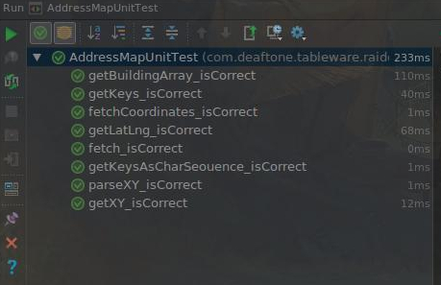
* 1.2 ScheduleEntryList Unit Tests

package com.deaftone.tableware.raidernav;

import org.junit.Before;

import org.junit.Test;

import static org.junit.Assert.*assertEquals*;

public class ScheduleEntryListUnitTest {

ScheduleEntryList sel;

private ScheduleSingleEntry sse;

private final String coursenumber = "RUSN 1502";

private final String building = "Foreign Language";

private final String starttime = "0900";

private final String endtime = "0950";

private boolean[] days = {false, true, true, true, true, true, false};

@Before

public void initialize() {

sel = new ScheduleEntryList();

sse= new ScheduleSingleEntry(coursenumber, building, starttime, endtime, days);

}

@Test

public void addEntry_isCorrect() {

sel.addEntry(sse);

*assertEquals*(building,sel.getEntry(0).getBuilding());

}

@Test

public void removeEntry_isCorrect() {

sel.removeEntry(sse);

*assertEquals*(0, sel.getEntryCount());

}

@Test

public void getEntry_isCorrect() {

sel.addEntry(sse);

*assertEquals*(building, sel.getEntry(0).getBuilding());

}

@Test

public void getEntryCount_isCorrect() {

*assertEquals*(0,sel.getEntryCount());

}

@Test

public void getName_isCorrect() {

*assertEquals*(null,sel.getName());

sel.setName("nomad");

*assertEquals*("nomad",sel.getName());

}

@Test

public void setName_isCorrect() {

sel.setName("House");

*assertEquals*("House",sel.getName());

}

@Test

public void enable_isCorrect() {

sel.enable();

*assertEquals*(true,sel.isEnabled());

}

@Test

public void disable_isCorrect() {

sel.disable();

*assertEquals*(false,sel.isEnabled());

}

@Test

public void setEnabled_isCorrect() {

sel.setEnabled(false);

*assertEquals*(false,sel.isEnabled());

}

@Test

public void isEnabled_isCorrect() {

*assertEquals*(false,sel.isEnabled());

sel.setEnabled(true);

*assertEquals*(true,sel.isEnabled());

}

}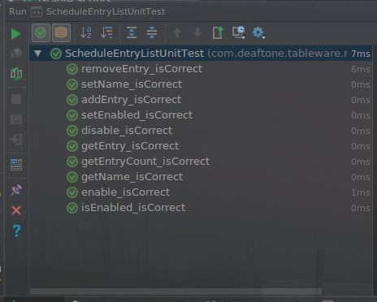

* 1.3 ScheduleSingleEntry Unit Tests
  + package com.deaftone.tableware.raidernav;
  + import org.junit.Before;
  + import org.junit.Test;
  + import static org.junit.Assert.*assertEquals*;
  + public class ScheduleSingleEntryUnitTest {
  + private ScheduleSingleEntry sse;
  + private final String coursenumber = "RUSN 1502";
  + private final String building = "Foreign Language";
  + private final String starttime = "0900";
  + private final String endtime = "0950";
  + private boolean[] days = {false, true, true, true, true, true, false};
  + @Before
  + public void initialize() {
  + sse = new ScheduleSingleEntry(
  + coursenumber, building, starttime, endtime, days);
  + }
  + @Test
  + public void getCourseNumber_isCorrect() {
  + *assertEquals*(coursenumber, sse.getCourseNumber());
  + }
  + @Test
  + public void setCourseNumber_isCorrect() {
  + sse.setCourseNumber("CS 4352");
  + *assertEquals*("CS 4352", sse.getCourseNumber());
  + }
  + @Test
  + public void getBuilding_isCorrect() {
  + *assertEquals*(building, sse.getBuilding());
  + }
  + @Test
  + public void setBuilding_isCorrect() {
  + sse.setBuilding("Holden Hall");
  + *assertEquals*("Holden Hall", sse.getBuilding());
  + }
  + @Test
  + public void getStartTime_isCorrect() {
  + *assertEquals*(starttime, sse.getStartTime());
  + }
  + @Test
  + public void setStartTime_isCorrect() {
  + sse.setStartTime("0300");
  + *assertEquals*("0300", sse.getStartTime());
  + }
  + @Test
  + public void getEndTime_isCorrect() {
  + *assertEquals*(endtime, sse.getEndTime());
  + }
  + @Test
  + public void setEndTime_isCorrect() {
  + sse.setEndTime("0400");
  + *assertEquals*("0400", sse.getEndTime());
  + }
  + @Test
  + public void getDays_isCorrect() {
  + *assertEquals*(false, sse.getDays()[0]);
  + *assertEquals*(true, sse.getDays()[1]);
  + }
  + @Test
  + public void setDays_isCorrect() {
  + boolean[] newdays = {true, false, true, true, true, true, false};
  + sse.setDays(newdays);
  + *assertEquals*(true, sse.getDays()[0]);
  + *assertEquals*(false, sse.getDays()[1]);
  + }
  + @Test
  + public void setActiveOnDay_isCorrect() {
  + sse.setActiveOnDay(0);
  + *assertEquals*(true, sse.getDays()[0]);
  + sse.setActiveOnDay(1);
  + *assertEquals*(true, sse.getDays()[1]);
  + }
  + @Test
  + public void setInactiveOnDay_isCorrect() {
  + sse.setInactiveOnDay(0);
  + *assertEquals*(false, sse.getDays()[0]);
  + sse.setInactiveOnDay(1);
  + *assertEquals*(false, sse.getDays()[1]);
  + }
  + @Test
  + public void isActiveOnDay_isCorrect() {
  + sse.setActiveOnDay(0);
  + sse.setInactiveOnDay(1);
  + *assertEquals*(true, sse.isActiveOnDay(0));
  + *assertEquals*(false, sse.isActiveOnDay(1));
  + }
  + }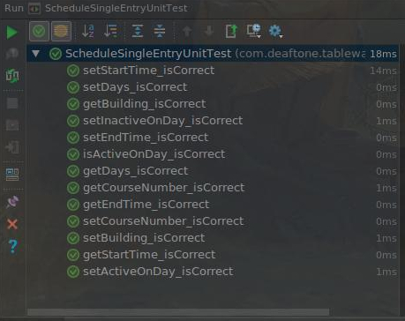

2. Use Case Testing

Formatting

**Title:**

**Actors:**

**Requirement:**

**Main Scenario:**

**Alternatives:**

**Test Situations:**

**Test Coverage:**

Base: number of main and alternative scenarios =

Test situations cover all cases

100% coverage of use case

**Test Record:**

**Test Case:**

* 2.1 Story 1

**Use Case:** Add Schedule

**Summary:** App User creates a new class schedule

**Actors:** User

**Dependency:**

**Precondition:** The application should be displaying the My Schedules screen

**Description:**

1. User presses Create New Schedule button on the My Schedules screen.

2. The application prompts the user to enter the schedule name.

3. User inputs schedule name and presses OK.

4. The system adds the schedule to a visible list on the My Schedules screen.

**Alternatives:**

3a. The user presses Cancel

3a.1 The system displays the My Schedules screen.

**Postcondition:** The user has created a schedule.

**Title: Add Schedule**

**Actors: User**

**Requirement: R1**

**Main Scenario:**

1. User presses Create New Schedule button on the My Schedules screen.

2. The application prompts the user to enter the schedule name.

3. User inputs schedule name and presses OK.

4. The system adds the schedule to a visible list on the My Schedules screen.

**Alternatives:**

3a. The user presses Cancel

3a.1 The system displays the My Schedules screen.

3b. The user inputs nothing and presses OK

3b.1 The system displays the My Schedules screen.

**Test Situations:**

1. New schedule is added to a visible list on the My Schedules screen.

2. User presses Cancel

3. The user inputs nothing and presses OK

**Test Coverage:**

Base: number of main and alternative scenarios = 3

Test situations cover all 3 cases

100% coverage of use case

**Test Record:**

**Test Case 1:**

User presses Create New Schedule button on the My Schedules screen.

The application prompts the user to enter the schedule name.

User inputs schedule name and presses OK

The system adds the schedule to a visible list on the My Schedules screen.

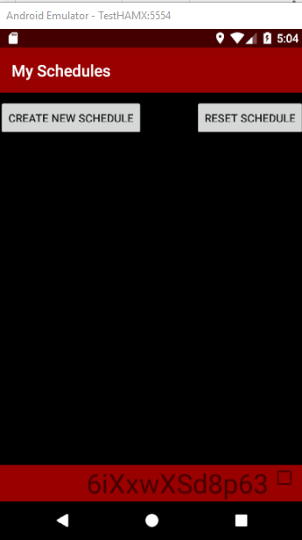 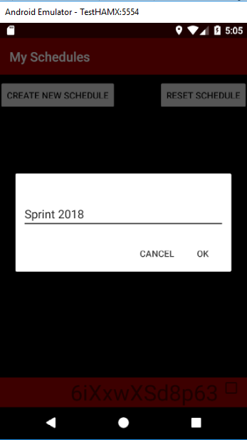 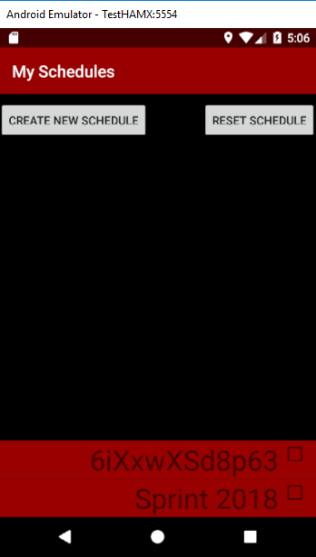

**Test Case 2:**

User presses Create New Schedule button on the My Schedules screen.

The application prompts the user to enter the schedule name.

The user presses Cancel

The system displays the My Schedules screen

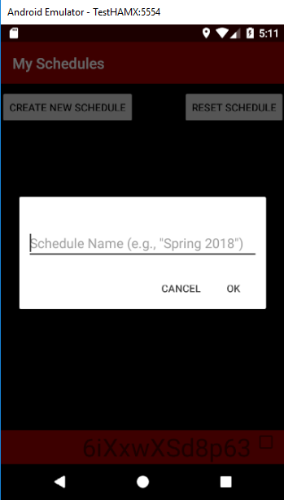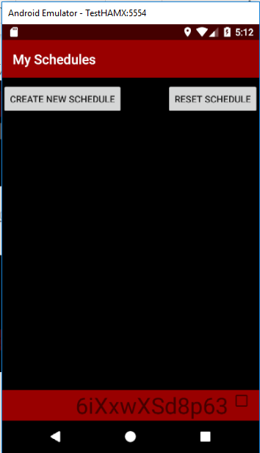

**Test Case 3:**

User presses Create New Schedule button on the My Schedules screen.

The application prompts the user to enter the schedule name.

The user inputs nothing and presses OK

An empty schedule is added

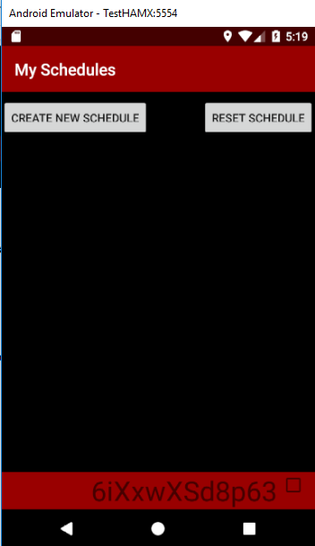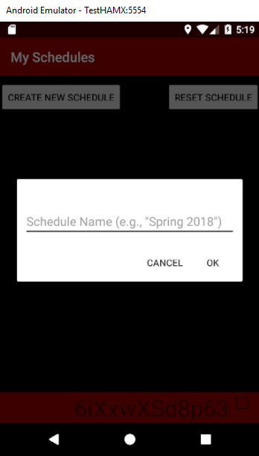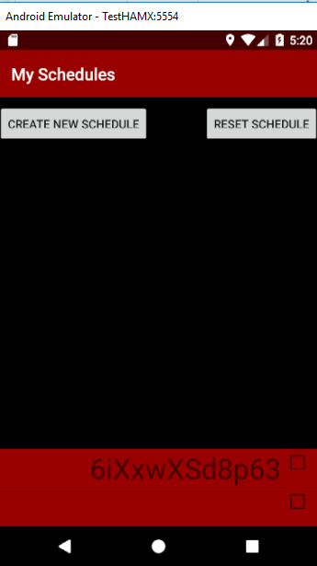

**Note on R1 Test Result:**

The user inputs nothing and presses OK, the empty schedule should not be added.

* 2.2 Story 2

**Use Case:** Save Class schedule

**Summary:** App User saves a created class schedule

**Actors:** User

**Dependency:** View Saved Schedules

**Precondition:** The user has entered the course’s details (name, building, days of week, and the starting and ending times) in the course edit screen.

**Description:**

1. User presses the Save button.

**Alternatives:**

1a. If the schedule saved for a specific day overlaps with regards to time with another schedule on the same day, the application displays an error message.

**Postcondition:** The class schedule is saved.

**Title:** Save Class schedule

**Actors:** User

**Requirement:** R2

**Main Scenario:**

User presses the Save button after entering course details

The class schedule is saved

**Alternatives:**

1a. The schedule saved for a specific day overlaps with regards to time with another schedule on the same day,

1a.1 The application displays an error message.

**Test Situations:**

1. User presses the Save button after entering course details, the class schedule is saved

2. The schedule saved for a specific day overlaps with regards to time with another schedule on the same day

**Test Coverage:**

Base: number of main and alternative scenarios = 2

Test situations cover all 2 cases

100% coverage of use case

**Test Record:**

**Test Case 1:**

User presses the Save button after entering course details

The class schedule is saved

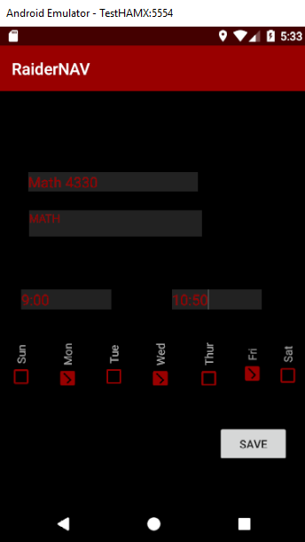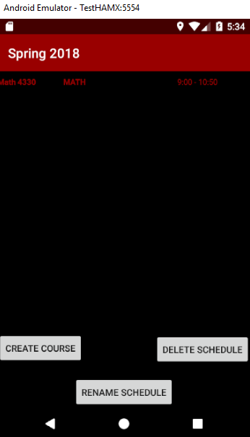

**Test Case 2:**

The schedule saved for a specific day overlaps with regards to time with another schedule on the same day

The class schedule is saved

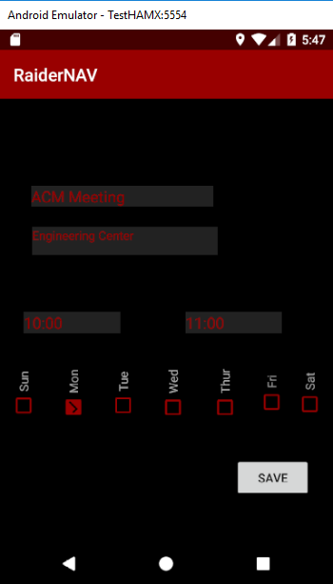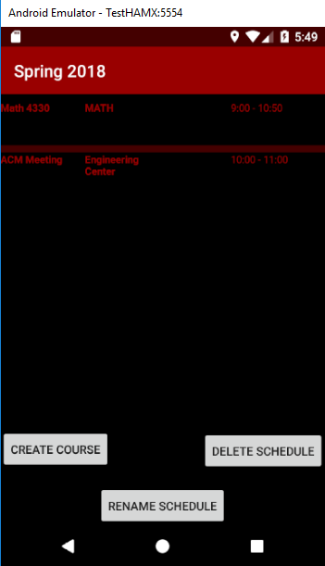

**Note on R2 Test:**

Time overlapped course should not be saved.

* 2.3 Story 3

**Use Case:** Edit Class schedule

**Summary:** App User edits a previously saved class schedule.

**Actors:** User

**Dependency:**

**Precondition:** The application should be in the My Schedules screen and the list of schedules must have at least one element.

**Description:**

1. The user presses desired schedule from list on My Schedules screen.

2. The application lists the courses saved to that schedule along with Create Course, Delete Schedule, and Rename Schedule buttons.

3. The user presses a desired course from the displayed list.

4. The application displays modifiable fields for the course name, building, start and end times, and days of the week, along with Save and Delete buttons.

5. The user fills in fields as desired and presses Save button.

**Alternatives:**

**Postcondition:** The user has edited a previously saved class schedule.

**Title:**  Edit Class schedule

**Actors:**  User

**Requirement: R3**

**Main Scenario:**

1. The user presses desired schedule from list on My Schedules screen.

2. The application lists the courses saved to that schedule along with Create Course, Delete Schedule, and Rename Schedule buttons.

3. The user presses a desired course from the displayed list.

4. The application displays modifiable fields for the course name, building, start and end times, and days of the week, along with Save and Delete buttons.

5. The user fills in fields as desired and presses Save button.

**Alternatives:** None

**Test Situations**:

Edited class schedule is saved

**Test Coverage:**

Base: number of main and alternative scenarios = 1

Test situations cover one case

100% coverage of use case

**Test Record:**

**Test Case:**

Edit Class schedule

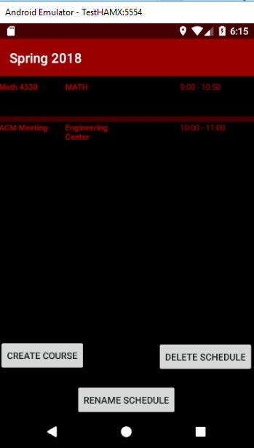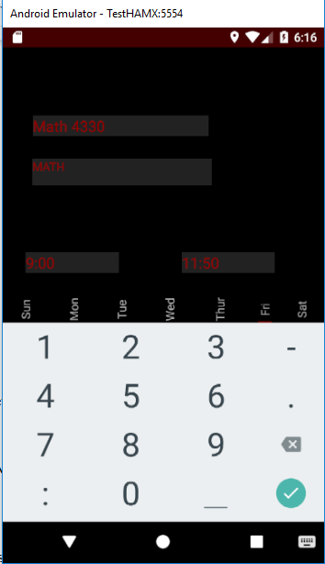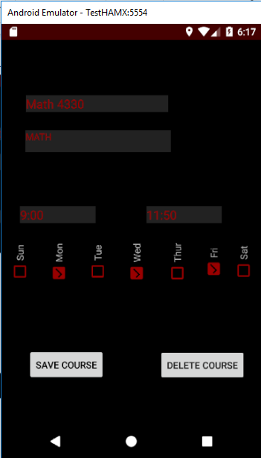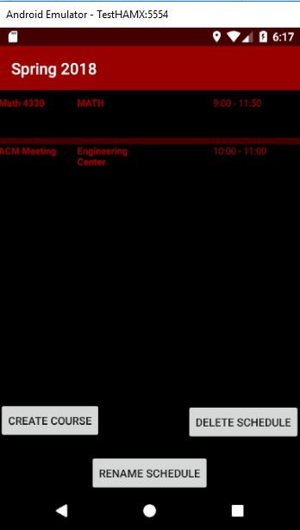

* 2.4 Story 4

**Use Case Name:** Delete Class Schedule

**Summary:** This user case will allow user to delete a previously created class schedule.

**Actor:** User

**Dependency:** View Saved Schedule

**Precondition:** The application should be in the My Schedules screen and the list of schedules must have at least one element.

**Description:**

1. The user presses desired schedule from list on My Schedules screen.

2. The application lists the courses saved to that schedule along with Create, Delete, and Rename buttons.

3. The user presses the Delete Schedule button.

4. The application deletes the schedule from the schedule list and returns the user to the My Schedules screen.

**Alternatives:**

**Postcondition:** User has deleted the class schedule.

**Title:** Delete Class Schedule

**Actors:** User

**Requirement: R4**

**Main Scenario:**

1. The user presses desired schedule from list on My Schedules screen.

2. The application lists the courses saved to that schedule along with Create, Delete, and Rename buttons.

3. The user presses the Delete Schedule button.

4. The application deletes the schedule from the schedule list and returns the user to the My Schedules screen.

**Alternatives:**

None

**Test Situations:**

Class Schedule is deleted

**Test Coverage:**

Base: number of main and alternative scenarios = 1

Test situations cover one case

100% coverage of use case

**Test Record:**

**Test Case:**

The user presses desired schedule from list on My Schedules screen.

The application lists the courses saved to that schedule along with Create, Delete, and Rename buttons.

The user presses the Delete Schedule button.

The application deletes the schedule from the schedule list and returns the user to the My Schedules screen.

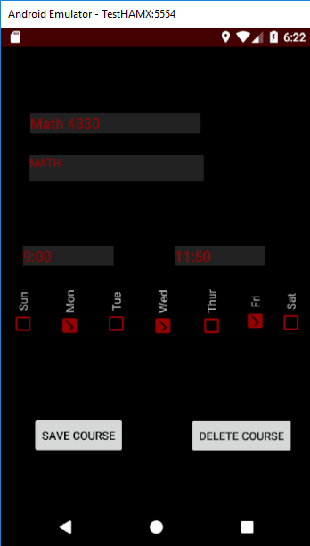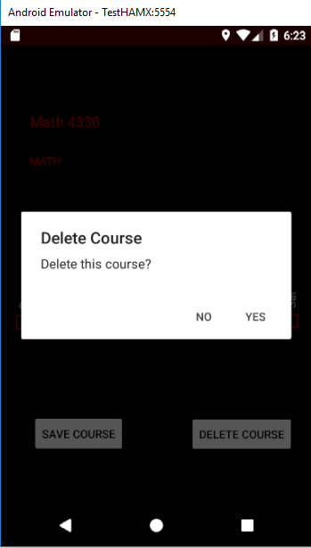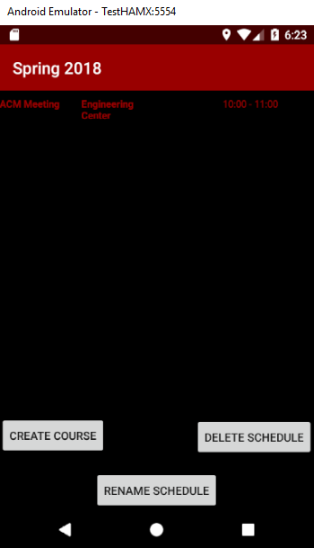

* 2.5 Story 5

**Use Case Name:** Navigate to Campus Destinations

**Summary:** This use case allows users to select a building name/acronym from a drop-down menu which the system will then determine a geographic location for and add to the daily route.

**Actor:** User and Mapping Engine

**Dependency:** The name (or acronym) of the building must be known by the user.

**Precondition:** The user has selected the “Add course” or “Create Schedule” option.

**Description:**

1. The user selects the desired building name/acronym from the drop-down menu.

2. The user enters other pertinent details for the course/schedule and selects “Save”.

3. The system passes the option selected to the CoordinateMap class.

4. The CoordinateMap class returns the location mapped to the desired selection.

**Alternatives:**

**Postcondition:** Coordinates representing the location of the user’s selection have been received by the system.

**Title:** Navigate to Campus Destinations

**Actors:** User and Mapping Engine

**Requirement: R5**

**Main Scenario:**

1. The user selects the desired building name/acronym from the drop-down menu.

2. The user enters other pertinent details for the course/schedule and selects “Save”.

3. The system passes the option selected to the CoordinateMap class.

4. The CoordinateMap class returns the location mapped to the desired selection.

**Alternatives:** None

**Test Situations:**

**Test Coverage:**

Base: number of main and alternative scenarios = 1

Test situations cover one case

100% coverage of use case

**Test Record:**

**Test Case:**

The correct location information was passed to system after user selected building.

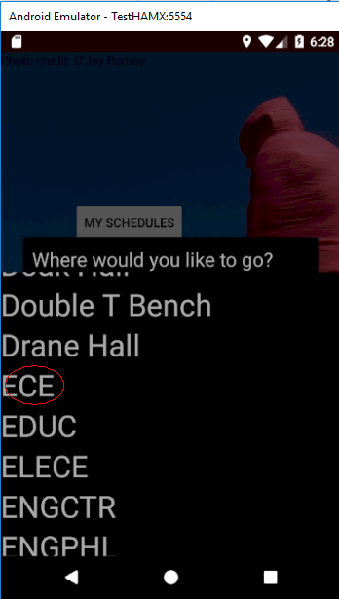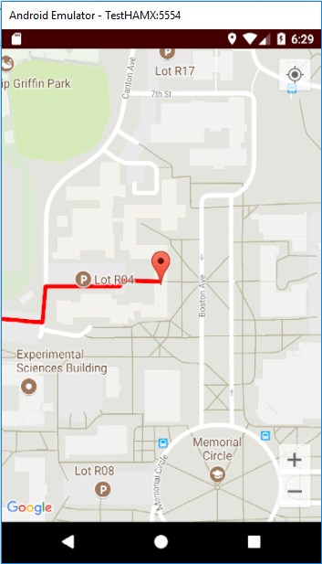

* 2.6 Story 6

This section intentionally left blank.

* 2.7 Story 7

This section intentionally left blank.

* 2.8 Story 8

**Use Case:** Calculate Shortest Route

**Actor:** User

**Dependency:** None

**Precondition:** None.

**Description:**

1. The user determines starting point and destination they are going to

2. The app finds the shortest route from the user

**Alternatives:**

**Postcondition:** The shortest route between starting point and destination has been calculated.

**Title:** Calculate Shortest Route

**Actors:** User and app

**Requirement: R8**

**Main Scenario:**

1. The user determines starting point and destination they are going to

2. The app finds the shortest route from the user

**Test Situations:**

Shortest route is generated on the map by the system.

**Test Coverage:**

Base: number of main and alternative scenarios = 1

Test situations cover one case

100% coverage of use case

**Test Record:**

**Test Case:**

1. The user determines starting point and destination they are going to

2. The app finds the shortest route from the user

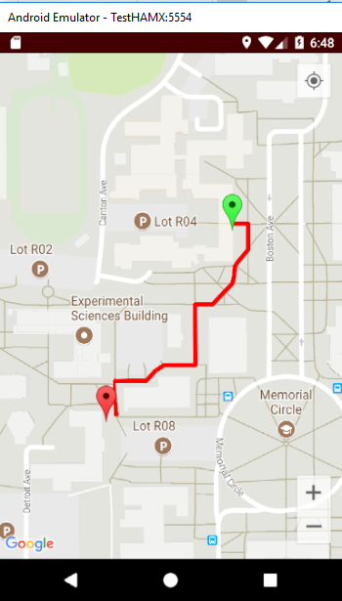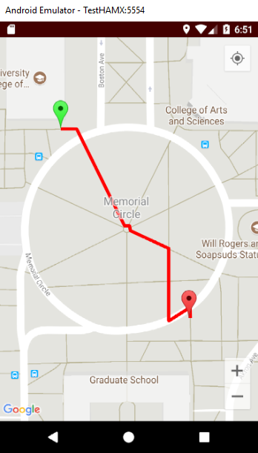

* 2.9 Story 9

**Use Case:** Display current location

**Actor:** User

**Dependency:** None

**Precondition:** User has already calculated a route

**Description:**

1. User starts their route towards the destination

2. Current location is retrieved from the GPS

3. Every 3-5 seconds, the time sends an input to the GPS to recalculate location

4. Current location is constantly displayed to the user on the map

**Postcondition:**

**Title:** Display current location

**Actors: App**

**Requirement: R9**

**Main Scenario:**

App shows user’s current location on the map.

**Test Situations:**

**App shows user’s current location on the map.**

**Test Coverage:**

Base: number of main and alternative scenarios = 1

Test situations cover one case

100% coverage of use case

**Test Record:**

**Test Case:**

App shows user’s current location (the blue dot) on the map.

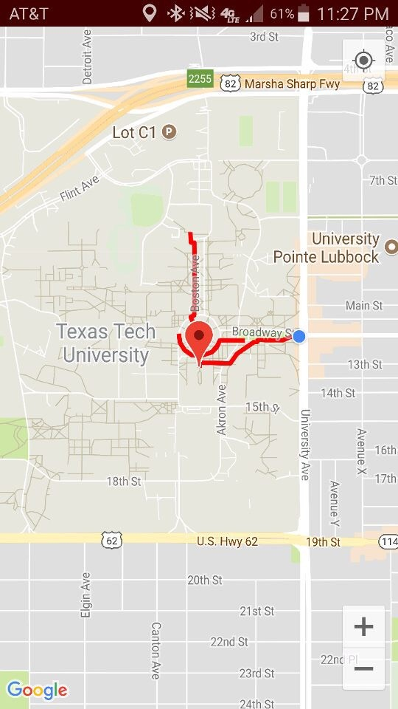

* 2.10 Story 10

This section intentionally left blank.

* 2.11 Story 11

This section intentionally left blank.

* 2.12 Story 12

This section intentionally left blank.

* 2.13 Story 13

This section intentionally left blank.

* 2.14 Story 14

This section intentionally left blank.

* 2.15 Story 15

This section intentionally left blank.

* 2.16 Story 16

This section intentionally left blank.

* 2.17 Story 17

This section intentionally left blank.

* 2.18 Story 18

This section intentionally left blank.

2.19 Story 19

**Use Case:** Edit Class schedule

**Summary:** App User edits a previously saved class schedule.

**Actors:** User

**Dependency:**

**Precondition:** The application should be in the My Schedules screen and the list of schedules must have at least one element.

**Description:**

1. The user presses desired schedule from list on My Schedules screen.

2. The application lists the courses saved to that schedule along with Create Course, Delete Schedule, and Rename Schedule buttons.

3. The user presses a desired course from the displayed list.

4. The application displays modifiable fields for the course name, building, start and end times, and days of the week, along with Save and Delete buttons.

5. The user fills in fields as desired and presses Save button.

**Postcondition:** The user has edited a previously saved class schedule.

**Title:** Edit Class schedule

**Actors: User**

**Requirement: R19**

**Main Scenario:**

1. User click the existing schedule.

2. User edits the destination location, class time in the schedule.

3. User click the “save” button to finish editing

**Alternatives:** None

**Test Situations:**

Edited class schedule is saved

**Test Coverage:**

Base: number of main and alternative scenarios = 1

Test situations cover 1 case

100% coverage of use case

**Test Record:**

**Test Case:**

Edit schedule

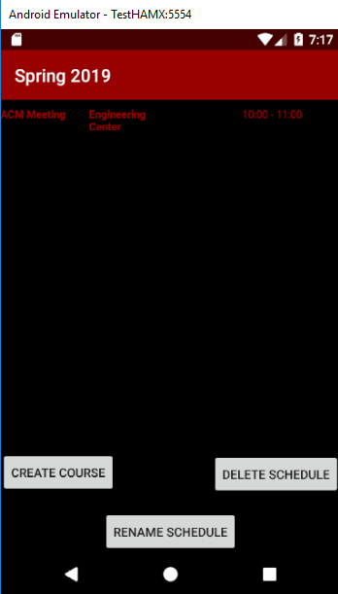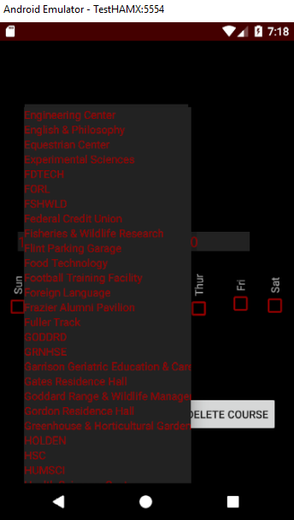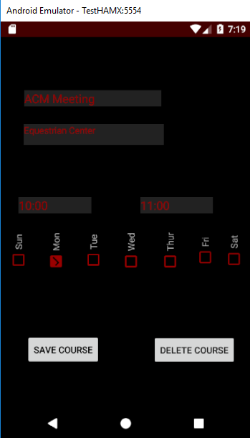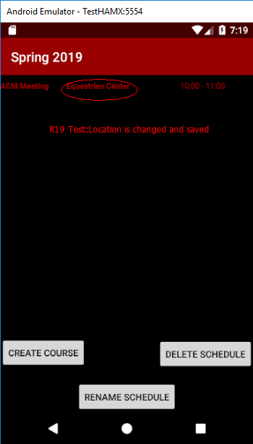

* 2.20 Story 20

This section intentionally left blank.

* 2.21 Story 21

**Use Case**: Display privacy policy

**Summary**: The app displays the privacy policy when the application is loaded the first time.

**Actor**: User

**Precondition**: User has opened the app for the first time.

**Description:**

1. The privacy implications of using the application is displayed to the user.

2. The user is prompted to select OK if he agrees to the terms.

**Postcondition:** The application home screen is loaded.

**Title:** Display privacy policy

**Actors:** User

**Requirement: R21**

**Main Scenario:**

1. The privacy implications of using the application is displayed to the user.

2. The user is prompted to select OK if he agrees to the terms.

**Test Situations:**

The privacy implication is displayed to the user.

**Test Coverage:**

Base: number of main and alternative scenarios = 1

Test situations cover all 1 cases

100% coverage of use case

**Test Record:**

**Test Case:**

User opens RaiderNav first time,the privacy implications is displayed to the user, after user click OK, APP shows the main screen.

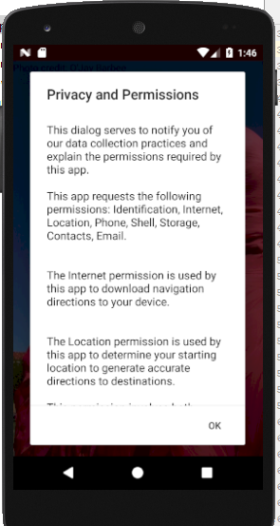 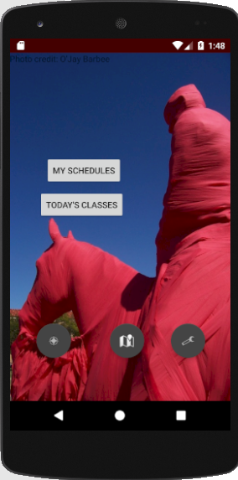

* 2.22 Story 22

This section intentionally left blank.

* 2.23 Story 23

This section intentionally left blank.

* 2.24 Story 24

**Use Case:** Navigate to Unscheduled Location

**Summary:** The app shall allow the user to generate a map to a location which is not within any schedule and which will not be saved to any schedule.

**Actor:** User

**Precondition:** User is currently on the main screen.

**Description:**

1. The user presses the unscheduled location button.

2. The system displays the list of locations to choose from.

3. The user selects a location from the list and confirms the decision.

4. The system displays a map to the destination.

**Alternatives:**

3a. The user selects the “Cancel” button.

3a.1 The system returns the user to the main screen.

**Postcondition:** The user has generated a map to an unscheduled destination.

**Title:** Navigate to Unscheduled Location

**Actors:** User

**Requirement: R24**

**Main Scenario:**

1. The user presses the unscheduled location button.

2. The system displays the list of locations to choose from.

3. The user selects a location from the list and confirms the decision.

4. The system displays a map to the destination.

**Alternatives:**

a. The user selects the “Cancel” button.

3a.1 The system returns the user to the main screen.

**Test Situations:**

1. App shows the selected building’s location on the map

2. App returns to the main screen after user selected “Cancel”

**Test Coverage:**

Base: number of main and alternative scenarios = 2

Test situations cover all 2 cases

100% coverage of use case

**Test Record:**

**Test Case 1:**

The user selects a location from the list and confirms the decision.

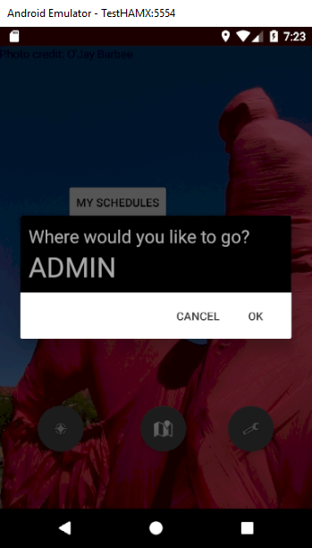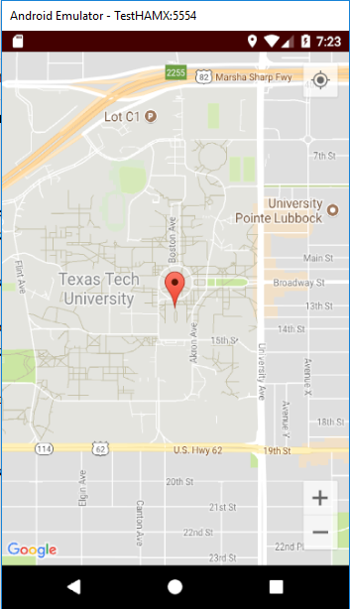

**Test Case 2:**

The user selects the “Cancel” button.

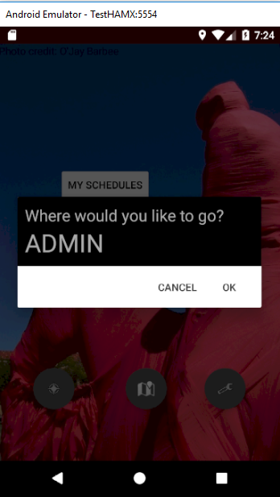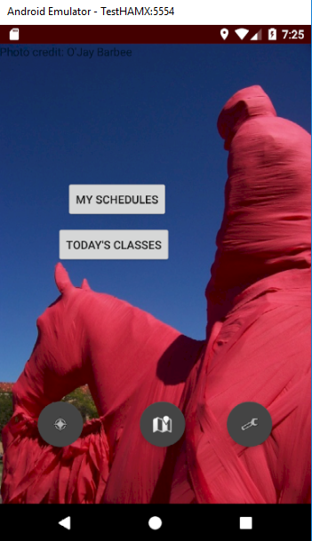

* 2.25 Story 25

This section intentionally left blank.

* 2.26 Story 26

This section intentionally left blank.

* 2.27 Story 27

This section intentionally left blank.

* 2.28 Story 28

This section intentionally left blank.

* 2.29 Story 29

**Use Case:** Rename Schedule

**Summary:** The app shall allow the user to rename a saved schedule.

**Actor:** User

**Precondition:** User previously saved a schedule in the app. User is currently on “My Schedules” screen.

**Description:**

1. The user selects a saved schedule.

2. The system displays the schedule details.

3. The user selects the “Rename Schedule” button.

4. The system displays a prompt showing the current schedule name.

5. The user enters a replacement name for the selected schedule using the Android keyboard and selects “Ok”.

6. The system returns the user to the “My Schedules” screen.

**Alternatives:**

5a. The user selects the “Cancel” button.

**Postcondition:** The user has successfully renamed a saved schedule.

**Title:** Rename Schedule

**Actors:** User

**Requirement: R29**

**Main Scenario:**

1. The user selects a saved schedule.

2. The system displays the schedule details.

3. The user selects the “Rename Schedule” button.

4. The system displays a prompt showing the current schedule name.

5. The user enters a replacement name for the selected schedule using the Android keyboard and selects “Ok”.

6. The system returns the user to the “My Schedules” screen.

**Alternatives:**

5a. The user selects the “Cancel” button.

**Test Situations:**

**1. New schedule name is saved**

**2.** The user selects the “Cancel” button.

**Test Coverage:**

Base: number of main and alternative scenarios = 2

Test situations cover all 2 cases

100% coverage of use case

**Test Record:**

**Test Case 1:**

Newschedulenameissaved

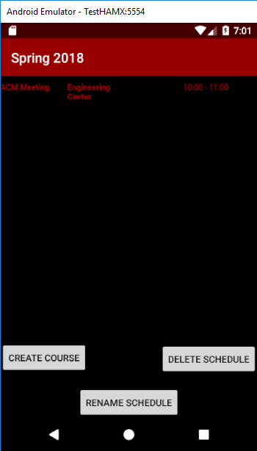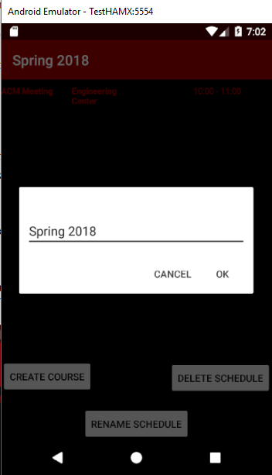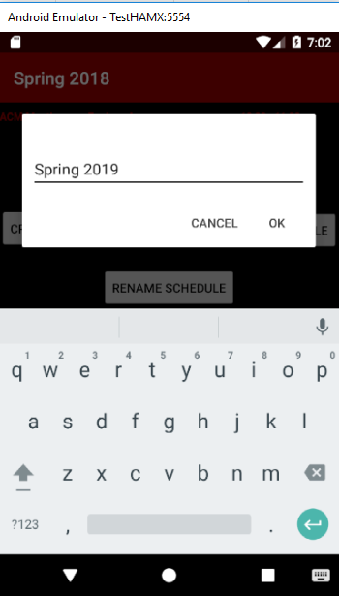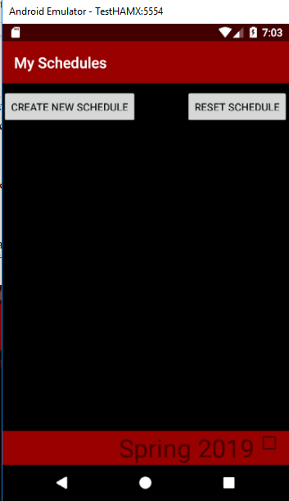

**Test Case 2:**

The user selects the “Cancel” button.

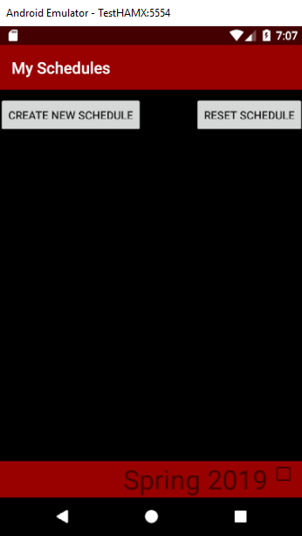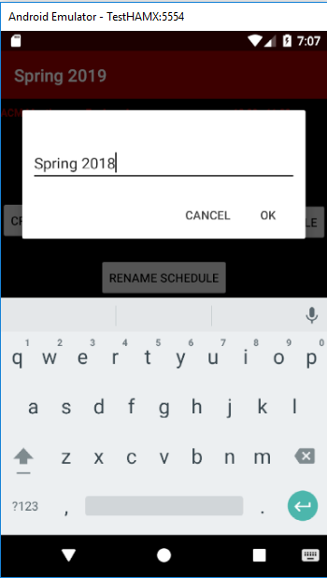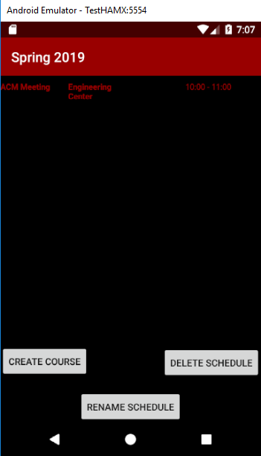

* 2.30 Story 30

**Use Case**: Delete Notification

Summary: Before the user deletes a schedule, the user must be given a notification to ensure that the user wants to delete the schedule, because all data will be lost.

**Actor**: User

**Precondition**: The user is at the schedule screen.

**Description**:

1. The user presses the Delete button.

2. A notification is given to the user to confirm the deletion, along with an option to cancel and not delete the schedule and a Delete button to delete the schedule.

3. If the user presses Delete, then the schedule will permanently be deleted and the user is then taken back to the schedules page.

**Alternatives:**

3a. If the user presses cancel, then they will be taken back to the main schedule page.

**Postcondition**: The user is returned to the schedule screen if they pressed Cancel or to the My Schedules screen if the user confirmed schedule deletion.

**Title:** Delete Notification

**Actors: User**

**Requirement: R30**

**Main Scenario:**

1. The user presses the Delete button.

2. A notification is given to the user to confirm the deletion, along with an option to cancel and not delete the schedule and a Delete button to delete the schedule.

3. If the user presses Delete, then the schedule will permanently be deleted and the user is then taken back to the schedules page.

**Alternatives:**

3a. If the user presses cancel, then they will be taken back to the main schedule page.

**Test Situations:**

1.Schedule is deleted after notified

2.Schedule keep remained after user chooses “Cancel” the delete operation.

**Test Coverage:**

Base: number of main and alternative scenarios = 2

Test situations cover all 2 cases

100% coverage of use case

**Test Record:**

**Test Case 1:**

Schedule is deleted after notified

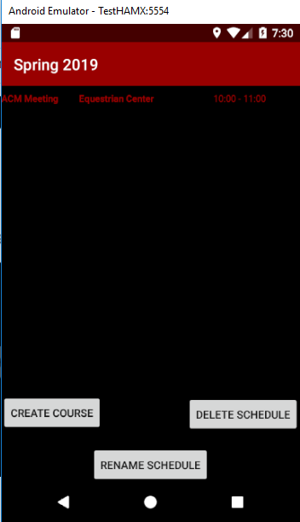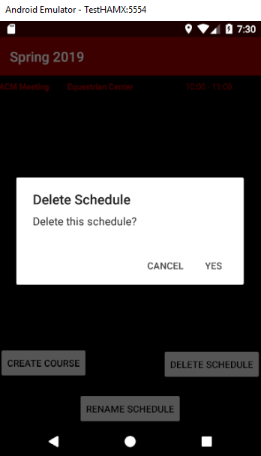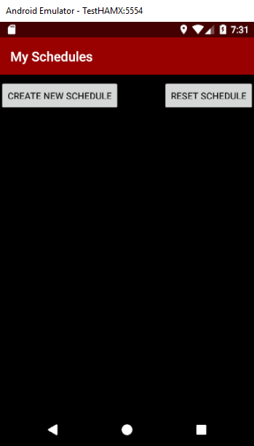

**Test Case 2:**

Schedule keep remained after user chooses “Cancel” the delete operation.

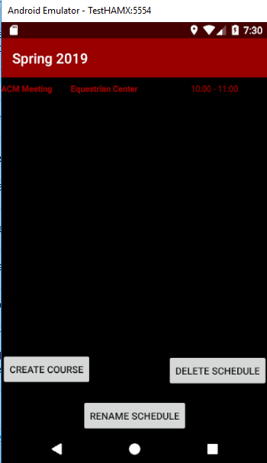

3. Acceptance Testing

Acceptance Criteria

* User stories 1-6, 8, 10-16, 21, 24, 29, and 30 must be implemented.
* Usability test scores must represent at least a 90% success rate.

Acceptance Evaluation

* User stories 1-5, 8, 19, 21, 24, 29, and 30 implemented
* User stories 6 and 10-16 NOT implemented.
* User test score represents 92.8% success rate.

Acceptance Decision

Acceptance Rejected

Reason:

* User stories 6 and 10-16 NOT implemented.