EFW ALUMNI COMMUNITY
Edit YAML Content and
Create a Pull Request on GitHub
Step-by-step guide for non-developer administrators
Goal Edit one or more YAML files on the dev-info branch, then send all changes to the dev branch in one Pull Request.

Repository
https://github.com/alumni-efw/alumni-efw.github.io
Item | Example
Branch for editing | dev-info
Pull Request destination | dev
Files to edit | YAML files under the _data folder
Final merge | Completed by the developer after review

Most important rule It is OK to have one commit for each file. Finish all file edits first, then create only one Pull Request.

Version 1.0 | July 2026

Quick Overview
- Sign in to GitHub.
- Open the EFW website repository.
- Change the branch to dev-info.
- Open and edit a YAML file under _data.
- Commit the file directly to dev-info.
- Repeat the edit and commit steps for any other files.
- After all edits are finished, create one Pull Request.
- Confirm base: dev and compare: dev-info.
- Send the Pull Request to the developer for review.
Example If you edit talk-time.yml, job-training.yml, and about-us.yml, you may have three commits. You still create only one Pull Request.

Before You Start
- A GitHub account
- Write access to the alumni-efw/alumni-efw.github.io repository
- The exact text, date, time, or link that you need to change
- A copy of the old content, if possible
No edit access? If you do not see the pencil-shaped Edit button, send your GitHub username to the repository administrator and ask for access.
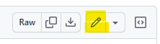

1. Sign In to GitHub
- Open https://github.com in your web browser.
- Select Sign in in the top-right corner.
- Enter your Username or email address and Password.
- Select Sign in.
- If GitHub asks for two-factor authentication, enter the code from your authentication app, text message, or security key.
Security Do not share your password or two-factor authentication code. On a shared computer, sign out when your work is finished.

2. Open the EFW Repository
The easiest method is to open this address:
github.com/alumni-efw/alumni-efw.github.io

You can also use the GitHub menus:
- Select your profile picture in the top-right corner.
- Select Your organizations.
- Select the alumni-efw organization.
- Open the Repositories tab and select alumni-efw.github.io.

3. Select the dev-info Branch
The current default branch name appears above the file list. It may show main branch.
- Select the branch button above the file list.
- Find dev-info under the Branches tab select dev-info.
- Confirm that the branch button now shows dev-info.

Branch button → Select dev-info
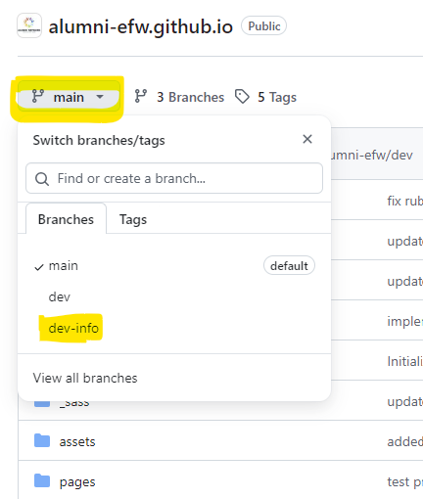

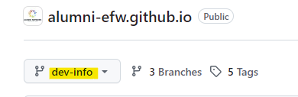

Important Always confirm that you are on dev-info before opening a file. Do not edit content directly on main or dev.

4. Find the YAML(.yml) File to update content
Information content files are mainly stored under the _data folder.
Page | Folder structure
Adult Education and employment resources  https://alumni-efw.github.io/adult-education-resources/ | _data/edu-resources/
Frequently asked questions  https://alumni-efw.github.io/faq/ | _data/faq/
Community guidelines  https://alumni-efw.github.io/guidelines/ | _data/guidelines.yml
Privacy information  https://alumni-efw.github.io/privacy/ | _data/privacy.yml
- Select _data in the file list.
- If needed, select the edu-resources or faq folder.
- Select the .yml file that you need to edit.
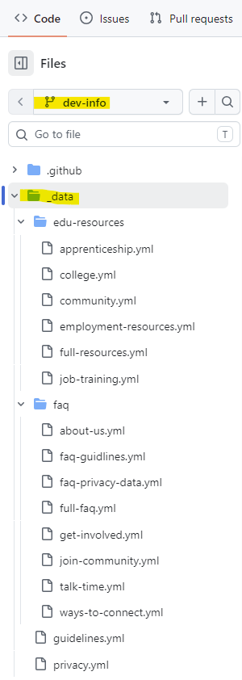 | - edu-resources: information for adult education and employment page  - full-resources.yml: meta data file for define section order, anchor information, and pdf location  - faq: FAQ data for both a full FAQ page and FAQ block. If you set highlighted: true, the FAQ item will also appear on FAQ section in the individual pages.  - full-faq.yml: meta data file for define section order in a full FAQ page.  - guidelines.yml: Community Guidelines contents  - privacy.yml: Privacy & Data Notice contents

5. Edit a YAML File in the GitHub Website
- Select the pencil-shaped icon (Edit this file) near the top-right of the file.
- Find the text that you need to change. You can use Ctrl+F in your browser.
- Change only the required value. Keep the comment, formatting, and spacing the same.
- Please read the comments carefully and follow the instruction.
- Select Preview changes to review your work.
In Preview changes, removed content is red and new content is green.
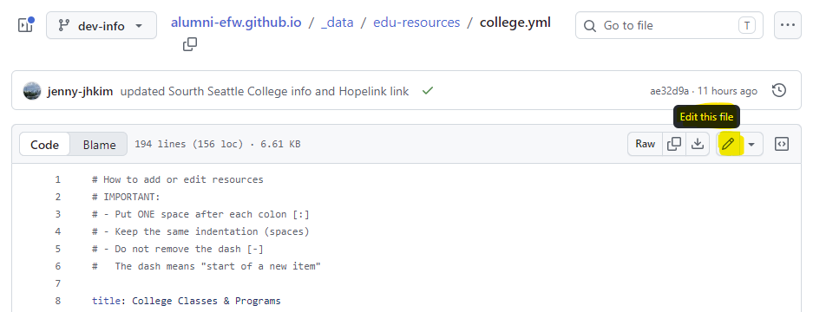
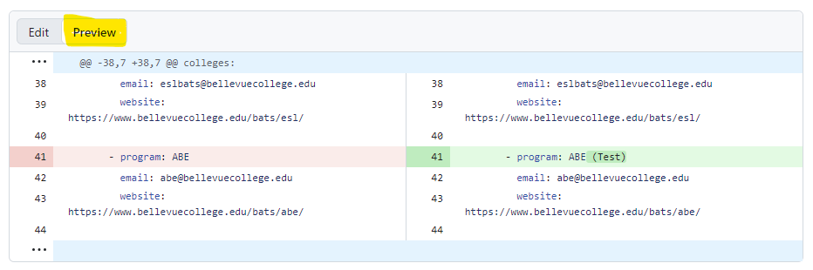

Important YAML Rules
- Keep the existing indentation. Use spaces, not the Tab key.
- Do not remove colons (:), hyphens (-), or quotation marks unless you are sure.
- Copy web links completely, including https://.
- If the text contains a special character, use double quotation marks (“ ”).
- If when the sentence is long or multiple lines, use > after colons (:). Need to add indentation each line.
- To add a new item, copy an existing item with the same structure and spacing, including its hyphen or special characters. Then edit the text, and check that the hyphen and indentation are still correct.
- Update the id numbers as appropriate, if necessary.

Case | Example
Before | title: I-BEST (No I-BEST programs)
After | title: I-BEST
Multiline text edit example  (ex. about-us.yml) | answer: >  EFW Alumni Community is a volunteer-led community for English for Work alumni.  It helps graduates stay connected after …
Special characters edit  Example  (ex. Privacy.yml) | content:  - The EFW Alumni Community website itself does not collect personal information directly.  - "However, we may use external forms, such as Fillout Forms, for activities such as:"
External Link example  (ex. college.yml) | website: https://example.org/program

Not sure? Change an existing value instead of creating a new structure. Ask the developer before adding or deleting a full item if you are not sure about the format.

5.1 How to add a link to text in YAML file
To make text clickable, especially faq files or privacy.yml or guidelines.yml, put the text inside square brackets [ ]. Then put the website address or page link inside parentheses ( ).
Format | [Text shown on the page](website address or page link)
Example in YAML file | 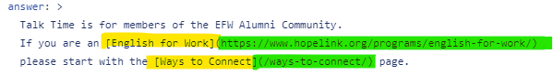  - Website address: https://www.example.org/examplelink  - Internal page link: /page-permalink/  For another website, enter the complete address beginning with https://.  For a page on the EFW Alumni Community website, use the page path beginning with /.
On the website

Important Do not add a space between ] and (.
For external links, always include the complete address beginning with https://. After editing, use Preview changes and carefully check the link text and address.

5.2 How to add/edit FAQ items
Navigate to: _data/faq/
# How to add or edit FAQ items
# IMPORTANT:
# - Put ONE space after each colon [:]
# - Keep the same indentation (spaces)
# - Do not remove the dash [-]
# The dash means "start of a new FAQ item"

# Format:
# - question: Your question here
# answer: Your answer here
# highlighted: true # optional

# About /highlighted/:
# - highlighted: true
# → This FAQ item will also appear on FAQ section in the individual page
#
# - If highlighted is omitted, it is treated as false by default
# → The item will appear only in the Full FAQ page
#
# - Add highlighted: true for FAQ items that should appear
# on both the Full FAQ page and the individual FAQ section

# Example:
# - question: Do you have any questions?
# answer: Yes. I'll send the message.
# highlighted: true

5.3 How to add/edit privacy or guidelines page
Navigate to: _data/privacy.yml or _data/guidelines.yml
# IMPORTANT:
# - Put ONE space after each colon [:]
# - Keep the same indentation (spaces)
# - Do NOT remove the dash [-]
# The dash means "start of a new section or list item"
#
# - If the text contains special characters such as [:] [#] [@] or starts with [-],
# wrap the text with double quotes [" "]
#
# Example:
# - "Our community is a place to:"

# Adding a new section
# Each section should include:
# - id: section number
# - title: section title
# - content: paragraph text list
# - bullets: optional bullet list

# Example format:
#
# sections:
# - id: 1
# title: Example title
# content:
# - First paragraph
# - Second paragraph
# bullets:
# - First bullet
# - Second bullet

5.4 How to update adult education and employment resources page
Navigate to: _data/edu-resources/
This folder contains separate YAML files for colleges, community classes, job training, employment resources and apprenticeships section.
Select the file that contains the information you want to update.

5.4.1 Add/edit field an Existing Resource
To update a contact person, phone number, email address, website, or program description:
- Open the correct YAML file.
- Use Ctrl+F to find the organization, college, or program name.
- Change only the information that needs to be updated.
- Keep the existing field names, spacing, and indentation.
- Select Preview changes and review the update.

Example
Before
- name: Example Training Program
location: Seattle, WA
info: Free career training for adults
email: contact@example.org
website: https://example.org/program

After (want to add phone info and update email address)
info: Free career training for adults <-existing field
phone: 111-222-1234 <-newly added field
email: new-contact@example.org <-updated field

5.4.2 Add new program or classes or new resource
Resource items do not always use the same fields. Some items have a phone number, email address, website, contact person, or several locations. These fields are optional and order is not matter.
The easiest way to add a new resource is to copy an existing item with a similar structure.
- Find an item with a similar format.
- Copy the complete item, including its first dash - and spacing.
- Paste it under the correct section.
- Replace the example information with the new information.
- Remove optional fields that are not needed.
- Confirm that the indentation has not changed.
- Example of college format (ex.college.yml)
colleges:
- name: ABC College
location: Seattle, WA
programs:
- program: English
phone: 123-444-1234 (optional field)
email: esl@example.edu (optional field)
website: https://www.example.edu/esl/ (optional field)

- program: ABE
email: abe@example.edu (optional field)
website: https://www.example.edu/abe/ (optional field)

- program: I-BEST
email: ibest@example.edu (optional field)
website: https://www.example.edu/i-best/ (optional field)

- Example of community program format (ex.community.yml)
programs:
- name: Organization or program name
location: City, WA
info: Short description of the class or program
contact: Contact person
phone: 000-000-0000
email: contact@example.org
website: https://example.org/

- Example of multiple Locations format
Some organizations have more than one location or branch. In this case, use a branches section.
Copy an existing item that already uses branches, then edit the information.
- name: Example Organization
location: King County, WA
info: English and computer classes
branches:
- branch: Seattle
phone: 206-555-1111
website: https://example.org/seattle

- branch: Renton
phone: 425-555-2222
website: https://example.org/renton

- The following fields are optional: Contact, phone, phone2, email, email2, website, website2, SNS, branches

! Do not add an optional field if no information is available. Do not leave it empty.
! Keep each branch and each program at the same indentation level. Each new branch/program/name must begin with a dash [-].

Not sure which format to use? Copy an existing resource that looks most similar to the new resource. Replace its content, remove fields you do not need, and confirm that the indentation level is sequential.

6. Commit the File to dev-info
After checking your edit, select the Commit changes… button. Commit changes pop-up will be shown.
- In Commit message, briefly describe what you changed.
- The Extended description is optional. Use it for extra details.
- Select Commit directly to the dev-info branch option.
- Select the Commit changes button to save the file.
Commit changes → Commit directly to dev-info → Commit changes
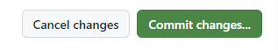

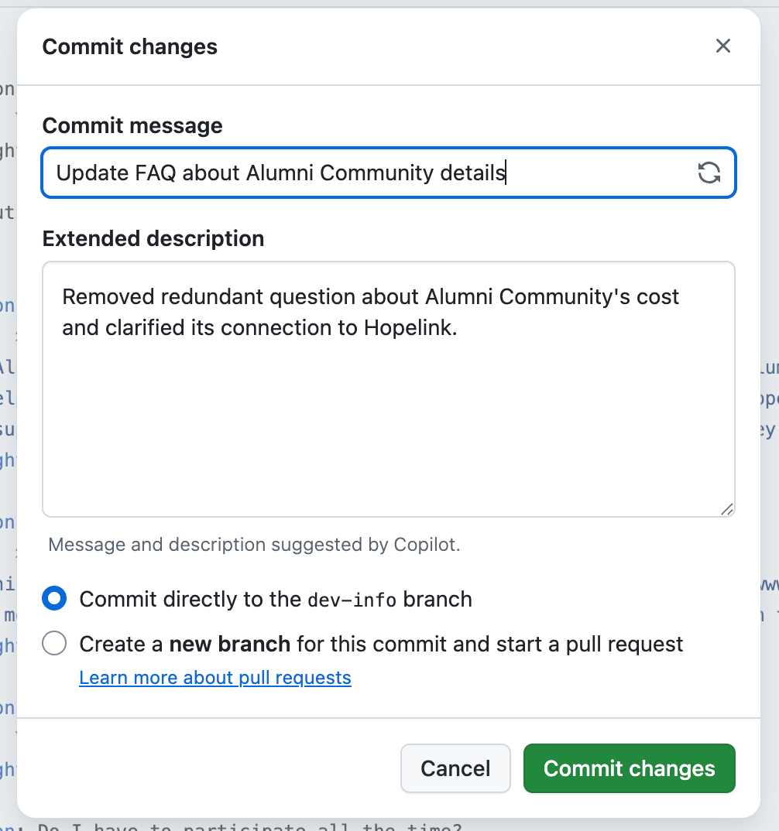

Commit Message Examples
Item | Example
Schedule | Update Talk Time schedule
Link | Update job training program link
Description | Revise alumni community FAQ
Several values | Update adult education resource details

Do not select Do not select Create a new branch for this commit and start a pull request. This can make it harder to collect several file edits in one Pull Request.

When You Need to Edit Several Files
After committing one file, return to the dev-info file list and edit the next file in the same way.
- Edit and commit the first file.
- Edit and commit the second file.
- Edit and commit any other files.
- After every file is finished, create one Pull Request.
Remember The number of commits does not need to match the number of Pull Requests. Several commits can be included in one Pull Request.

7. Create the Pull Request
Create the Pull Request only after you finish all file edits.
- Select Pull requests in the repository menu.
- Select the New pull request button.
- Set base to dev.
- Set compare to dev-info.
- Confirm that GitHub shows Able to merge or a list of changed files.
- Open Commits and Files changed. Confirm that all your changes are included.
- Select Create pull request.
- Enter a title and description and after checking all, then select Create pull request again.

Pull requests → New pull request → [ base: dev ← compare: dev-info ]
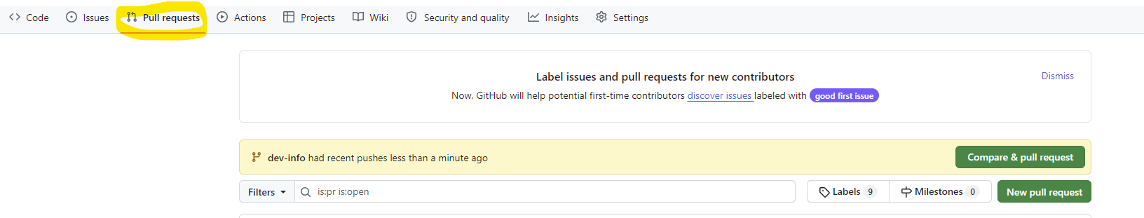
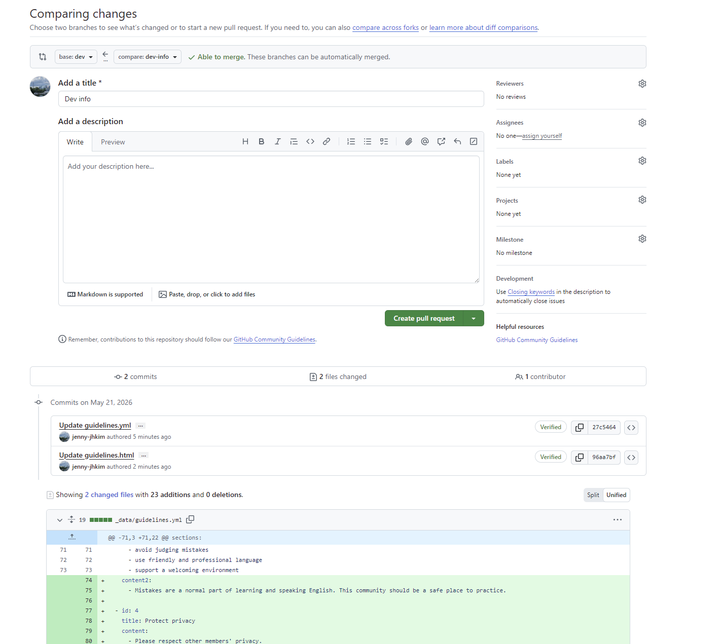

Make sure: 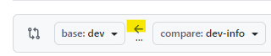

Check the direction The changes must move from dev-info to dev. The screen should show dev ← dev-info.

Pull Request Example
Item | Example
Title | Update September program information
Description | Updated Talk Time schedule, job training link, and FAQ wording. Please review dates and links before merging.

Use a clear title. In the description, list the files or information you changed and anything the developer should check.

8. After You Create the Pull Request
- Send the Pull Request link to the developer.
- Wait for the developer to review and merge it into dev.
- If the developer requests a change, edit the file again on dev-info.
- A new commit on dev-info is automatically added to the open Pull Request.
Forgot a file? Do not create another Pull Request. Edit the missing file on dev-info and commit it. The open Pull Request will update automatically.

If a Pull Request Is Already Open
Another administrator may already have an open dev-info → dev Pull Request.
- Open Pull requests and check that the existing PR shows dev ← dev-info.
- Open Files changed and confirm that your changes are included.
- If your changes are included, do not create a new PR. Tell the PR owner or developer.
Working together Tell other administrators before you begin editing. Keep only one open dev-info → dev Pull Request whenever possible.

What Happens After the Merge
After the developer merges dev-info into dev, the developer later promotes dev to main. When the main website deployment succeeds, automation updates dev-info to the latest main version.

Troubleshooting
Item | Example
No Edit button | Ask the repository administrator for Write access.
Cannot find dev-info | Confirm the repository name, then search again in the branch menu.
There isn't anything to compare | The change may already be in dev, or base and compare may be reversed.
A PR already exists | Use the existing dev-info → dev Pull Request.
YAML check fails | Check indentation, colons, quotation marks, and hyphens. Send the error to the developer.
Merge conflict | Do not try to fix it unless you know how. Contact the developer.
Edited main by mistake | Stop editing and immediately send the commit or PR link to the developer.
Committed a wrong value | Edit the correct value on dev-info and add another commit.

Final Checklist
- □ I am signed in with an account that has access to the EFW repository.
- □ The current branch is dev-info.
- □ I edited the correct YAML file under _data.
- □ I kept the existing indentation and YAML structure.
- □ I checked the edit in Preview changes.
- □ I committed each file directly to dev-info.
- □ I finished all file edits before creating one Pull Request.
- □ The PR base is dev and compare is dev-info.
- □ I checked every file in Files changed.
- □ I sent the Pull Request link to the developer.
Done You are finished when the Pull Request shows base: dev, compare: dev-info, and all edited files appear under Files changed.

