EduClinic Admin Portal User Guide
1.Dashboard
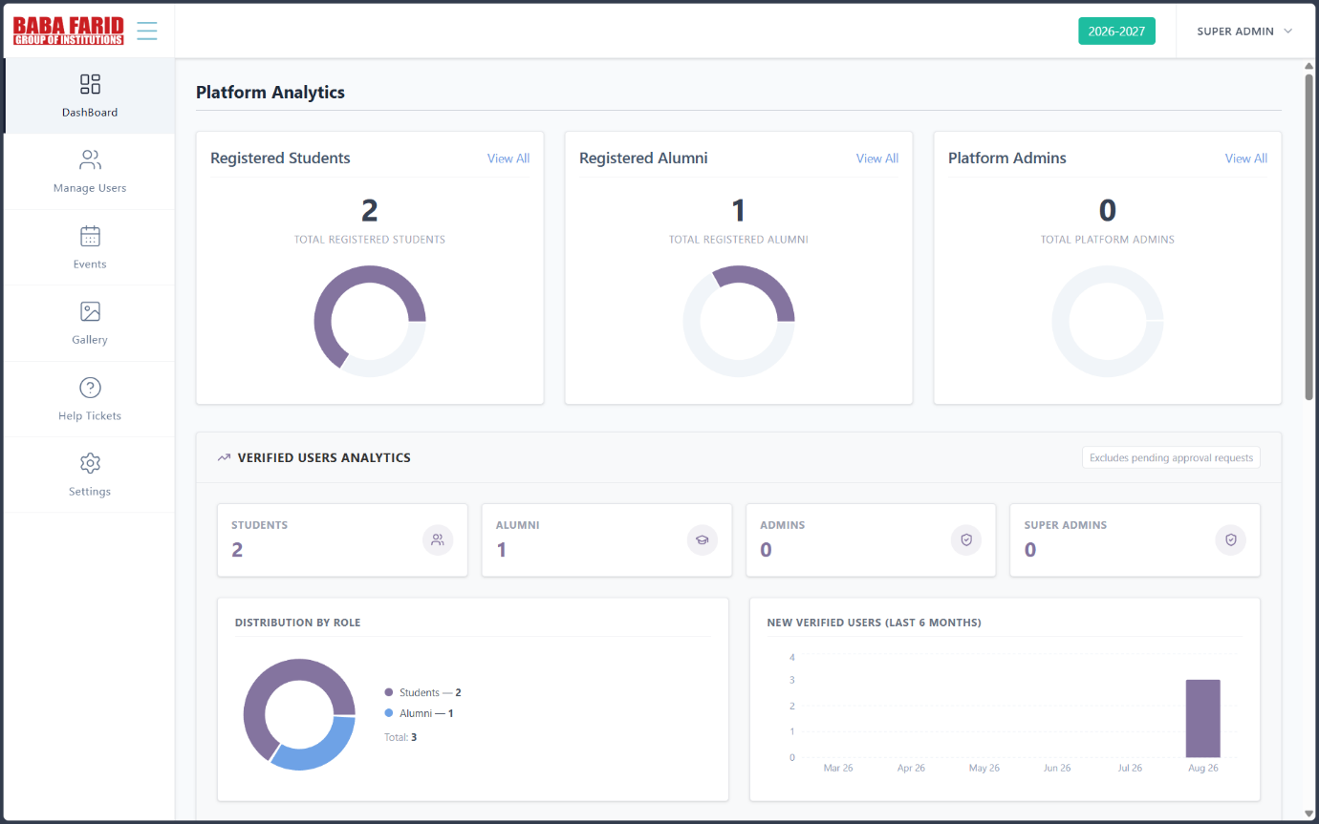
The Dashboard is the main page of the Admin Panel. It provides an overview of the platform by displaying analytics such as registered students, alumni, administrators, and verified user statistics. It also offers quick navigation to different management modules.

2. Manage Users
2.1 Manage Alumni & Students
Step 1: Access Manage Alumni & Students
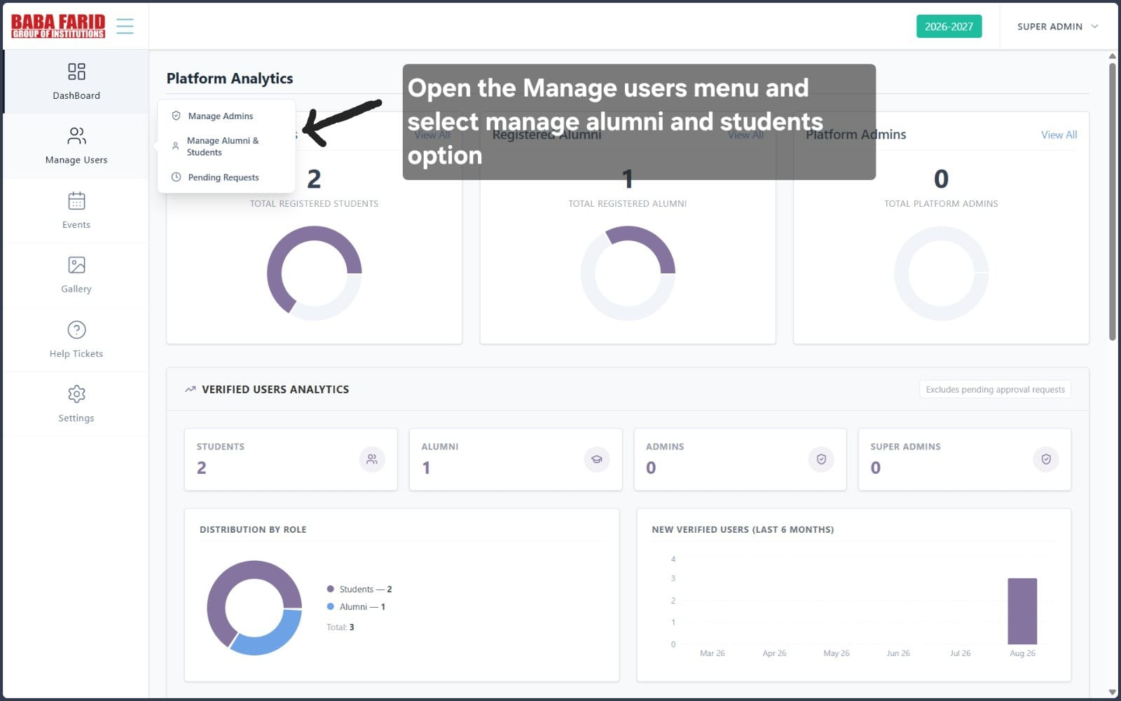
The administrator opens the Manage Users section from the dashboard. This menu provides options to manage admins, alumni & students, and pending registration requests.
Step 2: Manage Registered Users
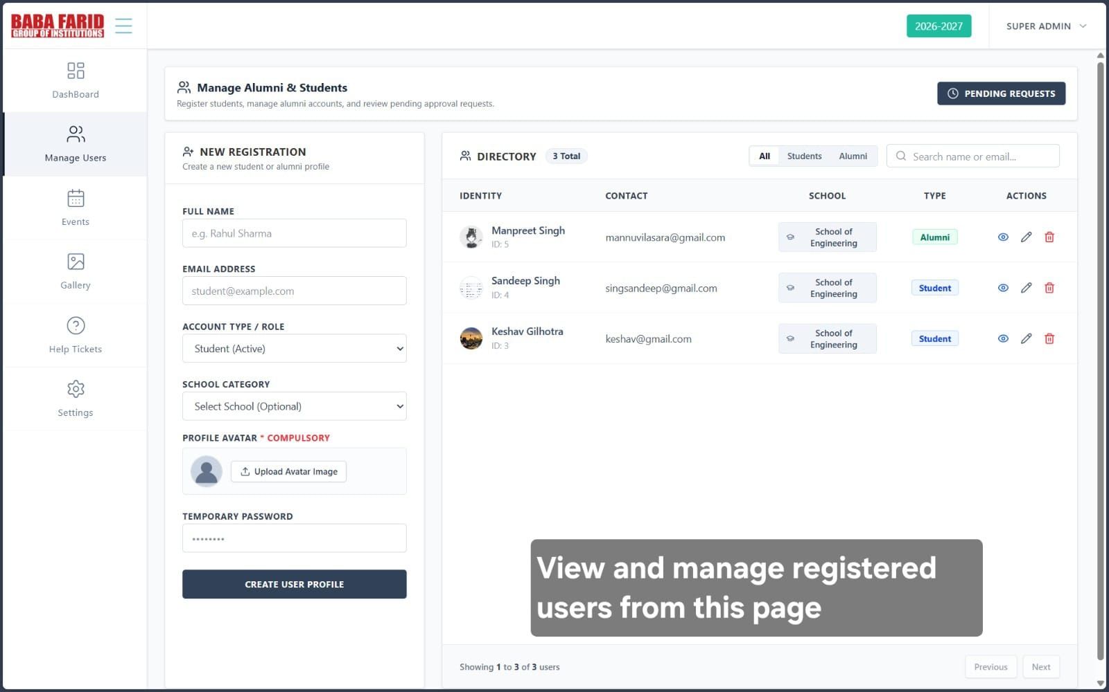
The Manage Users page displays all registered users along with their details. From this interface, the administrator can create new user profiles, search users, edit records, or access pending requests.
2.2 Pending Requests
Step 1: Open Pending Requests

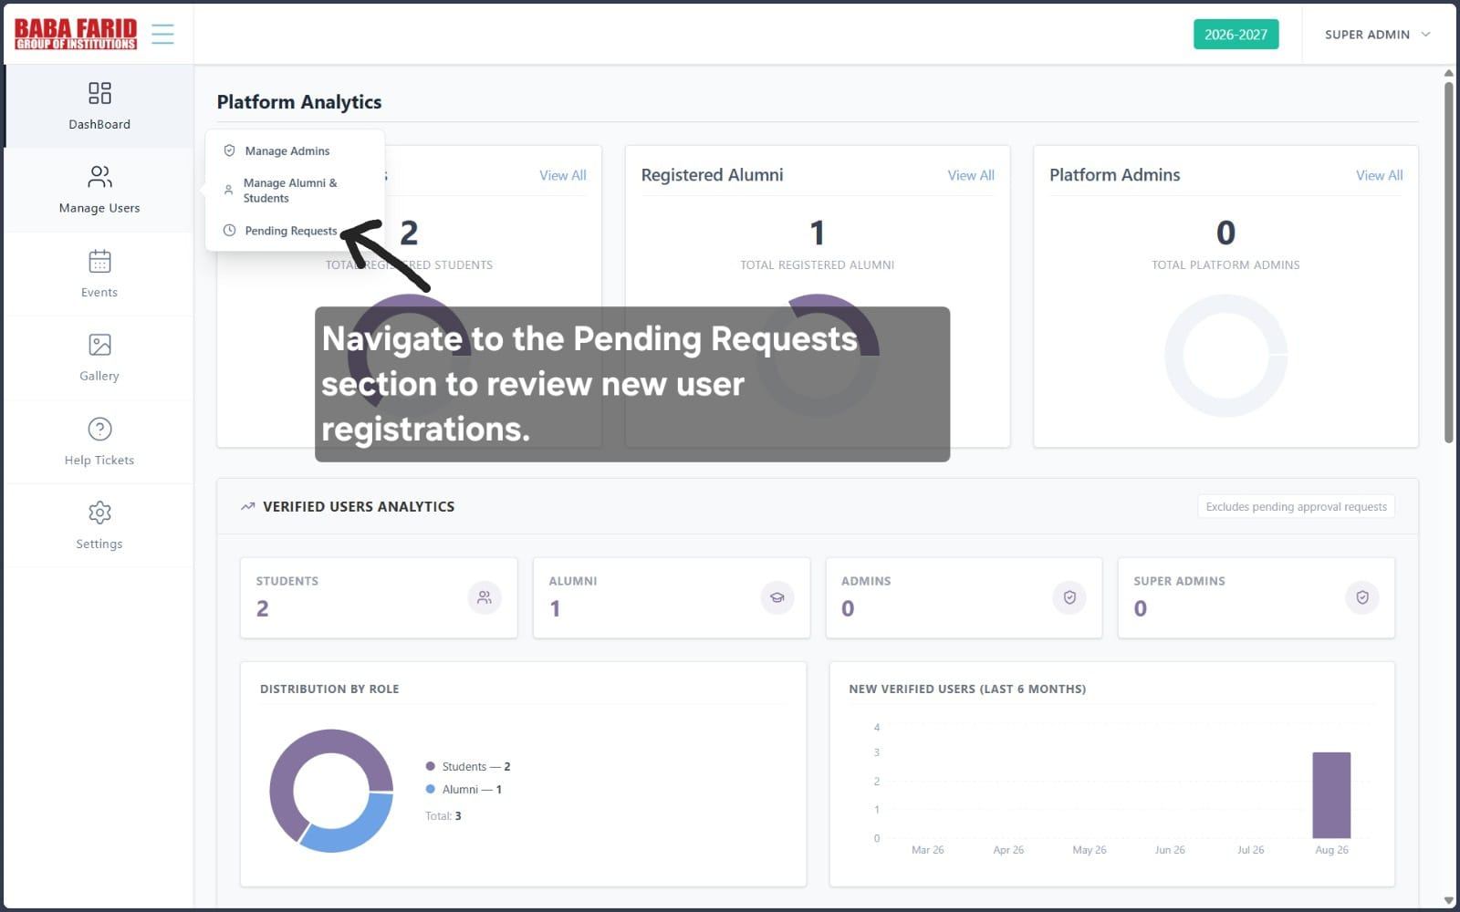
The administrator selects the Pending Requests option to view users waiting for approval before they can access the system.
Step 2: Review Pending Registration Requests
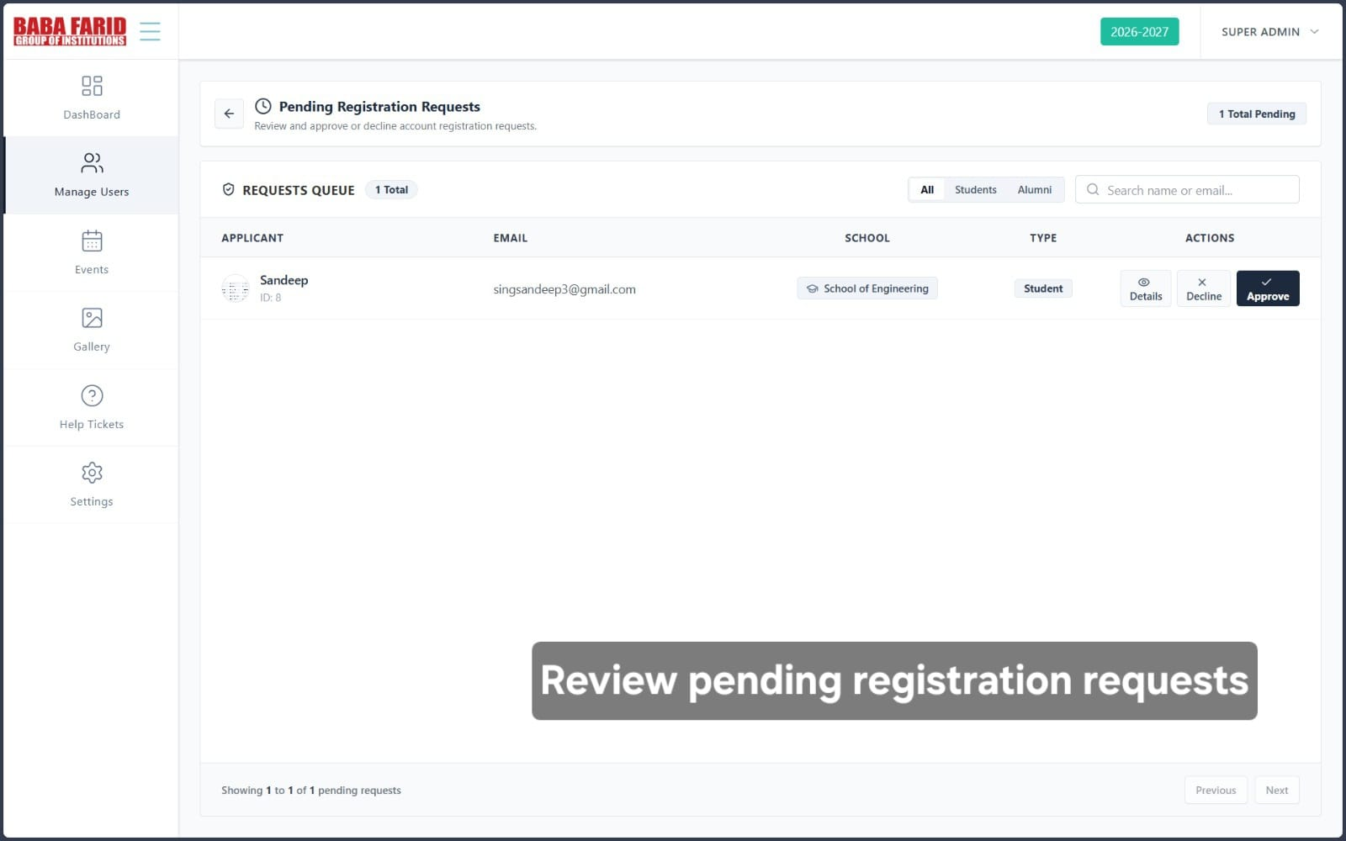
The Pending User page displays all users awaiting approval. The administrator can view applicant information and choose to approve, decline, or inspect further details.
Step 3: View Applicant Details
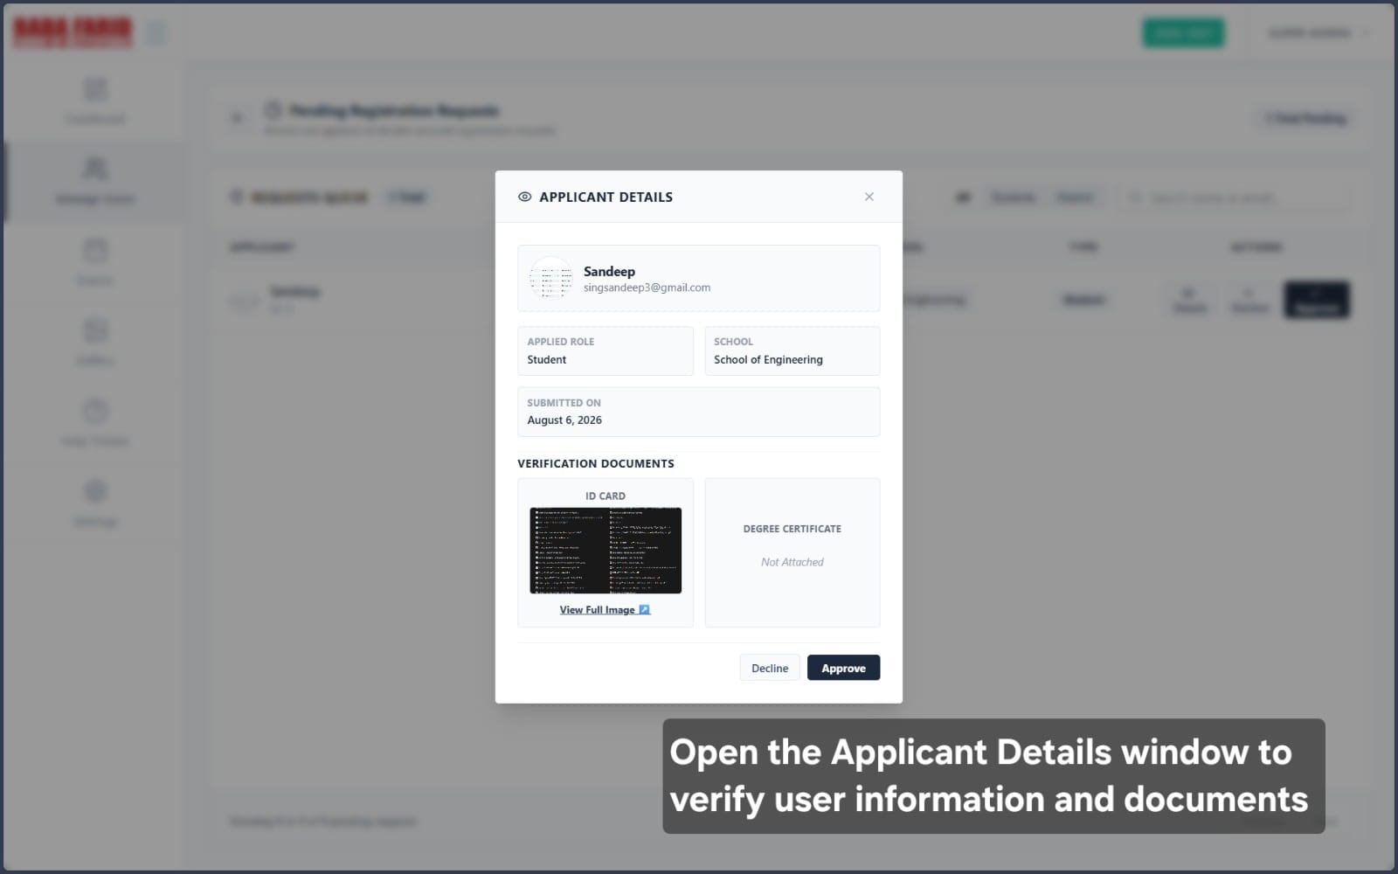
The Applicant Details view displays the applicant's profile, submitted documents, role, school, and verification information for review before approval.
Step 4: Review Registration Request
After verifying the applicant's information, the administrator can approve or decline the registration request.
3. Gallery
Step 1: Access Gallery Module
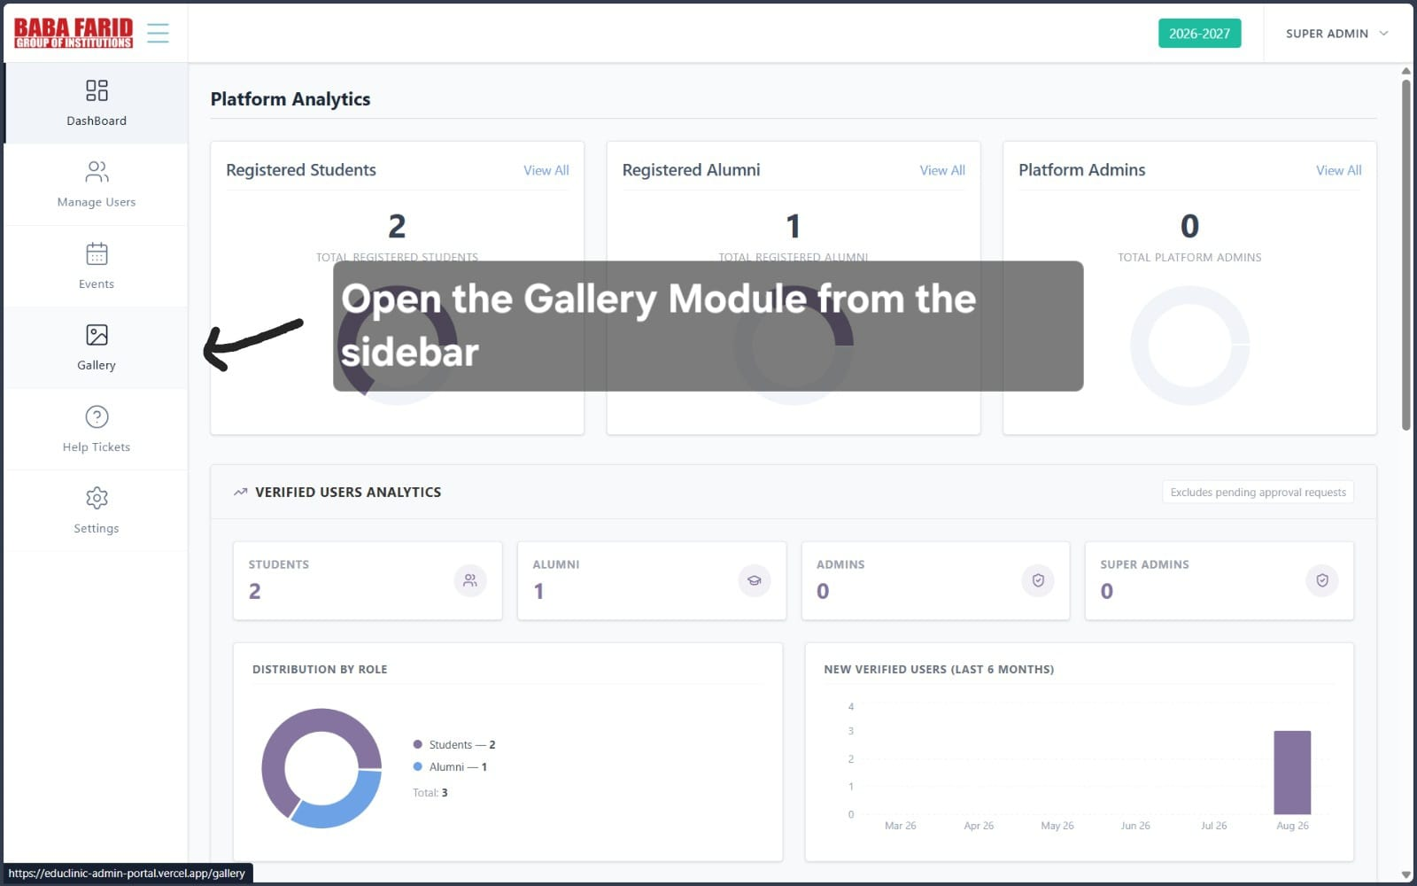
The administrator accesses the Gallery module to manage photo albums and organize event images.
Step 2: Select Gallery Category
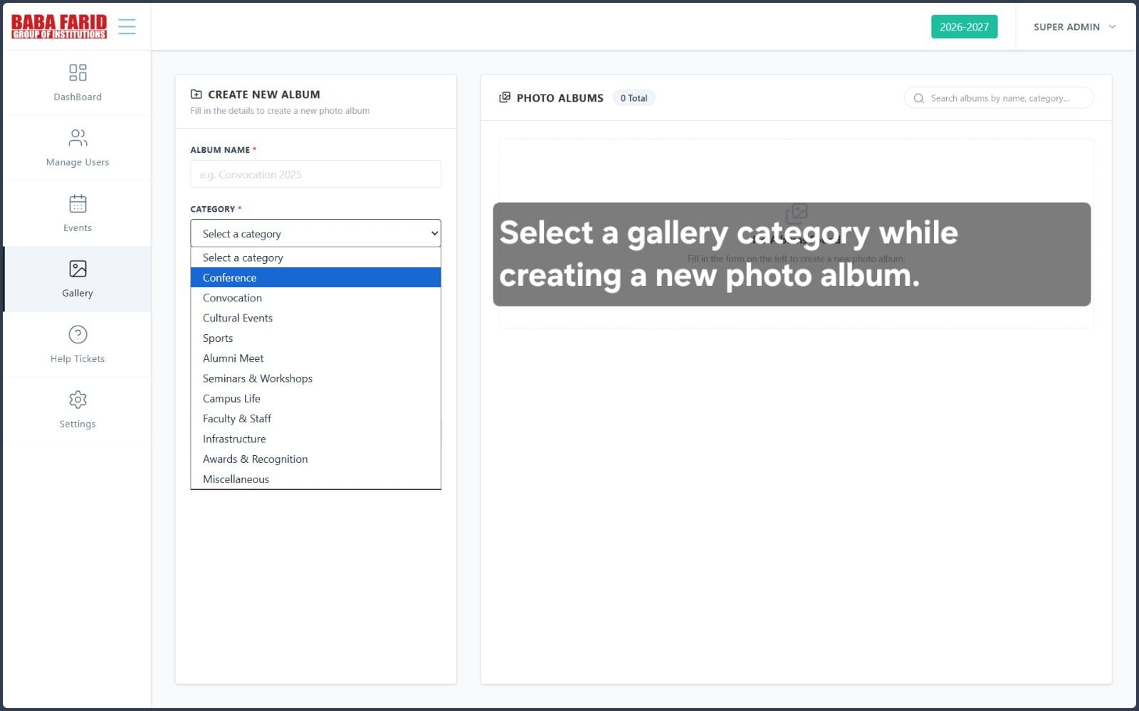
The administrator chooses an appropriate category such as Conference, Sports, Cultural Events, or Alumni Meet to organize uploaded images.

Step 3: Create Photo Album
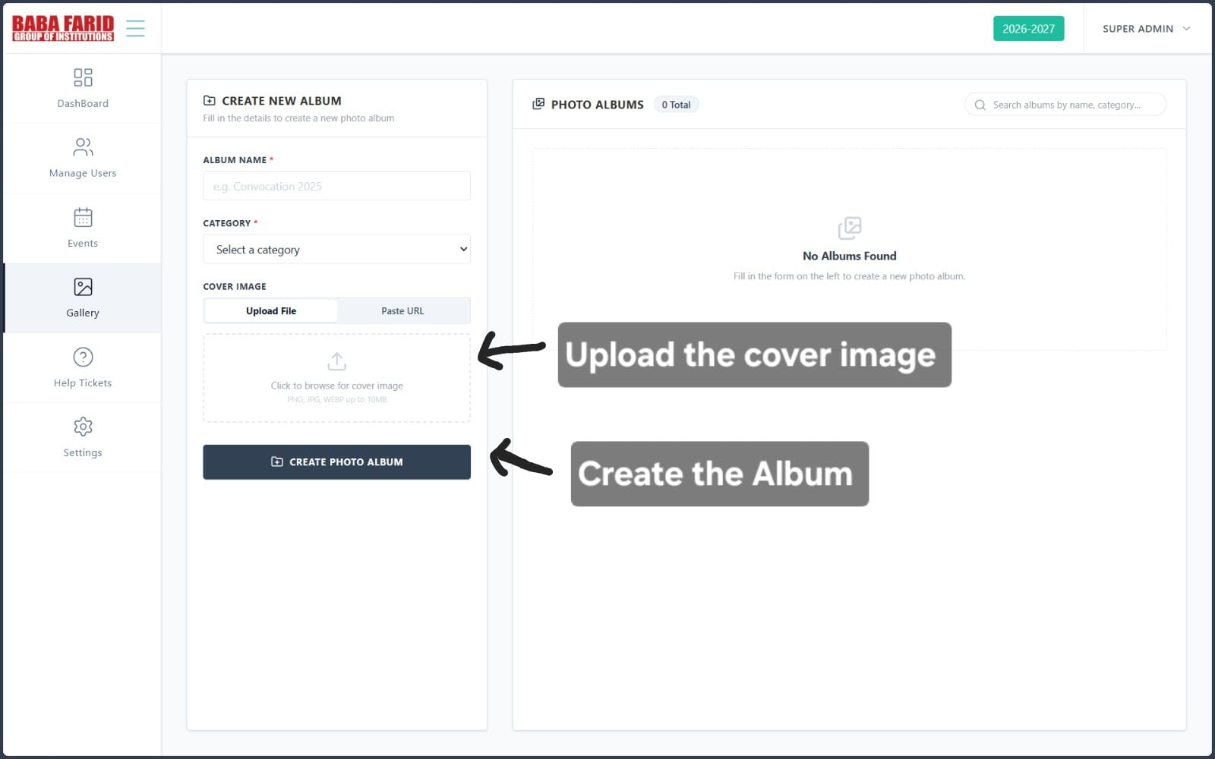
After entering the album information and selecting the category, the administrator uploads the cover image and creates the gallery album.

4. Events
Step 1: Access Events Module
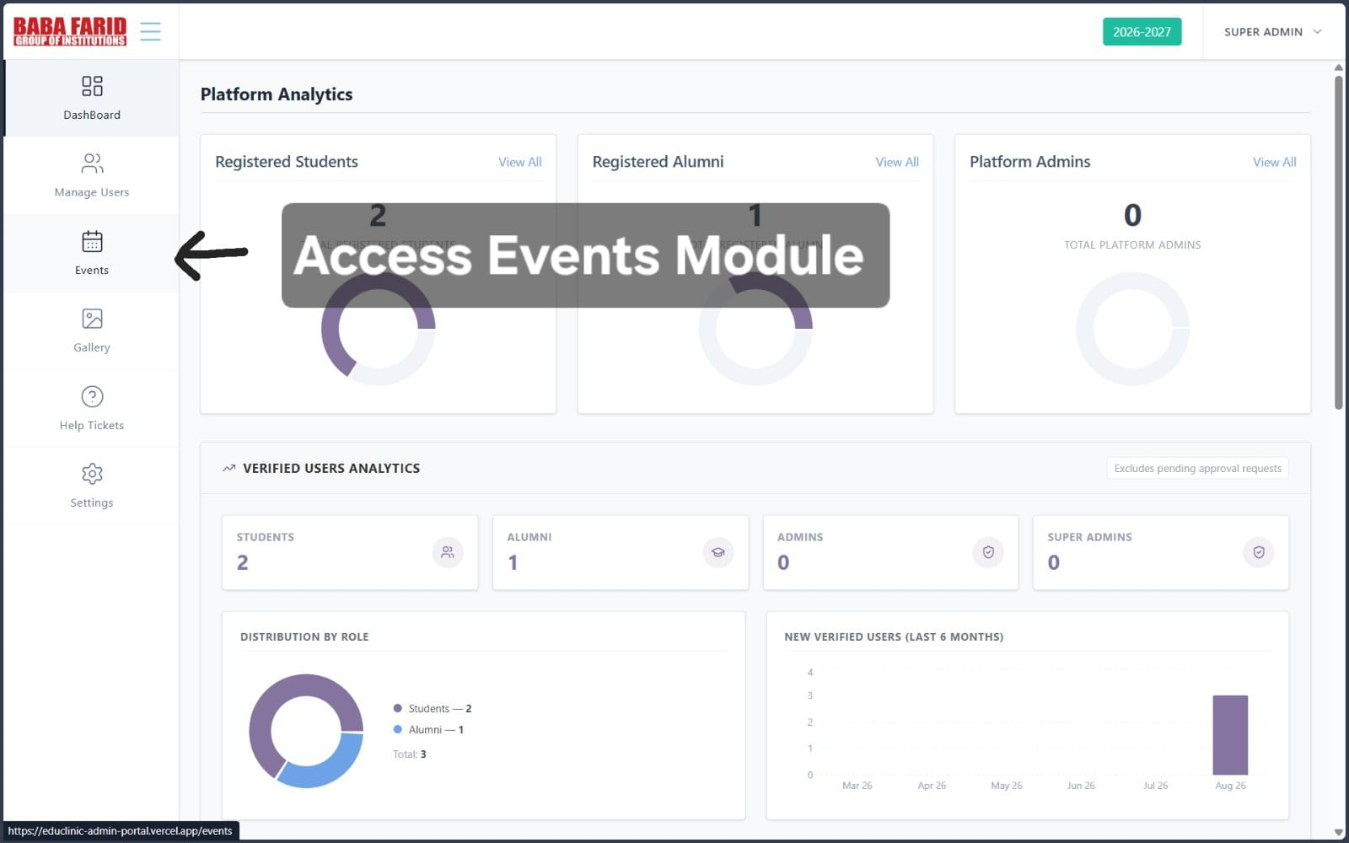
Open the Events module from the dashboard to manage all events and access event-related features.
Step 2: Create a New Event
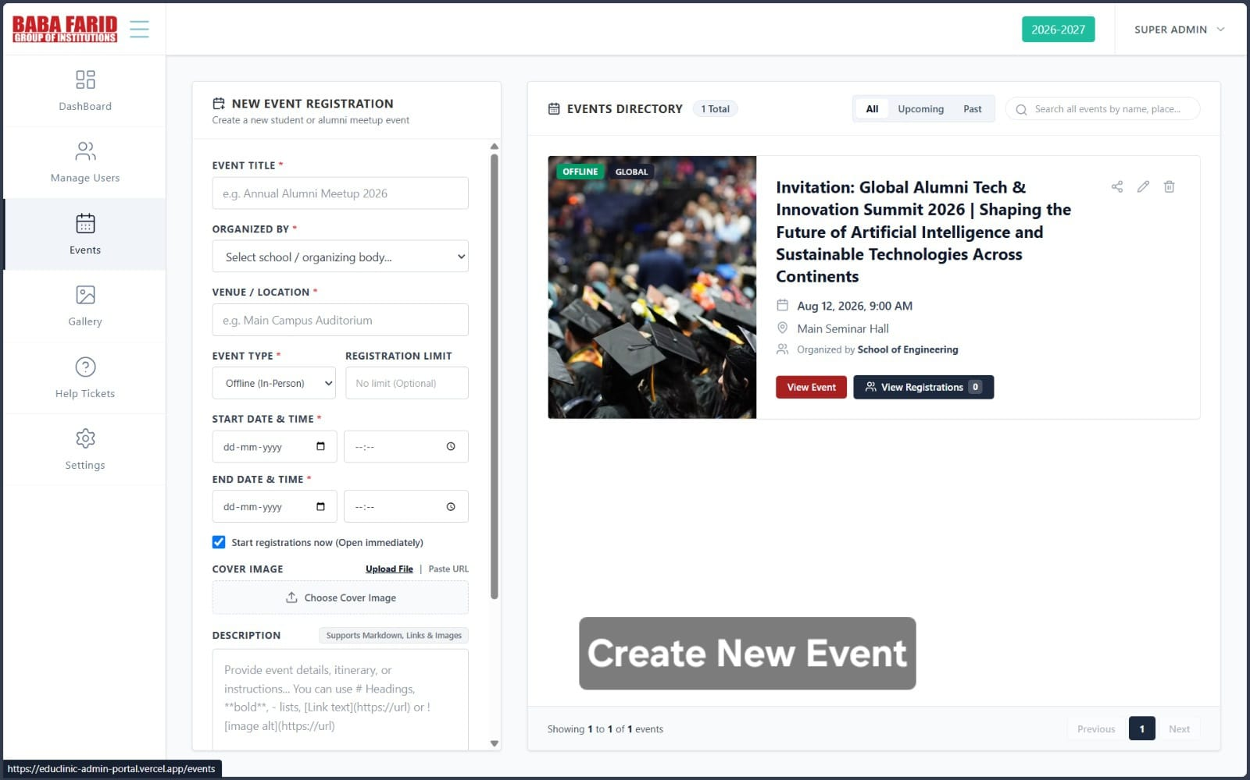
Enter the event information, including title, organizer, venue, schedule, registration details, cover image, and description to create a new event.
Step 3: View Event Details
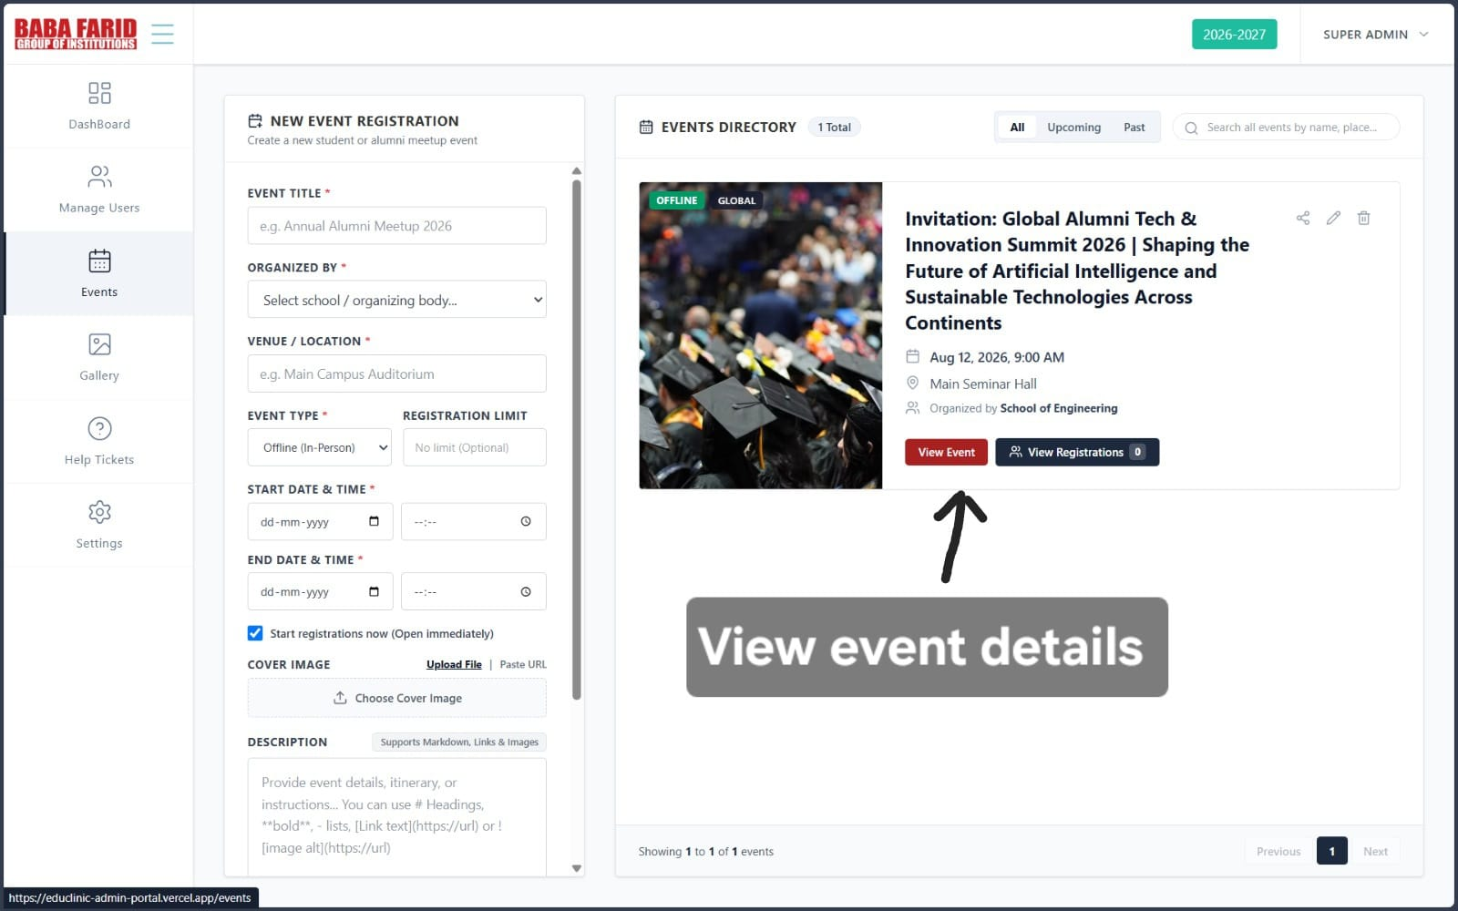
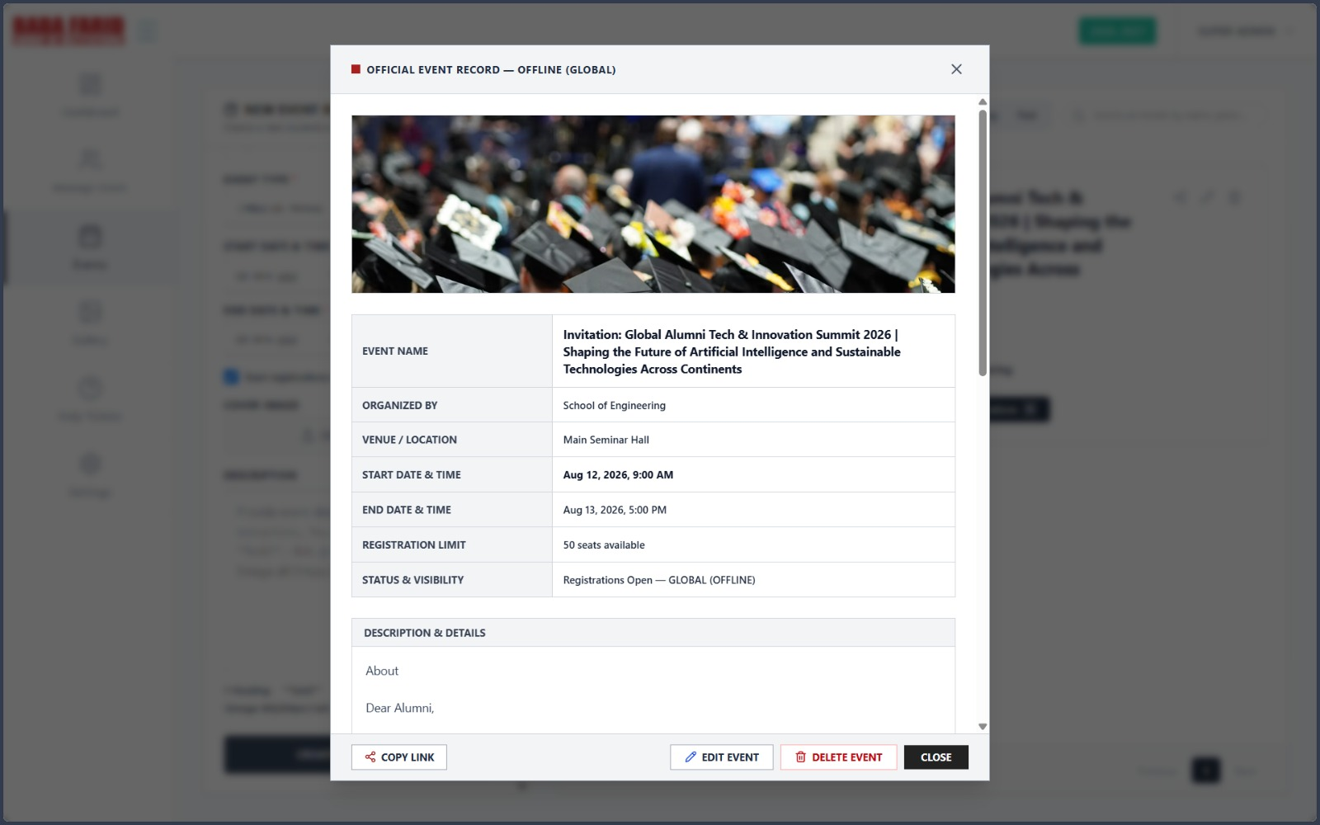
Select an event to view its complete details, including the organizer, venue, registration limit, event schedule, and description.
Step 4: View Event Registrations
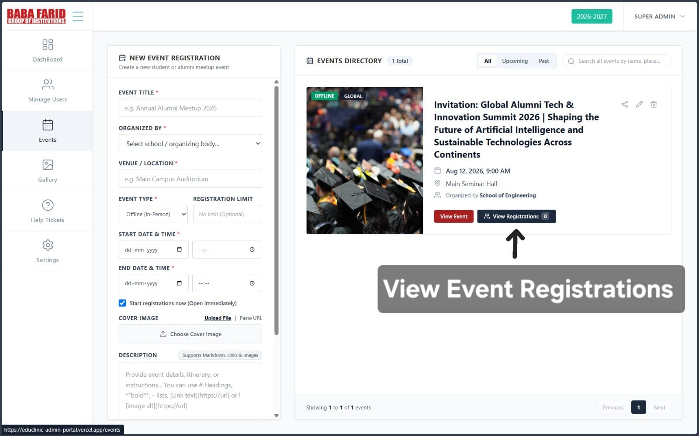
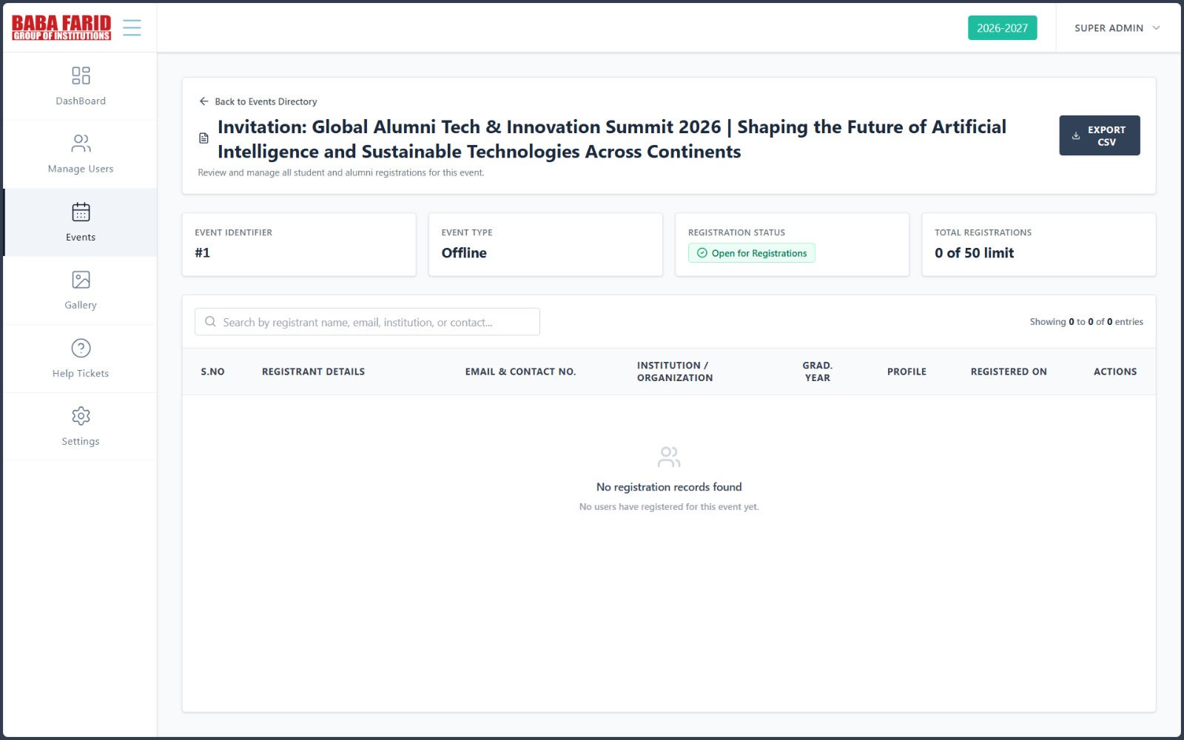
Click the View Registrations button to access the list of participants registered for the selected event. This page displays registration details, participant information, registration status, and provides an option to export the registration data as a CSV file.

