REPORT

GEN AI BOOTCAMP – DAY 2
AI PRODUCT INTELLIGENCE SYSTEM

1. STUDENT INFORMATION
Name: A Yasaswee Reddy
YEAR : 3rd year
College: Pallavi Engineering College
Program: Gen AI Bootcamp – Day 2
Project Title: AI Product Intelligence System

2. INTRODUCTION
Modern e-commerce platforms such as Amazon and Flipkart rely heavily on AI-driven systems to improve product discovery, recommendations, and catalog organization. These systems enhance user experience by intelligently analyzing product attributes and user intent.
The objective of this project is to build a simplified AI Product Intelligence System that demonstrates core functionalities used in real-world e-commerce platforms:
- Product recommendation based on contextual relationships
- Duplicate product detection and catalog cleaning
- Text-based product search system
- AI-generated product insights
This project combines rule-based logic with data-driven reasoning to simulate real-world AI applications.

3. DATASET DESCRIPTION
The dataset used for this project is sourced from Kaggle:
https://www.kaggle.com/code/sahandakramipour/fashion-product-images-small
Dataset Features
Feature | Description
id | Unique product identifier
gender | Target gender category
masterCategory | Primary category (Apparel, Accessories, etc.)
subCategory | Secondary category
articleType | Type of product (Shirts, Shoes, etc.)
baseColour | Product color
season | Suitable season
usage | Usage type (Casual, Formal, etc.)
Product DisplayName | Product name
Importance of Dataset
This dataset is widely used in AI experimentation for:
- Recommendation systems
- Product classification
- Similarity detection
- Information retrieval systems

4. SYSTEM ARCHITECTURE
The system consists of three core modules:
- Task 1: Smart Product Recommendation Engine
- Task 2: Unique Product Catalog Creation
- Task 3: Reverse Product Search System
- Bonus Feature: AI Product Insight Generator

TASK 1 – SMART PRODUCT RECOMMENDATION ENGINE
1. Problem Statement
The objective is to recommend complementary products instead of visually similar ones. This mimics real-world e-commerce cross-selling systems.

2. Conceptual Background
This task is based on association rule-based recommendation systems, commonly used in market basket analysis.
Key ideas:
- Products often bought together
- Usage-based grouping
- Category-based relationships
This is a simplified version of content-based recommendation systems.

3. Approach
The system generates recommendations using rule-based logic:
- Running shoes → socks, water bottle, fitness watch
- Shirts → jeans, belts, shoes
- Casual wear → lifestyle accessories

4. Example Output
Input Product: Running Shoe
Recommended Products:
- Sports Socks
- Fitness Watch
- Water Bottle

5. Explanation
Recommendations are generated using:
- Product category relationships
- Usage type mapping
- Real-world shopping behavior patterns

6. Test Cases
query_index = 50
show_recommendations(query_index)
query_index = 250
show_recommendations(query_index)

7. Screenshot (To Insert)
Input product :
query_index = 100
show_recommendations(query_index)
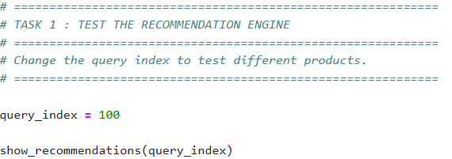

Recommendation output

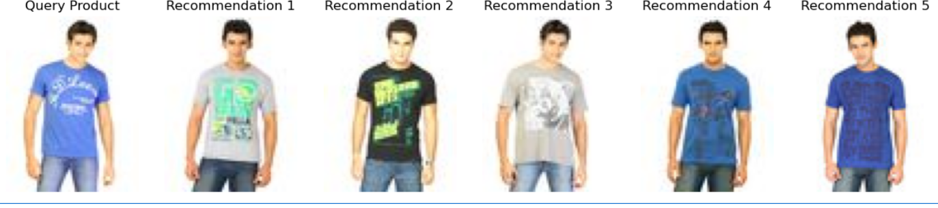

TASK 2 – UNIQUE PRODUCT CATALOG CREATION
- Problem Statement
E-commerce datasets often contain duplicate or near-duplicate products due to multiple sellers. The objective is to create a clean and unique product catalog.

2. Conceptual Background
This task focuses on data deduplication and clustering techniques.
Key concepts:
- Feature similarity detection
- Data cleaning and normalization
- Text similarity grouping
- Embedding-based similarity (theoretical extension)
In advanced systems, deep learning models like CLIP or Sentence Transformers are used.

3. Approach
Products are grouped based on:
- ProductDisplayName similarity
- Category and subcategory consistency
- Attribute matching (gender, usage, season)
Only one representative product is retained per group.

5. Final Result
Final Unique Catalog Size: 2417 products

6. Explanation
The deduplication process improves:
- Data quality
- Search accuracy
- Recommendation relevance
- Catalog organization
This is a critical preprocessing step in any AI-driven product system.

4. Sample Clean Catalog Output
id | gender | Master  Category | Sub  Category | Article  Type | Base  Color | season | year | usage | Product  DisplayName
15970 | Men | Apparel | Topwear | Shirts | Navy Blue | Fall | 2011 | Casual | Turtle Check Men Navy Blue Shirt
39386 | Men | Apparel | Bottomwear | Jeans | Blue | Summer | 2012 | Casual | Peter England Men Party Blue Jeans
59263 | Women | Accessories | Watches | Watches | Silver | Winter | 2016 | Casual | Titan Women Silver Watch
21379 | Men | Apparel | Bottomwear | Track Pants | Black | Fall | 2011 | Casual | Manchester United Men Solid Black Track Pants

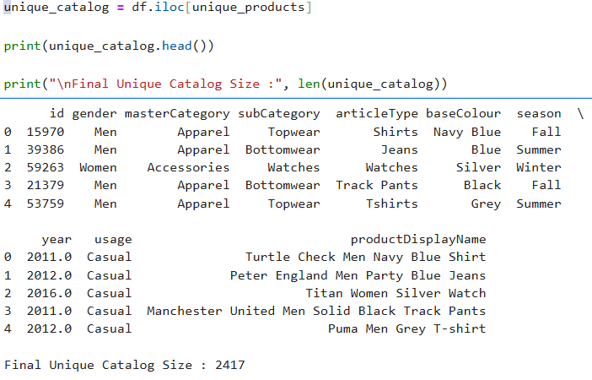

7. Screenshot :
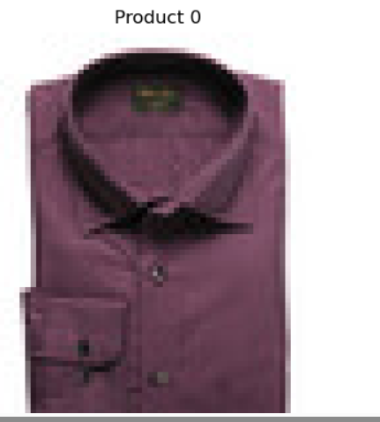

TASK 3 – REVERSE PRODUCT SEARCH SYSTEM
1. Problem Statement
Traditional systems require exact product names. This task enables users to search using natural language text.

2. Conceptual Background
This task is based on information retrieval systems.
Key concepts:
- Text matching
- Ranking algorithms
- Query-product similarity
- Semantic search (advanced concept)

3. Approach
The system matches user queries with:
- ProductDisplayName
- Category
- Usage type
Then ranks and returns the most relevant results.

4. Example Output
Input Query:
blue casual shirt
Output:
- Men’s Blue Casual Shirt
- Blue Checked Shirt
- Slim Fit Blue Shirt

5. Explanation
This simulates a search engine retrieval system, where products are ranked based on similarity to user intent.

6. Screenshot (To Insert)

- Query input:

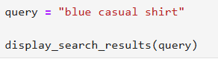

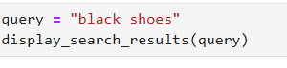

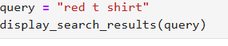

- Search output :

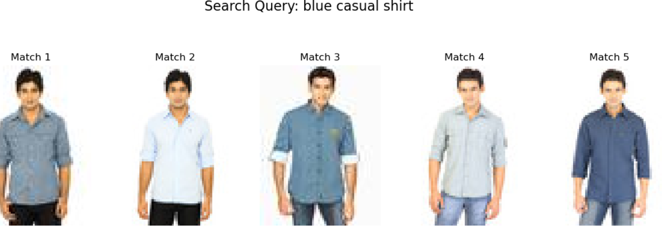
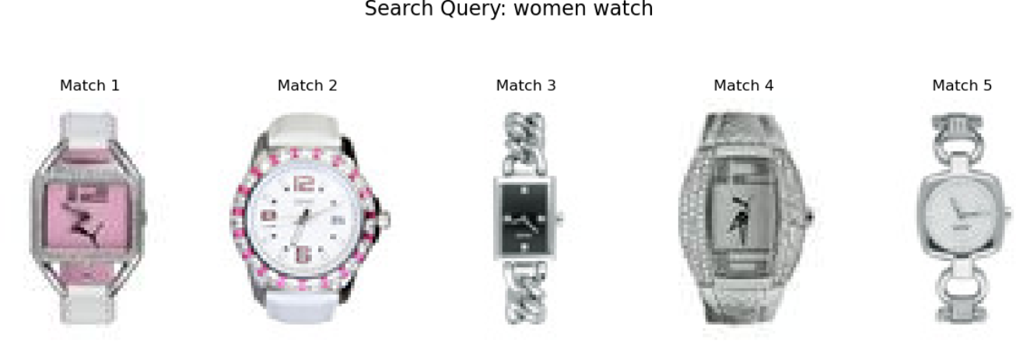

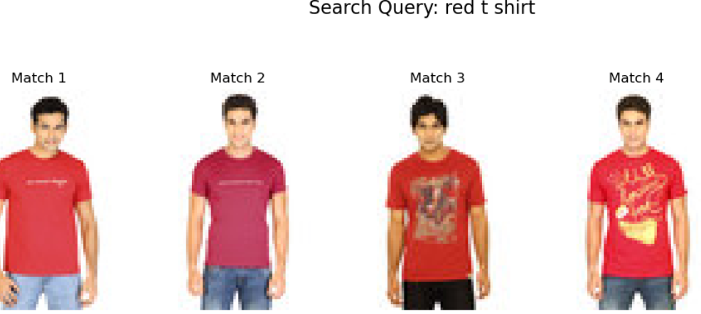

BONUS FEATURE – AI PRODUCT INSIGHT ENGINE
1. Objective
An additional feature was implemented to generate human-readable product insights from structured product data.

2. Conceptual Background
This feature is based on Natural Language Generation (NLG) principles.
Instead of showing raw attributes, the system converts structured data into meaningful sentences.
This simulates AI-powered product descriptions used in modern e-commerce platforms.

3. Implementation Approach
The system:
- Extracts product attributes
- Applies rule-based sentence generation
- Produces contextual product insights
Example:
This T-shirt is suitable for casual wear during summer season.

4. Key Highlights
- Converts structured data into natural language
- Improves user understanding
- Enhances product presentation quality
- Simulates AI-generated product descriptions

5. Importance in Real Systems
This concept is widely used in:
- E-commerce product pages
- AI shopping assistants
- Automated product description generation
- Recommendation explanation systems

6. Screenshot :
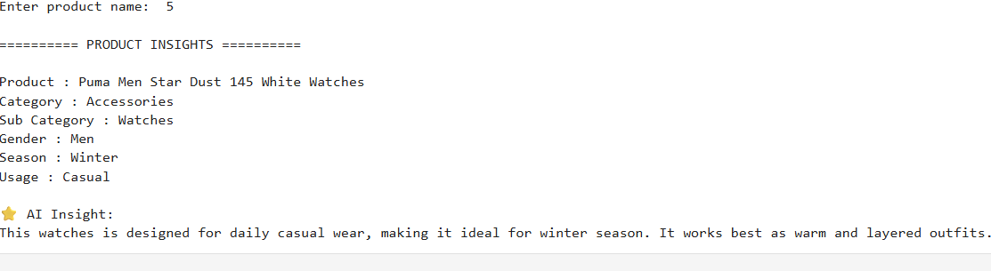

6. CONCLUSION
This project demonstrates a complete AI Product Intelligence System integrating multiple AI concepts:
- Recommendation systems
- Data cleaning and deduplication
- Information retrieval systems
- Natural language generation
The system replicates key functionalities used in real-world e-commerce platforms and provides a strong foundation for advanced AI-based enhancements such as embedding models and deep learning-based recommendation.

